Lab Assignment
Name : Rahat Hossain
Department : CSE
ID : 2110176146
Session : 2020-21
Course Title : Operating System Lab

Question-1:
Write a C program to create a main process named ‘parent_process’ having 3
child processes without any grandchildren processes.
Trace parent and child processes in the process tree.
Show that child processes are doing addition, subtraction and multiplication
on two variables initialized in the parent_process

Solution:

#include <stdio.h>
#include <unistd.h>
#include <sys/wait.h>
#include <sys/types.h>

int main() {
int a = 10, b = 5;
pid_t pid1, pid2, pid3;

printf("Parent process started.... PID = %d\n", getpid());

// First child for Addition
pid1 = fork();
if (pid1 < 0) {
perror("fork1 failed");
return 1;
}
if (pid1 == 0) {
printf("Child 1 (Addition) PID = %d, Parent PID = %d\n", getpid(), getppid());
int sum = a + b;
printf("Addition: %d + %d = %d\n", a, b, sum);
return 0;
}

// Second child for Subtraction
pid2 = fork();
if (pid2 < 0) {
perror("fork2 failed");
return 1;
}
if (pid2 == 0) {
printf("Child 2 (Subtraction) PID = %d, Parent PID = %d\n", getpid(), getppid());
int sub = a - b;
printf("Subtraction: %d - %d = %d\n", a, b, sub);
return 0;
}

// Third child for Multiplication
pid3 = fork();
if (pid3 < 0) {
perror("fork3 failed");
return 1;
}
if (pid3 == 0) {
printf("Child 3 (Multiplication) PID = %d, Parent PID = %d\n", getpid(), getppid());
int mul = a * b;
printf("Multiplication: %d * %d = %d\n", a, b, mul);
return 0;
}

// Wait for all 3 children
wait(NULL);
wait(NULL);
wait(NULL);

printf("Parent Process (PID = %d) finished.\n", getpid());
return 0;
}

Output:
Parent process started.... PID = 3495
Child 1 (Addition) PID = 3496, Parent PID = 3495
Addition: 10 + 5 = 15
Child 2 (Subtraction) PID = 3497, Parent PID = 3495
Subtraction: 10 - 5 = 5
Child 3 (Multiplication) PID = 3498, Parent PID = 3495
Multiplication: 10 * 5 = 50
Parent Process (PID = 3495) finished.

Output Screenshot :
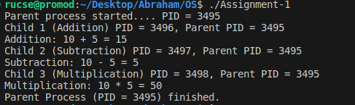

Explanation :
The parent process starts by initializing two variables (a = 10, b = 5) and creates three child processes.
- Child 1 performs addition (a + b)
- Child 2 performs subtraction (a - b)
- Child 3 performs multiplication (a * b)
- The parent process waits until all three child processes finish.
- Finally, the parent prints: "Parent Process finished."

Question-2:
Write a C program to create an orphan process.
Solution :
Orphan Process:
#include <stdio.h>
#include <stdlib.h>
#include <unistd.h>
#include <signal.h>
#include <sys/types.h>

int main() {
pid_t pid = fork();

if (pid < 0) {
perror("fork failed");
exit(1);
}

if (pid == 0) { // Child process
sleep(3); // Wait before terminating parent
printf("Child: Now killing my parent (PID: %d) and child PID = %d\n", getppid(), getpid());
kill(getppid(), SIGKILL); // Terminate parent

sleep(15); // Wait after parent dies
printf("Child: My PID is %d and my PPID is %d\n", getpid(), getppid());
}
else { // Parent process
printf("Parent: My PID is %d\n", getpid());
pause(); // Wait indefinitely for signal
}

return 0;
}

Output :
Parent: My PID is 3898
Child: Now killing my parent (PID: 3898) and child PID = 3899
Killed
Child: My PID is 3899 and my PPID is 1
Output Screenshot :
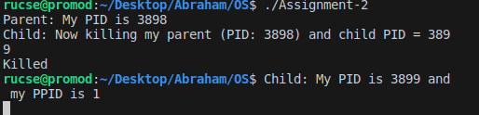
Explanation :
- The parent process starts and immediately creates a child process using fork().
- The parent prints its own PID and then waits indefinitely using pause().
- Meanwhile, the child process sleeps for 3 seconds, then sends a SIGKILL signal to its parent using kill(getppid(), SIGKILL).
- After killing the parent, the child waits another 15 seconds, then prints its own PID and new PPID (which becomes 1, because the original parent is dead and init/systemd adopts it).
- This demonstrates how a child can kill its parent, and how the child becomes an orphan, adopted by init process.
Question -3:
Write a C program to create a zombie process.
Solution :
Zombie Process:
#include <stdio.h>
#include <stdlib.h>
#include <unistd.h>

int main() {
pid_t pid = fork();

if (pid < 0) {
perror("fork failed");
exit(1);
if (pid == 0) {
// Child process
printf("Child: I am the child process. PID: %d\n", getpid());
exit(0); // Child finishes its work and exits
} else {
// Parent process
printf("Parent: I am the parent process. PID: %d\n", getpid());
printf("Parent: My child (PID: %d) has finished. But I won't call wait()!\n", pid);

// Parent sleeps but doesn't call wait(), so child becomes a zombie
sleep(30);
}

return 0;
}

Output :
Parent: I am the parent process. PID: 4838
Parent: My child (PID: 4839) has finished. But I won't call wait()!
Child: I am the child process. PID: 4839

Output Screenshot :
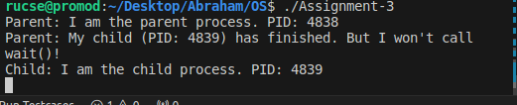
Status :
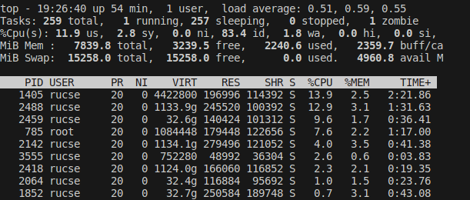

Explanation :
- The parent process creates a child process using fork().
- The child process prints its PID and exits immediately.
- The parent process prints its PID and the child's PID, but does NOT call wait() to clean up the child.
- The parent then sleeps for 30 seconds, during which time the child process becomes a zombie because it has exited but not been waited on.
- This demonstrates how not calling wait() causes zombie processes.

Question-4 :
Write a C program to create a main process named ‘parent_process’ having 3
child processes without any grandchildren processes. Child Processes’
names are child_1, child_2, child_3. Trace the position in the process tree.
Solution :
#include <stdio.h>
#include <stdlib.h>
#include <unistd.h>
#include <sys/wait.h>
#include <sys/prctl.h>
#include <string.h>

int main() {
prctl(PR_SET_NAME, (unsigned long)"parent_process", 0, 0, 0);

for (int i = 1; i <= 3; i++) {
pid_t pid = fork();
if (pid == 0) {
// child process block
char name[16];
sprintf(name, "child_%d", i); // child_1, child_2, child_3
prctl(PR_SET_NAME, (unsigned long)name, 0, 0, 0);

printf("This is %s (PID: %d, PPID: %d)\n", name, getpid(), getppid());

sleep(15); // so that we can observe in top or pstree
exit(0);
}
}

// parent waits for all children
for (int i = 0; i < 3; i++) {
wait(NULL);
}

printf("Parent process finished (PID: %d)\n", getpid());
return 0;
}

Output :
his is child_1 (PID: 30296, PPID: 30295)
This is child_2 (PID: 30297, PPID: 30295)
This is child_3 (PID: 30298, PPID: 30295)
Parent process finished (PID: 30295)

Screenshot :
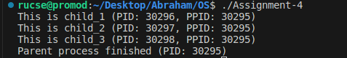

Process Tree:
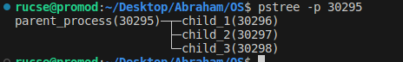

Explanation :
- The parent process sets its name as "parent_process".
- It then creates 3 child processes in a loop.
- Each child process sets its own name (child_1, child_2, child_3), prints its name, PID, and parent PID.
- Each child sleeps for 15 seconds so you can observe them using commands like top or pstree, then exits.
- The parent process waits for all 3 children to finish using wait().
- Finally, the parent prints that it has finished.

Question – 5 :
Write a C program to create a main process named ‘parent_process’ having
‘n’ child processes without any grandchildren processes. Child Processes’
names are child_1, child_2, child_3,......., child_n. Trace the position in the
process tree. Number of child processes (n) and name of child processes will
be given in the CLI of Linux based systems.
Example:
$ ./parent_process 3 child_1 child_2 child_3
Solution :
#include <stdio.h>
#include <stdlib.h>
#include <unistd.h>
#include <sys/wait.h>
#include <sys/prctl.h>
#include <string.h>

int main(int argc, char *argv[]) {
if (argc < 3) {
fprintf(stderr, "Usage: %s <number_of_children> <child_name1> <child_name2> ... <child_nameN>\n", argv[0]);
return 1;
}

int n = atoi(argv[1]);
if (n <= 0 || argc != n + 2) {
fprintf(stderr, "Error: Number of children and provided names count mismatch or invalid.\n");
return 1;
}

// Set parent process name
prctl(PR_SET_NAME, (unsigned long)"parent_process", 0, 0, 0);
printf("Parent process started (PID: %d)\n", getpid());

for (int i = 0; i < n; i++) {
pid_t pid = fork();

if (pid < 0) {
perror("Fork failed");
exit(1);
}

if (pid == 0) {
// Child process block
// Set child's process name from argv
prctl(PR_SET_NAME, (unsigned long)argv[i + 2], 0, 0, 0);

printf("This is %s (PID: %d, PPID: %d)\n", argv[i + 2], getpid(), getppid());
sleep(15); // So we can observe in pstree or top

exit(0);
}
// Parent continues to fork next child
}

// Parent waits for all children to finish
for (int i = 0; i < n; i++) {
wait(NULL);
}

printf("Parent process finished (PID: %d)\n", getpid());

return 0;
}

Output :
Parent process started (PID: 29052)
This is child_1 (PID: 29053, PPID: 29052)
This is child_2 (PID: 29054, PPID: 29052)
This is child_3 (PID: 29055, PPID: 29052)
Parent process finished (PID: 29052)
Screenshot :
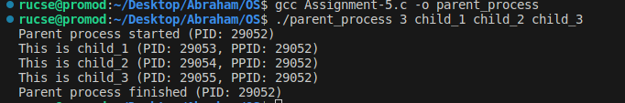
Process tree :
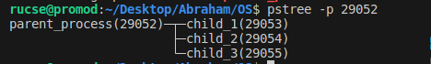

Explanation :
- The parent process starts and sets its name as "parent_process".
- It reads the number of child processes (n) and their names from the command line arguments.
- Then it creates n child processes in a loop using fork().
- Each child process sets its name from the corresponding command line argument, prints its name, PID, and parent PID.
- Each child sleeps for 15 seconds so you can observe them in pstree or top, then exits.
- The parent process waits for all child processes to finish using wait() in a loop.
- Finally, the parent prints that it has finished.

Question -6 :
Write a C program to create a main process named ‘parent_process’ having 3
child processes without any grandchildren processes. Child Processes’
names are child_1, child_2, child_3. Trace the position in the process tree.
Solution :
#include <stdio.h>
#include <stdlib.h>
#include <unistd.h>
#include <sys/wait.h>
#include <sys/prctl.h>
#include <string.h>

int main() {
// Set parent process name
prctl(PR_SET_NAME, (unsigned long)"parent_process", 0, 0, 0);

for (int i = 1; i <= 3; i++) {
pid_t pid = fork();
if (pid == 0) {
// Inside child process
char name[20];
sprintf(name, "child_%d", i); // child_1, child_2, child_3
prctl(PR_SET_NAME, (unsigned long)name, 0, 0, 0);

printf("I am %s (PID: %d, PPID: %d)\n", name, getpid(), getppid());

sleep(15); // So that we can observe process tree
exit(0);
}
}

// Parent waits for all child processes to finish
for (int i = 0; i < 3; i++) {
wait(NULL);
}

printf("Parent process (PID: %d) finished.\n", getpid());
return 0;
}

Output :
I am child_1 (PID: 32475, PPID: 32474)
I am child_2 (PID: 32476, PPID: 32474)
I am child_3 (PID: 32477, PPID: 32474)
Parent process (PID: 32474) finished.
Output Screenshot :
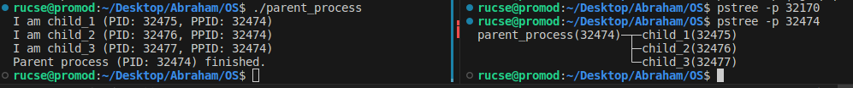
Explanation :
- The parent process sets its name as "parent_process".
- It then creates 3 child processes in a loop.
- Each child process sets its own name (child_1, child_2, child_3), prints its name, PID, and parent PID.
- Each child sleeps for 15 seconds so you can observe the processes in tools like pstree or top, then exits.
- The parent process waits for all children to finish using wait().
- Finally, the parent prints a message indicating it has finished.

Question – 7 :
Write a C program to analyze the effect of local and global variables on a
parent process and a child process.

Solution :
#include <stdio.h>
#include <stdlib.h>
#include <unistd.h>
#include<sys/types.h>
int global_var = 10; // Global variable

int main() {
int local_var = 20; // Local variable

pid_t pid = fork();

if (pid < 0) {
perror("Fork failed");
exit(1);
}

if (pid == 0) {
// Child process
global_var += 5;
local_var += 5;
printf("Child Process:\n");
printf("PID: %d, PPID: %d\n", getpid(), getppid());
printf("Global Variable: %d\n", global_var);
printf("Local Variable: %d\n\n", local_var);
} else {
// Parent process
sleep(1); // Ensure child prints first
global_var -= 5;
local_var -= 5;
printf("Parent Process:\n");
printf("PID: %d\n", getpid());
printf("Global Variable: %d\n", global_var);
printf("Local Variable: %d\n", local_var);
}

return 0;
}

Output :
Child Process:
PID: 33855, PPID: 33854
Global Variable: 15
Local Variable: 25

Parent Process:
PID: 33855
Global Variable: 5
Local Variable: 15
Output Screenshot :
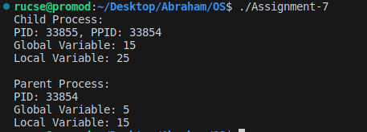

Question -8 :
Write a C program to show how two related processes can communicate with
each other by an unnamed pipe.
Solution :
#include <stdio.h>
#include <stdlib.h>
#include <unistd.h>
#include <string.h>
#include<sys/wait.h>
#include<sys/types.h>

int main() {
int pipefd[2]; // pipefd[0] = read end, pipefd[1] = write end
pid_t pid;
char write_msg[] = "Hello from parent!";
char read_msg[100];

// Create the pipe
if (pipe(pipefd) == -1) {
perror("Pipe creation failed");
exit(1);
}

pid = fork();

if (pid < 0) {
perror("Fork failed");
exit(1);
}

if (pid == 0) {
// Child process
close(pipefd[1]); // Close unused write end

read(pipefd[0], read_msg, sizeof(read_msg)); // Read from pipe
printf("Child received: %s\n", read_msg);

close(pipefd[0]); // Close read end
} else {
// Parent process
close(pipefd[0]); // Close unused read end

write(pipefd[1], write_msg, strlen(write_msg) + 1); // Write to pipe
printf("Parent sent: %s\n", write_msg);

close(pipefd[1]); // Close write end
wait(NULL); // Wait for child to finish
}

return 0;
}

Output :
Parent sent: Hello from parent!
Child received: Hello from parent!
Output Screenshot :
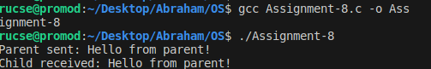
Explanation :
- The parent process creates a pipe for communication between processes.
- It then creates a child process using fork().
- The parent closes the read end of the pipe and writes the message "Hello from parent!" to the pipe.
- The child closes the write end of the pipe and reads the message from the pipe.
- The child then prints the received message.
- Both processes close their respective pipe ends after use.
- The parent waits for the child to finish before exiting.

Question -9:
Write a C program to show how two unrelated processes can communicate
with each other by a named pipe.
Solution :
Writer.c
#include <stdio.h>
#include <stdlib.h>
#include <fcntl.h>
#include <unistd.h>
#include <string.h>

int main() {
char *fifo = "myfifo";
int fd;
char msg[] = "Message from writer process";

// Open the FIFO for writing
fd = open(fifo, O_WRONLY);
if (fd == -1) {
perror("open");
exit(EXIT_FAILURE);
}

write(fd, msg, strlen(msg) + 1);
printf("Writer sent: %s\n", msg);

close(fd);
return 0;
}

Reader.c
#include <stdio.h>
#include <stdlib.h>
#include <fcntl.h>
#include <unistd.h>

int main() {
char *fifo = "myfifo";
int fd;
char buf[100];

// Open the FIFO for reading
fd = open(fifo, O_RDONLY);
if (fd == -1) {
perror("open");
exit(EXIT_FAILURE);
}

read(fd, buf, sizeof(buf));
printf("Reader received: %s\n", buf);

close(fd);
return 0;
}

Output :
Writer.c -:
Writer sent: Message from writer process
Reader.c -:
Reader received: Message from writer process

Output Screenshot :
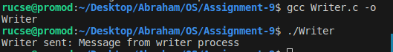
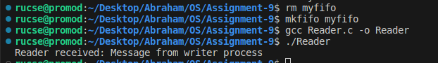
Explanation :
Creating FIFO using “mkfifo myfifo”
Then in Writer.c --

- Opens FIFO with O_WRONLY.
- Writes message using write().
- Closes FIFO.
In Reader.c :
- Opens FIFO with O_RDONLY.
- Reads message using read().
- Prints and closes FIFO.

Question-10 :
Write a C program to show how two related processes can communicate with
each other by a named pipe.

Solution :
#include <stdio.h>
#include <stdlib.h>
#include <unistd.h>
#include <fcntl.h>
#include <sys/types.h>
#include <sys/stat.h>
#include <string.h>
#include<sys/wait.h>

int main() {
char *fifo = "myfifo"; // FIFO file path
char msg[] = "Hello from parent to child!";
char buffer[100];
pid_t pid;

// Create the named pipe (FIFO)
if (mkfifo(fifo, 0666) == -1) {
perror("mkfifo");
}

pid = fork();

if (pid < 0) {
perror("fork");
exit(1);
}

if (pid == 0) {
// Child process: read from FIFO
int fd = open(fifo, O_RDONLY);
if (fd == -1) {
perror("open (child)");
exit(1);
}

read(fd, buffer, sizeof(buffer));
printf("Child received: %s\n", buffer);
close(fd);
} else {
// Parent process: write to FIFO
int fd = open(fifo, O_WRONLY);
if (fd == -1) {
perror("open (parent)");
exit(1);
}

write(fd, msg, strlen(msg) + 1);
printf("Parent sent: %s\n", msg);
close(fd);

wait(NULL); // wait for child to finish

// Remove the FIFO
unlink(fifo);
}

return 0;
}

Output :
Parent sent: Hello from parent to child!
Child received: Hello from parent to child!
Output Screenshot :
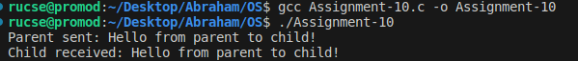
Explanation :
- A named pipe (myfifo) is created using mkfifo() for communication.
- The program uses fork() to create a child process.
- The parent process opens the FIFO in write-only mode and sends a message.
- The child process opens the FIFO in read-only mode and receives the message.
- After the message is transferred, the FIFO is removed using unlink().

Question-11:
Write a C program to show how two unrelated processes can communicate
with each other by a message queue.
Solution :

Receiver.c -
#include <stdio.h>
#include <stdlib.h>
#include <string.h>
#include <sys/ipc.h>
#include <sys/msg.h>

// message structure
struct msg_buffer {
long msg_type;
char msg_text[100];
};

int main() {
key_t key;
int msgid;

// Generate the same unique key
key = ftok("msgfile", 65);

// Get message queue
msgid = msgget(key, 0666 | IPC_CREAT);
if (msgid < 0) {
perror("msgget");
exit(1);
}

struct msg_buffer message;

// Receive message
msgrcv(msgid, &message, sizeof(message.msg_text), 1, 0);
printf("Receiver: Message received: %s\n", message.msg_text);

// Destroy the message queue
msgctl(msgid, IPC_RMID, NULL);

return 0;
}

Sender.c -

#include <stdio.h>
#include <stdlib.h>
#include <string.h>
#include <sys/ipc.h>
#include <sys/msg.h>

// message structure
struct msg_buffer {
long msg_type;
char msg_text[100];
};

int main() {
key_t key;
int msgid;

// Generate unique key
key = ftok("msgfile", 65);

// Create message queue
msgid = msgget(key, 0666 | IPC_CREAT);
if (msgid < 0) {
perror("msgget");
exit(1);
}

struct msg_buffer message;
message.msg_type = 1;

strcpy(message.msg_text, "Hello from sender process!");

// Send message
msgsnd(msgid, &message, sizeof(message.msg_text), 0);
printf("Sender: Message sent: %s\n", message.msg_text);

return 0;
}

Output :
Sender: Message sent: Hello from sender process!
Receiver: Message received: Hello from sender process!
Output Screenshot :
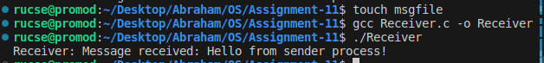
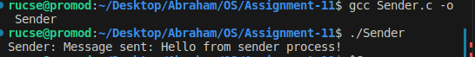
Explanation :
- This program demonstrates how two unrelated processes communicate via a System V message queue.
- A unique key is generated using ftok() to identify the message queue.
- The message queue is created or accessed with msgget().
- The sender process sends a message to the queue using msgsnd().
- The receiver process receives the message using msgrcv().
- After communication, the message queue is removed using msgctl() to free system resources.
- This method allows independent processes to exchange data reliably and asynchronously.

Question-12:
Solution :
#include <stdio.h>
#include <stdlib.h>
#include <string.h>
#include <sys/ipc.h>
#include <sys/msg.h>
#include <unistd.h>
#include <sys/wait.h>

// Message structure
struct msg_buffer {
long msg_type;
char msg_text[100];
};

int main() {
key_t key;
int msgid;
struct msg_buffer message;

// Generate unique key
key = ftok("progfile", 65);

// Create message queue
msgid = msgget(key, 0666 | IPC_CREAT);
if (msgid == -1) {
perror("msgget failed");
exit(EXIT_FAILURE);
}

pid_t pid = fork();

if (pid < 0) {
perror("fork failed");
exit(EXIT_FAILURE);
}

if (pid == 0) {
// Child process: Receive message
if (msgrcv(msgid, &message, sizeof(message.msg_text), 1, 0) == -1) {
perror("msgrcv failed");
exit(EXIT_FAILURE);
}
printf("Child received: %s\n", message.msg_text);
} else {
// Parent process: Send message
message.msg_type = 1;
strcpy(message.msg_text, "Hello from parent to child!");

if (msgsnd(msgid, &message, strlen(message.msg_text) + 1, 0) == -1) {
perror("msgsnd failed");
exit(EXIT_FAILURE);
}
printf("Parent sent: %s\n", message.msg_text);

wait(NULL); // Wait for child
// Remove message queue
if (msgctl(msgid, IPC_RMID, NULL) == -1) {
perror("msgctl failed");
exit(EXIT_FAILURE);
}
}

return 0;
}

Output :
Parent sent: Hello from parent to child!
Child received: Hello from parent to child!
Output Screenshot :
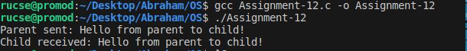
Explanation :
- The program creates a unique key using ftok() to identify the message queue.
- It creates or accesses the message queue with msgget().
- The program calls fork() to create a child process.
- The parent process sends a message to the queue using msgsnd().
- The child process receives the message from the queue using msgrcv().
- The parent waits for the child to finish with wait().
- Finally, the parent deletes the message queue using msgctl() to free system resources.

Question-13:
Write a C program to show how data inconsistency arises in a multi-threaded
process.
Solution :
#include <stdio.h>
#include <pthread.h>

#define NUM_ITER 1000000

int counter = 0; // Shared variable

void* increment(void* arg) {
for (int i = 0; i < NUM_ITER; i++) {
counter++; // Critical section without synchronization
}
return NULL;
}

int main() {
pthread_t t1, t2;

// Create two threads
pthread_create(&t1, NULL, increment, NULL);
pthread_create(&t2, NULL, increment, NULL);

// Wait for both threads to finish
pthread_join(t1, NULL);
pthread_join(t2, NULL);

// Expected final value: 2 * NUM_ITER
printf("Final counter value: %d (Expected: %d)\n", counter, 2 * NUM_ITER);

return 0;
}

Output :
Final counter value: 1067017 (Expected: 2000000)
Output Screenshot :
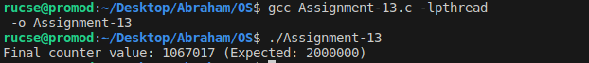
Explanation :
int counter = 0;
  - Shared global variable accessed by both threads.
- void* increment(void* arg)
  - A function run by each thread.
  - It increases counter by 1, one million times.
  - Since both threads run this, it should total 2,000,000.
- pthread_t t1, t2;
  - Thread variables declared.
- pthread_create(...)
  - Starts two threads that run the increment function.
- pthread_join(...)
  - Waits for both threads to finish.
- printf(...)
  - Prints final value of counter.

Threads are not synchronized. Shared variable is not protected, so intermediate values are overwritten. This is called a data inconsistency.

Question-14:
Solution :
#include <stdio.h>
#include <stdlib.h>
#include <unistd.h>
#include <sys/shm.h>
#include <sys/wait.h>

int main() {
// Create shared memory
int shmid = shmget(IPC_PRIVATE, sizeof(int), IPC_CREAT | 0666);
if (shmid == -1) {
perror("shmget failed");
exit(1);
}

// Attach shared memory
int *shared_counter = (int *)shmat(shmid, NULL, 0);
if (shared_counter == (void *)-1) {
perror("shmat failed");
exit(1);
}

*shared_counter = 0; // Initialize shared variable

pid_t pid = fork();

if (pid < 0) {
perror("fork failed");
exit(1);
}

if (pid == 0) {
// Child process
for (int i = 0; i < 100000; i++) {
(*shared_counter)++;
}
shmdt(shared_counter); // Detach from child
exit(0);
} else {
// Parent process
for (int i = 0; i < 100000; i++) {
(*shared_counter)++;
}
wait(NULL); // Wait for child
printf("Final counter value: %d\n", *shared_counter);
shmdt(shared_counter); // Detach from parent
shmctl(shmid, IPC_RMID, NULL); // Remove shared memory
}

return 0;
}

Output :
Final counter value: 126229
It can be different .We can see that clearly in screenshot . It provides different output in different run
Output Screenshot :
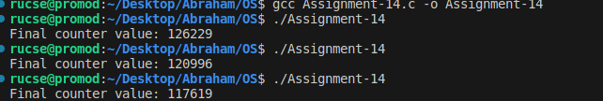
Explanation :
- Parent and child processes share a memory location (shared_counter).
- Both increment the counter without any lock.
- Since updates are not atomic, some increments are lost.
- This causes data inconsistency due to race conditions.
- Here expected output 200000 but we different out for race condition

Question-15:
Write a C program to show how data inconsistency arises in two unrelated
processes when they share a memory space.
Solution :
#include <stdio.h>
#include <stdlib.h>
#include <sys/ipc.h>
#include <sys/shm.h>
#include <sys/types.h>
#include <unistd.h>
#include <sys/wait.h>

int main() {
// 1. Create shared memory
int shmid = shmget(IPC_PRIVATE, sizeof(int), IPC_CREAT | 0666);
if (shmid == -1) {
perror("shmget failed");
exit(1);
}

int *counter = (int *)shmat(shmid, NULL, 0);
*counter = 0; // initialize

pid_t p1 = fork(); // first child

if (p1 == 0) {
// First child process
for (int i = 0; i < 100000; i++) {
(*counter)++;
}
shmdt(counter);
exit(0);
} else {
pid_t p2 = fork(); // second child

if (p2 == 0) {
// Second child process
for (int i = 0; i < 100000; i++) {
(*counter)++;
}
shmdt(counter);
exit(0);
} else {
// Parent process waits for both
wait(NULL);
wait(NULL);

printf("Final counter value: %d\n", *counter);

// Clean up shared memory
shmdt(counter);
shmctl(shmid, IPC_RMID, NULL);
}
}

return 0;
}

Output :
Final counter value: 127502
It can be different . We can see that clearly in screenshot

Output Screenshot :

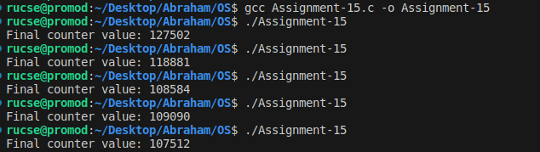

Explanation :
- Two unrelated processes are created using fork().
- They both access a common shared memory without any synchronization.
- Each process increments the shared counter 100000 times.
- Because of the race condition, the final value is often less than expected.
- This demonstrates how data inconsistency arises without synchronization in shared memory.

Question-16:
Write a C program to handle racing situations in a multi-threaded process.
Solution :
#include <stdio.h>
#include <stdlib.h>
#include <pthread.h>

int counter = 0; // shared variable
pthread_mutex_t lock; // mutex lock

void* increment(void* arg) {
for (int i = 0; i < 100000; i++) {
pthread_mutex_lock(&lock); // lock before accessing shared resource
counter++;
pthread_mutex_unlock(&lock); // unlock after done
}
return NULL;
}

int main() {
pthread_t t1, t2;

// initialize the mutex
pthread_mutex_init(&lock, NULL);

// create two threads
pthread_create(&t1, NULL, increment, NULL);
pthread_create(&t2, NULL, increment, NULL);

// wait for both threads to finish
pthread_join(t1, NULL);
pthread_join(t2, NULL);

// destroy the mutex
pthread_mutex_destroy(&lock);

// print final counter value
printf("Final counter value: %d\n", counter);

return 0;
}

Output :
Final counter value: 200000
Output Screenshot :
Explanation :
- A shared variable counter is accessed by two threads.
- Race condition is prevented using pthread_mutex_lock() and pthread_mutex_unlock().
- Each thread increments the counter 100000 times.
- Final output is consistent and correct (200000) because of proper synchronization using mutex.
- Demonstrates safe shared data access in multi-threaded processes.
Question-17:
Write a C program to handle racing situations in multiple unrelated processes.
Solution :
#include <stdio.h>
#include <stdlib.h>
#include <unistd.h>
#include <sys/ipc.h>
#include <sys/shm.h>
#include <sys/sem.h>
#include <sys/wait.h>

#define SHM_KEY 1234
#define SEM_KEY 5678

// semaphore operations
void sem_wait(int semid) {
struct sembuf s = {0, -1, 0};
semop(semid, &s, 1);
}

void sem_signal(int semid) {
struct sembuf s = {0, 1, 0};
semop(semid, &s, 1);
}

int main() {
int shmid, semid;
int *counter;

// create shared memory
shmid = shmget(SHM_KEY, sizeof(int), IPC_CREAT | 0666);
counter = (int *)shmat(shmid, NULL, 0);
*counter = 0;

// create semaphore with initial value 1
semid = semget(SEM_KEY, 1, IPC_CREAT | 0666);
semctl(semid, 0, SETVAL, 1);

// create 2 child processes
for (int i = 0; i < 2; i++) {
if (fork() == 0) {
for (int j = 0; j < 100000; j++) {
sem_wait(semid); // lock
(*counter)++;
sem_signal(semid); // unlock
}
shmdt(counter);
exit(0);
}
}

// wait for children
wait(NULL);
wait(NULL);

// print final result
printf("Final counter value: %d\n", *counter);

// cleanup
shmdt(counter);
shmctl(shmid, IPC_RMID, NULL);
semctl(semid, 0, IPC_RMID);

return 0;
}

Output :
Final counter value: 200000
Output Screenshot :
Explanation :
In this code
- Shared memory (shmget) is used to store a shared counter.
- Semaphore (semget) is used to synchronize access to the shared memory.
- Two unrelated child processes are created using fork().
- Each process increments the counter 100000 times using proper locking.
- The use of sem_wait and sem_signal ensures mutual exclusion, preventing race condition.
- Final result is correct due to synchronization.

Question-18:
Write a C program to show the usage of a Counter semaphore.
Solution :
#include <stdio.h>
#include <stdlib.h>
#include <unistd.h>
#include <sys/ipc.h>
#include <sys/sem.h>
#include <sys/wait.h>

#define SEM_KEY 1234
#define PROCESS_COUNT 5

// semaphore wait
void sem_wait(int semid) {
struct sembuf s = {0, -1, 0};
semop(semid, &s, 1);
}

// semaphore signal
void sem_signal(int semid) {
struct sembuf s = {0, 1, 0};
semop(semid, &s, 1);
}

int main() {
int semid = semget(SEM_KEY, 1, IPC_CREAT | 0666);

if (semid == -1) {
perror("semget failed");
exit(1);
}

// Initialize the semaphore to 2 (only 2 processes allowed at a time)
semctl(semid, 0, SETVAL, 2);

for (int i = 0; i < PROCESS_COUNT; i++) {
if (fork() == 0) {
printf("Process %d trying to enter critical section...\n", getpid());
sem_wait(semid);

printf("Process %d entered critical section\n", getpid());
sleep(2); // simulate some task
printf("Process %d leaving critical section\n", getpid());

sem_signal(semid);
exit(0);
}
}

// Wait for all child processes
for (int i = 0; i < PROCESS_COUNT; i++) {
wait(NULL);
}

// Cleanup
semctl(semid, 0, IPC_RMID);
return 0;
}

Output :
Process 27783 trying to enter critical section...
Process 27783 entered critical section
Process 27784 trying to enter critical section...
Process 27784 entered critical section
Process 27787 trying to enter critical section...
Process 27786 trying to enter critical section...
Process 27785 trying to enter critical section...
Process 27783 leaving critical section
Process 27784 leaving critical section
Process 27787 entered critical section
Process 27786 entered critical section
Process 27787 leaving critical section
Process 27786 leaving critical section
Process 27785 entered critical section
Process 27785 leaving critical section
Output Screenshot :
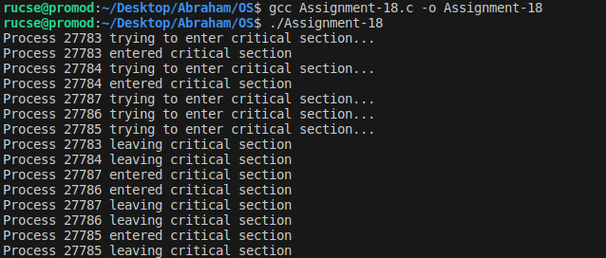
Explanation :
- A counter semaphore allows a fixed number of processes to access a critical section at the same time.
- semctl(..., SETVAL, 2) initializes the semaphore value to 2, meaning 2 processes can enter at a time.
- sem_wait() decreases the counter when a process enters.
- sem_signal() increases it when a process leaves.
- This prevents more than 2 processes from being in the critical section simultaneously.

Question-19:
Write a C program for creating a multi-threaded process and check:
A. If one thread in the process calls fork(), does the new process
duplicate all threads, or is the new process single-threaded?
B. If a thread invokes the exec() system call, does it replace the entire
code of the process?
C. If exec() is called immediately after forking, will all threads be
duplicated?
Solution :
#include <stdio.h>
#include <stdlib.h>
#include <unistd.h>
#include <pthread.h>
#include <sys/types.h>
#include <sys/wait.h>

void *thread_func(void *arg) {
printf("Thread %ld is running in process %d\n", (long)arg, getpid());
sleep(3); // to keep thread alive
return NULL;
}

int main() {
pthread_t t1, t2;

printf("Main process PID: %d\n", getpid());

// Create two threads
pthread_create(&t1, NULL, thread_func, (void *)1);
pthread_create(&t2, NULL, thread_func, (void *)2);

sleep(1); // ensure threads have started

// ------------ A. fork() from a thread ------------
pid_t pid = fork();

if (pid == 0) {
// Child process
printf("\n[A] In child process after fork()\n");
printf("Child PID: %d, PPID: %d\n", getpid(), getppid());

// See how many threads are active
sleep(5); // allow time for threads to finish if not duplicated
printf("Child exiting...\n");
exit(0);
} else {
// Parent process waits
wait(NULL);
}

// ------------ B. exec() from a thread ------------
pid = fork();
if (pid == 0) {
printf("\n[B] In child process before exec()\n");
execlp("ls", "ls", "-l", NULL); // this replaces whole process image
perror("execlp failed");
exit(1);
} else {
wait(NULL);
}

// ------------ C. exec() immediately after fork() ------------
pid = fork();
if (pid == 0) {
printf("\n[C] In child process (forked), now calling exec()\n");
execlp("echo", "echo", "Exec replaces process code!", NULL);
perror("exec failed");
exit(1);
} else {
wait(NULL);
}

// Join threads (though exec replaces them if called earlier)
pthread_join(t1, NULL);
pthread_join(t2, NULL);

printf("\nMain process exiting.\n");
return 0;
}

Output :
Main process PID: 29522
Thread 1 is running in process 29522
Thread 2 is running in process 29522

[A] In child process after fork()
Child PID: 29526, PPID: 29522
Child exiting...

[B] In child process before exec()
total 24
-rwxrwxr-x 1 rucse rucse 16528 Jul 2 23:06 myprogram
-rw-rw-r-- 1 rucse rucse 1886 Jul 2 23:05 program.c

[C] In child process (forked), now calling exec()
Exec replaces process code!

Main process exiting.
Output Screenshot :
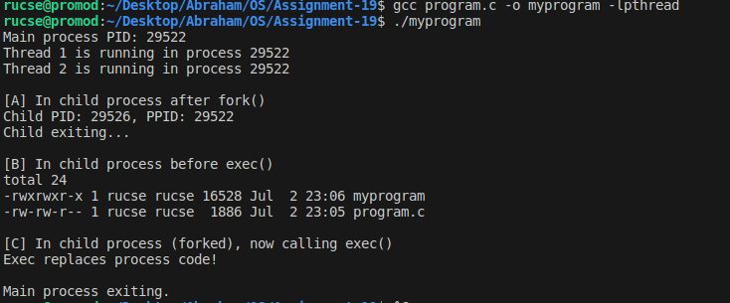
Explanation :
Main Process:
Creates 2 threads. Both run in the same process (same PID).
- [A] fork():
One thread calls fork().
➤ Only that thread is copied into the child process.
➤ Other threads are not duplicated.
➤ So, child process has only 1 thread.
- [B] exec():
The child process calls exec("ls -l").
➤ Entire old code and threads are replaced.
➤ Only the new program (ls -l) runs.
- [C] exec() after fork():
Since fork() gives a single-threaded child,
➤ exec() affects only that thread.
➤ New code runs cleanly without other threads.

Question-20:
Write a multithreaded program that calculates various statistical values for a
list of numbers. This program will be passed a series of numbers on the
command line and will then create three separate worker threads. One thread
will determine the average of the numbers, the second will determine the
maximum value, and the third will determine the minimum value. For
example, suppose your program is passed the integers
90 81 78 95 79 72 85
The program will report
A. The average value is 82
B. The minimum value is 72
C. The maximum value is 95
The variables representing the average, minimum, and maximum values will
be stored globally. The worker threads will set these values, and the parent
thread will output the values once the workers have exited.
Solution :
#include <stdio.h>
#include <stdlib.h>
#include <pthread.h>

// Global variables to store results
double average;
int minimum;
int maximum;

// Array of numbers and its size
int *numbers;
int count;

// Thread functions
void *calculate_average(void *arg) {
int sum = 0;
for (int i = 0; i < count; i++) {
sum += numbers[i];
}
average = (double)sum / count;
pthread_exit(0);
}

void *calculate_minimum(void *arg) {
minimum = numbers[0];
for (int i = 1; i < count; i++) {
if (numbers[i] < minimum)
minimum = numbers[i];
}
pthread_exit(0);
}

void *calculate_maximum(void *arg) {
maximum = numbers[0];
for (int i = 1; i < count; i++) {
if (numbers[i] > maximum)
maximum = numbers[i];
}
pthread_exit(0);
}

int main(int argc, char *argv[]) {
if (argc < 2) {
printf("Usage: %s number1 number2 ...\n", argv[0]);
return 1;
}

count = argc - 1;
numbers = (int *)malloc(count * sizeof(int));
for (int i = 0; i < count; i++) {
numbers[i] = atoi(argv[i + 1]);
}

pthread_t tid_avg, tid_min, tid_max;

// Create threads
pthread_create(&tid_avg, NULL, calculate_average, NULL);
pthread_create(&tid_min, NULL, calculate_minimum, NULL);
pthread_create(&tid_max, NULL, calculate_maximum, NULL);

// Wait for threads to complete
pthread_join(tid_avg, NULL);
pthread_join(tid_min, NULL);
pthread_join(tid_max, NULL);

// Output results
printf("A. The average value is %.2f\n", average);
printf("B. The minimum value is %d\n", minimum);
printf("C. The maximum value is %d\n", maximum);

free(numbers);
return 0;
}

Output :
A. The average value is 82.86
B. The minimum value is 72
C. The maximum value is 95
Output Screenshot :
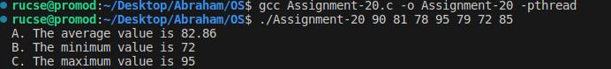
Explanation :
This program demonstrates how multiple threads can be used to calculate statistical values concurrently. It takes a list of integers as command line arguments and creates three threads:
- One thread calculates the average.
- Another finds the minimum value.
- The third finds the maximum value.
All threads work in parallel using the global array. After computation, the main thread collects the results and displays them.
This shows how multi-threading improves performance by performing independent calculations simultaneously.

Question-21:
The Fibonacci sequence is the series of numbers 0, 1, 1, 2, 3, 5, 8, ....
Formally, it can be expressed as:
fib0 = 0
fib1 = 1
fibn = fibn−1 + fibn−2
Write a multithreaded program that generates the Fibonacci sequence. This
program should work as follows: On the command line, the user will enter the
number of Fibonacci numbers that the program is to generate. The program
will then create a separate thread that will generate the Fibonacci numbers,
placing the sequence in data that can be shared by the threads (an array is
probably the most convenient data structure). When the thread finishes
execution, the parent thread will output the sequence generated by the child
thread. Because the parent thread cannot begin outputting the Fibonacci
sequence until the child thread finishes, the parent thread will have to wait for
the child thread to finish.
Solution :
#include <stdio.h>
#include <stdlib.h>
#include <pthread.h>

int *fib; // Global array to store Fibonacci numbers
int n; // Number of Fibonacci numbers to generate

void *generate_fibonacci(void *arg) {
if (n >= 1) fib[0] = 0;
if (n >= 2) fib[1] = 1;

for (int i = 2; i < n; i++) {
fib[i] = fib[i - 1] + fib[i - 2];
}

pthread_exit(NULL);
}

int main(int argc, char *argv[]) {
pthread_t tid;

if (argc != 2) {
printf("Usage: %s <number of Fibonacci terms>\n", argv[0]);
return 1;
}

n = atoi(argv[1]); // Convert string input to integer
if (n <= 0) {
printf("Please enter a positive integer.\n");
return 1;
}

fib = (int *)malloc(n * sizeof(int));
if (fib == NULL) {
perror("Memory allocation failed");
return 1;
}

// Create a thread to generate Fibonacci sequence
pthread_create(&tid, NULL, generate_fibonacci, NULL);

// Wait for the thread to finish
pthread_join(tid, NULL);

// Print the result
printf("Fibonacci sequence:\n");
for (int i = 0; i < n; i++) {
printf("%d ", fib[i]);
}
printf("\n");

free(fib);
return 0;
}

Output :
Fibonacci sequence:
0 1 1 2 3 5 8 13 21 34
Output Screenshot :
Explanation :
This program generates a Fibonacci sequence using threads.
- The user enters the number of terms as a command-line argument.
- A child thread computes the sequence and stores it in a global array.
- The parent thread waits (pthread_join) until the child finishes.
- Finally, the parent prints the full sequence.
This approach uses threading for background computation and synchronization to ensure the result is printed only after computation is complete.

Question-22:
Implement a server-client model to provide services to client processes
running in different terminals. Explain what you experience when you:
● Server process being a single threaded process tries to provide
services to multiple client processes.
● Server process being a multi-threaded process tries to provide
services to multiple client processes.
● Server process being a single threaded process tries to provide
services to multiple client processes with multiple child processes.
Solution :
Server.c --
#include <stdio.h>
#include <stdlib.h>
#include <string.h>
#include <unistd.h>
#include <netinet/in.h>

#define PORT 8080

int main() {
int server_fd, client_fd;
struct sockaddr_in address;
int addrlen = sizeof(address);
char buffer[1024] = {0};
char *msg = "Hello from single-threaded server\n";

server_fd = socket(AF_INET, SOCK_STREAM, 0);
if (server_fd == 0) { perror("socket failed"); exit(EXIT_FAILURE); }

address.sin_family = AF_INET;
address.sin_addr.s_addr = INADDR_ANY;
address.sin_port = htons(PORT);

bind(server_fd, (struct sockaddr *)&address, sizeof(address));
listen(server_fd, 3);

while (1) {
client_fd = accept(server_fd, (struct sockaddr *)&address, (socklen_t*)&addrlen);
if (client_fd < 0) { perror("accept"); exit(EXIT_FAILURE); }

read(client_fd, buffer, 1024);
printf("Received: %s", buffer);
send(client_fd, msg, strlen(msg), 0);
close(client_fd);
}

return 0;
}

Client.c--
#include <stdio.h>
#include <stdlib.h>
#include <string.h>
#include <unistd.h>
#include <netinet/in.h>
#include <arpa/inet.h>

#define PORT 8080

int main() {
int sock;
struct sockaddr_in serv_addr;
char buffer[1024] = {0};

sock = socket(AF_INET, SOCK_STREAM, 0);
serv_addr.sin_family = AF_INET;
serv_addr.sin_port = htons(PORT);
inet_pton(AF_INET, "127.0.0.1", &serv_addr.sin_addr);

connect(sock, (struct sockaddr *)&serv_addr, sizeof(serv_addr));

send(sock, "Hello server\n", strlen("Hello server\n"), 0);
read(sock, buffer, 1024);
printf("Message from server: %s", buffer);

close(sock);
return 0;
}

Output :
send:
Message from server: Hello from single-threaded server
Again----
Message from server: Hello from single-threaded server
Replay:
Received: Hello server
Received: Hello server
Output Screenshot :

Explanation :

● Single-threaded Server
- The server handles one client at a time.
- If multiple clients connect, they must wait in queue.
- Not efficient for real-time/multiple clients.

● Multi-threaded Server
- Each time a client connects, the server creates a new thread.
- All clients can be served concurrently.
- Better performance, but needs careful thread-safety.

● Server with Multiple Child Processes
- Uses fork() for each client.
- Each client is served by a separate process.
- More isolated and safer (one crash won't affect others), but resource heavy.

