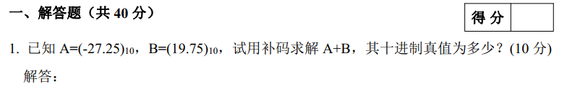

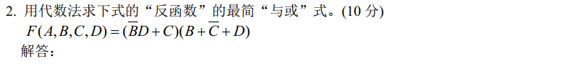

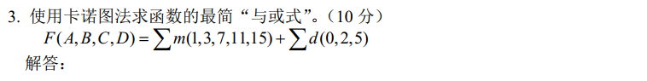

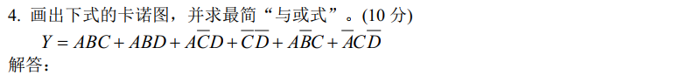

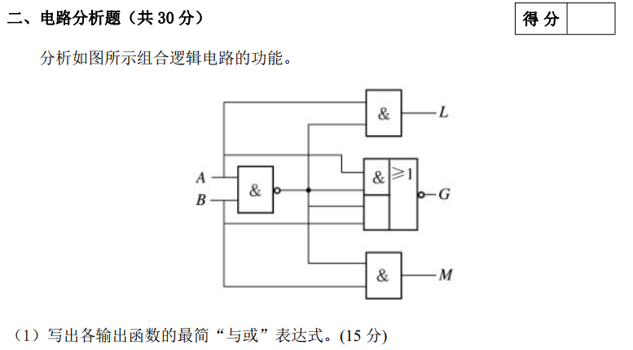

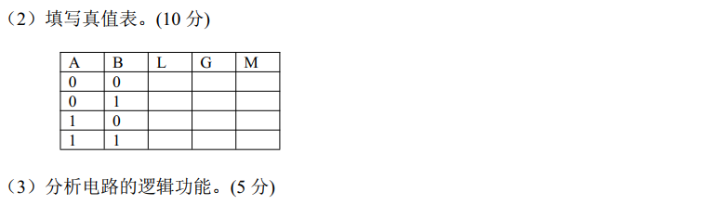

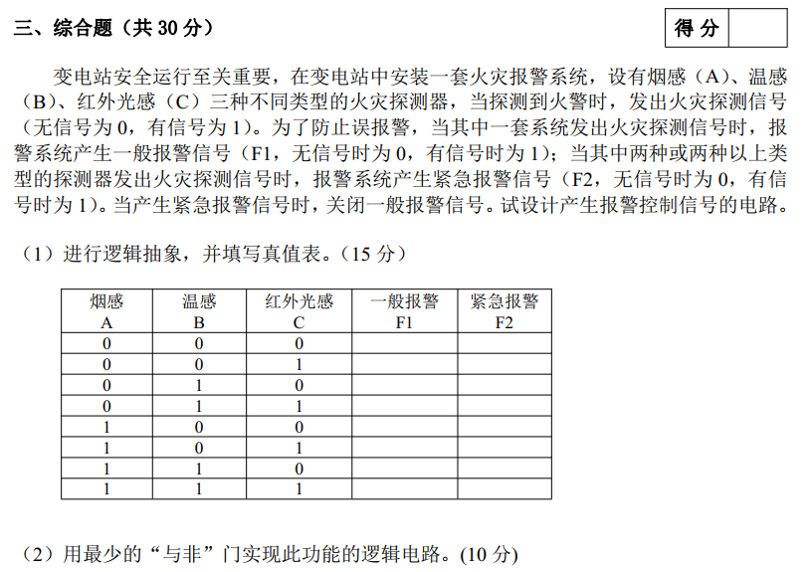

F:\WeChatMsg\WeChat Files\idabenxiang\FileStorage\Temp\1698910271920.png