|  |  |
| --- | --- |
| **No** | **Name** |
| **1** | Abraham |
| **2** | Drago |
| **3** | Bill |
| **4** | Bernard |

**API Documentation**

Get All Students

Description: This endpoint retrieves all student details, including their bio data, payment information, and financial status. It also provides aggregate data like total outstanding balances, total payments, and total expected fees for all students.

**Endpoint**:[*http://localhost:7001/api/students/getstudents*](http://localhost:7001/api/students/getstudents)

**Method**: GET

**Parameters**

* This endpoint does not require any query parameters.

### Response

* **Success Response:**
  + **Status**: 200 OK
  + **Body**:

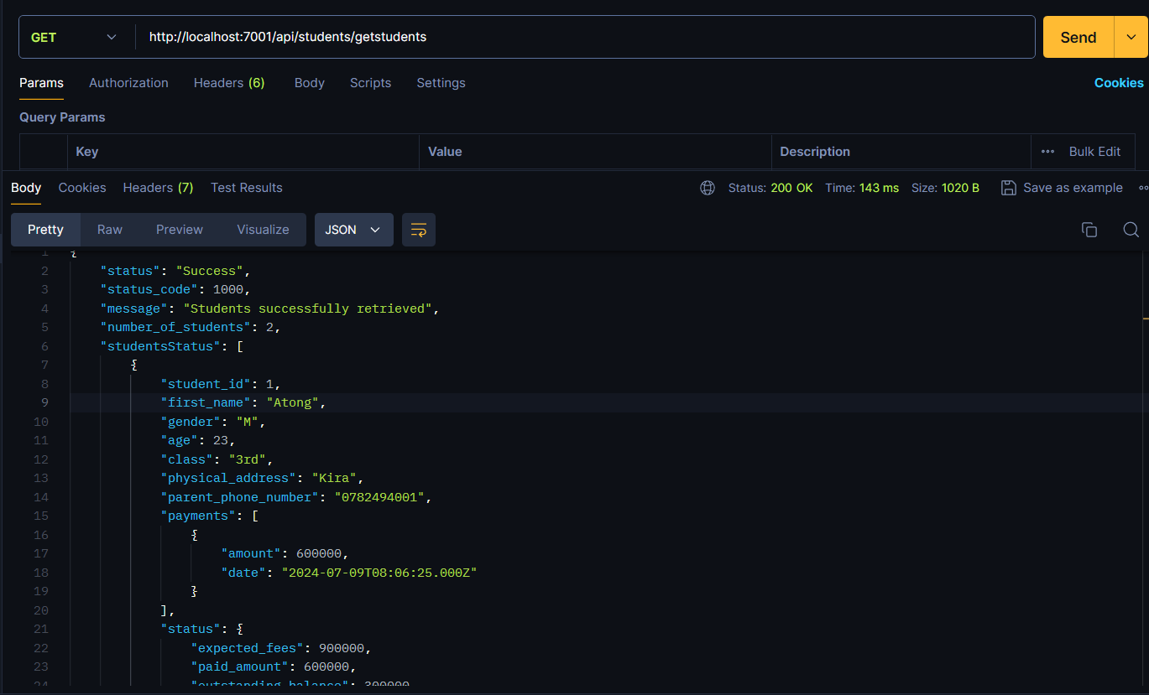

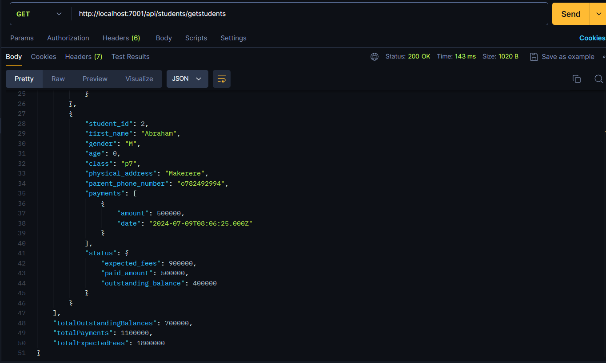

**Error Response**:

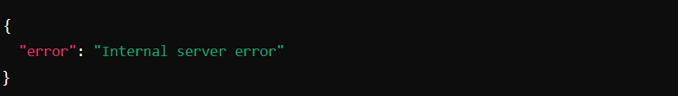

**Detailed Explanation**

Request

Method: GET

URL: http://localhost:7001/api/students/getstudents

Headers: None required

Body: None

Response

Status: 200 OK on success, 500 Internal Server Error on failure

**Fields:**

status: A string indicating the status of the request.

status_code: A numerical code representing the status of the request.

message: A string message indicating the result of the request.

number_of_students: The total number of students retrieved.

studentsStatus: An array of student objects, each containing:

student_id: The ID of the student.

first_name: The first name of the student.

gender: The gender of the student.

age: The age of the student.

class: The class of the student.

physical_address: The physical address of the student.

parent_phone_number: The phone number of the student's parent.

payments: An array of payment objects, each containing:

amount: The amount of the payment.

date: The date of the payment.

status: An object containing:

expected_fees: The expected fees for the student.

paid_amount: The total amount paid by the student.

outstanding_balance: The outstanding balance for the student.

totalOutstandingBalances: The total outstanding balances of all students.

totalPayments: The total payments made by all students.

totalExpectedFees: The total expected fees for all students.

•Each student object includes:

* student_id: Unique identifier of the student.
* first_name, gender, age, class, physical_address, parent_phone_number: Basic information about the student.
* payments: Array of payments made by the student, each containing amount and date.
* status: Financial status of the student including expected_fees, paid_amount, and outstanding_balance.

•Additionally, provides aggregated data:

* number_of_students: Total count of students.
* totalOutstandingBalances: Sum of outstanding balances across all students.
* totalPayments: Total sum of payments made by all students.
* totalExpectedFees: Total expected fees across all students.