
CAMPUS-AWARE INTELLIGENT LOST AND FOUND MANAGEMENT SYSTEM USING NATURAL LANGUAGE PROCESSING
A CAPSTONE PROJECT REPORT
Submitted in partial fulfilment of the requirements for the Course of
DSA0308 – NATURAL LANGUAGE PROCESSING
to the award of the degree of
BACHELOR OF TECHNOLOGY
IN
CSE – ARTIFICIAL INTELLIGENCE
Submitted by
S. MOHAMMAD ABRAR (192472185)
Under the Supervision of
DR. T. KUMARAGURUBARAN
SIMATS ENGINEERING
Saveetha Institute of Medical and Technical Sciences
Chennai–602105
SEPTEMBER 2026

SIMATS ENGINEERING
Saveetha Institute of Medical and Technical Sciences
Chennai – 602105
BONAFIDE CERTIFICATE

This is to certify that the Capstone Project entitled “Campus-Aware Intelligent Lost and Found Management System Using NLP” has been carried out by A. Syed Thoufiq (192424211), S. Mohammad Abrar (192472185), B. Praneeth (192472222), and K. Subrahmanya Venkata Sai Manikanta (192472220) under the supervision of Dr. T. Kumaragurubaran and is submitted in partial fulfilment of the requirements for the current semester of the B. Tech CSE–Artificial Intelligence program at Saveetha Institute of Medical and Technical Sciences, Chennai.

COURSE COORDINATOR | COURSE FACULTY / GUIDE
Dr. Devi  Professor  Department of CSE  SIMATS Engineering | Dr. T. Kumaragurubaran  Professor  Department of CSE  SIMATS Engineering
Saveetha School of Engineering
SIMATS

SIMATS ENGINEERING
Saveetha Institute of Medical and Technical Sciences
Chennai – 602105
DECLARATION

We, A. Syed Thoufiq (192424211), S. Mohammad Abrar (192472185), B. Praneeth (192472222), and K. Subrahmanya Venkata Sai Manikanta (192472220) of the Department of Computer Science Engineering, Saveetha Institute of Medical and Technical Sciences, Saveetha University, Chennai, hereby declare that the Capstone Project Work entitled “Campus-Aware Intelligent Lost and Found Management System Using NLP” is the result of our own bonafide efforts. To the best of our knowledge, the work presented herein is original, accurate, and has been carried out in accordance with the principles of engineering ethics and academic integrity.
We further declare that the data, results, analysis, and findings presented in this report have not been knowingly fabricated or falsified. All software libraries, datasets, references, and external resources used in the project have been appropriately acknowledged.

Place: Chennai
Date: 08/09/26
Signature of the Students with Names
A. Syed Thoufiq (192424211)
S. Mohammad Abrar (192472185)
B. Praneeth (192472222)
K. Subrahmanya Venkata Sai Manikanta (192472220)

SIMATS ENGINEERING
Saveetha Institute of Medical and Technical Sciences
Chennai – 602105

INDIVIDUAL CONTRIBUTION STATEMENT
The project was completed as a team effort. Each member was assigned primary responsibility for one core NLP module, while all members contributed to system integration, testing, documentation, and presentation. The contribution model below records the module-specific technical work and supporting activities.
Student Name /  Register No. | Specific  Responsibilities | Design & Development  Contribution | Testing & Analysis  Contribution | Report  Contribution | Approx.  Contribution (%)
A. Syed Thoufiq  (192424211) | Project planning; Module 1 – Campus Context & Item Information Extraction; item, location and date/time extraction. | NER pipeline development; entity extraction and campus-context identification. | Test item, location and time extraction using varied lost/found descriptions; validate extracted entities. | Ch. 1 – Introduction; Module 1 documentation; integration and presentation support. | 25%
S. Mohammad Abrar  (192472185) | Module 2 – Syntactic Structure Analysis; grammatical structure and word-category analysis. | HMM-based POS tagging using NLTK; noun, verb, adjective, preposition and modifier identification. | Test POS-tagging output and verify grammatical categories for different report descriptions. | Ch. 2 – Literature Review; Module 2 documentation; testing and presentation support. | 25%
B. Praneeth  (192472222) | Module 3 – Linguistic Feature Extraction; conversion of descriptions into comparable numerical features. | TF-IDF weighting; unigram, bigram and trigram extraction; feature-vector construction. | Validate feature generation and compare feature representations for sample lost/found reports. | Ch. 3 – Engineering Design; Module 3 documentation; feature-analysis and presentation support. | 25%
K. Subrahmanya Venkata Sai Manikanta  (192472220) | Module 4 – Lost-and-Found Similarity Matching; comparison, scoring and match ranking. | Cosine-similarity computation; location-aware comparison; ranking and threshold-based recommendation. | Test similarity scores, ranking behaviour and match recommendations using sample report pairs. | Ch. 4 & Ch. 5 – Implementation, Results and Conclusion; Module 4 documentation; final verification and presentation support. | 25%
TOTAL |  |  |  |  | 100%

ABSTRACT
Lost and found management on university campuses becomes increasingly difficult to handle manually as the volume of daily reports grows across hostels, libraries, canteens, and academic blocks. Traditional processes rely on notice boards, manual registers, or spreadsheets and have limited ability to connect a lost report with its corresponding found item when different reporters use different words. This project presents FindIt Campus, a Campus-Aware Intelligent Lost-and-Found Management System Using Natural Language Processing (NLP), which applies NLP and information-retrieval techniques to understand free-text item descriptions, extract campus-related information, and identify likely matches between lost and found reports. The system collects item category, free-text description, campus landmark, reporter details, date, and report status. Named Entity Recognition (NER) extracts attributes such as item name, colour, brand, and location. Hidden Markov Model (HMM)-based Part-of-Speech (POS) tagging identifies grammatical categories such as nouns, adjectives, and prepositional phrases. TF-IDF weighting combined with unigram, bigram, and trigram features converts descriptions into comparable numerical vectors. Cosine similarity is then computed between lost and found vectors, and candidate pairs above the configured similarity threshold of 0.70 are ranked and surfaced through the Find Matches action and administrative dashboard. Representative campus scenarios involving a backpack, headphones, and a student ID card showed that the correct counterpart was ranked first despite differences in wording. An unmatched charger case was also retained as open/unmatched, demonstrating that the system does not need to force a match. The project therefore demonstrates how lightweight, interpretable NLP can reduce manual reconciliation effort and support faster item recovery while retaining human verification before resolution.

Keywords: Lost and Found Management, Natural Language Processing, Named Entity Recognition, Part-of-Speech Tagging, TF-IDF, Cosine Similarity, Text Similarity Matching, Information Retrieval, Campus Management System, Smart Campus

TABLE OF CONTENTS
No. | CONTENTS | PAGE
i | CERTIFICATE FROM THE SUPERVISOR | ii
ii | DECLARATION BY THE CANDIDATE | iii
iii | INDIVIDUAL CONTRIBUTION STATEMENT | iv
iv | ABSTRACT | vi
v | TABLE OF CONTENTS | vii
vi | LIST OF FIGURES | viii
vii | LIST OF TABLES | ix
viii | LIST OF ABBREVIATIONS / SYMBOLS | x
1 | CHAPTER 1: INTRODUCTION AND ENGINEERING PROBLEM | 1
2 | CHAPTER 2: LITERATURE REVIEW AND EXISTING SOLUTIONS | 4
3 | CHAPTER 3: ENGINEERING DESIGN & TRADE-OFFS, SUSTAINABILITY, ETHICS, SAFETY, RISK & SECURITY | 6
4 | CHAPTER 4: IMPLEMENTATION, TESTING & RESULTS, PROJECT MANAGEMENT | 13
5 | CHAPTER 5: CONCLUSION, FUTURE WORK AND REFLECTION | 20
 | REFERENCES | 23
 | APPENDICES | 24

LIST OF FIGURES
Figure No. | Figure Name | Page No.
Figure 1 | System Architecture of FindIt Campus | 9
Figure A1 | Report Lost Item Interface | 24
Figure A2 | Report Found Item Interface | 25
Figure A3 | Browse Lost & Found Items Directory | 26
Figure A4 | Administrator Dashboard | 26

LIST OF TABLES
Table No. | Table Name | Page No.
Table 1 | Existing Approaches Comparison | 4
Table 2 | Stakeholder / User Requirements | 7
Table 3 | Functional and Non-Functional Requirements | 6
Table 4 | Design Specifications | 7
Table 5 | Alternative Solutions Evaluation | 10
Table 6 | Trade-off Analysis | 9
Table 7 | Sustainability, Ethics, Safety and Security Evidence | 12
Table 8 | Risk Register | 11
Table 9 | Tools / Software / Technologies Used in FindIt Campus | 13
Table 10 | Test Plan & Verification | 14
Table 11 | Matching Results / Key Outcomes | 15
Table 12 | Module Performance Parameters | 16
Table 13 | Objective Achievement | 17
Table 14 | Project Management Milestones | 18
Table 15 | Project Roles | 18
Table 16 | Project Budget | 19
Table B1 | NLP Pipeline Summary | 27

LIST OF ABBREVIATIONS / SYMBOLS
Abbreviation / Symbol | Description | Unit
NLP | Natural Language Processing | —
NER | Named Entity Recognition | —
POS | Part-of-Speech | —
HMM | Hidden Markov Model | —
TF-IDF | Term Frequency – Inverse Document Frequency | —
API | Application Programming Interface | —
UI/UX | User Interface / User Experience | —
CRUD | Create, Read, Update, Delete | —
JSON | JavaScript Object Notation | —
DB | Database | —
N-gram | Contiguous sequence of N words | —
SDG | Sustainable Development Goal | —

CHAPTER 1

INTRODUCTION AND ENGINEERING PROBLEM

1.1 Background
University campuses are dense, high-traffic environments in which personal belongings are frequently misplaced. Backpacks may be left in canteens, headphones forgotten in library reading rooms, ID cards dropped near administrative buildings, and chargers abandoned in laboratories. Traditionally, institutions manage such cases using a physical lost-and-found counter, notice board, register, or shared spreadsheet. When reports increase, a staff member must manually inspect descriptions and try to connect a lost report with a found item.
The central difficulty is that users do not describe objects in a standardized way. One person may write “blue Wildcraft backpack near the CSE block canteen,” while another may write “navy blue Wildcraft laptop bag left at a table near the juice stall.” Humans can recognize the connection from the shared context, but exact keyword search may not. NLP provides a practical way to normalize, structure, and compare such free-text descriptions.

1.2 Need for the Project
- Manual reconciliation becomes slow as the number of reports grows.
- Different users use different nouns, adjectives, abbreviations, and levels of detail for the same object.
- Exact keyword matching can miss valid matches when wording changes.
- Campus location is an important contextual signal for matching.
- A centralized platform can keep report status auditable and reduce repetitive staff effort.

1.3 Problem Statement
The engineering problem is to design and implement a web-based campus lost-and-found system that accepts free-text descriptions, extracts useful item and campus information, converts descriptions into comparable features, and automatically identifies and ranks likely matches between lost and found reports while keeping a human decision-maker in control of final resolution.

1.4 Project Aim
To design and develop an intelligent campus lost-and-found platform that uses lightweight NLP techniques to extract information from user descriptions and rank likely lost-and-found matches efficiently.

1.5 Project Objectives
- Design a guided web platform through which students and staff can report lost and found items.
- Extract structured information such as item, location, colour, brand, and time from free-text descriptions using NER.
- Identify grammatical structure and useful word categories using HMM-based POS tagging.
- Convert descriptions into numerical features using TF-IDF and unigram, bigram, and trigram representations.
- Compute cosine similarity between lost and found descriptions and rank likely matches.
- Provide an administrative view of open, matched, and resolved reports.
- Evaluate the system using representative campus scenarios and check that genuine matches rank above unrelated reports.

1.6 Scope
The project covers reporting lost and found items, browsing and filtering open reports, automatic candidate-match generation, similarity ranking, and administrative oversight of the report lifecycle. The current implementation is text-description driven. Although the reporting forms allow an optional photograph, image-based visual matching is outside the current similarity engine and is treated as future work. The intended deployment boundary is a single campus with a defined set of locations and item categories.

1.7 Assumptions and Constraints
The current prototype assumes a defined set of campus locations and item categories, reasonably descriptive user input, and access to stored lost/found reports. The matching engine is intended for a single-campus deployment and relies on text descriptions; optional photographs are not used by the current similarity engine. Final ownership decisions remain subject to human verification, and the system does not require a large labelled campus-specific training corpus.

1.8 Expected Engineering Outcome
The expected outcome is a maintainable and interpretable campus application in which classical NLP techniques operate as an intelligent matching layer inside a conventional reporting and database workflow. The system should reduce manual searching, surface likely matches quickly, and preserve human verification before an item is marked resolved.
The expected outcome is a maintainable and interpretable campus application in which classical NLP techniques operate as an intelligent matching layer inside a conventional reporting and database workflow. The system should reduce manual searching, surface likely matches quickly, and preserve human verification before an item is marked resolved.

CHAPTER 2

LITERATURE REVIEW AND EXISTING SOLUTIONS

2.1 Review Method
The project was informed by established textbooks and research in natural language processing, information retrieval, named entity recognition, POS tagging, term weighting, and hidden Markov models. The selected techniques were compared on suitability for short campus descriptions, computational cost, interpretability, and ease of integration into a web application.

2.2 Review of Existing Work
Conventional campus processes rely on static notices, registers, spreadsheets, or manual staff review. A second approach is exact keyword search, which is fast but brittle when descriptions use different words. More advanced approaches can use learned semantic embeddings or multimodal image-text models, but they generally require additional model infrastructure and, depending on the approach, domain data or tuning.

2.3 Comparative Analysis
Table 1 – Existing Approaches Comparison
Existing Approach | Advantage | Limitation | Relevance
Static register / notice board | Simple and familiar | No automatic matching; difficult to scale | Baseline manual process
Exact keyword search | Fast and easy to implement | Fails with vocabulary variation | Insufficient for the target problem
TF-IDF + N-grams + cosine similarity | Fast, interpretable, lightweight | Sensitive to vocabulary mismatch and deeper semantics | Selected for current project
Transformer-based semantic embeddings | Better semantic representation | Higher compute and implementation complexity; domain tuning may be needed | Future enhancement
Image-based matching | Can use visual appearance | Requires image model and reliable photos | Future enhancement

2.4 Research / Engineering Gap
The project identifies a practical gap between manual campus registers and heavier AI systems: there is a need for a lightweight, explainable matching layer that can work on short free-text reports without requiring a large campus-specific training corpus. The proposed design addresses this gap by combining structured extraction, linguistic analysis, vector-space feature engineering, and similarity ranking.

2.5 Proposed Contribution
The contribution is an integrated FindIt Campus workflow that combines four NLP modules—Campus Context and Item Information Extraction, Syntactic Structure Analysis, Linguistic Feature Extraction, and Lost-and-Found Similarity Matching—with reporting forms, browsing/filtering, a database, and an administrative dashboard. The pipeline is deliberately modular so that each stage can be tested independently.

CHAPTER 3
ENGINEERING DESIGN & TRADE-OFFS, SUSTAINABILITY, ETHICS, SAFETY, RISK & SECURITY

3.1 Requirements
The FindIt Campus system is designed to provide a simple and intelligent lost-and-found management platform for university campuses. The requirements are identified based on the needs of students, faculty, campus staff, security personnel, and administrators. The system combines conventional web-based reporting with an NLP pipeline for extracting information and identifying possible matches.

3.2 Constraints & Applicable Standards
Table 3 – Functional and Non-Functional Requirements
Requirement | Type | Target
Report Lost / Found | Functional | Successful submission of required report fields
NLP extraction | Functional | Item/location/time and descriptive entities processed
Similarity matching | Functional | Candidate matches ranked using cosine similarity
Search and filters | Functional | Reports filterable by type, category, location, and status
Admin dashboard | Functional | Open / Matched / Resolved reports visible
Processing efficiency | Non-functional | Matching runs fast enough for report-submission workflow
Usability | Non-functional | Guided forms understandable to non-technical users

Table 2 – Stakeholder / User Requirements
Stakeholder | Requirement
Students / Faculty | Fast, simple reporting; view possible matches; track status
Security / Administration | Verify matches; manage report status; monitor dashboard
Library / Canteen / Department Staff | Quickly submit found-item reports without specialized training
Campus Administration | Monitor open cases, matching activity, and resolution trends

3.3 Design Specifications
- Maintainability: lightweight libraries and separated NLP stages make debugging and future replacement of a module easier.
- Auditability: report status follows an explicit lifecycle such as Open → Matched → Resolved.
- Consistent taxonomy: item categories and campus locations are standardized across reporting, search, and administration.
- Data validation: required reporter details, category, and description are checked before processing.
- Modular design: the four NLP capabilities have clear inputs and outputs and can be tested independently.

3.4 Alternative Solutions & Evaluation
Table 4 – Design Specifications
Design Parameter | Target | Priority
Matching quality | True matches should be ranked above unrelated reports | High
Processing time | Fast enough for report-submission workflow | Medium
Interpretability | Similarity results should be understandable to administrators | High
Usability | Guided reporting and clear match presentation | High
Privacy and security | Collect only necessary report/contact information and restrict access | High
Maintainability | Four NLP modules remain independently testable | Medium

3.5 Selected Design & Detailed Design

3.5.1 Module 1 – Campus Context & Item Information Extraction
Objective: extract important information such as item, location, and time from user-submitted lost/found descriptions. The module parses the item description and detects campus-specific context such as block, room, or floor. Named Entity Recognition (NER) is the main technique.
Example: “I lost my black Dell laptop in Block B yesterday.” The desired structured output includes item/laptop, colour/black, location/Block B, and time/yesterday. The structured attributes can later be used as auxiliary signals during matching.

3.5.2 Module 2 – Syntactic Structure Analysis
Objective: analyze the grammatical structure of the description and identify important word categories. HMM-based POS tagging is used to assign tags such as noun, verb, adjective, and preposition. The Hidden Markov Model considers transition probabilities between tags and emission probabilities connecting words to likely tags, then selects a probable sequence of tags.
Example: “I lost my black leather wallet near Block A.” The tagger identifies “lost” as a verb, “black” and “leather” as adjectives, “wallet” as a noun, and “near” as a preposition. This grammatical structure helps distinguish descriptive words from other parts of the sentence.

3.5.3 Module 3 – Linguistic Feature Extraction
Objective: convert descriptions into meaningful numerical features for comparison. TF-IDF assigns higher weight to terms that are distinctive within the report collection, while n-grams preserve short word sequences. The implementation uses unigram, bigram, and trigram features and builds a vector for each report.
For example, “navy blue Wildcraft backpack near CSE canteen” can produce unigram features such as “navy”, “blue”, and “backpack”, bigrams such as “navy blue” and “CSE canteen”, and trigrams such as “navy blue Wildcraft”. These features are combined into a comparable vector representation.

3.5.4 Module 4 – Lost-and-Found Similarity Matching

3.6 Trade-off Analysis
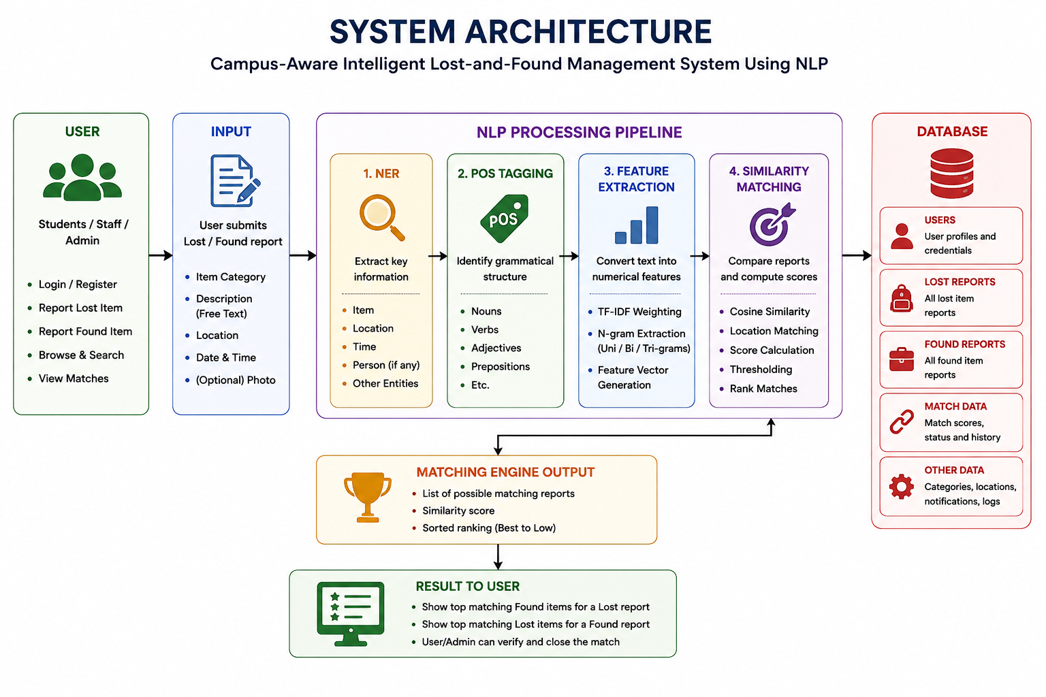
Figure 1 – System Architecture of FindIt Campus
The system follows a simple layered workflow: the user submits a lost or found report; the backend sends the free-text description through the NLP pipeline; the resulting features are compared with reports of the opposite type; candidate matches are ranked; and the results are returned to the user or administrator. Report data and match information are persisted in the database.
Table 6 – Trade-off Analysis
Design Option | Benefit | Trade-off | Decision
Exact keyword matching | Very low computation | Sensitive to vocabulary variation; may miss valid matches | Rejected as primary method
TF-IDF + n-grams + cosine | Low compute, interpretable, easy to deploy | Primarily lexical; weaker deep semantic understanding | Selected
Transformer embeddings | Better semantic robustness | Higher compute and engineering complexity | Future enhancement
Image similarity | Adds visual evidence | Requires image model and reliable photographs | Future enhancement

3.7 Sustainability, Ethics, Safety, Risk & Security
A score closer to 1 indicates greater similarity between the vector representations. In the project example, “iPhone lost near Block C” is compared with a corresponding found report and a similarity score of 0.87 is used to illustrate a strong match. The system does not treat a score as proof of ownership; final confirmation remains with a human.
cos(θ) = (A · B) / (||A|| × ||B||)
Cosine similarity is calculated as:
Objective: compare lost and found reports and rank the most likely matching items. The system computes cosine similarity between the feature vectors of reports of opposite types. Location matching is also considered as a campus-context signal. Candidate pairs above the configured threshold of 0.70 are surfaced for review and ranked from highest to lowest score.
Table 5 – Alternative Solutions Evaluation
Approach | Strength | Trade-off | Decision
Exact keyword matching | Very low compute | Poor with vocabulary variation | Rejected as primary method
TF-IDF + n-grams + cosine | Low compute; interpretable; easy to deploy | Lexical rather than deep semantic matching | Selected
Transformer embeddings | Better semantic robustness | Higher compute and engineering complexity | Future enhancement
Image similarity | Useful visual signal | Requires image model and good photos | Future enhancement

ENGINEERING DESIGN & TRADE-OFFS, SUSTAINABILITY, ETHICS, SAFETY, RISK & SECURITY
Table 8 – Risk Register
Risk | Impact | Level | Mitigation | Residual Risk
False-positive match | Wrong item could be handed to an incorrect claimant | High | Human verification; threshold; status control | Medium
False-negative match | Valid pair may not be surfaced | Medium | N-grams; location signal; configurable threshold | Medium
Poor description | Insufficient matching signal | Medium | Guided form; category and location fields | Low/Medium
Unauthorized access | Exposure of report/contact information | High | Authentication/access control; data minimization | Low
Incorrect status update | Loss of report traceability | Medium | Controlled status transitions and logging | Low

Table 7 – Sustainability, Ethics, Safety and Security Evidence
Domain | Consideration | Evidence / Approach | Impact on Final Decision
Sustainability | Reuse and waste reduction | NLP matching can help reunite owners with existing belongings; project aligns with SDG 12. | Supports reuse over unnecessary replacement.
Ethics | Responsible use of report and contact data | Data minimization, transparency and human-in-the-loop verification. | Reduces privacy and false-positive risks.
Safety | Safe software operation | Current system only performs reporting, NLP processing and matching; no physical control. | No direct physical safety hazard in the prototype.
Security | Protection of reports and personal details | Authentication/access control and limited collection of personal information. | Reduces unauthorized access risk.

The project supports SDG 12 by helping recover and reuse existing belongings instead of encouraging unnecessary replacement. Ethical safeguards include data minimization, transparency about NLP processing, access control, and human verification of candidate matches. The current prototype is software-based and does not create physical safety hazards; operational risk is concentrated in incorrect matches, poor descriptions, and unauthorized access.

CHAPTER 4
IMPLEMENTATION, TESTING & RESULTS, PROJECT MANAGEMENT

4.1 Development Approach & Resources
The project followed an incremental development approach covering problem analysis, requirements identification, NLP pipeline design, module implementation, application integration, testing, result evaluation, documentation, and presentation. Development resources included Python, NLTK, Scikit-learn, NumPy, a database-backed web application workflow, and existing computing resources. The approach emphasized modular development so that each NLP stage could be tested independently before integration.

4.2 Hardware / Software / Fabrication Implementation & Modern Tools Used
- User selects Report Lost or Report Found and enters category, date, location, and free-text description.
- Backend validates required fields and stores the report.
- NER extracts item-related and campus-related attributes.
- HMM-based POS tagging identifies grammatical categories.
- TF-IDF and n-gram extraction produce a numerical feature vector.
- The vector is compared against open reports of the opposite type using cosine similarity.
- Location/context is checked and candidate pairs above the 0.70 threshold are ranked.
- The Find Matches view and Admin dashboard display candidate matches for human verification.

4.2.1 Tools / Software / Technologies Used in FindIt Campus
Table 9 – Tools / Software / Technologies Used in FindIt Campus
Layer / Module | Technology / Technique | Purpose
Frontend UI | Responsive web application | Guided reporting, browse/filter directory, admin console
NER / item extraction | Python NLP libraries | Extract item, location, time, colour, brand
POS tagging | HMM-based POS tagging, Python, NLTK | Grammatical categories and structure
Feature extraction | TF-IDF + unigram/bigram/trigram, Scikit-learn, NLTK | Numerical feature vectors
Similarity matching | Cosine similarity, Scikit-learn, NumPy | Similarity score and ranking
Data storage | Relational / document database | Lost/found reports, users, status, match data
Administration | Dashboard with filters and status controls | Open / Matched / Resolved monitoring

4.3 Test Plan & Verification
The verification plan checked report submission, entity extraction, syntactic tagging, feature generation, similarity ranking, unmatched-case handling, and the administrative report lifecycle.
Table 10 – Test Plan & Verification
Test Case | Input / Scenario | Expected Result | Outcome
Report submission | Valid lost/found form | Report saved successfully | Pass
NER extraction | Backpack/headphones/ID examples | Key item and campus entities extracted | Pass
POS tagging | Representative descriptions | Noun/adjective/verb/preposition tags produced | Pass
Feature generation | Known sample descriptions | TF-IDF and n-gram vectors created | Pass
True-match ranking | 3 known matched pairs | Correct counterpart ranked first above 0.70 | Pass
Unmatched case | Lost 65W Dell USB-C charger | No forced found-item match; remains open | Pass
Admin workflow | Open → Matched → Resolved | Status visible and controllable | Pass

4.4 Results
The project evaluation used representative campus scenarios covering Bags & Backpacks, Electronics, and ID Cards. Three known lost/found pairs were tested, together with an unmatched charger report. The correct counterpart was consistently ranked first for the three true-match cases, even when wording differed between the lost and found descriptions.
Table 11 – Matching Results / Key Outcomes
Pair | Category | Vocabulary Overlap | Result
Backpack (#st-101 / #nd-201) | Bags | Partial overlap; “Wildcraft” shared, colour/noun differ | Correctly ranked top match
Headphones (#st-102 / #nd-202) | Electronics | Partial overlap; “Sony” shared, model vs generic wording | Correctly ranked top match
ID Card (#st-103 / #nd-203) | ID Cards | High overlap; roll number and lanyard colour shared | Correctly ranked top match; status Matched
Charger (#st-104) | Electronics | No corresponding found report | Correctly left Open / Unmatched

4.5 Data Analysis & Engineering Judgment
During the development/test window, the platform included five lost reports and five found submissions across Bags & Backpacks, Electronics, and ID Cards, with reports associated with CSE Block Canteen, Central Library, Admin Building, and Science Block Lab. The administrative view recorded 10 active NLP-generated candidate pairs and 18 items resolved in the current week during the reported test snapshot. These values are operational observations from the project test environment, not a statistically representative campus-wide benchmark.
Table 12 – Module Performance Parameters
Module | Technique / Tooling | Key Parameters Monitored
Campus Context & Item Information Extraction | NER, Python NLP libraries | Entity type; extracted entity; extraction accuracy
Syntactic Structure Analysis | HMM-based POS tagging, NLTK | POS tag; word category; tagging accuracy
Linguistic Feature Extraction | TF-IDF + N-gram extraction, Scikit-learn, NLTK | TF-IDF score; n-gram frequency; feature vectors
Lost-and-Found Similarity Matching | Cosine similarity, Scikit-learn, NumPy | Similarity score; ranking; threshold = 0.70

Engineering judgment: The representative tests indicate that the selected classical NLP pipeline is suitable for the current single-campus scope. The strongest evidence is consistent top-ranking of the known backpack, headphones, and ID-card counterparts, while the unmatched charger remained open. These observations support retaining the lightweight pipeline with a configurable threshold and human verification, while recognizing that larger-scale evaluation is still required for broader deployment. Key challenges observed included vocabulary drift such as “backpack” versus “bag”, short-text sparsity, threshold selection, ambiguous descriptions, and the need for human verification because similarity is a ranking signal rather than proof of ownership.
Recommendation: The current text-based pipeline should remain the primary matching mechanism for the present scope because it is lightweight, interpretable, and performed well on the representative scenarios tested. The similarity threshold should remain configurable, and future visual matching and notifications should be introduced as additional signals rather than immediately replacing the current pipeline.

4.6 Comparison with Existing Solutions & Achievement of Objectives
Compared with static registers and exact keyword search, FindIt Campus provides automated candidate generation and ranking while remaining more lightweight and interpretable than transformer-based semantic matching. The implemented objectives are supported by the four NLP modules, the reporting workflow, administrative status controls, and representative true-match and unmatched test cases.
Table 13 – Objective Achievement
Objective | Evidence | Achievement
Provide guided lost/found reporting | Report Lost and Report Found workflows are implemented. | Achieved
Extract structured information | NER extracts item and campus-related attributes from descriptions. | Achieved
Analyse grammatical structure | HMM-based POS tagging is included in Module 2. | Achieved
Generate comparable text features | TF-IDF and unigram/bigram/trigram features are generated. | Achieved
Rank likely matches | Cosine similarity, location context and threshold-based ranking are implemented. | Achieved
Support administration | Admin view provides report status and matching oversight. | Achieved
Validate matching behaviour | Backpack, headphones and ID-card scenarios ranked the correct counterpart first; charger remained unmatched. | Achieved

4.7 Strengths & Limitations
Strengths: The system integrates four complementary NLP stages into one campus workflow, uses lightweight and interpretable techniques, incorporates campus context such as location, supports ranked candidate matching, and retains human verification before resolution. The modular architecture also makes individual components easier to test and replace.
Limitations: The current matching engine is primarily lexical and may be affected by vocabulary mismatch, very short descriptions, ambiguous item details, and threshold selection. The prototype is intended for a single-campus scope and does not currently use image-based matching or advanced semantic embeddings.

4.8 Project Planning, Roles & Budget
Project planning covered problem analysis, NLP design, application design, integration, testing, and final documentation. The project used equal team contribution across the four assigned NLP modules, with shared integration, testing, documentation, and presentation responsibilities.
Table 14 – Project Management Milestones
Milestone | Main Activity | Status
Problem analysis | Identify manual matching problem and user workflow | Completed
NLP design | Define NER, HMM-POS, TF-IDF/n-gram and cosine pipeline | Completed
Application design | Build reporting, browsing and admin workflow | Completed
Integration | Connect NLP pipeline with stored reports and Find Matches action | Completed
Testing | Run matched and unmatched campus scenarios | Completed
Documentation | Prepare capstone report and presentation | Completed

Table 15 – Project Roles
Student | Assigned Responsibility
A. Syed Thoufiq (192424211) | Module 1 – Campus Context & Item Information Extraction; project planning and integration support
S. Mohammad Abrar (192472185) | Module 2 – Syntactic Structure Analysis; literature review and testing support
B. Praneeth (192472222) | Module 3 – Linguistic Feature Extraction; feature analysis and testing support
K. Subrahmanya Venkata Sai Manikanta (192472220) | Module 4 – Lost-and-Found Similarity Matching; results, verification and presentation support

4.8.1 Project Budget
The project is primarily software-based and uses open-source NLP/Python libraries and existing development resources. No separate software or dataset expenditure was reported.
Table 16 – Project Budget
Item | Estimated Cost | Actual Cost
Python / NLP libraries | Open-source | No separate cost reported
Development environment | Existing resources | No separate cost reported
Computer / development system | Existing resources | No separate cost reported
Dataset / sample reports | Project data / sample reports | No separate cost reported
Printing / documentation | Not separately reported | Not separately reported
TOTAL | Not separately reported | Not separately reported

CHAPTER 5
CONCLUSION, FUTURE WORK AND REFLECTION

5.1 Conclusion
FindIt Campus demonstrates that a lightweight NLP pipeline can improve a practical campus workflow. The system accepts free-text lost and found descriptions, extracts useful entities, analyzes syntactic structure, creates TF-IDF and n-gram features, and ranks candidate matches using cosine similarity. Representative tests showed that the correct counterpart was ranked first for the tested backpack, headphones, and student ID card scenarios, while an unmatched charger remained open rather than being forced into a false match.
The project also demonstrates an important engineering principle: the most sophisticated model is not always the most suitable model. For the present single-campus scope, a transparent and computationally inexpensive pipeline is easier to explain, maintain, and integrate. The system supports faster reunions and encourages reuse of existing belongings, aligning with the broader intent of SDG 12 – Responsible Consumption and Production.

5.2 Future Work
- Mobile application for easier reporting and tracking.
- Advanced semantic AI techniques for improved vocabulary robustness.
- Real-time notifications for potential matches.
- QR-code based reporting and item handover workflows.
- Campus map and location-aware features.
- Multilingual reporting and matching.
- Image-based similarity using uploaded item photographs.

5.3 Professional Learning & Individual Reflection

5.3.1 New Knowledge Acquired
The project strengthened understanding of natural language processing as a pipeline rather than a single algorithm. The team learned how NER extracts structured information, how HMM-based POS tagging models sequential word categories, how TF-IDF and n-grams represent short text, and how cosine similarity compares vector representations.

5.3.2 Engineering & Professional Skills Developed
The work provided practical experience with Python, NLTK, Scikit-learn, NumPy, database-backed application workflows, form validation, text preprocessing, vectorization, similarity scoring, ranking, dashboard-oriented presentation, testing, documentation, and teamwork.

5.3.2.1 Problem-Solving and Critical Thinking
A key learning was that the hardest part of the problem is vocabulary variation in very short descriptions. The team therefore had to balance accuracy, computational cost, explainability, and implementation effort. The resulting classical NLP pipeline was chosen because it provides a practical solution for the current campus scale without requiring a large labelled training dataset.

5.3.2.2 Challenges Encountered and Overcome
The major challenges were vocabulary drift, short descriptions, threshold selection, and ambiguous item descriptions. These were addressed through n-gram features, auxiliary category/location information, empirical threshold testing, and human-in-the-loop verification. The process demonstrated the importance of testing both true-match and true-non-match cases.

5.3.2.3 Application of Engineering Practices
The project applied modularity, validation, consistent taxonomies, traceable report status, and separation between the NLP processing layer and the application interface. These practices improve maintainability and make individual stages easier to test and replace.

5.3.2.4 Application of Ethical Principles
Ethical design was treated as a core requirement because a false-positive match could result in personal property being given to the wrong person. The system therefore proposes matches rather than making the final ownership decision. Data minimization, transparency about NLP processing, access control, and human verification are important safeguards.

5.3.3 Individual Reflection – A. Syed Thoufiq (192424211)
My primary contribution was Module 1, Campus Context & Item Information Extraction. I worked on extracting item, location, colour, brand, and date/time information from free-text lost-and-found descriptions using NER-oriented processing. This work strengthened my understanding of information extraction and showed how structured entities can provide useful context for downstream matching. I also contributed to project planning, integration, documentation, testing, and presentation.

5.3.4 Individual Reflection – S. Mohammad Abrar (192472185)
My primary contribution was Module 2, Syntactic Structure Analysis. I worked on HMM-based POS tagging to identify nouns, verbs, adjectives, prepositions, and other useful grammatical categories in item descriptions. This improved my understanding of statistical sequence tagging and its practical role in NLP pipelines. I also contributed to literature review, testing, documentation, integration, and presentation activities.

5.3.5 Individual Reflection – B. Praneeth (192472222)
My primary contribution was Module 3, Linguistic Feature Extraction. I worked on TF-IDF weighting and unigram, bigram, and trigram feature extraction to convert item descriptions into comparable numerical representations. This helped me understand how lexical features influence text similarity and how feature engineering affects matching quality. I also contributed to feature validation, documentation, integration, and presentation.

5.3.6 Individual Reflection – K. Subrahmanya Venkata Sai Manikanta (192472220)
My primary contribution was Module 4, Lost-and-Found Similarity Matching. I worked on cosine-similarity scoring, location-aware comparison, ranking, and threshold-based candidate recommendation. This strengthened my understanding of vector-space similarity and the importance of evaluating both correct and unmatched cases. I also contributed to implementation, results analysis, final verification, documentation, and presentation.

REFERENCES
[1] C. Gao, W. Zhang, W. Lam, and L. Bing, “Easy-to-hard learning for information extraction,” in Proc. Findings of the Association for Computational Linguistics: ACL 2023, Toronto, Canada, 2023, pp. 11913–11930.
[2] K. Pei, I. Jindal, and K. Chang, “Abstractive open information extraction,” in Proc. 2023 Conf. Empirical Methods in Natural Language Processing (EMNLP), Singapore, 2023, pp. 6146–6158.
[3] Y. Jiao, M. Zhong, S. Li, R. Zhao, S. Ouyang, H. Ji, and J. Han, “Instruct and extract: Instruction tuning for on-demand information extraction,” in Proc. 2023 Conf. Empirical Methods in Natural Language Processing (EMNLP), Singapore, 2023.
[4] T. Xie, Q. Li, J. Zhang, Y. Zhang, Z. Liu, and H. Wang, “Empirical study of zero-shot NER with ChatGPT,” in Proc. 2023 Conf. Empirical Methods in Natural Language Processing (EMNLP), Singapore, 2023, pp. 7935–7956.
[5] K. Karthikeyan et al., “Taxonomy expansion for named entity recognition,” in Proc. 2023 Conf. Empirical Methods in Natural Language Processing (EMNLP), Singapore, 2023, pp. 6895–6906.
[6] U. Katz, M. Vetzler, A. D. N. Cohen, and Y. Goldberg, “NERetrieve: Dataset for next generation named entity recognition and retrieval,” in Proc. Findings of the Association for Computational Linguistics: EMNLP 2023, Singapore, 2023.
[7] W. Otto, M. Zloch, L. Gan, S. Karmakar, and S. Dietze, “GSAP-NER: A novel task, corpus, and baseline for scholarly entity extraction focused on machine learning models and datasets,” in Proc. Findings of the Association for Computational Linguistics: EMNLP 2023, Singapore, 2023, pp. 8166–8176.
[8] C. Zhang, Y. Guo, Y. Tu, H. Chen, J. Tang, H. Zhu, Q. Zhang, and T. Gui, “Reading order matters: Information extraction from visually-rich documents by token path prediction,” in Proc. 2023 Conf. Empirical Methods in Natural Language Processing (EMNLP), Singapore, 2023, pp. 13716–13730.
[9] L. Qin, Q. Chen, X. Feng, Y. Wu, Y. Zhang, Y. Li, M. Li, W. Che, and P. S. Yu, “Large language models meet NLP: A survey,” arXiv preprint arXiv:2405.12819, 2024.
[10] A. Vasileiou and O. Eberle, “Explaining text similarity in Transformer models,” in Proc. 2024 Conf. North American Chapter of the Association for Computational Linguistics: Human Language Technologies (NAACL-HLT), Mexico City, Mexico, 2024, pp. 7859–7873.
[11] Z. Chen, H. Fan, Q. Wang, T. He, M. Liu, H. Chang, W. Yu, Z. Li, and B. Qin, “How do language models reshape entity alignment? A survey of LM-driven EA methods: Advances, benchmarks, and future,” in Proc. 2025 Conf. Empirical Methods in Natural Language Processing (EMNLP), Suzhou, China, 2025, pp. 23219–23234.

APPENDICES

Appendix A — System Screenshots and Module Reference

Figure A1 – Report Lost Item Interface
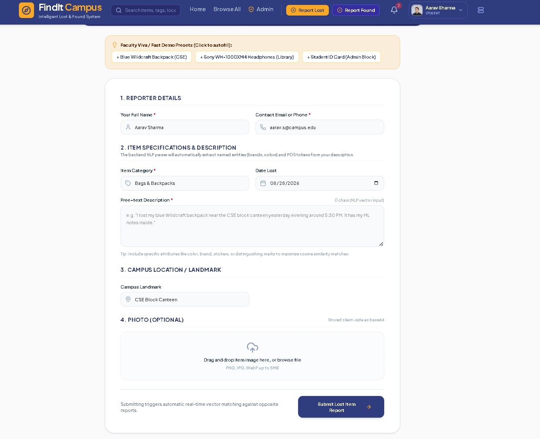
Report Lost form showing reporter details, item specification, campus landmark, and description input.

Figure A2 – Report Found Item Interface
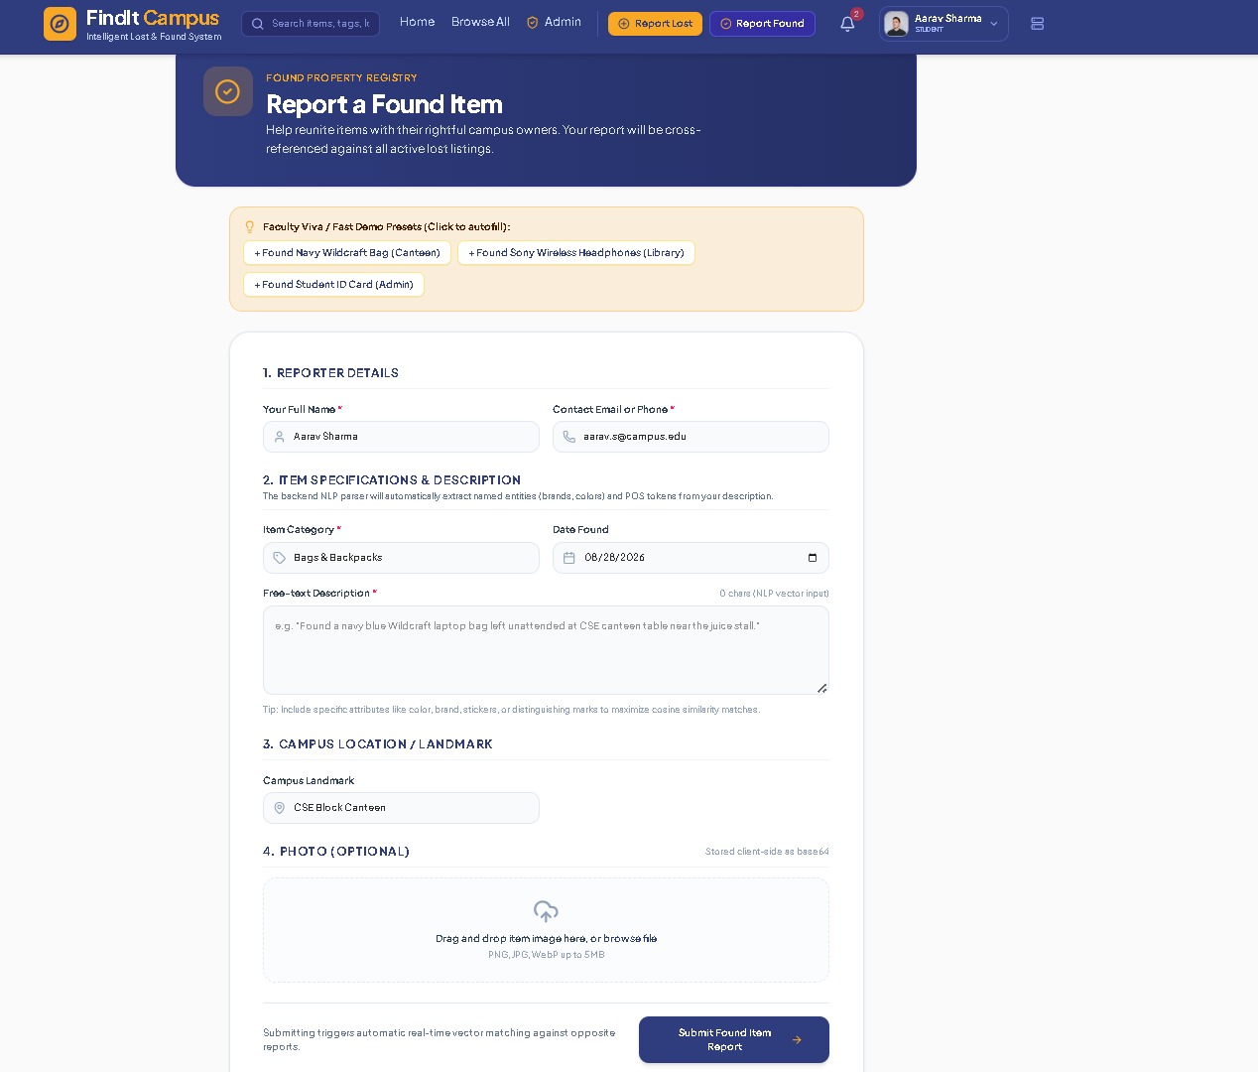
Report Found form mirroring the lost-item workflow for recovered items.

Figure A3 – Browse Lost & Found Items Directory
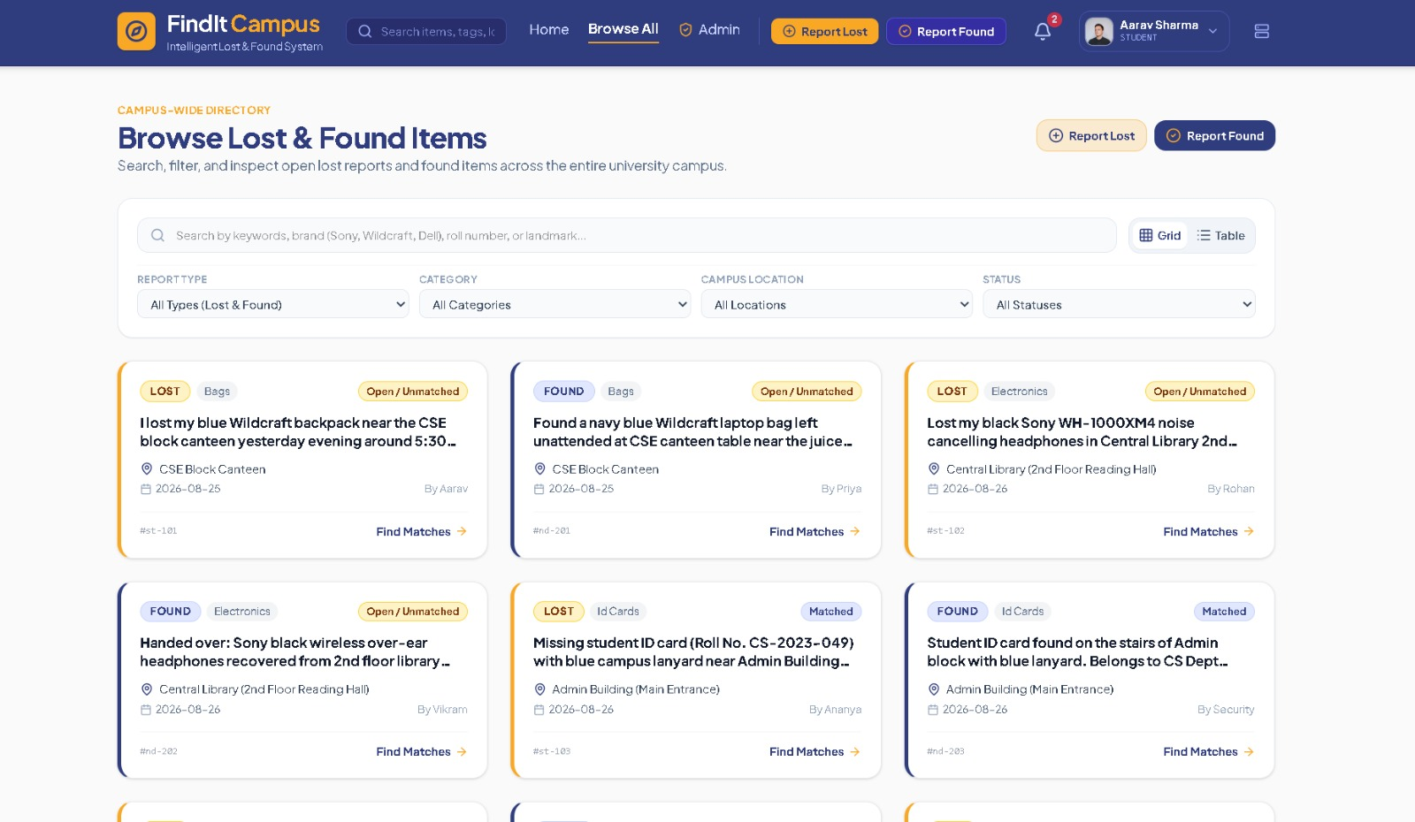
Campus-wide directory with search, category, location, and status filters.

Figure A4 – Administrator Dashboard
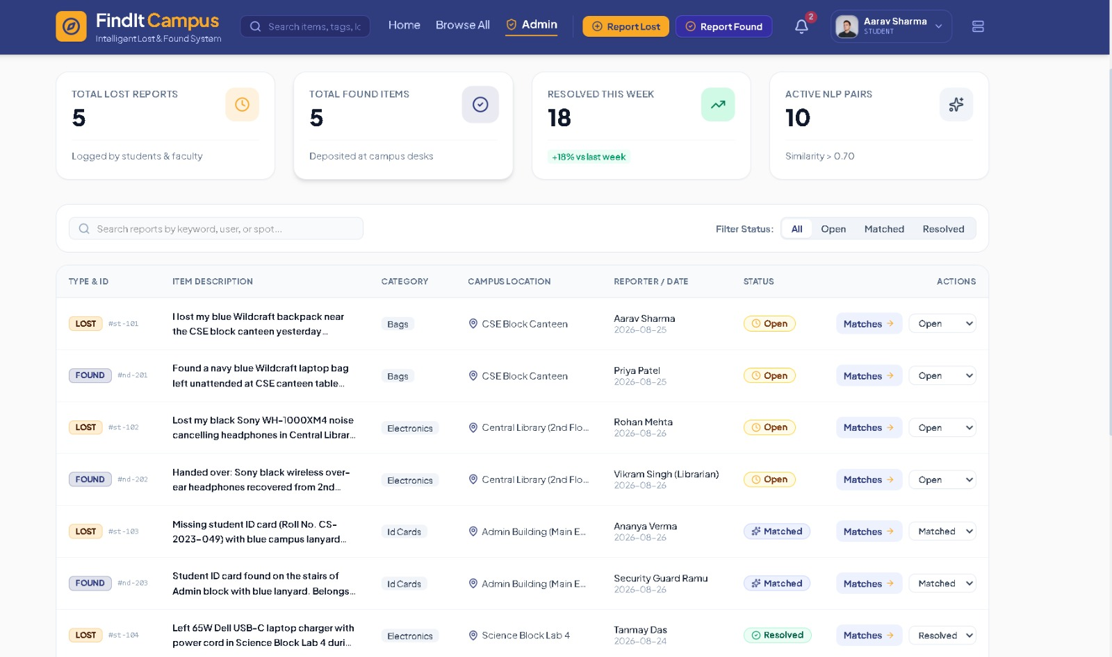
Admin console showing report volume, matching activity, weekly resolution indicators, and status controls.
Appendix B — NLP Pipeline Summary
The implemented conceptual pipeline is: User Report → Text Preprocessing → NER → HMM-based POS Tagging → TF-IDF + N-grams → Feature Vector → Cosine Similarity + Location Matching → Thresholding and Ranking → Possible Match → Human Verification → Matched / Resolved.
Table B1 – NLP Pipeline Summary
Module | Technique | Primary Output
Module 1 | NER | Extract item, location, time, colour, brand and related entities
Module 2 | HMM-based POS | Identify grammatical word categories and structure
Module 3 | TF-IDF + N-grams | Create comparable numerical/text features
Module 4 | Cosine Similarity | Score, threshold, and rank candidate reports

Appendix C – Source Code / Code Repository Information
This appendix provides information about the source code and implementation resources used for the Campus-Aware Intelligent Lost and Found Management System Using Natural Language Processing (NLP).
The implementation consists of a modular NLP pipeline integrated with the FindIt Campus reporting and matching workflow. The major software components include:
Component | Implementation / Purpose
User Interface | Lost-item and found-item reporting forms
Backend | Report validation, storage and matching workflow
NER Module | Extraction of item, location, time, colour and brand information
POS Module | HMM-based Part-of-Speech tagging
Feature Extraction | TF-IDF with unigram, bigram and trigram features
Similarity Module | Cosine similarity and location-aware comparison
Matching Module | Threshold-based candidate ranking
Administration | Match verification and report-status management

Appendix D – Datasheets / Software Requirements
Since FindIt Campus is primarily a software-based NLP application, conventional hardware datasheets are not applicable to the core implementation. The following software requirements are relevant to the project.
Software / Technology | Purpose
Python | NLP processing and implementation
NLTK | Natural language processing and HMM-based POS tagging
Scikit-learn | TF-IDF feature extraction and vector processing
Web Application Framework | User reporting and administrative interface
Database | Storage of lost/found reports and match information
HTML/CSS/JavaScript | User-interface development
Development Environment | Code development, testing and debugging

Appendix E – Experimental / Raw Data
This appendix contains the representative experimental data used for testing the FindIt Campus matching system.
The evaluation included lost and found reports from Bags & Backpacks, Electronics, and ID Cards, together with an unmatched charger case. Three known lost/found pairs were used to verify whether the correct counterpart was ranked first.
Case | Category | Experimental Purpose | Result
Backpack | Bags & Backpacks | Test matching with vocabulary variation | Correct counterpart ranked first
Headphones | Electronics | Test partial description overlap | Correct counterpart ranked first
Student ID Card | ID Cards | Test strong attribute similarity | Correct counterpart ranked first
65W Dell USB-C Charger | Electronics | Test unmatched condition | Remained Open / Unmatched
The test environment included five lost reports and five found submissions covering locations such as CSE Block Canteen, Central Library, Admin Building and Science Block Lab. These values represent the project test snapshot and are not intended as a statistically representative campus-wide dataset.
The actual raw dataset, if maintained separately, should be submitted with the project materials where institutional and privacy requirements permit.

Appendix F – Ethics / Institutional Approval
The FindIt Campus system handles lost-and-found descriptions and may contain user-provided information such as reporter details and item descriptions. Ethical considerations were therefore incorporated into the system design.
The project follows the principles of:
- Data minimization.
- Collection of only necessary information.
- Restricted access to administrative information.
- Human verification before final ownership resolution.
- Transparency regarding automated NLP processing.
- Avoidance of forced matches when similarity is insufficient.
- Protection against incorrect assignment of property.
A false-positive match could result in an item being given to the wrong person. Therefore, the NLP system recommends possible matches rather than making the final ownership decision.
Institutional Approval Status:
The available project report does not document a separate institutional ethics approval or approval number. If formal institutional approval was required or obtained, the relevant approval letter/certificate should be attached here. Otherwise, the ethical and responsible data-handling procedures documented in Chapter 3 should be retained as the project's ethics evidence.

Appendix E – Individual Contribution Evidence
The project was completed as a team effort, with each member taking primary responsibility for one core NLP module while contributing to integration, testing, documentation and presentation.

Individual Contribution Evidence
Student | Primary Module | Technical Contribution | Suggested Evidence
A. Syed Thoufiq | Module 1 – Campus Context & Item Information Extraction | NER pipeline; item, location and date/time extraction | NER source code, entity-extraction outputs, test screenshots
S. Mohammad Abrar | Module 2 – Syntactic Structure Analysis | HMM-based POS tagging and grammatical category identification | POS-tagging code, sample outputs, testing records
B. Praneeth | Module 3 – Linguistic Feature Extraction | TF-IDF, unigram/bigram/trigram extraction and feature-vector construction | Feature-extraction code, vector outputs, analysis results
K. Subrahmanya Venkata Sai Manikanta | Module 4 – Lost-and-Found Similarity Matching | Cosine similarity, location-aware comparison, ranking and thresholding | Similarity code, score outputs, ranking results and test cases

