WEEK 2 DELIVERABLE | AI SOLUTIONS ARCHITECT
Data Integration and Pipeline Strategy
ClaimIQ: From Raw Claim Data to Quality, AI-Ready Datasets
Prepared by: Abrar Ahmad Nath
Date: October 2026
Builds on: Week 1 - AI Architecture Blueprint (ClaimIQ)
Version: 1.0

Purpose of this document
This document defines how data is identified, collected, validated, cleaned, transformed, stored and delivered to the ClaimIQ AI modules. It describes each pipeline phase, the quality controls between phases, the challenges expected in integration, and the mitigation strategies chosen.

Contents
1. Introduction and Objectives
2. Data Requirements of the AI Modules
3. Data Source Identification
4. Integration Architecture and Pipeline Design
5. Pipeline Stages: Collection, Preprocessing, Cleaning, Transformation
6. Data Storage and Modelling
7. Data Quality Framework
8. Integration Challenges and Mitigation Strategies
9. Latency, Scalability and Cost Strategy
10. Governance, Security and Privacy
11. Innovative Approaches for Efficient and Scalable Data Management
12. Monitoring and Key Metrics
13. Implementation Plan
14. Conclusion
References

List of Figures
Figure 1 - Data Source Landscape and Ingestion Mechanisms
Figure 2 - End-to-End Data Pipeline Architecture
Figure 3 - Preprocessing, Cleaning and Transformation Flow
Figure 4 - Data Quality Gate and Error-Handling Flow
Figure 5 - Logical Data Model

1. Introduction and Objectives
In Week 1, ClaimIQ was designed as a modular, event-driven AI platform for health-insurance claims. Its AI modules (document intelligence, entity extraction, policy reasoning, fraud detection) are only as good as the data they receive. A strong model fed late, inconsistent or incomplete data produces unreliable decisions, and in a regulated domain those decisions must be explainable and reproducible.
This document therefore designs the data layer of ClaimIQ. Its objectives are to:
- Identify every data source the solution needs and choose a suitable integration mechanism for each.
- Define the stages of collection, preprocessing, cleaning and transformation, and the quality checks between them.
- Design a pipeline that is timely (seconds for live claims, hours for analytics), reliable (replayable and observable) and scalable.
- Analyse the main integration challenges (inconsistency, latency, schema change, quality assurance, privacy) and set out mitigations.
- Deliver quality-assured, well-documented data that can be consumed directly by AI training, inference and reporting.

1.1 Guiding data principles
- Keep the raw data, always. The original input is stored immutably so any result can be reproduced and any pipeline bug can be fixed by replay.
- Validate at every boundary. Data is checked when it enters and when it moves between layers, not only at the end.
- Contracts over assumptions. Producers and consumers agree on versioned schemas; changes are managed, not discovered in production.
- Quarantine, do not discard. Bad records are isolated with a reason code and can be corrected and replayed.
- Carry confidence and lineage with the data. Each value records where it came from, how sure the system is, and which version of the pipeline produced it.
- Minimise and protect personal data. Sensitive fields are tokenised early and exposed only where needed.

2. Data Requirements of the AI Modules
Different ClaimIQ modules need different data shapes, freshness and volumes. Understanding this first prevents building one generic pipeline that serves nobody well.
AI module | Training data needed | Inference-time data needed | Freshness / quality need
Document intelligence (OCR, layout) | Labelled page images with text and table annotations | Normalised page images | Seconds; image quality score is critical
Entity extraction | Documents with verified field values and bounding boxes | OCR text blocks with coordinates | Seconds; per-field confidence must be preserved
Medical code validation | Versioned ICD-10 / CPT code sets and mapped examples | Extracted diagnoses and procedure text | Code sets updated on release; version pinned
Policy reasoning (RAG) | Question-clause pairs for evaluation; policy text | Chunked, embedded and versioned policy corpus | Updated when a policy changes; old versions retained
Fraud and anomaly detection | Historical claims with confirmed outcomes; provider and member history | Current claim plus rolling-window features | Minutes for features; labels may arrive weeks later
Routing and reporting | Decisions, overrides, appeals | All of the above signals | Accuracy and lineage over speed

Design implication
Three data speeds are needed: a hot path (seconds) for live claim processing, a warm path (minutes) for rolling features and dashboards, and a cold path (hours to days) for training sets, backfills and audits. The pipeline is built once on shared storage and serves all three.

3. Data Source Identification
Sources are grouped into three families: operational data that is created as claims arrive, reference and master data that gives claims meaning, and learning data that the system generates about itself. Figure 1 shows the sources and how each reaches the landing zone.
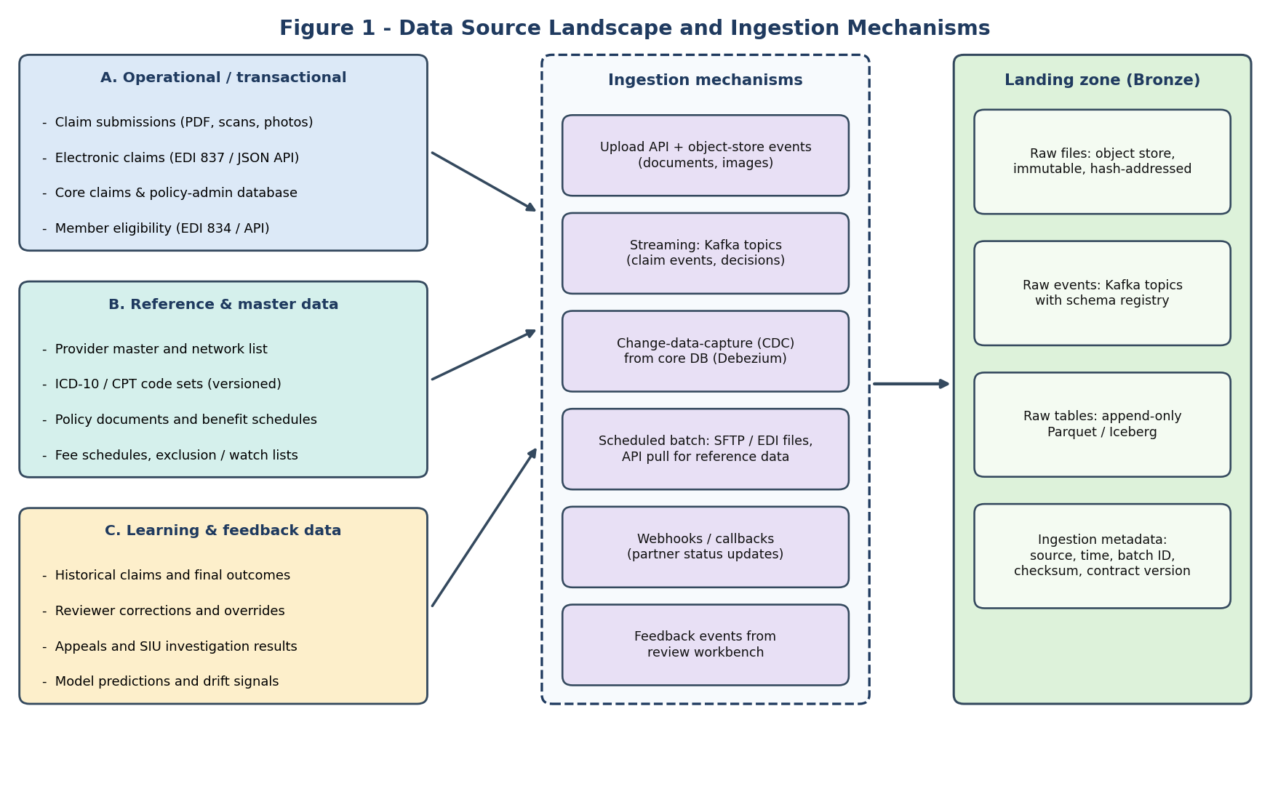
Figure 1 - Data Source Landscape and Ingestion Mechanisms

3.1 Source catalogue
Source | Type and format | Arrival pattern | Ingestion method | Main quality risks
Claim submissions | Unstructured: PDF, scans, phone photos | Continuous, bursty (month-end peaks) | Upload API; object-store events | Blur, skew, rotation, handwriting, multi-claim PDFs
Electronic claims | Semi-structured: EDI 837, JSON | Continuous / hourly batches | Streaming or SFTP batch | Missing segments, vendor-specific variants, duplicates
Core claims and policy-admin DB | Structured relational tables | Continuous changes | Change-data-capture (CDC) | Schema drift, late updates, soft deletes
Member eligibility | EDI 834 or API | Daily files plus on-demand lookups | Batch import; API call with cache | Stale coverage, retroactive changes
Provider master and network | Structured, partly manual | Weekly / monthly | Scheduled API or file pull | Duplicate providers, name variants, expired licences
Medical code sets (ICD-10, CPT) | Public reference tables | Annual / quarterly releases | Versioned file load | Wrong version applied to a service date
Policy documents and benefit schedules | Unstructured PDFs plus structured limits | On policy change | Document ingest plus versioning | Superseded clauses, scanned appendices, tables
Fee schedules, exclusion and watch lists | Structured reference lists | Periodic | Scheduled pull | Name matching ambiguity, outdated entries
Historical claims and outcomes | Structured (data warehouse export) | One-off backfill, then incremental | Bulk load, then CDC | Label noise, changing business rules over time
Reviewer corrections, appeals, SIU results | Events and case records | Continuous | Event stream from review workbench | Inconsistent reviewer behaviour, delayed final outcomes
Model predictions and monitoring signals | Events and metrics | Continuous | Event stream | Missing model version tags

3.2 Source prioritisation
Sources are introduced in order of value and risk. Phase 1 needs claim submissions, electronic claims, the core database, eligibility, provider and code sets. Policy documents and fee schedules follow with the RAG module. Fraud-oriented sources (watch lists, SIU outcomes, deep history) arrive with the fraud model. This keeps the first release focused while the architecture already allows each new source to be added through the same contract-and-landing process.

4. Integration Architecture and Pipeline Design
The pipeline follows the medallion pattern: data lands in a raw Bronze layer, is cleaned and conformed in Silver, and is shaped into AI-ready datasets in Gold. Quality gates (G1 to G3) sit between layers. An orchestration layer schedules batch work, while streaming handles live claims.
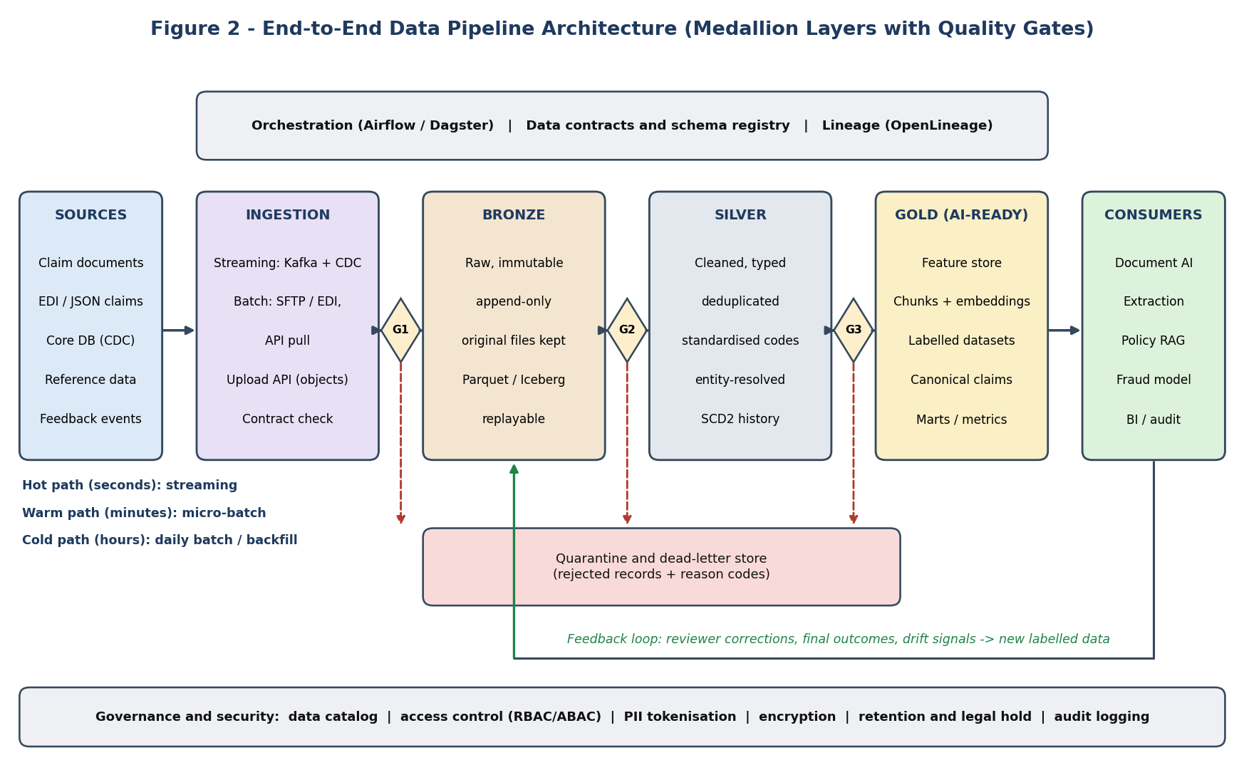
Figure 2 - End-to-End Data Pipeline Architecture

4.1 Layer responsibilities
Layer | Purpose | Rules
Ingestion | Receive data from each source with the right mechanism; check the data contract (G1). | No business transformation here; attach metadata (source, time, batch ID, checksum, contract version).
Bronze (raw) | Immutable copy of exactly what was received. | Append-only; original files kept by hash; never edited. Enables replay and audit.
Silver (clean and conformed) | Typed, deduplicated, standardised, entity-resolved records with history. | Passes gate G2. Rejected records go to quarantine. Deterministic, versioned transformations.
Gold (AI-ready) | Canonical claims, feature tables, chunks and embeddings, labelled training sets, marts. | Passes gate G3 (completeness, drift, leakage checks). Each dataset versioned and documented.
Consumers | AI modules, workbench, BI, audit. | Read only from Gold (or Silver for audit); never from Bronze directly.

4.2 Integration mechanisms and why each is used
Mechanism | Used for | Reason
Streaming (Kafka) | Live claim events, decisions, feedback | Low latency, ordering by claim ID, replay, multiple consumers.
Change-data-capture (Debezium) | Core claims / policy-admin database | Captures changes without load on the source or custom polling code; keeps Silver in near-real time.
Scheduled batch (SFTP, EDI, API pull) | Eligibility files, provider lists, code sets, partner bulk files | Sources that publish periodically; simple and auditable.
Upload API plus object storage | Documents and images | Large binary files are stored once; only references travel through events.
Request-response API with cache | Real-time eligibility lookup | Fresh answer needed for a single claim; cache protects the source.
Webhooks | Partner status updates | Push model avoids polling; signed and retried.

4.3 Technology choices
Concern | Choice | Alternative considered and reason for choice
Event streaming | Apache Kafka with schema registry | Cloud queues are simpler, but Kafka's replayable log suits audit and multiple consumers.
CDC | Debezium | Trigger-based or timestamp polling misses deletes and adds load to the source.
Orchestration | Airflow or Dagster (asset-based) | Cron scripts lack dependencies, retries and lineage. Dagster's asset view maps naturally to Bronze/Silver/Gold datasets.
Processing | Spark for large batch; Flink or Kafka Streams for streaming; SQL/dbt for transformations | One engine for everything is simpler, but batch and streaming have different needs. dbt keeps transformations testable and documented.
Storage format | Parquet tables in Apache Iceberg (or Delta Lake) on object storage | Plain files lack transactions and time travel. Table formats provide schema evolution, snapshots and reproducibility.
Operational store | PostgreSQL | Transactional claims, decisions and audit; also serves low-latency lookups.
Feature store | Feast (or managed equivalent) | Ad-hoc feature code causes training-serving skew; a feature store gives one definition for offline and online use.
Vector store | pgvector initially, dedicated engine at scale | Fewer moving parts early; retrieval interface hides later migration.
Data quality | Great Expectations or Soda checks, plus dbt tests | Hand-coded checks are inconsistent; declarative suites are reusable and reportable.
Catalog and lineage | DataHub or OpenMetadata with OpenLineage | Spreadsheet documentation goes stale; automated lineage supports audit and impact analysis.

5. Pipeline Stages: Collection, Preprocessing, Cleaning, Transformation
Figure 3 shows the two processing lanes. Documents follow an image-and-text lane; structured sources follow a record-and-field lane. Both converge on one canonical claim schema before enrichment and feature creation.
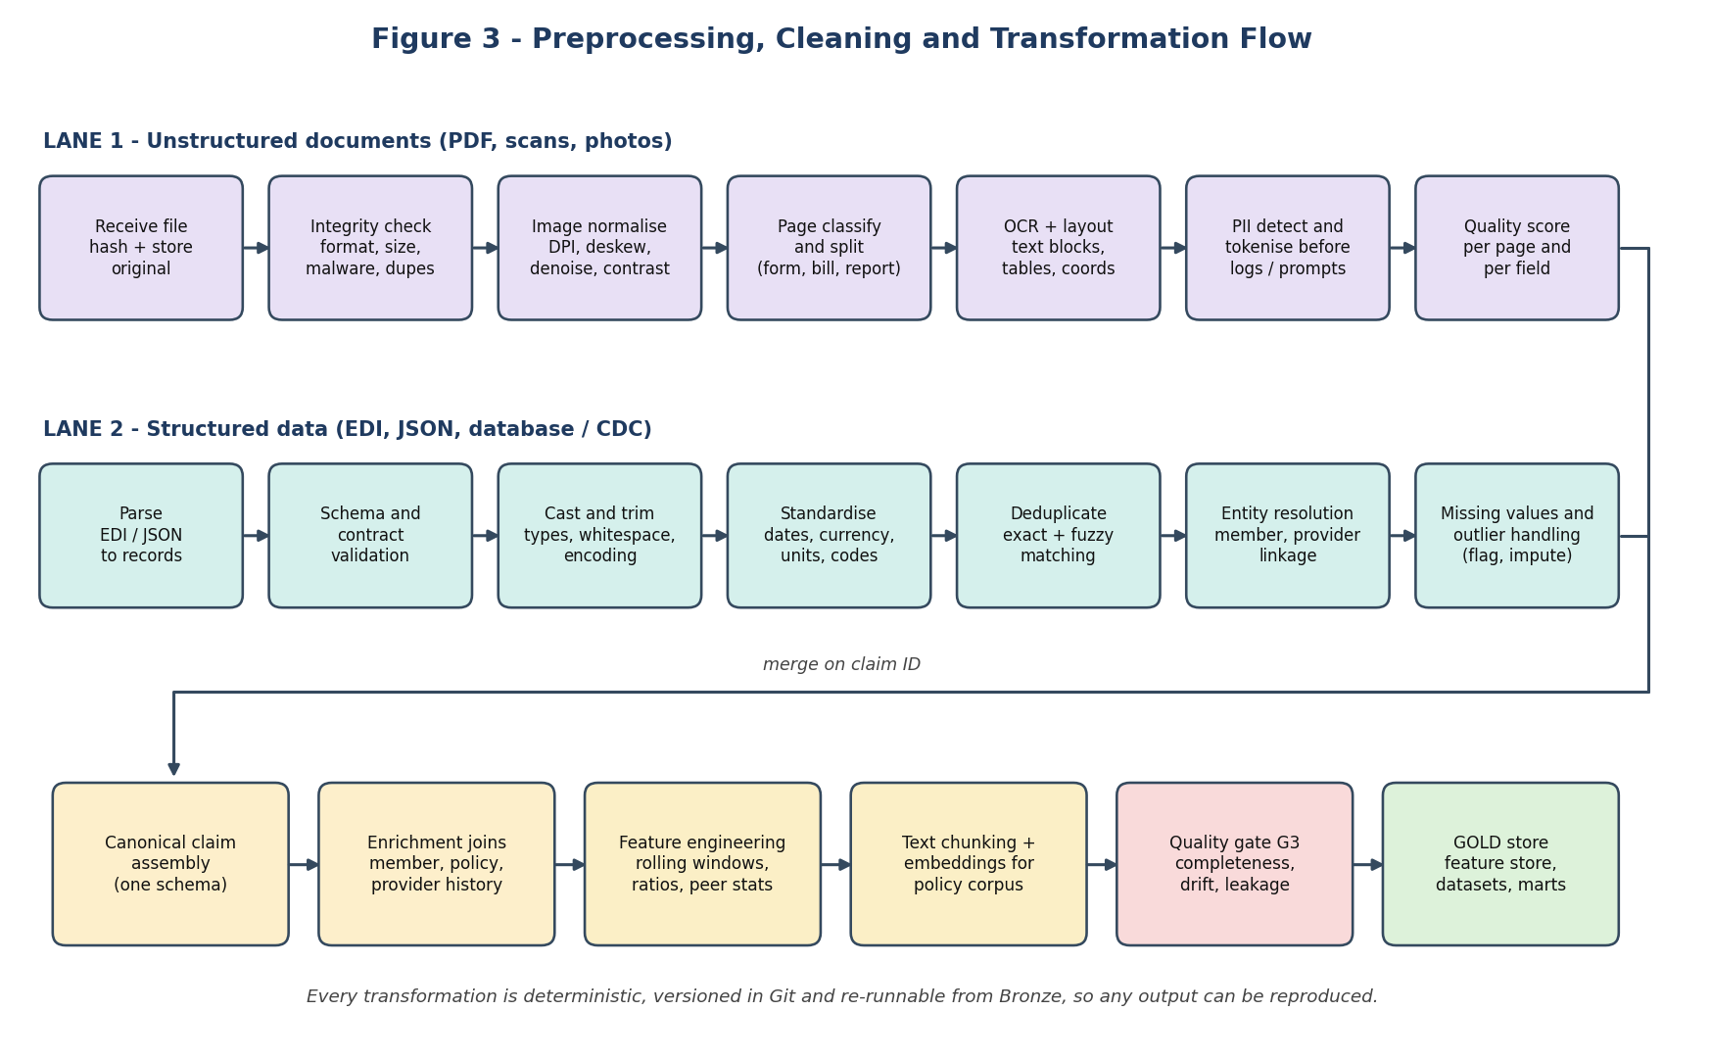
Figure 3 - Preprocessing, Cleaning and Transformation Flow

5.1 Stage 1 - Collection
- Capture with metadata: every item receives a unique ID, source, receipt time, batch ID, byte size and SHA-256 content hash.
- Contract check at the boundary (G1): structured payloads are validated against the registered schema version; documents against allowed type, size and page limits.
- Safe handling: malware scanning, encrypted storage, and no execution of document content.
- Idempotent landing: the content hash and source ID make re-delivery harmless, so a retried upload never creates a second claim.
- Backfill support: historical loads use the same landing process, flagged as backfill so they do not trigger live decisions.

5.2 Stage 2 - Preprocessing of documents
Technique | What it does | Why it matters
Format normalisation | Convert TIFF, JPEG, multi-page PDF to a standard page image set at a target resolution (for example 300 DPI). | OCR accuracy depends on consistent resolution.
Deskew and rotation correction | Detect page angle and orientation and straighten. | Photographed pages are often tilted or upside down.
Denoising and contrast enhancement | Remove specks, shadows and uneven lighting; adaptive thresholding for faint text. | Improves character recognition on poor scans.
Page classification and splitting | Identify page type (claim form, hospital bill, discharge summary, prescription) and split multi-claim PDFs. | Downstream extraction uses type-specific logic.
Layout and table detection | Locate text blocks, tables, stamps, signatures, reading order. | Line-item amounts live in tables; plain text loses structure.
OCR with confidence | Produce text with per-word confidence and coordinates. | Confidence travels to routing; coordinates support reviewer highlights.
Quality scoring | Compute blur, resolution, completeness score per page. | Very poor pages are sent for resubmission instead of processed unreliably.
PII detection and tokenisation | Detect names, IDs and contact data; replace with tokens in logs and external prompts. | Prevents leakage into logs, analytics and third-party services.

5.3 Stage 2 - Preprocessing of structured and text data
- Parsing: EDI and JSON converted to flat records; unknown fields preserved in a raw-payload column for traceability.
- Schema validation and type casting: dates, decimals and booleans cast with explicit rules; failures are quarantined, never silently coerced.
- Encoding and whitespace: Unicode normalisation, trimming, case rules (for example upper-case code fields).
- Text preparation for NLP: sentence segmentation, abbreviation expansion for medical shorthand, and language detection where multilingual documents are expected.

5.4 Stage 3 - Cleaning
Data issue | Technique | Example in ClaimIQ
Missing values | Classify as structurally missing, missing at random or critical. Critical fields are never imputed (block or review). Non-critical fields use flagged imputation (median, mode, or model-based) with an 'is_imputed' indicator. | Missing service date blocks the claim; missing optional referral field is left null.
Duplicates | Exact match on content hash and business key; fuzzy match on (member, provider, service date, amount) with tolerance. | Same bill submitted by portal and email.
Inconsistent formats | Canonical formats and mapping tables for dates, currency, units, gender codes and address parts. | '03/04/26' interpreted using source-specific locale, stored as ISO 8601.
Inconsistent categories and codes | Code normalisation against versioned registries; fuzzy mapping of free text to codes; unknown codes flagged. | Diagnosis text 'type 2 DM' mapped to the matching ICD-10 code with confidence.
Entity resolution | Blocking plus probabilistic record linkage (Fellegi-Sunter style scoring) on name tokens, date of birth, ID fragments, addresses; human review band for uncertain matches. | Same provider spelled three ways across hospital bills.
Outliers and impossible values | Rule limits (negative amount, future date), statistical tests (robust z-score, IQR) and isolation-based detection. Outliers are flagged, not deleted, because fraud can look like an outlier. | Claim amount 50 times the procedure median.
Arithmetic and cross-field inconsistencies | Recompute totals, check date ordering (admission before discharge), age versus procedure plausibility. | Line items do not sum to stated total.
Temporal issues | Event-time versus processing-time handling; late-arriving data merged using watermarks and idempotent upserts. | Eligibility update arrives after the claim was scored.

5.5 Stage 4 - Transformation
- Canonicalisation: every claim, whatever its channel, is mapped to one canonical schema (Figure 5) with source-specific mapping logic isolated in small adapters.
- Enrichment: joins with member coverage, policy version applicable on the service date, provider network status and fee schedules. Joins use point-in-time (as-of) logic so history is not distorted.
- Feature engineering for fraud: rolling counts and amounts per provider, member and diagnosis; claim-to-peer ratios; time since last claim; frequency of rare code combinations; provider-member graph features such as shared patients between providers.
- Text chunking for RAG: policy documents split into clause-aware chunks (about 300 to 500 tokens with overlap), each stored with policy ID, version, section and effective dates, then embedded.
- Encoding and scaling: categorical encoding (target or frequency encoding for high-cardinality codes, one-hot for small sets) and scaling only where the model requires it. Transformations are fitted on training data only and stored with the model.
- Dataset assembly and labelling: Gold training sets built with time-based splits to prevent leakage; labels derived from final outcomes, appeals and SIU findings, each with a label-confidence field.

6. Data Storage and Modelling
Figure 5 shows the logical model of the core entities. Each entity lives in the store best suited to its access pattern.
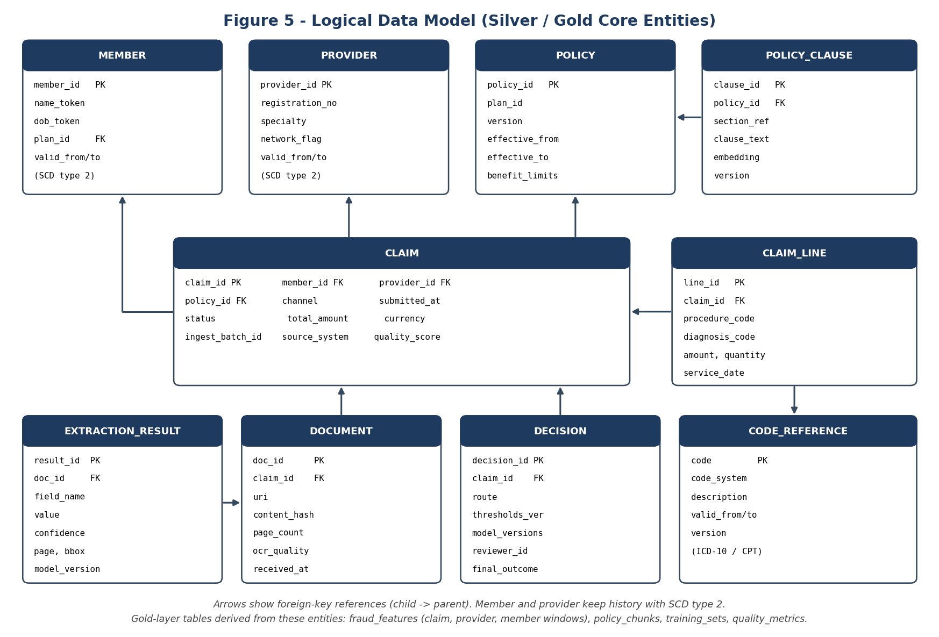
Figure 5 - Logical Data Model

6.1 Storage tiers
Data | Store | Format and organisation | Retention
Original documents | Object storage | Hash-addressed objects, versioned bucket | Per regulation (for example 7+ years); legal hold support
Raw events and tables (Bronze) | Kafka topics, Iceberg tables | Parquet, partitioned by ingestion date and source | Long-term, low-cost tier
Conformed data (Silver) | Iceberg tables | Parquet, partitioned by service month; SCD type 2 for member and provider | Long-term
Operational claims and decisions | PostgreSQL | Relational, indexed on claim ID, member ID, status | Hot for 12-24 months, then archived
Features | Feature store (offline Iceberg, online Redis) | Same definitions for training and serving | Offline long-term; online latest values only
Policy chunks and embeddings | Vector store | Chunk text, embedding, policy ID, version, effective dates | All versions retained
Quarantine and quality metrics | Iceberg / PostgreSQL | Rejected record, rule ID, severity, status | Until resolved plus audit period
Audit and lineage | Append-only tables, lineage store | Immutable | Per regulation

6.2 Modelling decisions
- SCD type 2 for member and provider: a claim is always evaluated against the member and provider facts valid at the service date.
- Versioned reference data: policy and code-set versions carry effective dates, so re-processing an old claim uses the rules of its time.
- Schema evolution: additive changes (new nullable columns) are backward compatible; breaking changes require a new major version and parallel run.
- Partitioning and clustering: partition by date for pruning; cluster or bucket by claim ID or provider ID for join speed.
- Table maintenance: automated compaction of small files and snapshot expiry to control cost and keep queries fast.

7. Data Quality Framework
Quality is enforced by gates rather than inspected after the fact. Figure 4 shows what happens to a record or batch at a gate.
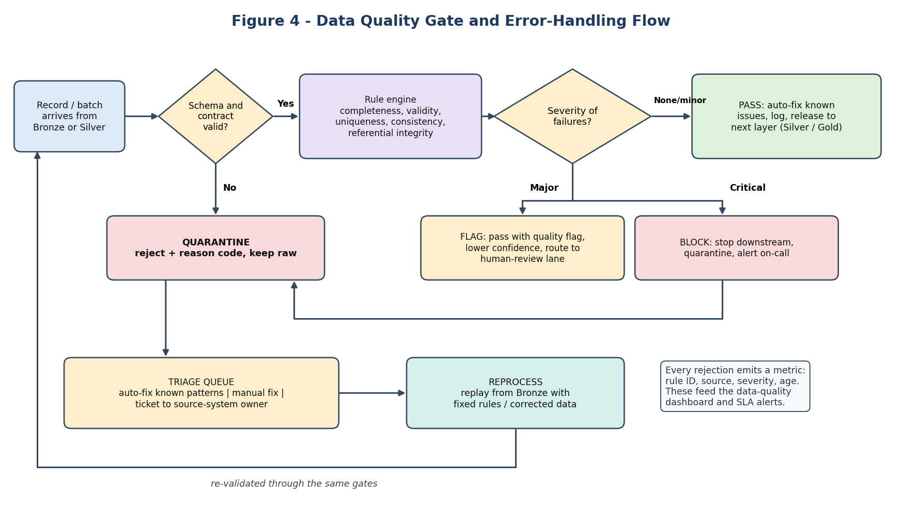
Figure 4 - Data Quality Gate and Error-Handling Flow

7.1 Quality dimensions and checks
Dimension | Example check | Example threshold / action
Completeness | Share of claims with member ID, provider ID, service date, total amount | Critical fields 100% (else block); optional fields tracked, alert if drop by more than 5 points
Validity | Dates parse, codes exist in registry version, amounts are positive and within limits | Invalid record quarantined with reason code
Uniqueness | No duplicate claim IDs or content hashes; fuzzy duplicate rate | Exact duplicate rejected; fuzzy duplicate routed to review
Consistency | Line items sum to total; admission precedes discharge; member and policy dates align | Mismatch flagged and quality score reduced
Referential integrity | Every claim links to a known member, provider, policy version | Unknown reference held until master data arrives (bounded wait), then quarantined
Timeliness | Event-to-availability delay per path | Alert when latency SLA is breached
Accuracy | Audited sample compared to ground truth; reviewer correction rate per field | Field accuracy tracked weekly; retraining trigger if it falls below target
Distribution stability (drift) | Population Stability Index and distribution tests on key features | Alert above agreed PSI; block Gold dataset release for training if severe

7.2 Example data contract and quality rules
Contracts and rules are stored as code, reviewed like any other change, and executed automatically. The following simplified example shows the idea.
contract: claim_event
version: 2.1.0
owner: intake-team
schema:
claim_id: {type: string, required: true, unique: true}
member_id: {type: string, required: true}
provider_id: {type: string, required: true}
service_date: {type: date, required: true, max: today}
total_amount: {type: decimal(12,2), required: true, min: 0}
currency: {type: string, enum: [INR, USD, EUR, GBP]}
quality_rules:
- rule: line_items_sum_equals_total # tolerance 0.01
severity: major
- rule: diagnosis_code_in_registry
severity: critical
freshness_sla: 5 minutes

7.3 Operating the quality process
- Severity model: minor issues are auto-fixed and logged; major issues pass with a flag and reduce confidence; critical issues block and alert.
- Quality score per claim: a numeric score is calculated from rule outcomes and passed to the AI routing logic, so poor data automatically increases the chance of human review.
- Ownership: each dataset has a named owner and steward; quarantine items are assigned to owners with ageing alerts.
- Continuous profiling: automated profiling compares each batch with the historical profile to catch problems that no rule anticipated.
- Closing the loop: frequent quarantine reasons are analysed monthly and fixed at the source or in the pipeline.

8. Integration Challenges and Mitigation Strategies
The table lists the main challenges expected when integrating the sources, with the impact on AI outcomes and the mitigation built into the design.
Challenge | Why it happens | Impact | Mitigation
Data inconsistency across sources | Different systems use different formats, code versions, spellings and identifiers | Wrong joins, duplicate entities, misleading features | Canonical schema; reference-data registries; entity resolution with human review band; standard mapping adapters; data dictionary
Schema drift and breaking changes | Source teams change fields without notice | Pipeline failures or silent corruption | Data contracts in a schema registry; compatibility checks in CI; consumer-driven contract tests; parallel run for major versions; raw payload retained
Latency and bottlenecks | Large files, OCR cost, batch windows, cross-region transfer | Slow decisions and queue build-up | Separate hot/warm/cold paths; parallel page processing; GPU pools; queue-based autoscaling; priority lanes; cache reference data; incremental (not full) loads
Late-arriving and out-of-order data | Retroactive eligibility, delayed documents, reviewer outcomes weeks later | Wrong state or training labels | Event-time processing with watermarks; idempotent upserts; as-of joins; label maturity windows before training
Poor document quality | Phone photos, handwriting, faded scans | Extraction errors | Quality scoring; resubmission requests; enhancement steps; ensemble OCR for low-quality pages; route to human review
Duplicate and conflicting records | Multiple channels, retries, resubmissions | Double payment, inflated fraud signals | Content hashing; business-key and fuzzy matching; idempotency keys; survivorship rules (most recent verified value wins, with source ranking)
Missing or incomplete data | Optional fields not provided, partial EDI | Biased features, failed rules | Field criticality classification; flagged imputation; missingness indicators as features; request-for-information workflow
Label noise and delayed ground truth | Reviewer inconsistency, appeals changing outcomes | Weak models | Label-confidence field; multi-review on samples; adjudicated gold set; time-based splits; update labels when appeals close
Training-serving skew | Features computed differently offline and online | Production accuracy below test accuracy | Feature store with one definition; point-in-time correctness tests; shadow scoring comparison
Data drift | New providers, new treatments, seasonality, fraud adaptation | Gradual accuracy loss | Drift monitors (PSI, KS test); alert and retraining triggers; champion-challenger testing
Privacy and compliance | Health and personal data across many systems | Legal and reputational harm | Tokenisation at ingest; field-level encryption; purpose-based access; masking in non-production; retention and deletion automation; audit logs
Source outages or slow APIs | External dependency failure | Stalled claims | Circuit breakers; cached reference snapshots; retry with back-off; degrade to human review; alerting on freshness
Volume spikes and cost | Month-end peaks, backfills, large embeddings runs | Delay and cost overrun | Autoscaling with limits; spot capacity for batch; tiered storage; compaction; cost per claim dashboard
Pipeline bugs | Logic errors in transformations | Bad data in Gold | Unit and data tests for each model; staging environment with sampled production data; versioned transformations; replay from Bronze after fix

9. Latency, Scalability and Cost Strategy

9.1 Service-level objectives (planning targets)
Path | Typical use | Target | Technique
Hot | Live claim from submission to AI-ready record | Digital claims under 30 seconds; scanned documents under 3 minutes (to Gold) | Streaming, parallel page processing, online feature lookup
Warm | Rolling provider and member features, dashboards | Refreshed every 5 to 15 minutes | Micro-batch / incremental materialisation
Cold | Training sets, backfills, audits | Hourly to daily | Large batch jobs on elastic compute
Reference data | Code sets, provider list, policies | Available within one hour of publication | Scheduled pull with change detection

9.2 Scalability techniques
- Horizontal scale by partition: Kafka and Iceberg partitions by claim ID or date allow parallel consumers and parallel jobs.
- Incremental processing: only new or changed data is processed, using CDC offsets and table snapshots.
- Back-pressure and autoscaling: consumer lag drives scaling of workers, so spikes are absorbed by queues rather than failures.
- Workload isolation: GPU-heavy OCR and embedding work runs in separate pools from lightweight validation.
- Pushdown and pruning: filters and column projection use partition and file statistics to avoid reading unneeded data.
- Caching: reference data and eligibility lookups cached with expiry; semantic cache for repeated policy retrievals.

9.3 Cost management
- Lifecycle rules move aged raw files and Bronze partitions to cheaper storage while keeping them replayable.
- Cascading processing: inexpensive image and rule checks first, expensive OCR or LLM steps only when needed.
- Per-claim cost metric (storage, compute, model calls) reported weekly; budget alerts per pipeline.

10. Governance, Security and Privacy
- Classification: every field is tagged (public, internal, confidential, restricted-health) in the catalog; tags drive masking and access.
- Tokenisation and encryption: direct identifiers are tokenised at ingestion; keys held in a managed key service; TLS in transit and encryption at rest.
- Access control: role- and attribute-based access, least privilege, purpose-limited views for analysts and data scientists; all reads of restricted data logged.
- Non-production data: development and testing use masked or synthetic data, never raw production records.
- Lineage and audit: automated lineage from source to decision; every Gold dataset records its input snapshots and code version, so any decision can be reproduced.
- Retention and deletion: policy-driven retention per data class; deletion and legal-hold workflows; deletion requests propagate to derived datasets and embeddings where required.
- Compliance alignment: controls are designed to support health-data privacy rules and data-protection laws (for example HIPAA-style safeguards and India's Digital Personal Data Protection Act); residency is configurable.
- Third-party services: only minimised, tokenised data is sent to external model or OCR services, under contractual controls.

11. Innovative Approaches for Efficient and Scalable Data Management
Approach | Description | Benefit
Confidence-carrying data | Every extracted field keeps its confidence, source coordinates and pipeline version through Silver and Gold. | Routing and explanations use real uncertainty; reviewers see the exact source region.
Quality-score-driven routing | Claim-level data quality score is an input to the confidence router. | Bad data automatically leads to more human review rather than silent errors.
Data contracts as code with CI checks | Schemas and quality rules versioned in Git; producer changes tested against consumers before release. | Prevents most schema-drift incidents.
Time travel and reproducible snapshots | Iceberg snapshots plus code versions allow rebuilding any past dataset exactly. | Audit-ready; fast debugging; reliable model comparison.
Active-learning labelling loop | Reviewer corrections on low-confidence cases are prioritised as new training labels. | Labelling effort is spent where the model is weakest.
Synthetic data for rare fraud patterns | Generate privacy-safe synthetic claims (and controlled perturbations of real fraud cases) to balance classes and test pipelines. | Better recall on rare patterns without exposing real data.
Embedding-based near-duplicate detection | Compare document embeddings and key fields to detect resubmitted or altered documents. | Catches duplicates that exact hashing misses.
Adaptive quality thresholds | Thresholds for drift and anomaly alerts adjust to seasonality using rolling baselines. | Fewer false alerts at month-end peaks.
Shadow pipelines for change | New transformation versions run beside production, outputs compared, then promoted. | Safe evolution without downtime.

12. Monitoring and Key Metrics
Area | Metric | Alert example
Freshness | Event-to-Gold latency by path (p50, p95, p99) | p95 hot-path latency above target for 10 minutes
Volume | Records and files per source per hour versus baseline | Source volume drops by more than 40% versus same hour last week
Quality | Rule pass rate by dataset and rule; quarantine rate; claim quality score distribution | Quarantine rate above 2% for any source
Reliability | Job success rate, retries, dead-letter queue depth, consumer lag | Consumer lag growing for 15 minutes
Schema | Contract violations, unexpected new fields | Any breaking change detected
Drift | PSI and distribution tests on key features and labels | PSI above agreed limit for a key feature
Cost | Cost per claim; storage growth; compute hours | Daily cost 30% above 4-week average
Data usage | Dataset consumers and query counts; unused datasets | Dataset with no consumers for 90 days (retire)

Dashboards are published to data owners and engineering; critical alerts page the on-call engineer, and monthly reviews convert recurring issues into permanent fixes.

13. Implementation Plan
Phase | Duration (indicative) | Deliverables | Exit criteria
1. Foundations | 3 weeks | Landing zone, Kafka, schema registry, object storage, orchestration, catalog, CI for contracts | Sample claim travels source to Bronze with lineage.
2. Core ingestion | 5 weeks | Upload API, EDI/JSON ingestion, CDC from core DB, eligibility and provider feeds, gates G1 and G2 | Contracts enforced; quarantine workflow operating.
3. Silver and quality | 5 weeks | Cleaning, standardisation, entity resolution, SCD2, code registries, quality dashboards | Agreed quality targets met on pilot data.
4. Gold and AI datasets | 6 weeks | Canonical claims, feature store, policy chunks and embeddings, training sets, gate G3 | AI modules train and serve from Gold with no skew in tests.
5. Optimise and harden | Ongoing | Backfills, cost tuning, drift monitoring, DR tests, extension to new sources | SLOs met at target volume.

14. Conclusion
The ClaimIQ data pipeline turns scattered, inconsistent and sensitive inputs into reliable, explainable, AI-ready data. It does so through a layered design: raw data is preserved, each layer is protected by explicit quality gates, bad records are quarantined and replayable, and every dataset carries lineage and versions.
The strategy addresses the main integration risks (inconsistency, latency, schema drift, label noise, privacy and cost) with specific controls rather than general intentions. Innovative elements such as confidence-carrying data, quality-score-driven routing, contract-as-code and reproducible snapshots connect the data layer directly to the decision logic designed in Week 1. The result is a pipeline that is scalable, auditable and ready to support the modelling work that follows.

References
Public resources consulted for data-engineering best practice (titles and publishers listed; consult current versions):
- Databricks - Medallion Architecture (Bronze, Silver, Gold) documentation.
- Martin Kleppmann - Designing Data-Intensive Applications (O'Reilly).
- Joe Reis and Matt Housley - Fundamentals of Data Engineering (O'Reilly).
- Apache Software Foundation - Apache Iceberg, Apache Kafka, Apache Spark and Apache Flink documentation.
- Debezium project - Change data capture documentation.
- Great Expectations and Soda - data quality testing documentation; dbt Labs - dbt documentation.
- Feast project - feature store documentation (training-serving consistency).
- OpenLineage and DataHub / OpenMetadata - lineage and catalog documentation.
- Fellegi and Sunter - A Theory for Record Linkage (1969), foundation of probabilistic entity resolution.
- Google Cloud - MLOps: Continuous delivery and automation pipelines in machine learning (data validation and monitoring sections).
- Data Contract specifications and community guidance (for example the Open Data Contract Standard).
- NIST - AI Risk Management Framework (data governance and quality considerations).

