WEEK 1 DELIVERABLE | AI SOLUTIONS ARCHITECT
AI Architecture Blueprint
ClaimIQ: A Scalable, Modular and Human-Supervised AI Platform for Health-Insurance Claims Processing
Prepared by: [Your Name]
Date: October 2026
Document type: Architectural blueprint and design rationale (early-stage planning)
Version: 1.0

Purpose of this document
This blueprint defines the problem, scope, high-level architecture, component design, algorithm choices, integration strategy and operating model for ClaimIQ. It is written so that engineering, data science, security and business stakeholders can review the same document and begin implementation planning.

Contents
1. Executive Summary
2. Research: Architectural Frameworks and Design Principles
3. Problem Statement and Scope
4. Requirements
5. High-Level Architecture
6. Component Design
7. Data Flow and Decision Layers
8. Algorithm, Framework and Technology Selection
9. Integration Strategy
10. Scalability, Modularity and Robustness
11. Security, Privacy and Responsible AI
12. MLOps, Monitoring and Evaluation
13. Risks and Mitigations
14. Implementation Roadmap
15. Conclusion
References

List of Figures
Figure 1 - Layered Reference Architecture
Figure 2 - End-to-End Data Flow (Claim Lifecycle)
Figure 3 - Decision Layer: Confidence-Based Routing Logic
Figure 4 - Integration and Deployment View

1. Executive Summary
Health-insurance claims processing is a document-heavy, rule-heavy and fraud-exposed workflow. Claims arrive as scanned forms, PDFs, images and electronic data; each must be read, coded, checked against policy terms and member eligibility, screened for fraud and finally approved, denied or investigated. Manual handling is slow, inconsistent and expensive, and it scales only by hiring more people.
ClaimIQ is the proposed AI solution. It combines document intelligence, language models, retrieval-augmented policy reasoning, statistical fraud detection and a rules engine behind an event-driven orchestration layer. A confidence-based router sends clearly valid claims straight through, sends uncertain claims to a human reviewer with an AI-prepared summary and evidence, and sends rule violations or suspicious claims down the deny or investigation path.
The architecture is designed around three qualities requested in the brief:
- Scalability: stateless services, queue-driven autoscaling, partitioned event streams and separate GPU and CPU pools.
- Modularity: every AI capability sits behind a versioned contract, so any model, vendor or framework can be replaced without touching its neighbours.
- Robustness: idempotent processing, retries, circuit breakers, dead-letter queues, graceful degradation to human review, and full auditability.
The document follows the order of an architect's early planning cycle: research, problem definition, requirements, architecture, component and algorithm decisions, integration, quality attributes, governance, risks and a phased roadmap.

2. Research: Architectural Frameworks and Design Principles
Before designing ClaimIQ, current public guidance on cloud, software and AI system architecture was reviewed. The table summarises what each source contributes and how it shapes this blueprint.
Framework / principle | Key idea | Application in ClaimIQ
Well-Architected frameworks (AWS, Azure, Google Cloud) | Evaluate a design across operational excellence, security, reliability, performance, cost and sustainability. | Section 10 and 11 are organised around these pillars; each major decision lists its trade-off.
C4 model (Simon Brown) | Describe software at four zoom levels: context, containers, components, code. | Figure 1 is a container-level view; Figure 4 shows deployment; Section 6 details components.
Domain-driven design and microservices | Split a system along business capabilities with clear contracts. | One service per capability (intake, document AI, extraction, policy reasoning, fraud, orchestration).
Event-driven architecture | Services communicate through immutable events, giving loose coupling and replay. | Kafka event bus carries claim lifecycle events; enables audit, replay and independent scaling.
Twelve-Factor App | Config in environment, stateless processes, disposable instances, logs as streams. | All services are containerised and stateless; state lives in managed stores.
MLOps maturity levels (Google Cloud guidance) | Move from manual model work to automated pipelines with continuous training and monitoring. | Target level 2: automated training, validation, registry, canary release and drift monitoring.
Retrieval-Augmented Generation (RAG) | Ground LLM answers in retrieved source documents to reduce hallucination and enable citations. | Policy reasoning module retrieves policy clauses and must cite them in every output.
Reliability patterns | Idempotency, retry with back-off, circuit breaker, saga, dead-letter queue, bulkhead. | Applied between every pair of services; see Section 10.
NIST AI Risk Management Framework; EU AI Act risk tiers | Govern, map, measure and manage AI risk; high-impact decisions need human oversight and transparency. | Human-in-the-loop router, explainability, audit trail and bias testing (Section 11).

2.1 Design principles adopted
- Contract first. Every module exposes a versioned schema; implementation details stay private.
- Models are replaceable components, not the architecture. The architecture must survive a change of OCR engine, LLM or fraud model.
- Deterministic where possible, probabilistic where necessary. Eligibility and arithmetic use rules; reading messy documents and interpreting policy text use ML.
- Human oversight by design. Low confidence never means a silent guess; it means a routed review.
- Observable and auditable by default. Every decision can be reconstructed from stored inputs, model versions, evidence and thresholds.
- Fail safe. When a dependency fails, the claim degrades toward manual review, never toward automatic approval.

3. Problem Statement and Scope

3.1 Problem statement
Insurers and third-party administrators receive large volumes of claims in inconsistent formats. Staff manually read documents, re-key data, look up policy clauses and judge whether a claim is valid. This causes slow turnaround, inconsistent decisions, data-entry errors, member dissatisfaction and undetected fraud, while operating cost grows linearly with claim volume.

3.2 Solution objective
Design an AI platform that automatically ingests, understands, validates and routes claims; automates the clear majority of routine cases; gives reviewers the evidence they need for the rest; and keeps every decision explainable and auditable.

3.3 Scope
In scope (Phase 1) | Out of scope (Phase 1)
Outpatient and inpatient reimbursement claims submitted as PDF, image, EDI or JSON | Cashless pre-authorisation at the hospital point of care
Document OCR, field extraction, medical coding validation | Provider network contracting and pricing negotiation
Policy-clause reasoning with citations | Customer-facing conversational assistant
Eligibility checks, fraud scoring, confidence routing | Actuarial pricing and underwriting models
Human review workbench, audit trail, feedback loop | Replacing the insurer's core policy-administration system

3.4 Stakeholders
Stakeholder | Interest
Claims adjusters / reviewers | Faster, better-prepared cases; clear evidence; fewer re-keying tasks.
Policyholders and providers | Fast, predictable and understandable decisions.
Special Investigation Unit (SIU) | Prioritised, explained fraud leads.
Compliance and audit | Traceability, human oversight, privacy compliance.
IT / platform and data science teams | Maintainable, observable system with clean interfaces.

3.5 Assumptions
- A core claims or policy-administration system already exists and exposes APIs or batch interfaces.
- Historical claims with outcomes are available for training, subject to privacy approval.
- Targets quoted in this document are planning targets to be validated against a pilot dataset.

4. Requirements

4.1 Functional requirements
ID | Requirement
FR-1 | Accept claims through portal, mobile, email/SFTP and partner APIs, and reject malformed or malicious files.
FR-2 | Extract patient, provider, dates, diagnoses, procedures, line items and amounts from unstructured documents.
FR-3 | Normalise and validate medical codes (ICD-10, CPT) and cross-check them with narrative text.
FR-4 | Check eligibility, coverage windows, limits and waiting periods using deterministic rules.
FR-5 | Interpret policy clauses relevant to the claim and return cited reasoning.
FR-6 | Score each claim for fraud or anomaly and explain the main contributing factors.
FR-7 | Route each claim to auto-approve, human review, deny or SIU according to configurable thresholds.
FR-8 | Provide a review workbench showing the AI summary, evidence, and one-click accept or override.
FR-9 | Store every decision, input, model version and reviewer action in an immutable audit log.
FR-10 | Capture reviewer outcomes as labelled data for retraining and evaluation.

4.2 Non-functional requirements (planning targets)
Attribute | Target | Architectural response
Throughput | Scale from 10,000 to 500,000 claims/day without redesign | Stateless services, partitioned Kafka topics, autoscaling.
Latency | p95 straight-through decision under 60 seconds for digital claims; under 5 minutes for scanned claims | Parallel processing of policy reasoning and fraud scoring; GPU model serving; caching.
Availability | 99.9% for intake and status APIs | Multi-AZ deployment, health probes, rolling updates.
Accuracy | Field-level extraction F1 of at least 0.95 on key fields; auto-approved error rate below 0.5% | Calibrated confidence, conservative thresholds, continuous evaluation.
Auditability | 100% of decisions reproducible | Immutable event log, versioned models and prompts.
Security / privacy | Encryption in transit and at rest; least-privilege access; PII masking in logs | mTLS, KMS, RBAC, tokenisation (Section 11).
Maintainability | Replace any single AI module in under one sprint | Contract-first design, model registry, adapters.
Cost efficiency | Cost per processed claim tracked and trending down | Tiered models, batching, cache, right-sized GPU pools.

5. High-Level Architecture
ClaimIQ is a layered, event-driven system. Figure 1 shows six horizontal layers and five cross-cutting concerns. Requests flow top-down; asynchronous events flow through the data and platform layer.
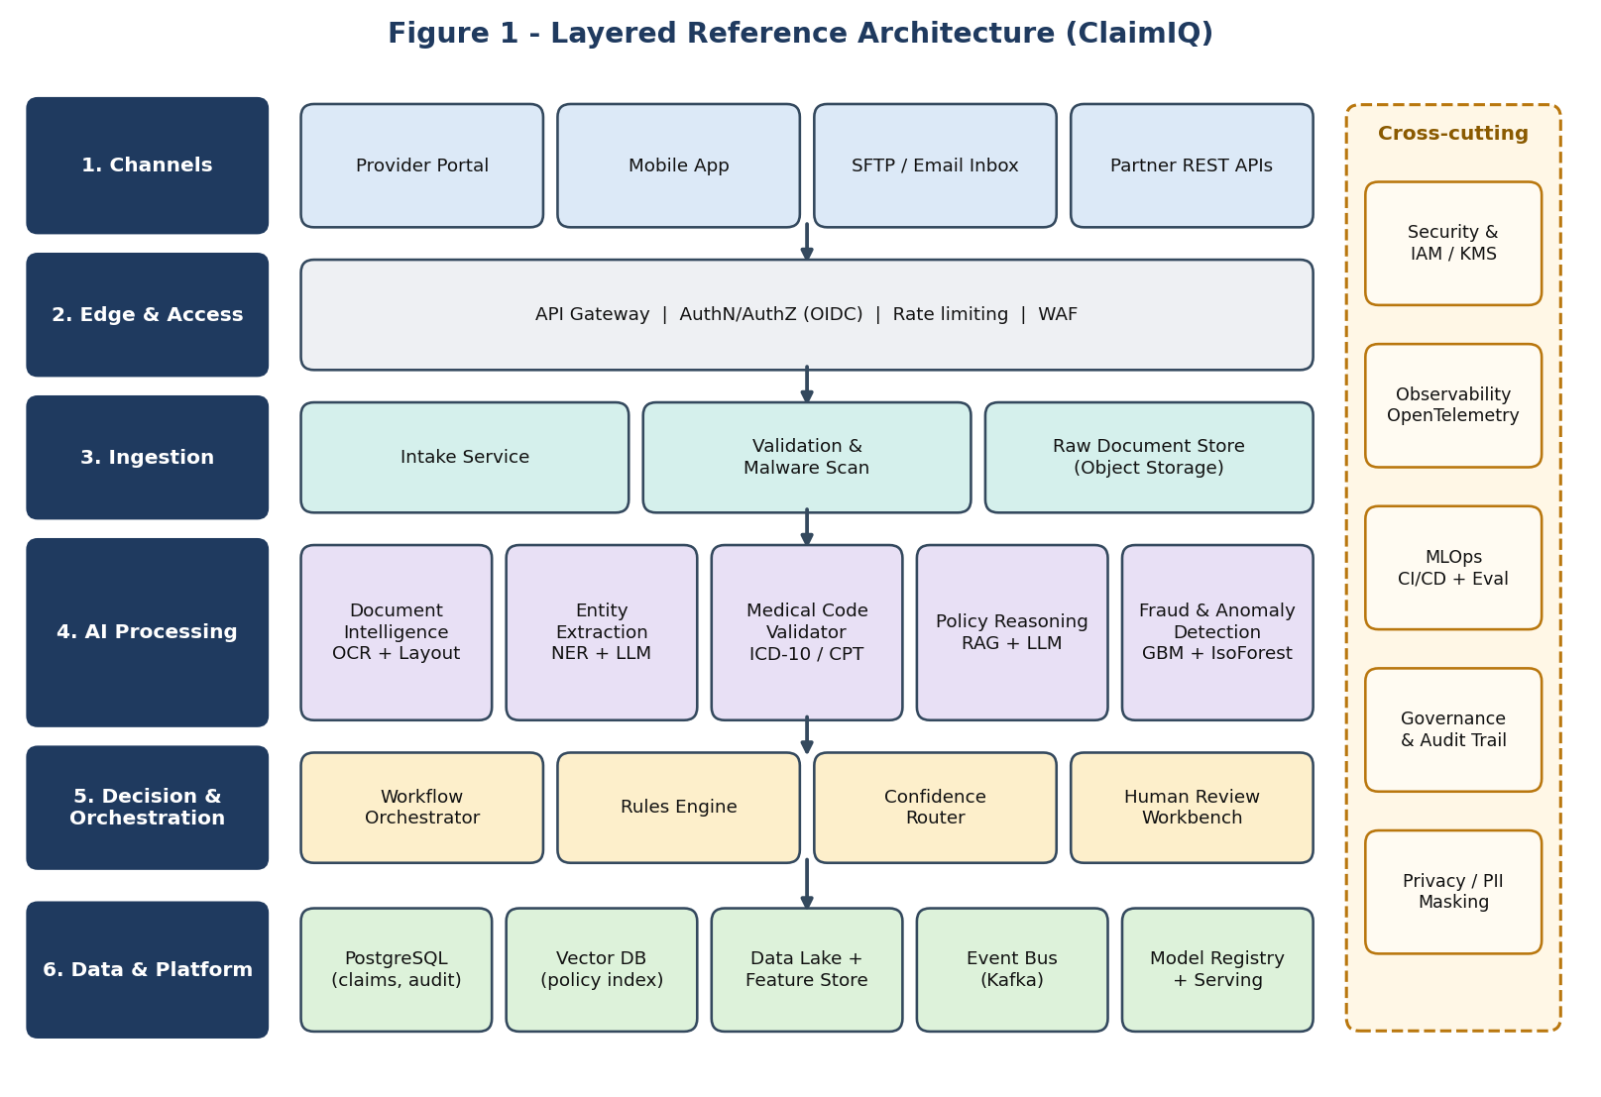
Figure 1 - Layered Reference Architecture (ClaimIQ)

5.1 Layer responsibilities
Layer | Responsibility | Key design choice
1. Channels | All ways a claim can enter the system. | Channel differences stop at the gateway; downstream services see one canonical claim object.
2. Edge and access | Authentication, authorisation, rate limiting, request validation. | OIDC/OAuth2, WAF and API gateway protect the internal network.
3. Ingestion | Receive documents, scan for malware, detect duplicates, store originals. | Original documents are immutable in object storage; processing works on copies and references.
4. AI processing | Five independent ML modules: document intelligence, extraction, code validation, policy reasoning, fraud detection. | Each module is a separate service with its own model lifecycle and scaling profile.
5. Decision and orchestration | Coordinate steps, apply business rules, route by confidence, support human review. | Durable workflow engine owns state, retries and timeouts so AI services stay stateless.
6. Data and platform | Operational database, vector index, data lake, feature store, event bus, model registry. | Right store for each access pattern instead of one database for everything.
Cross-cutting | Security, observability, MLOps, governance, privacy. | Provided by the platform to every service, not re-implemented per team.

6. Component Design
Each component below is deployable on its own and communicates only through its published contract. The table summarises responsibility, selected technology, and scaling or failure behaviour.
Component | Responsibility and technology | Scaling and failure behaviour
Intake Service | Receives uploads, assigns claim ID, validates format and size, performs duplicate detection by content hash.  FastAPI (Python); ClamAV scan; S3-compatible object store. | Stateless; horizontal scaling behind the gateway. Upload is acknowledged only after durable write.
Document Intelligence Service | Converts images and PDFs to text with layout, tables and reading order.  Layout-aware OCR (PaddleOCR or a managed document-AI API) plus table-structure detection. | GPU or CPU pool autoscaled on queue depth. Low-quality scans are flagged and passed on with a low-confidence marker.
Entity Extraction Service | Extracts structured fields into a fixed JSON schema.  Fine-tuned NER model for high-volume fields; LLM with schema-constrained output for irregular layouts; deterministic validators (dates, amounts, totals). | Cascade design: cheap model first, LLM only for low-confidence documents. Invalid JSON triggers a bounded retry, then review.
Medical Code Validator | Maps diagnoses and procedures to ICD-10 and CPT, checks consistency with narrative.  Exact lookup in a code registry plus embedding similarity for free-text descriptions. | Registry cached in memory; refreshed on a schedule. Unknown codes go to review.
Eligibility and Rules Engine | Coverage dates, limits, waiting periods, co-pay, duplicate claims.  Declarative rules (for example Drools or a Python rules library) versioned in Git. | Pure functions; trivially scalable; every rule hit is logged as evidence.
Policy Reasoning Service (RAG) | Finds the relevant policy clauses and answers 'is this treatment covered, and why?' with citations.  Hybrid retrieval (BM25 plus dense vectors), cross-encoder re-ranker, LLM with citation-required prompt. | Vector index is replicated; answers without valid citations are rejected automatically and routed to review.
Fraud and Anomaly Service | Produces fraud score F and top contributing factors.  Gradient-boosted trees on tabular and graph-derived features, plus Isolation Forest for unlabelled anomalies; SHAP for explanations. | Low-latency CPU inference; features from feature store. If unavailable, claims above a value threshold go to review.
Workflow Orchestrator | Runs the claim state machine, timers, retries and compensation.  Temporal (or equivalent durable-workflow engine). | State persisted; resumable after crashes; per-step timeouts and retry policies.
Confidence Router | Combines C, F, amount and policy-match into a route using configurable thresholds.  Versioned configuration; calibrated probabilities. | Thresholds changeable without redeploy; every routing decision stored with inputs.
Review Workbench | Shows claim, source image, extracted fields, AI summary, cited clauses and fraud factors; captures decisions.  React and TypeScript front end; case API. | Role-based queues; SLA timers; reviewer actions emitted as events for the feedback loop.
Audit and Feedback Store | Immutable decision log, labelled outcomes for retraining.  Append-only PostgreSQL tables and data-lake export. | Write-once; retention and legal-hold policies applied.

7. Data Flow and Decision Layers

7.1 End-to-end data flow
Figure 2 traces a claim from submission to payment and feedback. Steps 3 to 5 transform unstructured data into a validated structured claim; steps 6 to 8 gather independent evidence in parallel; step 9 makes the routing decision.
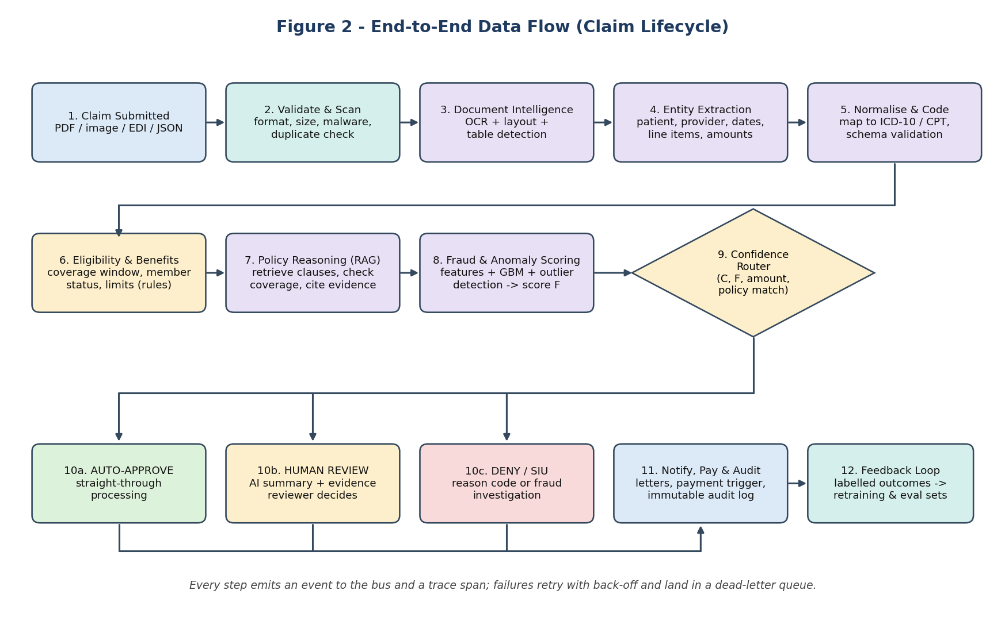
Figure 2 - End-to-End Data Flow (Claim Lifecycle)

7.2 Step-by-step description
- Submission. The claim is received through any channel and converted to a canonical envelope containing claim ID, channel, timestamp and document references.
- Validate and scan. File type, size and malware checks run; a content hash detects duplicates and prevents double payment.
- Document intelligence. OCR, layout and table detection produce text blocks with coordinates and per-block confidence.
- Entity extraction. Fields are extracted into a strict schema. Each field carries a confidence value and a pointer to its source region on the page.
- Normalise and code. Dates, currencies and codes are standardised; totals are recomputed and compared with the stated total.
- Eligibility and benefits. Deterministic rules confirm active coverage, limits and waiting periods.
- Policy reasoning. The RAG module retrieves relevant clauses and returns a coverage judgement with citations.
- Fraud and anomaly scoring. Models compare the claim with provider, patient and network patterns and return a score with explanations. Steps 7 and 8 run in parallel.
- Confidence routing. The router combines all signals (Section 7.3).
- Outcome. Auto-approve, human review, or deny/SIU.
- Notify, pay, audit. Letters and payments are triggered through adapters; the full decision record is written to the audit log.
- Feedback loop. Reviewer corrections and final outcomes become labelled data for evaluation and retraining.

7.3 Decision layer
The decision layer is intentionally small and transparent. Machine-learning modules produce evidence and scores; the router applies explicit rules to them. This separation makes thresholds easy to audit and tune.
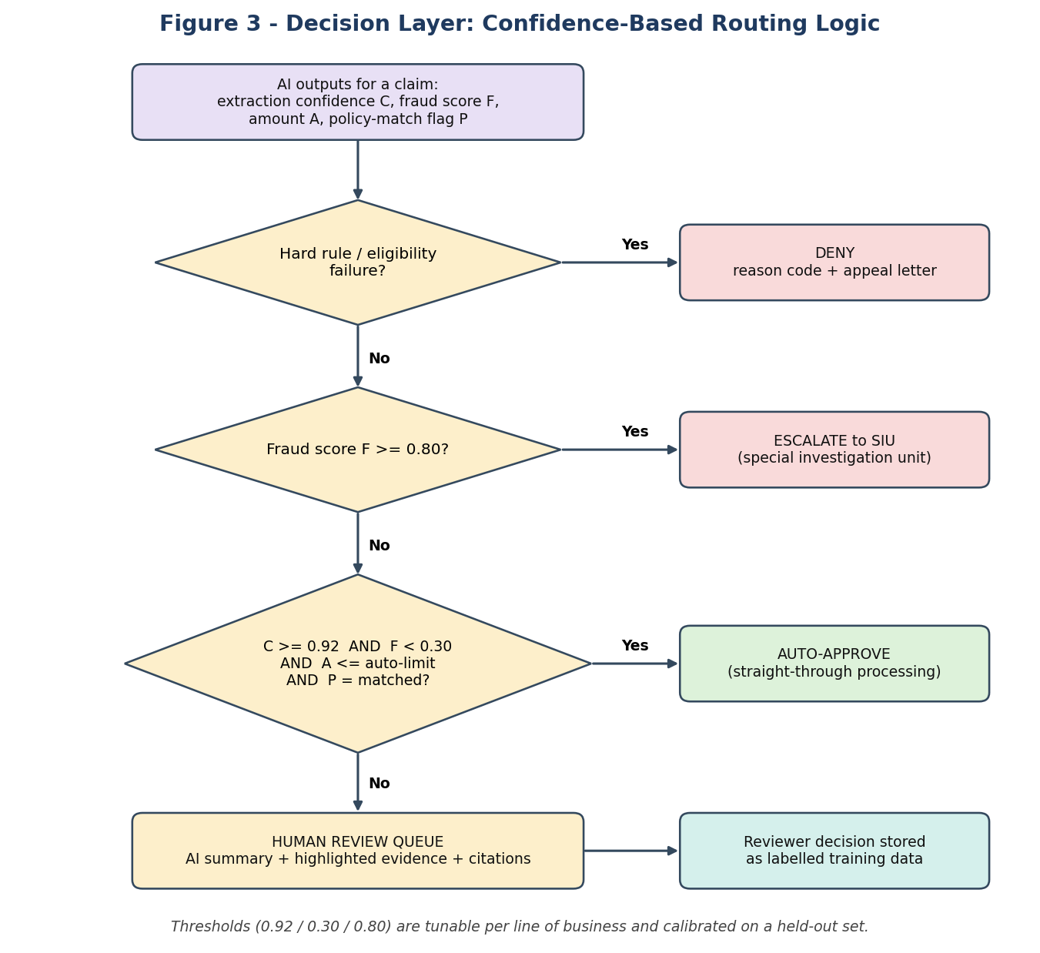
Figure 3 - Decision Layer: Confidence-Based Routing Logic
- Layer 1, hard rules: definitive eligibility failures are denied with a reason code. These are never decided by a probabilistic model.
- Layer 2, risk screen: a high fraud score escalates to the SIU regardless of other signals.
- Layer 3, straight-through gate: only claims that are simultaneously high-confidence, low-risk, within a monetary limit and policy-matched are auto-approved.
- Default path: anything else goes to a human reviewer with an AI-prepared summary. Uncertainty always resolves toward human review.

7.4 Core data entities
Entity | Content | Store
Claim | Canonical claim object, status, extracted fields with confidences | PostgreSQL
Document | Original files, page images, OCR output | Object storage
Evidence | Rule hits, cited policy clauses, fraud factors, source regions | PostgreSQL (JSONB)
Decision record | Route, thresholds used, model and prompt versions, reviewer action | Append-only audit tables
Policy corpus | Chunked policy text and embeddings with version metadata | Vector database
Training set | Labelled outcomes, corrections, evaluation snapshots | Data lake and feature store

8. Algorithm, Framework and Technology Selection
The table records the main design decisions, the options considered, and why the chosen option fits ClaimIQ. Choices favour proven, widely supported technology, with managed alternatives acceptable where the team prefers lower operational burden.
Decision | Chosen approach | Alternatives considered | Justification
Document reading | Layout-aware OCR with table detection | Plain OCR only; end-to-end vision-language model for everything | Layout and tables carry the line-item data. A vision-language model can be added as a fallback for the hardest pages without paying its cost on every page.
Field extraction | Cascade: fine-tuned NER first, schema-constrained LLM for low-confidence documents | LLM only; rules/regex only | Cascade controls cost and latency for common formats while keeping flexibility for irregular ones. Schema constraints and validators limit hallucination.
Medical coding | Exact registry lookup with embedding similarity fallback | Generative LLM coding | Codes are a closed vocabulary; lookup is exact and auditable. Embeddings handle free-text mismatches.
Policy reasoning | RAG: hybrid retrieval, re-ranker, LLM with mandatory citations | Fine-tune an LLM on policies; keyword search | Policies change often and differ by plan; retrieval gives freshness and traceability without retraining. Citation enforcement makes answers checkable.
Fraud detection | Gradient-boosted trees plus Isolation Forest; SHAP explanations | Deep neural networks; rules only | Tabular data suits tree ensembles; strong accuracy, fast inference and mature explainability. Isolation Forest covers new patterns without labels.
Confidence calibration | Isotonic regression or temperature scaling on a held-out set | Raw model scores | Routing thresholds are meaningful only if scores behave like probabilities.
Workflow orchestration | Temporal-style durable workflows | Airflow; hand-written queues | Claims are long-running, stateful, human-in-the-loop processes needing retries and timers; durable workflows fit better than batch schedulers.
Messaging | Apache Kafka | RabbitMQ; cloud-native queues | Partitioned, replayable log supports high throughput, audit and consumers added later.
Model serving | Triton / ONNX for classical and vision models; vLLM or hosted LLM API for language models | Single serving stack for all | Different workloads have different needs. A hosted API reduces effort at first; self-hosting is an option as volume grows.
Vector search | pgvector initially, dedicated engine (for example Qdrant) at scale | Managed vector service | Starting inside PostgreSQL reduces moving parts; the retrieval interface hides the later migration.
Backend and UI | Python (FastAPI) services; React and TypeScript front end | Java/Spring; Node.js | Python aligns with the ML ecosystem; typed API contracts via OpenAPI.
Infrastructure | Kubernetes, Terraform, GitOps (Argo CD) | Serverless only; VMs | Portable, supports GPU scheduling and queue-based autoscaling.

9. Integration Strategy
Integration is where AI systems usually fail in practice. ClaimIQ uses a small number of explicit patterns, applied consistently.
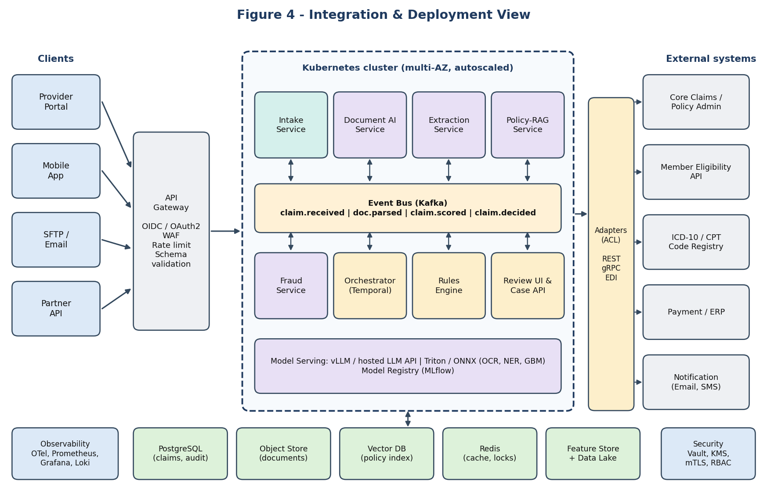
Figure 4 - Integration and Deployment View

9.1 Integration patterns
Pattern | Used for | Details
Synchronous REST / gRPC | Client-facing APIs; low-latency model inference calls | OpenAPI and Protobuf contracts; timeouts, retries with jitter and circuit breakers on every call.
Asynchronous events (Kafka) | Claim lifecycle between services | Events such as claim.received, doc.parsed, claim.scored and claim.decided; keyed by claim ID for ordering.
Adapters / anti-corruption layer | Core claims system, eligibility API, code registry, payment/ERP, notifications | Translate external models to the canonical claim model so legacy quirks do not leak inward.
Batch / EDI | Bulk submissions and settlement files from partners | Scheduled import converted to the same events as online claims.
Webhooks and callbacks | Status updates to providers and partners | Signed payloads with retry and replay.

9.2 Standard AI-module contract
Every AI module accepts and returns the same envelope. This is the key to modularity: the orchestrator and router do not need to know whether a result came from a rules library, a classical model or an LLM.
{
"claim_id": "CLM-2026-000123",
"module": "entity_extraction",
"module_version": "2.3.1",
"model_version": "ner-2026-09-14",
"status": "ok", // ok | degraded | failed
"output": { "patient_id": "...", "total_amount": 1250.00, ... },
"confidence": { "overall": 0.94, "fields": { "total_amount": 0.99 } },
"evidence": [ { "field": "total_amount", "page": 2, "bbox": [..] } ],
"latency_ms": 840,
"trace_id": "..."
}

9.3 Integration rules
- Idempotency: every command carries an idempotency key, so replays never double-pay or double-count.
- Schema registry and versioning: contracts are versioned; breaking changes require a new major version, with old and new run side by side until consumers migrate.
- Consumer-driven contract tests in CI prevent a module change from silently breaking its consumers.
- Saga pattern: multi-step actions such as approve, pay and notify have compensating steps if a later step fails.
- Back-pressure: consumers pull at their own rate; queue depth drives autoscaling rather than overloading services.
- Dead-letter queues: messages that exceed retry limits are parked, alerted and replayable after a fix.

10. Scalability, Modularity and Robustness

10.1 Scalability
Technique | How it is applied
Stateless horizontal scaling | All services are stateless; Kubernetes HPA scales on CPU, and KEDA scales on Kafka consumer lag.
Partitioning | Kafka topics partitioned by claim ID; database partitioned by submission date; vector index sharded by policy family.
Workload isolation | Separate GPU pool for OCR and LLM; CPU pool for rules and fraud; bulkheads stop one hot module from starving others.
Cost-aware model cascade | Cheap model first, expensive LLM only when confidence is low; semantic caching for repeated policy questions.
Batching | Dynamic batching on GPU model servers raises throughput for bulk scans.
Data growth | Hot data in PostgreSQL, historical data in data lake with lifecycle policies.

10.2 Modularity
Technique | How it is applied
Contract-first modules | Common envelope (Section 9.2); modules can be developed and deployed independently.
Model registry and strategy pattern | Each module resolves its model by name and version at start-up; swapping OCR engine, LLM or fraud model is a configuration change.
Shadow and canary releases | A new model runs in shadow mode on live traffic and is compared with the incumbent before taking real decisions; then 5% canary, then full rollout.
Feature flags and config thresholds | Routing thresholds, prompts and rules are versioned configuration, not code.
Independent ownership | Each module has its own repository, tests, evaluation set and on-call owner.

10.3 Robustness
Failure scenario | Designed behaviour
LLM provider outage or timeout | Circuit breaker opens; extraction falls back to the NER model, policy reasoning marks the claim 'needs review'. No auto-approval without a valid policy citation.
Poor scan quality | Quality score attached; low-quality documents route to review or to a request for resubmission.
Model returns invalid JSON or hallucinated field | Schema validation and cross-checks (totals, dates, codes); bounded retry; then human review.
Service crash mid-claim | Durable workflow resumes from last completed step; idempotency prevents duplicates.
Message poison / repeated failure | Dead-letter queue with alerting and replay tooling.
Data drift or model degradation | Drift monitors raise alerts; thresholds can be tightened immediately so more claims go to review.
Regional or zone failure | Multi-AZ deployment; database replication; documented RPO and RTO; periodic disaster-recovery drills and chaos tests.

11. Security, Privacy and Responsible AI

11.1 Security and privacy
- Data protection: TLS and mTLS in transit; encryption at rest with managed keys; secrets in a vault.
- Access control: least-privilege RBAC for services and users; reviewers see only the claims in their queue; all access is logged.
- PII handling: personally identifiable and health data are masked or tokenised in logs, prompts to external services and analytics datasets.
- Regulatory alignment: design supports health-data privacy and data-protection regimes (for example HIPAA-style controls and India's Digital Personal Data Protection Act); data residency is configurable per deployment.
- LLM-specific risks: prompt-injection defences (documents treated as untrusted data, never as instructions), output validation, and no tool access beyond the contract.
- Supply chain: signed container images, dependency scanning, and pinned model versions.

11.2 Responsible AI
- Human oversight: automated decisions are limited to approvals that pass strict gates; denials based on judgement are reviewed by a person.
- Explainability: every output includes evidence: source regions, rule hits, policy citations and fraud factors.
- Fairness testing: model performance and override rates are measured across segments such as age band, region and provider type; disparities trigger investigation.
- Documentation: each model has a model card (purpose, data, metrics, limits) and each release has an evaluation report.
- Contestability: members can appeal; appeals are a first-class workflow and feed the training data.

12. MLOps, Monitoring and Evaluation

12.1 Lifecycle
- Data and labelling: curated datasets versioned in the data lake; reviewer outcomes continuously add labels.
- Training and validation: automated pipelines train candidate models and run them against fixed evaluation sets and fairness checks.
- Registry and approval: passing models are registered with metrics and lineage; promotion requires sign-off.
- Release: shadow mode, canary, then full rollout with automatic rollback on metric regression.
- Monitoring: data drift, prediction drift, latency, cost and business metrics tracked in dashboards with alerts.
- Retraining: scheduled or drift-triggered, always through the same gated pipeline.

12.2 Key metrics
Category | Metric | Purpose
Extraction quality | Field-level precision, recall and F1; document-level exact-match rate | Detect OCR and extraction regressions.
Decision quality | Auto-approval error rate (audited sample); reviewer override rate | Check that automation is safe and calibrated.
Business impact | Straight-through-processing rate; average turnaround; cost per claim | Show value delivered.
Fraud | Precision at top-k; confirmed-fraud recall; investigator acceptance | Keep SIU workload productive.
Reliability | p50/p95/p99 latency; error rate; queue lag; dead-letter volume | Meet service-level objectives.
Drift and fairness | Population Stability Index; segment-level performance gaps | Detect silent degradation and bias.
LLM-specific | Citation validity rate; hallucination rate on test set; tokens per claim | Control quality and cost of language models.

13. Risks and Mitigations
Risk | Impact | Mitigation
Incorrect auto-approval (model error) | Financial loss; trust damage | Strict straight-through gate; amount limit; random audit sample; threshold tuning; instant rollback.
LLM hallucination in policy reasoning | Wrong coverage decisions | RAG with mandatory citations; citation verification; human review on failure.
Poor document quality or new formats | Lower automation rate | Quality scoring; resubmission workflow; continuous labelling of new layouts.
Bias against segments | Regulatory and reputational risk | Segment-level evaluation; human oversight; fairness reports.
Vendor or model lock-in | Cost and flexibility loss | Contract-first modules; adapters; model registry; open formats (ONNX).
Privacy breach | Legal penalties | Encryption, masking, least privilege, audit, penetration testing.
Integration delays with legacy systems | Schedule slip | Anti-corruption adapters; mock services; early integration spike.
Reviewer distrust or over-reliance | Poor adoption or rubber-stamping | Show evidence, not just answers; measure override and agreement rates; training.
Cost growth from LLM usage | Budget overrun | Cascade; caching; per-claim cost dashboard; budget alerts.

14. Implementation Roadmap
Phase | Duration (indicative) | Deliverables | Exit criteria
0. Foundation | 4 weeks | Repos, CI/CD, Kubernetes baseline, Kafka, observability, canonical claim schema, evaluation datasets | Walking skeleton processes a dummy claim end to end.
1. Core pipeline | 8 weeks | Intake, OCR, extraction, rules engine, review workbench; all claims go to human review with AI-prefilled fields | Extraction F1 target met on pilot data; reviewer time reduced.
2. Intelligence | 8 weeks | Policy RAG, code validator, fraud scoring, explanations, calibration | Citation validity and fraud precision targets met in shadow mode.
3. Controlled automation | 6 weeks | Confidence router and straight-through approval for a narrow low-risk claim class; audit sampling | Auto-approval error rate below target for four consecutive weeks.
4. Scale and harden | Ongoing | Load and chaos tests, DR drills, cost optimisation, extension to more claim types | SLOs met at target volume.

15. Conclusion
ClaimIQ shows how an AI Solutions Architect can turn a real-world problem into a structured, defensible design. The architecture separates concerns into layers, places machine learning behind stable contracts, uses deterministic rules where certainty is required, and keeps humans in control wherever the system is uncertain.
The design is scalable because services are stateless and driven by event queues; modular because each AI capability can be replaced independently; and robust because failures degrade toward human review rather than toward unsafe automation. Its decision layer, audit trail and responsible-AI practices make it suitable for regulated, high-impact environments.
The next step is to validate the planning targets on a pilot dataset, confirm thresholds with business owners, and begin Phase 0 of the roadmap.

References
The following public resources informed the research phase (titles and publishers listed; readers should consult the current versions):
- Amazon Web Services - AWS Well-Architected Framework (including the Machine Learning Lens).
- Microsoft - Azure Well-Architected Framework and Azure Architecture Center guidance on AI and event-driven architectures.
- Google Cloud - Architecture Framework and 'MLOps: Continuous delivery and automation pipelines in machine learning'.
- Simon Brown - The C4 model for visualising software architecture (c4model.com).
- Adam Wiggins - The Twelve-Factor App (12factor.net).
- Eric Evans - Domain-Driven Design: Tackling Complexity in the Heart of Software.
- Chris Richardson - Microservices Patterns (saga, circuit breaker and related patterns).
- Lewis et al. - Retrieval-Augmented Generation for Knowledge-Intensive NLP Tasks (2020).
- National Institute of Standards and Technology - AI Risk Management Framework (AI RMF 1.0).
- European Union - Artificial Intelligence Act (risk-based obligations and human oversight).
- Apache Kafka, Temporal, Kubernetes and KEDA project documentation.

