**Fuzzy Reasoning of Perceived Value in Customer Satisfaction**

Oaliza Fazle Chowdhury, Abrar Mahir Esam, and M. Akhtaruzzaman  
 Department of Computer Science and Engineering  
 Military Institute of Science and Technology  
 Dhaka, Bangladesh  
 atc.virtuallocker@gmail.com, abrarme118@gmail.com, and akhter900@gmail.com

**ABSTRACT**

Fuzzy logic has emerged as a leading methodology for sentiment analysis from linguistic terms. The study of fuzzy logic has witnessed substantial growth, paralleled by the development of advanced tools in this field. Its application extends to establishing an optimal balance between human reasoning and output prediction in domains such as recommendation systems for the food industry, restaurants, university subject rankings, and university rankings. This paper focuses on the flourishing restaurant industry. The recommendation process in the competitive corporate landscape is becoming increasingly complex, further aggravated by the growth of diverse online expression types, including reviews and ratings. The prevalence of fraudulent reviews poses a significant challenge in ascertaining the genuine intentions of customers, thereby impeding the process of obtaining accurate service evaluations. Soft computing techniques offer a promising solution to this problem, as they can analyze authentic customer feedback and generate reliable evaluations. The objective of this study is to analyze the factors that can influence customers' perceptions of the fine dining experience and its perceived value. A fuzzy-based model has been proposed to develop a recommendation system. To facilitate a comparative analysis and identify the optimal approach, different membership functions and defuzzification methods are employed, and a comprehensive comparative analysis is provided based on the study's findings. A detailed example is presented to illustrate the decision-making procedure.

**KEYWORDS**

Fuzzy Logic, Recommendation System, Membership Function, Perceived Value, Customer Satisfaction, Fuzzification, Defuzzification, Mamdani, Facility Comfort, Food Quality, Cleanliness.

**1 Introduction**

We live in the age of a plethora of other web services. We cannot imagine those online services without the use of recommendation system $^{[23]}$. In a nutshell, recommendation systems are algorithms designed to suggest relevant items to users. The recommendation system is beneficial to both users and service providers because it reduces the transaction costs associated with selecting and finding items from any web service. It aids in increasing sales, making sound decisions in online transactions, and rearranging the user's experience with web services $^{[2]}$.

There are various techniques for making recommendations, such as content-based filtering, collaborative filtering $^{[14]}$, hybrid filtering, and so on. Collaborative filtering is the most commonly used technique because it recommends items by identifying other users who have similar tastes. In content-based filtering, a user profile is created based on his or her browsing history or data provided by the user, and then likable contents are suggested to the user $^{[10]}$. Content-based filtering, collaborative filtering, and other approaches are combined in hybrid filtering $^{[13]}$. However, most recommendation systems work with a binary value of 0 or 1 $^{[9]}$. That is, after filtering the contents and performing calculations If the value becomes 1, the item will be suggested; otherwise, it will not. However, there may be values ranging from 0 to 1 that define how close the content is to being suggested. Then came fuzzy logic to define the values ranging from 0 to 1. It has been widely used in the design of a recommender system to more accurately suggest items and to deal with uncertainty, impreciseness in item features, and user behavior. Design of complex systems has been simplified by leveraging the explicability of the FL system and additionally the exploration of different rule-based methods have been also simplified and being applied in different research fields. In the sector of prediction or recommendation there are many ways like, ANN $^{[19]}$, FIS $^{[5]}$, ANFIS $^{[18]}$ and so on. Among them FIS is the simplest way to do human reasoning that resembles human thinking $^{[15]}$.

For the evaluation of the customer's performance expectancy, a fuzzy based system has been proposed. This section presents the details of the proposed fuzzy logic-based model. Figure 1 describes the framework of a fuzzy logic-based model. Here the input data enters a block that denotes fuzzification, resulting in a fuzzy set that can be used for subsequent processing. The rule base was designed using the Mamdani inference system. The output of this inference system is the fuzzy output which needs to be defuzzified using a defuzzification process that converts the fuzzy set to crisp set. In this study the defuzzification methods that were applied were; COA, BOA, MOM, LOM, SOM.

To summarize, the contributions of this paper are as follows:

1. This article provides a FLS based model for the analysis of the impact of customer satisfaction and the perceived value with the intention of determining whether a customer would recommend a place as shown in Figure 1. The impact of the factors such as; food quality, facility comfort, cleanliness and timelines on perceived value and customer satisfaction also depicted.
2. Developed 27 rules for each of the two scenarios to calculate a user's sentiment within the review system.
3. Comparative analysis with the aid of different defuzzification methods.

**2 Related Works**

In this particular work the authors worked to create a Fuzzy-Based Recommendation System using a fuzzy inference engine, which is a decision support system that assists students in choosing their major at university. They used a clustering-based technique to determine the students' preferred majors. $^{[3]}$

The authors in this article worked to improve ubiquitous hotel recommendations for online applications. They created the FUTCHER system, which is a fuzzy widespread traveler clustering and recommendation system for hotels. This system grouped travelers based on their decisions and past data. They then solved it using a fuzzy mixed binary-nonlinear programming model. $^{[4]}$

The researchers of this article worked to recommend a framework that helps users monitor their calories based on their BMI and also provides food suggestions based on their history and preferences. This recommender framework is built using personal preferences, Collaborative Filtering, and Fuzzy logic. Users can also use the Android application or Pedometer to track their steps or workouts. $^{[17]}$

The contributors in this research paper worked on developing recommendation systems that use fuzzy tools to detect common research topics as well as research gaps. They attempt to suggest future research directions and to improve the current recommendation systems. It is designed to analyze papers in terms of key features, evaluation strategies, datasets used, and application areas. $^{[23]}$

The purpose of this article is to detect possible threats inside a protected region and incorporate an automatic system based on fuzzy inference system detection into air defense measures. The proposed system used parameters like object’s distance, secondary radar input and speed of the flying object and tracked and categorized the object afterwards using the parameters and decision about missile launching was taken. Thus the system helped in providing instant technical support on decision making using the logics of a fuzzy system. $^{[25]}$

The authors in this paper proposed a fuzzy logic model to predict the intravenous fluid resuscitation rate for burn patients based on percentage total body surface area burned (%TBSA) and hourly urine output (HUO). They employed a Mamdani fuzzy inference system using clinical burn protocols as the knowledge base. Different membership functions and defuzzification methods were applied. Comparing manual physician calculations across test cases, they foundusing Gaussian membership functionswith center of area defuzzification provided the most accurate fluid rate predictions. Their fuzzy system can assist healthcare providers in quickly determining optimal resuscitation rates for burn patients. $^{[26]}$

In this research paper, a model is proposed to predict the impact of supply chain performance on customer’s perceived value. The input parameters were the indicators of the Supply Chain Operations Reference (SCOR) model and the method that was applied was Mamdani fuzzy inference, particularly based on expert and customer perceptions. Thus, with the help of fuzzy logic, a prediction on the impact of SCOR indicators on CPV is made which further helps in decision making and take supply chain continuous improvement initiatives. $^{[27]}$

This study uses a fuzzy system to make predictions and construct a decision model for the performance of online stores based on the performance influencing factors. The methods that were applied in the paper were- fuzzy logic theory and neural algorithm. The performance influencing factors or parameters used in this system were system quality, information quality and service quality. Furthermore, relationships among these factors have been established and a prediction has been made on customer's decision making using fuzzy logics. $^{[28]}$

This paper proposes a novel multi-criteria decision-making methodology called VIUE (Value, Impact, Urgency, Emotional) for prioritizing and personalizing customer interactions in contact centers. It extends the traditional ITIL approach by incorporating additional relevant factors like customer value (using the RFID model), emotional nature of the interaction, waiting times, and contact center workload. The methodology leverages linguistic 2-tuple models to handle subjective assessments, and the Analytic Hierarchy Process (AHP) to determine criteria weights dynamically. A case study demonstrates its application in a B2B software company, enabling prioritized resolution, personalized communication channels, and efficiency gains. Importantly, it addresses a gap in existing literature by providing a comprehensive linguistic decision model tailored specifically for the critical challenge of intelligent interaction prioritization in contact center operations. $^{[29]}$

In this article, an approach was proposed to evaluate customer satisfaction with a defined number of services. The fuzzy evaluation approach was applied as the method of the study. The main parameters of this work include the perception and the individual satisfaction with the service used. Three main categories of service users were taken and with the help of a fuzzy system applied in the customer experience hierarchy, customer satisfaction is evaluated within the defined services. $^{[30]}$

**3 System Design and Modeling**

To recommend the perceived value and customer satisfaction more effectively, a fuzzy logic-based architecture is presented as depicted in Figure 1. The first task required for the framework is the conversion of crisp input into a fuzzy input set. The authors chose two scenarios for this work. The primary task is to determine the perceived value based on the quality of food served, the comfort facilities available, and the time it takes to serve food, which is measured from the time the order is placed to the time the food is served on the table. The second step is to determine customer satisfaction based on the following factors: food quality, facility comfort, and cleanliness. The inputs are linguistic forms that are represented as a set of fuzzy with membership degrees. The triangular membership function was used in this work to compute MF. After that, the logic needs to be set up that resembles human reasoning. By comparison, the IF-THEN form of rules is considered to be the simplest way of expressing human thinking. In the Fuzzy logic-based system, the antecedents, as well as the consequence, are the linguistic variables and this characteristic makes the FLS system most useful for building a complex system. For simplicity, this work considered the Mamdani FIS method, which uses the IF-THEN format to build the rules, among the three methods of inference system Mamdani, Sugeno $^{[7]} ^{[3]}$, and Tsukamoto $^{[7]}$. Table 1 presents the overall scenario of the proposed fuzzy logic-based system.

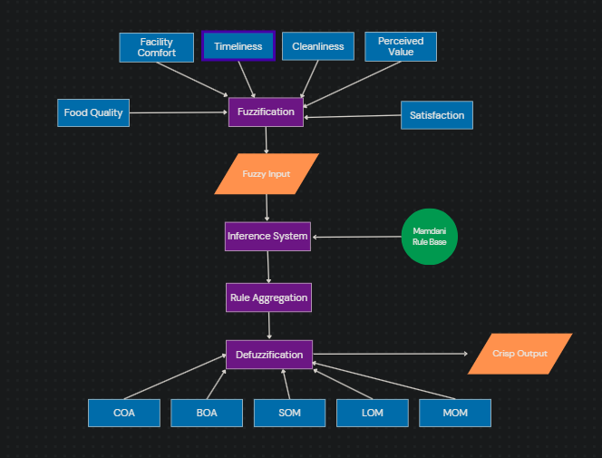

**Figure 1: Proposed Methodology**

**Table 1. Properties of the proposed FLS**

|  |  |
| --- | --- |
| Properties | Description |
| Method | Mamdani Rule Base system |
| Fuzzy AND operation | Minimum between two variables |
| Fuzzy OR operation | Maximum between two variables |
| Implication | MIN |
| Aggregation | MAX |
| Defuzzification | Centroid, Bisector, Mean of Maximum, Smallest of Maximum, Largest of Maximum |

The schematic diagram of Mamdani FIS is shown in Figure 2 that follows the following structure:

*IF a is X and b is Y THEN output is the membership function*

After designing the rule base, the defuzzification methods are applied to obtain the crisp values. This process is simply the opposite of the fuzzification procedure.

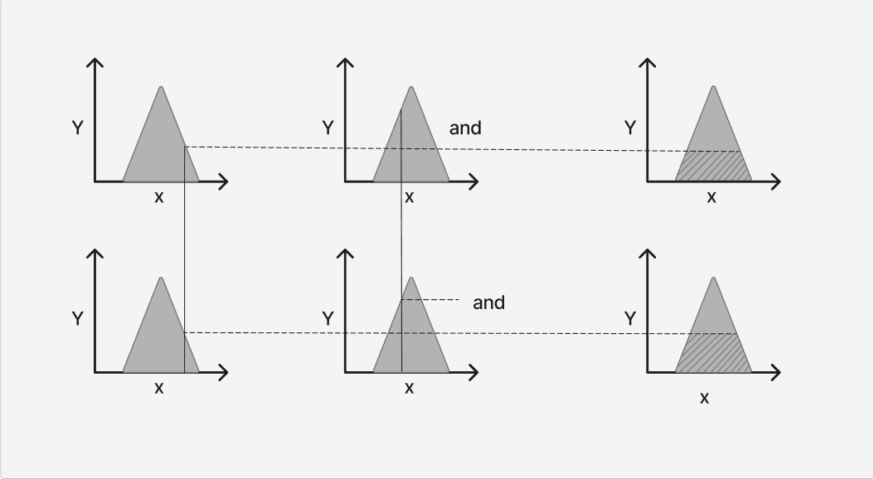

**Figure 2: Mamdani FIS-Block Representation**

For the upper first plot,

$$μ\left(x\right)= 0for x ≤ a,$$

$$μ\left(x\right)=\frac{\left(x - a\right)}{\left(b-a\right)}for a ≤ x ≤ b,$$

$$μ\left(x\right)=\frac{\left(c - x\right)}{\left(c-b\right)}for b ≤ x ≤ c,$$

$μ\left(x\right)= 0$, $for x ≥ c$

For the upper second plot,

$$μ\left(x\right)= 0 for x ≤ a$$

$$μ\left(x\right)=\frac{\left(x - a\right)}{\left(b - a\right)}for a ≤ x ≤ b$$

$$μ\left(x\right)= 1 for x = b$$

$$μ\left(x\right)=\frac{\left(c - x\right)}{\left(c - b\right)}for b ≤ x ≤ c$$

$$μ\left(x\right)= 0 for x ≥ c$$

For the upper third plot,

$$μ\left(x\right)= 0 for x ≤ a$$

$$μ\left(x\right)=\frac{\left(x - a\right)}{\left(b - a\right)}for a ≤ x ≤ b$$

$$μ\left(x\right)= 0 for x ≥ b$$

The bottom row shows the same membership functions but reflected vertically, representing monotonically decreasing quantities

**3.1 Development of Fuzzy System**

For the formulation of the Fuzzy Rule Base system, the popular fuzzy inference method was used which is known as the Mamdani Model. In order to develop a fuzzy system, it includes some steps as follows:

1. Recognizing the input and output linguistic terms, as well as their associated values (as depicted in Table 2 and Table 3.)
2. Identification of fuzzy sets and membership functions

For evaluating the performance expectancy, the task was subdivided into two parts as follows:

1. Case:1 The Impact of service quality on consumer perception.
2. Case:2 The effect of service quality and perceived value on customer satisfaction

### *Data set for Case-1:*

According to the analysis of $[21]$ the selected factors to analyze the perceived values are:

1. Food Quality that has three linguistic variables “High” with range of 6-10, “Medium” 2-8 and “Low” 0-2.
2. Facility Comfort with linguistic variable “Amazing” (6-10), “Acceptable” (2-8) and “Poor (0-4)”
3. Timeliness with the linguistic variables “Fast” (6-10), “Medium” (2-8) and “Poor” (0-4).
4. Another variable “Perceived Value” is used for the measurement of customer’s behavioral intention based on the input variables that have the range of 0-10 with five linguistic terms; “Very low”, “Low”, “Medium”, “High”, “Very High”.

**Table 2. Input and output variable for Case-1**

|  |  |  |
| --- | --- | --- |
| Input/output | Linguistic Variable | Linguistic Values |
| Input | Food Quality | High, Low or Medium |
| Facility Comfort | Poor, Acceptable or Amazing |
| Timeliness | Poor, Medium, Fast |
| Output | Perceived Value | Very low, Low, Medium, High, Very high |

### *Data set for Case-2:*

Further selected factors to analyze the Customer satisfaction values are:

1. Food Quality that have three linguistic variables “High” with range of 6-10, “Medium” 2-8 and “Low”
2. Facility Comfort with linguistic variable “Amazing” (6-10), “Acceptable” (2-8) and “Poor (0-4)”
3. Cleanlinesswith linguistic variable “Amazing” (6-10), “Acceptable” (2-8) and “Poor (0-4)”
4. Another variable, “Customer Satisfaction”, is used for the measurement of customer’s behavioral intention based on the input variables that have the range of 0-10 with three linguistic terms; “Satisfied”, “Neutral”, “Dissatisfied”.

**Table 3. Input and output variable for Case-2**

|  |  |  |
| --- | --- | --- |
| Input/output | Linguistic Variable | Linguistic Values |
| Input | Food Quality | High, Low or Medium |
| Facility Comfort | Poor, Acceptable or Amazing |
| Cleanliness | Poor, Acceptable or Amazing |
| Output | Customer Satisfaction | Satisfied, Neutral, Dissatisfied |

According to the study ,Customer satisfaction and perceived value both have a positive impact on the tendency of a customer to recommend a place $^{[21]}$. Sometimes there might be some cases where the food quality and the price of the food does not match. Rather they may be unreasonable. In that case the perceived value of a customer changes that impact the recommendation procedure. They might be satisfied with the food or the place but the perceived value may restrict them to recommend the place with a good score. This section presents the input and output variable as shown in Table 4.and values for the analysis of behavioral intention of a person based on two factors - perceived value and customer satisfaction.

**Table 4. Input and output variable for Behavioral Intention**

|  |  |  |
| --- | --- | --- |
| Input/output | Linguistic Variable | Linguistic Values |
| Input | Perceived Value | Very low, Low, Medium, High, Very high |
| Customer Satisfaction | Satisfied, Neutral, Dissatisfied |
| Output | Possibility to Recommend | Will not recommend, less possibility of Recommendation and Will Recommend |

**3.2 Designing the Fuzzy Membership Functions**

Facility Comfort, Food Quality, Cleanliness has an impact on the perceived value. Customer's perceived value changes when the place is not clean or the arrival of food is not on time. On the other hand, customer satisfaction relies Facility Comfort, Food Quality, Cleanliness. In this sector timeliness does not have that high impact because in fine dining system the service and the quality matter the most $^{[21]}.$ In Figure 1 the triangular membership function of the input variable is shown.

**3.3 Formulation of Fuzzy Rule Base**

In this work, fuzzy rules have been formulated separately for the two cases. IN **Case-1,** as there are three membership variable each having three values, a rule base has been formed with 3 * 3 * 3 forming twenty-seven rules. For example:

*If Food Quality is “High” and Facility Comfort is “Amazing” and Timeliness is “Fast” then Perceived Value is “Very High”*.

**Table 5. Fuzzy Rules for Case-1**

|  |  |  |  |
| --- | --- | --- | --- |
| **Food Quality** | **Facility Comfort** | | |
| Poor | Acceptable | Amazing |
|  | 1. **Timeliness: Poor** | | |
| Low | Very Low | Very Low | Low |
| Medium | Low | Low | Medium |
| High | Medium | Medium | High |
|  | 1. **Timeliness: Medium** | | |
| Low | Low | Medium | Medium |
| Medium | Low | High | High |
| High | Medium | High | Very High |
|  | 1. **Timeliness: Fast** | | |
| Low | Low | Medium | Medium |
| Medium | Medium | High | Very High |
| High | Medium | Very High | Very High |

In **Case-2,** as there are three membership variable each having three values, a rule base has been formed with 3 * 3 * 3 forming twenty-seven rules. For example:

**If Food Quality is “High” and Facility Comfort is “Amazing” and Cleanliness is “Amazing” then Customer is “Satisfied”.**

**Table 6. Fuzzy Rules for Case-2**

|  |  |  |  |
| --- | --- | --- | --- |
| **Food Quality** | **Facility Comfort** | | |
| Poor | Acceptable | Amazing |
|  | 1. **Cleanliness: Poor** | | |
| Low | Dissatisfied | Dissatisfied | Dissatisfied |
| Medium | Dissatisfied | Dissatisfied | Neutral |
| High | Neutral | Neutral | Satisfied |
|  | 1. **Cleanliness: Acceptable** | | |
| Low | Dissatisfied | Neutral | Neutral |
| Medium | Dissatisfied | Satisfied | Satisfied |
| High | Neutral | Satisfied | Satisfied |
|  | 1. **Cleanliness: Amazing** | | |
| Low | Dissatisfied | Neutral | Neutral |
| Medium | Neutral | Satisfied | Satisfied |
| High | Neutral | Satisfied | Satisfied |

In **Case-3,** As discussed in the previous section in this case there are two input variables having five and three input values so the total rules will be of 3* 5. That means fifteen rules will be formed in this scenario as depicted in Table 7.

For example:

**If Customer Satisfaction is “Neutral” and Perceived Value is “Medium” then Customer intention is “Less possibility to recommend”**

**Table 7. Fuzzy Rules for Case-3**

|  |  |  |  |  |  |
| --- | --- | --- | --- | --- | --- |
| **Customer Satisfaction** | **Perceived Value** | | | | |
| Very_Low | Low | Medium | High | Very_High |
| Dissatisfied | Will not Recommend | Will not Recommend | Will not Recommend | Less possibility to Recommend | Less Possibility to Recommend |
| Neutral | Will not Recommend | Will not Recommend | Less possibility to Recommend | Will Recommend | Will Recommend |
| Satisfied | Less possibility to Recommend | Less possibility to Recommend | Will Recommend | Will Recommend | Will Recommend |

**3.4 Rule Aggregation and Defuzzification**

Rule aggregation is the step of obtaining the output membership function. After the aggregation procedure, comes the defuzzification step. It is basically the opposite of the fuzzification process and produces crisp output that a user can understand. In this process of producing crisp output fuzzy sets along with corresponding membership degrees are provided and based on these the crisp output is produced. For the sake of achieving the goal in this work the authors proposed five types of defuzzification methods.

### *COA Method*

This is the most widely used defuzzification method, also known as the "Centroid" method. The COA is calculated using the following equation 1 after taking into account the range of output linguistic variables under the membership function $^{[16]}$.

$COA\left(x\right)=\frac{\int_{min}^{max}{x μ_{A}\left(x\right)dx}}{\int_{min}^{max}{ μ_{A}\left(x\right)dx}}$ (1)

### *BOA Method*

In this method the actual task is done by dividing the total fuzzy sets into 2 equal regions as shown in equation 2 $^{[8]}.$

$\int_{min}^{x}{ μ_{A}\left(x\right)dx=\int_{x}^{max}{ μ_{A}\left(x\right)dx}}$ (2)

### *Mean of Maximum Method*

In this method the defuzzified output is the element with the largest MF value but in case of more than one having maximum it calculates the mean value for finding the output $^{\left[18\right].}$

$MOM\left(x\right)=\frac{\int_{M}{x_{i} dx}}{|Mean|}$ (3)

### *Largest of Maximum Method:*

From the output membership function domain it selects the maximum value $^{[8]}$

### *Smallest of Maximum Method:*

From the maximum output MF domain, it selects the smallest one $^{[22]}$

**4 Research Analysis and Discussion**

To obtain the final result this model is divided into three parts. First, the perceived value is calculated then the customer satisfaction is evaluated based on the factors of facility comfort, timeliness, cleanliness, and food quality. After defuzzification of both cases, the defuzzified output enters into the final stage, and then the further processing is continued where based on the perceived value and customer satisfaction level the intention of a person to recommend a place is observed.

For the analysis of customer satisfaction first this method generated the membership values and presented them graphically for better visualization.

**Case-1:**

In this scenario the input and output membership function generated for the analysis of the impact of the factors on Perceived Value. As depicted in Figure 3 Figure 8 Input Membership Function: Facility Comfort, the membership function of the input variable facility comfort is shown in terms of “Poor”, “Acceptable” and, “Amazing”. In the same way Figure 4 & Figure 5, are the graph showing the input membership function for food quality and Timeliness that is used for the evaluation of Perceived Value. Again, Figure 6 represents the output membership function having the linguistic value “Very Low”, “Low”, “Medium”, “High” and “Very High”. Finally, the output membership activity of the customer satisfaction based on the “Facility Comfort'' =5, “Food quality” =6 and “Timeliness” =7 input terms with the five defuzzification methods COA, BOA, MOM, LOM, and SOM applied and graphically represented in Figure 7.

The impact of different defuzzification methods on output with the change of input is shown in Figure 7. First 10 input and their corresponding defuzzified output is presented in Table 8 Defuzzified Values Derived Through Different Defuzzification Methods (Case-1) Table 8.

**Table 8. Defuzzified Values Derived Through Different Defuzzification Methods (Case-1)**

|  |  |  |  |  |  |  |  |
| --- | --- | --- | --- | --- | --- | --- | --- |
| Food Quality | Facility Comfort | Timeliness | Op. Centroid | Op. Bisector | Op.  LOM | Op.  MOM | Op.  SOM |
| 1 | 2 | 1 | .77 | .75 | 1 | 0 | 0 |
| 2 | 2 | 4 | .77 | .75 | 1 | 0 | 0 |
| 4 | 4 | 4 | 7 | 7 | 7 | 7 | 7 |
| 2.5 | 3 | 1 | 2.39 | 2.437 | 4 | 3 | 2 |
| 6 | .5 | .5 | 2.99 | 3 | 3 | 3 | 3 |
| 10 | 10 | 10 | 9.33 | 9.41 | 10 | 10 | 10 |
| 7.5 | 10 | .5 | 6.4 | 5.75 | 7 | 6.8 | 4 |
| .5 | 6 | .5 | 2.99 | 3 | 3 | 3 | 3 |
| .5 | .5 | .5 | .68 | .61 | 0 | 0 | 0 |
| 5.88 | 9.44 | .5 | 5 | 5 | 5 | 5 | 5 |

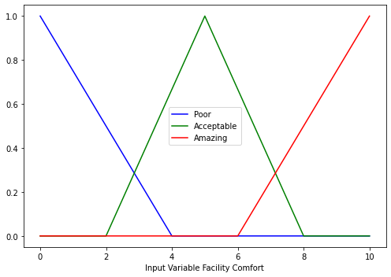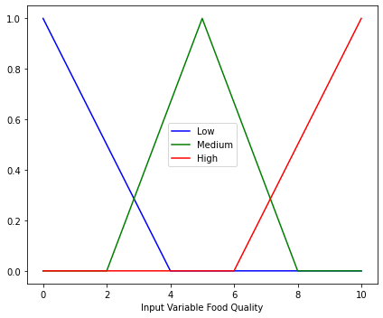

(a) (b)

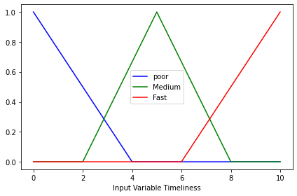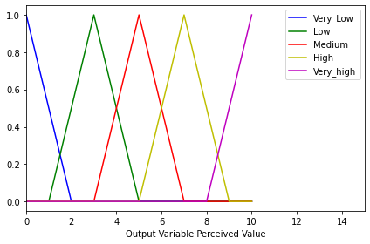

(c) (d)

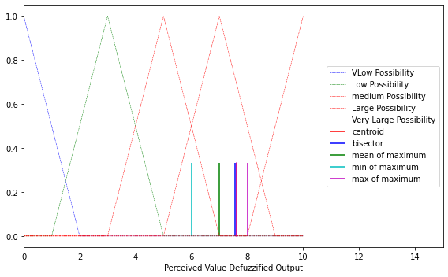

(e)

**Figure 3: Design of input output MF of Case-1, (a) Input Membership Function: Facility Comfort, (b) Input Membership Function: Food Quality, (c) Input Membership Function: Timeliness, (d) Output Membership Function: Perceived Value, (e) Output Membership Activity**

**Case-2**:

Similarly, for case-2 the input and output membership function generated for the analysis of the impact of the factors on Customer Satisfaction. As depicted in Figure 8 Input Membership Function: Facility Comfort, the membership function of the input variable facility comfort is shown in terms of “Poor”, “Acceptable” and, “Amazing”. In the same way Figure 9 & Figure 10, are the graphs showing the input membership function for food quality and Cleanliness that is used for the evaluation of Customer satisfaction. Again, Figure 11 Figure 11 represents the output membership function having the linguistic value “Dissatisfied”, “Satisfied” and “Neutral”. Finally, the output membership activity of the customer satisfaction based on the “Facility Comfort'' =5, “Food quality” =6, and “Cleanliness” =7 input terms with the five defuzzification methods COA, BOA, MOM, LOM, and SOM applied as depicted in, Figure 12 Output Membership Activity.

The impact of different defuzzification methods on output with the change of input is shown in**.** First 10 inputs are presented in Table 9.

**Table 9. Defuzzified Values Derived Through Different Defuzzification Methods (Case-2)**

|  |  |  |  |  |  |  |  |
| --- | --- | --- | --- | --- | --- | --- | --- |
| Food Quality | Facility Comfort | Cleanliness | Op. Centroid | Op. Bisector | Op.  LOM | Op.  MOM | Op.  SOM |
| **1** | 2 | 1 | 1.5 | 1.5 | 2 | 1 | 0 |
| **2** | 2 | 4 | 1.5 | 1.5 | 2 | 1 | 0 |
| **4** | 4 | 4 | 8.55 | 8.67 | 10 | 9.5 | 7 |
| **2.5** | 3 | 1 | 1.67 | 1.62 | 2 | 1 | 0 |
| **6** | .5 | .5 | 1.44 | 1.325 | 1 | .5 | 0 |
| **10** | 10 | 10 | 8.8667 | 8.828 | 10 | 10 | 10 |
| **7.5** | 10 | .5 | 6.28 | 6.25 | 10 | 7 | 4 |
| **.5** | 6 | .5 | 1.44 | 1.32 | 1 | .5 | 0 |
| **.5** | .5 | .5 | 1.36 | 1.21 | 0 | 0 | 0 |
| **5.88** | 9.44 | .5 | 4.99 | 5 | 5 | 5 | 5 |

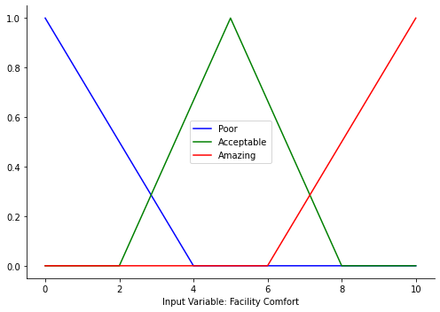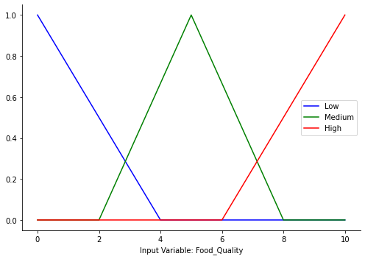

(a) (b)

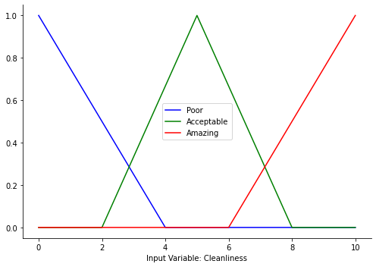 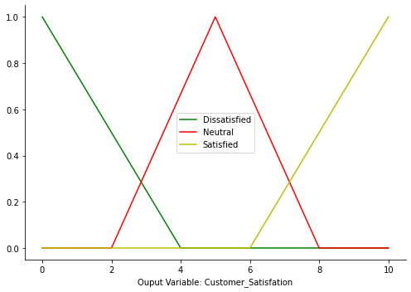

(c) (d)

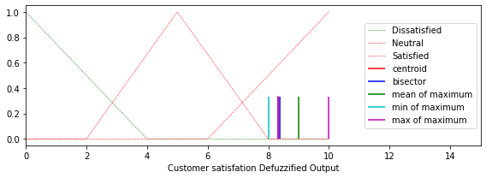

(e)

**Figure 4: Design of input/output of case-2, (a) Input Membership Function: Facility Comfort, (b) Input Membership Function: Food Quality, (c) Input Membership Function: Cleanliness, (d) Output Membership Function: Customer Satisfaction, (e) Output Membership Activity**

|  |  |
| --- | --- |
| **(a)** | **(b)** |
| **(c)** | **(d)** |

**Figure 5: Input output designs for behavioral intention, (a) Input Membership Function: Customer Satisfaction, (b) Input Membership Function: Perceived Value, (c) Output Membership Activity Behavioral Intention, (d) Output Membership Activity**

Finally, the 3D plot of the input perceived value and customer satisfaction and output customer intention is shown in Figure 17.

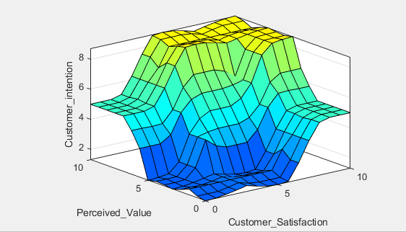

**Figure 6: 3D plot of customer intention based on perceived value and customer satisfaction.**

**5 Conclusion and Future Work**

Finding a better place to have food has been considered as a source of entertainment. Many people consider the review of another person who has been in one place and shared their opinion. From the huge amount of reviews, it is difficult to judge a place. For this reason, this work presented a fuzzy based model that can analyze the customer sentiment to recommend a place for food. This system will reduce the load of reading a huge number of posts mentioning the ratings of a place. Again, this work analyzed the recommendation system in two perspectives based on the worthiness of a place with consistent price and quality as well as the customer satisfaction after being in that place with better service. Five defuzzification methods have been applied.

From the final result it is clear that the customer satisfaction and the perceived value both have a positive impact on the overall intention of a customer to give a good review. Through a service a person gets fully satisfied but if there is any mismatch between the service provided and the perceived value then the possibility to recommend a place may deteriorate However, this work presented a possible solution of a recommendation system with assuming some possible values that may have an impact on the factors. For computational simplicity only the parameters that may have the highest impact on the fine dining system have been considered.

Future research -

* will take into account additional variables like cost, aesthetics, and other aspects to observe changes in the outcome.
* will also compare various defuzzification techniques to ensure that the system performs as intended.
* will address additional areas of recommendation based on this study, like online meal delivery services and fast food businesses, among others.
* Incorporating the AFNIS model will improve the system's efficiency through deeper analysis $^{[6]}$

**ACKNOWLEDGMENTS**

Authors would like to express their gratitude to the Ministry of Defence (MoD), and the Department of CSE, MIST, Bangladesh. They also would like to thank Quantum Robotics and Automation Research Group (QRARG), and DAZDREAM Technologies for the insightful comments, suggestions, and guidelines.

**REFERENCES**

[1] K. Al Fararni, F. Nafis, B. Aghoutane, A. Yahyaouy, J. Riffi, and A. Sabri, “Hybrid recommender system for tourism based on big data and AI: A conceptual framework,” *Big Data Mining and Analytics*, vol. 4, no. 1, pp. 47–55, 2021.

[2] H. Al-Dossari and S. Alyahya, “Using Fuzzy-Logic in Decision Support System based on Personal Ratings,” *International Journal of Advanced Computer Science and Applications*, vol. 11, no. 4, pp. [339–343, 2020](https://thesai.org/Downloads/Volume11No4/Paper_46-Using_Fuzzy_Logic_in_Decision_Support_System.pdf)

[3] S. Alghamdi, N. Alzhrani, and H. Algethami, “Fuzzy-based recommendation system for university major selection,” *IJCCI 2019 - Proceedings of the 11th International Joint Conference on Computational Intelligence*, pp. [317–324, 2019](https://pdfs.semanticscholar.org/c023/4c6a4b579b32a06d121e5a5f3b5ed7fa94c7.pdf).

[4] T. Chen, “A fuzzy ubiquitous traveler clustering and hotel recommendation system by differentiating travelers’ decision-making behaviors,” *Applied Soft Computing Journal*, vol. [96, 2020](https://link.springer.com/article/10.1007/s10489-022-03461-z)

[5] S. Forouzandeh, K. Berahmand, E. Nasiri, and M. Rostami, “A Hotel Recommender System for Tourists Using the Artificial Bee Colony Algorithm and Fuzzy TOPSIS Model: A Case Study of TripAdvisor,” *International Journal of Information Technology & Decision Making*, vol. 20, no. 1, pp. [399–429, 2021](https://www.researchgate.net/profile/Kamal-Berahmand/publication/347564024_A_Hotel_Recommender_System_for_Tourists_Using_the_Artificial_Bee_Colony_Algorithm_and_Fuzzy_TOPSIS_Model_A_Case_Study_of_TripAdvisor/links/649a435e95bbbe0c6ef6b7da/A-Hotel-Recommender-System-for-Tourists-Using-the-Artificial-Bee-Colony-Algorithm-and-Fuzzy-TOPSIS-Model-A-Case-Study-of-TripAdvisor.pdf)

[6] E. Habibi, M. Salehi, G. Yadegarfar, and A. Taheri, “Optimization of the ANFIS using a genetic algorithm for physical work rate classification,” *International Journal of Occupational Safety and Ergonomics*, vol. 26, no. 3, pp. [436–443, 2020](https://www.researchgate.net/profile/Ghasem-Yadegarfar/publication/323099433_Optimization_of_ANFIS_using_a_genetic_algorithm_for_physical_work_rate_classification/links/5da479e3a6fdcc8fc34fef0a/Optimization-of-ANFIS-using-a-genetic-algorithm-for-physical-work-rate-classification.pdf)

[7] R. A. E. Murnawan and S. Lestari, “Comparison of Sugeno and Tsukamoto Fuzzy Inference System Method for Determining Estimated Production Amount,” *Turkish Journal of Computer and Mathematics Education*, vol. 12, no. 8, pp. [1467–1476, 2021](https://www.researchgate.net/profile/Murnawan-Murnawan/publication/356681209_Comparison_of_Sugeno_and_Tsukamoto_Fuzzy_Inference_System_Method_for_Determining_Estimated_Production_Amount/links/61a8b62aaade5b1bf5f96882/Comparison-of-Sugeno-and-Tsukamoto-Fuzzy-Inference-System-Method-for-Determining-Estimated-Production-Amount.pdf)

[8] J. G. Nayak, L. G. Patil, and V. K. Patki, “Development of water quality index for Godavari River (India) based on fuzzy inference system,” *Groundwater for Sustainable Development*, vol. 10, p. [100350, 20201](https://www.ijeat.org/wp-content/uploads/papers/v4i3/C3791024315.pdf)

[9] M. Nilashi, E. Yadegaridehkordi, O. Ibrahim, S. Samad, A. Ahani, and L. Sanzogni, “Analysis of Travellers’ Online Reviews in Social Networking Sites Using Fuzzy Logic Approach,” *International Journal of Fuzzy Systems*, vol. 21, no. 5, pp. [1367–1378, 2019](https://link.springer.com/article/10.1007/s40815-019-00630-0)

[10] A. Niyazov, E. Mikhailova, and O. Egorova, “Content-based Music Recommendation System,” *2021 29th Conference of Open Innovations Association (FRUCT)*, pp. 274–279, 2021.

[11] K. Okada, P. X. Tan, and E. [Kamioka, “Five-Factor Musical Preference Prediction for Solving New User Cold-Start Problem in Content-Based Music Recommender System,” *n.d.*,](https://shibaura.elsevierpure.com/en/publications/exploiting-music-model-to-solve-cold-start-user-problem-in-conten)

[12] S. N. Putri and D. R. S. Saputro, “Construction fuzzy logic with curve shoulder in inference system Mamdani,” *Journal of Physics: Conference Series*, vol. 1776, no. 1, p. [12060, 2021](https://www.mybib.com/tools/ieee-citation-generator)

[13] D. P. D. Rajendran and R. P. Sundarraj, “Using topic models with browsing history in hybrid collaborative filtering recommender system: Experiments with user ratings,” *International Journal of Information Management Data Insights*, vol. 1, no. 2, p. 100027, 2021.

[14] F. Rezaimehr and C. Dadkhah, “A survey of attack detection approaches in collaborative filtering recommender systems,” *Artificial Intelligence Review*, vol. 54, no. 3, pp. [2011–2066, 2021](https://www.scribbr.com/citation/generator/ieee/)

[15] J. A. Rojas, H. E. Espitia, and L. A. Bejarano, “Design and Optimization of a Fuzzy Logic System for Academic Performance Prediction,” *Symmetry*, vol. 13, p. [133, 2021](https://www.researchgate.net/publication/348518623_Design_and_Optimization_of_a_Fuzzy_Logic_System_for_Academic_Performance_Prediction/fulltext/60995825458515d3150eed41/Design-and-Optimization-of-a-Fuzzy-Logic-System-for-Academic-Performance-Prediction.pdf)I

[16] N. Shamshiden and others, “Anti-lock Braking System Control Based on Fuzzy Logic,” *Bánki Közlemények (Bánki Reports)*, vol. 4, no. [1, 2021](https://www.researchgate.net/profile/Sinan-Kocak-2/publication/352247865_Anti-lock_Braking_System_Control_Based_on_Fuzzy_Logic_Fuzzy_logika_alapu_blokkolasgatlo_fekrendszer_vezerlese/links/60c090d492851cecf1669ec0/Anti-lock-Braking-System-Control-Based-on-Fuzzy-Logic-Fuzzy-logika-alapu-blokkolasgatlo-fekrendszer-vezerlese.pdf)

[17] M. Shrimal, M. Khavnekar, S. Thorat, and D. [Jyoti, “Nutriflow: A Diet Recommendation System,” *SSRN*,](https://papers.ssrn.com/sol3/papers.cfm?abstract_id=3866863)

[18] A. Solichin and F. H. Saputri, “An Adaptive Neuro-Fuzzy Inference System (ANFIS) Method for Recommending Employee Mutations in a Manufacturing Company,” *Journal of Physics: Conference Series*, vol. 1908, no. 1, p. [12016, 2021](https://www.scribbr.com/citation/generator/ieee/)

[19] S. Sood and M. Saini, “Hybridization of Cluster-Based LDA and ANN for Student Performance Prediction and Comments Evaluation,” *Education and Information Technologies*, vol. 26, no. 3, pp. 2863–2878, 2021

[20] Y. Tian and Z. Wang, “A Switched Fuzzy Filter Approach to H∞ Filtering for Takagi-Sugeno Fuzzy Markov Jump Systems with Time Delay: The Continuous-Time Case,” *Information Sciences*, vol. 557, pp. 236–249, 2021.

[21] I. Tuncer, C. Unusan, and C. Cobanoglu, “Service Quality, Perceived Value and Customer Satisfaction on Behavioral Intention in Restaurants: An Integrated Structural Model,” *Journal of Quality Assurance in Hospitality and Tourism*, vol. 22, no. 4, pp. [447–475, 2021](https://sci-hub.se/10.1080/1528008x.2020.1802390)

[22] Vahabzadeh, A., Kasaeian, A., Monsef, H., & Aslani, A. (2020). “A Fuzzy-SOM Method for Fraud Detection in Power Distribution Networks with High Penetration of Roof-Top Grid-Connected PV.” *Energies*[, 13(5), 1287](https://www.mdpi.com/1996-1073/13/5/1287)

[23] **Yera, R., & Martínez, L. (2017)**. “Fuzzy Tools in Recommender Systems: A Survey.” *International Journal of Computational Intelligence Systems*, **10**[, 776–803](https://link.springer.com/article/10.1007/s11704-024-40231-1)

[24] **Zhang, Z., Dong, M., Ota, K., Zhang, Y., & Ren, Y. (2021)**. “LBCF: A Link-Based Collaborative Filtering for Overfitting Problem in Recommender System.” *IEEE Transactions on Computational Social Systems*, **1–15**. [DOI: 10.1109/tcss.2021.3081424](https://sci-hub.se/10.1109/TCSS.2021.3081424)

[25] Arif, M. A. I., Islam, Z., Sharmee, S. S., & Akhtaruzzaman, M. (2023). “An Intelligent Air Defense Recommendation Model based on Fuzzy Inference System.” In *Proceedings of the IEEE International Conference on Intelligent Systems and Applications* (pp. 979-984). [IEEE](https://www.mybib.com/tools/ieee-citation-generator)

[26] Suha, S. A., Akhtaruzzaman, M., & Sanam, T. F. (2022). “A Fuzzy Model for Predicting Burn Patients’ Intravenous Fluid Resuscitation Rate.” *Healthcare Analytics*[, 2, 100070](https://www.researchgate.net/profile/Md-Akhtaruzzaman-2/publication/361409559_A_fuzzy_model_for_predicting_burn_patients)

[27] Zanon, L. G., Munhoz Arantes, R. F., Calache, L. D. D. R., & Carpinetti, L. C. R. (2019). “A Decision Making Model Based on Fuzzy Inference to Predict the Impact of SCOR® Indicators on Customer Perceived Value.” *International Journal of Production Economics*[, 223, 107520](https://www.sciencegate.app/document/10.1016/j.ijpe.2019.107520)

[28] Guo, L.-X., Lin, C.-C., Huang, P.-F., Jhou, S.-Y., Chen, S.-C., & Tsai, F.-S. (2021). “Fuzzy Logic Analysis for Key Factors for Customer Loyalty in E-Shopping Environment.” *Frontiers in Psychology*[, 12, 742699](https://www.frontiersin.org/journals/psychology/articles/10.3389/fpsyg.2021.742699/full)

[29] G. M. Díaz and R. A. C. González, "Fuzzy Logic and Decision Making Applied to Customer Service Optimization," Axioms, vol. 12, no. 5, p. 448, May 2023. [Online]. Available:<https://doi.org/10.3390/axioms12050448>

[30] A. Tsenov, I. Ivanov, T. Poparova, and S. Neykov, "Fuzzy evaluation of customer satisfaction with mobile services," in Proc. 10th International Conference on Telecommunication in Modern Satellite, Cable and Broadcasting Services (TELSIKS), Nis, Serbia, 2011, pp. 531-534. [Online]. Available:<https://doi.org/10.1109/TELSKS.2011.6143199>