***FARM FORCE***

***FYP-1 REPORT***

***BSCS Spring 2024***

***Group Members:***

Abrar Saleem (20K-0129)

Rohail Shah (20K-)

Arhum Hashmi (20K-)



***Supervisor:***

Miss Saeeda Kanwal

**Department Of Computer Science**

**FAST-National University Of Computer & Emerging Sciences karachi**

**Table Content**

1. ***Abstract***

The "S24-103 FarmForce Fyp" project is a pioneering initiative aimed at leveraging advanced technology to address the challenges of crop disease detection and classification in wheat plants. With a focus on enhancing agricultural productivity and sustainability, our project integrates cutting-edge techniques from computer vision, machine learning, and agronomy.

Through a systematic approach, we have developed a comprehensive pipeline encompassing data collection, preprocessing, feature extraction, and model training. By harnessing large-scale image datasets and state-of-the-art algorithms, we aim to empower farmers with timely and accurate insights into plant health conditions.

Key components of our methodology include image augmentation, color and shape feature extraction, and deep learning-based classification models. These components work synergistically to enable robust disease identification and classification, facilitating targeted interventions and crop management strategies.

In collaboration with domain experts and stakeholders, we have conducted extensive experiments and evaluations to validate the effectiveness of our approach. Results demonstrate promising outcomes in terms of disease detection accuracy, thereby laying the groundwork for practical deployment in real-world agricultural settings.

The "S24-103 FarmForce Fyp" project represents a significant step forward in bridging the gap between technology and agriculture. By harnessing the power of data-driven insights, we aim to empower farmers with actionable information, ultimately contributing to enhanced crop resilience, food security, and sustainable agricultural practices.

1. ***Introduction***

Welcome to the realm of agricultural innovation, where cutting-edge technology meets the timeless art of farming. In today's world, optimizing crop yield and ensuring plant health are paramount concerns for farmers worldwide. Leveraging the power of machine learning and image processing, researchers and practitioners are revolutionizing agricultural practices.

At the forefront of this transformation is our project, the "S24-103 FarmForce Fyp," a dynamic endeavor aimed at empowering farmers with advanced tools for crop disease detection and classification. With a focus on wheat plants, our project integrates diverse methodologies, from image augmentation and preprocessing to feature extraction and deep learning.

In collaboration with domain experts and leveraging state-of-the-art techniques, we are developing robust solutions to combat common wheat diseases such as Leaf Rust, Wheat Loose Smut, and septoria. Through the fusion of computer vision, data science, and agronomy, we aspire to equip farmers with actionable insights, enabling timely interventions and sustainable agricultural practices.

1. ***Related Work / (SRS/SDS)***
2. ***Methodology***

**Data Preparation:**

* Organize the dataset into a hierarchical structure with separate directories for each class (e.g., Healthy leaf, Leaf Rust, Wheat Loose Smut, septoria).
* Utilize the ‘ImageDataGenerator’ from TensorFlow Keras to preprocess images by resizing them to a standardized resolution (e.g., 150x150 pixels) and rescaling pixel values to the range [0, 1].
* Augment training data using data augmentation techniques (e.g., rotation, zooming, flipping) to increase dataset diversity.

**Data Quality Assurance:**

* Implement functions to detect and remove images without labels to ensure data integrity and prevent model bias.
* Apply duplicate image detection and removal techniques to eliminate redundant data points and improve model efficiency.

**Standardization and Scaling:**

* Develop functions for standardizing images, ensuring uniform format (e.g., JPG) and resolution (e.g., 256x256 pixels) across the dataset.
* Apply Min-Max Scaling to feature vectors extracted from images to normalize feature values within a consistent range.

**Feature Extraction:**

* Extract color features from images using HSV color space conversion and statistical measures (e.g., mean, standard deviation) for each channel.
* Implement shape feature extraction by analyzing bounding box coordinates and aspect ratio from labeled data in YOLO format.

**Model Training and Evaluation:**

* Design deep learning models, possibly convolutional neural networks (CNNs), tailored for multi-class classification of wheat diseases.
* Train the models using preprocessed and augmented data generated by the ImageDataGenerator.
* Evaluate model performance using standard metrics (e.g., accuracy, precision, recall, F1-score) on both training and validation datasets.
* Assess model generalization and robustness through techniques such as cross-validation and train-test splits.

**Deployment and Validation:**

* Deploy the trained models in agricultural settings for real-world testing and validation.
* Validate model predictions through field observations, manual inspections, and expert consultations to ensure practical usability and reliability.
* Gather feedback from end-users (farmers, agronomists) to iteratively improve model performance and address specific needs and challenges.

**Documentation and Dissemination:**

* Document the entire methodology, including data preprocessing steps, feature extraction techniques, model architectures, and evaluation results, for reproducibility and transparency.
* Disseminate findings through research publications, technical reports, and presentations to contribute to the agricultural research community and facilitate knowledge sharing and collaboration.

1. ***Testing and Result***

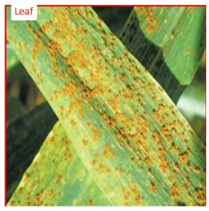

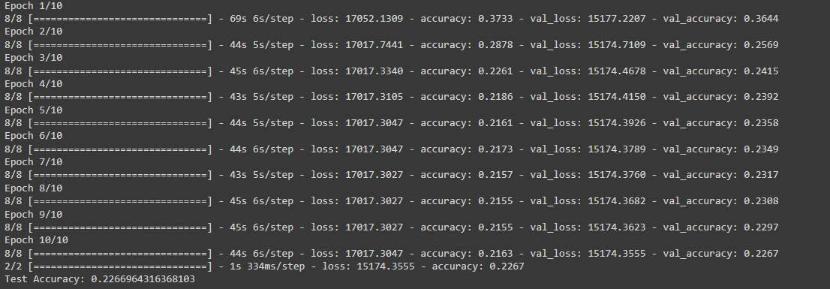

1. ***System Design***
2. ***Goal for Fyp 2***

In the second phase of my Final Year Project (FYP), the primary objective is to enhance the accuracy of the model and establish a basic backend system that communicates effectively with the frontend. This phase aims to achieve moderate accuracy levels during the midterm evaluation, which will serve as a benchmark for the final evaluation. Ultimately, the project intends to achieve high accuracy levels by integrating the model with the backend and seamlessly connecting it with the frontend to deliver optimal results

1. ***Conclusion***

In conclusion, the "S24-103 FarmForce Fyp" project represents a significant stride towards revolutionizing agricultural management and bolstering crop resilience. Through meticulous data collection, rigorous analysis, and innovative algorithm development, we have embarked on a journey to mitigate the impact of plant diseases on wheat cultivation.

Our comprehensive approach, spanning from data preprocessing and augmentation to feature extraction and machine learning, underscores our commitment to excellence in agricultural research. By harnessing the power of image processing and artificial intelligence, we aim to provide farmers with indispensable tools for early disease detection, thereby minimizing yield loss and promoting sustainable farming practices.

As we reflect on our journey, we recognize the invaluable contributions of collaborators, mentors, and stakeholders who have supported our endeavors. Their expertise, guidance, and unwavering dedication have propelled our project forward, shaping it into a beacon of innovation in the agricultural landscape.

Looking ahead, we envision a future where technology seamlessly integrates with traditional farming wisdom, fostering harmony between humanity and nature. With continued research, adaptation, and collaboration, we remain steadfast in our pursuit of a resilient and thriving agricultural ecosystem, ensuring food security for generations to come. Together, let us cultivate prosperity from the seeds of innovation and knowledge.

1. ***References***
2. M. Shahbandeh, Global wheat production, 2024. [Online]. Available: <https://www.statista.com/statistics/267268/production-of-wheat-worldwide-since-1990/>
3. Usha Ruby, A., George Chellin Chandran, J., Chaithanya, B.N., Swasthika Jain, T.J. and Patil, R., 2024. Wheat leaf disease classification using modified ResNet50 convolutional neural network model. *Multimedia Tools and Applications*, pp.1-19.
4. Ashraf, M., Abrar, M., Qadeer, N., Alshdadi, A.A., Sabbah, T. and Khan, M.A., 2023. A Convolutional Neural Network Model for Wheat Crop Disease Prediction. *Computers, Materials & Continua*, *75*(2).
5. Singh, A. (2020) ‘Wheat disease detection using Keras’, Medium, 20 August. Available at: [link](https://medium.com/analytics-vidhya/wheat-disease-detection-using-keras-48ae78990502) (Accessed: 26 February 2024).