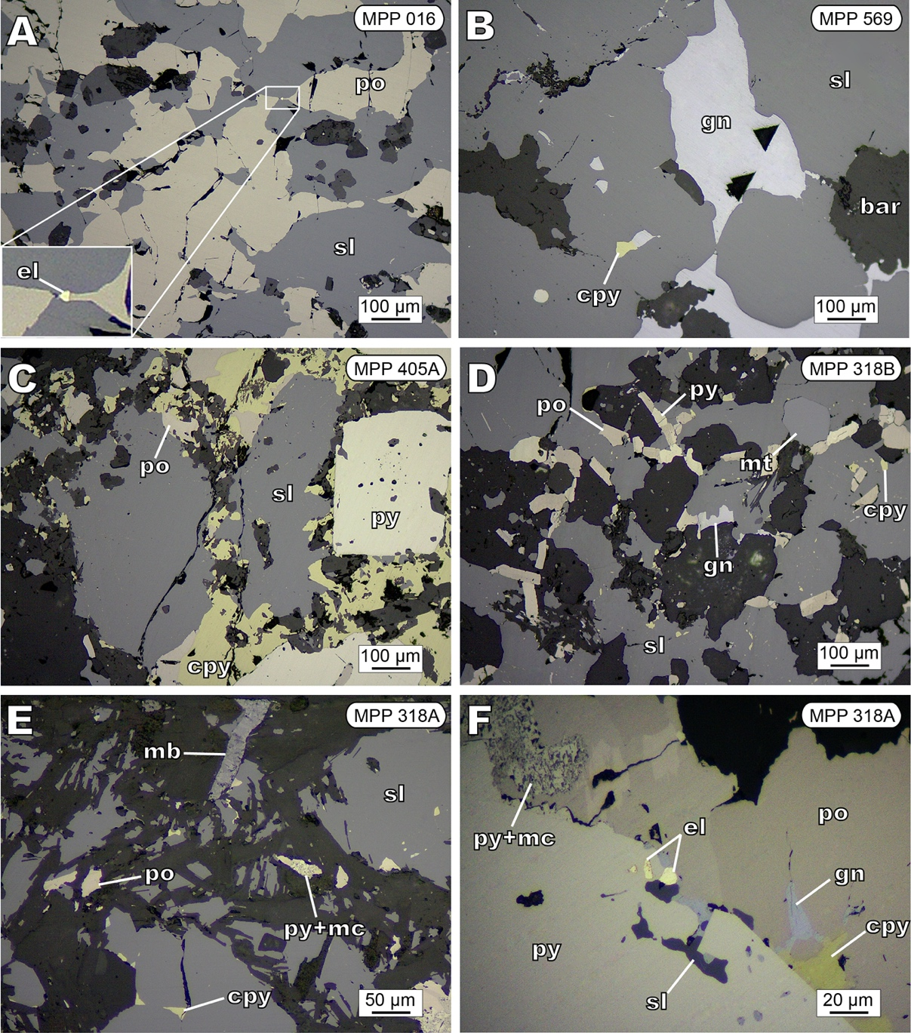
Fig. S1. Photomicrographs (reflected light) of textural features in samples used for this study from the Perubar deposit. A) Pyrrhotite intergrown with massive sphalerite. A minute (4 µm) grain of electrum occurs in the contact between both minerals. B) Sphalerite-galena assemblage with local chalcopyrite inclusions in a matrix of baryte. C) Pyrrhotite, pyrite, sphalerite, and chalcopyrite. A pyrite crystal shows microporosity in its core and massive overgrowth bands. D) Subhedral magnetite crystal surrounded by massive sphalerite, the latter also including pyrite and pyrrhotite inclusions. E) Elongated molybdenite crystal in contact with sphalerite. F) Electrum grains (4-8 µm) along pyrite grain boundaries. Pyrrhotite partly replaced by pyrite and marcasite. Abbreviations: bar: baryte; cpy: chalcopyrite; el: electrum; gn: galena; mc: marcasite; mt: magnetite; mb: molybdenite; py: pyrite; po: pyrrhotite; sl: sphalerite.

