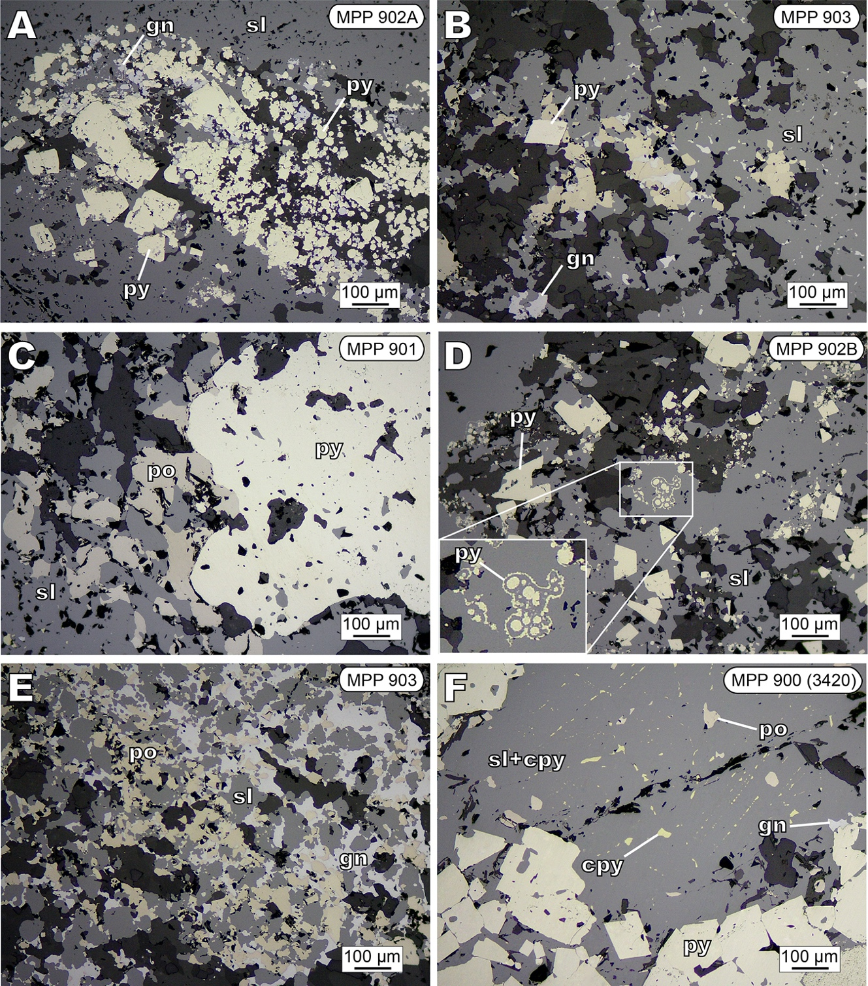
Fig. S2. Photomicrographs (reflected light) of textural features in samples used for this study from the Palma deposit. A) Aggregates of spheroidal and subhedral pyrite grains cemented by sphalerite and galena. B) Mass of sphalerite and minor galena along with relictic pyrrhotite. C) Sphalerite replacement of pyrrhotite; sphalerite also lines voids in cariated pyrite. D) Pyrite partly showing "atoll-like texture" in massive sphalerite. E) Pyrrhotite aggregates replaced by massive sphalerite and galena. F) Subhedral pyrite in massive sphalerite with pyrrhotite relicts. Fine disseminations of chalcopyrite in sphalerite. Abbreviations: cpy: chalcopyrite; gn: galena; py: pyrite; po: pyrrhotite; sl: sphalerite.

