Trace element zoning and temperature variation in sphalerite from the giant Nannihu porphyry-skarn-epithermal polymetallic system, Central China
Chang Wang¹, Zhan-Ke Li^{1, 2*}, Ioan Sanislav³, Yi Zheng⁴, Xiao-Ming Li¹, Rong-Zhen Zhang⁵, Jia Hu¹, Jun Zhang¹

1. School of Earth Resources, China University of Geosciences, Wuhan, Hubei Province 430074, China
2. State Key Laboratory of Geological Processes and Mineral Resources, China University of Geosciences, Wuhan, Hubei Province 430074, China
3. Economic Geology Research Centre (EGRU), College of Science and Engineering, James Cook University, Townsville, Queensland, Australia
4. School of Earth Sciences and Engineering, Sun Yat-Sen University, Zhuhai, Guangdong Province 519000, China
5. Henan Academy of Geology, Zhengzhou, Henan Province 450001, China
*Corresponding author: Dr. Zhan-Ke Li (lizk@cug.edu.cn)

Electronic supplementary figures
ESM 2-Figure S1. BSE images of sphalerite from the Nannihu ore field
ESM 2-Figure S2. Violin plot for Ga, Ge, Cd and In in sphalerite from the Nannihu deposit
ESM 2-Figure S3. Representative single-spot LA-ICP-MS spectra for selected elements in sphalerite

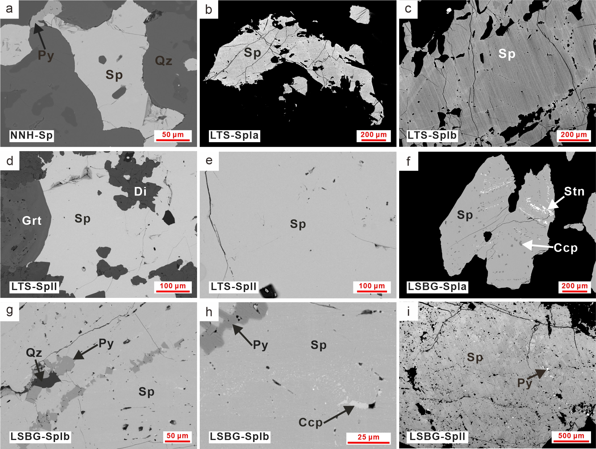
ESM 2-Figure S1. BSE images of sphalerite from the Nannihu ore field. Abbreviations: Py: pyrite, Sp: sphalerite, Ccp: chalcopyrite, Qz: quartz, Stn: stannite; Di: diopside.
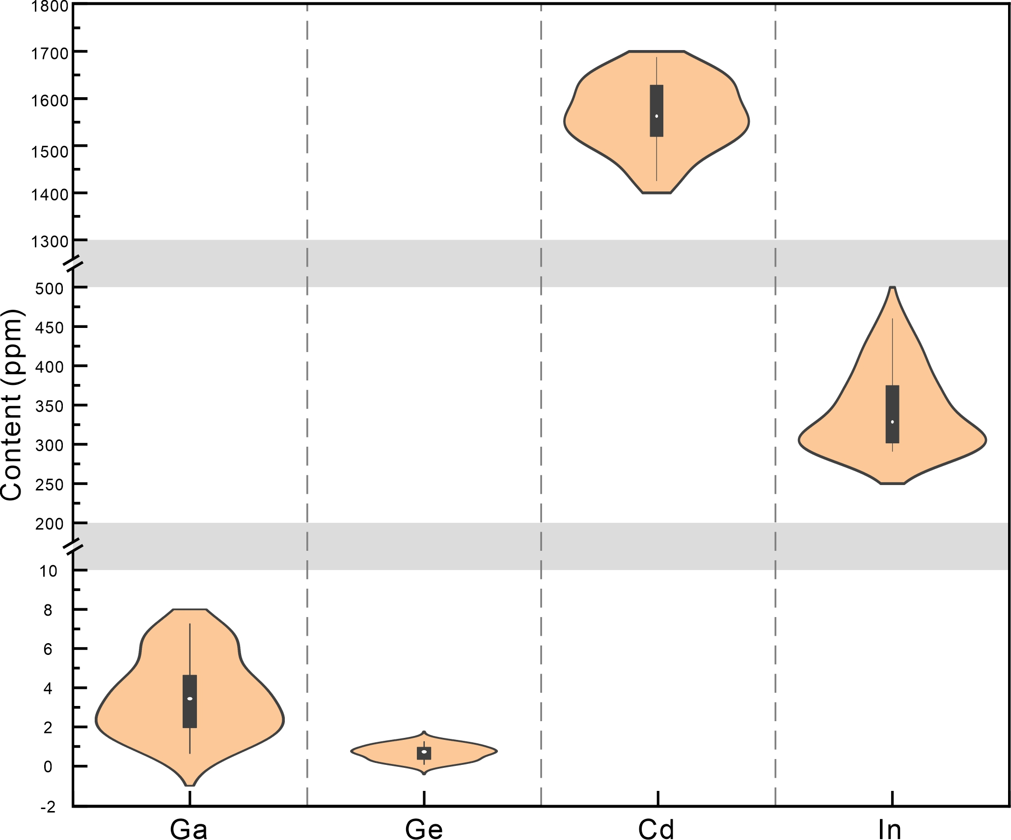
ESM 2-Figure S2. Violin plot for Ga, Ge, Cd and In in sphalerite from the Nannihu deposit.
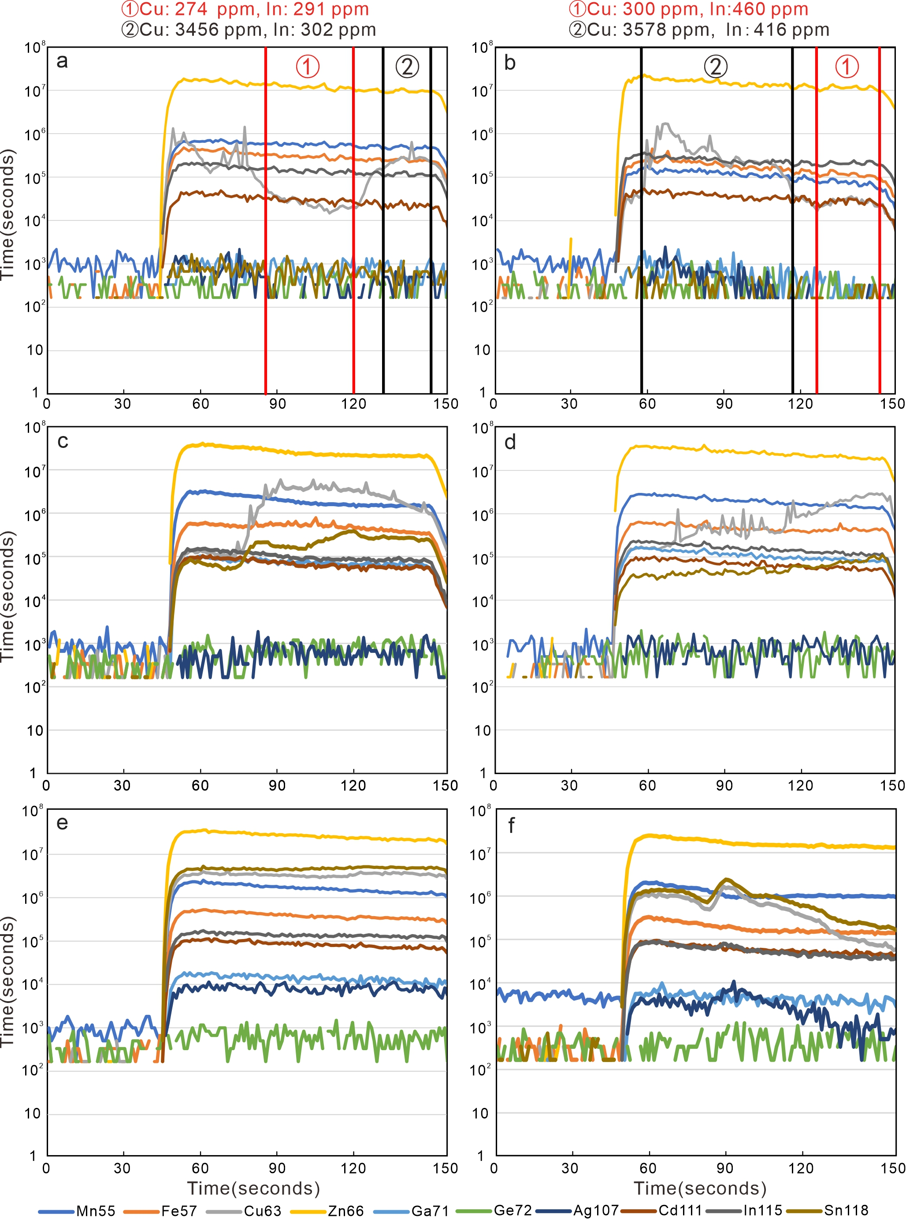
ESM 2-Figure S3. Representative single-spot LA-ICP-MS spectra for selected elements in sphalerite. (a-b) Sphalerite from the Nannihu deposit. Smooth and parallel signals for Zn, Mn, Fe, Ag, and Cd, with ragged peaks in the signal for Cu due to chalcopyrite inclusions. (c-d) LSBG-SpIa. Smooth spectra for Zn, Mn, Fe, In, Ga, and Cd with irregular peaks in in the signals for Cu and Sn due to the presence of stannite. (e) LSBG-SpIb. Smooth profiles for all elements, despite the presence of submicro-inclusions. (f) LSBG-SpIb. Irregular signals for Cu and Sn with peaks in the signals for In and Ag, attributable to stannite inclusions

