Supplementary Figures
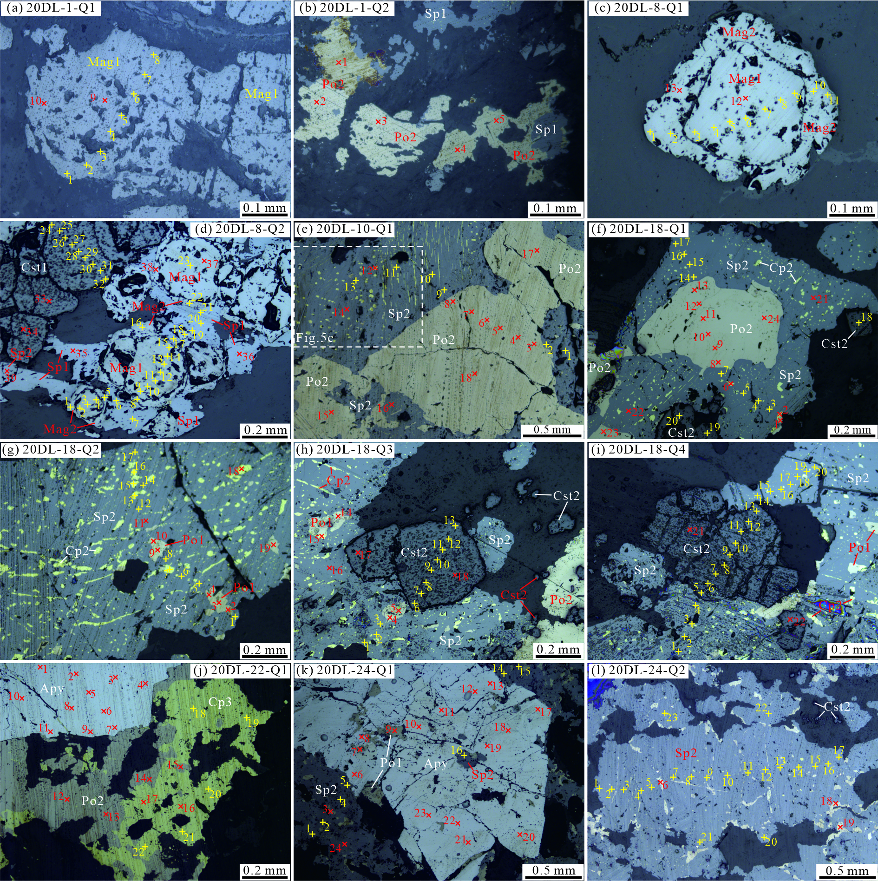
Fig.S1 Photomicrographs of measured ore samples with analytical spot in the Dulong Sn-Zn-In deposit (Plane-polarized light)
“×” and “＋” represent the measured spots of EPMA and LA-ICP-MS analysis, respectively.
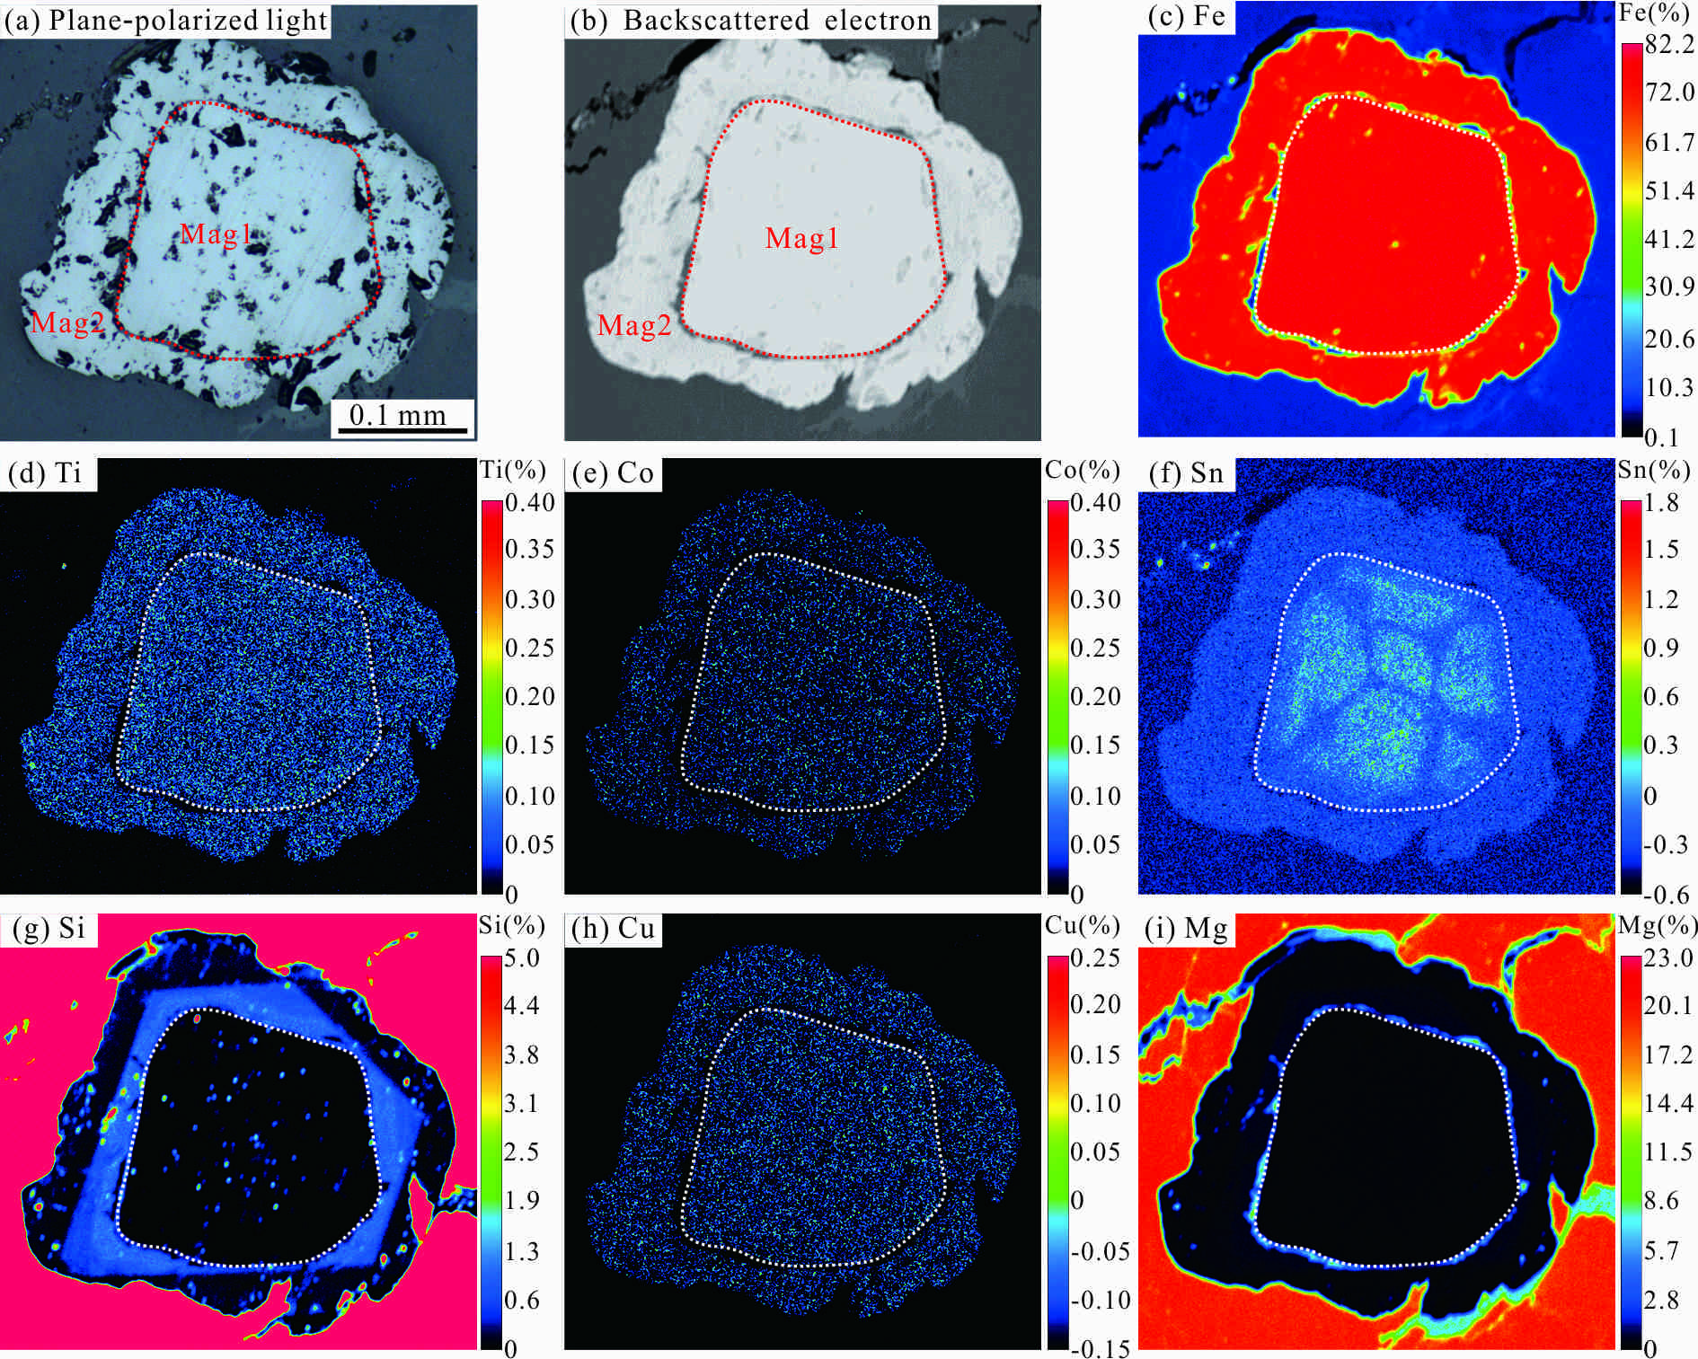
Fig.S2 EPMA element distribution maps of the sample 20DL-8-Q1
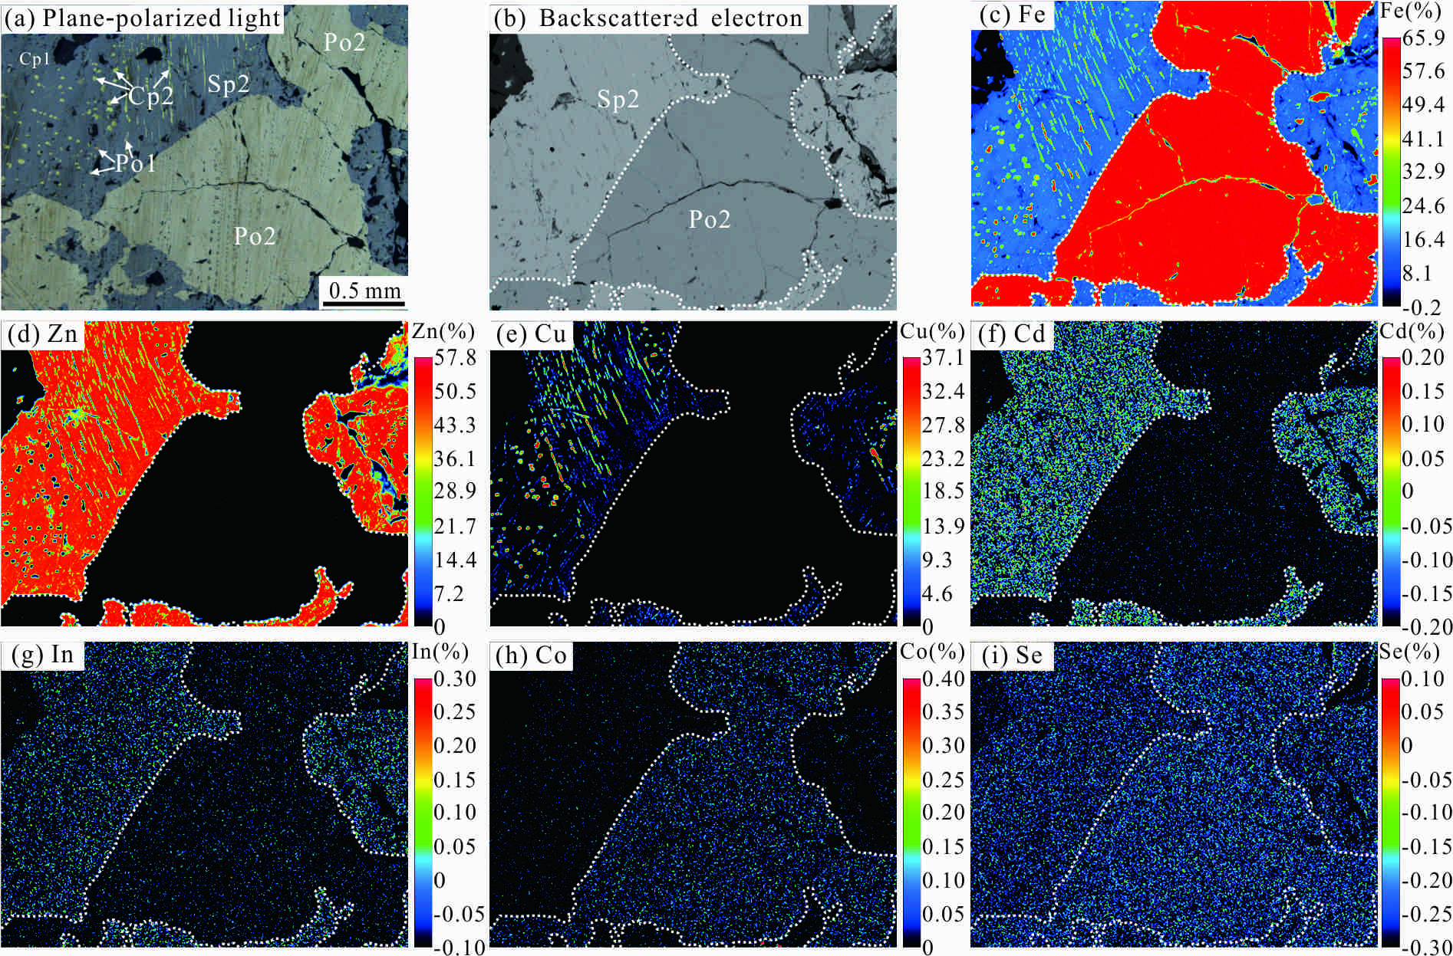
Fig.S3 EPMA element distribution maps of the sample 20DL-10-Q1
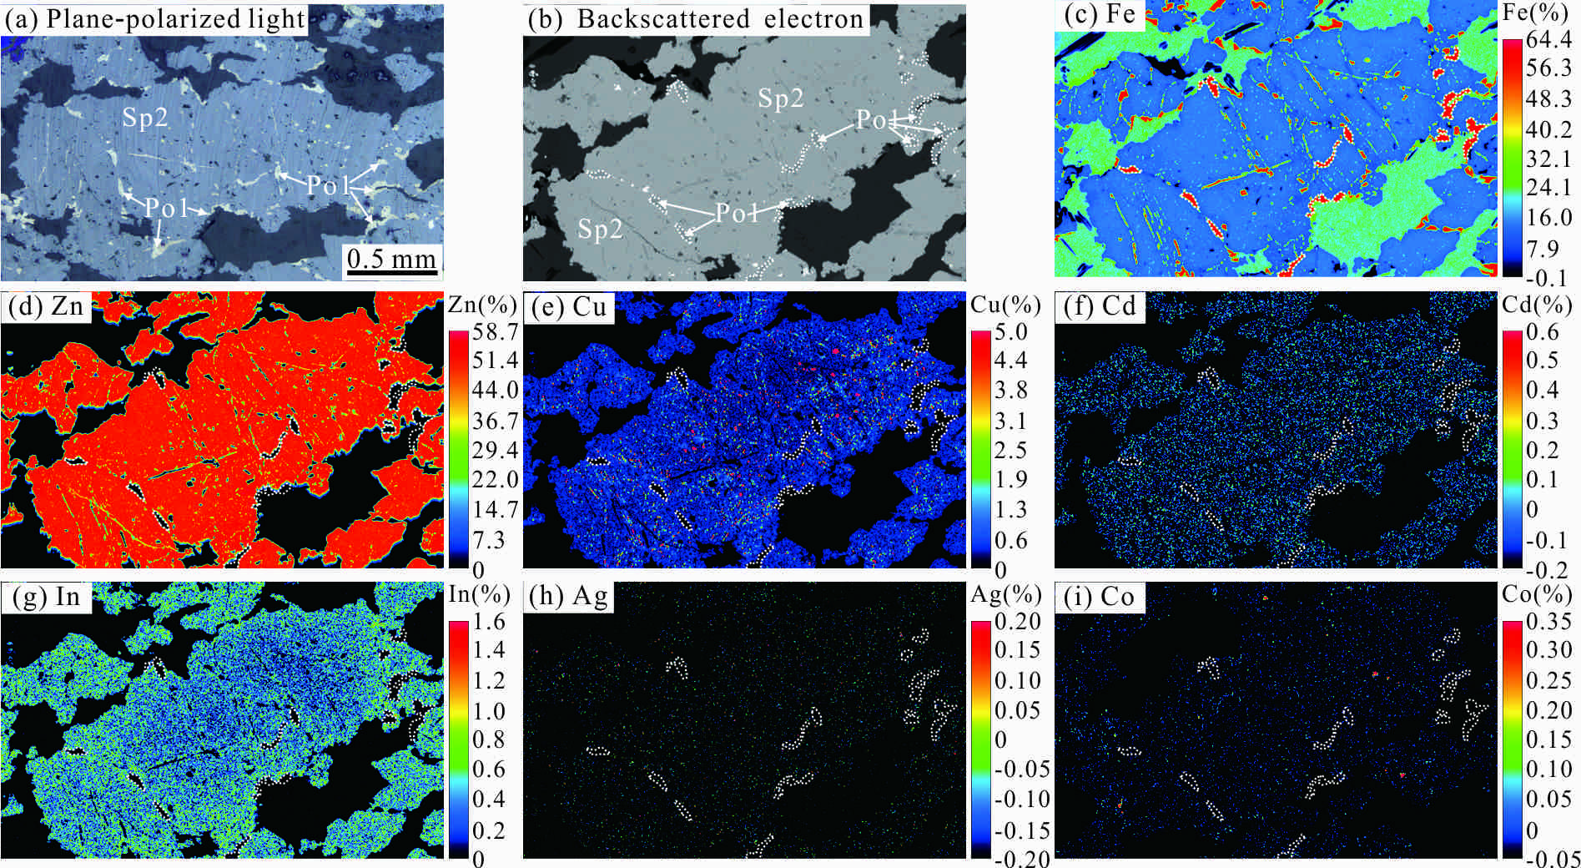
Fig.S4 EPMA element distribution maps of the sample 20DL-24-Q2
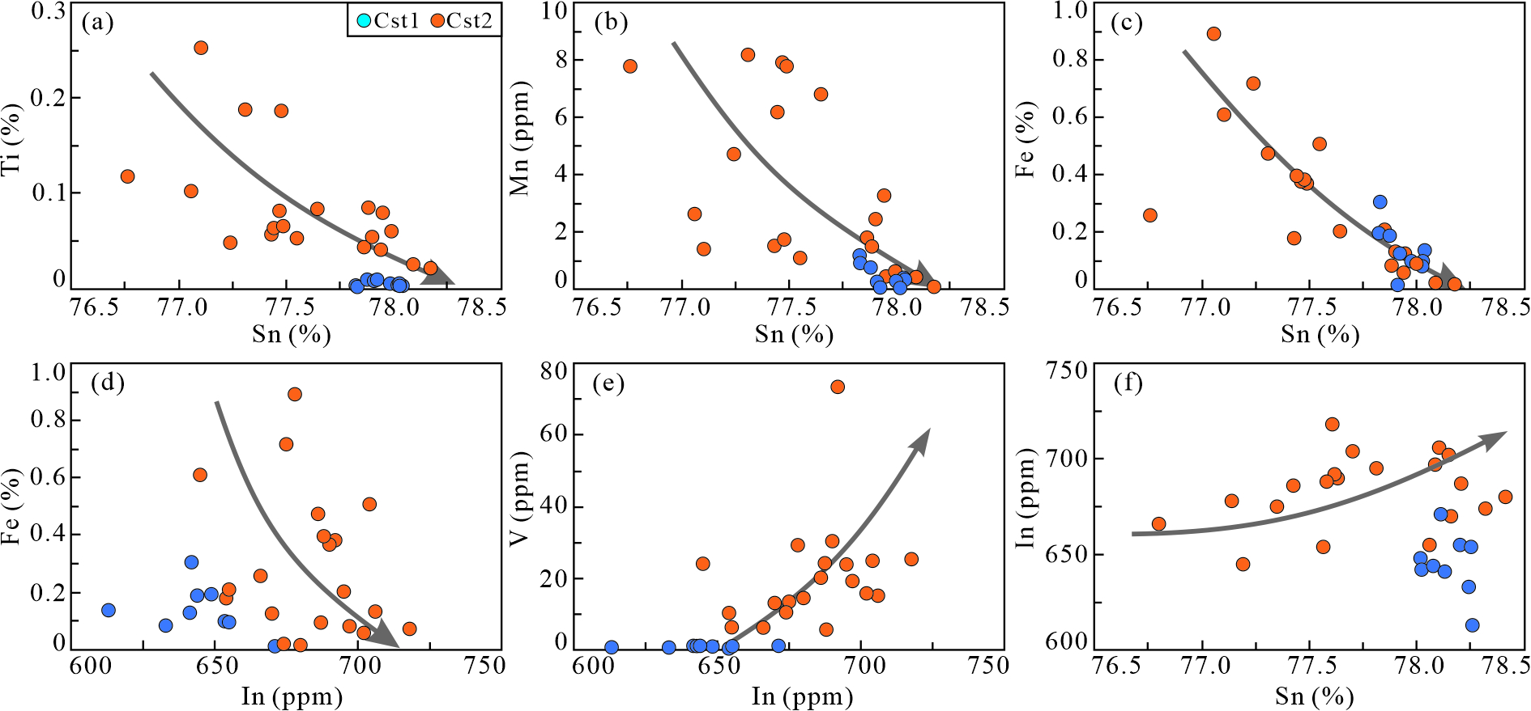
Fig.S5 Binary diagram of the metallogenic elements of cassiterite in the Dulong Sn-Zn-In deposit
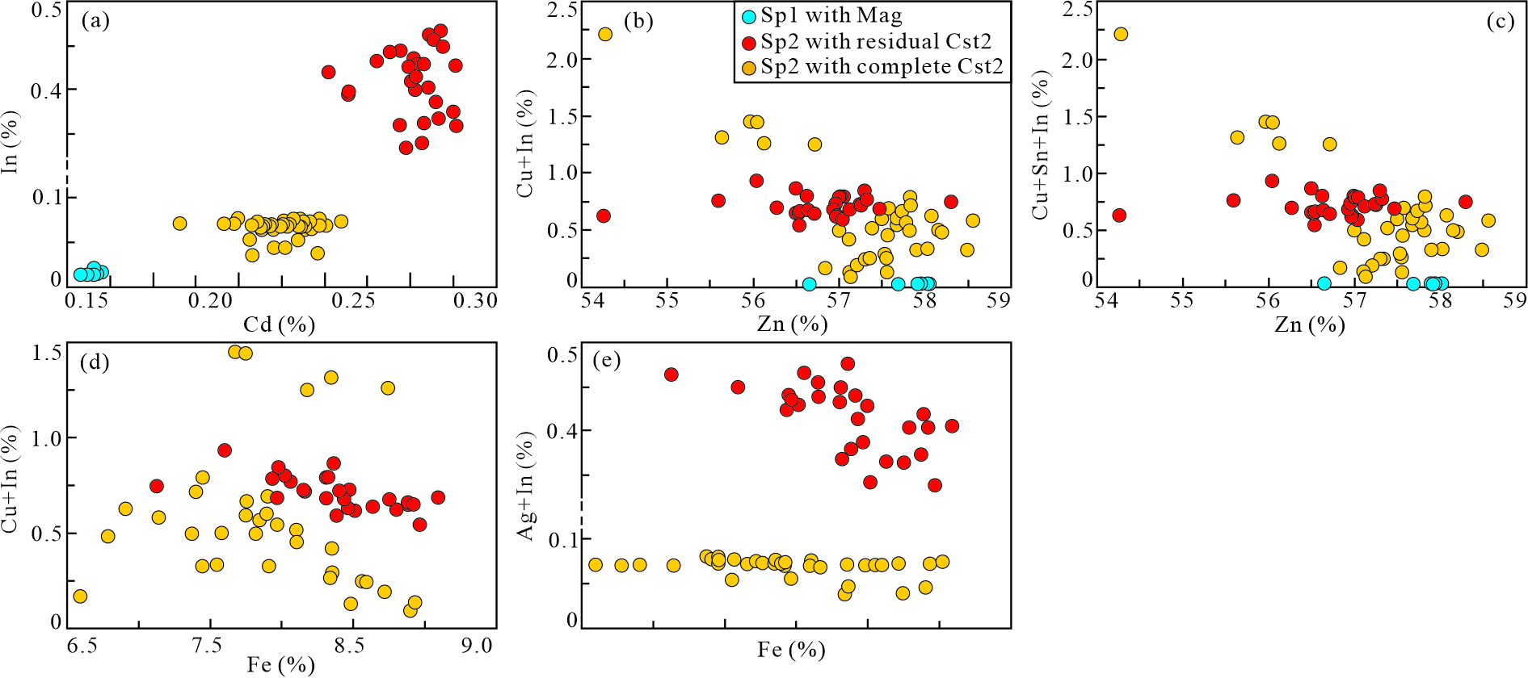
Fig.S6 Binary diagram of the metallogenic elements of sphalerite in the Dulong Sn-Zn-In deposit
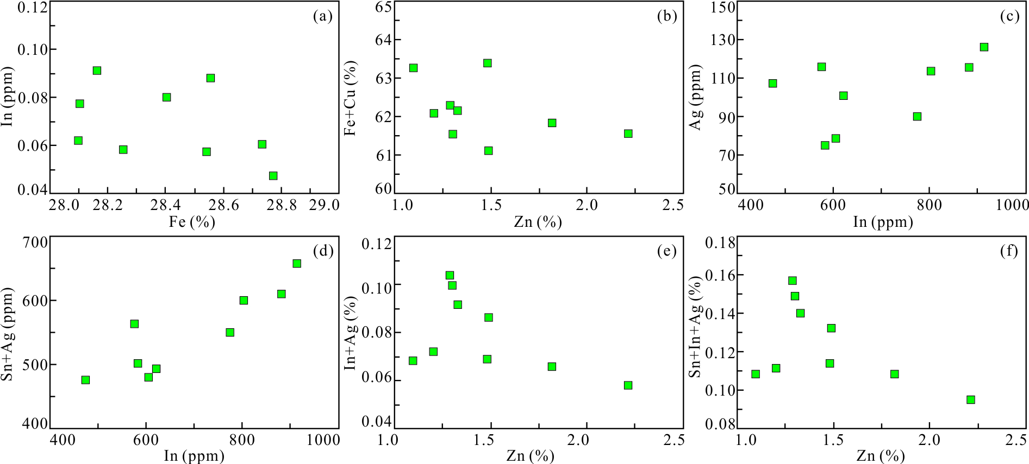
Fig.S7 Binary diagram of the metallogenic elements of chalcopyrite in the Dulong Sn-Zn-In deposit

Supplementary Tables
Tables S1 EPMA data of oxides in the Dulong Sn-Zn-In deposit
Analytical spot | Mineral | TiO2 | SnO2 | SiO2 | FeO | MnO | Cr2O3 | HfO2 | MgO | In2O3 | Ta2O5 | CoO | PbO | P₂O₅ | Total
20DL-1-Q1-09 | Mag1 | 0.063 | 0.133 | <d.l. | 91.459 | 0.038 | <d.l. | * | 0.515 | <d.l. | * | 0.124 | 0.053 | 0.040 | 92.425
20DL-1-Q1-10 | Mag1 | 0.045 | 0.097 | <d.l. | 91.605 | <d.l. | 0.044 | * | 0.340 | <d.l. | * | 0.148 | 0.053 | 0.031 | 92.363
20DL-8-Q1-12 | Mag1 | <d.l. | 0.108 | <d.l. | 92.049 | 0.045 | <d.l. | * | 0.547 | <d.l. | * | 0.116 | <d.l. | <d.l. | 92.906
20DL-8-Q1-13 | Mag2 | 0.047 | 0.173 | <d.l. | 91.544 | <d.l. | <d.l. | * | 0.384 | <d.l. | * | 0.138 | <d.l. | <d.l. | 92.286
20DL-8-Q2-37 | Mag1 | <d.l. | 0.052 | <d.l. | 92.081 | 0.073 | <d.l. | * | 0.347 | <d.l. | * | 0.163 | <d.l. | <d.l. | 92.716
20DL-8-Q2-38 | Mag2 | <d.l. | 0.051 | 2.081 | 89.275 | 0.103 | <d.l. | * | 0.852 | <d.l. | * | 0.116 | 0.034 | <d.l. | 92.512
20DL-8-Q2-33 | Cst1 | <d.l. | 99.482 | <d.l. | 0.120 | <d.l. | <d.l. | <d.l. | <d.l. | <d.l. | 0.088 | * | * | * | 99.765
20DL-8-Q2-34 | Cst1 | <d.l. | 99.344 | <d.l. | 0.103 | <d.l. | <d.l. | <d.l. | <d.l. | <d.l. | 0.106 | * | * | * | 99.697
20DL-18-Q1-18 | Cst2 | 0.137 | 99.254 | <d.l. | 0.088 | <d.l. | 0.068 | <d.l. | 0.044 | <d.l. | 0.159 | * | * | * | 99.750
20DL-18-Q1-19 | Cst2 | <d.l. | 99.321 | <d.l. | 0.072 | 0.078 | 0.295 | 0.365 | 0.026 | <d.l. | 0.212 | * | * | * | 100.369
20DL-18-Q1-20 | Cst2 | <d.l. | 99.303 | 0.068 | 0.318 | <d.l. | 0.188 | 0.270 | 0.031 | <d.l. | 0.104 | * | * | * | 100.370
20DL-18-Q3-17 | Cst2 | <d.l. | 99.392 | <d.l. | 0.256 | <d.l. | 0.205 | 0.238 | 0.042 | <d.l. | 0.115 | * | * | * | 100.351
20DL-18-Q3-18 | Cst2 | <d.l. | 99.414 | <d.l. | 0.905 | <d.l. | 0.117 | <d.l. | <d.l. | <d.l. | 0.099 | * | * | * | 100.535
20DL-18-Q4-21 | Cst2 | <d.l. | 99.288 | 0.072 | 0.578 | <d.l. | 0.218 | <d.l. | <d.l. | <d.l. | 0.154 | * | * | * | 100.310
20DL-18-Q4-22 | Cst2 | <d.l. | 99.275 | <d.l. | 0.613 | 0.037 | <d.l. | <d.l. | 0.033 | <d.l. | 0.203 | * | * | * | 100.225
Note: The element content in this table is %. The symbols of * and <d.l. indicates that the element is not measured and its content is below the detection limit, respectively. The detection limit of every oxide is listed below: TiO₂ 0.043%, SnO₂ 0.047%, SiO₂ 0.062%, FeO 0.032%, MnO 0.029%, Cr₂O₃ 0.031%, HfO₂ 0.154%, MgO 0.020%, In₂O₃ 0.033%, ZrO₂ 0.057%, Ta₂O₅ 0.075 %, CoO 0.029%, PbO 0.027%, P₂O₅ 0.030%.

Table S2 EPMA data of sulfides in the Dulong Sn-Zn-In deposit
Analytical spot | Mineral | Sb | Sn | In | Cd | Ag | As | Se | Zn | Cu | Ni | Co | Fe | Mn | Pb | S | Au | Total
20DL-1-Q2-01 | Po2 | 0.021 | 0.026 | <d.l. | <d.l. | <d.l. | 0.022 | <d.l. | <d.l. | <d.l. | <d.l. | 0.086 | 59.512 | <d.l. | <d.l. | 39.433 | 0.044 | 99.144
20DL-1-Q2-02 | Po2 | 0.021 | <d.l. | <d.l. | <d.l. | 0.016 | <d.l. | <d.l. | 0.037 | <d.l. | 0.038 | 0.069 | 59.999 | <d.l. | <d.l. | 39.594 | <d.l. | 99.774
20DL-1-Q2-03 | Po2 | 0.024 | 0.015 | 0.010 | <d.l. | <d.l. | <d.l. | 0.032 | 0.365 | <d.l. | <d.l. | 0.106 | 59.846 | <d.l. | 0.041 | 39.693 | 0.053 | 100.185
20DL-1-Q2-04 | Po2 | <d.l. | <d.l. | <d.l. | 0.011 | <d.l. | <d.l. | <d.l. | 0.247 | <d.l. | <d.l. | 0.087 | 58.797 | <d.l. | 0.015 | 38.070 | 0.044 | 97.271
20DL-1-Q2-05 | Po2 | <d.l. | <d.l. | <d.l. | <d.l. | <d.l. | <d.l. | <d.l. | 0.065 | <d.l. | 0.017 | 0.090 | 59.013 | <d.l. | 0.025 | 38.087 | <d.l. | 97.297
20DL-10-Q1-03 | Po2 | 0.016 | 0.019 | 0.039 | <d.l. | <d.l. | <d.l. | 0.026 | 0.148 | <d.l. | <d.l. | 0.086 | 60.557 | <d.l. | 0.072 | 38.869 | <d.l. | 99.832
20DL-10-Q1-04 | Po2 | <d.l. | <d.l. | 0.042 | <d.l. | <d.l. | <d.l. | 0.018 | <d.l. | <d.l. | <d.l. | 0.087 | 60.401 | <d.l. | 0.019 | 38.870 | <d.l. | 99.437
20DL-10-Q1-05 | Po2 | <d.l. | 0.047 | <d.l. | 0.040 | <d.l. | 0.018 | <d.l. | 0.010 | <d.l. | 0.014 | 0.119 | 60.596 | <d.l. | <d.l. | 38.834 | <d.l. | 99.678
20DL-10-Q1-06 | Po2 | 0.021 | <d.l. | <d.l. | <d.l. | <d.l. | <d.l. | <d.l. | <d.l. | <d.l. | <d.l. | 0.118 | 60.164 | <d.l. | <d.l. | 38.784 | 0.049 | 99.136
20DL-10-Q1-07 | Po2 | 0.034 | <d.l. | <d.l. | 0.047 | 0.010 | <d.l. | 0.040 | <d.l. | <d.l. | <d.l. | 0.097 | 60.455 | <d.l. | <d.l. | 38.845 | <d.l. | 99.528
20DL-10-Q1-08 | Po2 | 0.036 | 0.016 | 0.011 | <d.l. | <d.l. | <d.l. | <d.l. | 0.067 | 0.006 | 0.015 | 0.107 | 60.132 | <d.l. | 0.068 | 39.028 | <d.l. | 99.486
20DL-10-Q1-15 | Po2 | <d.l. | 0.023 | <d.l. | 0.023 | <d.l. | 0.035 | <d.l. | <d.l. | <d.l. | <d.l. | 0.103 | 60.827 | <d.l. | 0.012 | 38.866 | <d.l. | 99.889
20DL-10-Q1-17 | Po2 | <d.l. | 0.050 | 0.037 | 0.051 | <d.l. | <d.l. | 0.039 | <d.l. | 0.007 | <d.l. | 0.078 | 60.700 | <d.l. | 0.076 | 38.923 | 0.021 | 99.982
20DL-10-Q1-18 | Po2 | <d.l. | 0.023 | 0.006 | <d.l. | <d.l. | <d.l. | <d.l. | <d.l. | 0.013 | <d.l. | 0.106 | 60.836 | <d.l. | 0.076 | 38.834 | <d.l. | 99.894
20DL-18-Q1-01 | Po2 | 0.029 | 0.061 | <d.l. | <d.l. | <d.l. | <d.l. | 0.043 | 0.537 | 0.070 | 0.031 | 0.110 | 60.212 | <d.l. | <d.l. | 38.982 | 0.025 | 100.100
20DL-18-Q1-08 | Po2 | 0.063 | <d.l. | <d.l. | <d.l. | <d.l. | <d.l. | 0.027 | 0.182 | <d.l. | <d.l. | 0.103 | 60.547 | <d.l. | <d.l. | 38.578 | <d.l. | 99.500
20DL-18-Q1-09 | Po2 | <d.l. | 0.029 | <d.l. | <d.l. | 0.050 | <d.l. | <d.l. | 0.027 | <d.l. | <d.l. | 0.091 | 60.894 | <d.l. | 0.038 | 38.661 | <d.l. | 99.790
20DL-18-Q1-10 | Po2 | <d.l. | 0.016 | <d.l. | 0.044 | 0.043 | <d.l. | 0.030 | <d.l. | <d.l. | <d.l. | 0.103 | 60.819 | <d.l. | 0.021 | 38.804 | <d.l. | 99.880
20DL-18-Q1-11 | Po2 | <d.l. | <d.l. | <d.l. | 0.033 | <d.l. | <d.l. | <d.l. | <d.l. | <d.l. | <d.l. | 0.120 | 60.565 | <d.l. | 0.040 | 38.848 | <d.l. | 99.606
20DL-18-Q1-12 | Po2 | <d.l. | 0.065 | <d.l. | <d.l. | 0.011 | <d.l. | <d.l. | <d.l. | <d.l. | 0.010 | 0.099 | 60.782 | <d.l. | <d.l. | 38.771 | 0.042 | 99.780
20DL-18-Q1-13 | Po2 | <d.l. | <d.l. | <d.l. | <d.l. | 0.010 | <d.l. | 0.051 | 0.235 | <d.l. | 0.022 | 0.086 | 60.601 | <d.l. | <d.l. | 39.107 | 0.074 | 100.186
20DL-18-Q1-23 | Po2 | 0.036 | 0.047 | <d.l. | <d.l. | <d.l. | 0.036 | 0.022 | <d.l. | <d.l. | <d.l. | 0.079 | 60.743 | <d.l. | <d.l. | 38.724 | 0.051 | 99.738
20DL-18-Q1-24 | Po2 | 0.019 | 0.015 | <d.l. | <d.l. | <d.l. | 0.029 | <d.l. | 0.586 | 0.046 | <d.l. | 0.110 | 60.615 | <d.l. | 0.015 | 38.775 | 0.022 | 100.232
20DL-18-Q2-02 | Po1 | <d.l. | <d.l. | 0.013 | <d.l. | 0.023 | <d.l. | 0.052 | 1.676 | <d.l. | 0.011 | 0.084 | 59.777 | <d.l. | <d.l. | 39.062 | <d.l. | 100.698
20DL-18-Q2-03 | Po1 | <d.l. | <d.l. | <d.l. | <d.l. | <d.l. | <d.l. | <d.l. | 0.378 | <d.l. | 0.009 | 0.117 | 60.605 | <d.l. | 0.025 | 38.830 | 0.017 | 99.9810
20DL-18-Q2-04 | Po1 | <d.l. | <d.l. | <d.l. | 0.030 | <d.l. | <d.l. | <d.l. | 0.623 | <d.l. | <d.l. | 0.088 | 60.395 | <d.l. | <d.l. | 39.166 | <d.l. | 100.302
20DL-18-Q2-09 | Po1 | 0.018 | <d.l. | 0.009 | <d.l. | <d.l. | 0.035 | <d.l. | 0.451 | 0.012 | 0.013 | 0.098 | 60.475 | <d.l. | <d.l. | 38.886 | 0.024 | 100.021
20DL-18-Q2-10 | Po1 | 0.071 | <d.l. | 0.008 | 0.011 | <d.l. | <d.l. | <d.l. | 0.928 | 0.044 | <d.l. | 0.099 | 59.964 | <d.l. | 0.015 | 39.124 | 0.047 | 100.311
20DL-18-Q2-19 | Po1 | <d.l. | 0.044 | 0.005 | 0.022 | <d.l. | 0.053 | <d.l. | 0.595 | <d.l. | <d.l. | 0.099 | 61.042 | <d.l. | <d.l. | 38.996 | <d.l. | 100.856
20DL-18-Q3-04 | Po1 | <d.l. | 0.023 | <d.l. | 0.013 | 0.019 | <d.l. | 0.037 | 0.780 | 0.017 | <d.l. | 0.081 | 60.001 | <d.l. | <d.l. | 38.729 | 0.057 | 99.757
20DL-18-Q3-05 | Po1 | <d.l. | <d.l. | <d.l. | 0.027 | 0.013 | <d.l. | <d.l. | 0.388 | <d.l. | <d.l. | 0.082 | 60.535 | <d.l. | <d.l. | 38.614 | <d.l. | 99.659
20DL-18-Q3-14 | Po1 | <d.l. | <d.l. | <d.l. | 0.013 | <d.l. | 0.017 | <d.l. | 0.216 | 0.096 | <d.l. | 0.101 | 60.459 | <d.l. | <d.l. | 38.602 | 0.022 | 99.526
20DL-22-Q1-12 | Po2 | 0.025 | <d.l. | <d.l. | <d.l. | <d.l. | 0.021 | <d.l. | 0.008 | <d.l. | <d.l. | 0.103 | 60.553 | <d.l. | <d.l. | 38.993 | <d.l. | 99.703
20DL-22-Q1-13 | Po2 | <d.l. | <d.l. | 0.009 | <d.l. | <d.l. | <d.l. | <d.l. | <d.l. | 0.026 | <d.l. | 0.090 | 60.908 | <d.l. | 0.041 | 38.918 | 0.051 | 100.043
20DL-22-Q1-14 | Po2 | <d.l. | <d.l. | 0.013 | 0.056 | 0.039 | <d.l. | <d.l. | <d.l. | 0.078 | <d.l. | 0.091 | 60.303 | <d.l. | 0.015 | 39.050 | 0.045 | 99.690
20DL-22-Q1-15 | Po2 | <d.l. | 0.022 | 0.046 | <d.l. | <d.l. | <d.l. | <d.l. | 0.012 | 0.297 | <d.l. | 0.101 | 60.222 | <d.l. | <d.l. | 38.656 | 0.023 | 99.379
20DL-24-Q1-03 | Po1 | <d.l. | 0.021 | 0.012 | 0.028 | <d.l. | <d.l. | 0.044 | 0.555 | 0.011 | <d.l. | 0.087 | 59.807 | <d.l. | <d.l. | 38.660 | 0.025 | 99.250
20DL-24-Q1-07 | Po1 | <d.l. | <d.l. | <d.l. | <d.l. | 0.021 | 0.033 | <d.l. | 0.025 | <d.l. | <d.l. | 0.079 | 60.287 | <d.l. | 0.012 | 39.040 | 0.025 | 99.522
20DL-24-Q1-09 | Po1 | <d.l. | 0.018 | 0.023 | 0.030 | <d.l. | <d.l. | 0.036 | <d.l. | <d.l. | <d.l. | 0.104 | 60.412 | <d.l. | 0.080 | 39.324 | <d.l. | 100.027
20DL-24-Q2-06 | Po1 | 0.035 | 0.021 | 0.053 | <d.l. | <d.l. | <d.l. | <d.l. | 0.510 | 0.024 | <d.l. | 0.084 | 60.130 | <d.l. | 0.010 | 39.027 | <d.l. | 99.894
20DL-24-Q2-18 | Po1 | <d.l. | <d.l. | <d.l. | 0.017 | <d.l. | 0.034 | <d.l. | 0.469 | <d.l. | <d.l. | 0.099 | 60.104 | <d.l. | 0.051 | 39.018 | 0.022 | 99.814
20DL-24-Q2-19 | Po1 | <d.l. | <d.l. | 0.020 | <d.l. | 0.017 | <d.l. | <d.l. | 0.295 | <d.l. | <d.l. | 0.087 | 59.899 | <d.l. | <d.l. | 38.737 | <d.l. | 99.055
20DL-22-Q1-01 | Apy | <d.l. | <d.l. | <d.l. | <d.l. | 0.016 | 45.134 | 0.191 | <d.l. | <d.l. | 0.011 | 0.093 | 34.863 | 0.019 | 0.042 | 19.428 | <d.l. | 99.797
20DL-22-Q1-02 | Apy | 0.021 | 0.037 | 0.043 | <d.l. | 0.039 | 45.177 | 0.099 | <d.l. | <d.l. | 0.018 | 0.096 | 35.094 | 0.010 | <d.l. | 19.509 | <d.l. | 100.143
20DL-22-Q1-03 | Apy | <d.l. | <d.l. | 0.021 | 0.026 | <d.l. | 45.142 | 0.203 | <d.l. | <d.l. | 0.022 | 0.141 | 34.962 | <d.l. | 0.031 | 19.454 | <d.l. | 100.002
20DL-22-Q1-04 | Apy | <d.l. | <d.l. | 0.009 | <d.l. | 0.025 | 45.051 | 0.155 | <d.l. | <d.l. | <d.l. | 0.109 | 34.898 | 0.010 | 0.012 | 19.127 | <d.l. | 99.396
20DL-22-Q1-05 | Apy | <d.l. | <d.l. | <d.l. | <d.l. | <d.l. | 45.075 | 0.144 | <d.l. | <d.l. | 0.012 | 0.083 | 34.965 | 0.012 | <d.l. | 19.477 | <d.l. | 99.768
20DL-22-Q1-06 | Apy | <d.l. | <d.l. | <d.l. | <d.l. | 0.037 | 44.922 | 0.242 | <d.l. | <d.l. | <d.l. | 0.082 | 34.807 | 0.022 | 0.034 | 19.117 | <d.l. | 99.263
20DL-22-Q1-07 | Apy | 0.020 | <d.l. | <d.l. | <d.l. | <d.l. | 45.023 | 0.112 | <d.l. | <d.l. | 0.030 | 0.137 | 34.373 | 0.024 | 0.048 | 19.352 | 0.122 | 99.241
20DL-22-Q1-08 | Apy | <d.l. | <d.l. | 0.089 | <d.l. | 0.015 | 45.138 | 0.124 | <d.l. | <d.l. | <d.l. | 0.101 | 35.493 | <d.l. | 0.020 | 19.655 | <d.l. | 100.635
20DL-22-Q1-09 | Apy | <d.l. | <d.l. | 0.024 | <d.l. | 0.022 | 45.537 | 0.131 | <d.l. | <d.l. | <d.l. | 0.214 | 34.873 | 0.016 | <d.l. | 19.460 | 0.023 | 100.300
20DL-22-Q1-10 | Apy | 0.063 | 0.057 | <d.l. | <d.l. | 0.047 | 44.988 | 0.230 | <d.l. | <d.l. | 0.014 | 0.203 | 34.819 | 0.041 | 0.019 | 19.322 | <d.l. | 99.803
20DL-22-Q1-11 | Apy | 0.034 | <d.l. | 0.018 | <d.l. | <d.l. | 45.196 | 0.162 | 0.024 | 0.036 | <d.l. | 0.204 | 34.967 | <d.l. | <d.l. | 19.129 | 0.034 | 99.804
20DL-24-Q1-06 | Apy | <d.l. | <d.l. | 0.024 | <d.l. | 0.015 | 44.618 | 0.164 | 0.028 | <d.l. | 0.022 | 0.201 | 35.082 | 0.038 | 0.043 | 19.533 | <d.l. | 99.768
20DL-24-Q1-08 | Apy | <d.l. | 0.020 | 0.010 | <d.l. | <d.l. | 44.851 | 0.187 | <d.l. | <d.l. | <d.l. | 0.415 | 35.001 | 0.013 | <d.l. | 19.623 | <d.l. | 100.120
20DL-24-Q1-10 | Apy | <d.l. | <d.l. | 0.009 | 0.011 | 0.027 | 44.933 | 0.163 | <d.l. | 0.009 | 0.018 | 0.594 | 34.373 | 0.015 | 0.042 | 19.513 | <d.l. | 99.707
20DL-24-Q1-11 | Apy | 0.021 | <d.l. | 0.014. | <d.l. | <d.l. | 44.787 | 0.176 | 0.042 | 0.011 | 0.025 | 0.377 | 34.517 | 0.027 | <d.l. | 19.336 | <d.l. | 99.319
20DL-24-Q1-12 | Apy | <d.l. | 0.015 | <d.l. | <d.l. | 0.019 | 44.516 | 0.204 | <d.l. | <d.l. | <d.l. | 0.585 | 34.557 | 0.016 | 0.060 | 19.502 | 0.024 | 99.498
20DL-24-Q1-13 | Apy | 0.026 | <d.l. | <d.l. | 0.014 | <d.l. | 44.734 | 0.238 | 0.129 | <d.l. | <d.l. | 0.439 | 34.701 | 0.010 | 0.027 | 19.452 | <d.l. | 99.770
20DL-24-Q1-17 | Apy | <d.l. | <d.l. | 0.054 | <d.l. | <d.l. | 44.072 | 0.221 | 0.044 | <d.l. | <d.l. | 0.341 | 34.752 | 0.025 | 0.029 | 19.699 | 0.023 | 99.260
20DL-24-Q1-18 | Apy | 0.016 | <d.l. | <d.l. | 0.014 | <d.l. | 44.158 | 0.189 | <d.l. | <d.l. | 0.013 | 0.143 | 34.932 | 0.029 | <d.l. | 19.460 | <d.l. | 98.954
20DL-24-Q1-19 | Apy | 0.026 | <d.l. | <d.l. | 0.027 | <d.l. | 45.221 | 0.113 | <d.l. | 0.014 | <d.l. | 0.412 | 35.022 | 0.018 | 0.047 | 19.564 | 0.040 | 100.504
20DL-24-Q1-20 | Apy | <d.l. | 0.019 | <d.l. | <d.l. | <d.l. | 43.717 | 0.208 | <d.l. | <d.l. | <d.l. | 0.422 | 34.538 | 0.024 | <d.l. | 19.747 | <d.l. | 98.675
20DL-24-Q1-21 | Apy | <d.l. | <d.l. | <d.l. | <d.l. | <d.l. | 44.282 | 0.168 | <d.l. | 0.006 | <d.l. | 0.462 | 34.883 | 0.039 | 0.045 | 19.222 | 0.090 | 99.197
20DL-24-Q1-22 | Apy | <d.l. | <d.l. | <d.l. | 0.010 | <d.l. | 43.478 | 0.191 | <d.l. | <d.l. | <d.l. | 0.618 | 34.834 | 0.048 | <d.l. | 19.678 | <d.l. | 98.857
20DL-24-Q1-23 | Apy | 0.062 | <d.l. | 0.044 | <d.l. | <d.l. | 44.759 | 0.247 | <d.l. | 0.005 | <d.l. | 0.429 | 35.087 | 0.020 | 0.023 | 19.442 | 0.071 | 100.189
20DL-8-Q2-35 | Sp1 | <d.l. | <d.l. | <d.l. | 0.085 | <d.l. | <d.l. | 0.033 | 53.794 | <d.l. | <d.l. | 0.014 | 12.108 | 0.027 | 0.026 | 33.366 | <d.l. | 99.343
20DL-8-Q2-36 | Sp1 | <d.l. | <d.l. | <d.l. | 0.078 | <d.l. | <d.l. | <d.l. | 53.818 | <d.l. | <d.l. | <d.l. | 12.255 | 0.021 | 0.021 | 33.408 | <d.l. | 99.098
20DL-8-Q2-39 | Sp2 | <d.l. | 0.035 | 0.135 | 0.108 | <d.l. | <d.l. | 0.041 | 53.216 | 0.064 | <d.l. | 0.029 | 12.539 | 0.154 | <d.l. | 33.356 | <d.l. | 99.677
20DL-10-Q1-14 | Sp2 | 0.023 | <d.l. | 0.055 | 0.120 | <d.l. | <d.l. | <d.l. | 52.697 | 0.054 | <d.l. | 0.024 | 12.922 | 0.143 | <d.l. | 33.539 | <d.l. | 99.577
20DL-10-Q1-16 | Sp2 | <d.l. | <d.l. | 0.131 | 0.153 | <d.l. | 0.023 | <d.l. | 53.648 | 0.027 | <d.l. | 0.014 | 11.511 | 0.094 | <d.l. | 33.248 | 0.058 | 98.907
20DL-18-Q1-21 | Sp2 | <d.l. | 0.047 | 0.147 | 0.181 | <d.l. | <d.l. | <d.l. | 52.851 | 0.066 | <d.l. | 0.011 | 12.737 | 0.170 | <d.l. | 33.796 | <d.l. | 100.006
20DL-18-Q1-22 | Sp2 | 0.031 | <d.l. | 0.061 | 0.142 | <d.l. | <d.l. | <d.l. | 52.732 | 0.114 | <d.l. | 0.021 | 12.571 | 0.158 | <d.l. | 33.595 | 0.050 | 99.475
20DL-18-Q2-11 | Sp2 | 0.026 | <d.l. | 0.029 | 0.108 | <d.l. | <d.l. | <d.l. | 55.371 | 0.120 | <d.l. | 0.017 | 10.291 | 0.124 | <d.l. | 33.619 | <d.l. | 99.705
20DL-18-Q3-16 | Sp2 | <d.l. | <d.l. | 0.145 | 0.120 | <d.l. | <d.l. | 0.036 | 53.192 | 0.045 | <d.l. | 0.026 | 12.425 | 0.168 | <d.l. | 33.305 | <d.l. | 99.462
20DL-24-Q1-24 | Sp2 | <d.l. | <d.l. | 0.601 | 0.109 | <d.l. | <d.l. | 0.060 | 52.446 | 0.317 | 0.009 | 0.035 | 13.047 | 0.085 | <d.l. | 33.610 | <d.l. | 100.319
20DL-10-Q1-12 | Cp2 | <d.l. | <d.l. | 0.083 | <d.l. | 0.011 | <d.l. | 0.043 | 1.198 | 33.309 | 0.009 | 0.027 | 30.233 | <d.l. | 0.074 | 34.805 | <d.l. | 99.792
20DL-18-Q1-02 | Cp2 | <d.l. | <d.l. | 0.076 | 0.021 | 0.018 | 0.024 | <d.l. | 1.962 | 33.101 | <d.l. | 0.048 | 29.813 | <d.l. | <d.l. | 35.226 | 0.022 | 100.311
20DL-18-Q1-06 | Cp2 | <d.l. | <d.l. | 0.074 | <d.l. | 0.025 | <d.l. | <d.l. | 1.034 | 33.329 | <d.l. | 0.038 | 30.223 | <d.l. | <d.l. | 34.668 | 0.039 | 99.430
20DL-18-Q2-18 | Cp2 | <d.l. | <d.l. | 0.082 | <d.l. | <d.l. | <d.l. | <d.l. | 1.422 | 33.483 | 0.008 | 0.046 | 29.841 | <d.l. | <d.l. | 34.682 | <d.l. | 99.564
20DL-18-Q3-15 | Cp2 | <d.l. | <d.l. | 0.073 | <d.l. | <d.l. | <d.l. | <d.l. | 1.095 | 33.430 | <d.l. | 0.053 | 30.064 | <d.l. | 0.018 | 34.612 | <d.l. | 99.345
20DL-22-Q1-16 | Cp3 | <d.l. | 0.038 | 0.061 | <d.l. | 0.055 | <d.l. | <d.l. | 0.056 | 33.892 | 0.021 | 0.046 | 30.703 | <d.l. | 0.012 | 34.974 | 0.044 | 99.902
20DL-22-Q1-17 | Cp3 | <d.l. | 0.029 | 0.053 | <d.l. | 0.061 | <d.l. | <d.l. | 0.177 | 33.804 | 0.008 | 0.039 | 30.616 | <d.l. | <d.l. | 34.968 | 0.050 | 99.805
Note: The element content in the table is %. The symbol of <d.l. indicates that the element content is below the detection limit, and the detection limit is listed below: Sb 0.016%, Sn 0.014%, In 0.005%, Cd 0.010%, Ag 0.010%, As 0.016%, Se 0.018%, Zn 0.010%, Cu 0.005%, Ni 0.008 %, Co 0.010%, Fe 0.010%, Mn 0.010%, Pb 0.014%, S 0.006%, and Au 0.016%.

Tables S3 In-situ LA-ICP-MS data of oxides in the Dulong Sn-Zn-In deposit
Analytical spot | Mineral | Fe | Mg | Sn | Si | Mn | Ti | Sc | V | Cr | Co | Ni | Cu | Zn | Ga | Ge | As | Zr | In | W | Pb
20DL-1-Q1-01 | Mag1 | 697541 | 4340 | 12020 | 3302 | 98.0 | 529 | <d.l. | 20.5 | 163 | 0.28 | 4.52 | 0.94 | 15.8 | 16.1 | 18.3 | 18.7 | 22.6 | 11.9 | 27.9 | 1.58
20DL-1-Q1-02 | Mag1 | 673248 | 13735 | 4499 | 16280 | 395 | 271 | 0.39 | 7.75 | 208 | 0.22 | 3.75 | <d.l. | 109 | 17.2 | 13.7 | 5.70 | 2.21 | 4.50 | 7.73 | 1.28
20DL-1-Q1-03 | Mag1 | 677094 | 14641 | 3672 | 12532 | 573 | 473 | 0.35 | 8.98 | 253 | 0.29 | 3.47 | 0.72 | 285 | 26.2 | 16.1 | 4.97 | 2.51 | 5.32 | 2.08 | 0.86
20DL-1-Q1-04 | Mag1 | 698708 | 5813 | 7032 | 3236 | 866 | 967 | <d.l. | 10.3 | 209 | 0.39 | 4.94 | <d.l. | 297 | 23.3 | 8.72 | <d.l. | 1.68 | 6.69 | 2.97 | 0.30
20DL-1-Q1-05 | Mag1 | 696241 | 7833 | 2211 | 4737 | 289 | 203 | 0.43 | 10.6 | 3524 | <d.l. | 5.48 | 1.02 | 113 | 22.6 | 21.9 | 11.1 | 4.46 | 2.98 | 7.65 | 1.60
20DL-1-Q1-06 | Mag1 | 668061 | 8856 | 22770 | 8074 | 774 | 886 | 0.67 | 22.8 | 1519 | 0.95 | 8.60 | 0.94 | 38.0 | 15.6 | 25.6 | 35.0 | 84.3 | 11.7 | 73.7 | 9.50
20DL-1-Q1-07 | Mag1 | 708748 | 4793 | 1495 | 1917 | 109 | 651 | <d.l. | 23.8 | 691 | 0.22 | <d.l. | <d.l. | 23.2 | 18.0 | 22.9 | 6.87 | 3.31 | 2.08 | 9.44 | 0.70
20DL-1-Q1-08 | Mag1 | 694418 | 9524 | 2107 | 5899 | 103 | 971 | 0.35 | 16.7 | 130 | 0.42 | <d.l. | 1.14 | 30.3 | 23.2 | 34.8 | 27.1 | 5.67 | 2.94 | 47.9 | 1.43
20DL-8-Q1-01 | Mag2 | 711233 | 3931 | 160 | 4091 | 419 | 27.0 | <d.l. | <d.l. | <d.l. | <d.l. | <d.l. | <d.l. | 77.8 | 12.6 | 199 | 3.30 | 0.18 | 0.16 | 3.27 | 0.27
20DL-8-Q1-02 | Mag2 | 692518 | 6410 | 212 | 12949 | 822 | 41.3 | 1.05 | 1.77 | <d.l. | 0.23 | <d.l. | <d.l. | 129 | 42.1 | 1149 | 11.3 | <d.l. | 0.28 | 5.93 | 0.86
20DL-8-Q1-03 | Mag1 | 716419 | 2462 | 611 | 1134 | 601 | 69.4 | <d.l. | 6.36 | 5.15 | <d.l. | <d.l. | <d.l. | 129 | 24.3 | 167 | <d.l. | <d.l. | 0.67 | 0.06 | <d.l.
20DL-8-Q1-04 | Mag1 | 714387 | 2716 | 1838 | 1552 | 613 | 4.97 | <d.l. | 7.71 | <d.l. | <d.l. | 2.67 | <d.l. | 139 | 12.7 | 308 | <d.l. | <d.l. | 1.92 | 0.08 | 0.01
20DL-8-Q1-05 | Mag1 | 713442 | 3037 | 3101 | 1422 | 615 | 9.70 | <d.l. | 11.3 | <d.l. | <d.l. | 3.10 | <d.l. | 154 | 5.43 | 352 | <d.l. | 0.16 | 3.16 | 0.30 | <d.l.
20DL-8-Q1-06 | Mag1 | 712762 | 3287 | 3104 | 1471 | 612 | 232 | <d.l. | 11.9 | 6.26 | <d.l. | <d.l. | <d.l. | 163 | 2.50 | 441 | 3.98 | 0.53 | 3.65 | 0.48 | 0.06
20DL-8-Q1-07 | Mag1 | 711920 | 3074 | 2443 | 1419 | 609 | 311 | 0.33 | 17.5 | 5.11 | 0.20 | 3.94 | <d.l. | 152 | 2.85 | 368 | <d.l. | <d.l. | 2.39 | <d.l. | <d.l.
20DL-8-Q1-08 | Mag1 | 712285 | 2820 | 2581 | 1139 | 607 | 5.25 | <d.l. | 10.8 | 5.54 | 0.22 | <d.l. | <d.l. | 129 | 4.81 | 324 | 4.31 | <d.l. | 2.82 | 0.11 | <d.l.
20DL-8-Q1-09 | Mag1 | 716097 | 2545 | 933 | 1370 | 585 | 18.4 | <d.l. | 3.45 | <d.l. | <d.l. | <d.l. | <d.l. | 123 | 15.4 | 188 | <d.l. | 0.22 | 1.14 | <d.l. | <d.l.
20DL-8-Q1-10 | Mag2 | 698773 | 7455 | 262 | 5999 | 161 | 28.8 | 1.07 | 3.87 | 8.21 | <d.l. | <d.l. | <d.l. | 144 | 32.8 | 1045 | 19.6 | 0.77 | 0.41 | 4.44 | 2.07
20DL-8-Q1-11 | Mag2 | 707647 | 5085 | 109 | 5439 | 499 | 18.6 | <d.l. | 0.13 | <d.l. | <d.l. | <d.l. | <d.l. | 79.6 | 23.1 | 247 | <d.l. | <d.l. | 0.02 | 1.93 | 0.24
20DL-8-Q2-01 | Mag2 | 701526 | 5856 | 345 | 7495 | 127 | 58.0 | 0.43 | 4.82 | 8.25 | <d.l. | <d.l. | 0.75 | 133 | 2.67 | 360 | 6.77 | 0.20 | 0.93 | 5.30 | 0.99
20DL-15-Q2-02 | Mag1 | 716381 | 2870 | 1084 | 1138 | 409 | 43.8 | <d.l. | 8.49 | 16.3 | <d.l. | <d.l. | <d.l. | 93.2 | 1.59 | 152 | 3.56 | <d.l. | 0.70 | 0.37 | 0.09
20DL-15-Q2-03 | Mag1 | 713004 | 3966 | 2169 | 1595 | 594 | 10.8 | <d.l. | 7.00 | 11.1 | <d.l. | 3.71 | <d.l. | 129 | 2.06 | 273 | <d.l. | <d.l. | 2.44 | <d.l. | <d.l.
20DL-15-Q2-04 | Mag1 | 714914 | 3132 | 1972 | 1179 | 456 | 54.6 | <d.l. | 9.91 | 15.8 | <d.l. | 4.83 | <d.l. | 100 | 1.92 | 270 | <d.l. | <d.l. | 2.49 | 0.16 | 0.09
20DL-15-Q2-05 | Mag2 | 697926 | 6439 | 376 | 5874 | 158 | 55.6 | 0.69 | 5.03 | 264 | <d.l. | <d.l. | <d.l. | 113 | 4.19 | 419 | 21.2 | 1.28 | 1.53 | 6.31 | 0.94
20DL-15-Q2-08 | Mag2 | 695181 | 6577 | 283 | 7389 | 136 | 58.3 | 0.62 | 5.70 | 49.3 | 0.21 | <d.l. | <d.l. | 128 | 5.04 | 491 | 17.4 | 0.37 | 1.15 | 4.35 | 0.52
20DL-15-Q2-09 | Mag1 | 706020 | 4638 | 1695 | 6150 | 185 | 44.6 | <d.l. | 8.84 | 10.6 | <d.l. | <d.l. | <d.l. | 79.9 | 2.17 | 253 | <d.l. | <d.l. | 1.25 | 0.73 | <d.l.
20DL-15-Q2-10 | Mag1 | 715479 | 3228 | 973 | 1394 | 486 | 8.49 | <d.l. | 12.7 | 22.9 | <d.l. | <d.l. | <d.l. | 94.8 | 1.97 | 267 | <d.l. | <d.l. | 0.48 | 0.40 | 0.09
20DL-15-Q2-11 | Mag1 | 712557 | 4024 | 2829 | 1402 | 627 | 24.6 | <d.l. | 12.2 | 4.69 | <d.l. | 3.29 | <d.l. | 124 | 1.16 | 361 | <d.l. | <d.l. | 3.08 | 0.29 | <d.l.
20DL-15-Q2-12 | Mag1 | 712882 | 3898 | 2862 | 1272 | 599 | 25.2 | <d.l. | 9.48 | <d.l. | 0.22 | <d.l. | <d.l. | 126 | 1.50 | 351 | <d.l. | <d.l. | 2.47 | 0.34 | 0.07
20DL-15-Q2-13 | Mag1 | 712657 | 3880 | 2863 | 1433 | 593 | 34.8 | <d.l. | 9.47 | <d.l. | <d.l. | <d.l. | <d.l. | 128 | 1.48 | 346 | <d.l. | <d.l. | 2.87 | 0.08 | <d.l.
20DL-15-Q2-14 | Mag1 | 714332 | 3983 | 918 | 1478 | 604 | 11.4 | 0.32 | 13.2 | <d.l. | <d.l. | <d.l. | <d.l. | 121 | 1.81 | 350 | <d.l. | <d.l. | 0.65 | 0.46 | <d.l.
20DL-15-Q2-15 | Mag1 | 715512 | 2483 | 1829 | 1518 | 327 | 8.60 | <d.l. | 12.9 | <d.l. | <d.l. | <d.l. | <d.l. | 76.5 | 2.06 | 282 | <d.l. | <d.l. | 2.17 | 0.08 | <d.l.
20DL-15-Q2-16 | Mag2 | 692885 | 7524 | 151 | 8296 | 414 | 36.1 | 1.06 | 0.14 | 6.22 | <d.l. | <d.l. | <d.l. | 101 | 25.8 | 889 | 7.87 | <d.l. | 0.35 | 1.64 | 0.30
20DL-15-Q2-18 | Mag2 | 697964 | 6589 | 192 | 7464 | 182 | 65.5 | 1.13 | 2.41 | 370 | 0.20 | <d.l. | <d.l. | 105 | 12.5 | 886 | 12.3 | 0.76 | 2.06 | 3.13 | 1.22
20DL-15-Q2-22 | Mag2 | 695908 | 4351 | 118 | 6704 | 165 | 29.5 | 0.73 | 1.25 | 251 | 0.69 | <d.l. | <d.l. | 137 | 9.03 | 421 | 8.29 | 0.39 | 2.13 | 0.84 | 4.72
20DL-15-Q2-23 | Mag1 | 711912 | 4732 | 2052 | 1454 | 703 | 298 | <d.l. | 18.4 | 10.8 | <d.l. | 2.55 | <d.l. | 185 | 1.23 | 349 | <d.l. | 0.16 | 1.97 | <d.l. | 0.08
20DL-8-Q2-24 | Cst1 | 1380 | 4.69 | 780373 | 1391 | <d.l. | 16.0 | 0.65 | 0.52 | <d.l. | 14.0 | 101 | 0.14 | 1.69 | <d.l. | <d.l. | <d.l. | 255 | 613 | 9.33 | <d.l.
20DL-8-Q2-25 | Cst1 | 861 | 54.6 | 780217 | 1582 | <d.l. | 40.8 | 4.14 | 0.67 | 11.7 | 14.3 | 95.5 | <d.l. | 0.94 | <d.l. | <d.l. | <d.l. | 360 | 633 | 19.6 | <d.l.
20DL-8-Q2-26 | Cst1 | 1317 | 8.56 | 779239 | 1580 | <d.l. | 106 | 6.55 | 1.37 | 6.10 | 14.3 | 96.0 | <d.l. | 3.76 | 0.34 | <d.l. | <d.l. | 793 | 641 | 9.90 | <d.l.
20DL-8-Q2-27 | Cst1 | 1894 | 23.8 | 778769 | 1567 | <d.l. | 105 | 7.90 | 1.10 | <d.l. | 14.1 | 99.2 | <d.l. | 1.40 | <d.l. | <d.l. | <d.l. | 764 | 644 | 5.33 | <d.l.
20DL-8-Q2-28 | Cst1 | 1003 | 25.7 | 780306 | 1284 | <d.l. | 52.3 | 4.88 | 0.67 | <d.l. | 14.6 | 95.6 | <d.l. | 0.69 | <d.l. | <d.l. | <d.l. | 592 | 654 | 13.3 | <d.l.
20DL-8-Q2-29 | Cst1 | 1967 | 363 | 778254 | 1799 | 1.19 | 58.2 | 1.68 | 0.93 | <d.l. | 14.5 | 97.5 | <d.l. | 1.19 | <d.l. | <d.l. | 4.19 | 377 | 648 | 17.3 | 0.08
20DL-8-Q2-30 | Cst1 | 3067 | 81.2 | 778300 | 1520 | 0.93 | 17.4 | 0.24 | 1.41 | 3.54 | 15.1 | 98.8 | <d.l. | 0.97 | 0.08 | <d.l. | <d.l. | 183 | 642 | 25.8 | 0.04
20DL-8-Q2-31 | Cst1 | 977 | 23.9 | 779857 | 1464 | <d.l. | 50.9 | 3.83 | 0.50 | <d.l. | 14.6 | 103 | <d.l. | 2.41 | 0.10 | <d.l. | <d.l. | 819 | 655 | 21.9 | <d.l.
20DL-8-Q2-32 | Cst1 | 165 | <d.l. | 779088 | 1567 | <d.l. | 92.4 | 1.20 | 0.97 | <d.l. | 14.5 | 99.5 | <d.l. | <d.l. | 0.12 | <d.l. | <d.l. | 42.6 | 671 | 223 | <d.l.
20DL-18-Q1-18 | Cst2 | 2585 | 80.7 | 767618 | 1694 | 7.78 | 1184 | 2.74 | 6.32 | 1.50 | 14.0 | 101 | <d.l. | 1.41 | 7.61 | <d.l. | <d.l. | 37.4 | 666 | 952 | 0.08
20DL-18-Q1-19 | Cst2 | 1799 | 857 | 774305 | 3294 | 1.54 | 576 | 1.96 | 10.4 | 26.2 | 14.3 | 99.5 | <d.l. | 9.33 | 1.54 | 2.67 | <d.l. | 55.8 | 654 | 62.9 | 0.03
20DL-18-Q1-20 | Cst2 | 837 | 11.1 | 778846 | 1376 | 1.51 | 860 | 20.9 | 19.2 | 5.36 | 14.7 | 105 | <d.l. | 4.18 | 7.68 | <d.l. | <d.l. | 46.1 | 697 | 974 | 0.05
20DL-18-Q3-06 | Cst2 | 2112 | 156 | 778620 | 1537 | 1.82 | 444 | 2.54 | 6.33 | 4.13 | 15.1 | 97.0 | <d.l. | 0.89 | 18.3 | <d.l. | <d.l. | 34.3 | 655 | 223 | 0.11
20DL-18-Q3-07 | Cst2 | 145 | 268 | 781710 | 1205 | <d.l. | 226 | 3.56 | 14.5 | 6.90 | 15.1 | 97.5 | <d.l. | <d.l. | 0.21 | <d.l. | <d.l. | 40.2 | 680 | 15.1 | <d.l.
20DL-18-Q3-08 | Cst2 | 8922 | 141 | 770589 | 1552 | 2.65 | 1028 | 13.1 | 29.3 | 7.84 | 14.2 | 92.7 | <d.l. | 1.13 | 69.3 | 4.39 | <d.l. | 16.1 | 678 | 159 | 0.21
20DL-18-Q3-09 | Cst2 | 6111 | 49.1 | 771039 | 1537 | 1.41 | 2528 | 21.8 | 24.1 | 7.92 | 15.1 | 96.4 | <d.l. | 0.88 | 25.2 | 4.70 | 1.97 | 56.6 | 645 | 768 | 0.12
20DL-18-Q3-10 | Cst2 | 4744 | 26.1 | 773093 | 1619 | 8.19 | 1884 | 17.2 | 20.2 | 15.7 | 15.3 | 97.9 | <d.l. | 14.0 | 22.8 | 2.34 | 2.02 | 56.3 | 686 | 281 | 1.38
20DL-18-Q3-11 | Cst2 | 1270 | 148 | 779489 | 1350 | <d.l. | 802 | 3.04 | 13.1 | 3.93 | 14.6 | 97.7 | <d.l. | <d.l. | 9.31 | <d.l. | <d.l. | 64.1 | 670 | 34.3 | 0.06
20DL-18-Q3-12 | Cst2 | 958 | 98.5 | 779905 | 1386 | <d.l. | 611 | 4.08 | 24.2 | 4.67 | 14.9 | 96.5 | <d.l. | 0.69 | 8.25 | <d.l. | <d.l. | 43.4 | 687 | 47.3 | 0.07
20DL-18-Q3-13 | Cst2 | 2043 | 84.3 | 776460 | 2022 | 6.81 | 843 | 24.6 | 23.9 | 9.24 | 14.0 | 102 | <d.l. | 1.30 | 14.8 | <d.l. | 2.00 | 30.8 | 695 | 674 | 0.21
20DL-18-Q4-05 | Cst2 | 3745 | 151 | 774679 | 2043 | 7.89 | 825 | 8.55 | 24.7 | 8.66 | 14.8 | 101 | <d.l. | 12.2 | 27.7 | <d.l. | <d.l. | 24.6 | 718 | 821 | 0.38
20DL-18-Q4-06 | Cst2 | 3675 | 37.3 | 774866 | 2132 | 7.79 | 666 | 12.9 | 30.4 | 4.17 | 15.1 | 101 | <d.l. | 4.21 | 28.0 | 2.92 | 1.89 | 26.2 | 690 | 404 | 0.28
20DL-18-Q4-07 | Cst2 | 605 | <d.l. | 779396 | 1954 | 3.28 | 422 | 1.73 | 15.8 | 12.0 | 15.1 | 103 | <d.l. | 2.86 | 0.27 | <d.l. | <d.l. | 34.9 | 702 | 12.0 | 0.03
20DL-18-Q4-08 | Cst2 | 5084 | 60.5 | 775493 | 1489 | 1.10 | 539 | 18.9 | 24.9 | <d.l. | 14.3 | 100 | <d.l. | 1.23 | 30.2 | 2.42 | 2.89 | 14.4 | 704 | 135 | 0.11
20DL-18-Q4-09 | Cst2 | 3821 | 42.5 | 774769 | 1462 | 1.74 | 1870 | 60.1 | 73.4 | 12.4 | 14.8 | 98.3 | <d.l. | 0.91 | 17.0 | 4.02 | <d.l. | 72.7 | 692 | 193 | 0.14
20DL-18-Q4-10 | Cst2 | 7181 | 44.0 | 772419 | 1735 | 4.73 | 490 | 4.90 | 13.5 | 9.03 | 14.4 | 103 | <d.l. | 4.23 | 63.1 | 5.03 | 2.40 | 10.8 | 675 | 437 | 0.27
20DL-18-Q4-11 | Cst2 | 1336 | 4.68 | 779018 | 1547 | 2.46 | 555 | 3.43 | 15.2 | 12.2 | 15.0 | 97.1 | <d.l. | 1.51 | 9.99 | <d.l. | <d.l. | 36.1 | 706 | 307 | 0.11
20DL-18-Q4-12 | Cst2 | 236 | 10.6 | 780900 | 1538 | 0.44 | 268 | 2.05 | 10.5 | 11.8 | 14.0 | 99.2 | <d.l. | 1.52 | 0.49 | <d.l. | <d.l. | 24.0 | 674 | 11.6 | <d.l.
20DL-18-Q4-13 | Cst2 | 3966 | 189 | 774436 | 1784 | 6.20 | 644 | 4.06 | 5.67 | 4.57 | 15.6 | 94.6 | <d.l. | 5.67 | 33.0 | <d.l. | 2.68 | 16.3 | 688 | 879 | 0.34
Note: The element content in the table is ppm，and the symbol of <d.l. indicates that the element content is below the detection limit. The detection limit of measured element for magnetite is listed below: Fe 38.8ppm, Mg 2.47ppm, Sn 1.25ppm, Si 357ppm, Mn 1.61ppm, Ti 1.16ppm, Sc 0.31ppm, V 0.13ppm, Cr 4.69ppm, Co 0.20ppm, Ni 2.36ppm, Cu 0.72ppm, Zn 1.81ppm, Ga 0.16ppm, Ge 3.32ppm, As 3.25ppm, Zr 0.16ppm, In 0.05ppm, W 0.06ppm, Pb 0.06ppm. The detection limit of measured element for cassierite is listed below: Fe 25.4ppm, Mg 1.47ppm, Sn 1.14ppm, Si 194ppm, Mn 0.80ppm, Ti 0.56ppm, Sc 0.17ppm, V 0.07ppm, Cr 2.70ppm, Co 0.14ppm, Ni 1.39ppm, Cu 0.42ppm, Zn 0.45ppm, Ga 0.08ppm, Ge 1.93ppm, As 1.81ppm, Zr 0.11ppm, In 0.02ppm, W 0.05ppm, Pb 0.03ppm.

Tables S4 In-situ LA-ICP-MS data of sulfides in the Dulong Sn-Zn-In deposit
Analytical spot | Mineral | Cr | Mn | Fe | Co | Ni | Cu | Zn | Ga | Ge | As | Ag | Cd | In | Sn | Sb | Au | Tl | Bi | Pb | T (°C)
20DL-8-Q2-06 | Sp1 | 16.0 | 343 | 78213 | 2.12 | <d.l. | 107 | 580382 | 0.23 | 1.80 | <d.l. | 14.1 | 1615 | 159 | 10.7 | 0.80 | <d.l. | 0.15 | 1.84 | 6.28 | 354
20DL-8-Q2-07 | Sp1 | 11.9 | 394 | 85532 | 1.63 | <d.l. | 103 | 576848 | 0.27 | 1.77 | <d.l. | 10.8 | 1593 | 158 | 2.42 | 0.25 | <d.l. | 0.03 | 5.45 | 3.88 | 355
20DL-8-Q2-17 | Sp1 | 34.7 | 231 | 91617 | 1.67 | <d.l. | 98.8 | 566563 | 0.16 | 2.94 | <d.l. | 18.7 | 1553 | 156 | 12.9 | 0.50 | <d.l. | 0.07 | 2.99 | 9.73 | 351
20DL-8-Q2-19 | Sp1 | 5.29 | 440 | 82092 | 1.77 | <d.l. | 97.2 | 580393 | 0.28 | <d.l. | <d.l. | 10.0 | 1604 | 163 | 1.46 | <d.l. | <d.l. | <d.l. | 0.55 | 0.65 | 389
20DL-8-Q2-20 | Sp1 | 2.16 | 432 | 83037 | 1.77 | <d.l. | 93.4 | 579651 | 0.12 | 0.91 | <d.l. | 8.72 | 1586 | 158 | 1.83 | <d.l. | <d.l. | 0.03 | 0.36 | 0.50 | 373
20DL-8-Q2-21 | Sp1 | 12.4 | 453 | 83278 | 1.83 | <d.l. | 99.4 | 579140 | 0.11 | <d.l. | <d.l. | 10.2 | 1590 | 164 | 2.38 | 0.09 | <d.l. | <d.l. | 0.70 | 2.02 | 376
20DL-10-Q1-01 | Sp2 | 22.4 | 520 | 79683 | 3.00 | <d.l. | 4892 | 576695 | 3.60 | <d.l. | <d.l. | 11.0 | 2304 | 540 | 2.23 | 0.63 | <d.l. | 0.04 | 4.79 | 5.43 | 359
20DL-10-Q1-02 | Sp2 | 19.3 | 469 | 75454 | 2.86 | <d.l. | 2824 | 580260 | 3.07 | <d.l. | <d.l. | 13.7 | 2135 | 533 | 1.96 | 0.90 | <d.l. | 0.06 | 5.78 | 8.51 | 345
20DL-10-Q1-09 | Sp2 | 1.33 | 520 | 83523 | 3.11 | <d.l. | 2478 | 575302 | 10.4 | <d.l. | <d.l. | 11.1 | 2262 | 449 | 1.89 | 0.87 | <d.l. | 0.10 | 40.9 | 11.7 | 329
20DL-10-Q1-10 | Sp2 | 1.28 | 846 | 83379 | 2.67 | <d.l. | 2261 | 575518 | 7.93 | <d.l. | <d.l. | 8.13 | 2373 | 389 | 5.33 | 0.35 | <d.l. | <d.l. | 6.17 | 7.10 | 344
20DL-10-Q1-11 | Sp2 | <d.l. | 881 | 87412 | 2.51 | 1.44 | 12223 | 561265 | 13.8 | 1.38 | <d.l. | 7.32 | 2145 | 370 | 5.06 | 0.09 | <d.l. | <d.l. | 2.86 | 2.98 | 326
20DL-10-Q1-13 | Sp2 | 1.23 | 985 | 88985 | 2.57 | <d.l. | 489 | 571337 | 22.0 | <d.l. | <d.l. | 4.50 | 2219 | 439 | 1.05 | <d.l. | <d.l. | <d.l. | 0.84 | 0.51 | 336
20DL-18-Q1-03 | Sp2 | 1.77 | 1213 | 87203 | 6.28 | <d.l. | 1191 | 572066 | 4.64 | 1.00 | <d.l. | 7.52 | 2406 | 715 | 2.99 | <d.l. | <d.l. | <d.l. | 0.48 | 0.17 | 350
20DL-18-Q1-04 | Sp2 | 0.99 | 1051 | 78436 | 6.19 | <d.l. | 4956 | 577804 | 5.66 | <d.l. | <d.l. | 11.1 | 2460 | 731 | 2.22 | 0.23 | <d.l. | <d.l. | 6.33 | 3.64 | 352
20DL-18-Q1-05 | Sp2 | 2.03 | 788 | 75806 | 6.38 | <d.l. | 4243 | 581485 | 6.04 | <d.l. | <d.l. | 9.31 | 2388 | 758 | 2.59 | 0.14 | <d.l. | <d.l. | 1.39 | 1.72 | 356
20DL-18-Q1-07 | Sp2 | 1.83 | 737 | 73988 | 6.12 | <d.l. | 6415 | 578299 | 2.18 | <d.l. | <d.l. | 13.0 | 2163 | 743 | 5.49 | 0.40 | <d.l. | 0.04 | 5.26 | 4.79 | 361
20DL-18-Q1-14 | Sp2 | 11.4 | 776 | 89310 | 6.80 | <d.l. | 680 | 571076 | 1.24 | 1.22 | <d.l. | 13.2 | 2178 | 689 | 1.98 | 0.08 | <d.l. | <d.l. | 4.12 | 2.03 | 359
20DL-18-Q1-15 | Sp2 | <d.l. | 1219 | 85603 | 6.15 | <d.l. | 1775 | 573403 | 4.93 | 0.99 | <d.l. | 9.71 | 2317 | 687 | 3.34 | <d.l. | <d.l. | <d.l. | 0.44 | 0.31 | 349
20DL-18-Q1-16 | Sp2 | 1.77 | 1210 | 84821 | 6.29 | <d.l. | 606 | 575548 | 5.45 | <d.l. | <d.l. | 6.91 | 2273 | 692 | 1.39 | <d.l. | <d.l. | <d.l. | 0.42 | 0.13 | 352
20DL-18-Q1-17 | Sp2 | 1.87 | 993 | 78175 | 6.12 | <d.l. | 4231 | 578163 | 3.53 | <d.l. | <d.l. | 9.49 | 2341 | 725 | 1.23 | <d.l. | <d.l. | <d.l. | 1.82 | 2.64 | 359
20DL-18-Q4-01 | Sp2 | 1.41 | 787 | 71405 | 6.36 | <d.l. | 5129 | 585596 | 3.56 | <d.l. | <d.l. | 13.5 | 2305 | 689 | 1.85 | 0.09 | <d.l. | <d.l. | 2.39 | 2.11 | 348
20DL-18-Q4-02 | Sp2 | <d.l. | 933 | 81769 | 5.72 | <d.l. | 11851 | 567163 | 4.95 | 0.94 | 0.71 | 16.8 | 2186 | 652 | 2.94 | <d.l. | <d.l. | 0.03 | 1.59 | 1.17 | 345
20DL-18-Q4-03 | Sp2 | 1.19 | 1120 | 78936 | 5.79 | <d.l. | 5319 | 576734 | 5.90 | <d.l. | <d.l. | 13.5 | 2244 | 694 | 1.73 | 0.08 | <d.l. | <d.l. | 1.99 | 1.22 | 351
20DL-18-Q4-04 | Sp2 | <d.l. | 1029 | 74439 | 6.50 | <d.l. | 2549 | 584862 | 5.12 | <d.l. | <d.l. | 12.0 | 2266 | 712 | 1.05 | 0.09 | <d.l. | <d.l. | 3.12 | 4.45 | 352
20DL-18-Q4-14 | Sp2 | <d.l. | 717 | 73719 | 6.04 | <d.l. | 4194 | 569979 | 1.81 | <d.l. | <d.l. | 15.1 | 2096 | 776 | 19.9 | 0.31 | 0.04 | 0.09 | 2.50 | 4.56 | 357
20DL-18-Q4-15 | Sp2 | 10.3 | 754 | 76732 | 6.26 | <d.l. | 13788 | 559659 | 2.60 | <d.l. | <d.l. | 22.9 | 2185 | 701 | 3.62 | 0.49 | <d.l. | 0.27 | 6.91 | 10.4 | 354
20DL-18-Q4-16 | Sp2 | <d.l. | 1150 | 77556 | 5.72 | <d.l. | 5981 | 577319 | 2.15 | <d.l. | <d.l. | 19.8 | 2327 | 693 | 4.74 | 0.33 | <d.l. | 0.05 | 7.49 | 7.83 | 361
20DL-18-Q4-17 | Sp2 | <d.l. | 1157 | 83500 | 5.72 | <d.l. | 3512 | 571130 | 2.78 | 0.92 | <d.l. | 22.3 | 2199 | 686 | 10.8 | 0.16 | <d.l. | 0.07 | 2.52 | 6.34 | 355
20DL-18-Q4-18 | Sp2 | 1.34 | 937 | 77433 | 6.09 | <d.l. | 5270 | 574949 | 3.12 | <d.l. | <d.l. | 20.1 | 2249 | 713 | 3.12 | 0.31 | <d.l. | 0.13 | 10.6 | 6.46 | 357
20DL-18-Q4-19 | Sp2 | 1.81 | 1093 | 81020 | 6.23 | 1.25 | 4488 | 573815 | 2.97 | <d.l. | <d.l. | 12.8 | 2262 | 687 | 3.13 | <d.l. | <d.l. | 0.07 | 3.49 | 2.49 | 356
20DL-18-Q4-20 | Sp2 | <d.l. | 1030 | 79086 | 6.12 | <d.l. | 2529 | 578969 | 2.16 | 1.05 | <d.l. | 13.8 | 2384 | 723 | 1.49 | 0.08 | <d.l. | <d.l. | 3.11 | 1.45 | 355
20DL-18-Q2-01 | Sp2 | 9.30 | 671 | 74467 | 6.62 | <d.l. | 7146 | 578231 | 2.34 | <d.l. | <d.l. | 13.1 | 2281 | 766 | 1.36 | 0.26 | 0.04 | 0.12 | 5.44 | 4.77 | 358
20DL-18-Q2-05 | Sp2 | 58.4 | 827 | 83447 | 6.49 | <d.l. | 12434 | 556356 | 6.82 | <d.l. | <d.l. | 17.4 | 2049 | 708 | 4.03 | 0.61 | <d.l. | 0.57 | 6.79 | 6.87 | 343
20DL-18-Q2-06 | Sp2 | 3.12 | 506 | 77464 | 6.54 | <d.l. | 13710 | 560460 | 7.58 | <d.l. | <d.l. | 16.0 | 2081 | 719 | 4.33 | 0.49 | <d.l. | 0.40 | 3.76 | 8.41 | 341
20DL-18-Q2-08 | Sp2 | 61.1 | 390 | 90316 | 6.27 | <d.l. | 21436 | 542789 | 6.21 | <d.l. | <d.l. | 17.2 | 1893 | 722 | 11.8 | 0.92 | <d.l. | 0.51 | 5.16 | 9.47 | 337
20DL-18-Q2-12 | Sp2 | 4.82 | 1030 | 79007 | 7.13 | <d.l. | 6212 | 575723 | 4.47 | <d.l. | <d.l. | 9.81 | 2289 | 709 | 4.62 | 0.20 | <d.l. | <d.l. | 10.1 | 4.30 | 348
20DL-18-Q2-14 | Sp2 | 4.83 | 880 | 85929 | 7.13 | <d.l. | 1747 | 573000 | 6.12 | <d.l. | <d.l. | 8.94 | 2213 | 702 | 5.80 | 0.12 | <d.l. | 0.03 | 3.24 | 5.59 | 359
20DL-18-Q2-17 | Sp2 | 38.3 | 1021 | 81051 | 6.87 | 1.40 | 3807 | 575600 | 5.70 | 1.62 | <d.l. | 10.6 | 2318 | 731 | 2.88 | 0.10 | <d.l. | <d.l. | 0.89 | 0.76 | 338
20DL-18-Q3-01 | Sp2 | 1.03 | 589 | 69078 | 6.12 | <d.l. | 5584 | 580764 | 3.03 | 1.07 | <d.l. | 9.34 | 2209 | 686 | 1.78 | 0.49 | <d.l. | 0.32 | 8.63 | 3.73 | 341
20DL-18-Q3-02 | Sp2 | 3.35 | 608 | 67847 | 6.17 | <d.l. | 4127 | 581997 | 4.67 | 1.59 | <d.l. | 10.5 | 2145 | 702 | 1.94 | 0.56 | <d.l. | 0.41 | 33.7 | 3.66 | 332
20DL-18-Q3-03 | Sp2 | 2.05 | 533 | 65893 | 6.26 | <d.l. | 954 | 568336 | 8.42 | 1.97 | <d.l. | 8.69 | 2144 | 715 | 1.71 | 0.46 | <d.l. | 1.13 | 3.83 | 4.39 | 320
20DL-24-Q1-01 | Sp2 | 1.32 | 748 | 79678 | 4.17 | <d.l. | 2502 | 574685 | 3.66 | 1.18 | <d.l. | 16.9 | 2711 | 4338 | 66.9 | <d.l. | <d.l. | <d.l. | 0.73 | 0.22 | 354
20DL-24-Q1-02 | Sp2 | 4.29 | 750 | 80210 | 4.09 | 1.19 | 3739 | 566240 | 6.99 | <d.l. | 0.90 | 19.9 | 2688 | 4271 | 12.6 | 0.38 | <d.l. | 0.09 | 13.6 | 0.85 | 375
20DL-24-Q1-04 | Sp2 | 1.75 | 709 | 84351 | 3.24 | <d.l. | 2672 | 569319 | 11.9 | <d.l. | 0.74 | 16.1 | 2691 | 4116 | 8.06 | 0.13 | <d.l. | 0.07 | 10.7 | 0.92 | 344
20DL-24-Q1-05 | Sp2 | 1.42 | 812 | 83036 | 3.68 | <d.l. | 2484 | 571184 | 7.47 | <d.l. | 2.19 | 15.6 | 2746 | 4305 | 255 | 0.19 | <d.l. | <d.l. | 16.5 | 0.29 | 353
20DL-24-Q1-14 | Sp2 | 11.3 | 765 | 83622 | 3.88 | <d.l. | 3973 | 564967 | 7.44 | 1.24 | 2.54 | 44.4 | 2803 | 4688 | 13.9 | 1.15 | 0.10 | 0.19 | 13.1 | 3.87 | 347
20DL-24-Q1-15 | Sp2 | 1.07 | 731 | 81509 | 3.95 | <d.l. | 2757 | 572399 | 2.67 | <d.l. | <d.l. | 23.9 | 2810 | 4517 | 3.53 | 0.08 | <d.l. | <d.l. | 4.81 | 0.52 | 379
20DL-24-Q1-16 | Sp2 | 1.50 | 742 | 83830 | 2.72 | <d.l. | 2147 | 570362 | 4.94 | 1.52 | 2.12 | 17.8 | 2845 | 3768 | 21.6 | 0.42 | <d.l. | 0.11 | 2.48 | 0.60 | 348
20DL-24-Q2-01 | Sp2 | 1.40 | 790 | 88807 | 4.75 | <d.l. | 2462 | 565434 | 3.73 | <d.l. | <d.l. | 17.0 | 2716 | 4158 | 5.50 | <d.l. | <d.l. | 0.03 | 4.16 | 0.61 | 371
20DL-24-Q2-02 | Sp2 | 2.40 | 822 | 89204 | 4.87 | <d.l. | 2494 | 564962 | 7.19 | <d.l. | 1.03 | 17.7 | 2712 | 4020 | 5.14 | <d.l. | <d.l. | <d.l. | 1.07 | 0.16 | 357
20DL-24-Q2-03 | Sp2 | 0.93 | 839 | 90875 | 4.64 | <d.l. | 2897 | 562726 | 5.54 | <d.l. | <d.l. | 18.6 | 2763 | 4037 | 5.02 | <d.l. | <d.l. | <d.l. | 1.43 | 0.25 | 366
20DL-24-Q2-04 | Sp2 | 10.9 | 856 | 88015 | 4.54 | <d.l. | 2235 | 542614 | 5.84 | 1.62 | 1.38 | 24.6 | 2478 | 4005 | 29.5 | 0.72 | 0.10 | 0.27 | 3.14 | 1.16 | 348
20DL-24-Q2-05 | Sp2 | 0.96 | 789 | 84077 | 4.71 | <d.l. | 2963 | 569568 | 4.87 | 1.56 | <d.l. | 19.3 | 2705 | 4358 | 5.36 | <d.l. | <d.l. | <d.l. | 5.21 | 0.87 | 349
20DL-24-Q2-07 | Sp2 | 1.19 | 838 | 79765 | 4.88 | <d.l. | 4170 | 572930 | 6.20 | 1.66 | <d.l. | 36.9 | 2858 | 4286 | 18.6 | 0.53 | 0.36 | 0.06 | 31.2 | 2.04 | 345
20DL-24-Q2-08 | Sp2 | 1.46 | 869 | 88740 | 4.75 | <d.l. | 2806 | 565272 | 6.44 | 1.54 | <d.l. | 16.8 | 2795 | 3703 | 6.43 | <d.l. | <d.l. | <d.l. | 1.54 | 0.24 | 347
20DL-24-Q2-09 | Sp2 | 1.17 | 880 | 87533 | 4.92 | <d.l. | 3138 | 566363 | 6.04 | 1.45 | <d.l. | 17.6 | 2851 | 3631 | 6.57 | 0.18 | <d.l. | <d.l. | 3.00 | 0.66 | 349
20DL-24-Q2-10 | Sp2 | 1.45 | 854 | 89665 | 4.82 | <d.l. | 2082 | 565356 | 6.17 | <d.l. | 0.85 | 14.6 | 2684 | 3359 | 4.61 | 0.09 | <d.l. | <d.l. | 0.66 | 0.14 | 360
20DL-24-Q2-11 | Sp2 | 27.8 | 857 | 84634 | 5.19 | <d.l. | 2452 | 569721 | 6.94 | <d.l. | <d.l. | 15.0 | 2787 | 3856 | 3.88 | 0.13 | <d.l. | <d.l. | 7.43 | 0.50 | 357
20DL-24-Q2-12 | Sp2 | 1.01 | 825 | 83245 | 4.77 | <d.l. | 4271 | 569921 | 11.7 | <d.l. | <d.l. | 19.4 | 2746 | 3649 | 8.64 | 0.22 | 0.06 | 0.06 | 9.09 | 0.99 | 356
20DL-24-Q2-13 | Sp2 | 2.66 | 826 | 85109 | 4.83 | <d.l. | 2770 | 569627 | 5.61 | 1.49 | 0.92 | 17.2 | 2738 | 3406 | 7.84 | 0.12 | <d.l. | 0.06 | 11.1 | 0.66 | 347
20DL-24-Q2-14 | Sp2 | 2.19 | 749 | 86314 | 4.85 | <d.l. | 2841 | 567108 | 5.65 | 1.58 | 1.07 | 30.1 | 2656 | 3616 | 8.94 | 0.56 | 0.29 | 0.30 | 61.6 | 2.22 | 346
20DL-24-Q2-15 | Sp2 | 15.4 | 818 | 95848 | 4.97 | <d.l. | 3559 | 555946 | 10.7 | 1.20 | <d.l. | 19.8 | 2479 | 3995 | 18.1 | 0.18 | <d.l. | 0.10 | 36.6 | 1.74 | 346
20DL-24-Q2-16 | Sp2 | 1.97 | 791 | 83097 | 4.63 | <d.l. | 3460 | 570444 | 4.34 | <d.l. | 1.03 | 19.7 | 2627 | 4451 | 5.09 | 0.12 | <d.l. | <d.l. | 52.2 | 0.84 | 356
20DL-24-Q2-17 | Sp2 | 1.95 | 786 | 80608 | 4.91 | <d.l. | 3072 | 573187 | 1.97 | <d.l. | 0.96 | 19.5 | 2764 | 4631 | 5.24 | 0.17 | <d.l. | <d.l. | 5.08 | 0.48 | 374
20DL-24-Q2-20 | Sp2 | 21.3 | 677 | 71254 | 4.86 | <d.l. | 2869 | 582990 | 0.73 | <d.l. | 0.79 | 20.4 | 2777 | 4591 | 3.57 | 0.02 | <d.l. | 0.03 | 7.50 | 0.72 | 398
20DL-24-Q2-21 | Sp2 | 1.00 | 742 | 75998 | 5.31 | 2.74 | 4885 | 560394 | 4.22 | <d.l. | 0.81 | 19.8 | 2662 | 4454 | 6.49 | 0.46 | 0.12 | <d.l. | 34.5 | 0.74 | 374
20DL-24-Q2-22 | Sp2 | 17.7 | 717 | 79354 | 4.09 | <d.l. | 3645 | 570005 | 0.77 | <d.l. | <d.l. | 25.6 | 2411 | 4218 | 9.44 | 0.59 | <d.l. | 0.34 | 19.9 | 1.53 | 378
20DL-24-Q2-23 | Sp2 | 2.38 | 792 | 81594 | 4.62 | <d.l. | 2812 | 572524 | 1.50 | 2.20 | 0.79 | 19.0 | 2578 | 4358 | 3.90 | 0.13 | <d.l. | 0.02 | 4.48 | 0.52 | 359
20DL-18-Q2-07 | Cp2 | 33.6 | 20.4 | 284038 | 0.86 | 2.77 | 337638 | 13278 | 0.94 | 4.03 | 44.2 | 114 | 30.6 | 801 | 487 | 2.87 | 0.89 | 0.35 | 121 | 3.83 | --
20DL-18-Q2-13 | Cp2 | 26.7 | 14.5 | 281031 | 0.63 | 2.38 | 330187 | 14883 | 0.70 | 3.67 | 29.8 | 90.3 | 41.3 | 773 | 460 | 2.40 | 0.76 | 0.83 | 109 | 4.06 | --
20DL-18-Q2-15 | Cp2 | 30.1 | 18.8 | 281617 | 0.97 | 3.56 | 341395 | 12869 | 0.88 | 4.18 | 47.7 | 127 | 37.7 | 912 | 532 | 1.95 | 0.95 | 0.40 | 113 | 3.77 | --
20DL-18-Q2-16 | Cp2 | 19.4 | 23.3 | 285561 | 0.66 | 3.03 | 329968 | 13006 | 0.73 | 3.15 | 33.2 | 116 | 29.4 | 880 | 495 | 3.13 | 0.84 | 0.47 | 97.4 | 3.69 | --
20DL-22-Q1-18 | Cp3 | 0.96 | 16.7 | 287334 | 0.52 | 1.12 | 345397 | 10958 | 0.81 | 3.18 | 42.0 | 78.8 | 46.3 | 605 | 402 | 4.13 | 0.15 | 1.57 | 55.2 | 6.43 | --
20DL-22-Q1-19 | Cp3 | 12.4 | 9.83 | 282536 | 0.39 | <d.l. | 335908 | 18183 | 0.66 | 2.85 | 38.3 | 75.2 | 55.8 | 582 | 427 | 2.96 | 0.63 | 0.78 | 88.5 | 4.87 | --
20DL-22-Q1-20 | Cp3 | 46.5 | 10.8 | 287730 | 0.05 | <d.l. | 327894 | 22135 | 0.45 | 3.52 | 5.01 | 107 | 82.7 | 474 | 369 | 3.24 | 0.72 | 0.66 | 57.2 | 5.96 | --
20DL-22-Q1-21 | Cp3 | 33.8 | 12.1 | 280985 | 0.20 | <d.l. | 340046 | 12027 | 0.28 | 2.61 | 9.94 | 101 | 61.9 | 621 | 393 | 4.52 | 0.48 | 1.47 | 103 | 7.14 | --
20DL-22-Q1-22 | Cp3 | 6.61 | 7.29 | 285410 | 0.18 | 2.02 | 348602 | 14824 | 0.35 | 1.24 | 2.17 | 116 | 51.2 | 574 | 448 | 1.68 | <d.l. | 0.81 | 143 | 3.95 | --
Note: The element content in the table is ppm. the symbol of <d.l. indicates that the element content is below the detection limit, and the detection limit of measured element for the sulfides is listed below: Cr 0.94ppm, Mn 0.52ppm, Fe 3.56ppm, Co 0.05ppm, Ni 1.09ppm, Cu 0.97ppm, Zn 1.22ppm, Ga 0.06ppm, Ge 0.89ppm, As 0.62ppm, Ag 0.06ppm, Cd 0.32ppm, In 0.04ppm, Sn 0.19ppm, Sb 0.07ppm, Au 0.04ppm, Tl 0.03ppm, Bi 0.02ppm, Pb 0.03ppm.

