

**American International University- Bangladesh**

**CSC 3215: Web Technologies**

**CO1 and CO3 Evaluation**

**Project Report**

**Spring 2019-2020**

**Project Title: Event Planner Management**

**Section: I**

|  |  |
| --- | --- |
| Student Name | Student Id |
| Md. Shakibul Alam | **18-36556-1** |
|  |  |
|  |  |
|  |  |

**Event Planner Management**

Introduction: This project is about bring the event planners and users (who want to take service) in one platform. Users can choose the planners as their wish. As this way, this will be a business solution and solve the problems in a great way.

Background Study: Here are the website we take as reference

1. eventPlanner.com
2. fiverr.com
3. ayojok.com

Here are four (04) types of user,

1. users or client
2. admin
3. planner
4. vendor

Features List:

Users:

* Admin
* Event planner
* Vendor
* User

Admin:

* Can verify registered Event planner
* Can verify registered User
* CRUD Event planner with search
* CRUD all User with search
* Can see event order list from individual Event planner with user info.
* Can see event avg and total profit from delivered event program.

Event planner:

* Can register to the system
* CRUD all type of event plan that will be shown in home page of the system
* Can discount offer in event plan
* Can see the order list
* Can see his total profit from his delivered event program.
* Can contact with user
* Approve vendor request

Vendor

* Added by admin
* Offer items
* Search and request to serve in event
* Search other vendors
* History of previous service

User:

* Can register to the system
* Can choose their event from event planner.
* Can order/booking their event.
* Can cancel order/booking event.
* Can contact with event planner
* Can give review the event programs
* Can search anything.

Relation Ship Entity Diagram:

|  |  |  |  |  |  |  |
| --- | --- | --- | --- | --- | --- | --- |
| username | Full Name | type | password | email | gender | Address |
| String(primary key) | String | String | String | String | String | String |

Tools Used:

1. VS code editor
2. Notepad++
3. Xampp server
4. Chrome Browser

System Image against the Specification:

Some UI of **Admin**:

Login: login with username and password.

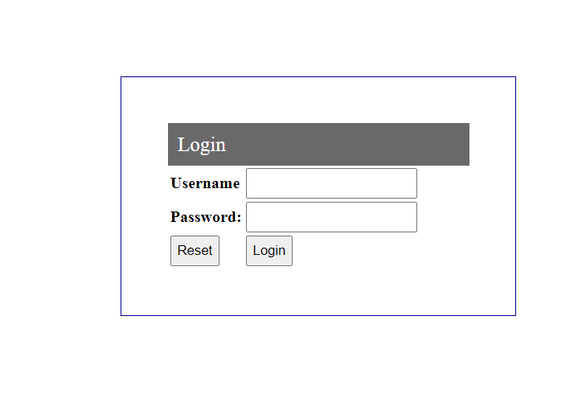

**Dashboard**: This is a Dashboard and some summery details will be there.

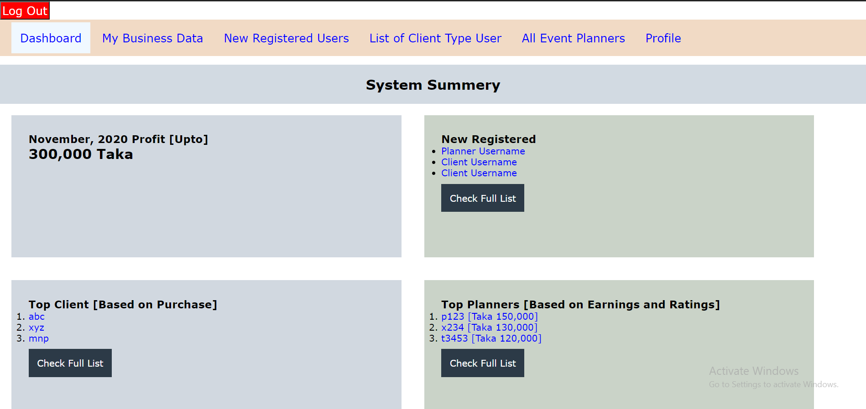

**My Business Data**: Our Business data will show there with some projected calculation.

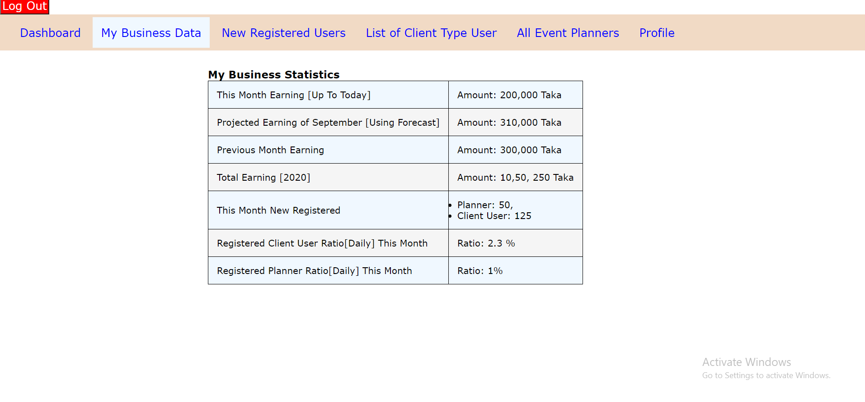

**New Registered User**: New Unapproved user will be there. Admin can approve the users and event planners.

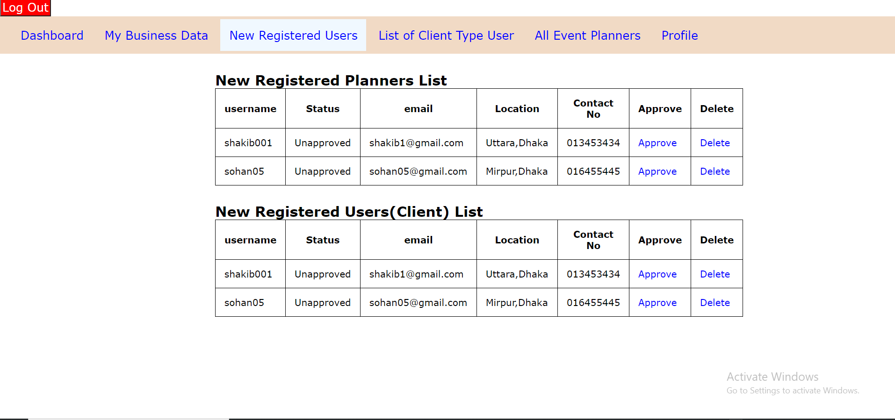

**List of Client and Event Planners**: List of event planners and client will be there and admin visit their profile and do crud operation.

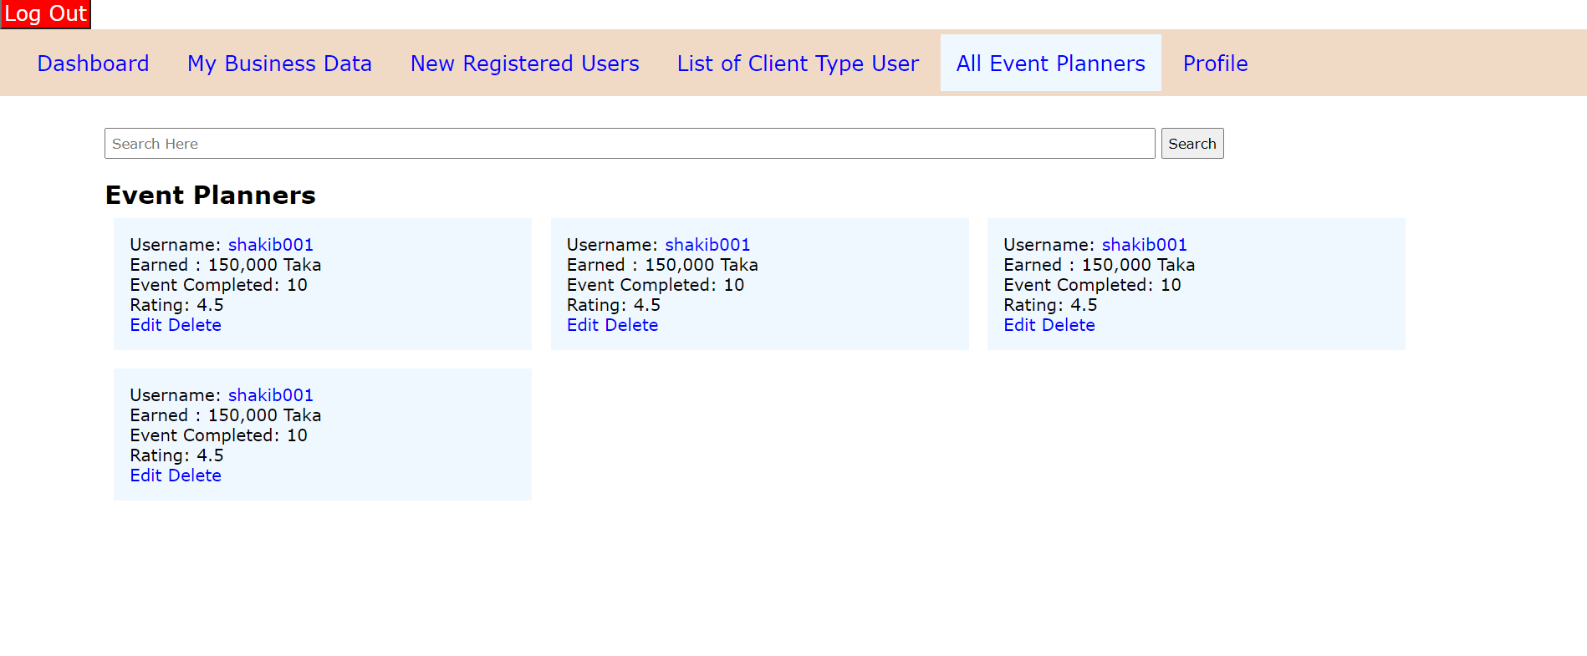

**Profile**: Admin Profile details with edit option. 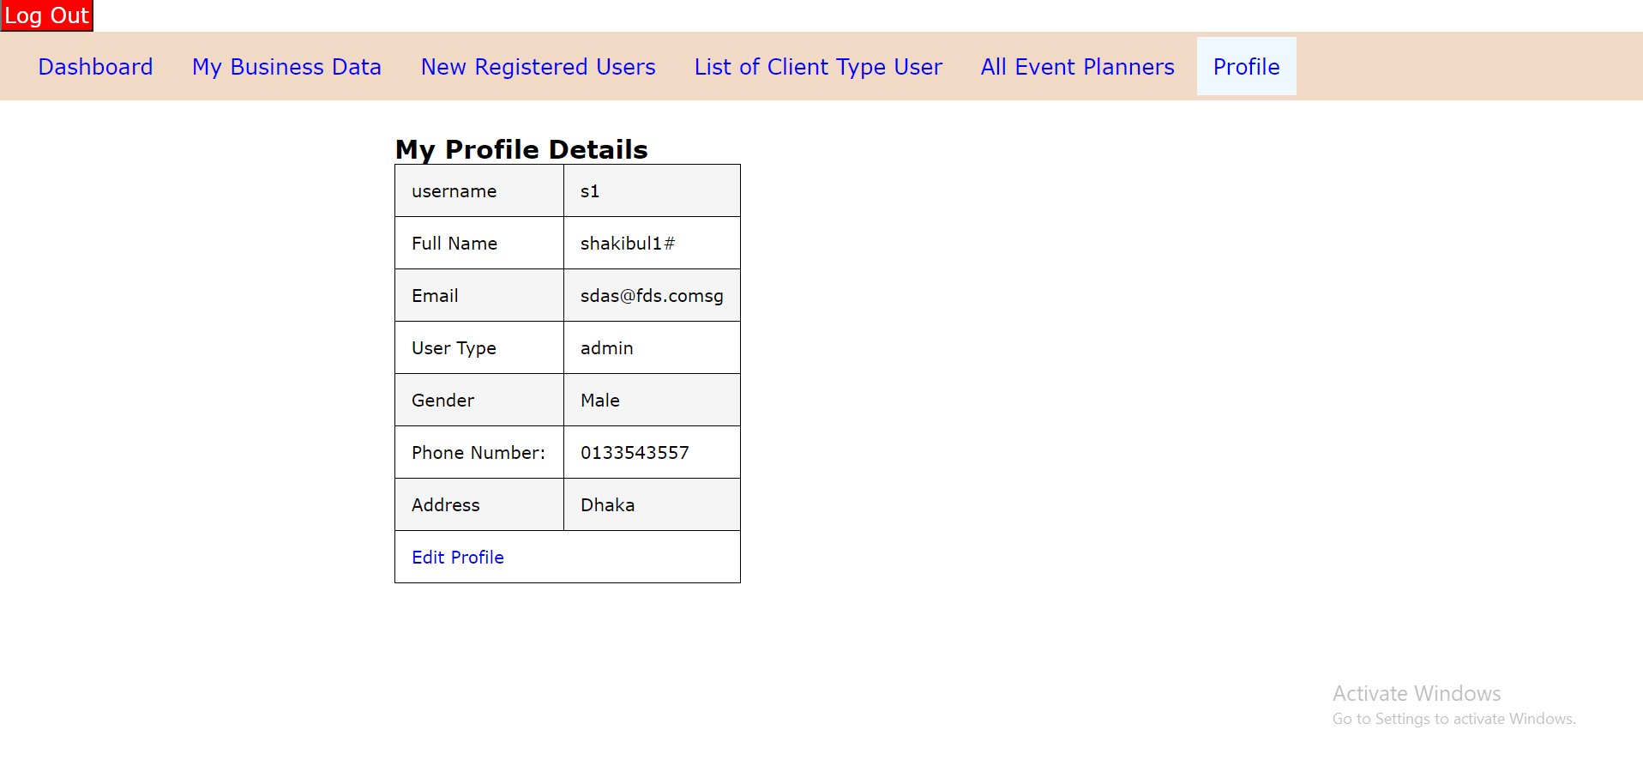

**Edit Profile**: Profile can be updated except the username. 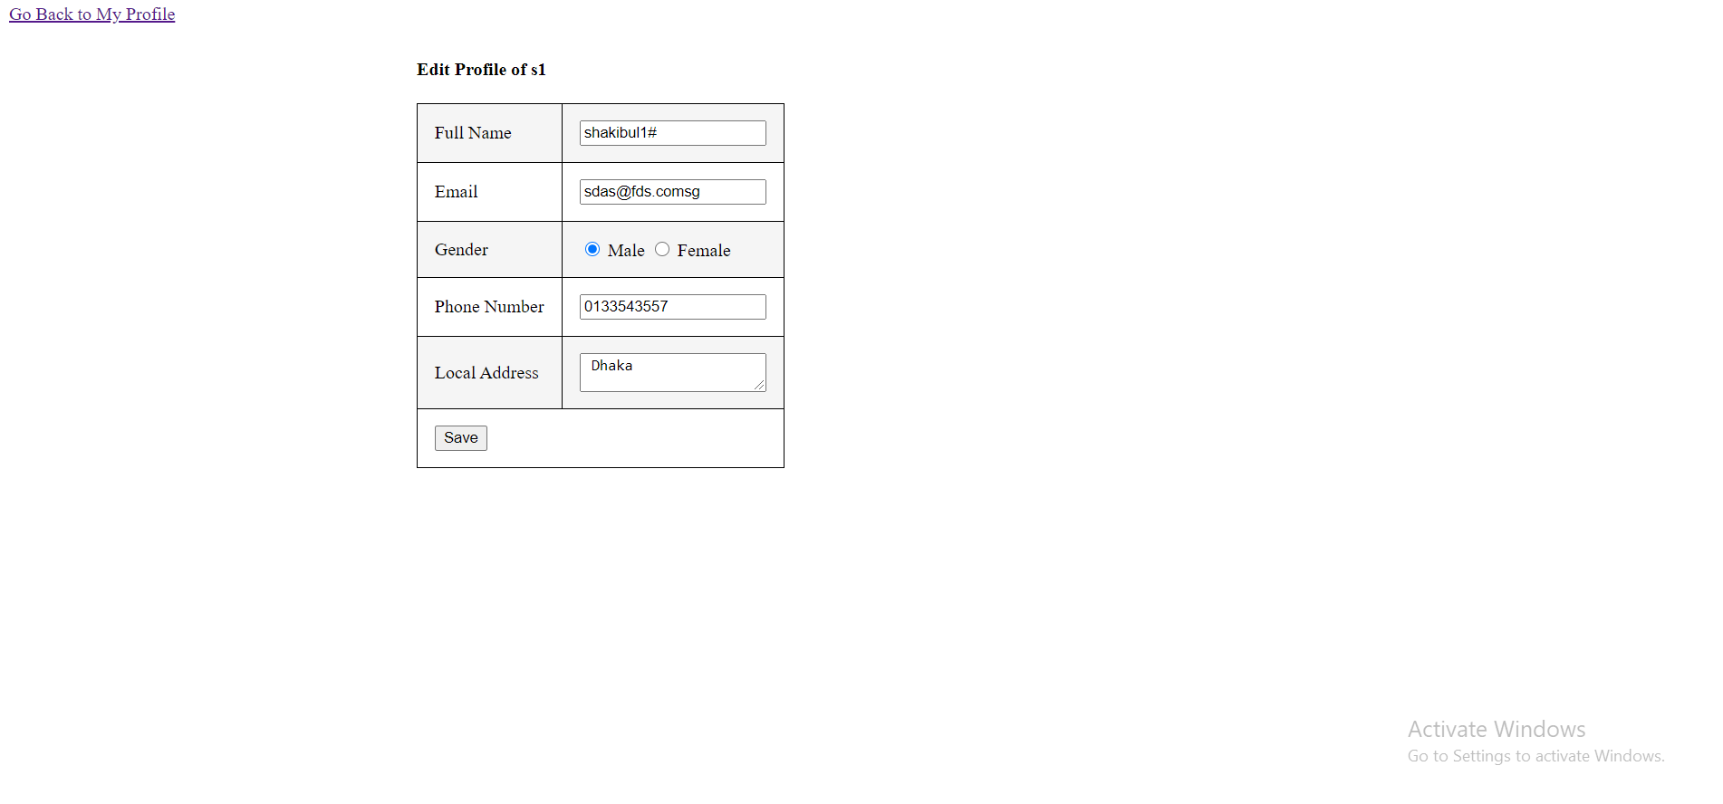

User:

Planner:

Vendor: