
ARTI501- NATURAL LANGUAGE PROCESSING

STUDENT PROCEDURAL MANUAL

2022-2023
DEPARTMENT OF COMPUTER ENGINEERING
College of Computer Science and Information Technology
كلية علوم الحاسب وتقنية المعلومات

Session Topic/Title | Session No. | Session Duration (Minutes)
Introduction to Natural Language Processing | 1 | 120

Introduction to Natural Language processing

Natural language processing (NLP): Subfield of linguistics, computer science, and information engineering concerned with the interactions between computers and human (natural) languages, in particular, how to program computers to process and analyze large amounts of natural language data.

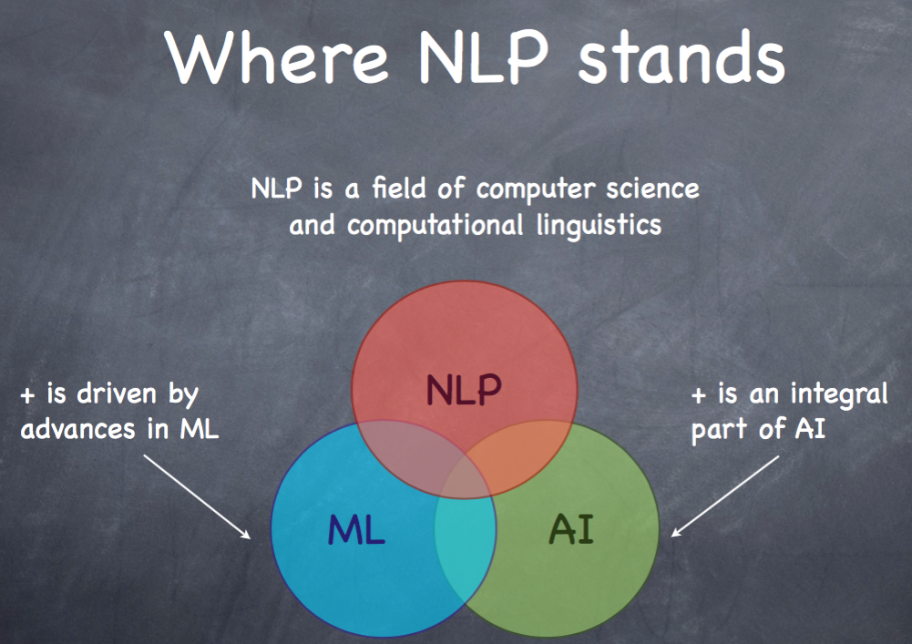

What is it all about?

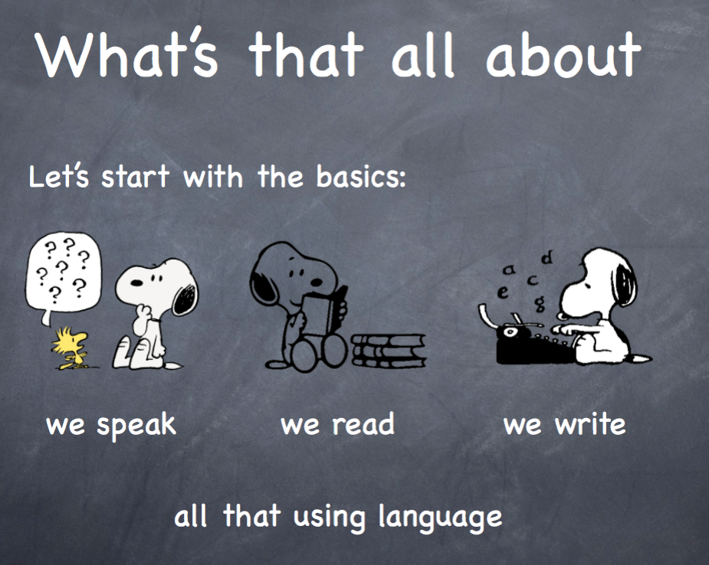

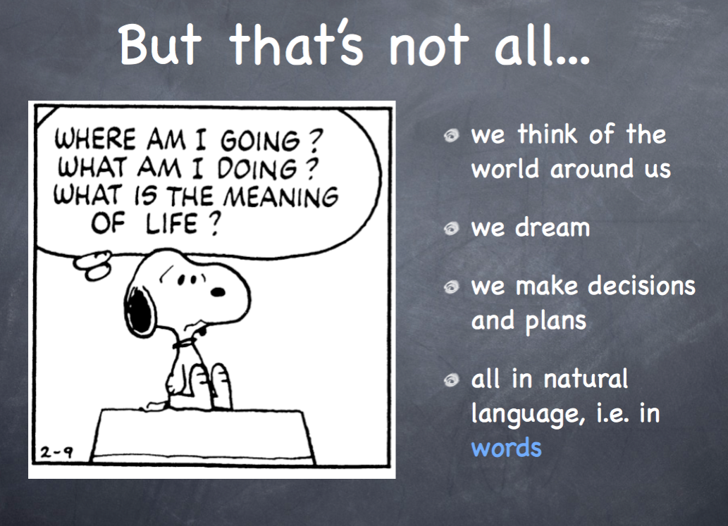
What are the raw materials for NLP revolution?
1. Data: There is a huge amount of human knowledge that has been digitized.
2. Compute: Our personal computers are very powerful, and it has never been easier to rent more computing power.
3. Algorithms: We use a combination of Computer Science, Machine Learning, Deep Learning, and linguist techniques.

Why NLP is hard?
It’s the nature of the human language that makes NLP difficult.
Some examples:
1. Ambiguity: One word/sentence can have different meanings.



2. Spelling Errors: There are some words that are usually misspelled by people.

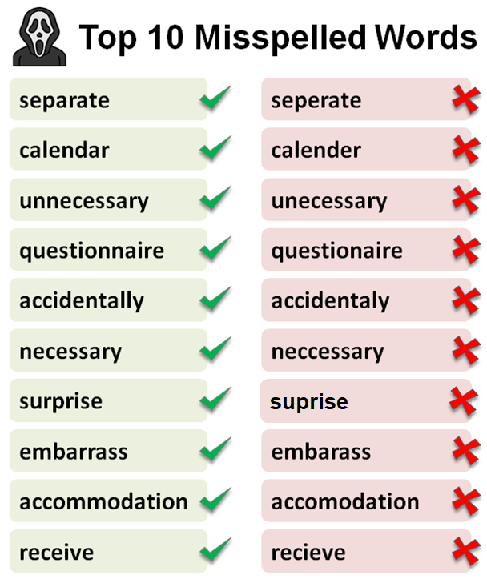

3. Phonetics and Phonology: Different words that have the same pronunciation.
- there / their
- plane / plain
- ice cream / I scream
4. Order of Context: "Dog bites man" and "Man bites dog" have vastly different meanings

In ML terms, why is NLP hard?
1. Input: Large, discrete, open-ended input state spaces
2. Output: Variable length output spaces
3. Algorithms: Recycled from other fields

Top Used Text File Types
- CSV
- Text Files
- JSON
- SQL
- HTML
- PDF
- DOCX
NLP Libraries

There are many popular NLP libraries that we will cover in the next labs. In this lab, we will get introduced to NLTK.

NLTK
Natural Language Toolkit (nltk) is a Python package for NLP https://www.nltk.org/

What are Corpus / Corpora?
a collection of written texts, especially the entire works of a particular author or a body of writing on a particular subject.

!pip install nltk

import nltk

Arabic Libraries (Extra)

Camel-Tools: https://camel-tools.readthedocs.io/en/latest/
PyArabic: https://pyarabic.readthedocs.io/ar/latest/
Farasa: https://farasa.qcri.org/

NLP Applications

1. Information Extraction
The automated retrieval of specific information related to a selected topic from a body or bodies of text.
2. Machine Translation
The process of using artificial intelligence to automatically translate text from one language to another without human involvement.
3. Sentiment Analysis
Identifying sentiments and opinions stated in a text.

Example of an NLP Pipeline

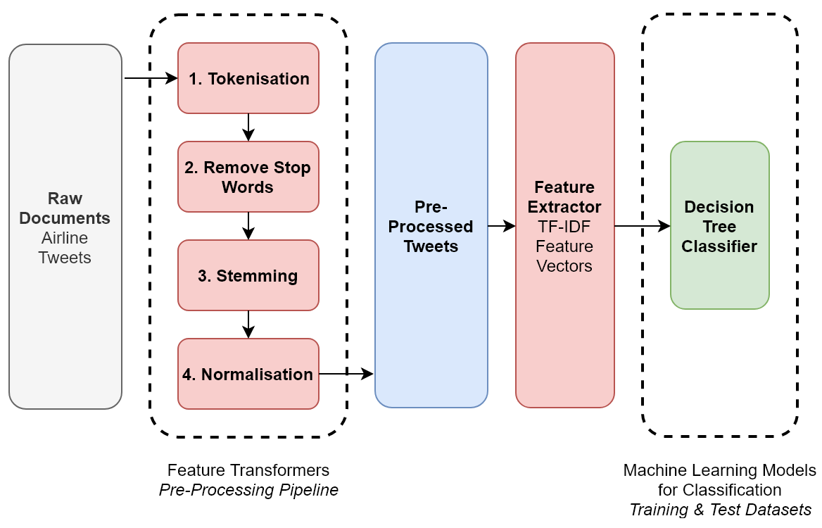

- Text Acquisition:
Obtain the text data from a source, such as a file, a web page, or a database.

- Text Preprocessing:
  - Tokenization: Split the text into individual words or tokens.
  - Lowercasing: Convert all tokens to lowercase to ensure uniformity.
  - Removing Punctuation: Strip away punctuation marks from tokens.
  - Stopword Removal: Eliminate common words (e.g., "and," "the," "is") that may not carry significant meaning.
  - Stemming/Lemmatization: Reduce words to their base or root form (e.g., "running" to "run").

- Feature Extraction:
  - Bag-of-Words (BoW): Create a vector representation of the text using the frequency of each token in the document.
  - TF-IDF (Term Frequency-Inverse Document Frequency): Assign weights to tokens based on their importance in the document relative to the entire corpus.

- Model Building:
Choose a machine learning model for sentiment analysis, such as a Naive Bayes classifier, Support Vector Machine (SVM), or a neural network.

- Session Outcomes

SLO1: Fundamentals of NLP
SLO2: Students demonstrate the ability to search for datasets of different types of files and how to open them.

- Tool(s)/Software | .

-Jupyter Notebook.
- Spyder.
- Any python IDE

- procedural steps (Tasks)

Task#1:

Students should work in groups and search online for one of the different types of datasets.
- CSV
- Text Files
- JSON
- SQL
- HTML
- PDF
- DOCX
Task#2:
Download and open the dataset.

- Assessment | Plan questions/tasks to confirm that students have achieved each of the above SLOs. Outcome 1 is the most important one, followed by 2, 3 and 4, as per time availability. The questions/tasks below are just for guidance and the laboratory instructor can come up with his own questions/tasks.

- Resources | Suggest further resources for the students to manage their learning after the class. Make sure that the resources are specific and different to suit all students, e. g. Figures, Tables, Links, etc.

- Page # 000 in the textbook of …………….
- Figure # 5 at page 23 for …………..
- Link: www.aaaaaa...............
Appendix:

