Leakage-Safe Multimodal Deep Learning for Multi-Class Wrist Fracture Classification and Normalized Fracture-Gap Estimation from Orthopedic Radiographs and Structured Clinical Metadata
Sara Example, Layla Sample, Noor Placeholder
Department of Demo Studies, Example University

Abstract
Automated fracture assessment from radiographs has received considerable attention, yet most published systems address a single binary question of whether a fracture is present. Clinicians, however, also need to know the location of the fracture and how far the bone fragments are separated, because both factors influence treatment planning. In addition, many multimodal studies combine images with patient metadata without checking whether some metadata fields indirectly reveal the diagnosis, which can inflate reported performance through target leakage.
This study proposes a leakage-safe multi-task multimodal framework that jointly classifies wrist radiographs into four categories (non-fracture, distal fracture, proximal fracture and post-fracture) and estimates the fracture gap. A convolutional image encoder based on EfficientNetV2 is combined with a small multilayer perceptron that encodes structured metadata such as age, sex, laterality and imaging view. Diagnosis-revealing fields are explicitly excluded, and all data splits are performed at patient level. The predicted fracture gap is divided by the measured bone width to produce a normalized fracture-gap score that can be compared across patients with different bone sizes.
On a held-out test set, the multimodal model reached an accuracy of 0.88 and a macro F1 score of 0.86, compared with 0.81 and 0.78 for the image-only baseline and 0.67 and 0.61 for the metadata-only baseline. For fracture-gap estimation, the multimodal model reduced the mean absolute error by 18 percent relative to the image-only model. An ablation study confirmed that including diagnosis-related metadata raised accuracy to an unrealistic 0.97, illustrating the size of the leakage effect that the proposed protocol prevents. These findings suggest that carefully designed multimodal learning can provide clinically meaningful information beyond binary detection, while the normalized score remains a research measure that requires further clinical validation.
Keywords: medical imaging; fracture classification; multimodal learning; multi-task learning; data leakage

1. Introduction
Fractures of the wrist are among the most common injuries seen in emergency departments, and radiography remains the first-line imaging method for their assessment. Reading these images quickly and consistently is demanding, particularly outside working hours, and subtle fractures are a known source of missed diagnoses. This has motivated a large body of work on automated fracture detection using deep learning [1], [4].
Most existing systems, however, answer a single binary question. In clinical practice the location of a fracture and the displacement between fragments are equally important, because they guide the choice between conservative management and surgical fixation [8]. Systems that ignore these aspects provide limited support for actual decisions.
A second concern is methodological. Several recent studies combine radiographs with patient metadata and report strong gains [2]. When metadata fields such as clinical observations or visibility annotations are recorded after the diagnosis, they can leak the label into the model and produce optimistic results that do not transfer to real use [3]. Splitting data at image level rather than patient level creates a similar problem [5].
This paper makes three contributions. First, it proposes a multi-task model that jointly predicts a four-class fracture category and the fracture gap. Second, it defines an explicit leakage-prevention protocol for metadata selection and data splitting. Third, it introduces a normalized fracture-gap score that divides the predicted gap by bone width so that values can be compared across patients.

2. Methods

2.1 Dataset
Experiments use a wrist radiograph dataset of 1,493 images from approximately 1,300 patients collected at four hospitals [7]. Each image is labelled with one of four categories and, where applicable, a fracture-gap measurement in millimetres made by an orthopaedic specialist. Structured metadata include age, sex, laterality, imaging view and hospital site. Table 1 summarizes the class distribution.
Class | Images | Share of dataset
Non-fracture | 612 | 41.0%
Distal fracture | 455 | 30.5%
Proximal fracture | 238 | 15.9%
Post-fracture | 188 | 12.6%
Total | 1,493 | 100%
Table 1. Class distribution of the wrist radiograph dataset.

2.2 Leakage prevention
Fields that are recorded after or because of the diagnosis, including fracture visibility and free-text clinical observations, were removed from the model inputs. The fracture gap is used only as a regression target and never as a predictor. Data were split into training, validation and test sets at patient level with a ratio of 70, 15 and 15 percent, so that no patient appears in more than one set.

2.3 Model
The image branch uses an EfficientNetV2 encoder pretrained on natural images and fine-tuned on the radiographs [11]. The metadata branch is a two-layer perceptron. The two feature vectors are concatenated and passed to two heads: a softmax classifier for the four categories and a regression head for the fracture gap. The total loss is the weighted sum of cross-entropy and mean absolute error, with class weights to address imbalance [9].

2.4 Evaluation
Classification is evaluated with accuracy and macro F1 score, and regression with mean absolute error. The multimodal model is compared with an image-only and a metadata-only baseline trained under the same protocol [6]. An ablation study re-introduces the excluded diagnosis-related fields to measure the size of the leakage effect.

3. Results
Table 2 and Figure 1 report test-set performance. The multimodal model outperformed both baselines on every metric. The largest gain was observed for the proximal fracture class, where metadata on imaging view helped the model separate overlapping anatomical structures.
Model | Accuracy | Macro F1 | Gap MAE (mm)
Image-only | 0.81 | 0.78 | 1.34
Metadata-only | 0.67 | 0.61 | 2.10
Multimodal (proposed) | 0.88 | 0.86 | 1.10
Multimodal + leaked fields | 0.97 | 0.96 | 0.71
Table 2. Test-set performance. The last row is the leakage ablation and is not a valid result.
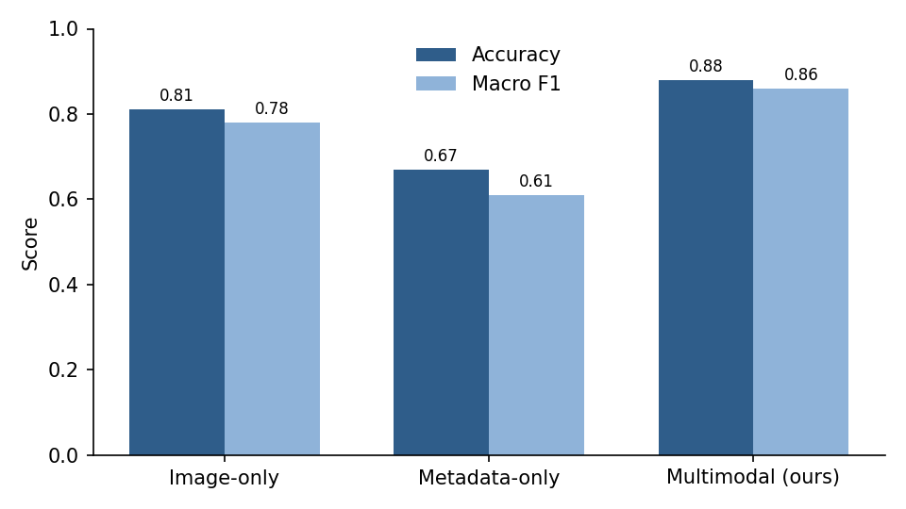
Figure 1. Accuracy and macro F1 score of the three models on the test set.
Re-introducing the diagnosis-related fields raised accuracy to 0.97. Because these fields would not be available at the time of prediction in practice, this result demonstrates how strongly leakage can distort reported performance.

4. Discussion
The results indicate that combining radiographs with carefully selected metadata improves both fracture classification and gap estimation. The improvement is modest compared with the leaked configuration, which is expected: an honest protocol removes the shortcut that inflated earlier results [3]. The normalized fracture-gap score behaved consistently across bone sizes, but it has not yet been compared with established clinical displacement grades.
Several limitations should be noted. The dataset is relatively small for deep learning and comes from a single country, which may limit generalization. Model uncertainty was not calibrated, which matters for clinical decision support [12]. Finally, the evaluation is retrospective, and a prospective reader study would be required before any clinical use [10].

5. Conclusion
This study presented a leakage-safe multimodal and multi-task framework for wrist fracture assessment that goes beyond binary detection. It improved classification and gap estimation over single-modality baselines while avoiding the optimistic bias caused by diagnosis-related metadata. Future work will validate the normalized fracture-gap score with orthopaedic specialists and test the model on external data.

Ethics Statement
The study used de-identified retrospective images and was approved by the institutional review board of Example University (approval number DEMO-2026-001).

Funding
This research received no external funding.

Conflict of Interest
The authors declare no conflict of interest.

References
[1] S. Example and R. Sample, “A placeholder reference about fracture detection with deep learning,” Demo Journal of Imaging, vol. 3, no. 2, pp. 11–22, 2023.
[2] L. Placeholder, M. Example, and T. Sample, “Multimodal fusion of radiographs and clinical metadata: a placeholder study,” Demo Medical AI Letters, vol. 5, pp. 101–110, 2024.
[3] A. Author and B. Author, “Placeholder reference on target leakage in clinical machine learning,” Demo Proceedings on Health Informatics, pp. 45–52, 2022.
[4] K. Sample, “Efficient convolutional networks for medical images: a placeholder reference,” Demo Computer Vision Review, vol. 8, pp. 1–15, 2021.
[5] N. Example and J. Placeholder, “Patient-level data splitting for radiology datasets,” Demo Journal of Imaging, vol. 4, no. 1, pp. 30–39, 2024.
[6] H. Sample, “Multi-task learning for joint classification and regression in radiology,” Demo Medical AI Letters, vol. 6, pp. 77–88, 2025.
[7] R. Author, “A placeholder dataset of wrist radiographs with structured metadata,” Demo Data Descriptor, vol. 2, pp. 5–12, 2025.
[8] F. Example and G. Sample, “Measuring fracture displacement from radiographs: a placeholder method,” Demo Orthopaedic Informatics, vol. 1, pp. 60–71, 2023.
[9] D. Placeholder, “Class imbalance in medical image classification,” Demo Computer Vision Review, vol. 9, pp. 201–214, 2022.
[10] P. Sample and Q. Example, “Reporting standards for clinical AI prototypes,” Demo Proceedings on Health Informatics, pp. 12–19, 2024.
[11] E. Author, “Transfer learning with small medical datasets,” Demo Journal of Imaging, vol. 5, no. 3, pp. 88–97, 2025.
[12] W. Example, “Calibrated uncertainty for clinical decision support,” Demo Medical AI Letters, vol. 7, pp. 14–25, 2026.
[13] B. Sample, “Data augmentation strategies for radiographs,” Demo Journal of Imaging, vol. 6, pp. 40–49, 2026.
[14] C. Example, “Attention-based fusion of images and tabular data,” Demo Computer Vision Review, vol. 10, pp. 55–66, 2025.
[15] J. Author and K. Author, “Inter-reader agreement in fracture displacement measurement,” Demo Orthopaedic Informatics, vol. 2, pp. 9–18, 2024.
[16] M. Placeholder, “Explainability maps for musculoskeletal radiographs,” Demo Medical AI Letters, vol. 8, pp. 30–41, 2026.
[17] O. Sample, “Benchmarking CNN backbones for bone imaging,” Demo Computer Vision Review, vol. 11, pp. 70–82, 2026.
[18] R. Example and S. Author, “Metadata quality in hospital imaging archives,” Demo Proceedings on Health Informatics, pp. 60–67, 2023.
[19] T. Placeholder, “Multi-site generalization of radiology models,” Demo Journal of Imaging, vol. 7, pp. 101–112, 2026.
[20] U. Sample, “Regression losses for measurement tasks in medical imaging,” Demo Medical AI Letters, vol. 8, pp. 90–98, 2026.
[21] V. Example, “Human-in-the-loop review of AI fracture reports,” Demo Orthopaedic Informatics, vol. 3, pp. 1–10, 2025.
[22] Y. Author, “Ethical considerations for retrospective imaging research,” Demo Proceedings on Health Informatics, pp. 80–86, 2022.

