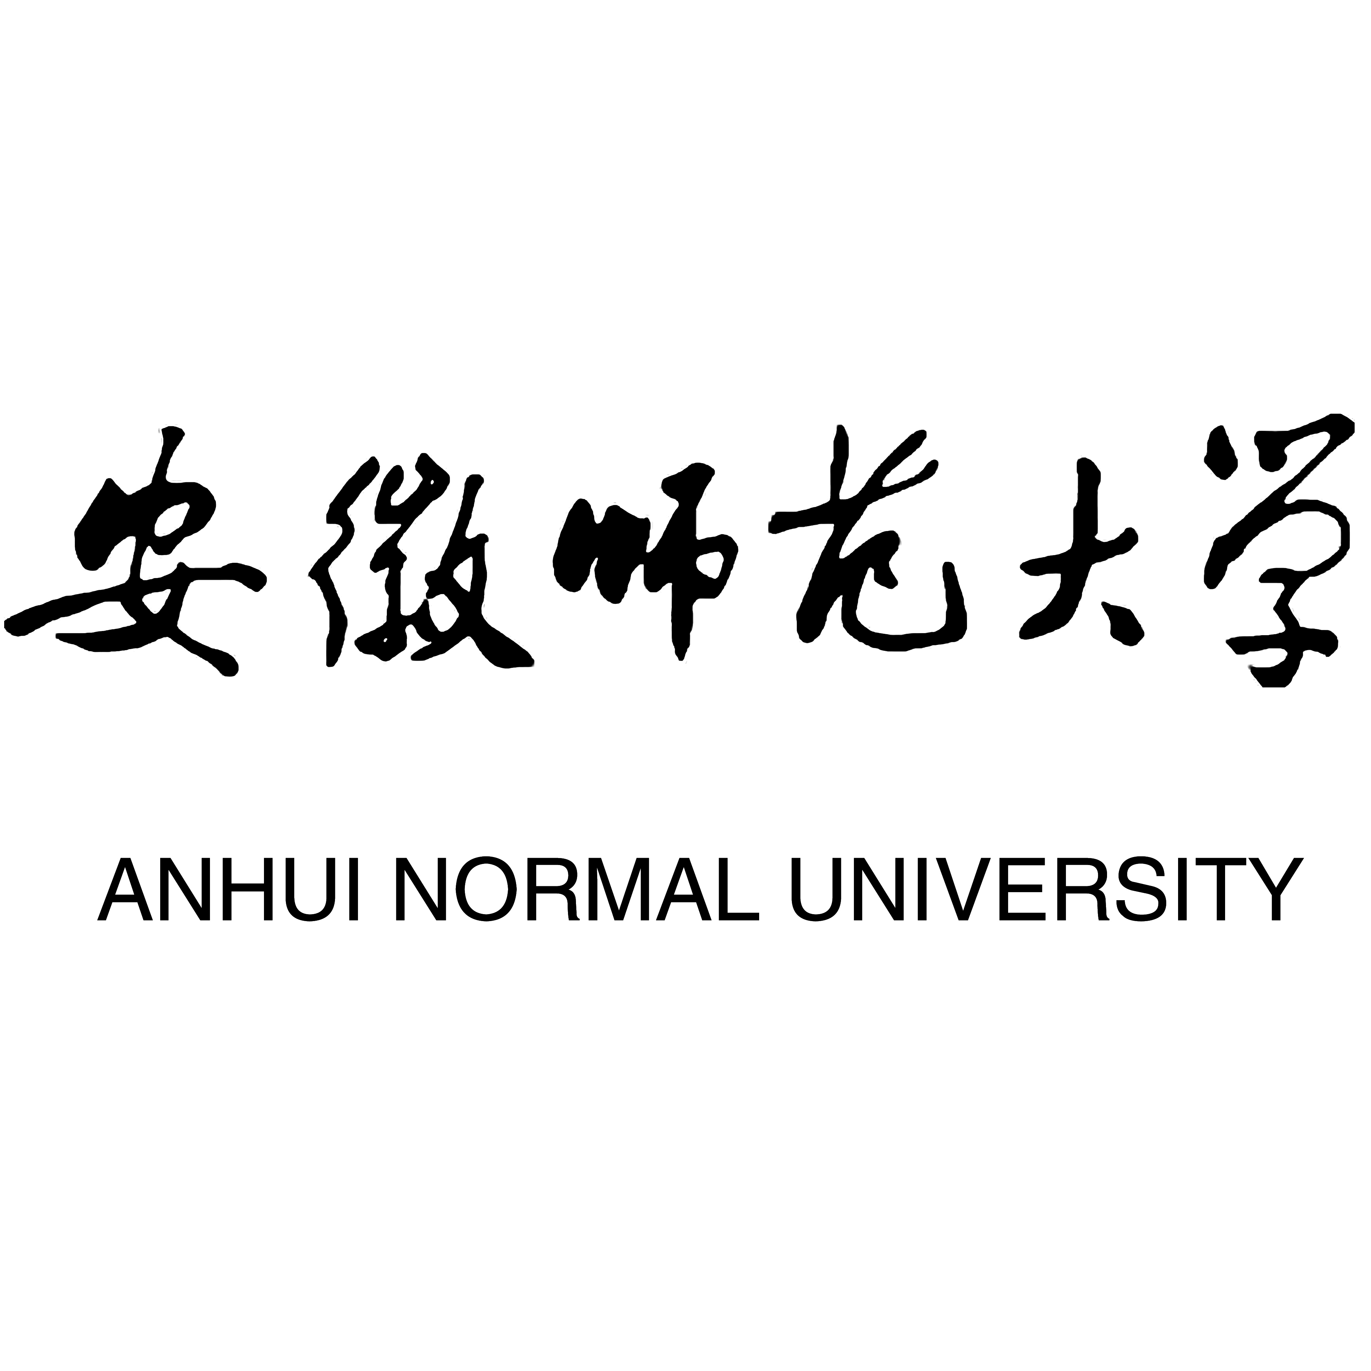

APPLICATION FORM FOR STUDY AT AHNU
护照姓名  Full Name | 姓Surname: Khan |  |  |  |  |  |  |  |  |  |  | 中文名Chinese Name |  |  | 中文名Chinese Name: 艾哈迈德
护照姓名  Full Name | 名Given Name: Ahmed
国籍 Nationality: Pakistan  Nationality: |  |  |  |  |  |  |  | 性别 男Male □ Male ☑ Female □  Sex 女Female□
出生日期 年 月 日 1995  Date of Birth Year Month Day |  |  |  |  |  |  |  | 婚姻状况 Marital Status:  Marital Status
宗教 Religion:  Religion: |  |  |  |  |  |  |  | 出生地点 Place of Birth: Islamabad  Place of Birth:
护照号码 Passport No.: AB1234567  Passport No.： |  |  | 最高学历 Highest Diploma: Bachelor  Highest Diploma Obtained: |  |  |  |  |  |  |  |  |  |  |  |  | 职业 Occupation: Student  Occupation:
永久通信地址Permanent Address at Home Country(including postal code of your city or province): 123 Main St, Islamabad

电话Phone Tel.:+ +92-300-1234 |  |  |  |  |  | 邮箱Email: ahmed@test.com |  |  |  |  |  |  |  | 微信 Wechat： ahmed_khan
推荐单位Institution for Reference: Uni Islamabad |  |  |  |  |  | 推荐单位电话Tel. for Reference: +92-51-1234 |  |  |  |  |  |  |  | 经费担保人或机构Financial Guarantor: Self
当前中国住址Present address in China: Hefei, Anhui

教育背景Education Background
毕业学校  Institutions |  |  |  |  | 学习专业  Major or Specialty |  |  |  |  | 学习时间  Years attended (from/to) |  |  |  |  |  |  |  |  | 毕/结业证书Certificates obtained
是否曾在华学习?  Have you ever studied in China? |  |  |  |  |  |  |  |  |  |  | 是 Yes □ 否 No □ □
在华学习院校Chinese Institutions you have studied: |  |  |  |  |  |  |  |  |  |  | 在华学习时间Duration of your former study in China:
工作经历 Working Experience
工作单位Employer |  | 所在地Location |  |  |  |  |  |  | 职务Position |  |  |  |  |  |  |  |  | 工作时间Period of Employment
HSK考试等级或其他汉语水平证书Level of HSK or other language certificate:
汉语学习经历 Chinese learning experience
学习机构或学校  Institutions |  |  |  | 学习时间  Years attended(from/to) |  |  |  |  |  |  |  |  | 请提交成绩单扫描件  Please submit the scanned of your transcript
申请信息Application Information
学生类别Program to Take: Graduate Program ☑ |  |  |  |  |  |  | 申请专业及研究方向Specialty and Direction of Research: Computer Science |  |  |  |  |  |  |  |  |  | 计划学习时间Intended Length of Study: 3 years
本科生
Undergraduate Program □
硕士研究生
Graduate Program □
博士研究生
Ph. D. Program □
普通进修生General Scholars □
学习经费来源Financial Resources for Your Study: Self-supported ☑
政府公派Government Support□ 个人自费Self-supported□
推荐人或经济担保人Referee / Financial Guarantor:
姓名 Full Name: Email:
电话Tel.: 传真Fax:
申请人保证：
1．以上提供的情况是真实无误的。
2．在中国学习期间遵守中国政府的法律和学校的规章制度。
I hereby affirm that:
1．All information in this form is true and correct.
2．I shall abide by the laws of Chinese government and the regulations of Anhui University.
申请人签字 日期
Signature of the Applicant: ____________________ Date: ____
注意：申请人在递交本申请表的同时，请提交招生简章要求的各种证明文件。不完整的申请表或未按要求交验有关资料，将会延误对此申请的审理时间。
Note: Applicant should submit this form together with all other documents required in our admission brochure. An incomplete application, or failure to submit supporting documents, will DELAY the process of your application.

