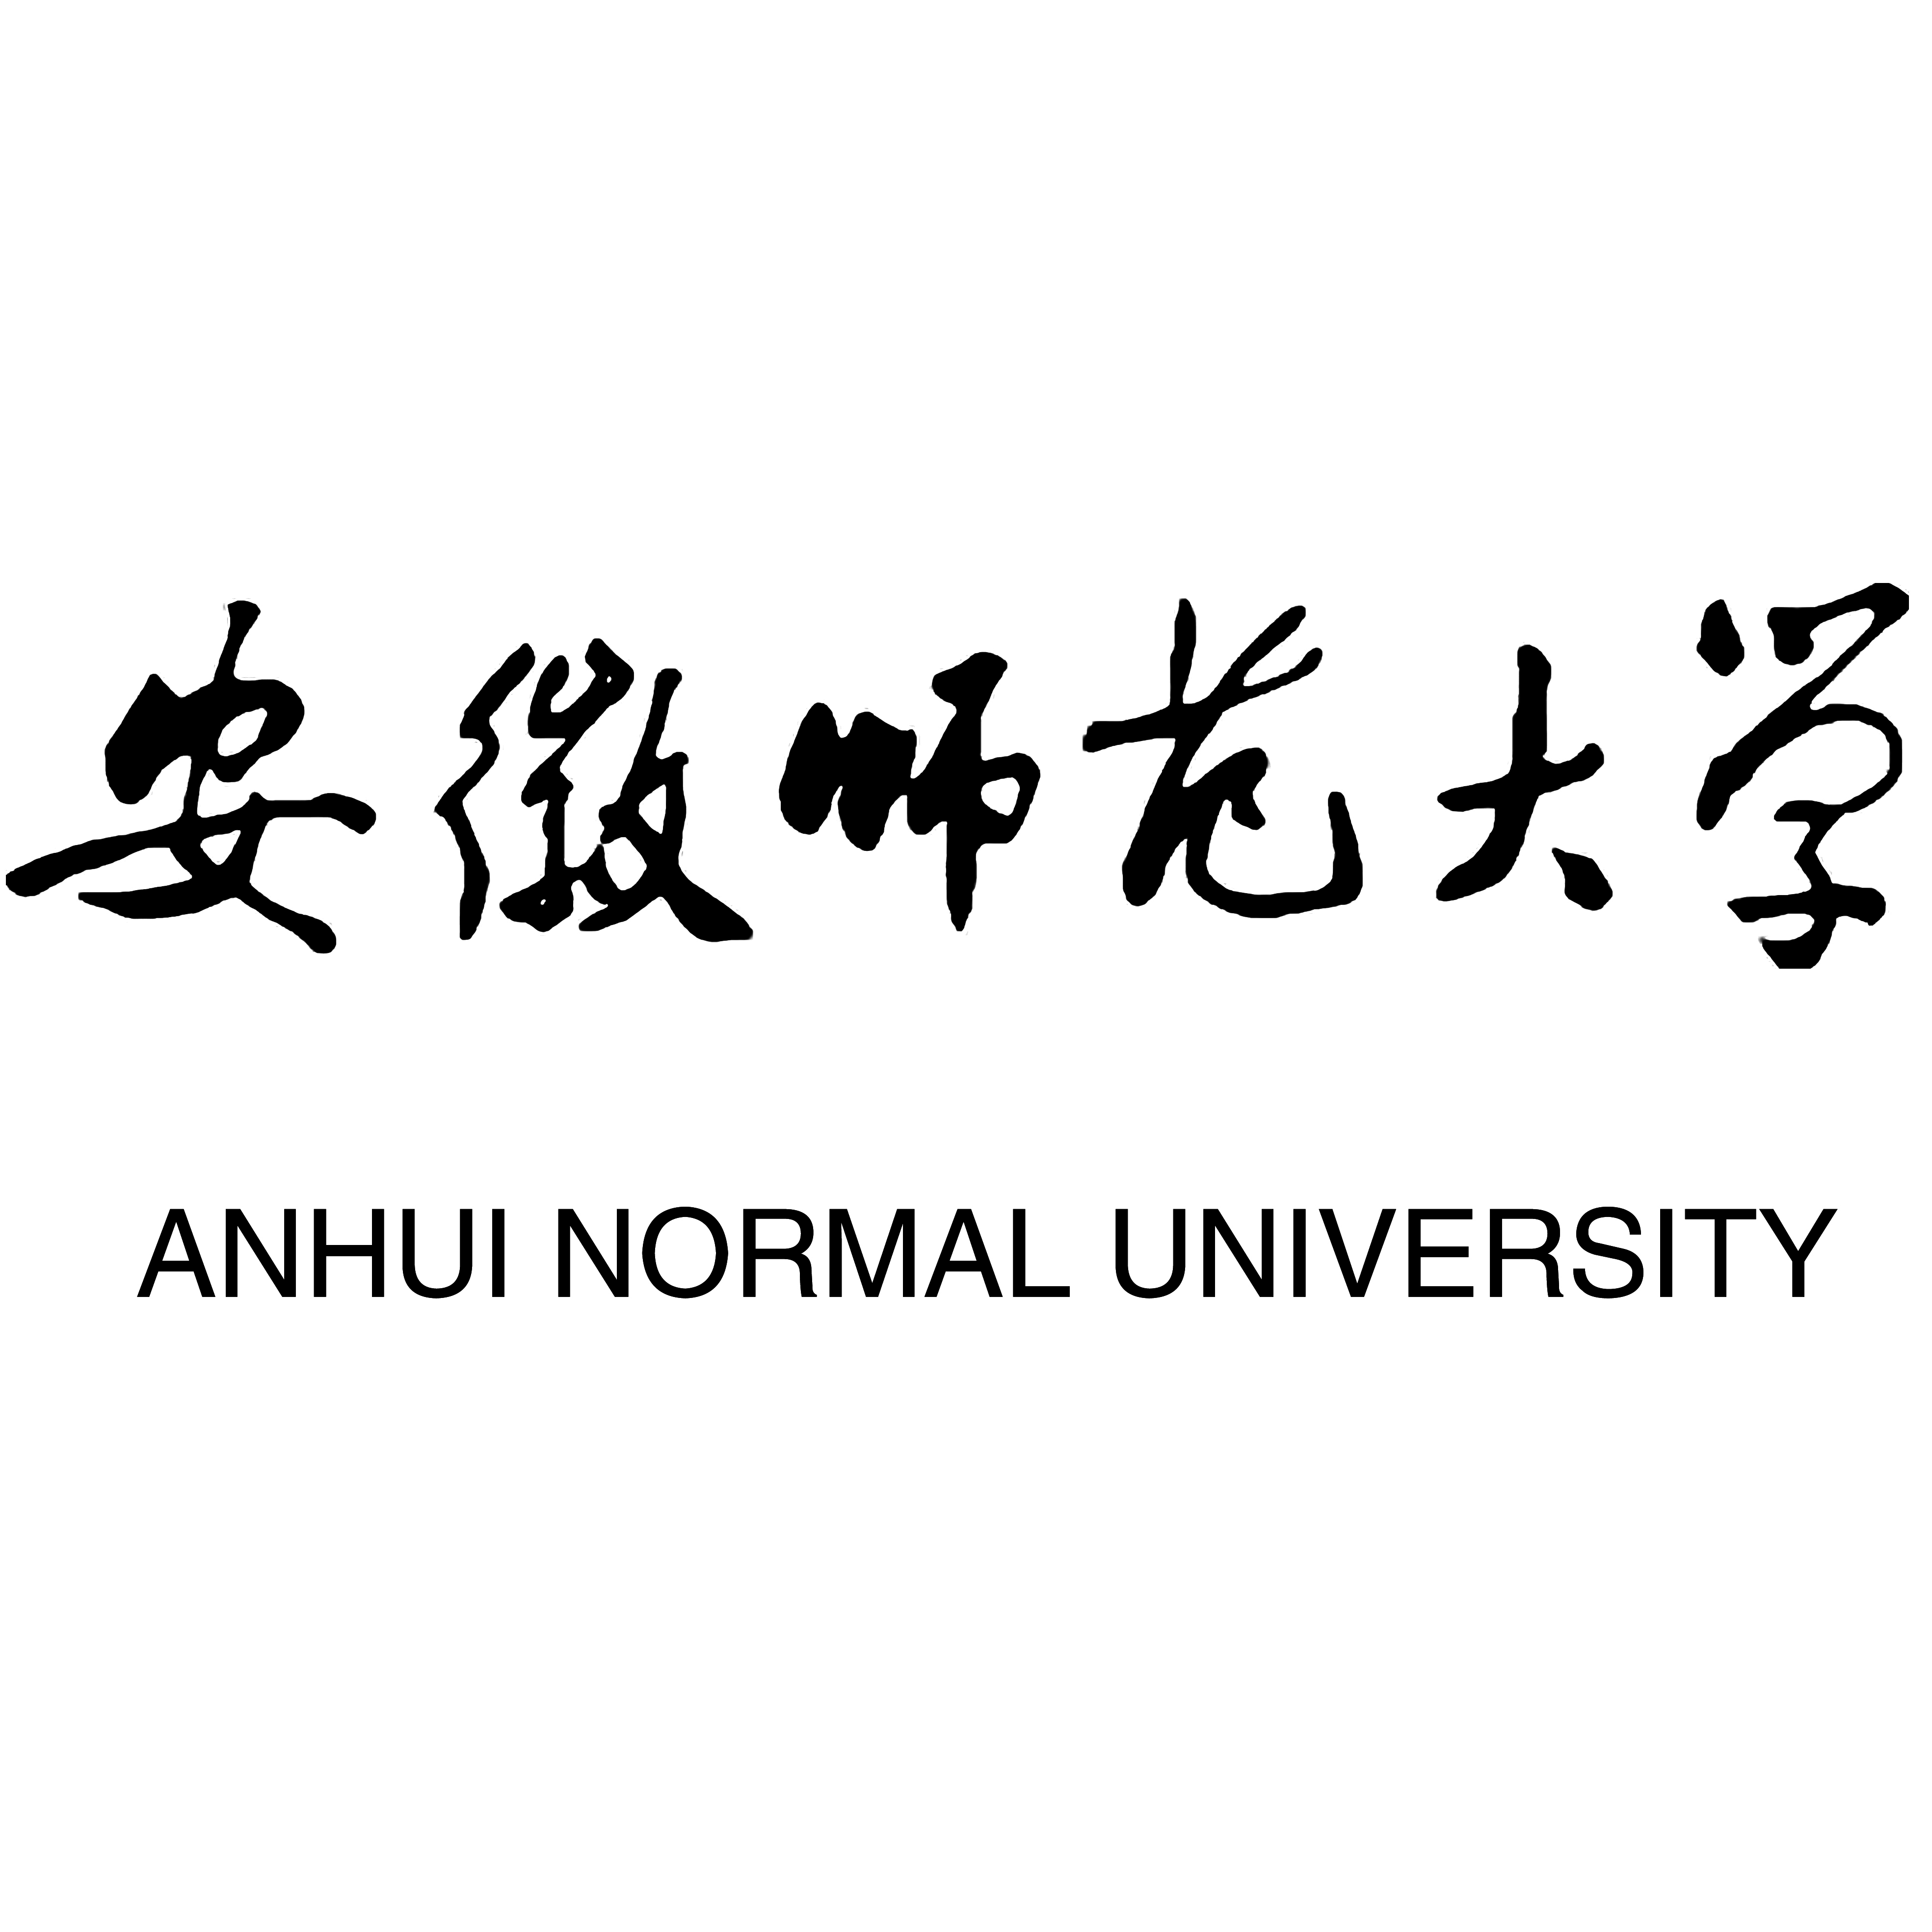

APPLICATION FORM FOR STUDY AT AHNU
护照姓名  Full Name | 姓 KhanSurname: |  |  |  |  |  |  |  |  |  |  | 中文名Chinese Name |  |  | ???? ????
护照姓名  Full Name | 名 AhmedGiven Name:
国籍 Pakistan  Nationality: |  |  |  |  |  |  |  | 性别 Male ? Female ? 男Male □  Sex 女Female□
出生日期 1995 年 月 日  Date of Birth Year Month Day |  |  |  |  |  |  |  | 婚姻状况 Single  Marital Status
宗教 Islam  Religion: |  |  |  |  |  |  |  | 出生地点 Islamabad, Pakistan  Place of Birth:
护照号码 AB1234567  Passport No.： |  |  | 最高学历 Bachelor  Highest Diploma Obtained: |  |  |  |  |  |  |  |  |  |  |  |  | 职业 Student  Occupation:
永久通信地址 123 Main St, Islamabad, PakistanPermanent Address at Home Country(including postal code of your city or province):

电话 +92-300-1234567Phone Tel.:+ |  |  |  |  |  | 邮箱 ahmed.khan@example.comEmail: |  |  |  |  |  |  |  | 微信 ahmedkhan95 Wechat：
推荐单位 University of IslamabadInstitution for Reference: |  |  |  |  |  | 推荐单位电话 +92-51-1234567Tel. for Reference： |  |  |  |  |  |  |  | 经费担保人或机构 SelfFinancial Guarantor：
当前中国 住址Present address in China:

教育背景Education Background
毕业学校  Institutions |  |  |  |  | 学习专业  Major or Specialty |  |  |  |  | 学习时间  Years attended (from/to) |  |  |  |  |  |  |  |  | 毕/结业证书Certificates obtained
是否曾在华学习?  Have you ever studied in China? |  |  |  |  |  |  |  |  |  |  | 是 ?Yes □ 否 No □
在华 学习院校 Chinese Institutions you have studied |  |  |  |  |  |  |  |  |  |  | 在华学习时间 Duration of your former study in China
工作经历 Working Experience
工作单位Employer |  | 所在地Location |  |  |  |  |  |  | 职务Position |  |  |  |  |  |  |  |  | 工作时间Period of Employment
HSK 考试等级或其他汉语水平证书 Level of HSK or other language certificate:
汉语学习经历 Chinese learning experience
学习机构或学校  Institutions |  |  |  | 学习时间  Years attended(from/to) |  |  |  |  |  |  |  |  | 请提交成绩单扫描件  Please submit the scanned of your transcript
申请信息Application Information
学生类别 Graduate Program ?Program to Take |  |  |  |  |  |  | 申请专业及 Computer Science研究方向Specialty and Direction of Research |  |  |  |  |  |  |  |  |  | 计划学习时间 3 yearsIntended Length of Study
本科生
Undergraduate Program □
硕士研究生
Graduate Program □
博士研究生
Ph. D. Program □
普通进修生General Scholars □
学习经费来源 Self-supported ?Financial Resources for Your Study
政府公派Government Support□ 个人自费Self-supported□
推荐人或经济担保人 Name: Dr. Smith Email: smith@uni.edu Tel: +1-555-0100Referee / Financial Guarantor:
姓名 Full Name: Email:
电话Tel.: 传真Fax:
申请人保证：
1．以上提供的情况是真实无误的。
2．在中国学习期间遵守中国政府的法律和学校的规章制度。
I hereby affirm that:
1．All information in this form is true and correct.
2．I shall abide by the laws of Chinese government and the regulations of Anhui University.
申请人签字 日期
Signature of the Applicant: ____________________ Date: ____
注意：申请人在递交本申请表的同时，请提交招生简章要求的各种证明文件。不完整的申请表或未按要求交验有关资料，将会延误对此申请的审理时间。
Note: Applicant should submit this form together with all other documents required in our admission brochure. An incomplete application, or failure to submit supporting documents, will DELAY the process of your application.

