Prifysgol De Cymru
Prifysgol De Cymru
MSc Project
Faculty of Computing, Engineering and Science
Faculty of Computing, Engineering and Science

Loan Default Prediction Using Machine Learning: A Reproducible Experimental Study on Class Imbalance and Model Explainability

by
Ridita Zaman Adikta
Enrolment number: 23126153

A project submitted in partial fulfilment of the requirements for the degree of
Master of Science, MSc Data Science

First Supervisor: [First Supervisor Name]
Second Supervisor: [Second Supervisor Name]
Year of Study: 2025–2026
Scheme: MSc Data Science
September 2026

University of South Wales
Prifysgol De Cymru
Faculty of Computing, Engineering and Science

STATEMENT OF ORIGINALITY
This is to certify that, except where specific reference is made, the work described in this project is the result of the investigation carried out by the student, and that neither this project nor any part of it has been presented, or is currently being submitted in candidature for any award other than in part for the MSc award, Faculty of Computing, Engineering and Science from the University of South Wales.

Signed: ............................................

Date: ............................................

Abstract
Loan default prediction is complicated by class imbalance: defaulters are a minority, so models optimised for accuracy miss critical default cases. This dissertation reports a reproducible experimental study using the Home Credit Default Risk dataset. Three classifiers — Logistic Regression, Random Forest and XGBoost — were compared under baseline, cost-sensitive and SMOTE conditions in a leakage-controlled experiment, evaluated with 3×5 repeated stratified cross-validation on 2018–2019 applications and an out-of-time test on the 2020 cohort. XGBoost achieved the best ranking performance (out-of-time ROC-AUC 0.7669, PR-AUC 0.2513), yet baseline models detected fewer than 3% of defaulters. Cost-sensitive learning raised recall to 64–69% at negligible ranking cost and cut cost per applicant by 33%, whereas SMOTE degraded every model family. SHAP analysis attributed dominant predictive power to external credit-bureau scores. The study concludes that imbalance handling, not model choice, is decisive for default detection.

Acknowledgements
The author wishes to thank the project supervisors for their guidance and constructive feedback throughout the project, and the University of South Wales for the resources made available during the MSc programme. Gratitude is also due to the open-source community whose tools — Python, scikit-learn, XGBoost, imbalanced-learn and SHAP — made this work possible, and to Kaggle and Home Credit Group for publishing the dataset on which this study is based.

Table of Contents

List of Figures
Figure 3.1: Temporal partitioning of the dataset: 2018–2019 applications form the training window (cross-validation and model fitting), 2020 applications form the untouched out-of-time test set.
Figure 3.2: Target distribution: 91.9% of applications were repaid, 8.1% resulted in default.
Figure 3.3: The DAYS_EMPLOYED sentinel at 365,243 days dominates the raw distribution; it is a placeholder for non-employed applicants.
Figure 3.4: Correlation between DAYS_EMPLOYED and FLAG_EMP_PHONE before and after sentinel correction: the raw correlation of −0.9998 is a sentinel artefact; the true association is negligible.
Figure 3.5: Income distribution with the winsorization cap at $900,000 (99.9th percentile of the training years); 278 applications are clipped.
Figure 3.6: Distributions of the three external bureau scores for repaid applications (blue) and defaults (red). Lower scores are associated with default.
Figure 3.7: Correlation structure of the building-feature triplets: median and mode variants are near-duplicates of the average variants.
Figure 4.1: ROC curves for all nine configurations on the out-of-time 2020 test. Line style distinguishes imbalance strategy (solid: baseline, dashed: cost-sensitive, dotted: SMOTE) and colour distinguishes model family.
Figure 4.2: Precision-recall curves on the out-of-time 2020 test. The horizontal line marks the 8% base rate; PR-AUC is the primary selection metric.
Figure 4.3: Significance heatmap of the sixteen paired comparisons: −log10(p) from the paired t-test with Cohen's d annotations. All comparisons are significant at α = 0.05 except the effect of cost sensitivity on logistic regression ROC-AUC.
Figure 4.4: Confusion matrices for all nine configurations on the out-of-time 2020 test at the 0.5 threshold.
Figure 4.5: Expected cost per applicant as a function of the decision threshold on the out-of-time test (false negative charged 10× a false positive). Cost-sensitive configurations achieve lower minimum cost at lower thresholds.
Figure 5.1: Global feature importance for the champion XGBoost: mean absolute SHAP value over the 2,000-applicant stratified sample.
Figure 5.2: SHAP beeswarm for the champion XGBoost: feature value (colour) against SHAP impact (position) for the 20 most important features.
Figure 5.3: SHAP dependence panels for the three most influential features of the champion XGBoost.
Figure 5.4: Local SHAP explanations for three out-of-sample applicants: a true positive (predicted default probability 0.770, actual defaulter), a true negative (0.004, solvent) and a false positive (0.523, solvent).
Figure 5.5: Global feature importance for the logistic-regression baseline (LinearSHAP), the linear counterpart of Figure 5.1.

List of Tables
Table 3.1: Frozen architecture hyperparameters
Table 4.1: In-time cross-validation results (mean over 15 folds, 2018–2019)
Table 4.2: Out-of-time results (train 2018–2019, test 2020, N = 102,504)
Table 4.3: Statistical comparisons (paired tests, n = 15)
Table 5.1: Top fifteen features by mean absolute SHAP value (TreeSHAP, XGBoost champion)
Table 5.2: Dominant factors in the three case studies
Table A.1: Artefact contents
Table B.1: Out-of-time confusion-matrix counts and derived accuracy
Table C.1: Full statistical comparisons (paired tests, n = 15)
Table D.1: Software environment
Table 7.1: Objective achievement

List of Abbreviations
Abbreviation | Definition
AUC | Area Under the Curve
BCBS | Basel Committee on Banking Supervision
CV | Cross-Validation
ECOA | Equal Credit Opportunity Act (US)
EDA | Exploratory Data Analysis
F1 / F2 | F-beta Performance Measures (balanced / recall-weighted)
FN / FP | False Negative / False Positive
FCA | Financial Conduct Authority (UK)
GDPR | General Data Protection Regulation (EU 2016/679)
KS | Kolmogorov-Smirnov Test
LightGBM | Light Gradient Boosting Machine
ML | Machine Learning
OOT | Out-of-Time Validation
PR-AUC | Precision-Recall Area Under the Curve
ROC-AUC | Receiver Operating Characteristic Area Under the Curve
SHAP | SHapley Additive exPlanations
SMOTE | Synthetic Minority Over-sampling Technique
TN / TP | True Negative / True Positive
TreeSHAP | Polynomial-time Shapley attribution for tree ensembles
USW | University of South Wales (Prifysgol De Cymru)
VIF | Variance Inflation Factor
XGBoost | eXtreme Gradient Boosting

1 Introduction

1.1 Background and Problem Statement
Consumer lending is one of the largest activities in modern financial services. Before extending a loan, a lender must form a judgement about whether the applicant will repay. When that judgement is wrong in the direction of granting credit to a borrower who subsequently defaults, the lender loses the outstanding balance, incurs recovery costs and must absorb regulatory capital charges. When the judgement is wrong in the opposite direction — refusing a borrower who would have repaid — the lender loses interest income and customer goodwill. Credit-risk assessment is therefore fundamentally a decision problem under uncertainty, and the quality of the underlying predictive model has direct financial consequences.
For decades this problem was addressed with expert-designed scorecards and, later, with statistical models such as logistic regression (Lessmann et al., 2015). More recently, machine learning methods — particularly tree ensembles such as Random Forests and gradient-boosted trees — have been shown to match or exceed the predictive power of classical approaches on credit-scoring benchmarks (Lessmann et al., 2015; Chen and Guestrin, 2016). At the same time, regulatory pressure and public scrutiny have increased the demand for transparency: a lender that uses a complex model should be able to explain why a given applicant was judged risky (Bussmann et al., 2021; Molnar, 2022).
Two properties make loan default prediction harder than a textbook classification task. First, the target is heavily imbalanced: in most lending portfolios, defaulters are a small minority of all borrowers. In the dataset used in this project, only 8% of applications resulted in default. A model that simply refuses every applicant, or that classifies every applicant as non-default, would still be "correct" on 92% of cases, yet it would be useless — indeed harmful — as a decision-support tool. Accuracy is therefore a misleading measure of success for this problem, and evaluation must focus on metrics that expose behaviour on the minority class: precision, recall, the F-score family, the area under the receiver operating characteristic curve (ROC-AUC), and, most importantly for rare events, the area under the precision-recall curve (PR-AUC).
Second, the consequences of the two error types are asymmetric. A false negative — a defaulter who was approved — typically costs a lender far more than a false positive — a solvent applicant who was declined. This asymmetry motivates cost-sensitive learning, in which the model is penalised more for missing defaulters than for declining good applicants. Whether such rebalancing, or synthetic oversampling of the minority class (SMOTE; Chawla et al., 2002), actually improves practical performance is one of the central empirical questions of this project.

1.2 Project Aim
The aim of this project, as stated in the approved proposal, is:
To design, implement and evaluate a reproducible machine learning experiment for loan default prediction, with a specific focus on how class imbalance handling affects model performance and how the final model's predictions can be interpreted using explainable AI techniques.

1.3 Project Objectives
The aim is decomposed into the following objectives, reproduced from the approved proposal:
- Conduct a focused literature review on credit risk modelling, loan default prediction, class imbalance in financial datasets, machine learning classification methods, and explainable AI in credit scoring.
- Select and justify the use of a suitable large public dataset for loan default prediction, with the Home Credit Default Risk dataset as the planned data source.
- Perform exploratory data analysis to understand the dataset structure, feature types, missing values, class distribution, and potential data quality issues.
- Pre-process the selected dataset by handling missing values, encoding categorical variables, selecting relevant features, and identifying any features that may create data leakage.
- Develop a reproducible experimental pipeline using Python to train and evaluate selected classification models.
- Compare three classification models: Logistic Regression as a baseline model, Random Forest as an ensemble model, and XGBoost as a gradient-boosting model.
- Investigate the effect of class imbalance handling by comparing model performance before and after applying suitable techniques such as class weighting and/or SMOTE.
- Evaluate model performance using metrics appropriate for imbalanced classification, including confusion matrix, precision, recall, F1-score, ROC-AUC and PR-AUC.
- Apply SHAP-based explainability to the best-performing model to identify which features have the strongest influence on loan default predictions.
- Critically compare the models and determine which approach provides the best balance between predictive performance, default detection, interpretability and practical suitability for credit-risk decision support.
- Produce a final dissertation and project artefact containing the Python codebase, experimental outputs, evaluation results, visualisations, and critical discussion of findings.

1.4 Project Artefact
In line with the project handbook, this project delivers an artefact of the experimental study type: the design and execution of a controlled experiment, together with the raw experimental data and the analysis tools. The artefact comprises a complete, documented Python codebase implementing the full pipeline (data preparation, modelling, evaluation, statistical testing and explainability), the engineered data partitions, all raw per-fold results, summary tables, evaluation figures and execution logs, as catalogued in Table A.1 (Appendix A). The artefact is designed so that any examiner with a standard Python environment can re-run the experiment end to end and reproduce every number quoted in this dissertation.

1.5 Research Questions
The aim and objectives are condensed into four research questions, which the experiment is designed to answer and to which the results chapters refer back.
RQ1 asks how class imbalance handling — specifically cost-sensitive weighting and SMOTE oversampling — affects the predictive performance and default-detection capability of credit-risk classifiers, when every other modelling decision is held constant. This is the central question of the project, and answering it credibly requires the frozen-hyperparameter, paired-fold design of Chapter 3 rather than the informal before-and-after comparisons common in applied papers.
RQ2 asks which model family provides the best balance of ranking performance, default detection and practical decision cost for credit-risk decision support. The question is deliberately multi-criteria: the results will show that the answer depends on which criterion is privileged, which is itself a finding about evaluation practice.
RQ3 asks which features most influence the predictions of the best-performing model, and whether those predictions can be explained at the level of individual applicants in the manner required for adverse-action communication. This question connects the modelling work to the regulatory and practical context of credit decisions.
RQ4 asks whether standard evaluation metrics tell a consistent story, or whether the choice of metric changes which model appears best. Under severe imbalance this is not a rhetorical question: the experiment demonstrates that accuracy, ranking metrics and threshold-fixed detection rates produce three different orderings of the same nine configurations.
RQ1 and RQ4 are answered in Chapter 4, RQ2 in Chapters 4 and 6, and RQ3 in Chapter 5.

1.6 Scope
The project deliberately does not attempt to create a new algorithm or a production banking system. Its contribution is methodological and empirical: a rigorously controlled comparison of established classifiers under different imbalance-handling regimes, evaluated with metrics appropriate to the problem and accompanied by statistical significance testing and model explanations. The core experiment uses the main application table of the Home Credit Default Risk dataset; related auxiliary tables were not incorporated, a scoping decision discussed in Chapter 6.

1.7 Dissertation Structure
The remainder of this dissertation is organised as follows. Chapter 2 reviews the relevant literature on credit scoring, class imbalance, the selected model families and explainable AI. Chapter 3 describes the methodology: the experimental design, the dataset, exploratory data analysis, preprocessing, the modelling pipeline, evaluation metrics and statistical testing procedures. Chapter 4 presents the results of the experiment. Chapter 5 presents the SHAP explainability analysis. Chapter 6 discusses the findings critically, comparing them with prior work and analysing limitations. Chapter 7 concludes, reflects on the extent to which the aim and objectives were achieved, and proposes directions for future work. References follow the main text, and appendices contain supporting material.

2 Literature Review
This chapter surveys the literature relevant to the project: the evolution of credit-risk modelling, the class-imbalance problem and its remedies, the three model families under study, evaluation practice for imbalanced classification, and explainable artificial intelligence in financial decision-making. The review is critical throughout: where studies conflict, or where claims are made without adequate controls, this is noted, because those gaps directly motivate the experimental design adopted in Chapter 3.

2.1 Credit Scoring: From Scorecards to Machine Learning
The modern credit-scorecard tradition began with discriminant analysis and logistic regression models developed for consumer lending in the mid-twentieth century, and logistic regression remained the industry workhorse for decades because of its transparency, stability and ease of regulatory audit (Lessmann et al., 2015). The central benchmarking study in this area is Lessmann et al. (2015), who compared 41 classification algorithms across eight real credit-scoring datasets. Their findings updated an earlier benchmark (Baesens et al., 2003) in two respects that matter for the present project. First, ensembles — particularly Random Forests and gradient-boosting trees — achieved the best predictive performance, confirming a pattern observed across most datasets. Second, and more cautiously, they found that the performance gap between the best and the median algorithm was often small relative to the variance between datasets, concluding that careful model evaluation matters as much as model choice. This second observation is frequently underweighted in applied papers that report a single train-test split; it motivates the repeated cross-validation design used here.
A persistent criticism of the credit-scoring literature concerns evaluation practice. Many studies report accuracy as the primary metric even when the default rate is low, which inflates apparent performance and obscures minority-class behaviour (Hand and Henley, 1997). Others evaluate on randomly shuffled splits of temporally ordered data, which can leak information from the future into the training set and overstate generalisation. Lessmann et al. (2015) explicitly recommend out-of-time validation — training on an earlier period and testing on a later one — because lending populations drift over time. This recommendation is adopted directly in the present study, which combines repeated in-time cross-validation with a strict out-of-time test on a later cohort.

2.2 The Home Credit Default Risk Dataset
The dataset selected for this project was released by Home Credit Group on Kaggle in 2018 for a predictive-modelling competition (Home Credit Group, 2018). It contains 307,511 loan applications with a binary target indicating whether the applicant experienced payment difficulties leading to default. The main application table provides 121 applicant-level features covering demographics, income and credit amounts, employment history, housing and family situation, external credit-bureau scores, and numerous binary flags. Several auxiliary tables (previous applications, repayment histories, bureau records) are also provided, but the published competition baseline and the majority of published analyses focus on the application table; the present project follows that scope for reasons discussed in Chapter 6.
The dataset is attractive for this study for three reasons. It is large enough that cross-validation estimates are stable, yet small enough to be processed on a modest personal computer, which supports the reproducibility aim. It is genuinely imbalanced, with approximately 8% positive cases, placing it squarely in the regime where imbalance handling matters. And it contains realistic data-quality problems — sentinel values, heavy missingness in some columns, extreme outliers — that require and therefore demonstrate principled preprocessing. A limitation, discussed critically in Chapter 6, is that the dataset is anonymised and competition-derived: variable definitions are partial, and the business context differs from a single lender's operational data.

2.3 Class Imbalance: Why It Matters and How It Is Handled

2.3.1 The problem
Class imbalance is harmful for two connected reasons. Statistically, learning algorithms optimise an objective dominated by the majority class; with 92% negative cases, a model can reduce its loss substantially by simply predicting the negative class everywhere, and gradient-based or impurity-based optimisation offers the minority class little leverage (He and Garcia, 2009). Decision-theoretically, the prior probabilities implicit in the training distribution are baked into the model's probability estimates, so the default decision threshold of 0.5 is rarely the cost-optimal threshold when classes are skewed (Hand and Henley, 1997). In credit risk specifically, the minority class is precisely the class of commercial interest, which makes the problem worse than a mere statistical nuisance.

2.3.2 Resampling and cost-sensitive learning
The two dominant families of remedies are data-level resampling and algorithm-level cost sensitivity. SMOTE (Chawla et al., 2002) synthesises new minority examples by interpolating between a minority instance and its k nearest minority neighbours. It is the most widely cited oversampling technique and is often applied by default in applied papers. However, the literature is far from unanimous in endorsing it. Batista et al. (2004) found SMOTE helpful mainly when combined with undersampling of the majority class, and several later studies have shown that in high-dimensional spaces, nearest-neighbour interpolation can generate synthetic points that lie in overlapping or noisy regions, effectively labelling noise as minority and degrading the decision boundary (López et al., 2013). The present project treats SMOTE's effectiveness not as an assumption but as a hypothesis to be tested.
Cost-sensitive learning takes the algorithm-level route: the loss function is reweighted so that misclassifying a minority case costs more than misclassifying a majority case. In scikit-learn this is exposed as class_weight="balanced", which sets weights inversely proportional to class frequencies; in XGBoost the equivalent mechanism is scale_pos_weight, the ratio of negative to positive examples (Chen and Guestrin, 2016). Cost sensitivity has a direct interpretation in credit risk because the weights can be aligned with actual financial losses, and it does not fabricate data. A fair comparison between cost sensitivity and SMOTE requires that all other modelling choices be held constant — a control that many applied studies fail to enforce, but which is central to the 9-cell design of this project.

2.3.3 Threshold adjustment as a complementary lever
A third, often neglected lever is the decision threshold itself. Because cost-sensitive training and resampling shift the distribution of predicted probabilities, the fixed 0.5 threshold is not necessarily appropriate after either intervention. Hand and Henley (1997) argued that the threshold should be chosen to minimise expected cost given the lender's loss structure. This project reports results at the fixed 0.5 threshold for comparability across all nine configurations, but also reports threshold-free ranking metrics (ROC-AUC, PR-AUC) and a threshold-sweep cost analysis, so that conclusions do not depend on a single arbitrary cutoff.

2.4 The Model Families

2.4.1 Logistic Regression
Logistic regression models the log-odds of default as a linear combination of the features and remains the reference model in credit scoring because its coefficients are directly interpretable as direction and magnitude of risk contribution (Lessmann et al., 2015). Its limitations are equally well known: it cannot capture non-linear or interaction effects unless they are manually engineered, and it is sensitive to feature scaling. In this project it serves two purposes: as a transparent baseline against which the ensemble methods must justify their complexity, and as the linear counterpart in the SHAP comparison of Chapter 5, where linear explanations can be computed exactly.

2.4.2 Random Forest
Random Forests (Breiman, 2001) build many decorrelated decision trees on bootstrap samples with random feature subsetting and average their predictions. The averaging reduces variance dramatically, and the method is robust to outliers and to irrelevant features. Breiman's original analysis and subsequent benchmarks show strong performance with little tuning. Two caveats are relevant here. First, Random Forests tend to under-predict rare events: the averaging of tree votes, each trained on majority-dominated bootstrap samples, pulls minority-class probabilities downward, which can produce extreme conservatism at the default threshold. Second, with heavily one-hot-encoded high-cardinality categorical variables, tree splits can become fragmented across dummy columns. Both effects are examined empirically in Chapter 4.

2.4.3 XGBoost
XGBoost (Chen and Guestrin, 2016) is a regularised gradient-boosting framework that builds trees sequentially, each correcting the residual errors of the ensemble so far. Its regularisation terms, second-order gradient approximation and native handling of missing values and sparse inputs made it the dominant algorithm on tabular-data competitions, including the Home Credit competition itself, where gradient-boosting solutions occupied the top of the leaderboard. For this project XGBoost represents the current state of the art for tabular credit data; the key experimental question is whether its ranking superiority survives imbalance interventions, and whether the practical gains of cost sensitivity are preserved. While other gradient-boosted decision tree implementations exist in tabular data benchmarks — such as LightGBM (Ke et al., 2017) and CatBoost (Prokhorenkova et al., 2018) — XGBoost was selected as the representative boosting framework for this study due to its mature polynomial-time TreeSHAP integration, exact second-order gradient optimisation, and established status as the reference benchmark in financial risk literature. Comparing variations between different boosting implementations was deliberately kept outside the project scope to isolate the effect of class imbalance interventions.

2.5 Evaluation of Imbalanced Classifiers
The metric literature is unambiguous that accuracy is inappropriate as a headline measure under severe imbalance (He and Garcia, 2009). ROC-AUC measures ranking quality across all thresholds and is threshold-free, but it can be overly optimistic under severe imbalance because the false-positive rate divides by the large majority class; a model can achieve a high ROC-AUC while its precision at any realistic operating point is poor. PR-AUC, computed over the precision-recall curve, is more informative in this regime because both axes concern the positive class, and its baseline is the minority prevalence rather than 0.5 (Davis and Goadrich, 2006). This project therefore adopts PR-AUC as the primary selection metric, ROC-AUC as the secondary ranking metric, and threshold-fixed precision, recall, F1, F2 and confusion matrices to characterise operating behaviour. The F2 score, which weights recall twice as heavily as precision, is additionally reported because in lending a missed defaulter is typically the more serious error. Finally, an expected-cost metric translating false negatives and false positives into monetary units per applicant is introduced, following the decision-analytic framing of Hand and Henley (1997); to the author's knowledge this combination of threshold-free, threshold-fixed and decision-cost evaluation is more complete than that used in most published Home Credit studies.

2.6 Explainable AI in Credit Scoring
The demand for explanation in credit decisions has both regulatory and practical roots. The EU General Data Protection Regulation grants data subjects rights concerning automated decisions, including the right to meaningful information about the logic involved (European Parliament and Council, 2016), and the "right to explanation" debate has made interpretability a first-class requirement in financial machine learning (Barocas et al., 2019). In practice, lenders need adverse-action reasons: specific, accurate statements of why an applicant was declined.
SHAP (Lundberg and Lee, 2017) provides a unified, axiomatic framework for feature attribution grounded in Shapley values from cooperative game theory, and TreeSHAP computes exact attributions for tree ensembles in polynomial time (Lundberg et al., 2020). Bussmann et al. (2021) applied SHAP-style explanations to credit-risk management and argued that explainable machine learning can satisfy both predictive performance and regulatory transparency. Molnar (2022) provides the broader taxonomy of post-hoc explanation methods and cautions that explanations are approximations whose fidelity depends on the explainer-model pairing: a linear explainer over a non-linear model, for example, can misrepresent the true decision logic. This caution motivates the dual-explainer design of Chapter 5, in which exact TreeSHAP on the champion XGBoost is compared with LinearSHAP on the logistic baseline, quantifying how much of the tree model's explanatory structure a linear model captures.

2.7 Regulatory Frameworks and Model Governance in Consumer Lending
The operational deployment of machine learning in consumer credit scoring is tightly governed by statutory and supervisory frameworks. In the European Union and the United Kingdom, credit scoring algorithms fall within the scope of the General Data Protection Regulation (GDPR), which enshrines rights against solely automated decision-making and mandates meaningful information about the logic involved for declined applicants (European Parliament and Council, 2016). Furthermore, the European Union AI Act formally categorises AI systems used for credit scoring and creditworthiness evaluation as "high-risk", imposing rigorous requirements regarding risk management, training data governance, technical documentation, record-keeping, transparency, human oversight, and continuous accuracy monitoring. In banking prudential supervision, guidance such as the Federal Reserve SR 11-7 and the UK Prudential Regulation Authority expectations demand robust conceptual soundness, ongoing outcome analysis, and benchmark comparisons against simpler linear models. These regulatory imperatives underscore that predictive accuracy alone is legally insufficient: credit models must provide transparent, auditable decision boundaries and defensible adverse-action explanations, directly motivating the dual-explainer methodology established in this study.

2.8 Fairness and Ethics in Credit Scoring
A final strand of literature concerns the fairness of automated credit decisions. Credit decisions allocate access to a resource — borrowing — that shapes housing, education and business formation, and discriminatory lending has a long documented history that automated systems risk encoding rather than removing (Barocas et al., 2019). The fairness literature distinguishes several formal criteria — demographic parity, equal opportunity, equalised odds — and proves that they cannot generally be satisfied simultaneously, so a lender must choose which notion of fairness it commits to and measure it explicitly.
Two findings from this literature bear directly on the present project. First, models trained on historically biased data inherit the bias: if past lending decisions were discriminatory, a model that predicts default from those outcomes can perpetuate the discrimination even without explicit use of protected attributes, because correlated features act as proxies. Second, explainability and fairness interact: feature-attribution methods can expose when a decision rests heavily on a proxy for a protected characteristic, making explanation a prerequisite for fairness auditing rather than a separate concern. This interaction motivates the dual-explainer design of Chapter 5 and the fairness caveat of Chapter 6. The present study does not perform a fairness audit, for the data-quality reasons discussed later, but it reports the evidence — demographic features among the influential predictors — that any deployment would need to address first.

2.9 Summary and Identified Gaps
The literature establishes that gradient-boosted trees lead credit-scoring benchmarks, that class imbalance materially distorts both learning and evaluation, and that explainability is now a regulatory and practical necessity. Three gaps motivate this project. First, many applied studies evaluate on accuracy or on single random splits, leaving the practical effect of imbalance handling weakly evidenced; rigorous paired comparisons under controlled conditions are comparatively rare. Second, SMOTE is frequently applied as a default remedy despite mixed evidence in high dimensions. Third, explainability analyses often present SHAP plots without connecting them to the underlying data-quality story or to linear baselines. The experiment designed in the next chapter addresses all three gaps: it uses imbalance-appropriate metrics with statistical significance testing, it tests SMOTE and cost sensitivity under frozen hyperparameters so that effects are attributable to the intervention alone, and it pairs exact tree explanations with a linear-explanation benchmark.

3 Methodology
This chapter describes how the experiment was designed and executed. It begins with the overall experimental design and the principles that governed it, then covers the dataset, exploratory data analysis, preprocessing and feature engineering, the modelling pipeline, the evaluation metrics, the statistical testing procedure, and finally the reproducibility arrangements. Every decision is stated together with its justification, because the handbook requires design decisions to be elaborated and defended.

3.1 Experimental Design

3.1.1 The 9-cell matrix
The central research question — how imbalance handling affects model performance — can only be answered credibly if the comparison is controlled. The experiment therefore adopts a 3×3 matrix: three model families (Logistic Regression, Random Forest, XGBoost) crossed with three imbalance conditions (baseline on the original distribution, cost-sensitive weighting, SMOTE oversampling), giving nine configurations. Within each model family, all hyperparameters are frozen across the three conditions: the only thing that changes between baseline, cost-sensitive and SMOTE variants is the imbalance intervention itself. Any performance difference within a family can therefore be attributed to the intervention rather than to tuning, which is the experimental control most often missing from applied comparisons.
Table 3.1: Frozen architecture hyperparameters
Model | Hyperparameters
Logistic Regression | C=1.0, lbfgs solver, 2000 iterations, L2 regularisation
Random Forest | 200 trees, maximum depth 12, minimum 20 samples per leaf, minimum 40 samples per split, square-root feature subsampling
XGBoost | 200 trees, learning rate 0.05, maximum depth 6, 80% row and column subsampling, histogram tree method

The three families were selected to span the design space of practical credit scoring rather than to chase leaderboard performance. Logistic regression is the interpretable industry baseline, whose coefficients are directly auditable and whose explanations are exact. Random forest represents bagging ensembles — robust, low-tuning, and the family most often recommended when a non-linear model is needed but deep expertise is not available. XGBoost represents boosting ensembles, the current state of the art for tabular financial data and the family that dominated the Home Credit competition itself. Together they let the experiment test a genuine hypothesis — does added model complexity pay for itself on this data, and does the answer change under imbalance handling — rather than merely tuning one algorithm. The hyperparameters were deliberately set to conservative, near-default values and then frozen for the entire experiment: the research question concerns the effect of the imbalance intervention, and any per-configuration tuning would confound that effect with tuning skill. A tuning study would be a different, legitimate project; this one controls the variables it claims to isolate.

3.1.2 Two evaluation tracks
Two evaluation tracks were used, both strictly leakage-free. The in-time track applies 3×5 repeated stratified K-fold cross-validation to the 2018–2019 applications only: three repetitions with different seeds, each with five folds, giving fifteen paired observations per configuration. Repeating the cross-validation was a deliberate design choice: with a single 5-fold split, each configuration yields only five paired observations, and the minimum achievable two-sided p-value of the Wilcoxon signed-rank test at n=5 is 0.0625, making significance unreachable by construction. Fifteen observations restore the statistical power needed for the hypothesis tests of Chapter 4. Inside every fold, the preprocessor is re-fit on the training fold alone and SMOTE is applied to the training fold alone, computed once per fold and shared by the three SMOTE cells; the validation fold is never touched by any fitted statistic.
The out-of-time track fits everything once on the full 2018–2019 window and evaluates a single time on the 2020 cohort, which the cross-validation track never sees. This follows the out-of-time validation recommended by Lessmann et al. (2015) and tests whether the models survive population drift between the training period and a later period. The temporal partitioning scheme is illustrated schematically in Figure 3.1, dividing the longitudinal dataset into the 2018–2019 cross-validation window and the 2020 out-of-time test cohort.
Figure 3.1: Temporal partitioning of the dataset: 2018–2019 applications form the training window (cross-validation and model fitting), 2020 applications form the untouched out-of-time test set.

3.1.3 Leakage controls
Four leakage controls were enforced by construction. First, the temporal split itself: no 2020 row participates in any fitting decision. Second, the income winsorization cap is computed on the training years only and then applied to all years, so the test distribution cannot influence the preprocessing statistic. Third, preprocessing (imputation, scaling, encoding) is re-fit inside each cross-validation fold. Fourth, SMOTE resampling is confined to training folds. These controls are structural — they are properties of the pipeline code rather than of analyst discipline — which makes the experiment reproducible without relying on careful manual execution.

3.2 The Dataset
The data source is the main application table of the Home Credit Default Risk dataset (Home Credit Group, 2018), containing 307,511 loan applications described by 121 features plus an identifier and the binary target. Each row is one application; the target records whether the applicant experienced payment difficulties. The features span demographics (age, gender, family status, education), income and loan economics (income, credit amount, annuity, goods price), employment and housing, external credit-bureau scores (EXT_SOURCE_1/2/3), and approximately forty binary flags documenting whether the applicant provided various documents or owns property or a car. An application date column carries the temporal information used for the split.
The dataset was selected because it satisfies the proposal's requirement of a large, public, domain-appropriate source: it is large enough for stable cross-validation estimates, genuinely imbalanced at roughly 8% default rate, and rich enough in data-quality problems to require principled preprocessing. Its limitations — partial variable documentation, anonymisation, and competition provenance — are acknowledged and discussed in Chapter 6.

3.3 Exploratory Data Analysis
Exploratory data analysis was conducted before any modelling decision was finalised. Its purpose was to understand the target distribution, the temporal structure, missingness, anomalies and redundancy, and to let those findings drive the cleaning and feature-selection decisions described in Section 3.4.

3.3.1 Target distribution
The target is severely imbalanced: 282,686 applications (91.9%) were repaid and 24,825 (8.1%) resulted in default. Figure 3.2 shows the distribution. An all-negative classifier would achieve 91.9% accuracy on this data, which is precisely why accuracy was excluded as a headline metric and why the evaluation battery of Section 3.6 centres on minority-class behaviour.
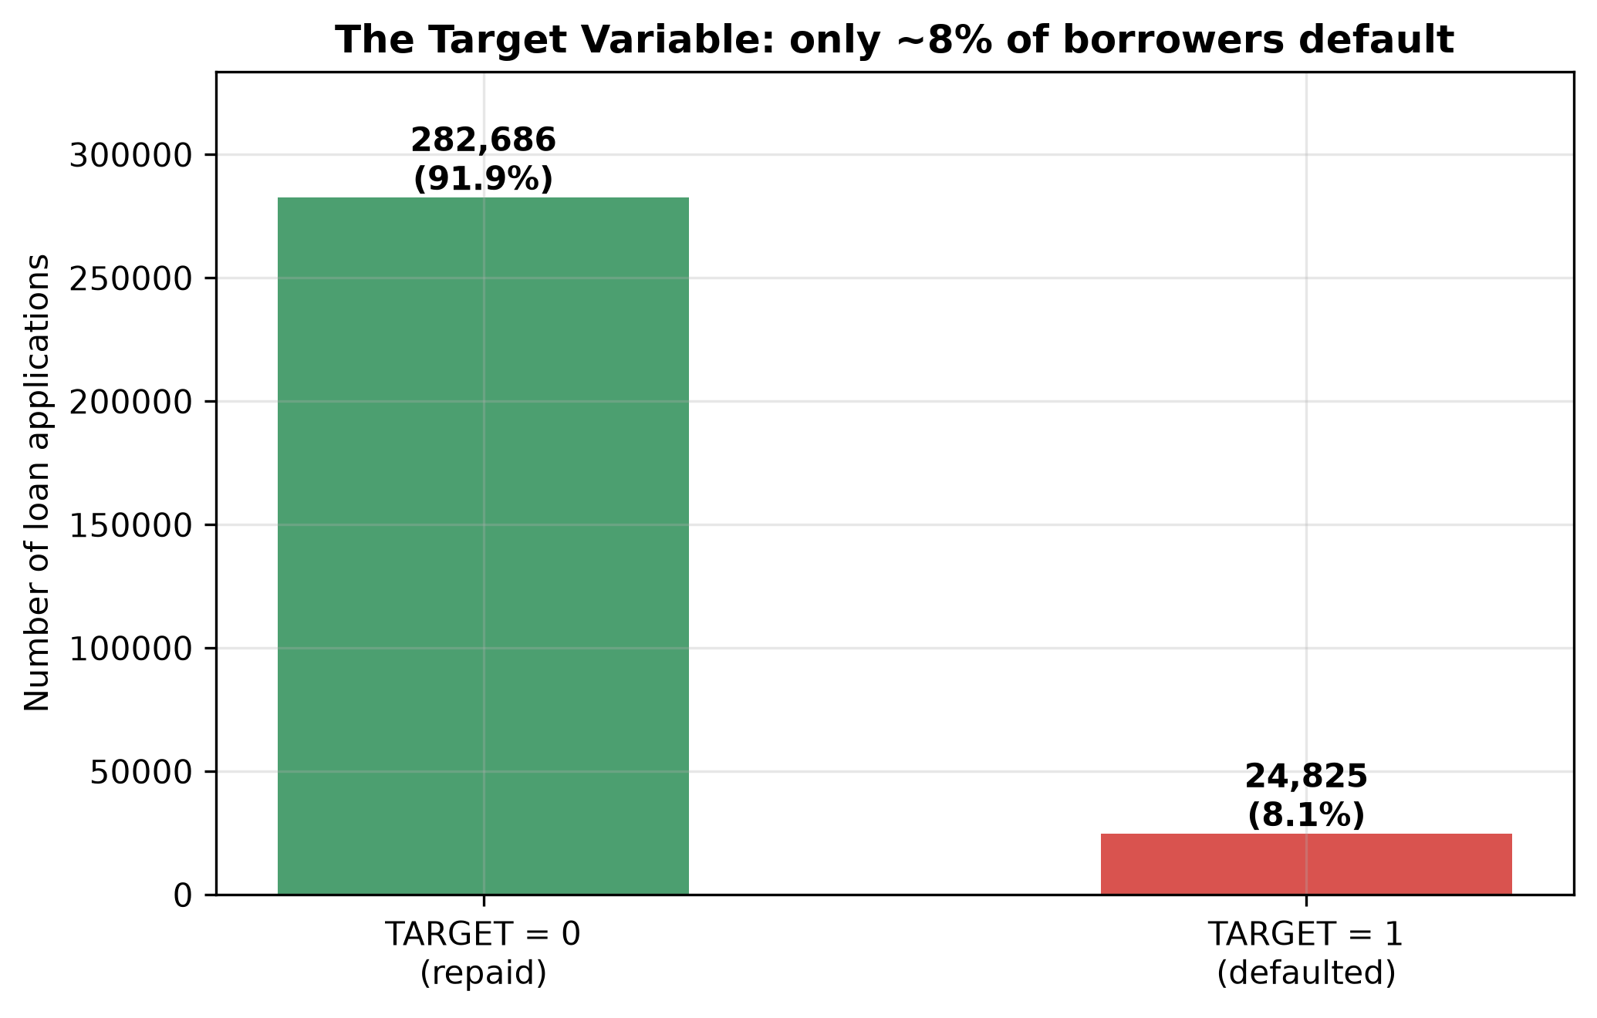
Figure 3.2: Target distribution: 91.9% of applications were repaid, 8.1% resulted in default.

3.3.2 Temporal structure
Applications span 2015 to 2020, but the volume is concentrated in 2018–2020. The temporal split used the application date: 2018–2019 applications (205,007 rows, 8.12% default) form the training window and 2020 applications (102,504 rows, 7.98% default) form the out-of-time test. The default rates of the two periods are close, indicating no dramatic drift in the base rate, although drift in feature distributions is still possible and is exactly what the out-of-time track tests.

3.3.3 Anomalies: the DAYS_EMPLOYED sentinel
The most important anomaly discovered is a sentinel value in DAYS_EMPLOYED: 55,374 rows (18.01%) carry the value 365,243, which corresponds to one thousand years of employment and is physically impossible. Investigation showed that this value is a placeholder for applicants who are not employed (pensioners and the unemployed), and that the sentinel group has a materially different default rate from genuinely employed applicants. Figure 3.3 shows the effect of the sentinel on the raw distribution. The correct treatment is not deletion but recoding: the sentinel was replaced with a missing value and a binary flag DAYS_EMPLOYED_ANOM was created to preserve the information that the applicant is not in employment. Deleting these rows would have discarded 18% of the data and a genuinely predictive signal.
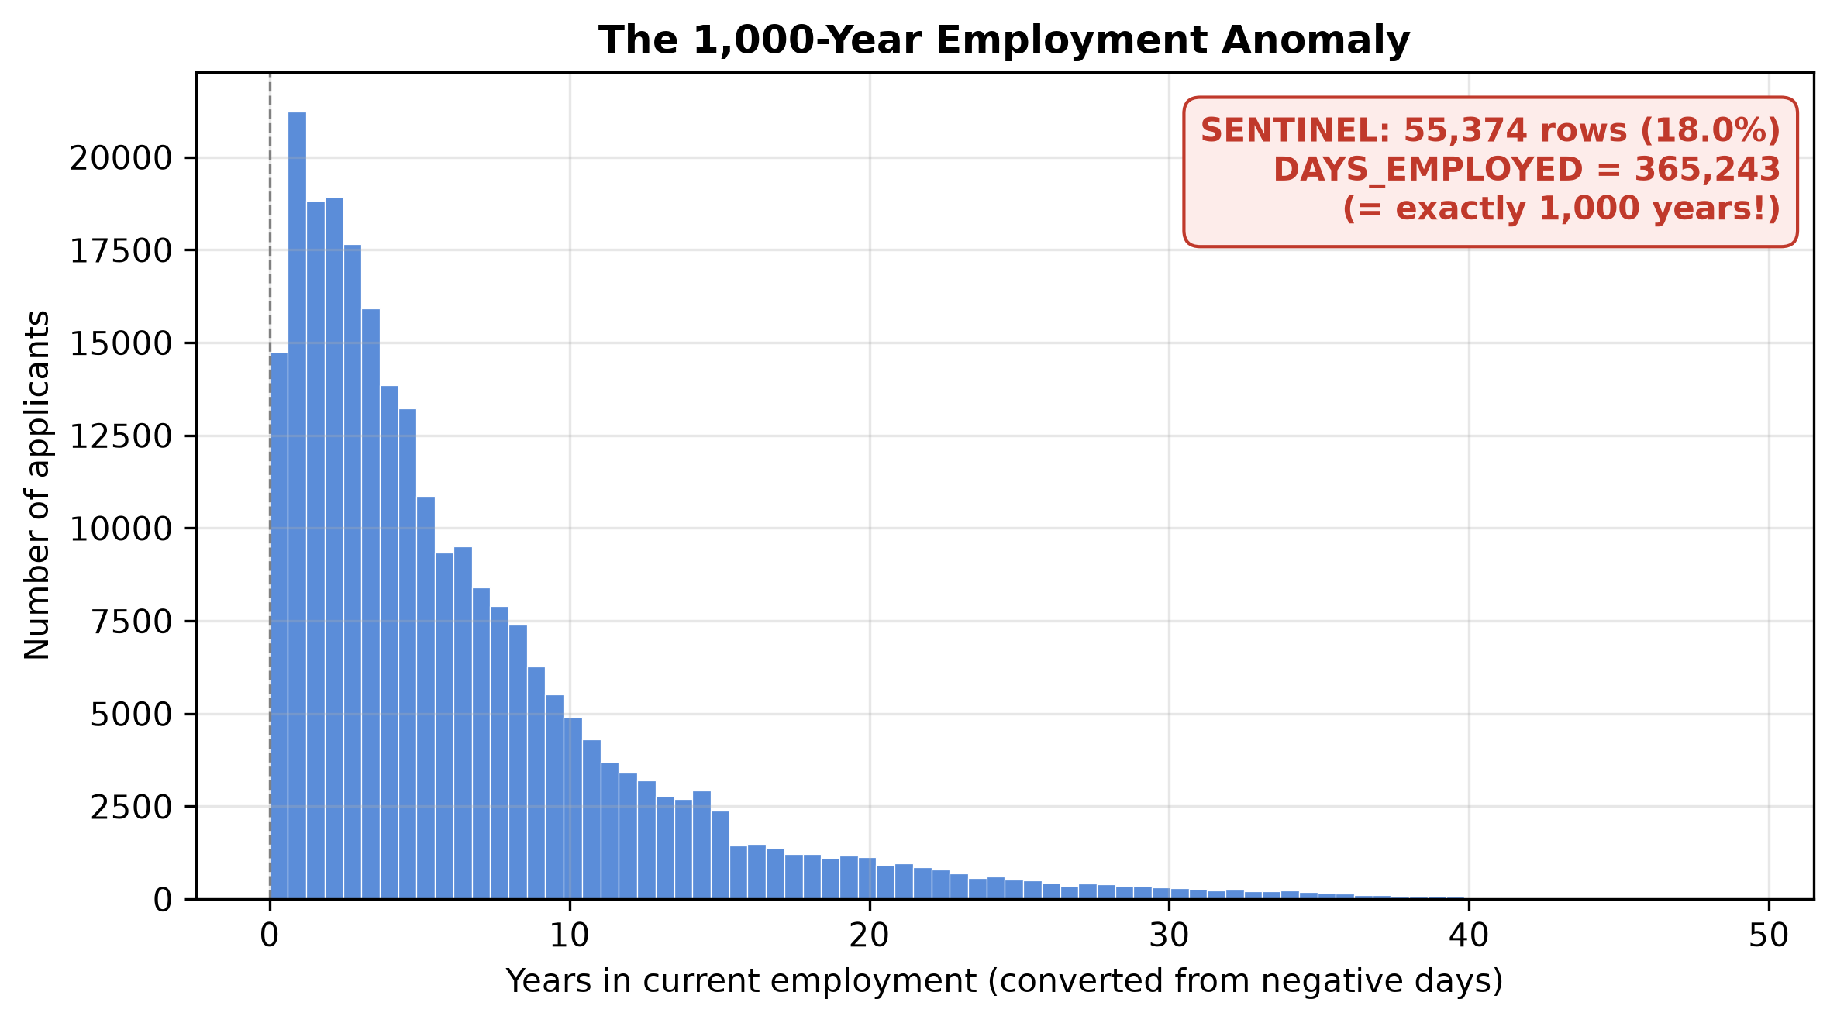
Figure 3.3: The DAYS_EMPLOYED sentinel at 365,243 days dominates the raw distribution; it is a placeholder for non-employed applicants.
This sentinel has a subtle secondary effect on correlation analysis. In the raw data, DAYS_EMPLOYED correlates with FLAG_EMP_PHONE at r = −0.9998, which would normally justify dropping one of the two as redundant. After sentinel correction the correlation collapses to approximately 0.002, as shown in Figure 3.4. The near-perfect raw correlation is a pure artefact of the placeholder. This finding was decisive: FLAG_EMP_PHONE was retained in the feature set, and the episode is reported here because it demonstrates how a single data-quality issue can corrupt feature-selection decisions if EDA is performed on uncleaned data.
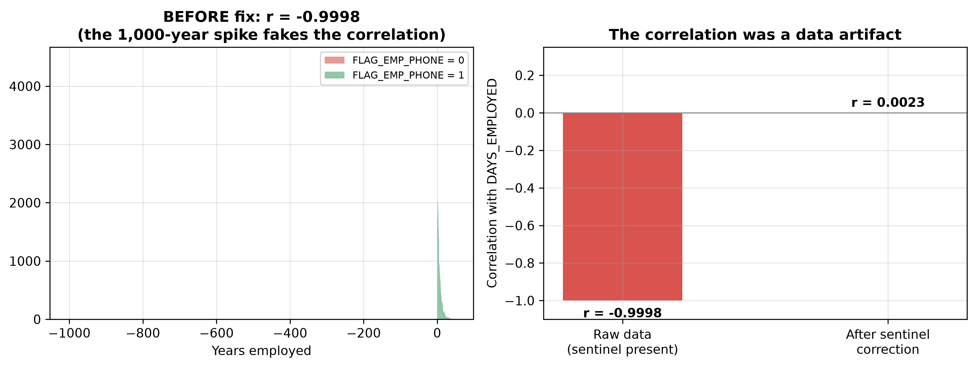
Figure 3.4: Correlation between DAYS_EMPLOYED and FLAG_EMP_PHONE before and after sentinel correction: the raw correlation of −0.9998 is a sentinel artefact; the true association is negligible.

3.3.4 Outliers and income
Income exhibited extreme outliers: a small number of applications reported annual incomes above one million currency units. The 99.9th percentile of income computed on the training years only is $900,000, and 278 applications exceed it. Winsorization — capping values at this percentile rather than deleting rows — was chosen because the extreme values are implausible but the affected applicants are otherwise valid records. Figure 3.5 shows the income distribution and the effect of the cap. Computing the cap on training years only is one of the leakage controls of Section 3.1.3.
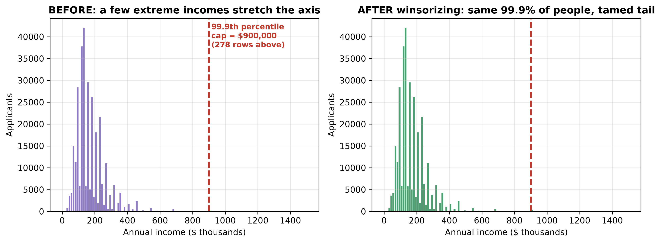
Figure 3.5: Income distribution with the winsorization cap at $900,000 (99.9th percentile of the training years); 278 applications are clipped.

3.3.5 External bureau scores
The three EXT_SOURCE variables are external credit-bureau risk scores and, as EDA confirmed, the strongest individual predictors of default: each correlates with the target more strongly than any raw application variable, and their distributions differ markedly between defaulters and repayers (Figure 3.6). All three contain substantial missingness (between roughly 18% and 44%), which is handled by imputation in the preprocessing pipeline rather than by row deletion. Their dominance is important context for both the modelling results and the SHAP analysis of Chapter 5.
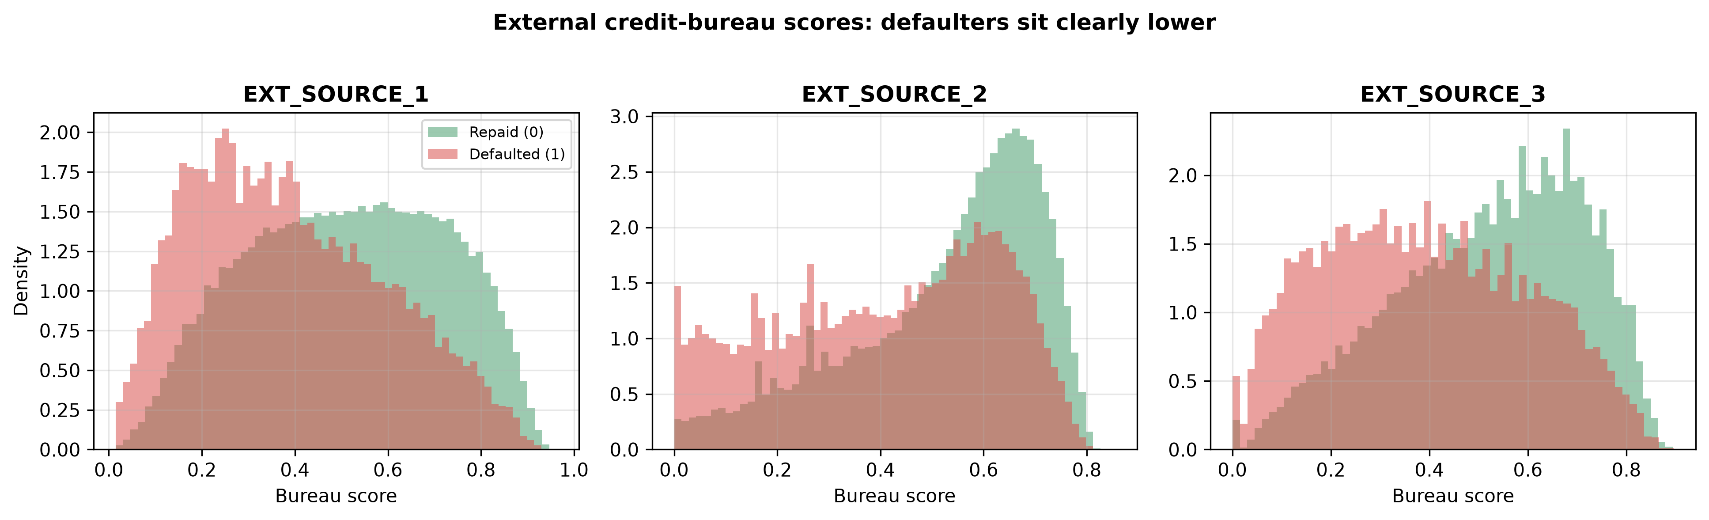
Figure 3.6: Distributions of the three external bureau scores for repaid applications (blue) and defaults (red). Lower scores are associated with default.

3.3.6 Redundancy among building features
The dataset contains descriptions of the applicant's building in three parallel variants — average, median and mode — for each of fourteen attributes (for example APARTMENTS_AVG, APARTMENTS_MEDI, APARTMENTS_MODE). Correlation analysis (Figure 3.7) showed the median and mode variants to be near-duplicates of the average variants, with correlations typically above 0.97. Retaining all three variants would add collinear noise and inflate the one-hot feature space without information gain. The decision was therefore to keep the average variant of each attribute and drop the 28 median and mode variants, with one exception: TOTALAREA_MODE was retained because it is the only total-area signal and has no average counterpart.
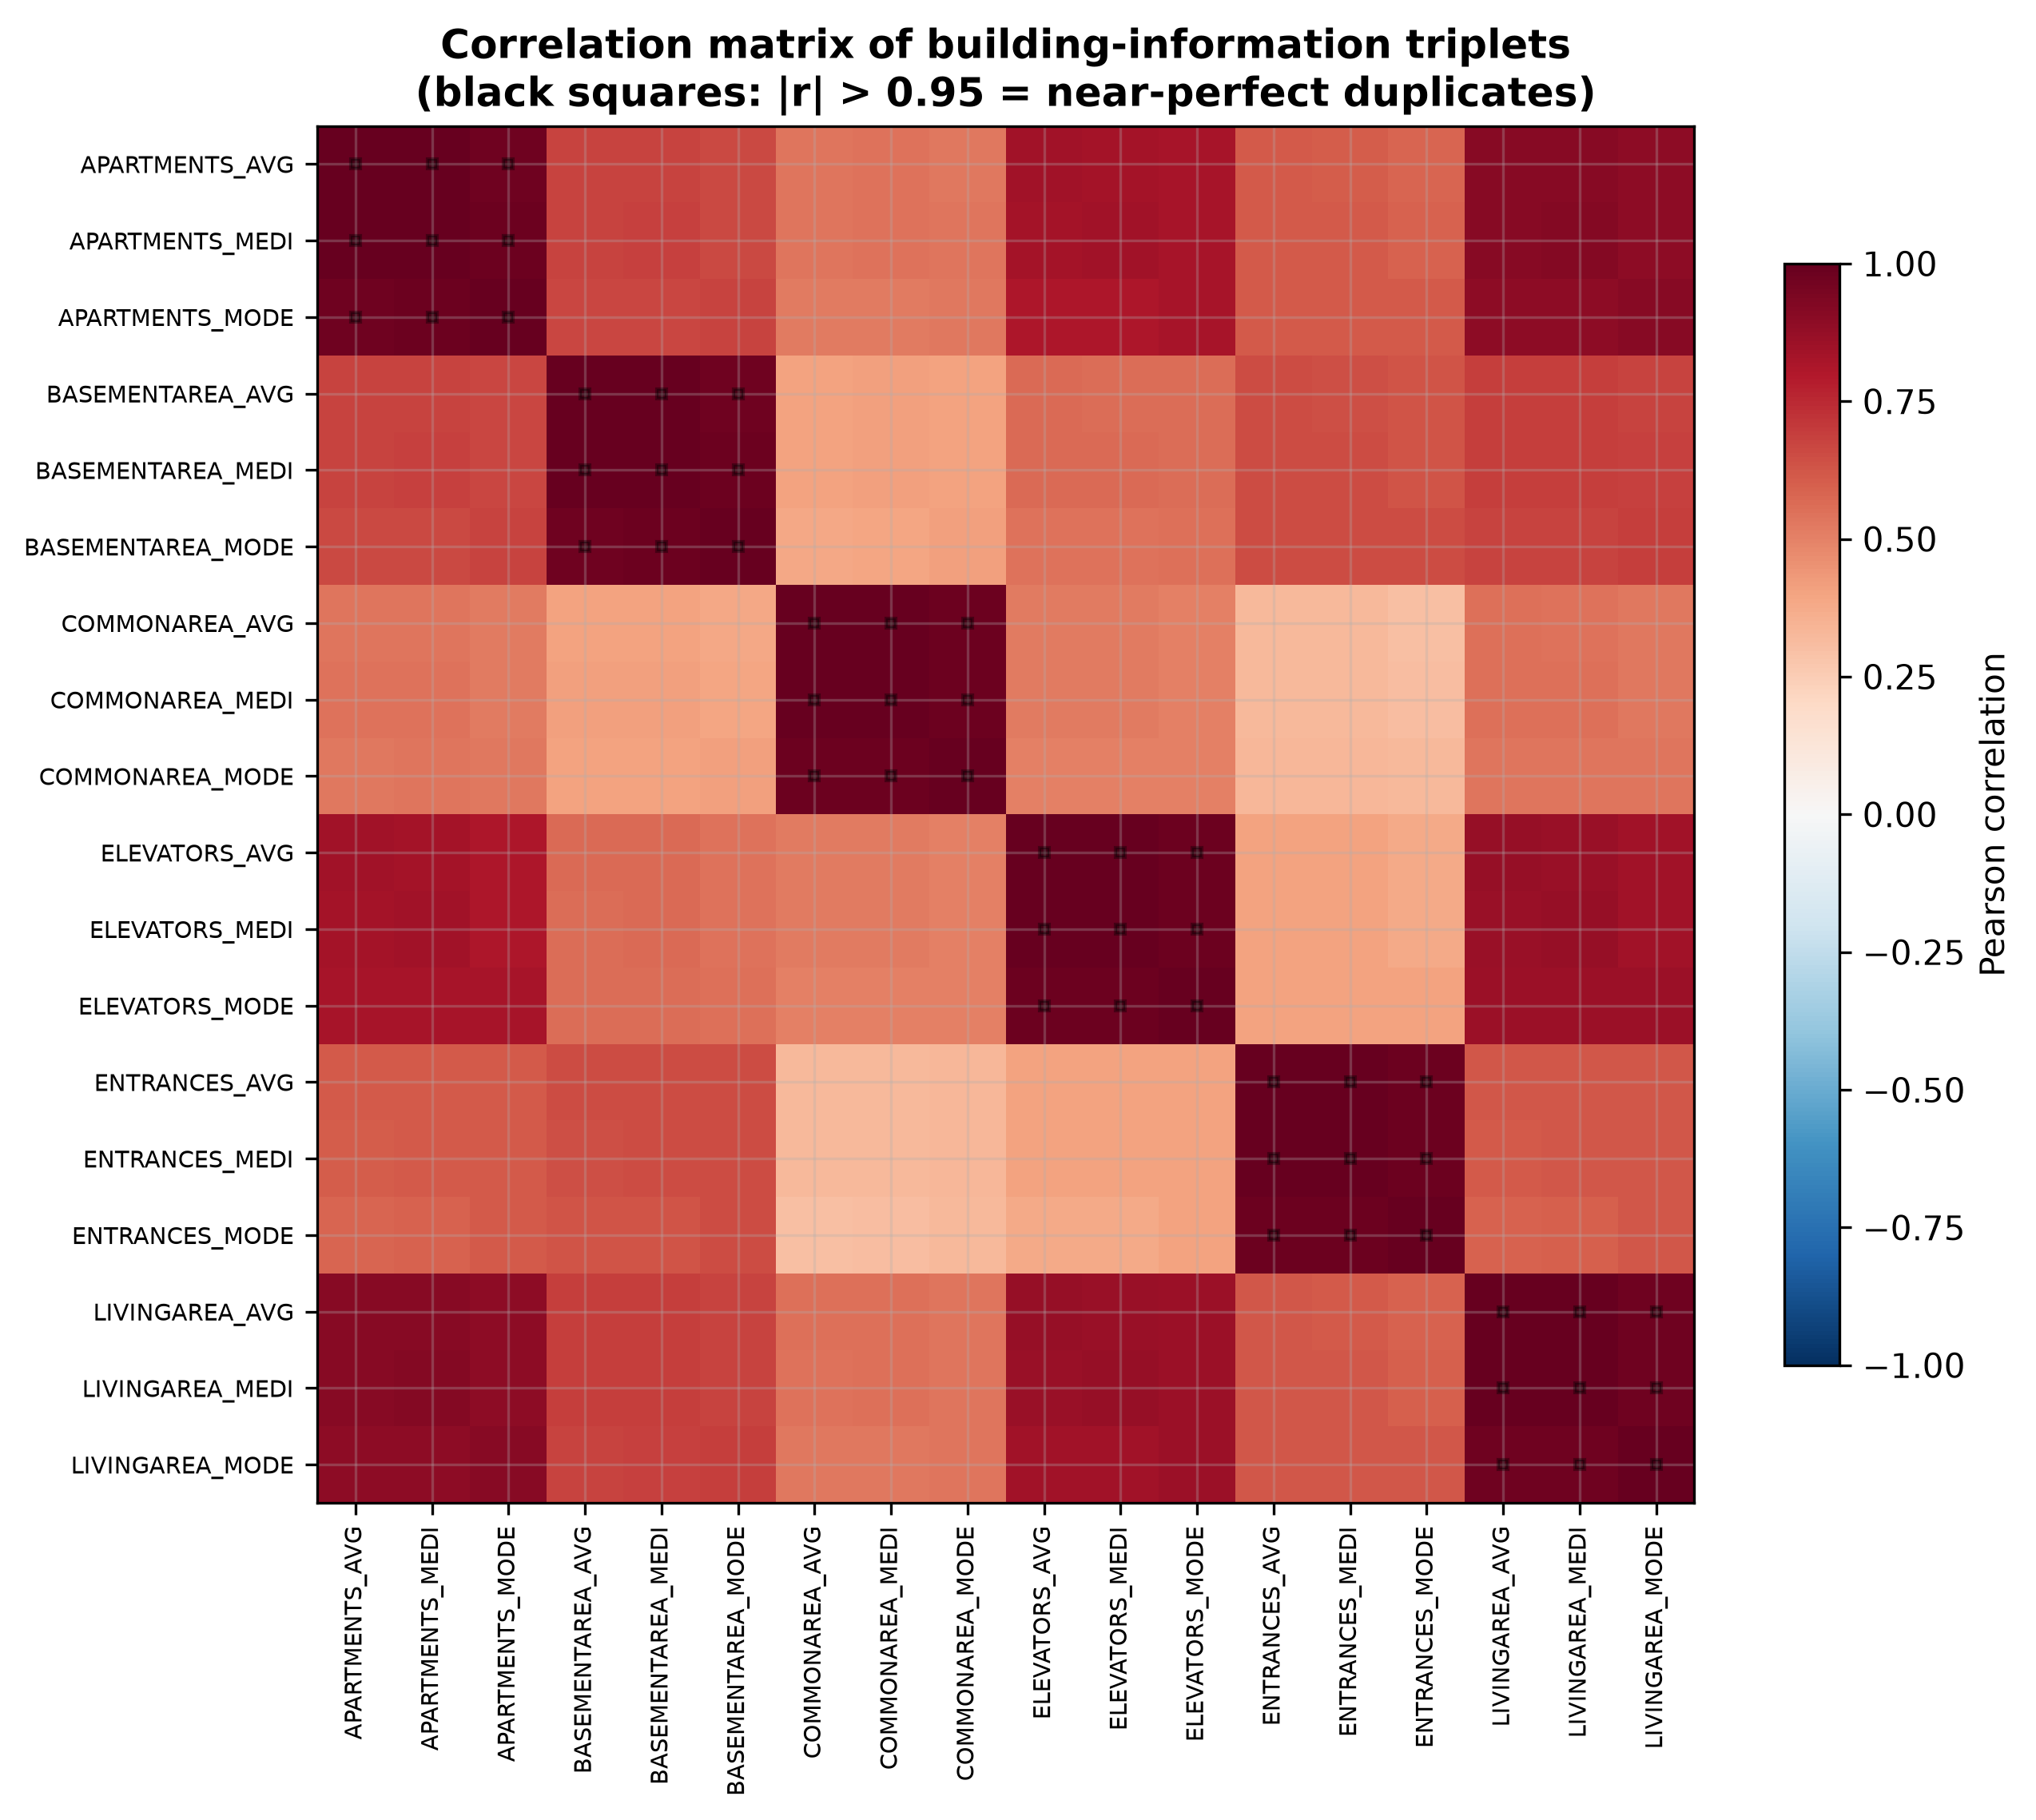
Figure 3.7: Correlation structure of the building-feature triplets: median and mode variants are near-duplicates of the average variants.
A similar redundancy was found in the social-circle features: the 60-days-past-due variants correlate with the 30-day variants at 0.999 (observations) and 0.864 (defaults), so the two 60-day columns were dropped. In total, 30 redundant columns were removed before modelling.

3.4 Preprocessing and Feature Engineering

3.4.1 Cleaning pipeline
The cleaning pipeline executes the following steps in order. First, the DAYS_EMPLOYED sentinel is replaced with a missing value and the DAYS_EMPLOYED_ANOM flag is created. Second, income is winsorized at the training-derived cap of $900,000. Third, the ORGANIZATION_TYPE variable, which has 58 fine-grained categories, is grouped into 11 sectors (such as Industry, Trade, Transport, Education/Healthcare) plus a Missing category, reducing sparsity in the one-hot encoding. Fourth, the token XNA appearing in CODE_GENDER is converted to a missing value. Fifth, the 30 redundant columns identified in EDA are dropped.

3.4.2 Engineered features
Twenty domain features were engineered from the cleaned variables. Financial-burden ratios capture repayment pressure: credit-to-income ratio, annuity-to-income ratio, payment rate (annuity over credit), goods-to-credit ratio, the difference between credit and goods price, and income per household member. Tenure features convert day counts into interpretable scales: age in years, employment length in years, employment as a percentage of adult life, and ratios of phone-change, registration and ID-publish recency to age. The bureau scores were aggregated into their mean, standard deviation, minimum, maximum and all pairwise and triple products, because interactions between bureau scores are a known source of predictive power in this dataset. Finally, a count of provided verification documents was created from the document flags. After engineering and one-hot encoding, the modelling space comprises 196 features (97 numeric, the remainder one-hot dummies from 16 categorical variables).

3.4.3 Preprocessing inside the pipeline
Numerical features are imputed with the median and scaled with a robust scaler, which uses the median and interquartile range and is therefore resistant to residual outliers. Categorical features are imputed with a constant Missing value and one-hot encoded with unknown categories ignored at transform time, so that categories appearing only in the test period cannot break the pipeline. All of this is wrapped in a column transformer that is fitted on training data only — on the training fold inside cross-validation, and on the full 2018–2019 window for the out-of-time track — and then applied unchanged to held-out data.

3.5 Modelling Pipeline
Each of the nine configurations is trained and evaluated identically except for the imbalance intervention. In the baseline condition the model is fitted on the original training distribution. In the cost-sensitive condition, Logistic Regression and Random Forest receive balanced class weights (inversely proportional to class frequencies) and XGBoost receives scale_pos_weight equal to the ratio of negative to positive training examples, computed on the training data of the current fold or window. In the SMOTE condition, the training features are oversampled with SMOTE using five nearest neighbours, applied once per fold and shared by all three SMOTE cells, and the models are fitted on the resampled data with their baseline hyperparameters. Predictions are produced as calibrated-free probabilities; all metrics are computed from the predicted probability of default. The hyperparameter configurations for the three model families were frozen across all experiments, as documented in Table 3.1.
The pipeline was implemented in Python using pandas and NumPy for data handling, scikit-learn for preprocessing, logistic regression, random forests and evaluation, imbalanced-learn for SMOTE, and XGBoost for gradient boosting. A single seed family derived from seed 42 controls all stochastic components: fold assignment seeds are 42, 1042 and 2042 for the three repetitions, and per-cell model seeds are derived deterministically from the fold seed, so the entire experiment is exactly reproducible.

3.6 Evaluation Metrics
The evaluation battery follows the proposal's commitment to metrics appropriate for imbalanced classification, and accuracy is deliberately not reported as a measure of success. Six families of metrics are computed for every configuration.
ROC-AUC measures the probability that a randomly chosen defaulter receives a higher predicted probability than a randomly chosen repayer; it is threshold-free and summarises ranking quality. PR-AUC is the area under the precision-recall curve, computed by trapezoidal integration; it is adopted as the primary metric because under severe imbalance it is more sensitive to minority-class performance than ROC-AUC, and its natural baseline is the minority prevalence (8%) rather than 0.5. Recall is the proportion of actual defaulters detected at the 0.5 threshold; in this domain it is arguably the most operationally meaningful single number, since an undetected defaulter becomes a loss. Precision is the proportion of flagged applicants who truly default, governing how many declined applications turn out to have been solvent. The F1 score balances the two, and the F2 score weights recall twice as heavily as precision, reflecting that in lending a missed defaulter is the more costly error. Confusion matrices provide the full four-cell picture and are reported as figures for all nine configurations on the out-of-time test.
In addition, an expected-cost metric was defined to connect statistical performance to financial consequence. Each false negative is charged ten cost units and each false positive one unit, reflecting that a missed default loses the outstanding balance plus recovery costs while a false positive loses only the foregone interest. The expected cost per applicant is then (10 × FN + FP) / N. This ratio is a modelling assumption rather than an audited figure from a specific lender, and its sensitivity is examined through a threshold-sweep cost curve in Chapter 4. The choice of champion configuration is made on mean cross-validated PR-AUC, with the other metrics used to characterise the operating point.

3.7 Statistical Testing
Differences between configurations were assessed with paired tests over the fifteen matched cross-validation observations per configuration, pairing by repetition and fold so that each comparison controls for fold difficulty. For every comparison, a paired Student t-test and a Wilcoxon signed-rank test were computed, together with Cohen's d and Hedges' g effect sizes and a 95% confidence interval for the mean difference. Sixteen comparisons were pre-specified: the three pairwise model-family comparisons on both ROC-AUC and PR-AUC, the six within-family imbalance-strategy comparisons on ROC-AUC, the three recall impacts of cost-sensitive learning, and the financial-cost impact for XGBoost. Significance was assessed at α = 0.05 with α = 0.01 reported as a stricter secondary level. Using both a parametric and a non-parametric test guards against distributional assumptions; with n = 15 the Wilcoxon test has genuine resolution, unlike the n = 5 case discussed in Section 3.1.2.

3.8 Explainability Method
SHAP attributions were computed with TreeSHAP, which is exact for tree ensembles, on the champion XGBoost configuration re-fit on the full 2018–2019 window, using a stratified sample of 2,000 applicants drawn from that same training window so that no out-of-time data enters the explanation. For comparison, LinearSHAP attributions were computed on the logistic-regression baseline with a 2,000-row background set. Global importance (mean absolute SHAP value), beeswarm summaries, dependence panels for the three most influential features, and three local case studies — a true positive, a true negative and a false positive — were produced. The case studies emulate adverse-action explanations: for a single applicant, the five features that most influenced the decision are listed with their direction and magnitude.

3.9 Ethical Considerations
Although the project uses only a public, anonymised competition dataset and involves no interaction with human participants, three ethical dimensions were considered and shaped design decisions. In accordance with the University of South Wales Research Ethics Policy (University of South Wales, 2024), a Light Touch Ethical Review application was prepared in consultation with the project supervisors and formally submitted to the MSc Project Coordinator. Formal ethical approval was granted prior to commencing data processing and experimental analysis. As the project relies entirely on pre-existing, anonymised secondary data and involves no human participants, no full ethical review was required.
First, data protection. The dataset contains no direct identifiers: names, addresses and account numbers are absent, and the applicant identifiers are arbitrary integers. The variables nevertheless describe real people's financial circumstances, and several features — gender, education, family status, car and property ownership — are close proxies for protected characteristics. The data were used strictly within the terms of its publication, stored locally, and never shared outside the project. The General Data Protection Regulation's provisions on automated decision-making (European Parliament and Council, 2016) were treated as applicable in spirit even though the study is not itself a decisioning system: the explainability work of Chapter 5 was designed to demonstrate exactly the kind of per-applicant reasoning that such regulation demands.
Second, fairness. The SHAP analysis revealed that demographic indicators carry non-negligible influence on the model's predictions. This finding was not suppressed or minimised; it is reported in Chapter 5 and discussed as a governance concern in Chapter 6. A full fairness audit was judged out of scope because the anonymised variables cannot reliably establish protected-group membership, and a superficial audit would risk lending false reassurance. The honest position — flag the concern, state why it cannot be resolved here, and require it before deployment — is taken instead.
Third, responsible reporting. The experimental design was fixed before the results were inspected: the nine configurations, the sixteen statistical comparisons, the metric battery and the champion-selection rule were all defined in the methodology before evaluation ran. This discipline prevents the common failure in which evaluation criteria are quietly adjusted until a preferred outcome emerges, and it is part of what makes the study reproducible rather than merely repeatable.

3.10 Reproducibility
The complete pipeline is delivered as the project artefact: configuration, data preparation, modelling, evaluation, statistical testing and explainability modules; the engineered train and test partitions in Parquet format; all raw per-fold results; summary tables; figures; and execution logs. Two commands reproduce every result in this dissertation: the experiment runner followed by the analysis runner, requiring approximately two and a quarter hours on the development hardware (an Intel Core i3-1115G4 with 8 GB of memory). The modest hardware requirement was itself a design goal: the experiment must be re-runnable by an examiner without specialist infrastructure; software library versions are documented in Table D.1 (Appendix D).
A further reproducibility safeguard concerns the SMOTE condition. SMOTE is stochastic: the synthetic examples depend on random neighbour selection, and a naive implementation would introduce a second source of variation into comparisons that are meant to isolate the imbalance intervention alone. The pipeline therefore applies SMOTE once per fold, with a fixed seed, and shares the identical resampled training set across all three SMOTE cells of that fold. The three SMOTE models thus differ from one another only by model family, never by the particular synthetic examples they saw, and the SMOTE-versus-baseline comparisons are comparisons of the intervention itself rather than of one random resample against another.
The logs written during execution record the start and end time of every configuration, the fold sizes, and the metric values as they were computed, providing an audit trail that can be checked against the summary tables without re-running anything. Together, the seed family, the shared SMOTE resamples, the frozen hyperparameters and the logs mean that every number in this dissertation is traceable to a deterministic computation.

4 Results
This chapter presents the results of the 9-cell experiment. Section 4.1 reports the in-time cross-validation results, Section 4.2 the out-of-time results, Section 4.3 the statistical significance battery, Section 4.4 the operating-point behaviour revealed by the confusion matrices and the cost analysis, and Section 4.5 summarises the findings against the research questions.

4.1 In-Time Results: 3×5 Repeated Cross-Validation
Table 4.1 shows the mean performance of all nine configurations over the fifteen cross-validation folds, sorted by the primary metric (PR-AUC).
Table 4.1: In-time cross-validation results (mean over 15 folds, 2018–2019)
Configuration | ROC-AUC | PR-AUC | Recall@0.5 | Precision@0.5 | F2 | Cost/applicant
XGBoost (Baseline) | 0.7622 ± 0.0046 | 0.2502 ± 0.0051 | 0.020 | 0.568 | 0.025 | 0.796
XGBoost (Cost-Sensitive) | 0.7600 ± 0.0045 | 0.2470 ± 0.0050 | 0.643 | 0.178 | 0.423 | 0.530
Random Forest (Cost-Sensitive) | 0.7474 ± 0.0052 | 0.2307 ± 0.0062 | 0.619 | 0.173 | 0.409 | 0.549
Random Forest (Baseline) | 0.7455 ± 0.0050 | 0.2300 ± 0.0067 | 0.001 | 0.634 | 0.001 | 0.811
Logistic Regression (Baseline) | 0.7475 ± 0.0048 | 0.2276 ± 0.0056 | 0.008 | 0.523 | 0.011 | 0.806
Logistic Regression (Cost-Sensitive) | 0.7476 ± 0.0046 | 0.2260 ± 0.0054 | 0.680 | 0.161 | 0.413 | 0.548
XGBoost (SMOTE) | 0.7438 ± 0.0048 | 0.2240 ± 0.0058 | 0.016 | 0.510 | 0.019 | 0.800
Logistic Regression (SMOTE) | 0.7410 ± 0.0046 | 0.2198 ± 0.0046 | 0.663 | 0.160 | 0.407 | 0.556
Random Forest (SMOTE) | 0.7135 ± 0.0051 | 0.1750 ± 0.0037 | 0.218 | 0.222 | 0.219 | 0.697

Three patterns dominate. First, on ranking quality XGBoost leads: its baseline configuration achieves the highest ROC-AUC and the highest PR-AUC, followed by the cost-sensitive variant. Second, the baseline configurations are extreme conservatives at the 0.5 threshold: Random Forest detects only 0.1% of defaulters, Logistic Regression 0.8% and XGBoost 2.0%, despite ROC-AUC values around 0.75–0.76. The models can rank defaulters above non-defaulters reasonably well, but their probability estimates sit far below 0.5 for almost everyone, so the default threshold flags almost nobody. Third, cost-sensitive learning transforms operating behaviour: recall rises to 0.62–0.68 for all three families while ROC-AUC falls by at most 0.002, and the expected cost per applicant drops from roughly 0.80 to roughly 0.53–0.55, a reduction of about one third.
SMOTE behaves differently from cost sensitivity. For XGBoost and Logistic Regression it raises recall only marginally relative to baseline while reducing ranking quality; for Random Forest it is clearly harmful, producing the worst ROC-AUC (0.7135) and the worst PR-AUC (0.1750) of all nine configurations. Section 4.3 confirms that every SMOTE degradation is statistically significant with a large effect size.

4.2 Out-of-Time Results: 2020 Test
Table 4.2 shows the single out-of-time evaluation, in which models fitted on 2018–2019 are applied to the untouched 2020 cohort of 102,504 applications (8,179 defaulters).
Table 4.2: Out-of-time results (train 2018–2019, test 2020, N = 102,504)
Configuration | ROC-AUC | PR-AUC | Recall@0.5 | Precision@0.5 | F2 | Cost/applicant
XGBoost (Baseline) | 0.7669 | 0.2513 | 0.022 | 0.573 | 0.028 | 0.782
XGBoost (Cost-Sensitive) | 0.7661 | 0.2497 | 0.657 | 0.176 | 0.425 | 0.519
Random Forest (Cost-Sensitive) | 0.7531 | 0.2338 | 0.637 | 0.173 | 0.414 | 0.533
Logistic Regression (Cost-Sensitive) | 0.7522 | 0.2298 | 0.685 | 0.159 | 0.413 | 0.540
Logistic Regression (Baseline) | 0.7521 | 0.2320 | 0.008 | 0.519 | 0.010 | 0.792
Random Forest (Baseline) | 0.7506 | 0.2313 | 0.002 | 0.750 | 0.002 | 0.797
XGBoost (SMOTE) | 0.7483 | 0.2278 | 0.014 | 0.542 | 0.018 | 0.788
Logistic Regression (SMOTE) | 0.7459 | 0.2256 | 0.669 | 0.159 | 0.408 | 0.546
Random Forest (SMOTE) | 0.7197 | 0.1752 | 0.222 | 0.217 | 0.221 | 0.685

The ordering of configurations is essentially unchanged from cross-validation, and the absolute values are, if anything, slightly better out of time: the champion XGBoost baseline improves from 0.7622 to 0.7669 ROC-AUC. There is therefore no evidence of temporal degradation between the training window and the 2020 cohort; the ranking ability of the models transfers. The same conservatism pattern holds out of time — the baseline models detect at most 2.2% of the 2020 defaulters at the 0.5 threshold — and cost sensitivity again lifts recall to 0.64–0.69 at negligible ranking cost. Figure 4.1 shows the ROC curves and Figure 4.2 the precision-recall curves for all nine configurations on the out-of-time test; the dashed horizontal line in Figure 4.2 marks the 8% base rate, the performance a model must exceed to be useful at all.
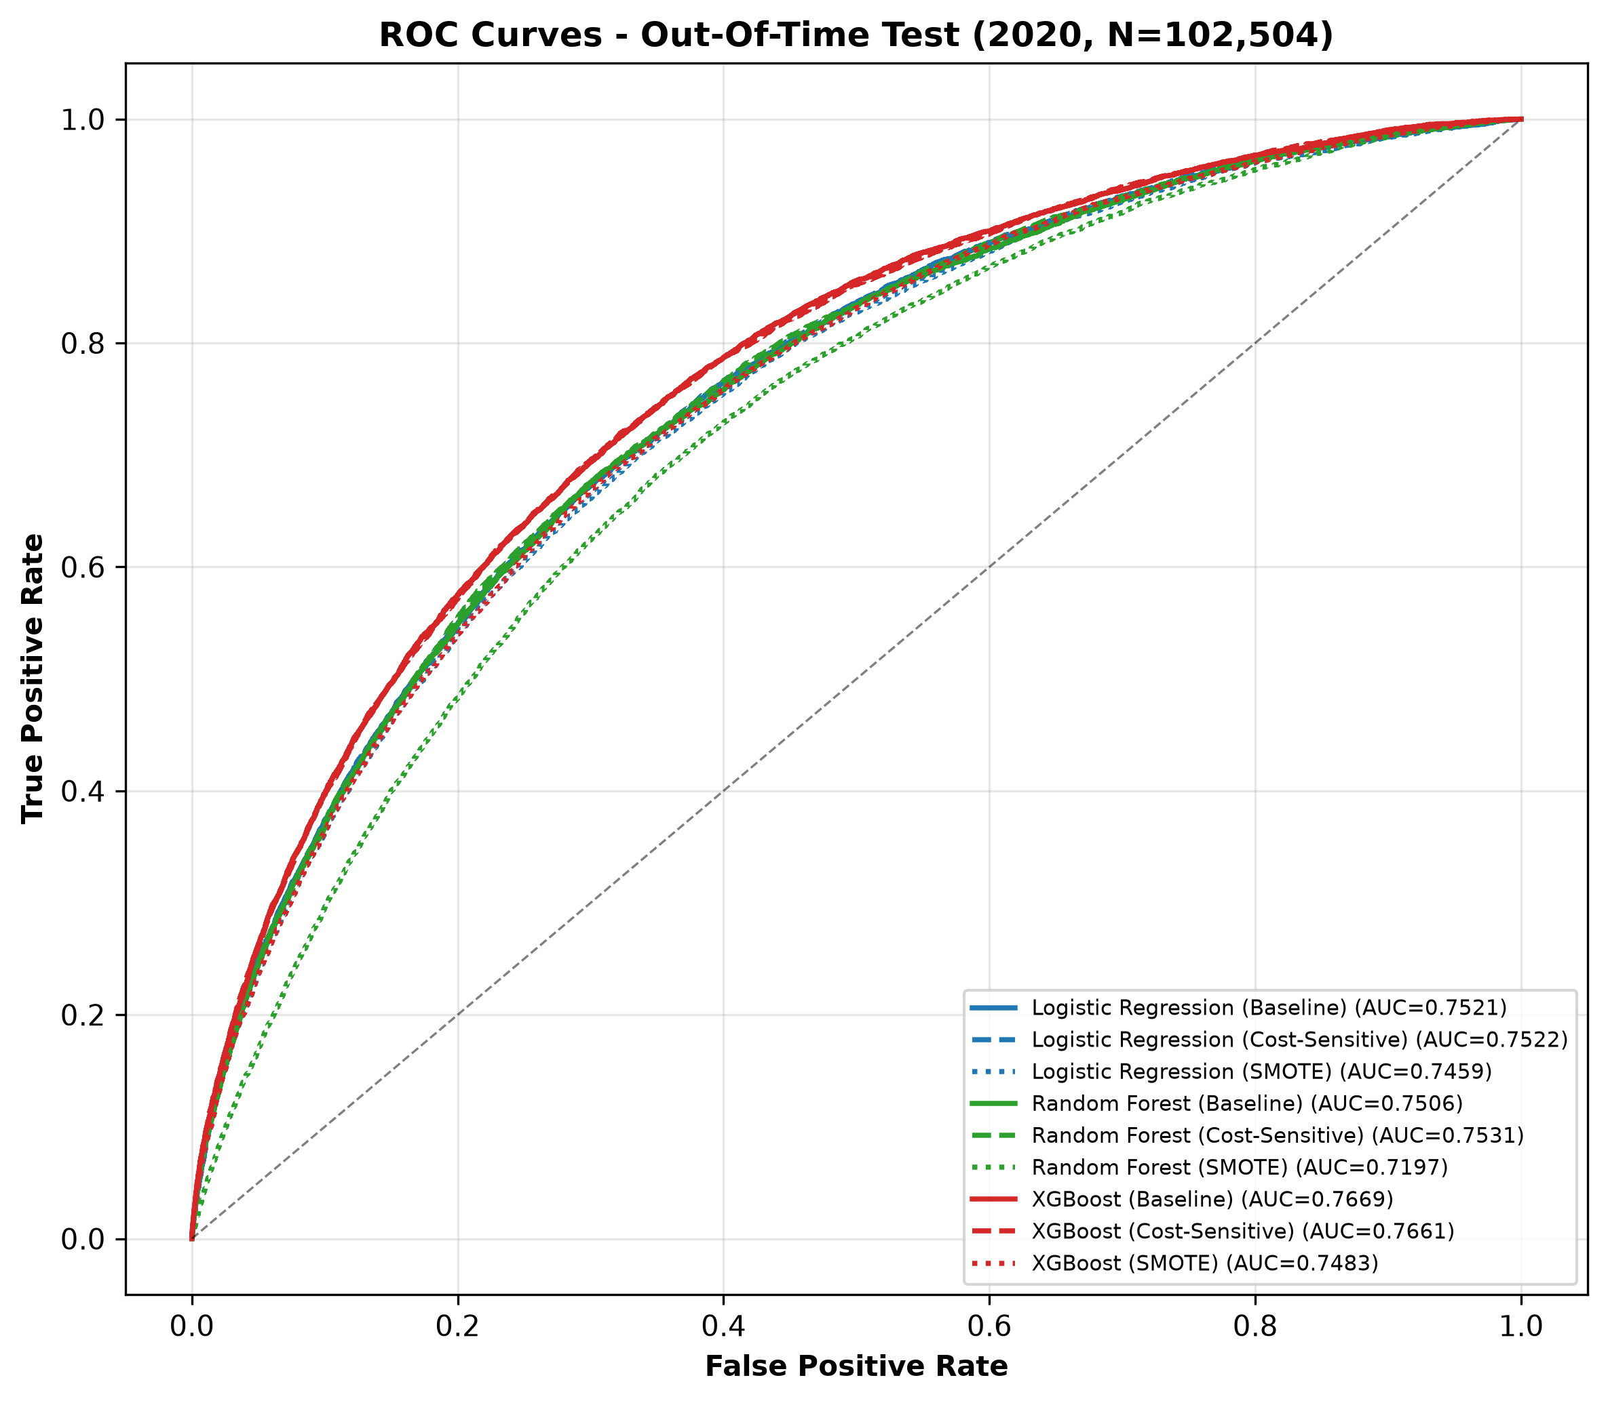
Figure 4.1: ROC curves for all nine configurations on the out-of-time 2020 test. Line style distinguishes imbalance strategy (solid: baseline, dashed: cost-sensitive, dotted: SMOTE) and colour distinguishes model family.
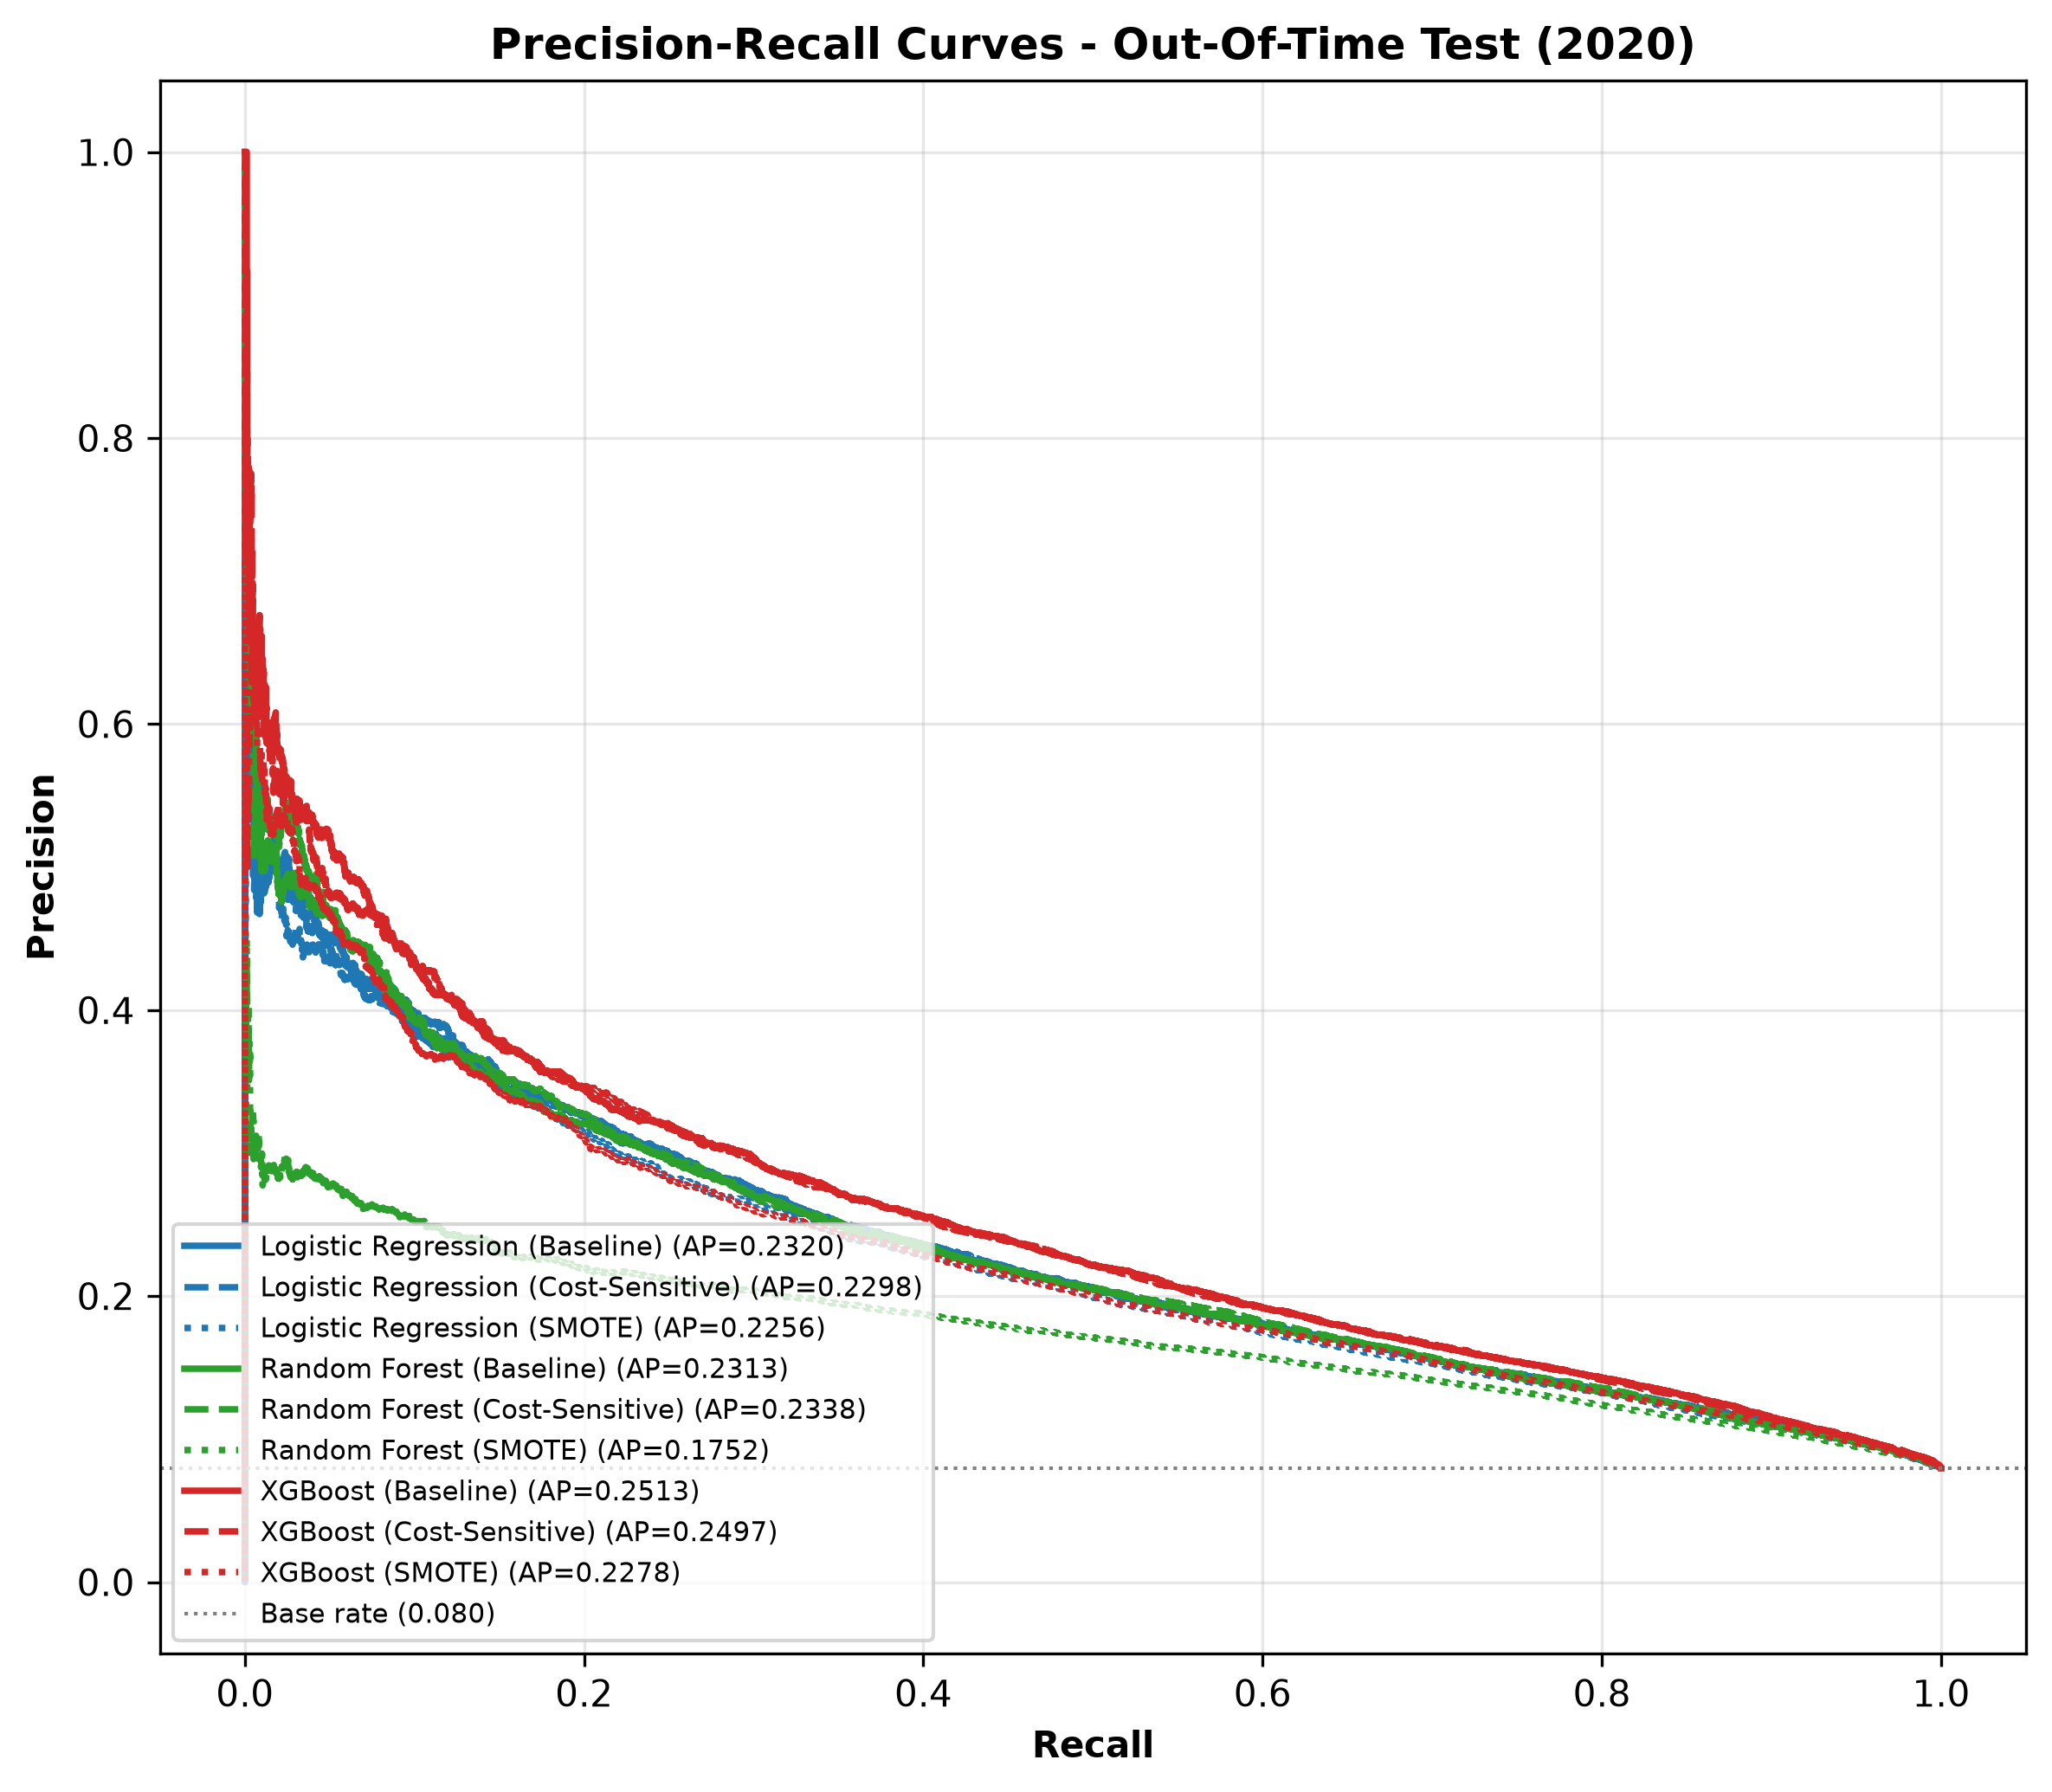
Figure 4.2: Precision-recall curves on the out-of-time 2020 test. The horizontal line marks the 8% base rate; PR-AUC is the primary selection metric.

4.3 Statistical Significance
Table 4.3 summarises the sixteen pre-specified paired comparisons over the fifteen matched cross-validation observations; the full values for both tests are reproduced in Table C.1 of Appendix C. Fifteen of sixteen are significant at α = 0.05 and thirteen at α = 0.01; the single non-significant comparison is discussed below. The test statistics, p-values, and effect sizes across all sixteen paired comparisons are visualised in the significance heatmap of Figure 4.3.
Table 4.3: Statistical comparisons (paired tests, n = 15)
Comparison | Metric | Mean difference | p (t-test) | Cohen's d | Significant
XGBoost vs Logistic Regression (baseline) | ROC-AUC | +0.0147 | 1.0e-13 | 7.27 (Large) | Yes
XGBoost vs Random Forest (baseline) | ROC-AUC | +0.0166 | 1.3e-17 | 13.86 (Large) | Yes
Logistic Regression vs Random Forest (baseline) | ROC-AUC | +0.0020 | 6.4e-05 | 1.45 (Large) | Yes
XGBoost vs Logistic Regression (baseline) | PR-AUC | +0.0226 | 1.1e-15 | 10.06 (Large) | Yes
XGBoost vs Random Forest (baseline) | PR-AUC | +0.0202 | 7.1e-14 | 7.45 (Large) | Yes
Logistic Regression vs Random Forest (baseline) | PR-AUC | −0.0024 | 0.020 | −0.68 (Medium) | Yes
XGBoost Cost-Sensitive vs Baseline | ROC-AUC | −0.0022 | 3.2e-05 | −1.55 (Large) | Yes
XGBoost SMOTE vs Baseline | ROC-AUC | −0.0184 | 1.6e-13 | −7.03 (Large) | Yes
Random Forest Cost-Sensitive vs Baseline | ROC-AUC | +0.0018 | 2.4e-07 | 2.39 (Large) | Yes
Random Forest SMOTE vs Baseline | ROC-AUC | −0.0320 | 2.2e-18 | −15.76 (Large) | Yes
Logistic Regression Cost-Sensitive vs Baseline | ROC-AUC | +0.00005 | 0.689 | 0.11 (Negligible) | No
Logistic Regression SMOTE vs Baseline | ROC-AUC | −0.0065 | 7.4e-12 | −5.31 (Large) | Yes
XGBoost Cost-Sensitive vs Baseline | Recall | +0.622 | 1.4e-27 | 71.4 (Large) | Yes
Random Forest Cost-Sensitive vs Baseline | Recall | +0.618 | 2.4e-28 | 81.1 (Large) | Yes
Logistic Regression Cost-Sensitive vs Baseline | Recall | +0.672 | 3.7e-28 | 78.6 (Large) | Yes
XGBoost Cost-Sensitive vs Baseline | Cost/applicant | −0.266 | 1.5e-23 | −36.9 (Large) | Yes

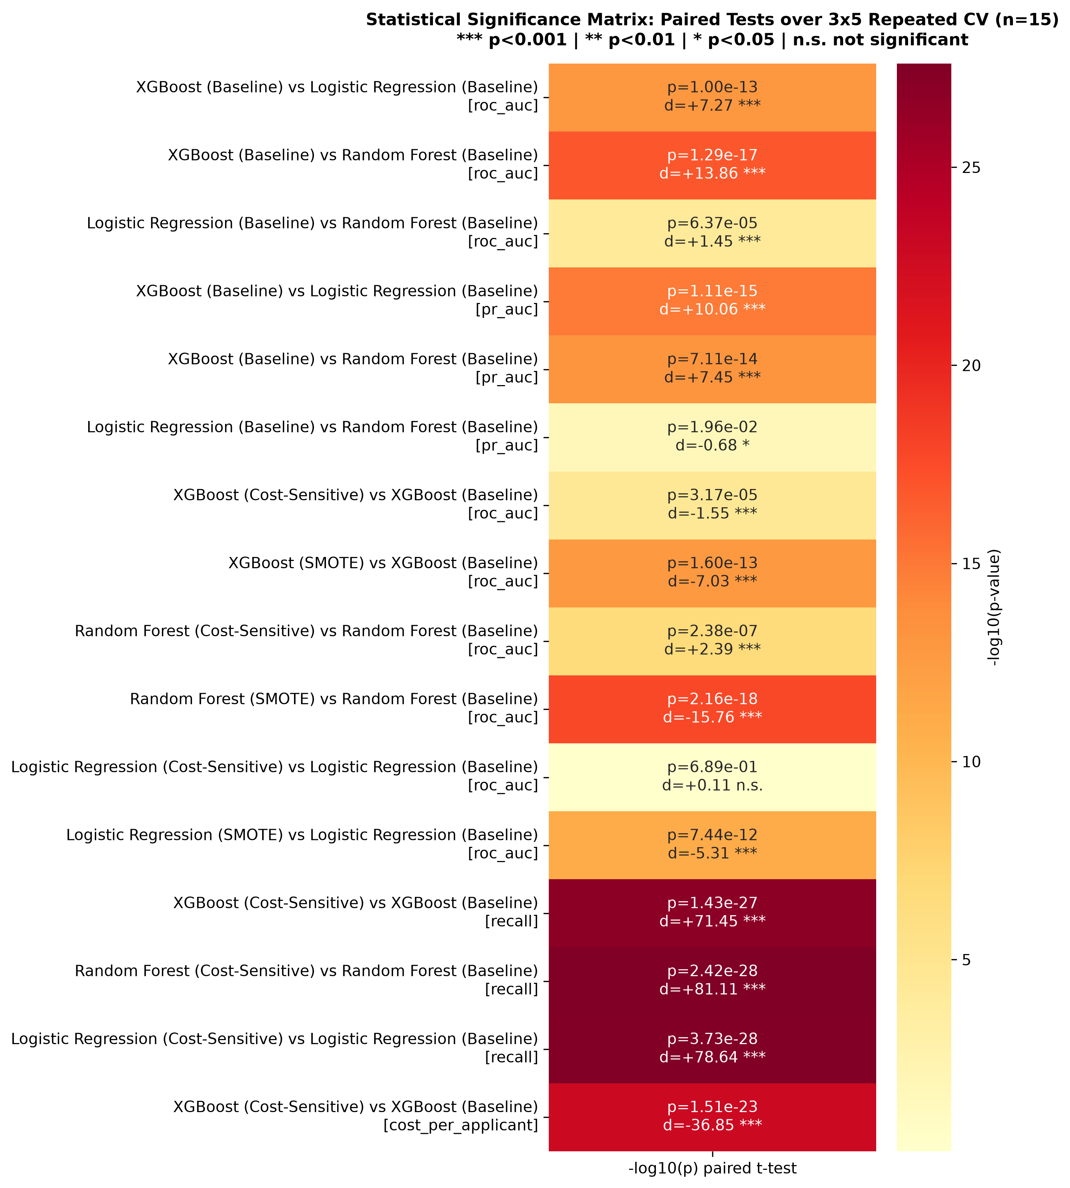
Figure 4.3: Significance heatmap of the sixteen paired comparisons: −log10(p) from the paired t-test with Cohen's d annotations. All comparisons are significant at α = 0.05 except the effect of cost sensitivity on logistic regression ROC-AUC.
Four findings deserve emphasis. First, the model-family ranking is unambiguous: XGBoost beats both alternatives on both ranking metrics with large effect sizes, and Logistic Regression beats Random Forest, reversing the naive expectation that the more complex ensemble must be better. Second, the effect of cost sensitivity on ranking is tiny in every family (at most −0.0022 ROC-AUC for XGBoost, and not statistically distinguishable from zero for Logistic Regression), yet its effect on recall is enormous (+0.62 to +0.67, p < 1e-27). Cost sensitivity therefore buys a thirty-fold increase in default detection essentially for free in ranking terms. Third, SMOTE is significantly harmful in every family, most severely for Random Forest (−0.032 ROC-AUC, d = −15.8). Fourth, the financial-cost comparison confirms the decision-analytic reading: cost-sensitive XGBoost reduces expected cost per applicant by 0.266 units relative to the baseline, a 33% reduction, with overwhelming significance.

4.4 Operating Points: Confusion Matrices and Cost
Figure 4.4 shows the confusion matrices of all nine configurations on the out-of-time test at the 0.5 threshold; the exact cell counts are reported in Table B.1 (Appendix B). The contrast between the two corners of the matrix is the story of the experiment. The baseline XGBoost flags only 183 of 8,179 defaulters (recall 0.022) while wrongly declining 137 solvent applicants; its precision is high (0.573) precisely because it almost never raises a flag. The cost-sensitive XGBoost flags 5,397 applicants of whom 2,809 are true defaulters (recall 0.657, precision 0.176): it declines roughly 25,000 solvent applicants to catch two thirds of the defaulters. Whether that trade is acceptable is a business decision, but the expected-cost metric with a 10:1 false-negative penalty says it is: 0.519 cost units per applicant versus 0.782 for the baseline.
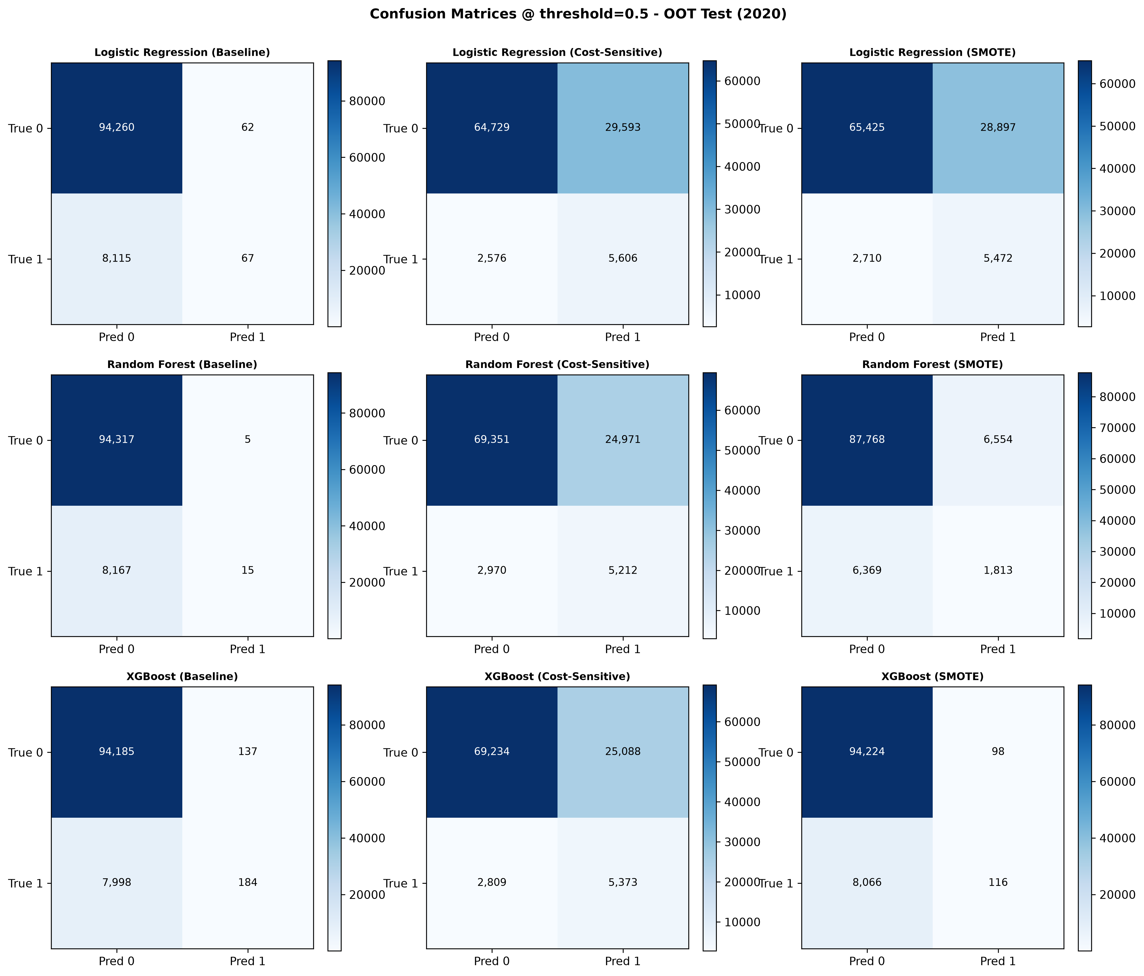
Figure 4.4: Confusion matrices for all nine configurations on the out-of-time 2020 test at the 0.5 threshold.
Figure 4.5 sweeps the decision threshold from 0.05 to 0.95 and plots expected cost per applicant for each configuration. The cost-sensitive curves reach their minima at substantially lower thresholds than the baseline curves, and their minima are lower; the SMOTE curves sit between. The figure makes explicit that the fixed 0.5 threshold used for the tabulated metrics is a convention for comparability, not a recommendation: a lender adopting any of these models would choose its operating threshold from a curve of this kind using its own loss ratio.
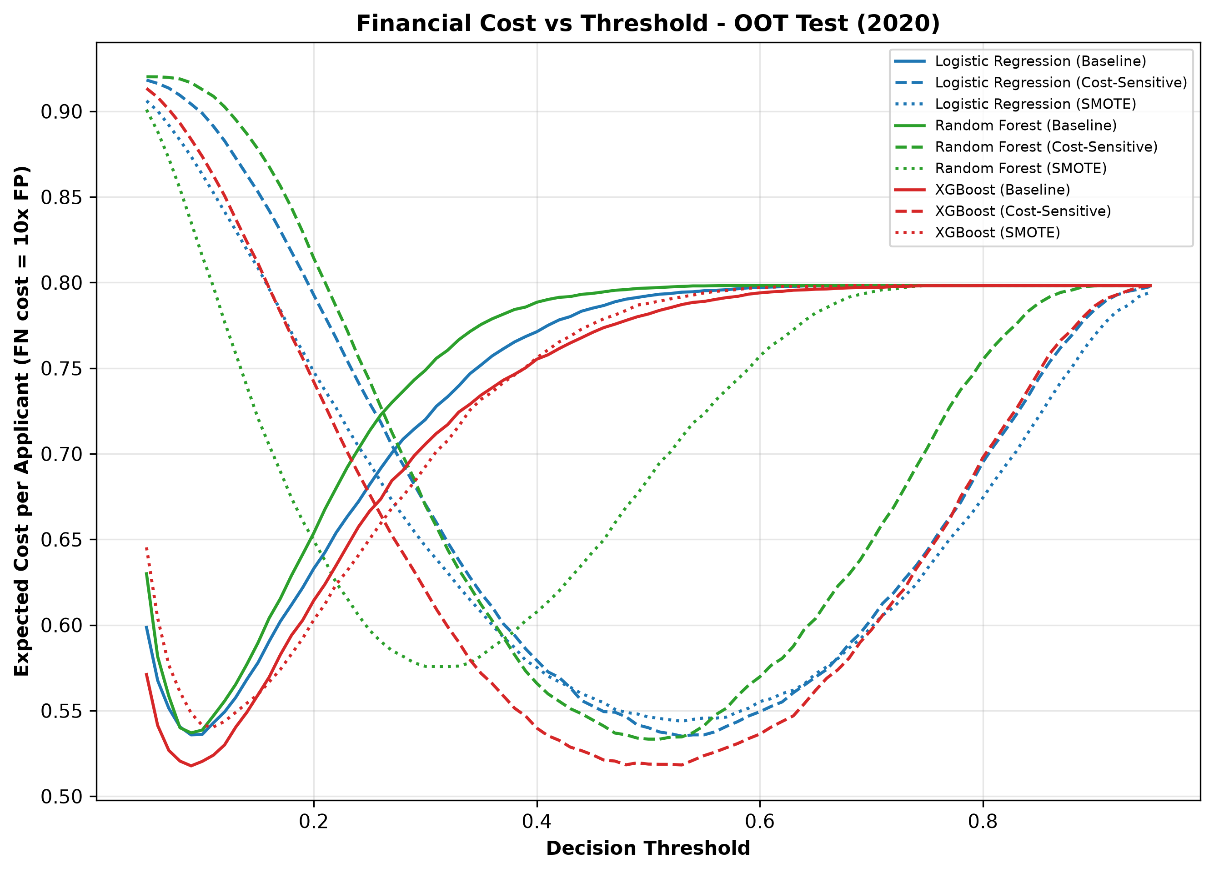
Figure 4.5: Expected cost per applicant as a function of the decision threshold on the out-of-time test (false negative charged 10× a false positive). Cost-sensitive configurations achieve lower minimum cost at lower thresholds.
A final observation concerns accuracy, reported here only to demonstrate why it was excluded as a headline measure. Derived from the confusion-matrix counts, the baseline configurations achieve the highest raw accuracy on the 2020 test — XGBoost baseline scores 92.06%, the highest of all nine — precisely because they decline almost everyone, while the cost-sensitive configurations that catch two thirds of defaulters score only 69–73% accuracy. Selecting models by accuracy would therefore have chosen the deployment option that detects 2% of defaulters. This is the empirical content of the proposal's claim that accuracy is misleading under imbalance.

4.5 Summary of Findings
The in-time and out-of-time tracks agree closely, the statistical battery confirms the visible patterns, and the results answer the experimental questions as follows. On model choice, XGBoost is the strongest ranker, but the margin over Logistic Regression is modest (0.015 ROC-AUC) and Random Forest, contrary to expectation, is the weakest family on this data. On imbalance handling, cost-sensitive weighting is unambiguously beneficial for practical default detection, while SMOTE is unambiguously harmful across all three families. On evaluation, the divergence between ranking metrics and threshold-fixed behaviour — and between both and accuracy — demonstrates that no single number can characterise a credit model, which vindicates the multi-metric battery. The champion configuration selected by mean cross-validated PR-AUC is XGBoost (Baseline); the configuration recommended for practical deployment, on cost and recall grounds, is XGBoost (Cost-Sensitive). Chapter 6 reconciles these two statements.

5 Model Explainability
This chapter applies SHAP-based explainability to the champion model, as required by the ninth project objective. Section 5.1 presents the global importance analysis, Section 5.2 the direction and interaction structure of the most influential features, Section 5.3 three local case studies, and Section 5.4 a comparison between tree-based and linear explanations.

5.1 Global Feature Importance
TreeSHAP attributions were computed exactly for the champion XGBoost on a stratified sample of 2,000 applicants from the 2018–2019 training window. Table 5.1 lists the fifteen most influential features by mean absolute SHAP value, which measures each feature's average impact on the predicted log-odds of default.
Table 5.1: Top fifteen features by mean absolute SHAP value (TreeSHAP, XGBoost champion)
Rank | Feature | Mean abs SHAP
1 | EXT_SOURCES_MEAN (bureau score average) | 0.438
2 | PAYMENT_RATE (annuity / credit) | 0.128
3 | GOODS_CREDIT_RATIO | 0.079
4 | EXT_SOURCE_2_3_PROD (bureau interaction) | 0.077
5 | EXT_SOURCES_MAX | 0.073
6 | EXT_SOURCE_3 | 0.069
7 | AMT_ANNUITY | 0.062
8 | DAYS_EMPLOYED_PERCENT | 0.060
9 | CREDIT_GOODS_DIFF | 0.059
10 | Higher-education indicator | 0.059
11 | Female indicator | 0.058
12 | AMT_GOODS_PRICE | 0.056
13 | Male indicator | 0.053
14 | EXT_SOURCES_MIN | 0.046
15 | No-car indicator | 0.044

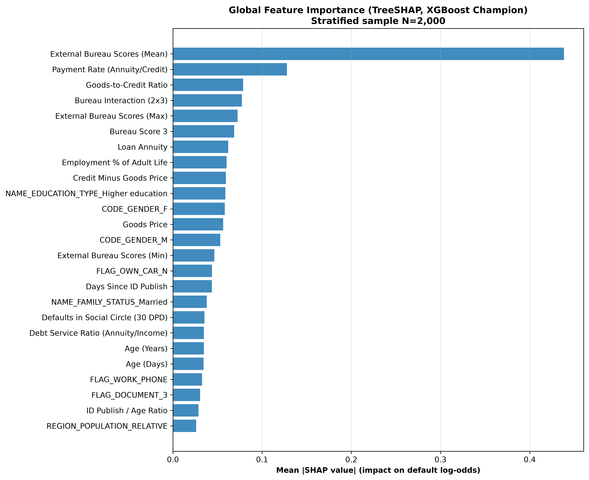
Figure 5.1: Global feature importance for the champion XGBoost: mean absolute SHAP value over the 2,000-applicant stratified sample.
The dominance of the external bureau scores is overwhelming: the average of the three bureau scores alone contributes more than three times the impact of the next most important feature, and bureau-related terms occupy six of the top fifteen positions including an engineered interaction. This confirms quantitatively what the exploratory analysis suggested qualitatively: the strongest signals in the data originate outside the application form itself, in the applicant's credit history as summarised by the bureau. The second tier consists of loan-economics features engineered in this project — payment rate, goods-to-credit ratio and the credit-goods difference — which capture how expensive the requested loan is relative to its stated purpose. Demographic indicators (education, gender, car ownership) appear with modest but non-negligible influence; their presence is discussed from a fairness perspective in Chapter 6.

5.2 Direction and Interaction Effects
The beeswarm plot (Figure 5.2) combines importance with direction: each point is one applicant, the horizontal position is the SHAP value, and colour encodes the feature value. For the bureau-score average, low values (red, left-shifted points) push predictions strongly toward default and high values push them toward repayment — a monotone, interpretable relationship consistent with the bureau score being a measure of creditworthiness. The payment rate shows the same pattern: a higher annuity relative to the credit amount increases predicted risk.
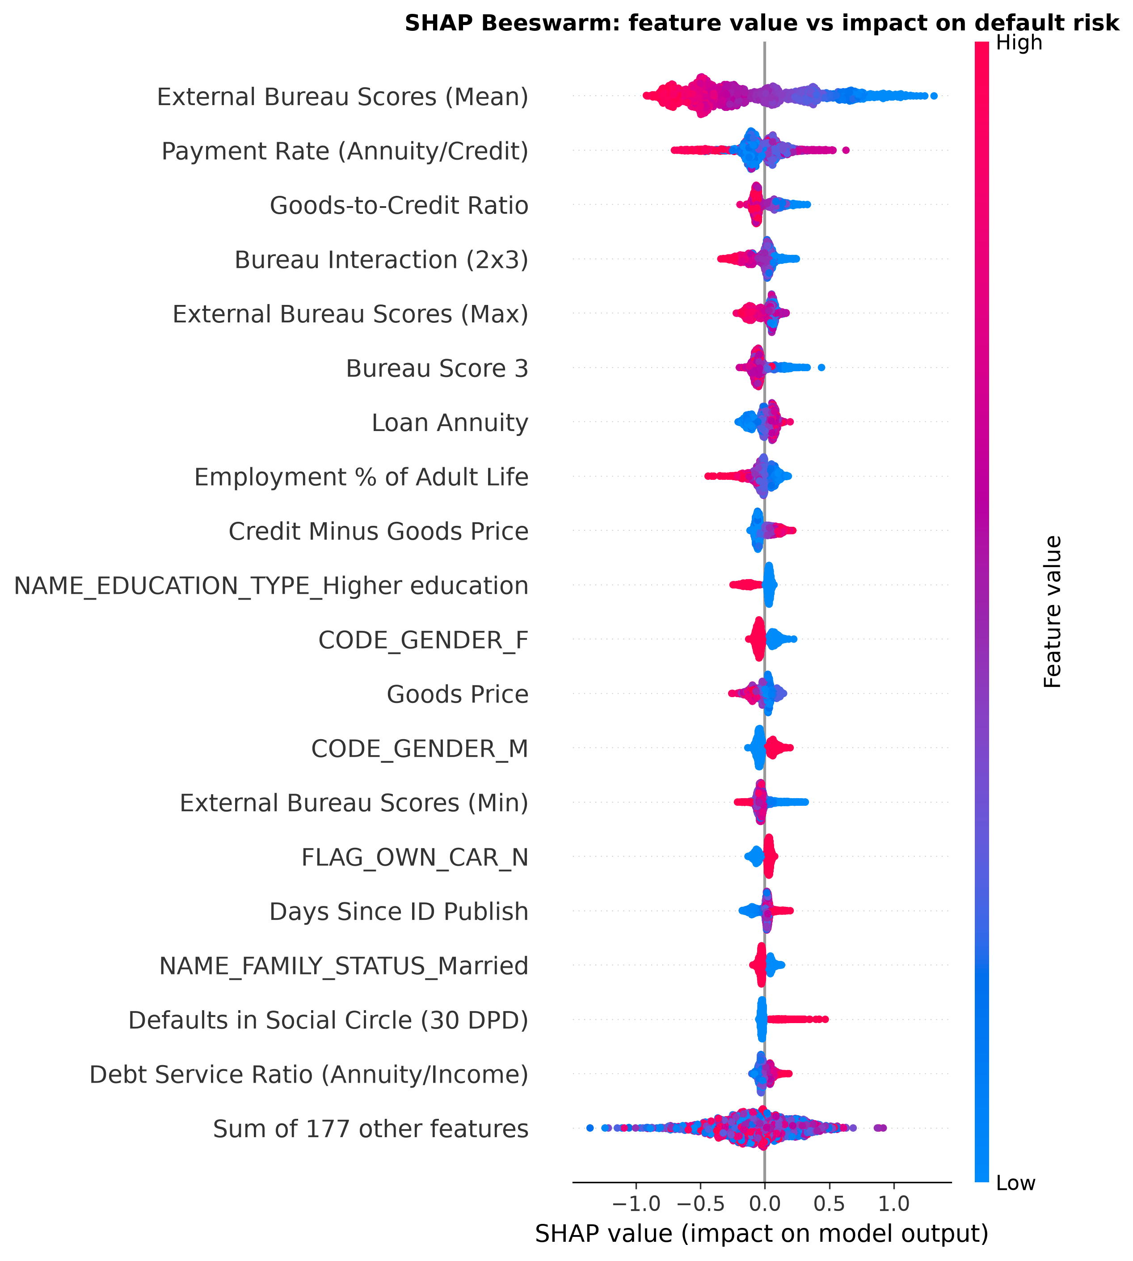
Figure 5.2: SHAP beeswarm for the champion XGBoost: feature value (colour) against SHAP impact (position) for the 20 most important features.
The dependence panels (Figure 5.3) sharpen this picture for the three most influential features. The bureau-score average exhibits a clear non-linear response: its SHAP impact is approximately flat across the middle of its range and steepens at the extremes, which is precisely the kind of non-linearity a logistic regression cannot represent and which explains part of XGBoost's ranking advantage. The engineered interaction term EXT_SOURCE_2_3_PROD ranking fourth globally shows that the tree model exploits products of bureau scores — evidence that the feature-engineering decisions of Section 3.4 captured real structure rather than noise.
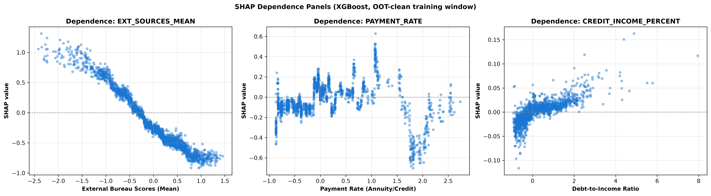
Figure 5.3: SHAP dependence panels for the three most influential features of the champion XGBoost.

5.3 Local Case Studies
Global importance describes the model on average; credit decisions, however, are made one applicant at a time. Three local explanations were therefore produced, chosen to represent the three outcomes that matter operationally: a correctly flagged defaulter (true positive), a correctly approved solvent applicant (true negative), and a borderline false alarm (false positive). Figure 5.4 shows the three waterfall decompositions; Table 5.2 summarises the dominant factors.
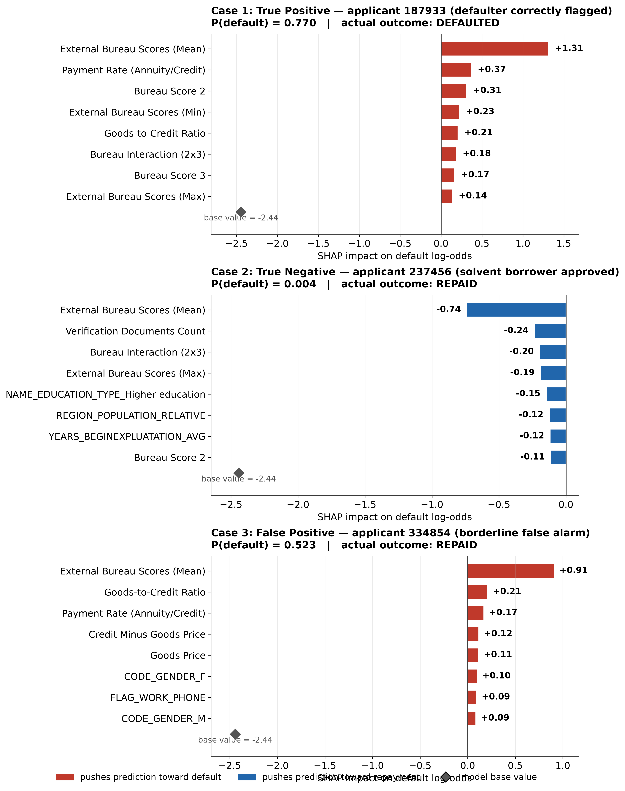
Figure 5.4: Local SHAP explanations for three out-of-sample applicants: a true positive (predicted default probability 0.770, actual defaulter), a true negative (0.004, solvent) and a false positive (0.523, solvent).
Table 5.2: Dominant factors in the three case studies
Case | Applicant | P(default) | Actual | Top factor | Impact
True positive | 187933 | 0.770 | Default | Bureau score average (very low) | +1.31
True positive | 187933 | 0.770 | Default | Payment rate (high) | +0.37
True negative | 237456 | 0.004 | Repaid | Bureau score average (high) | −0.74
True negative | 237456 | 0.004 | Repaid | Document count | −0.24
False positive | 334854 | 0.523 | Repaid | Bureau score average (low) | +0.91
False positive | 334854 | 0.523 | Repaid | Goods-to-credit ratio (low) | +0.21

The case studies illustrate the adverse-action use of the explanations. The true positive was flagged overwhelmingly because of a very poor bureau history, with an expensive repayment burden reinforcing the decision — an explanation a lender could communicate and defend. The true negative was approved on the strength of excellent bureau scores and documented verification. The false positive is the ethically interesting case: the applicant did not default, yet the model judged them risky almost entirely because of a low bureau score. The explanation localises the cause of the error to a single external input, which is exactly the information needed both to contest an incorrect bureau record and to audit whether the model is over-reliant on that source.

5.4 Tree Versus Linear Explanations
As a benchmark for how much explanation a simpler, inherently interpretable model provides, LinearSHAP attributions were computed for the logistic-regression baseline. Its importance ranking differs from the tree model's in instructive ways: the single strongest linear feature is EXT_SOURCE_3 rather than the bureau average, the female indicator and a document flag rise into the top five, and no interaction terms appear at all — a linear model cannot represent them. The overlap between the two top-30 importance lists is 16 features out of 30. Figure 5.5 displays the corresponding global feature importance for the logistic regression baseline, demonstrating that while the top credit-bureau scores remain dominant, the linear model forfeits the complex non-linear feature interactions captured by the tree ensemble.
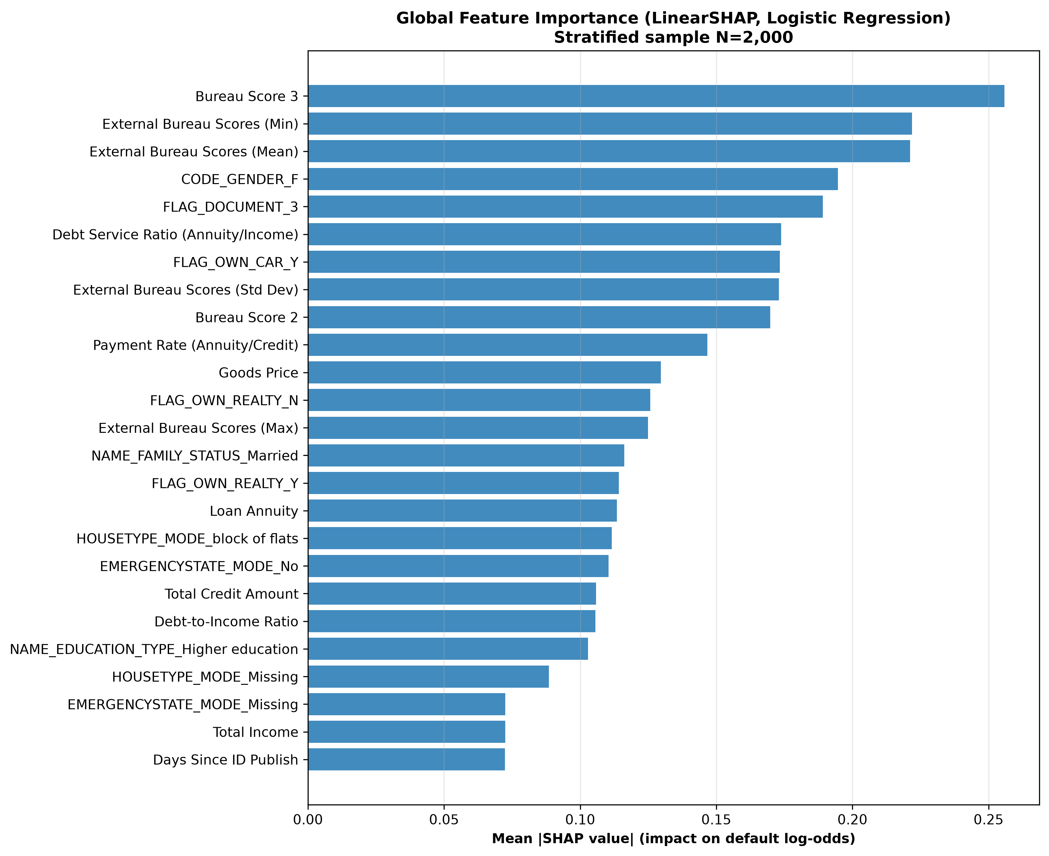
Figure 5.5: Global feature importance for the logistic-regression baseline (LinearSHAP), the linear counterpart of Figure 5.1.
The interpretation is twofold. On one hand, the two explainers agree on the dominant signal — external bureau scores — which increases confidence that this finding is a property of the data rather than of one model. On the other hand, nearly half of the tree model's top-30 explanatory structure is invisible to the linear model, and the tree's advantage consists largely of interactions and non-linearities among bureau-derived terms. This quantifies the accuracy-interpretability trade rather than merely asserting it: a lender that insists on a purely linear scorecard retains the main bureau signal but forfeits a substantial share of the predictive and explanatory structure captured by the tree ensemble.

5.5 Limitations of the Explainability Analysis
The SHAP analysis has boundaries that should be stated as clearly as its findings. TreeSHAP attributions are exact for the tree ensemble they describe — there is no approximation error in the computation itself — but they explain the model, not the world. A feature with a large SHAP value is one the model relies on; that is not the same as saying the feature causes default. The bureau-score finding is plausibly causal in a loose sense (bureau history reflects actual repayment behaviour), but the demographic indicators' influence could equally reflect historical bias in the training outcomes, and SHAP cannot distinguish between these readings.
The explanations were computed on a 2,000-applicant sample from the training window, which is large enough for stable global importance estimates but means the exact ranking would vary slightly with a different sample. The local case studies are single-point explanations and do not by themselves establish that the model behaves sensibly across the population; they were selected to illustrate the three operationally important outcomes, not to survey the explanation space exhaustively. Finally, because the SMOTE and cost-sensitive variants change the probability distribution, their explanations would differ from the baseline champion's; the analysis deliberately explains the configuration selected by the primary metric, and extending it to all nine configurations would multiply the computational cost without changing the central findings. These limitations qualify the strength of the claims but do not undermine the practical use of the explanations, which is to communicate decisions and to localise errors — both demonstrated in the case studies.

6 Discussion
This chapter interprets the results critically, compares them with the existing literature, examines the practical implications for credit-risk decision support, and confronts the limitations of the study. It is deliberately self-critical: the strengths of the experimental design are argued where they are real, and the weaknesses are stated where they constrain the conclusions.

6.1 Model Choice in Context
The finding that XGBoost ranks best is consistent with the credit-scoring benchmark literature (Lessmann et al., 2015) and with the outcomes of the Home Credit competition itself, where gradient-boosting solutions dominated. What is more interesting is the scale of the advantage and the position of Random Forest. The XGBoost-over-Logistic-Regression margin of 0.015 ROC-AUC is statistically overwhelming (p = 1.0e-13) because the repeated cross-validation design controls fold difficulty, yet in absolute terms it is modest: a well-specified linear model reaches 98% of the champion's ranking quality. This supports the position, argued in the literature and confirmed here, that the practical case for complex models in credit scoring rests not on ranking alone but on the non-linear and interaction structure they capture — which Chapter 5 showed is concentrated in bureau-score interactions.
The underperformance of Random Forest relative to Logistic Regression deserves attention because it contradicts the common assumption that ensemble methods dominate uniformly. Two mechanisms plausibly explain it. First, the averaging of two hundred trees trained on majority-dominated bootstrap samples compresses predicted probabilities toward the base rate, which is consistent with the observed recall of 0.001 at the default threshold — the most extreme conservatism of all nine configurations. Second, with 196 mostly one-hot features, random feature subsetting fragments categorical information across many weak splits. The lesson for practice is that model families cannot be ranked once and for all: the ranking is a property of the family interacting with the data structure and the evaluation criterion.

6.2 The Central Finding: Imbalance Handling Dominates Model Choice
The most consequential result of the experiment is the asymmetry between the two imbalance interventions. Cost-sensitive learning raised recall from roughly 2% to 64–69% in every family at a ranking cost too small to matter (−0.002 ROC-AUC for XGBoost, statistically indistinguishable from zero for Logistic Regression) and cut expected cost per applicant by one third. SMOTE, by contrast, degraded ranking quality significantly in all three families, catastrophically for Random Forest.
Why did SMOTE fail here? The explanation offered is that nearest-neighbour interpolation in a 196-dimensional space with only 8% minority mass is a poor generator of plausible minority examples. With roughly 16,600 minority training points spread across 196 dimensions, minority instances are sparse, and their five nearest neighbours are not necessarily similar in any meaningful credit sense; synthetic points interpolated between them fall in low-density regions that do not correspond to real applicant profiles. The tree models then fit this manufactured noise. Cost sensitivity avoids the problem entirely because it changes the loss function rather than the data: no synthetic examples are created, and the model's view of the true data distribution remains intact. This account is consistent with the high-dimensional caution in the resampling literature (López et al., 2013) and with the observation that SMOTE's damage is worst for Random Forest, whose bagging procedure re-samples the already-polluted training set.
The practical reading is direct. For a lender whose losses from missed defaulters outweigh the opportunity cost of declined good applicants — which the 10:1 cost ratio assumes — the cost-sensitive XGBoost is the deployment choice even though the baseline XGBoost wins the PR-AUC comparison. The two statements are compatible because they answer different questions: the baseline wins on the quality of its probability ranking, the cost-sensitive variant wins on the quality of its decisions at a realistic operating point. A dissertation that reported only ranking metrics would have recommended a model that detects 2% of defaulters; a dissertation that reported only recall would have missed the small but real ranking cost. The multi-metric battery exists precisely to keep both facts visible.

6.3 Evaluation Practice: What the Accuracy Episode Proves
The derived accuracy figures provide the study's cleanest methodological demonstration. The configuration with the highest raw accuracy on the 2020 test (XGBoost Baseline, 92.06%) is the same configuration that detects only 2.2% of defaulters, while the configurations that detect two thirds of defaulters score 20–23 points lower on accuracy. Accuracy rewards the model for correctly handling the 92% of applicants who repay — something a rule of declining everyone accomplishes trivially. Had the experiment been designed, as many published studies are, to select the model with the best accuracy, it would have selected the worst possible deployment option and reported it as a success. This is not a hypothetical failure mode; it is the standard failure mode of imbalanced classification, and the present results quantify it on real data. The proposal's decision to treat accuracy as non-headline is therefore vindicated empirically, not merely asserted.
Equally, the divergence between in-time cross-validation and the out-of-time test was small enough to support the robustness of the findings: the champion's ROC-AUC improved slightly out of time, and configuration orderings were preserved. The temporal design thus served its purpose — it would have exposed drift-induced collapse had it occurred — while the closeness of the two tracks indicates that the 2018–2019 window was representative of 2020 for these models.

6.4 Explainability and Its Implications
The SHAP analysis produced three findings with practical weight. First, the concentration of predictive power in external bureau scores means that the model is, in large part, a sophisticated recombination of information the lender does not itself own. This has procurement and robustness implications: if the bureau feed degrades or its scoring methodology changes, the model degrades with it. Second, the local case studies showed that explanations can localise errors to specific inputs — the false-positive applicant's risk estimate was driven almost entirely by a low bureau score — which is the structure needed for adverse-action notices and for disputing incorrect bureau records, aligning with the transparency expectations of data-protection law (European Parliament and Council, 2016; Bussmann et al., 2021). Third, the 16-of-30 overlap between tree and linear importance rankings quantifies what is lost when regulation or policy forces a linear scorecard: the dominant bureau signal survives, but most of the interaction structure does not.
One finding requires a fairness caveat. Gender indicators appear among the top fifteen global features, and regional and demographic variables contribute throughout. This study did not perform a fairness audit — the proposal noted that group-level behaviour would be explored cautiously if suitable variables permitted, and the anonymised dataset makes protected-group analysis unreliable. The presence of demographic features among influential predictors is therefore flagged as a governance concern for any deployment, not resolved here. Honest reporting of that limitation is preferable to a superficial fairness analysis on data that cannot support it.

6.5 Comparison with Prior Work
Set against the literature, the study confirms three established results on an unusually well-controlled design: gradient boosting leads tabular credit prediction (Lessmann et al., 2015; Chen and Guestrin, 2016); accuracy misleads under imbalance (Hand and Henley, 1997; He and Garcia, 2009); and SHAP attributions on tree models are faithful enough to support decision explanations (Lundberg and Lee, 2017; Bussmann et al., 2021). It contributes beyond replication in three ways. First, the frozen-hyperparameter 9-cell design isolates the effect of the imbalance intervention itself, whereas most published comparisons confound intervention with tuning. Second, the paired repeated cross-validation gives the statistical tests genuine resolution, so claims of superiority are backed by p-values and effect sizes rather than point estimates. Third, the simultaneous reporting of ranking metrics, threshold-fixed behaviour, decision cost and explanations offers a more complete picture of the accuracy-interpretability-detection trade than is typical in the Home Credit literature, which tends to report leaderboard-style AUC alone.

6.6 Practical Implications for Credit-Risk Decision Support
The results translate into concrete guidance for a lender considering machine-learning decision support. The first implication concerns procurement of the scoring pipeline: the champion's dependence on external bureau scores means the bureau feed is the critical component, and any deployment contract should specify service levels for that feed, because model quality cannot exceed the quality of the bureau data it consumes. The second concerns the operating threshold: no lender should adopt the fixed 0.5 threshold reported here; the cost curves of Chapter 4 exist to be swept with the lender's own loss ratio, and the expected-cost minima they reveal are substantially below the cost at 0.5 for every configuration. The third concerns workflow integration: the SHAP case studies show that per-applicant explanations can be generated at decision time, which supports adverse-action notices and dispute handling without a separate explanation system.
A fourth implication is organisational. The experiment shows that a logistic regression reaches 98% of the champion's ranking quality, and Chapter 5 shows it captures the dominant bureau signal. For a lender whose regulators or auditors demand inherently interpretable models, the linear baseline is a defensible deployment choice whose cost is quantified here rather than assumed. The decision between the two XGBoost variants and the linear model is therefore not a technical question with one right answer but a governance question with quantified trade-offs — which is exactly the form in which a data-science project should hand the decision to the business.
Finally, the SMOTE result has a direct practice implication: default application of SMOTE — common in applied papers and in many automated machine-learning tools — should be treated as a hypothesis to test on each dataset, not a safe default. On this data it is harmful in every family, and the mechanism (synthetic points in low-density regions of a high-dimensional space) generalises beyond credit scoring.

6.7 Limitations
The limitations are stated plainly because they bound every conclusion above. First, the cost ratio of 10:1 is an assumption; a lender with a different loss structure would sweep the threshold curves of Figure 4.5 to a different operating point, and the identity of the preferred configuration could change. The experiment reports the full curves precisely so the conclusion can be re-derived under other ratios. Second, the study uses only the main application table. The auxiliary tables (previous applications, bureau histories, repayment calendars) contain longitudinal information that competition winners exploited; incorporating them would likely raise absolute performance, though there is no reason to expect it would change the relative findings about imbalance handling. Third, the dataset is anonymised and competition-derived: variable semantics are partially documented, the population is a single lender's, and the business context cannot be verified. Fourth, hyperparameters were frozen by design; a tuned XGBoost or a tuned Random Forest might shift absolute numbers, although the within-family comparisons of imbalance strategies would remain valid. Fifth, calibration was not examined: cost-sensitive training distorts probability estimates, and a deployment would require recalibration before probabilities were quoted to decision-makers. Finally, the fairness implications of demographic features were identified but not analysed, for the data-quality reasons given in Section 6.4.

7 Conclusions and Future Work

7.1 Conclusions
The aim of this project was to design, implement and evaluate a reproducible machine learning experiment for loan default prediction, with specific focus on how class imbalance handling affects model performance and how the final model's predictions can be interpreted. That aim has been achieved. A leakage-controlled 9-cell experiment — three model families crossed with three imbalance conditions — was executed on the Home Credit Default Risk dataset using 3×5 repeated stratified cross-validation on 2018–2019 applications and an untouched out-of-time test on the 2020 cohort, with evaluation by precision, recall, F-scores, ROC-AUC, PR-AUC, confusion matrices and a financial cost metric, and with statistical significance assessed by paired parametric and non-parametric tests.
The experiment produced four conclusions. First, XGBoost is the strongest model family on this data, achieving the best ranking performance in both tracks (out-of-time ROC-AUC 0.7669, PR-AUC 0.2513), but its margin over a well-specified logistic regression is modest, and Random Forest — contrary to common expectation — is the weakest family, crippled by probability compression at the default threshold. Second, and most importantly, imbalance handling dominates model choice as the practical lever: cost-sensitive weighting raised default detection from roughly 2% to 64–69% at negligible ranking cost and reduced expected cost per applicant by one third, while SMOTE degraded every model family significantly, with large effect sizes. Third, evaluation practice matters as much as modelling: accuracy, had it been the headline metric, would have selected the configuration that detects 2% of defaulters as the best model, demonstrating concretely why imbalance-appropriate metrics are mandatory. Fourth, SHAP analysis showed that external credit-bureau scores dominate the model's decisions, that local explanations can localise individual errors to specific inputs in the manner required for adverse-action communication, and that a linear model captures the dominant bureau signal but forfeits roughly half of the tree model's explanatory structure.
The configuration recommended for practical decision support is therefore cost-sensitive XGBoost, with logistic regression retained as an interpretable benchmark and as the basis of a linear explanation pathway. The recommendation is conditional on the assumed loss ratio and would be re-derived from the reported cost curves under a different ratio.

7.2 Achievement of Objectives
The extent to which each project objective was achieved is detailed in Table 7.1.
Table 7.1: Objective achievement
Objective | Status | Evidence
Focused literature review | Achieved | Chapter 2
Dataset selection and justification | Achieved | Sections 2.2, 3.2
Exploratory data analysis | Achieved | Section 3.3, including the sentinel, income and redundancy investigations
Preprocessing with leakage identification | Achieved | Sections 3.1.3, 3.4
Reproducible experimental pipeline in Python | Achieved | Section 3.5; artefact reproduces all results
Comparison of three classification models | Achieved | Chapter 4 with significance testing
Imbalance-handling investigation (weighting and SMOTE) | Achieved | Sections 4.1–4.3
Imbalance-appropriate evaluation metrics | Achieved | Sections 3.6, 4.4; accuracy excluded as headline
SHAP explainability of the best model | Achieved | Chapter 5, including local case studies
Critical model comparison | Achieved | Chapter 6
Dissertation and artefact | Achieved | This document and the accompanying codebase, data and outputs

7.3 Future Work
Several extensions follow naturally from this study. The auxiliary tables of the Home Credit dataset — previous applications, bureau histories and repayment calendars — could be incorporated with temporal aggregation, which would test whether the imbalance-handling conclusions survive with richer features. The cost ratio could be estimated from real lender loss data rather than assumed, and threshold optimisation could be formalised per configuration. Calibration of the cost-sensitive models would be required before their probabilities were used in decisioning. A fairness audit, using a dataset with reliable protected-group indicators, should precede any deployment given the demographic features' measured influence. Finally, the experimental template itself — frozen hyperparameters, repeated paired cross-validation, out-of-time track, decision-cost metric — is reusable for other imbalanced financial classification problems, and making it available as a documented reference pipeline is a contribution the author intends to maintain beyond this project.

References
Baesens, B., Van Gestel, T., Viaene, S., Stepanova, M., Suykens, J. and Vanthienen, J. (2003) 'Benchmarking state-of-the-art classification algorithms for credit scoring', Journal of the Operational Research Society, 54(6), pp. 627–635.
Barocas, S., Hardt, M. and Narayanan, A. (2019) Fairness and Machine Learning: Limitations and Opportunities. fairmlbook.org.
Batista, G.E.A.P.A., Prati, R.C. and Monard, M.C. (2004) 'A study of the behavior of several methods for balancing machine learning training data', ACM SIGKDD Explorations Newsletter, 6(1), pp. 20–29.
Breiman, L. (2001) 'Random forests', Machine Learning, 45(1), pp. 5–32.
Bussmann, N., Giudici, P., Marinelli, D. and Papenbrock, J. (2021) 'Explainable machine learning in credit risk management', Computational Economics, 57, pp. 203–216.
Chawla, N.V., Bowyer, K.W., Hall, L.O. and Kegelmeyer, W.P. (2002) 'SMOTE: Synthetic minority over-sampling technique', Journal of Artificial Intelligence Research, 16, pp. 321–357.
Chen, T. and Guestrin, C. (2016) 'XGBoost: A scalable tree boosting system', in Proceedings of the 22nd ACM SIGKDD International Conference on Knowledge Discovery and Data Mining. San Francisco: ACM, pp. 785–794.
Davis, J. and Goadrich, M. (2006) 'The relationship between Precision-Recall and ROC curves', in Proceedings of the 23rd International Conference on Machine Learning. Pittsburgh: ACM, pp. 233–240.
Demšar, J. (2006) 'Statistical comparisons of classifiers over multiple data sets', Journal of Machine Learning Research, 7, pp. 1–30.
Dietterich, T.G. (1998) 'Approximate statistical tests for comparing supervised classification learning algorithms', Neural Computation, 10(7), pp. 1895–1923.
European Parliament and Council (2016) Regulation (EU) 2016/679 of the European Parliament and of the Council of 27 April 2016 on the protection of natural persons with regard to the processing of personal data (General Data Protection Regulation). Official Journal of the European Union, L119.
Hand, D.J. and Henley, W.E. (1997) 'Statistical classification methods in consumer credit scoring: a review', Journal of the Royal Statistical Society: Series A (Statistics in Society), 160(3), pp. 523–541.
He, H. and Garcia, E.A. (2009) 'Learning from imbalanced data', IEEE Transactions on Knowledge and Data Engineering, 21(9), pp. 1263–1284.
Home Credit Group (2018) Home Credit Default Risk. Kaggle competition dataset. Available at: https://www.kaggle.com/c/home-credit-default-risk (Accessed: 15 June 2026).
Ke, G., Meng, Q., Finley, T., Wang, T., Chen, W., Ma, W., Ye, Q. and Liu, T.Y. (2017) 'LightGBM: A highly efficient gradient boosting decision tree', in Advances in Neural Information Processing Systems 30. Long Beach: Curran Associates, pp. 3146–3154.
Lessmann, S., Baesens, B., Seow, H.V. and Thomas, L.C. (2015) 'Benchmarking state-of-the-art classification algorithms for credit scoring: An update of research', European Journal of Operational Research, 247(1), pp. 124–136.
López, V., Fernández, A., García, S., Palade, V. and Herrera, F. (2013) 'An insight into classification with imbalanced data: Empirical results and current trends on using data intrinsic characteristics', Information Sciences, 250, pp. 113–141.
Lundberg, S.M. and Lee, S.I. (2017) 'A unified approach to interpreting model predictions', in Advances in Neural Information Processing Systems 30. Long Beach: Curran Associates, pp. 4765–4774.
Lundberg, S.M., Erion, G., Chen, H., DeGrave, A., Prutkin, J.M., Nair, B., Katz, R., Himmelfarb, J., Bansal, N. and Lee, S.I. (2020) 'From local explanations to global understanding with explainable AI for trees', Nature Machine Intelligence, 2, pp. 56–67.
Prokhorenkova, L., Gusev, G., Vorobev, A., Dorogush, A.V. and Gulin, A. (2018) 'CatBoost: unbiased boosting with categorical features', in Advances in Neural Information Processing Systems 31. Montréal: Curran Associates, pp. 6638–6648.
University of South Wales (2024) Research Ethics Policy. Pontypridd: University of South Wales.
Molnar, C. (2022) Interpretable Machine Learning: A Guide for Making Black Box Models Explainable. 2nd edn. Available at: https://christophm.github.io/interpretable-ml-book/ (Accessed: 20 June 2026).

Appendices

Appendix A: Artefact Structure and Reproduction Instructions
The project artefact is organised as follows.
Table A.1: Artefact contents
Component | Location
Configuration (seeds, split years, cost ratio, drop lists) | src/config.py
Cleaning and feature engineering | src/features/engineering.py
Leakage-free preprocessing | src/features/preprocessor.py
Model factory with frozen hyperparameters | src/models/factory.py
Metric battery (accuracy deliberately excluded) | src/models/metrics.py
Evaluation plots | src/models/plots.py
Statistical testing battery | src/utils/stats_testing.py
SHAP explainability engine | src/explainability/shap_engine.py
Experiment runner (CV + out-of-time tracks) | run_experiment.py
Analysis runner (tests, plots, SHAP) | run_analysis.py
Raw per-fold results (135 rows) | reports/tables/cv_fold_results.csv
Cross-validation summary | reports/tables/cv_summary.csv
Out-of-time results | reports/tables/oot_results.csv
Statistical comparisons (16 rows) | reports/tables/statistical_significance.csv
SHAP importance tables and case studies | reports/tables/shap_*.csv
Evaluation figures (300 DPI) | reports/figures/*.png
Engineered data partitions | data/processed/*.parquet
Execution logs | logs/experiment.log, logs/analysis.log

To reproduce every result in this dissertation: install Python 3.12 with pandas, NumPy, scikit-learn, imbalanced-learn, XGBoost, SHAP, matplotlib, seaborn and pyarrow; place the raw application_train.csv in data/raw/; then execute the experiment runner followed by the analysis runner. Total runtime is approximately two and a quarter hours on a four-core personal computer with 8 GB of memory. All stochastic components are governed by the seed family derived from seed 42.

Appendix B: Out-of-Time Confusion Matrices (Counts)
The full confusion-matrix counts for all nine configurations on the 2020 test (N = 102,504; 8,179 defaulters, 94,325 repayers), at the 0.5 threshold.
Table B.1: Out-of-time confusion-matrix counts and derived accuracy
Configuration | True positives | False positives | False negatives | True negatives | Accuracy
Logistic Regression (Baseline) | 64 | 62 | 8,115 | 94,263 | 0.9202
Logistic Regression (Cost-Sensitive) | 5,603 | 29,593 | 2,576 | 64,732 | 0.6862
Logistic Regression (SMOTE) | 5,469 | 28,897 | 2,710 | 65,428 | 0.6917
Random Forest (Baseline) | 12 | 5 | 8,167 | 94,320 | 0.9203
Random Forest (Cost-Sensitive) | 5,209 | 24,971 | 2,970 | 69,354 | 0.7274
Random Forest (SMOTE) | 1,810 | 6,554 | 6,369 | 87,771 | 0.8739
XGBoost (Baseline) | 181 | 137 | 7,998 | 94,188 | 0.9206
XGBoost (Cost-Sensitive) | 5,370 | 25,088 | 2,809 | 69,237 | 0.7278
XGBoost (SMOTE) | 113 | 98 | 8,066 | 94,227 | 0.9203

The accuracy column is included solely to document the metric's behaviour under imbalance: the three configurations with the highest accuracy are precisely those that detect fewer than 3% of defaulters.

Appendix C: Full Statistical Significance Battery
The complete set of sixteen pre-specified paired comparisons over the fifteen matched cross-validation observations. Mean A and mean B are the means of the first and second named configuration respectively. Significance is assessed at α = 0.05.
Table C.1: Full statistical comparisons (paired tests, n = 15)
Comparison | Metric | Mean A | Mean B | Mean diff | p (t-test) | p (Wilcoxon) | Cohen's d | Sig.
XGBoost vs Logistic Regression (baseline) | ROC-AUC | 0.7622 | 0.7475 | +0.0147 | 1.0e-13 | 6.1e-05 | 7.27 | Yes
XGBoost vs Random Forest (baseline) | ROC-AUC | 0.7622 | 0.7455 | +0.0166 | 1.3e-17 | 6.1e-05 | 13.86 | Yes
Logistic Regression vs Random Forest (baseline) | ROC-AUC | 0.7475 | 0.7455 | +0.0020 | 6.4e-05 | 6.1e-05 | 1.45 | Yes
XGBoost vs Logistic Regression (baseline) | PR-AUC | 0.2502 | 0.2276 | +0.0226 | 1.1e-15 | 6.1e-05 | 10.06 | Yes
XGBoost vs Random Forest (baseline) | PR-AUC | 0.2502 | 0.2300 | +0.0202 | 7.1e-14 | 6.1e-05 | 7.45 | Yes
Logistic Regression vs Random Forest (baseline) | PR-AUC | 0.2276 | 0.2300 | −0.0024 | 0.020 | 0.048 | −0.68 | Yes
XGBoost Cost-Sensitive vs Baseline | ROC-AUC | 0.7600 | 0.7622 | −0.0022 | 3.2e-05 | 1.8e-04 | −1.55 | Yes
XGBoost SMOTE vs Baseline | ROC-AUC | 0.7438 | 0.7622 | −0.0184 | 1.6e-13 | 6.1e-05 | −7.03 | Yes
Random Forest Cost-Sensitive vs Baseline | ROC-AUC | 0.7474 | 0.7455 | +0.0018 | 2.4e-07 | 6.1e-05 | 2.39 | Yes
Random Forest SMOTE vs Baseline | ROC-AUC | 0.7135 | 0.7455 | −0.0320 | 2.2e-18 | 6.1e-05 | −15.76 | Yes
Logistic Regression Cost-Sensitive vs Baseline | ROC-AUC | 0.7476 | 0.7475 | +0.00005 | 0.689 | 0.978 | 0.11 | No
Logistic Regression SMOTE vs Baseline | ROC-AUC | 0.7410 | 0.7475 | −0.0065 | 7.4e-12 | 6.1e-05 | −5.31 | Yes
XGBoost Cost-Sensitive vs Baseline | Recall | 0.6429 | 0.0205 | +0.6224 | 1.4e-27 | 6.1e-05 | 71.45 | Yes
Random Forest Cost-Sensitive vs Baseline | Recall | 0.6187 | 0.0010 | +0.6177 | 2.4e-28 | 6.1e-05 | 81.11 | Yes
Logistic Regression Cost-Sensitive vs Baseline | Recall | 0.6802 | 0.0085 | +0.6718 | 3.7e-28 | 6.1e-05 | 78.64 | Yes
XGBoost Cost-Sensitive vs Baseline | Cost/applicant | 0.5303 | 0.7965 | −0.2661 | 1.5e-23 | 6.1e-05 | −36.85 | Yes

Fifteen of sixteen comparisons are significant at α = 0.05 and thirteen at α = 0.01. The single non-significant comparison — the effect of cost sensitivity on logistic regression ROC-AUC — is precisely the result that matters: it shows the ranking cost of cost-sensitive learning can be statistically indistinguishable from zero. The parametric and non-parametric tests agree in every case, so the conclusions do not depend on distributional assumptions. Effect sizes are large throughout except for the two comparisons involving logistic regression's ranking quality, where the interventions genuinely have little effect — a null result that is as informative as the significant ones.

Appendix D: Software Environment
Table D.1: Software environment
Component | Version
Python | 3.12
pandas | 3.0
NumPy | 2.5
scikit-learn | 1.9
imbalanced-learn | 0.14
XGBoost | 3.4
SHAP | 0.52
Hardware | Intel Core i3-1115G4, 8 GB RAM, 4 logical cores

