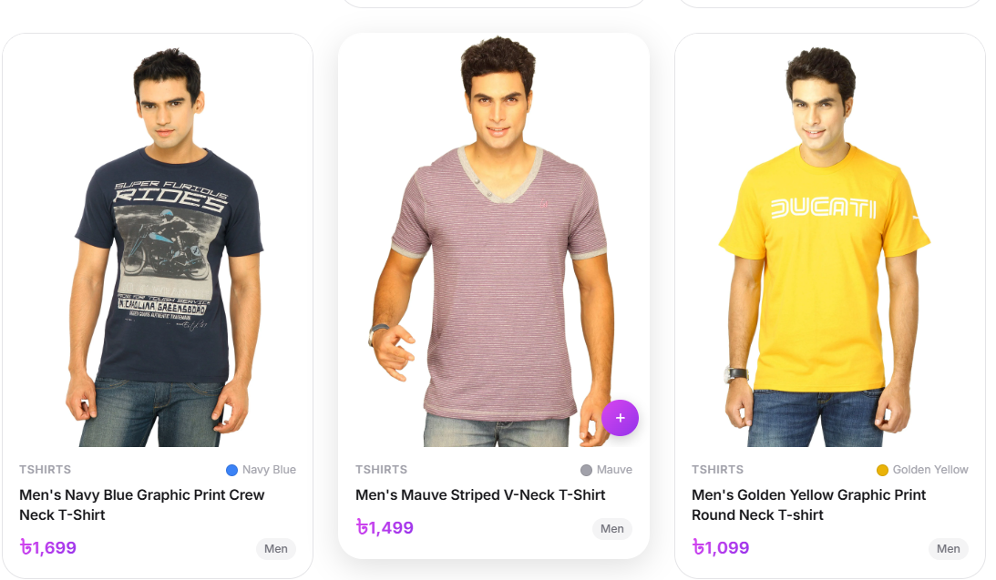
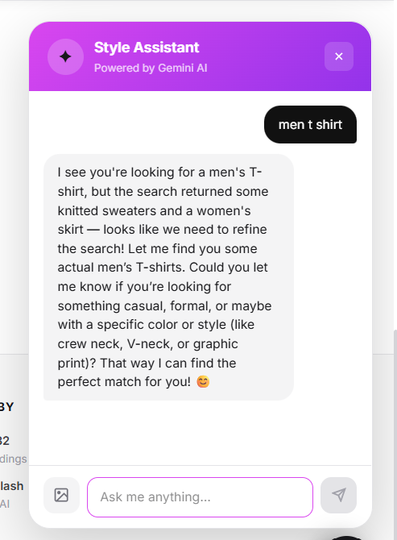
1.

I am expecting the agent too understand the user query and then pull this kind of product show it in chat interface but you can see they cannot even understand the user query.
2. despit having men t-shirt in the store(above image(, you can see it miserably failed to pull men t-shirt and getting me this result in the below screenshot when search “men t shirt”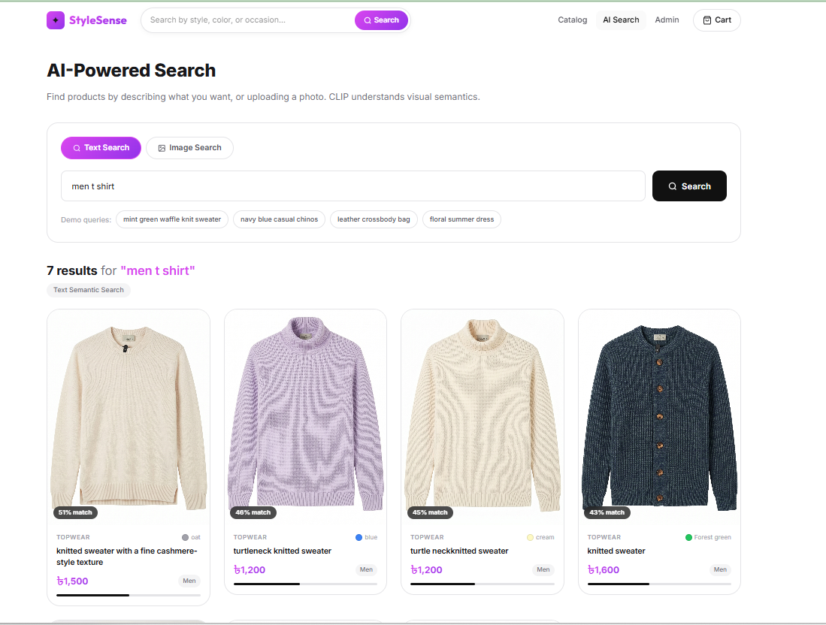
3.i have searched for “girl floral dress “ and I am expecting below images to show up,, but sigh

4. I did some mock order and shown in database. Then I asked the agent to cancel my order. But, the agent asked order number and email . I shared with it . it confirms that it cancel my order. But in database it is shown.
5. You need to create authentication. Allow user to create profile and creat mock order. So that when an user order and cancel order, it should be reflected in his profile. So , the agentic ai behaviour that I asked you to in file updated requirement is not correctly functioning.

2.

