(a) | (b)
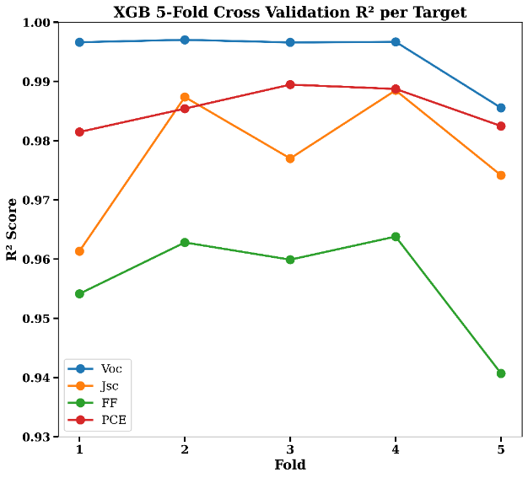 | 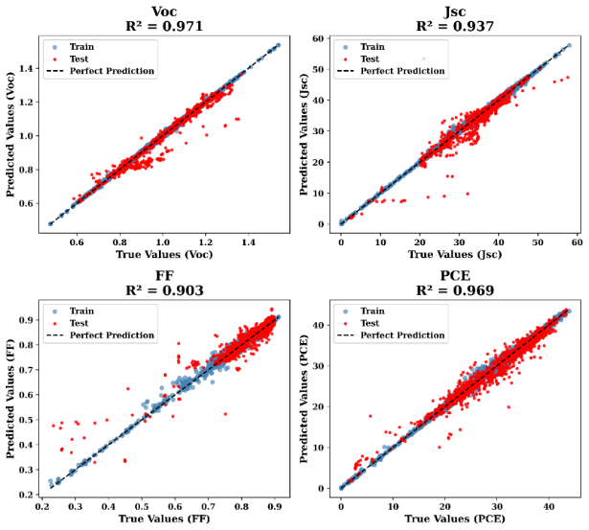
Figure S1 (a) Five-fold cross-validation performance of the XGBoost model viewing R² scores for each target parameter (V_{OC}, J_{SC}, FF, and PCE), demonstrating model consistency and robustness across different folds. (b) Comparison of actual versus predicted values for V_{OC}, J_{SC}, FF, and PCE using the XGBoost model, including training and testing data.
(a) | (b) | (c)
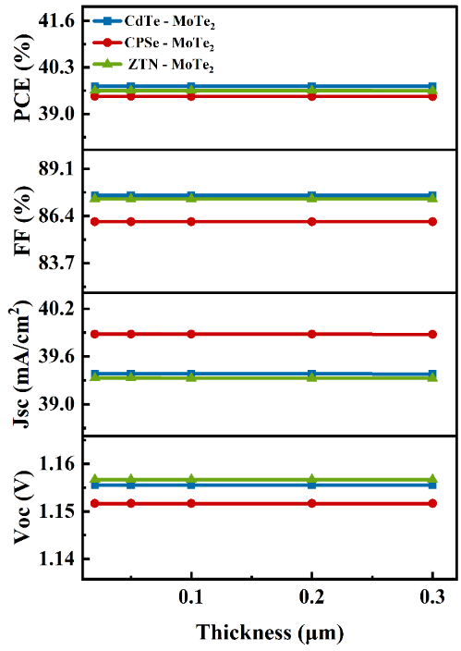 | 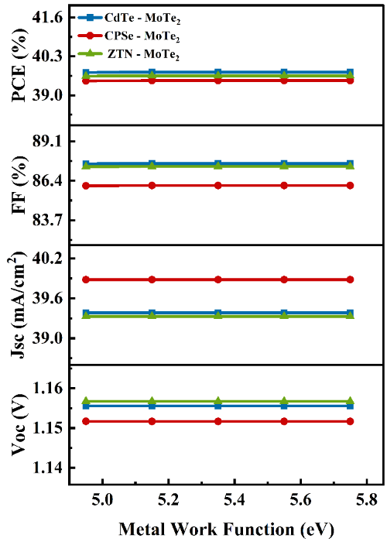 | 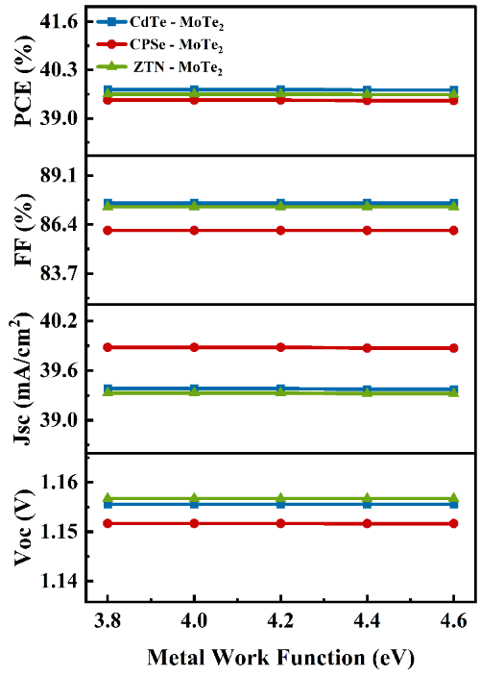
Figure S2 The variation in the output performance of proposed devices as a function of (a) ITO layer Thickness, (b) Left contact Metal work function and (c) Contact Metal work function.

