Metadata-Driven Ingestion Framework
A Simple, Beginner-Friendly Learning Guide
SQL Database → Azure Data Factory → ADLS Gen2 → Databricks
Every screenshot is explained in plain language, including the motive behind each ADF step and the meaning of every pipeline expression that starts with @.

Contents

(To fill this in: open in Word, click here, press F9, choose “Update entire table”.)

1. What is a metadata-driven ingestion framework?
The problem it solves. Imagine you must copy 200 tables from a database into a data lake. The naive way is to build 200 separate pipelines — one per table. That becomes impossible to maintain: 200 things to change, test, and fix.
The idea. Instead of hard-coding each table into a pipeline, we store the instructions — which table, where to put it, how to load it — as rows in database tables. These instruction tables are called metadata. Then we build one smart pipeline that reads those instructions and does the work for any table. Adding a new table becomes: insert one row — no new pipeline.
In simple terms
Think of a delivery company. Instead of building a new truck and route for every customer, they keep one address book (a list of deliveries) and one driver reads the list and delivers to each address.
The address book = the metadata tables. The driver = the one pipeline. A new customer = one new row in the address book.
The four ideas you will see repeated:
- Source System table — the list of systems we pull data from.
- Entity Config table — the master instruction sheet: one row per table to ingest.
- Watermark table — a bookmark that remembers how far we got last time, so we only pull new/changed rows (this is called an incremental load).
- Pipeline Run Log table — a diary of every run (success/failure, row counts, errors) for auditing.

2. The big picture (how the pieces fit)
Data flows left to right, and the control tables in SQL tell the Data Factory what to do:
- Azure SQL Database — holds both the source data (the sales.Orders table) and the control/metadata tables (the ctl schema).
- Azure Data Factory (ADF) — the engine. It reads the metadata, then copies data from SQL to the lake, updates the watermark, and logs the run.
- ADLS Gen2 (the lake) — cheap, folder-based storage where the copied data lands as Parquet files.
- Databricks — used at the end to read the landed data and confirm it is correct (and later, to transform it).
Why it matters
Keeping the instructions as data (not code) makes the solution scalable and easy to maintain. Onboarding a new table is a one-line insert, and non-developers can read the config to understand what runs.

3. The Azure resources used
To save cost, existing resources in the resource group were reused instead of creating new ones. Here is each one.

3.1 Storage account — practicedatabricks (this is our lake)
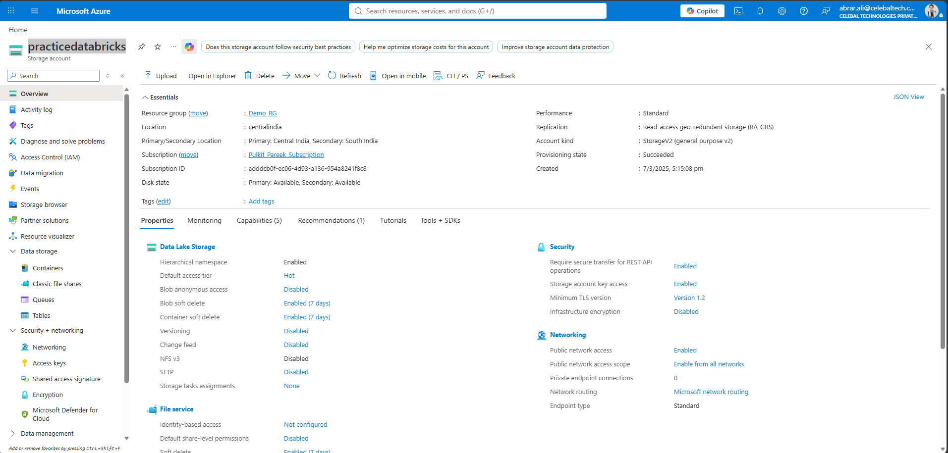
The ADLS Gen2 storage account that will store the ingested data.
In simple terms
This is the data lake — the place where copied data will be dumped as files. It uses ADLS Gen2, which gives real folders (a “hierarchical namespace”), perfect for organising raw / bronze / silver layers later.

3.2 Azure Data Factory — mohan-adf (the engine)
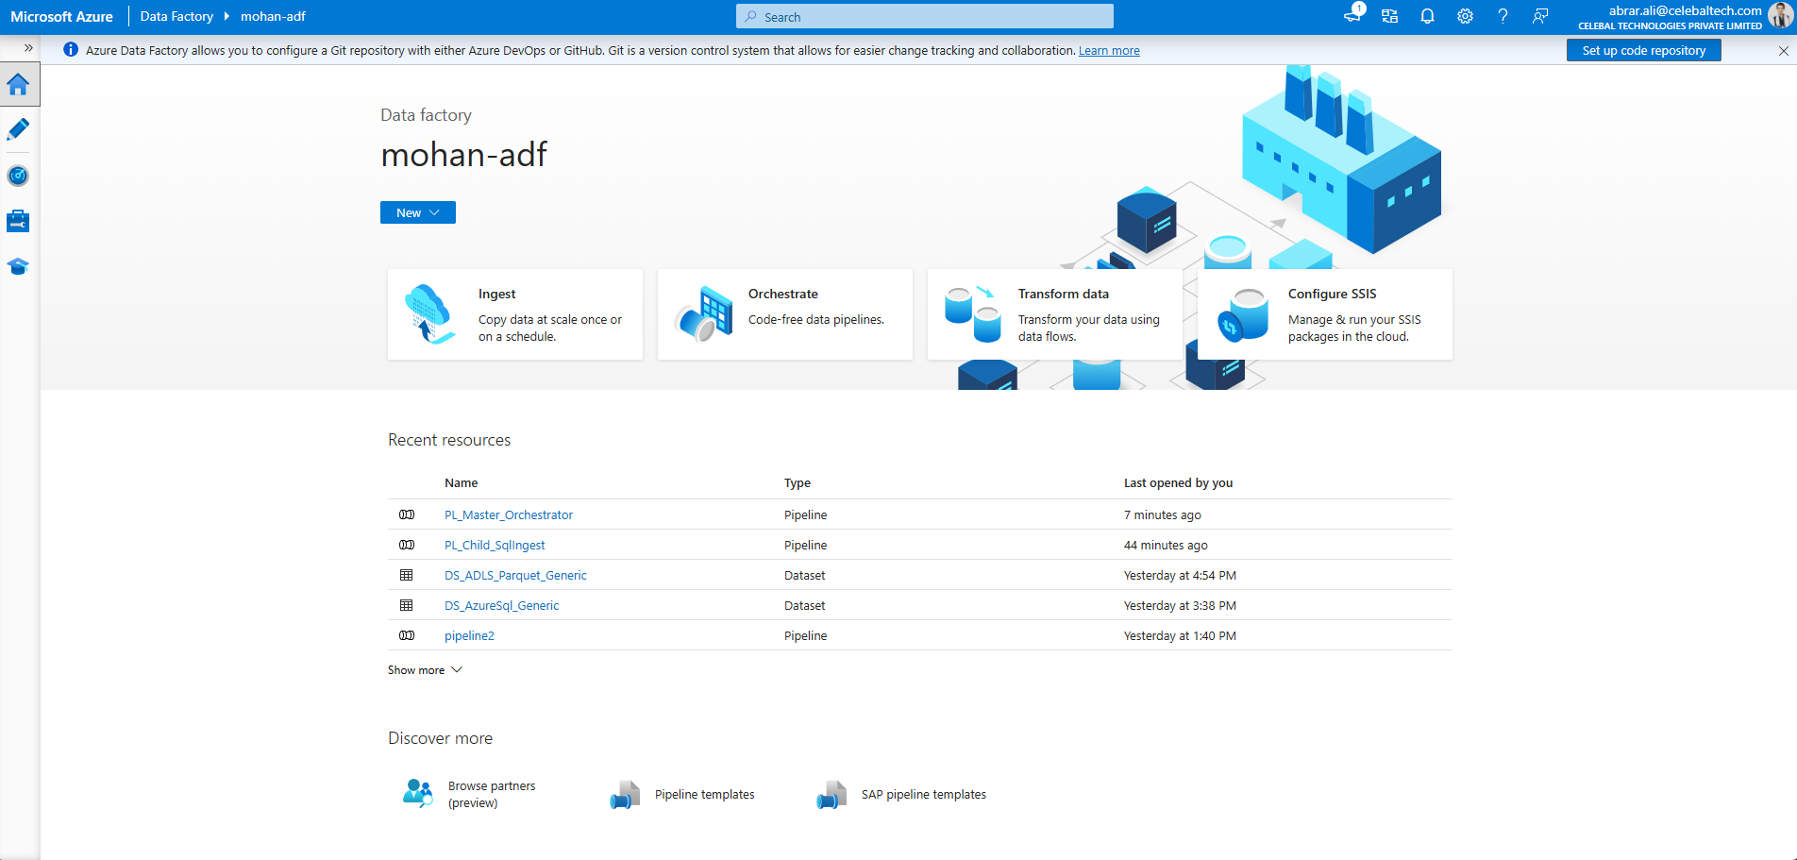
Azure Data Factory, the tool that orchestrates and moves the data.
In simple terms
ADF is the “mover”. It connects to the source and the lake, runs the pipelines, and follows the instructions stored in the metadata tables.

3.3 Azure SQL Database — databrickslearningdb / practicedb (source + control)
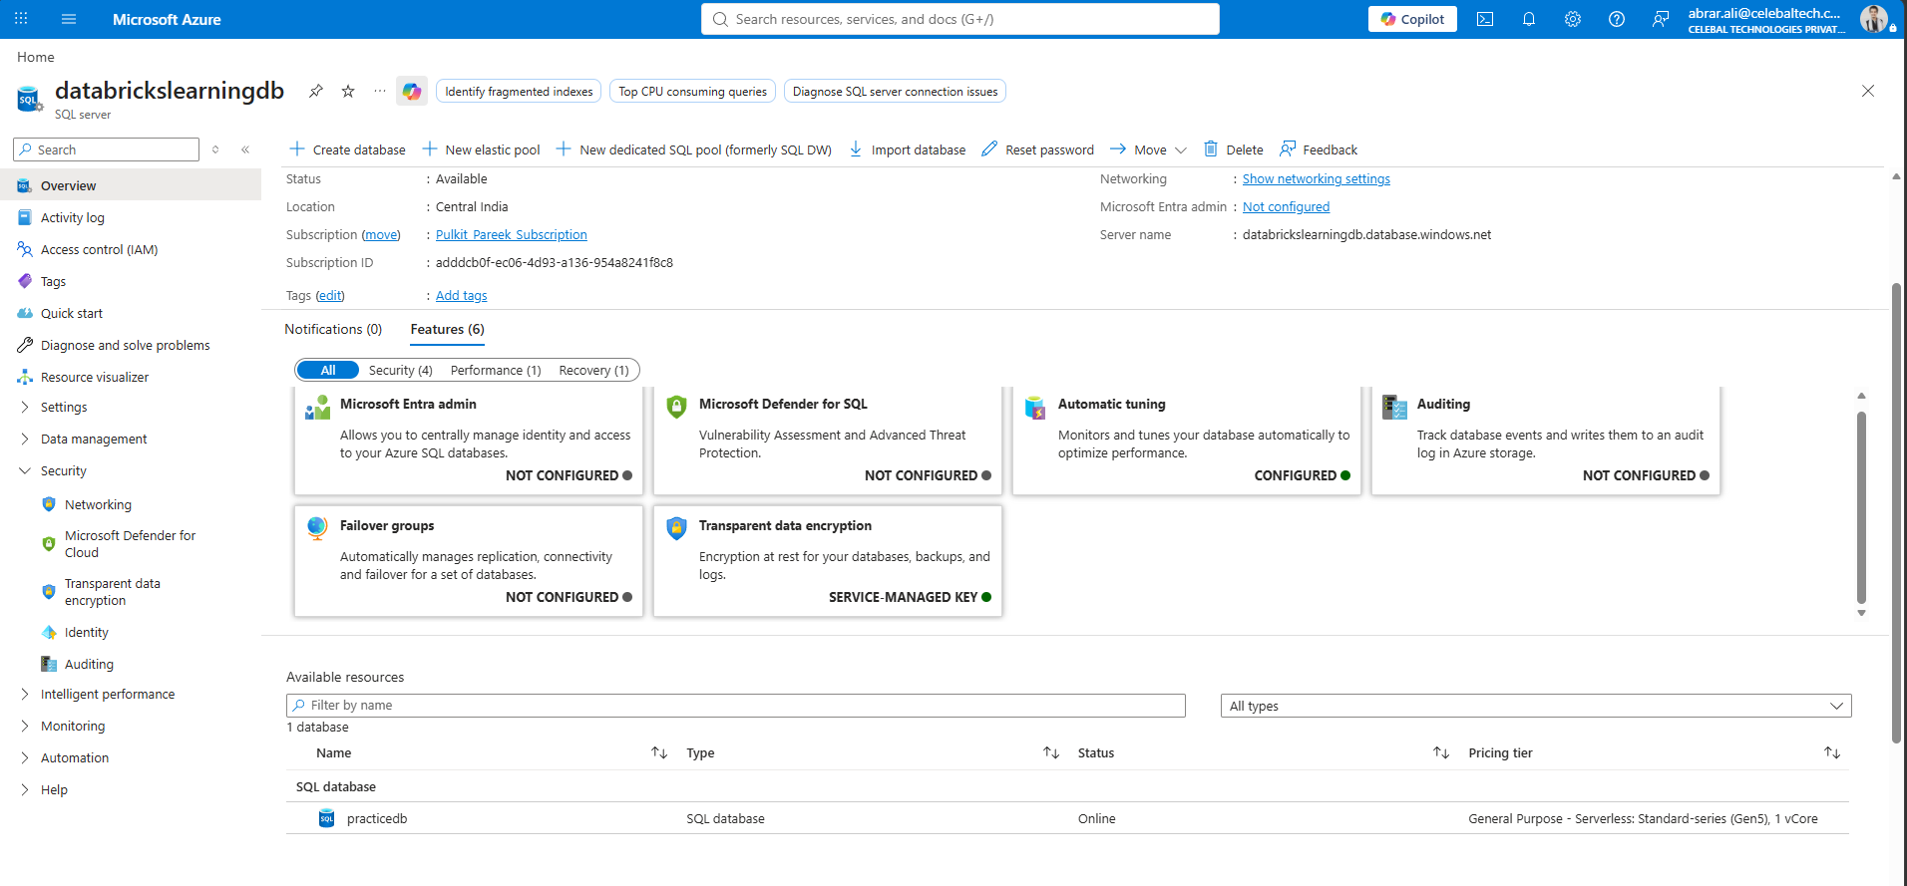
The SQL database used for BOTH the source data and the control tables.
In simple terms
To save money, one database (practicedb) holds everything, kept tidy using two separate schemas: ctl for the framework tables and sales for the sample source data.

3.4 Databricks — personal free trial
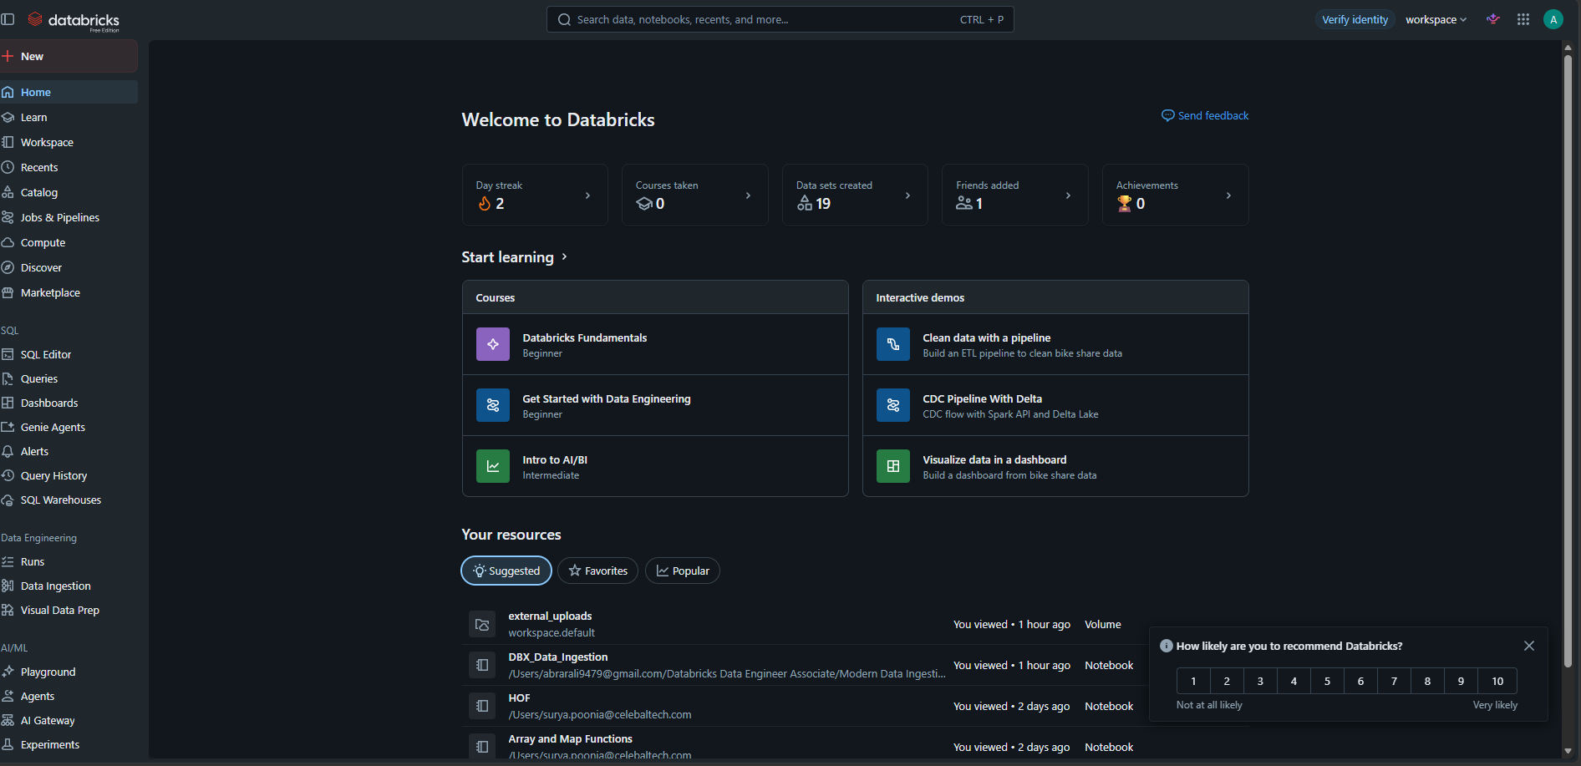
The Databricks workspace, used at the end to verify the data.
In simple terms
Databricks will read the landed files to confirm the ingestion worked. For this stage it is only used for a final check; the heavy transformation comes later.

4. Giving ADF permission, and creating the landing zone

4.1 Let ADF write to the lake (Storage Blob Data Contributor)
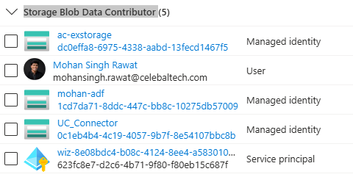
ADF's identity is granted the Storage Blob Data Contributor role on the storage account.
In simple terms
ADF has its own built-in identity (a “managed identity”). We give that identity permission to write files into the storage account. No password is stored anywhere.
Why it matters
Without this permission ADF cannot drop files into the lake, and the copy would fail with a “403 / permission” error. Using the identity (instead of a key or password) is the secure, recommended way.

4.2 Create the “lake” container (the dumping zone)
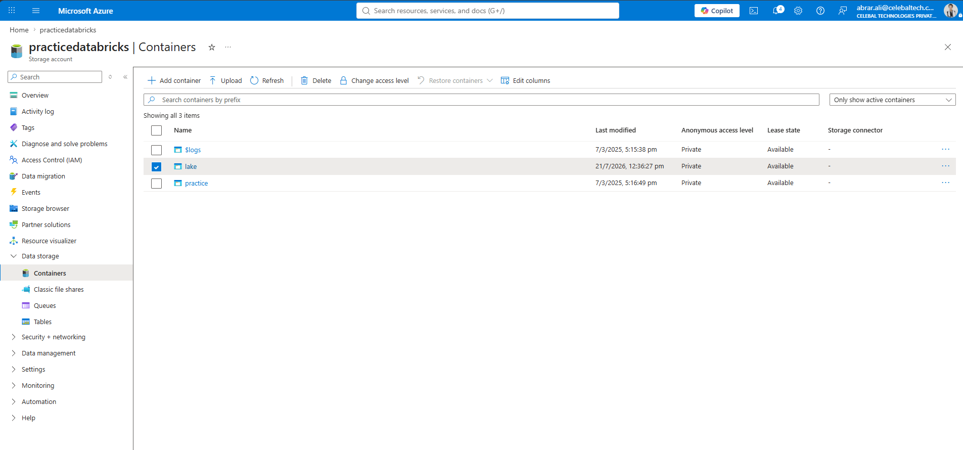
A container named “lake” is created inside the storage account.
In simple terms
A container is the top-level folder. Everything we ingest will live under lake/ (for example lake/raw/sales/orders). It is the “dumping zone” for incoming data.

5. Building the control (metadata) database

5.1 Connect to SQL and create the ctl schema
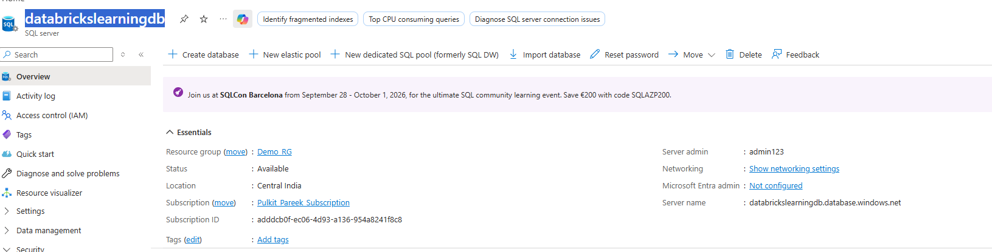
The connection details used to reach the SQL server from SSMS (server name, admin login, SQL authentication).
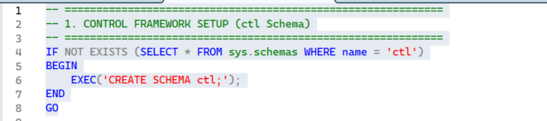
A dedicated schema named “ctl” is created to hold all control tables.
In simple terms
A schema is like a labelled drawer inside the database. Putting all framework tables in the ctl drawer keeps them separate from the actual business data in the sales drawer.

5.2 Table 1 — Source System (the list of sources)
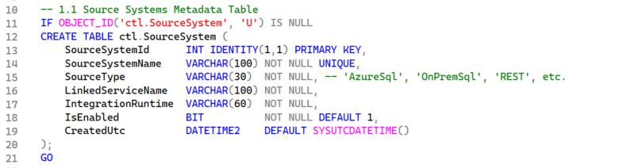
ctl.SourceSystem — one row per source system.
In simple terms
This table registers each place we pull data from. For each source it records the type (Azure SQL, REST API, etc.), and which ADF linked service and integration runtime to use.
Why it matters
It is the central registry of “where data comes from.” The rest of the framework points back to it, so connection choices live in one place.

5.3 Table 2 — Entity Config (the instruction sheet)
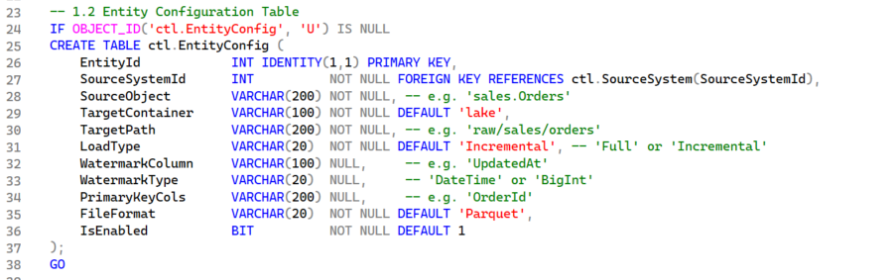
ctl.EntityConfig — the central control table, one row per table to ingest.
In simple terms
This is the heart of the framework. Each row describes one table to ingest: its name, the target folder, whether to load Full or Incremental, the watermark column, the primary key, and the file format. It links to Source System through SourceSystemId (a foreign key).
Why it matters
Because every ingestion detail is stored here as data, onboarding a new table is just adding a new row — no pipeline changes. That is what makes the solution scalable and easy to maintain.

5.4 Table 3 — Watermark (the bookmark)
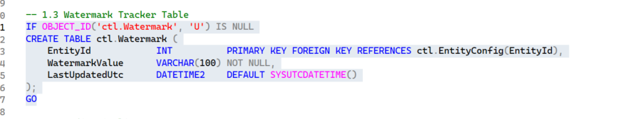
ctl.Watermark — remembers the last processed value per entity.
In simple terms
A watermark is a bookmark. It stores the latest value already loaded (for example, the most recent UpdatedAt timestamp). Next time, the pipeline only pulls rows newer than the bookmark — that is an incremental load.
Why it matters
This avoids reloading old data every time, which saves time and cost and keeps the lake from filling with duplicates.

5.5 Table 4 — Pipeline Run Log (the diary)
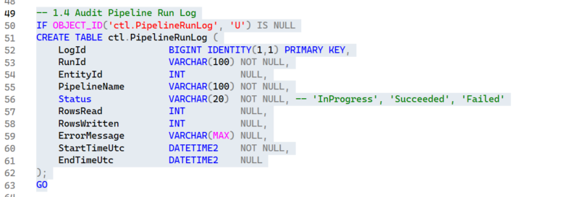
ctl.PipelineRunLog — an audit trail of every run.
In simple terms
Every time the pipeline runs, it writes a row here: which pipeline, status (InProgress / Succeeded / Failed), rows read and written, start/end time, and any error message.
Why it matters
This gives you history to monitor health, troubleshoot failures, and prove what happened — essential in real projects.

6. The stored procedures (the reusable logic)
Stored procedures are saved pieces of SQL logic that ADF can call by name. Three do the heavy lifting.

6.1 usp_GetEntitiesToLoad — “what should I load?”
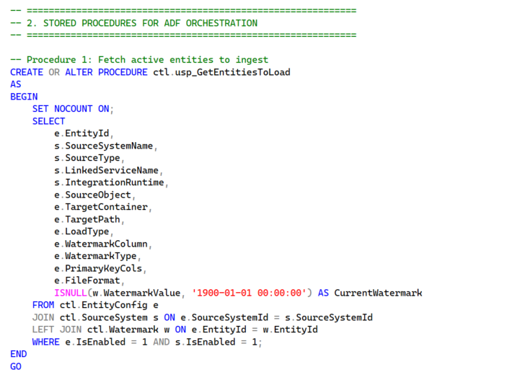
Returns the list of active entities plus each one's current watermark.
In simple terms
It joins the three tables (Source System + Entity Config + Watermark) and returns one tidy list of everything that is enabled to load, along with the last watermark value for each. ADF's first step calls this to get its to-do list.

6.2 usp_UpdateWatermark — “move the bookmark forward”
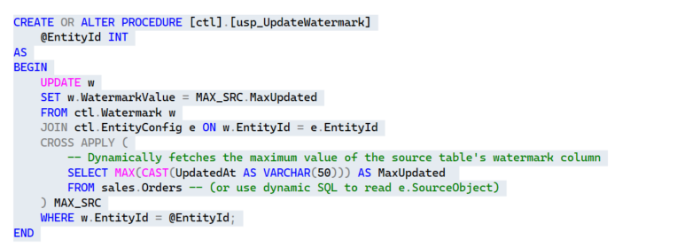
After a successful load, advances the watermark for that entity.
In simple terms
After data is copied, this proc updates the bookmark to the newest value. In this build it is given only the EntityId and works out the new high value (the MAX of the watermark column) from the source itself, then saves it.
Why it matters
If the bookmark did not move, the next run would keep pulling the same rows. Advancing it only after success is what makes re-runs safe.

6.3 usp_LogPipelineRun — “write the diary entry”
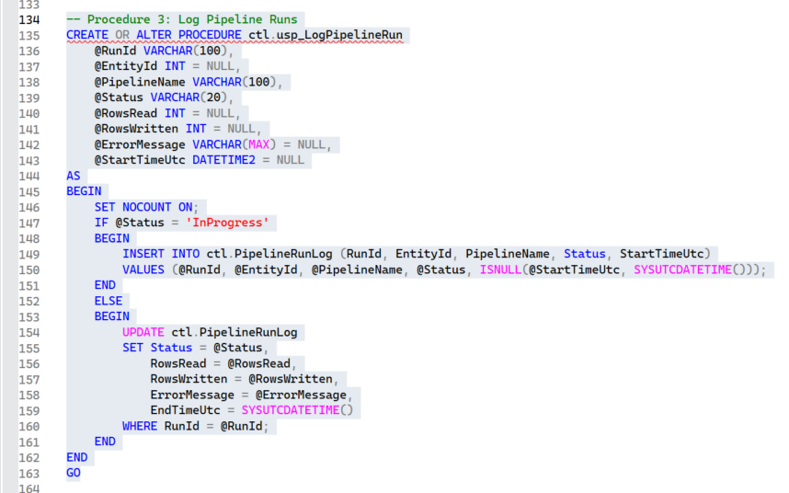
Inserts a row when a run starts, and updates it when the run ends.
In simple terms
Called with status InProgress at the start (it inserts a new diary row) and again at the end with Succeeded or Failed plus row counts and any error (it updates the same row).

7. The sample source and seeding the first entry

7.1 The sample source table (sales.Orders)
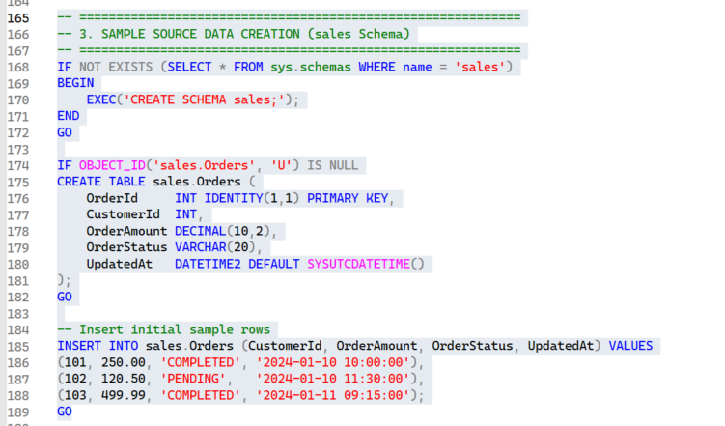
The sample sales.Orders table we will ingest, in its own “sales” schema.
In simple terms
In a real company the source is already full of data. In this practice setup we own the source, so we create and fill sales.Orders ourselves. It has an UpdatedAt column, which will be our watermark.

7.2 Register the first source in the metadata
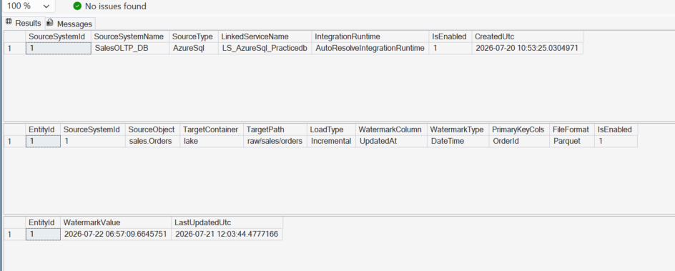
The metadata tables after inserting the first source and entity.
In simple terms
We add one row to Source System (our SQL DB) and one row to Entity Config (the sales.Orders table), plus a baseline watermark so the first run pulls everything after 1 Jan 2024.
The seeding code (simplified):
-- 1) register the source system
INSERT INTO ctl.SourceSystem (SourceSystemName, SourceType,
LinkedServiceName, IntegrationRuntime, IsEnabled, CreatedUtc)
VALUES ('SalesOLTP_DB','AzureSql','LS_AzureSql_Practicedb',
'AutoResolveIntegrationRuntime', 1, SYSUTCDATETIME());

-- 2) register the table to ingest (get the id, don't hard-code it)
DECLARE @SourceSystemID INT =
(SELECT SourceSystemId FROM ctl.SourceSystem
WHERE SourceSystemName = 'SalesOLTP_DB');
INSERT INTO ctl.EntityConfig (SourceSystemId, SourceObject,
TargetContainer, TargetPath, LoadType, WatermarkColumn,
WatermarkType, PrimaryKeyCols, FileFormat)
VALUES (@SourceSystemID, 'sales.Orders', 'lake',
'raw/sales/orders', 'Incremental', 'UpdatedAt',
'DateTime', 'OrderId', 'Parquet');

-- 3) baseline watermark
DECLARE @EntityID INT = (SELECT EntityId FROM ctl.EntityConfig
WHERE SourceObject = 'sales.Orders');
INSERT INTO ctl.Watermark (EntityId, WatermarkValue, LastUpdatedUtc)
VALUES (@EntityID, '2024-01-01 00:00:00', SYSUTCDATETIME());
Important — security warning
One correction that was applied here. The TargetPath must be a plain, static string like raw/sales/orders.
An earlier attempt stored an ADF expression year=@{formatDateTime(utcNow(),'yyyy')} inside the value. That does not work, because values read from a Lookup are treated as plain text and are never evaluated — the folder would literally be named year=@{...}. The dated folders are built inside the pipeline instead (see 10.3).

8. Azure Data Factory — connections (linked services)
A linked service is a saved connection ADF uses to reach a system. We need two: one to the SQL database, one to the lake.

8.1 SQL linked service (LS_AzureSql_Practicedb)
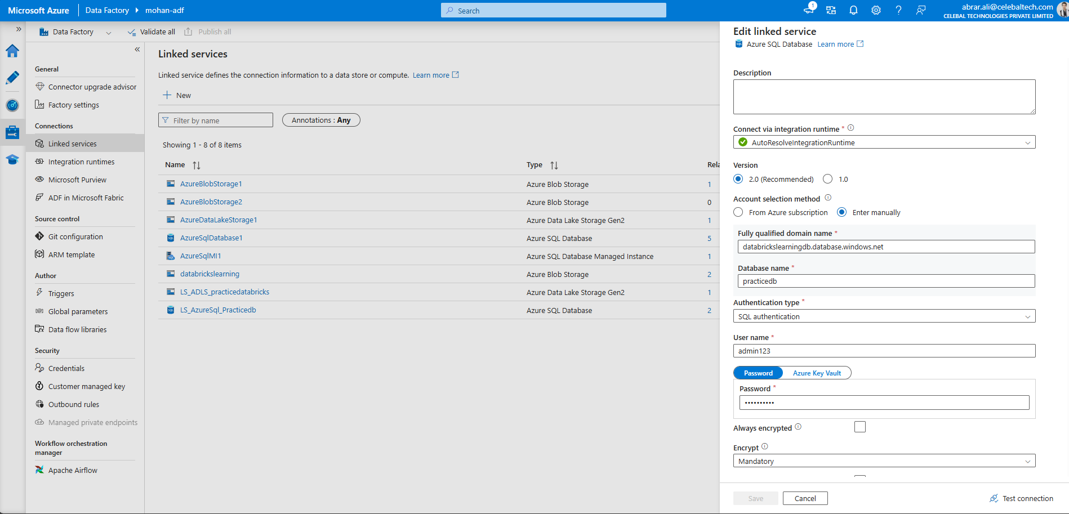
The linked service that connects ADF to the SQL database.
In simple terms
This is the connection to our SQL DB (server databrickslearningdb, database practicedb) using SQL authentication. Its name matches the LinkedServiceName stored in the metadata, so everything stays consistent. Because the ctl and sales schemas live in the same database, this one connection serves both the control lookups and the source reads.

8.2 ADLS Gen2 linked service (LS_ADLS_practicedatabricks)
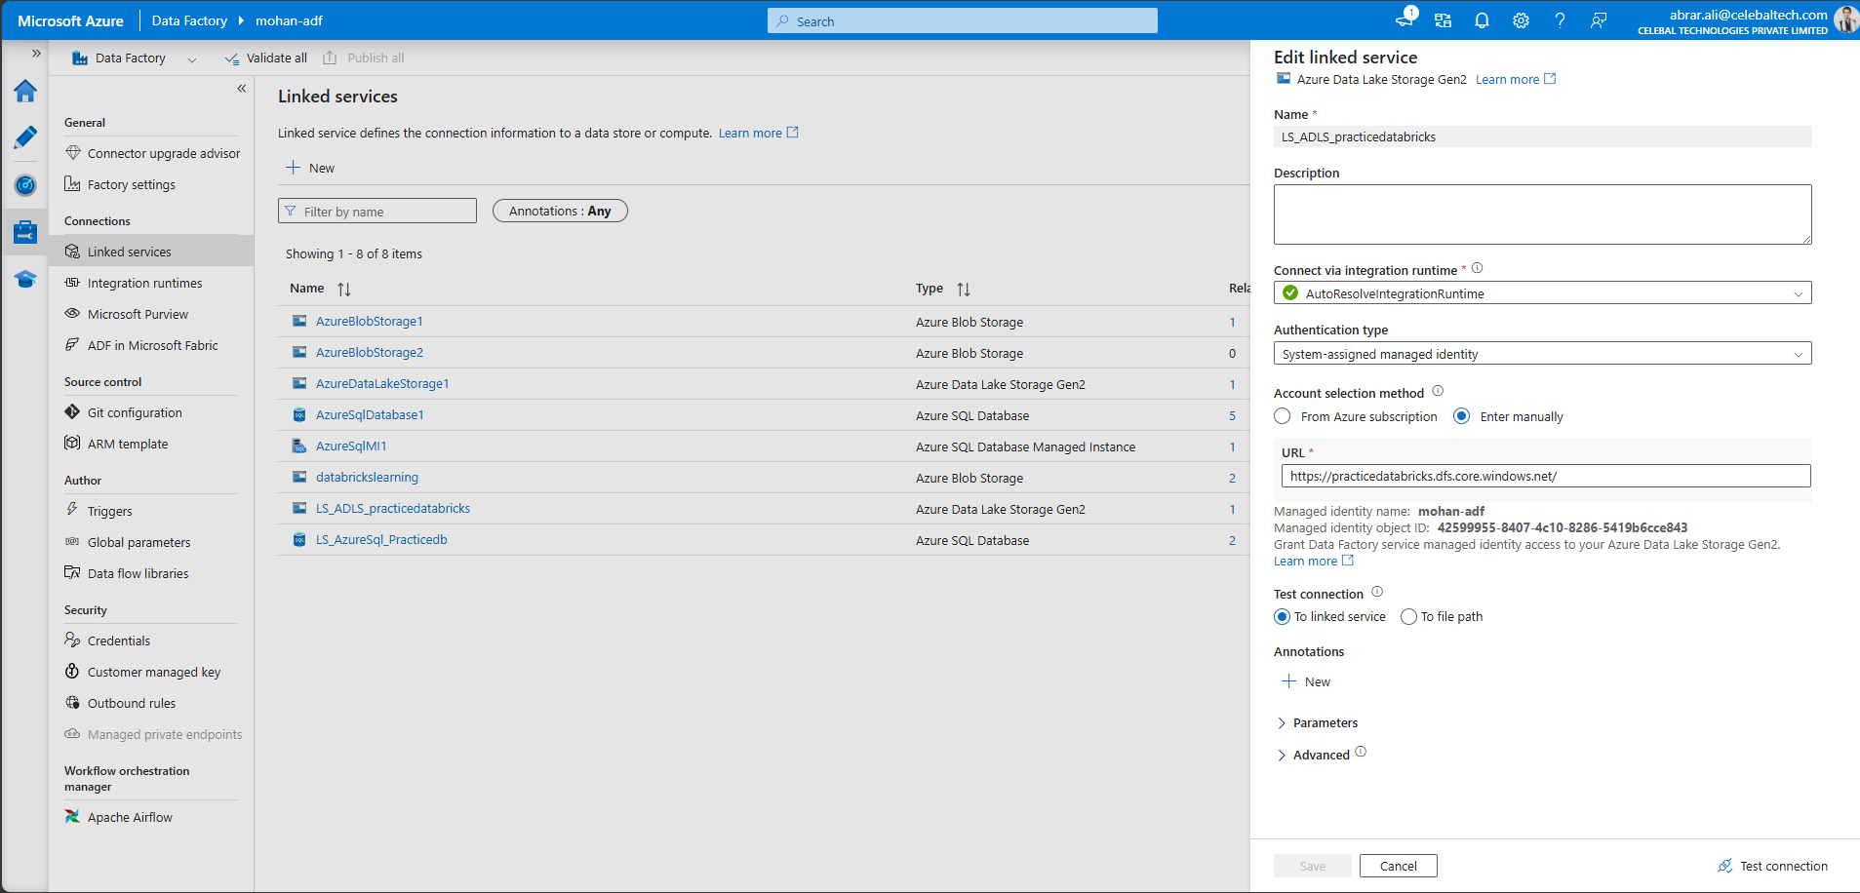
The linked service that connects ADF to the data lake using its managed identity.
In simple terms
This is the connection to the lake (practicedatabricks) using the System-assigned managed identity — the same identity we gave write permission in step 4.1. The URL uses the dfs.core.windows.net endpoint, which is the Gen2 (folder-aware) endpoint.

9. Azure Data Factory — the reusable dataset
A dataset is a pointer to data. Instead of one dataset per table, we build one parameterised dataset that works for any table.
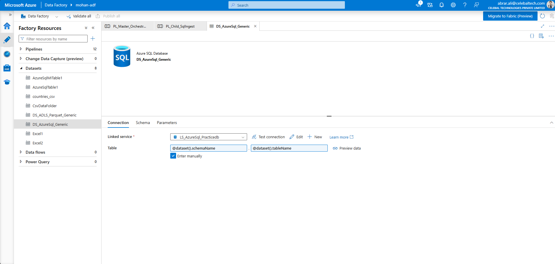
DS_AzureSql_Generic — the table name is not fixed; it comes from parameters.
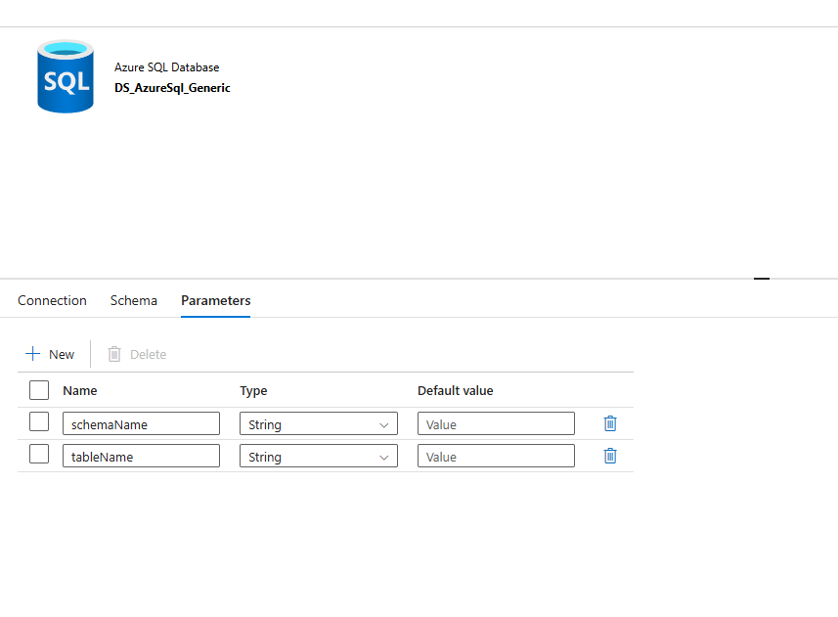
The dataset's two parameters: schemaName and tableName.
In simple terms
The table is set to @dataset().schemaName and @dataset().tableName instead of a fixed name. The pipeline fills these in at run time, so this single dataset can point at ctl.EntityConfig, sales.Orders, or any other table.
Expression (starts with @) | What it means in plain English
@dataset().schemaName | Use whatever value was passed into this dataset's schemaName parameter.
@dataset().tableName | Use whatever value was passed into this dataset's tableName parameter.
Why it matters
This is the ADF side of “metadata-driven.” One reusable dataset + parameters means you never build a new dataset per table.

10. The master pipeline (PL_Master_Orchestrator)
The master pipeline is the “foreman.” It gets the to-do list, then loops over it and hands each job to a worker pipeline.

10.1 Step 1 — Lookup: get the to-do list
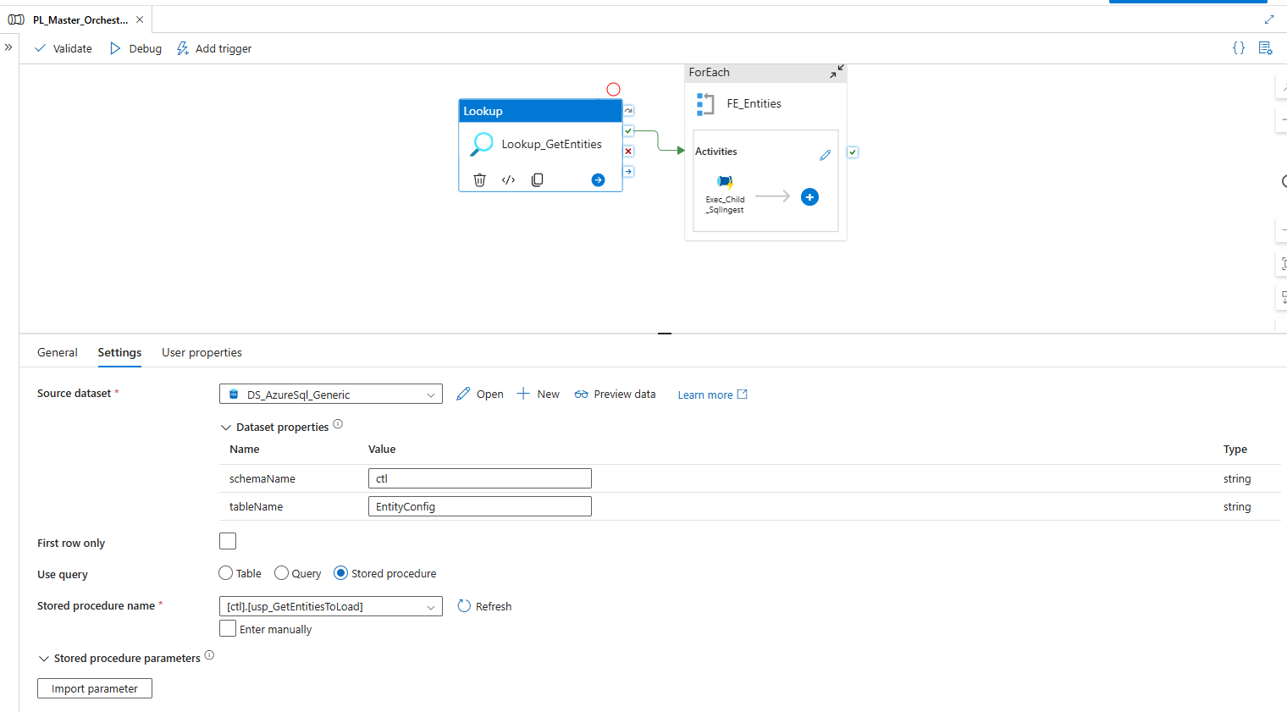
The Lookup activity runs usp_GetEntitiesToLoad to fetch all entities to load.
In simple terms
The Lookup calls the stored procedure usp_GetEntitiesToLoad through the generic dataset (pointed at ctl.EntityConfig). “First row only” is unticked so it returns the whole list, not just one row.

10.2 Step 2 — ForEach: loop over every entity
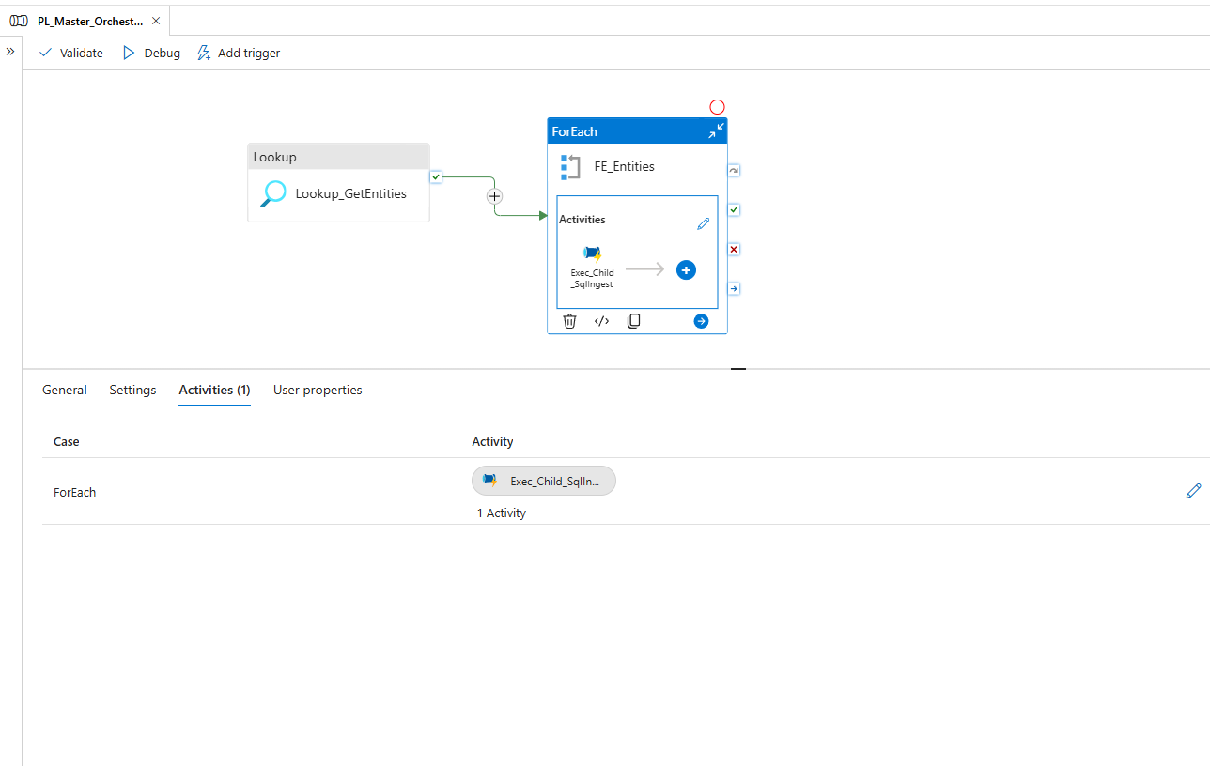
The ForEach activity (FE_Entities) loops over the list and contains one worker step.
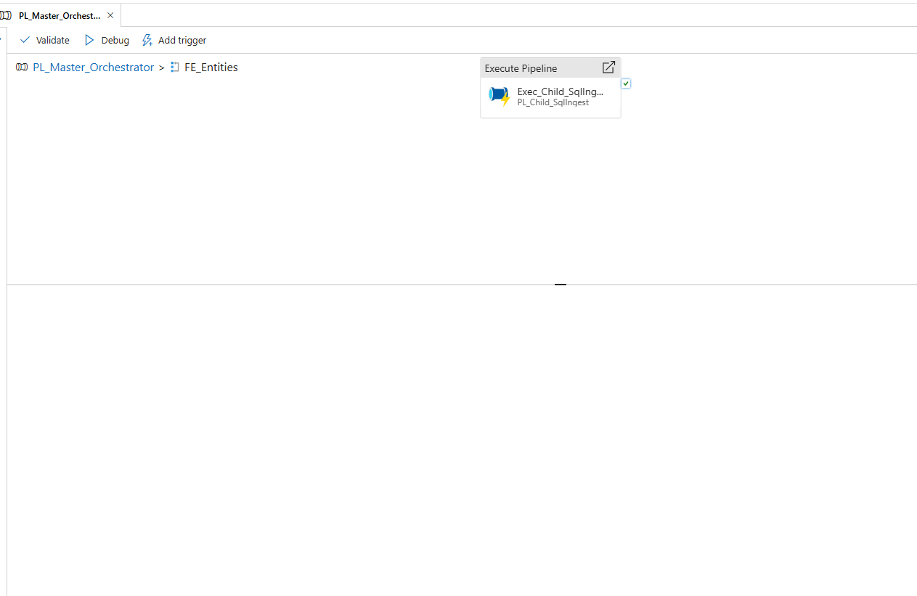
Inside the loop: an Execute Pipeline activity that calls the child pipeline.
In simple terms
ForEach repeats the same steps once per entity in the list. Its Items setting is the Lookup's output, and inside it calls the worker pipeline PL_Child_SqlIngest for each row.
Expression (starts with @) | What it means in plain English
@activity('Lookup_GetEntities').output.value | The list of rows the Lookup returned. ForEach loops over this list, one entity at a time.

10.3 Step 3 — pass each entity's instructions to the worker
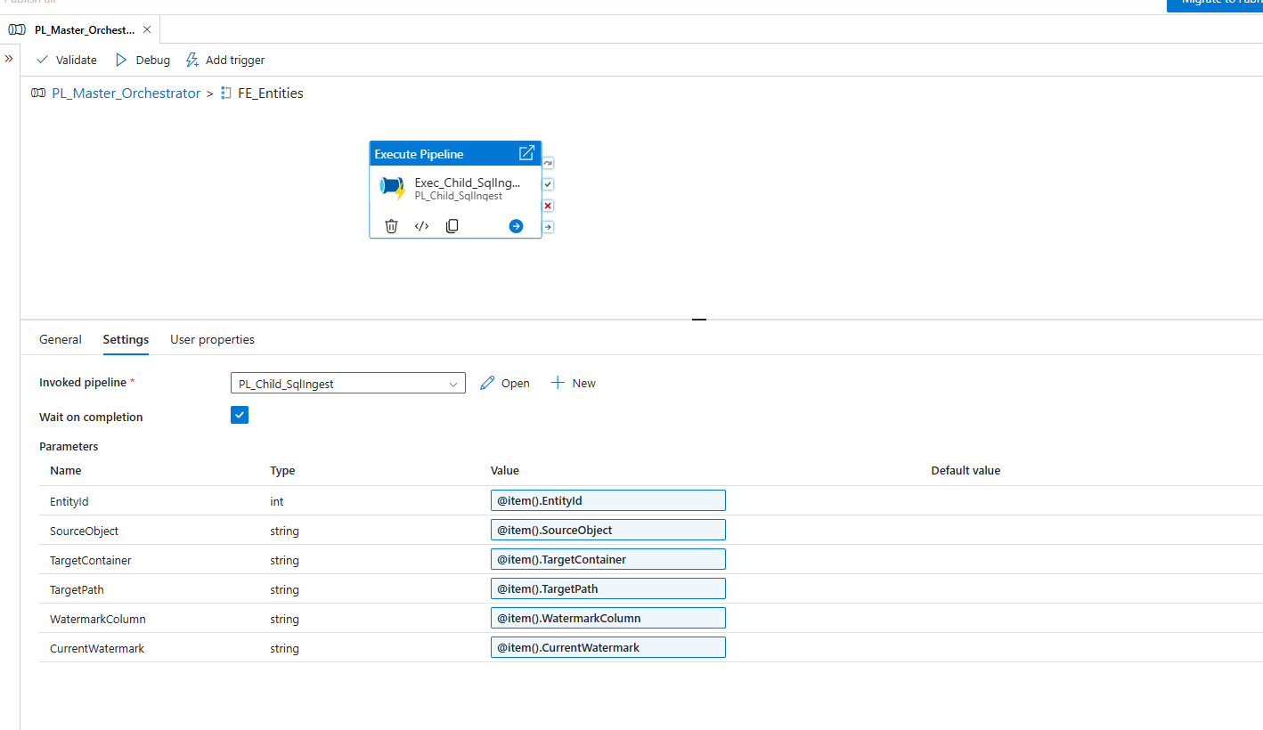
Execute Pipeline passes the current row's values into the child pipeline's parameters.
In simple terms
For each entity, the loop passes that row's values into the child pipeline. @item() means “the current row in the loop,” and .SomeColumn picks a value from it. “Wait on completion” is ticked so the master waits for each job to finish.
Expression (starts with @) | What it means in plain English
@item().EntityId | The EntityId of the row currently being processed in the loop.
@item().SourceObject | The source table name for this row, e.g. sales.Orders.
@item().TargetContainer | The target container for this row, e.g. lake.
@item().TargetPath | The target folder for this row, e.g. raw/sales/orders.
@item().WatermarkColumn | The column used as the bookmark, e.g. UpdatedAt.
@item().CurrentWatermark | The last processed value for this entity (from the Watermark table).

11. The child pipeline (PL_Child_SqlIngest)
This is the worker that actually loads ONE table. Its flow is: log start → copy the data → update the watermark → log success (or log failure).

11.1 Log the start of the run
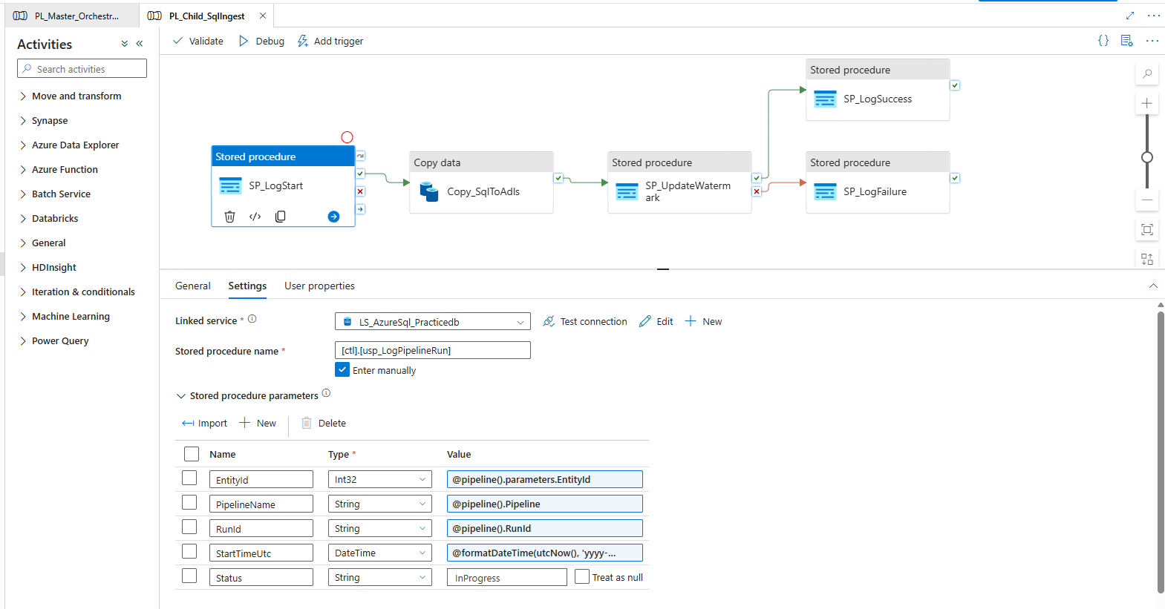
SP_LogStart writes an InProgress row via usp_LogPipelineRun, then the flow continues to Copy.
In simple terms
The first step records that this run has started (status InProgress), capturing the run id, pipeline name, and start time.
Expression (starts with @) | What it means in plain English
@pipeline().parameters.EntityId | The EntityId value that the master passed into this child pipeline.
@pipeline().Pipeline | The name of this pipeline (PL_Child_SqlIngest).
@pipeline().RunId | The unique ID ADF assigns to this particular run (used to find the diary row later).
@formatDateTime(utcNow(),'yyyy-MM-dd HH:mm:ss') | The current UTC time, written as text in that format.

11.2 Copy the data — SOURCE side (the incremental query)
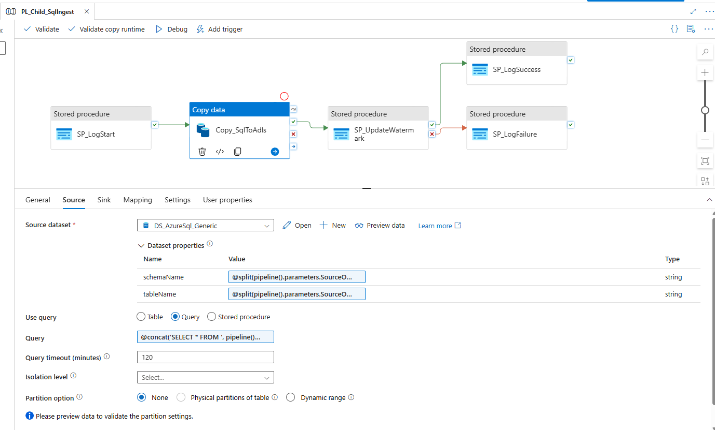
The Copy activity reads only new/changed rows using a dynamic query.
In simple terms
The source table name is split out of SourceObject, and a query is built that pulls only rows newer than the watermark. That is what makes the load incremental.
Expression (starts with @) | What it means in plain English
@split(pipeline().parameters.SourceObject,'.')[0] | Split 'sales.Orders' at the dot and take the first part → 'sales' (the schema).
@split(pipeline().parameters.SourceObject,'.')[1] | Take the second part → 'Orders' (the table).
@concat('SELECT * FROM ', pipeline().parameters.SourceObject, ' WHERE ', pipeline().parameters.WatermarkColumn, ' > ''', pipeline().parameters.CurrentWatermark, '''') | Glue text together to build: SELECT * FROM sales.Orders WHERE UpdatedAt > '<last watermark>'. Only rows changed after the bookmark are pulled.
Good-to-know (production refinement)
For total correctness, real pipelines also “freeze” an upper bound at the start (WHERE col > watermark AND col <= now) so rows that arrive during the copy aren't skipped. This build keeps it simple; the upper-bound tweak is the natural next improvement.

11.3 Copy the data — SINK side (where the file lands)
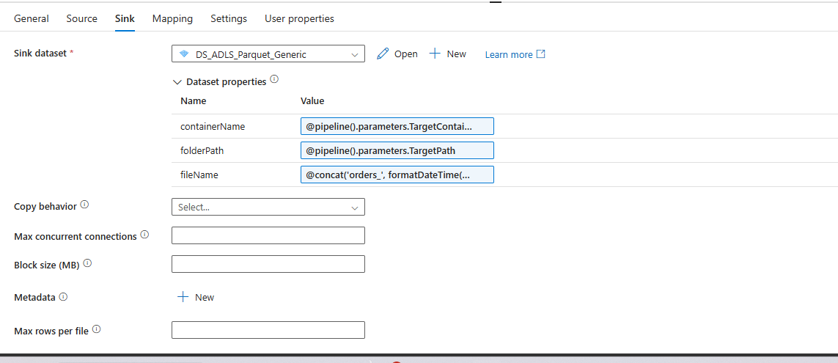
The Copy activity writes the rows to the lake as a Parquet file.
In simple terms
The data is written into lake/raw/sales/orders as a Parquet file. The file name includes a timestamp so every run creates a new, unique file.
Expression (starts with @) | What it means in plain English
@pipeline().parameters.TargetContainer | The container to write into (lake).
@pipeline().parameters.TargetPath | The folder to write into (raw/sales/orders).
@concat('orders_', formatDateTime(utcNow(),'yyyyMMddHHmmss'), '.parquet') | Build a unique file name like orders_20260722105143.parquet using the current time.

11.4 Advance the watermark (only after a successful copy)
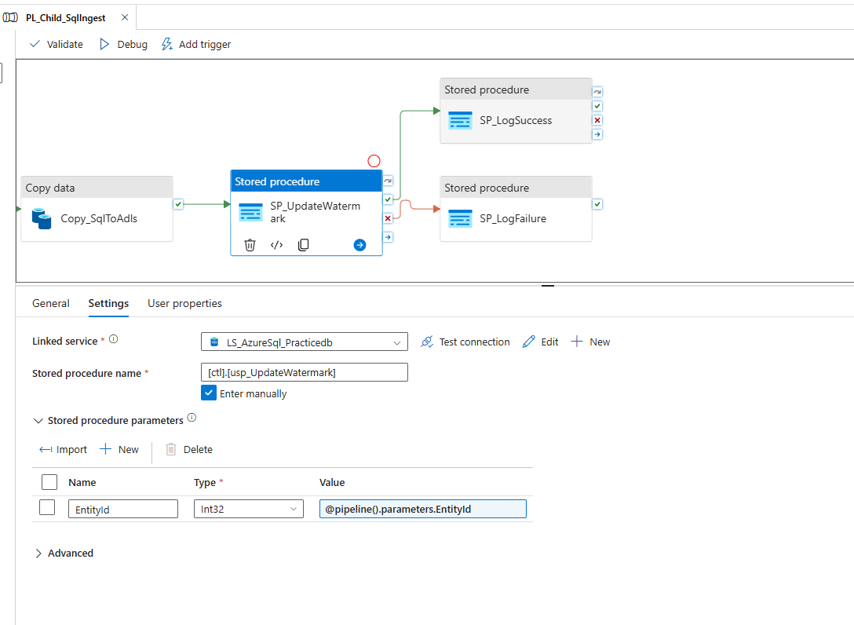
SP_UpdateWatermark moves the bookmark forward for this entity.
In simple terms
Once the copy succeeds, this calls usp_UpdateWatermark with the EntityId. The proc works out the newest value in the source and saves it, so the next run only pulls rows newer than this.
Expression (starts with @) | What it means in plain English
@pipeline().parameters.EntityId | Tells the proc which entity's bookmark to move.

11.5 Log success — the green (success) path
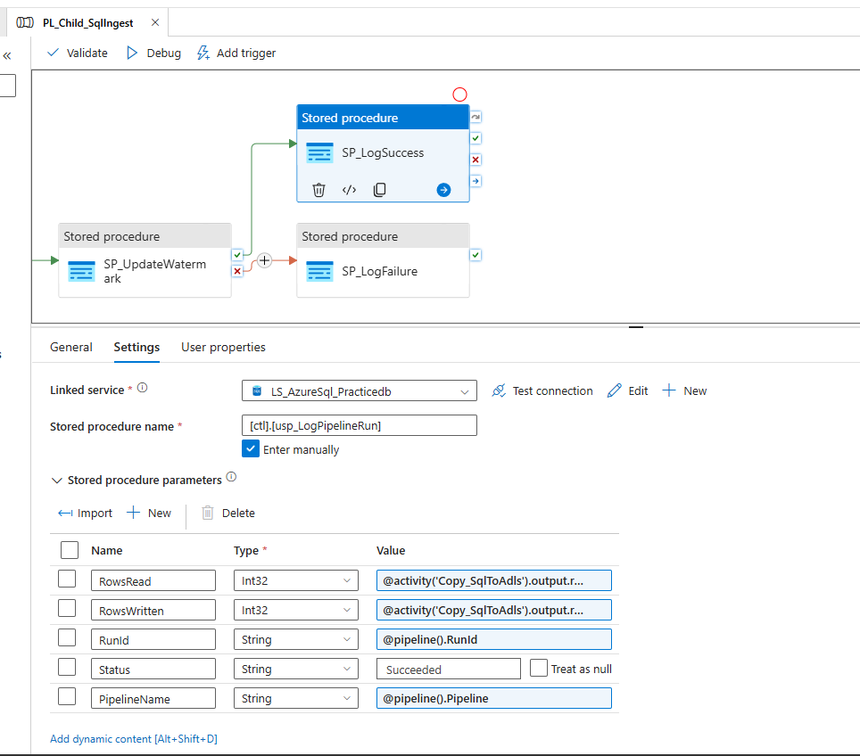
SP_LogSuccess updates the diary row to Succeeded with row counts from the Copy.
In simple terms
On success, the diary row is updated to Succeeded, including how many rows were read and written — those numbers come straight from the Copy activity's output.
Expression (starts with @) | What it means in plain English
@activity('Copy_SqlToAdls').output.rowsRead | How many rows the Copy activity read from the source.
@activity('Copy_SqlToAdls').output.rowsCopied | How many rows the Copy activity wrote to the lake.
@pipeline().RunId | The run id, used to update the correct diary row.

11.6 Log failure — the red (failure) path
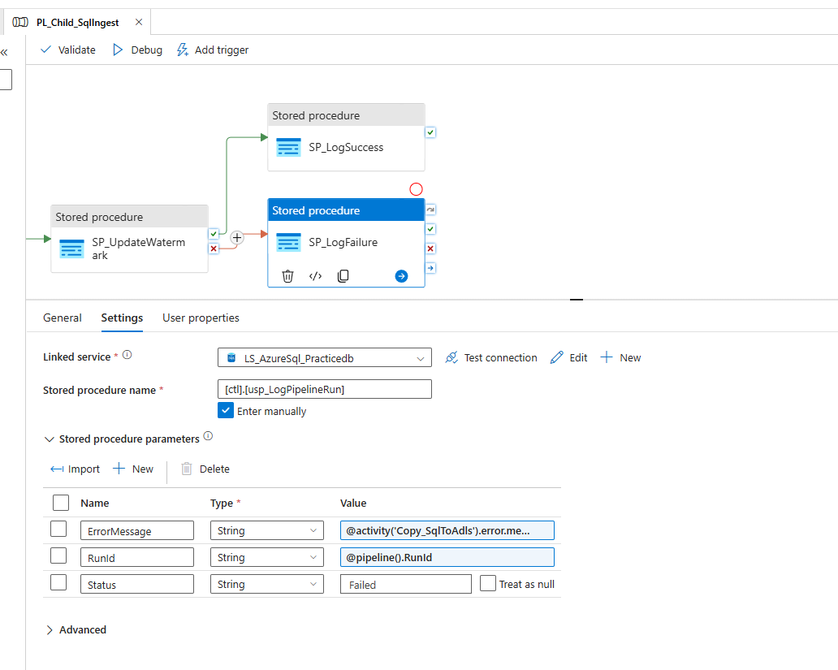
SP_LogFailure records the error message if a step fails.
In simple terms
If a step fails, the red arrow leads here and the diary row is updated to Failed, capturing the actual error text so you can troubleshoot.
Expression (starts with @) | What it means in plain English
@activity('Copy_SqlToAdls').error.message | The error message produced by the Copy activity when it fails.
@pipeline().RunId | The run id, used to update the correct diary row.
Why it matters
The success/failure split (green vs red arrows) means every run ends with an honest diary entry — either the row counts on success, or the error on failure. That is how you monitor and debug in production.

12. The result in the lake
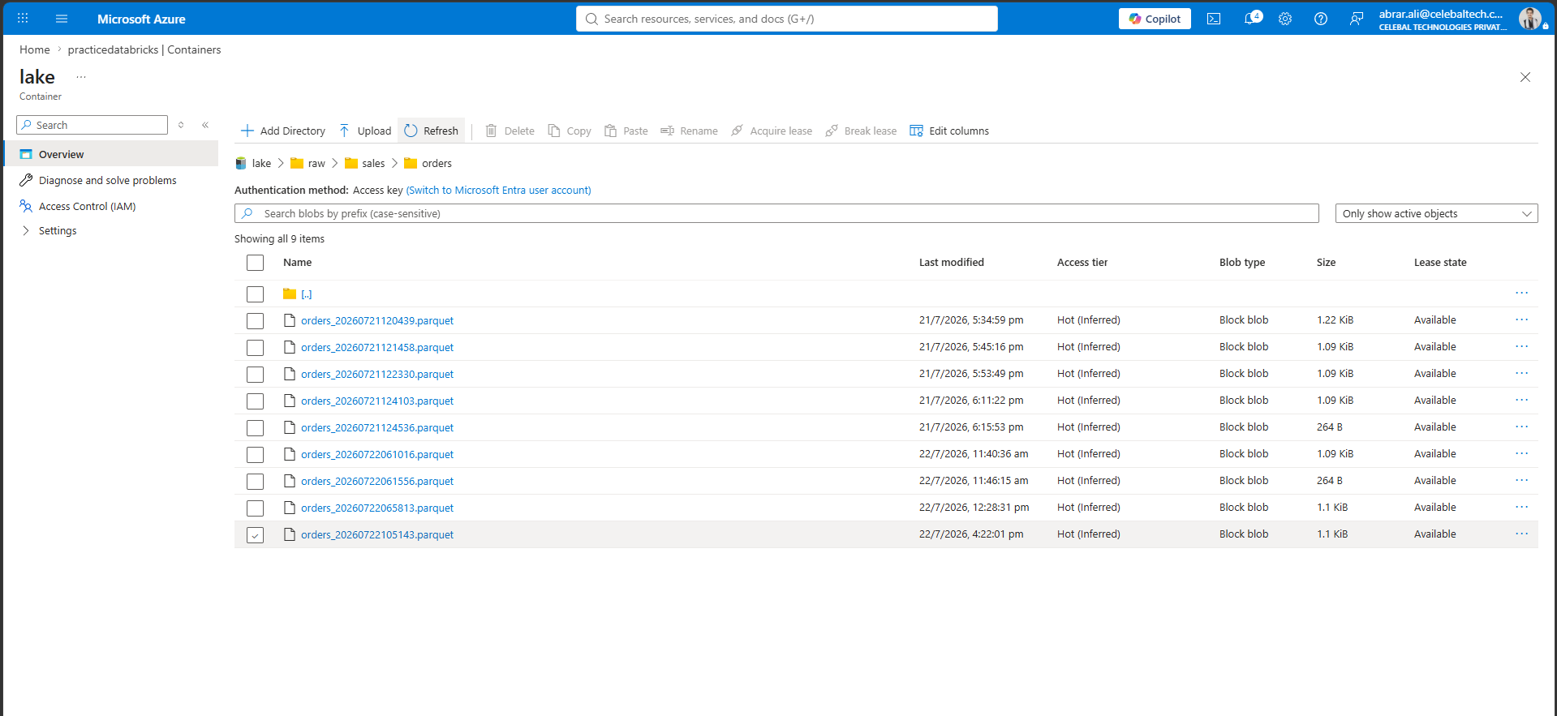
The raw/sales/orders folder now holds one Parquet file per run.
In simple terms
Each run produced a timestamped Parquet file. Notice the sizes: the larger files are runs that actually found new/changed rows; the tiny ~264-byte files are runs where nothing changed — which proves the incremental logic is working (no data means an almost-empty file).

13. Verifying the data in Databricks
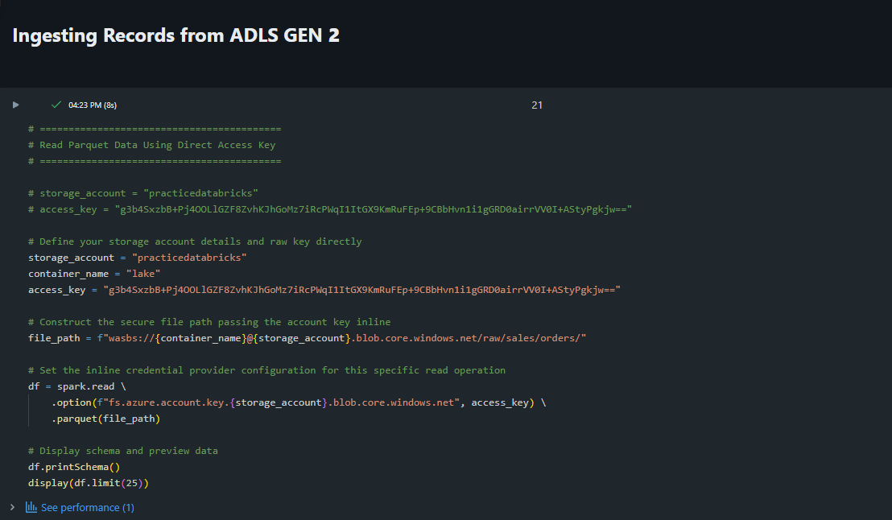
A Databricks notebook reads the Parquet files back and previews the data.
In simple terms
Finally, Databricks reads the landed Parquet files and displays them, confirming the ingested data is correct and readable downstream.
Important — security warning
This notebook has the storage account access key hard-coded in plain text, and it is visible in the screenshot. Anyone who sees that key gets full access to the entire storage account.
Please do two things: (1) go to the storage account → Access keys → Rotate/Regenerate that key now so the exposed one stops working; (2) instead of pasting keys into notebooks, use a Databricks secret scope (backed by Key Vault) or the workspace's managed identity / Unity Catalog access. Never store keys in notebook code.

14. Cheat sheet — the @ expressions in one place
ADF expressions always start with @. Here are the building blocks used in this project, in plain English.
Expression (starts with @) | What it means in plain English
@pipeline().parameters.X | The value X that was passed into this pipeline.
@pipeline().RunId | The unique ID of the current run.
@pipeline().Pipeline | The name of the current pipeline.
@item() | The current row while looping inside a ForEach.
@item().X | The value of column X in the current loop row.
@activity('Name').output.X | A value X from the output of a previous activity called 'Name'.
@activity('Name').output.value | The full list of rows returned by a Lookup activity.
@activity('Name').error.message | The error text if the activity 'Name' failed.
@dataset().X | The value X passed into a parameterised dataset.
@split(text,'.') | Cut text into pieces at every dot; [0] is the first piece, [1] the second.
@concat(a, b, c) | Join pieces of text together into one string.
@formatDateTime(utcNow(),'...') | The current UTC time written as text in the given format.
utcNow() | The current date and time in UTC.

15. The whole flow in ten plain sentences
If someone asks you to explain this project, this is the story:
1. A trigger (or a manual run) starts the master pipeline.
2. The master pipeline's Lookup calls usp_GetEntitiesToLoad and gets the list of tables to load, each with its current watermark.
3. A ForEach loops over that list, one entity at a time.
4. For each entity it calls the child pipeline, passing the entity's details with @item().
5. The child logs an InProgress row in the run log.
6. The child's Copy activity builds an incremental query (only rows newer than the watermark) and writes the results to the lake as a timestamped Parquet file.
7. On success, it advances the watermark so the next run only picks up newer rows.
8. It updates the run log to Succeeded with the row counts; if anything failed, it logs Failed with the error.
9. Adding a new table needs no new pipeline — just one new row in ctl.EntityConfig.
10. Databricks reads the landed files to confirm the data is correct.
That is a complete, working metadata-driven ingestion framework — and now you understand every screenshot, every step's purpose, and every @ expression behind it.

