A Project Report on
Online Car Buy/Sell
Submitted
In Partial Fulfillment of the Requirements
for the Degree Of
Master of Science
[Computer Applications & Information Technology]-VI

Submitted to

Department of Computer Science,
HEMCHANDRACHARYA
NORTH GUJARAT UNIVERSITY

Submitted By: Project Guide:
Sunasara Abrarali Z. [29] Dr. Jignesh B. Patel
Kadiwal Shiraj A. [182] Mr. Amit Patel
Haba Faizal M. [61]
May, 2024

ACKNOWLEDGEMENT

With immense pleasure, we present this report on the project assignment titled “Online Car Buy Sell”.
We are lifelong indebted towards Dr.B.M.Patel Director of DCS H.N.G. University, Patan for Providing us environment that is best suited for outgrowth of the students personality and bring up there moral and constant encourage and guidance helped us in completing this project
We are also lifelong indebted to the professor Dr. Jignesh B. Patel for provide us with inspiration, knowledge and all kinds of support throughout 6th semester of M.Sc. (CA & IT) studies. We from the fathoms of out heart, thank all the members of DCS H.N.G. University. for their invaluable technical and moral support.
The encouragement and help received from our parents, family members, friends and colleagues cannot be. expressed in terms of words. Without this moral support, the work would have been lift unfinished

With Sincere Regards,
Sunasara Abrarali Z.
Kadiwal Shiraj A.
Haba Faizal M.

INDEX
1.INTRODUCTION…….……………….............……….1
1.1 Project Profile……………….………..……............. 2
1.2 Project Definition…………...………………............3
2.SYSTEM ANALYSIS………….……..……..................4
2.1 Hardware & Software Configuration………..............5
2.2 Requirement Analysis……………………….............5
2.3 Existing System………………………...……...........6
2.4 Need for New System……………………….............7
2.5 System Modules………………….……..…..............7
3.SYSTEM DESIGN…………….…….……....................8
3.1 DFD Diagram…………..……….…..…….................12
3.2 Data Dictionary……….…….…….………................20
3.3 ER-Diagram ...............................................................21
4.INTERFACE DESIGN …………………......................22
4.1 Screenshots………….………………..……...............22
4.1.1 User Module ........................................................... 22
4.1.2 Admin Module ........................................................35
5.CONCLUSION AND FUTURE WORK…...................38
5.1 Conclusion…………………..…………….................
5.2 Future Work……...…………..……………................
6.REFERENCES……………………………..................40

1.INTRODUCTION

- Car Trading means buy/sell used cars including budget, model, prices, company etc.
- Our project is meant to give people a better and trustworthy platform where they can sell and buy cars of their own choice and obviously on their own terms and condition.
- With the help of internet and computer systems a man from remote area can buy/sell his car from anywhere the country/world.
- We can also add option of the online auction of heritage and vintage cars in which customers can take part in the auction. This will eliminate the barrier of distance and area.

1.1 Project Profile

Project Definition | Online Car Buy/sell System
Front End | HTML, CSS, Bootstrap, JavaScript
Back End | JSP, Servlet
Database Toll | MySQL
Documentation Tool | MS Word, MS PowerPoint, Canva
Project Duration | 50 Days
Team Size | 3(Three)
Developed By | Sunasara Abrarali  Kadiwal Shiraj  Haba Faizal
Submit To | Dept. of Computer Science,  HNGU, Patan
Internal Guide | Dr. Jignesh B Patel  Mr. Amit Patel

1.2 Project Definition

- The main purpose of “car buy/sell system” is sell/buy used/second-hand cars online. Using this project anyone can buy/sell used cars online including by budget, cities, model, company etc.
- This project would become the best market place and information source on old cars bought and sold in India. In this project, we want to make the some modules like car seller module, car buyer module, find cars including budget, car comparisons etc.
- This project will provide facility to all buyer, seller and dealers for buy/sell cars. If anyone want to buy used cars online, then first he will register in this website and then he can see all the details about the sell used cars including prices, model and cities.
- It provides the best used cars for the cheapest prices, creating more value for customers visiting.
- It provides the message of new dealing cars, used cars to the visitor who register in the website.
- This system is based on the buyer budget, seller budget for the buying/selling used cars. The main goal is to provide easy way for buying and selling used cars online.
- Any person can register in the website and after that he can buy used cars, sell used cars, compare the cars regarding budget, model, company, city. Unregistered person may only see common pages with all buyer and seller’s information.

2.SYSTEM ANALYSIS

2.1 Hardware & Software Configuration
The hardware requirements Online Car Buy Sell are
- Processor: Pentium IV Processor
- Hard Disk: 80 GB HDD
- Ram: 512 MB and above
The Software specification are
- Operating System: Window 7 and above
- HTML, CSS, Bootstrap (Front End)
- MY SQL (Back end)
- JSP, Servlet (Server-side programming)
- XAMPP Server

2.2 Requirement Analysis
The first step in developing the system is analysing the problem. Before developing a system, the problem should be well defined Identifying the need for a new information system and launching an investigation and a feasible study must be done to check whether the software is visible for the organization. This unit we have done this study.
Lack of security is another problem of the existing system. That may lead to serious problems. It will affect the business career. In the existing system, there is no facility for the user to see the data. The existing system is not reliable because of human errors.
Because of the above reasons the existing system need to be change, for the easy and smooth running of the system.

2.3 Existing System
At present all the activities in transaction are handled manually. Manual data processing system, whole providing economy, flexibility and adaptability at low data volumes become more complex when the volume of data becomes large. As an organization expands in size and function, a stage is reached when manual procedures become inadequate and inefficient. No matter how many clerks are employed a stage is reached then it becomes impossible to systemize such a large amount of information. What is required then is an upgrading in the class of information processing technology.
The present system is not sufficient to hold all the information that is necessary for the processing. So the library is in need of new computerized system, which is very flexible, user friendly and capable of holding the system in a robust manner.

LIMITATIONS OF EXISTING SYSTEM
There were a lot of reasons for the introduction of the new system. They are mainly due to the drawbacks and efficiency of the existing system.
- Physical volume of the data is very large.
- The delay in information search and retrieval.
- Problems in updating and backup.
- Damages of Paper containing the information.
- Considerable time taken for report generation.

2.4 Need for new system
The system study phase studies the problem, identifies alternate solution, evaluates these solutions and finally recommends best solution. The system gives the structure and function of the system. A detailed system study is essential for developing an efficient system. The proposed system provides a better user interface. The system is a menu driven program.

2.5 System Modules
TECHNICAL FEASIBILITY STUDY
It is a study of resource availability that may affect the availability to achieve an acceptable system. It is essential that the process of analysis and definition be conducted in parallel with an assessment of technical feasibility.
It centers on the existing computer system and to what extent it can support the proposed system. Though information in manual system is enormous, it is easily handled by the Access (which is a RDBMS software). It is easy to find and buy a system, which support this software. So it is technically feasible.
ECONOMIC FEASIBILITY STUDY
Tremendous is the range of changes that accompanies the new technology. Introduction of a computerized system has some merits and demerits can lead to monetary gains. The cost to buy a computer system for running this software is quite cheap. We get benefit because we serve more borrowers quickly and easily. So this system is economically feasible.
BEHAVIORAL FEASIBILITY STUDY
The hierarchy of the new system is much better than the old. The new system is very much user friendly and the operational cost is bearable. The maintenance and working of the new system needs less human effort.

3. SYSTEM DESIGN

The logical flow of a system and define the boundaries of a system. It includes the following steps:
- Reviews the current physical system - its data flows, file content, volumes, frequencies etc.
- Prepares output specifications - that is, determines the format, content and frequency of reports.
- Prepares input specifications - format, content and most of the input functions.
- Prepares edit, security and control specifications.
- Specifies the implementation plan.
- Prepares a logical design walk through of the information flow, output, input, controls and implementation plan.
- Reviews benefits, costs, target dates and system constraints.

PHYSICAL DESIGN:
Physical system produces the working systems by define the design specifications that tell the programmers exactly what the candidate system must do. It includes the following steps.
- Design the physical system.
- Specify input and output media.
- Design the database and specify backup procedures.
- Design the database and specify backup procedures.
- Plan system implementation.
- Prepare a conversion schedule and target date.
- Determine training procedures, courses and timetable.
- Devise a test and implementation plan and specify any new hardware/software.
- Update benefits, costs, and conversion date and system constraints.

MODULE DESIGN :-

There are main two module.
- User
- Admin

- User
1.1 Visitor/Guest
  - Can browse the website.
  - View listings of cars available for sale.
  - Read information about the website and its services.
  - Cannot access features related to buying or selling without login.

  - Registered User
  - Can create an account on the website.
  - Access basic features like saving favourite listings, setting preferences, and receiving notifications.
  - Can access the subscription page to buy a subscription plan.
  - Once subscribed, can access features for buying and selling cars.

1.3 Subscriber
  - Paid user with access to premium features.
  - Can create listings to sell cars.
  - Can contact sellers and negotiate prices.
  - Can view detailed information about listings.
  - Can participate in forums or discussions related to cars.
  - May have access to additional perks or benefits depending on the subscription tier.

- Admin
2.1 Website Administrator
  - Manages the overall functioning of the website.
  - Can add, edit, or remove listings.
  - Manages user accounts and subscriptions.
  - Monitors and moderates user-generated content, such as forum discussions and comments.
  - Handles technical issues and ensures the website's smooth operation.
  - Manages payment processing and subscription plans.
  - Responds to user inquiries.

2.2 Content Moderator
  - Monitors user-generated content for compliance with community guidelines and terms of service.
  - Reviews and approves new listings before they are published.
  - Handles reported content and takes appropriate action, such as removing or editing posts that violate guidelines.
  - Helps enforce policies regarding prohibited items or illegal activities.
  - Assists users with content-related questions or concerns.

3.1 DFD Diagram

- DFD level 0

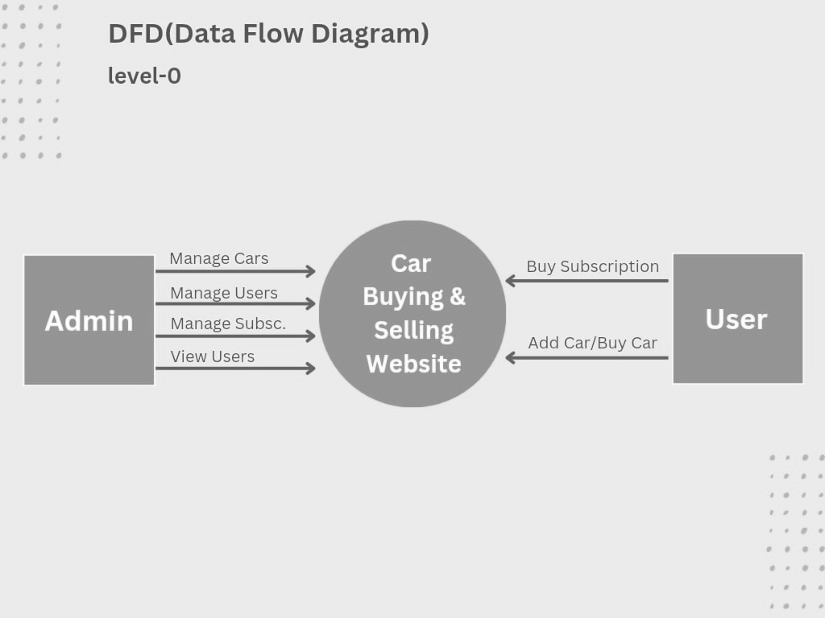

- DFD level 1
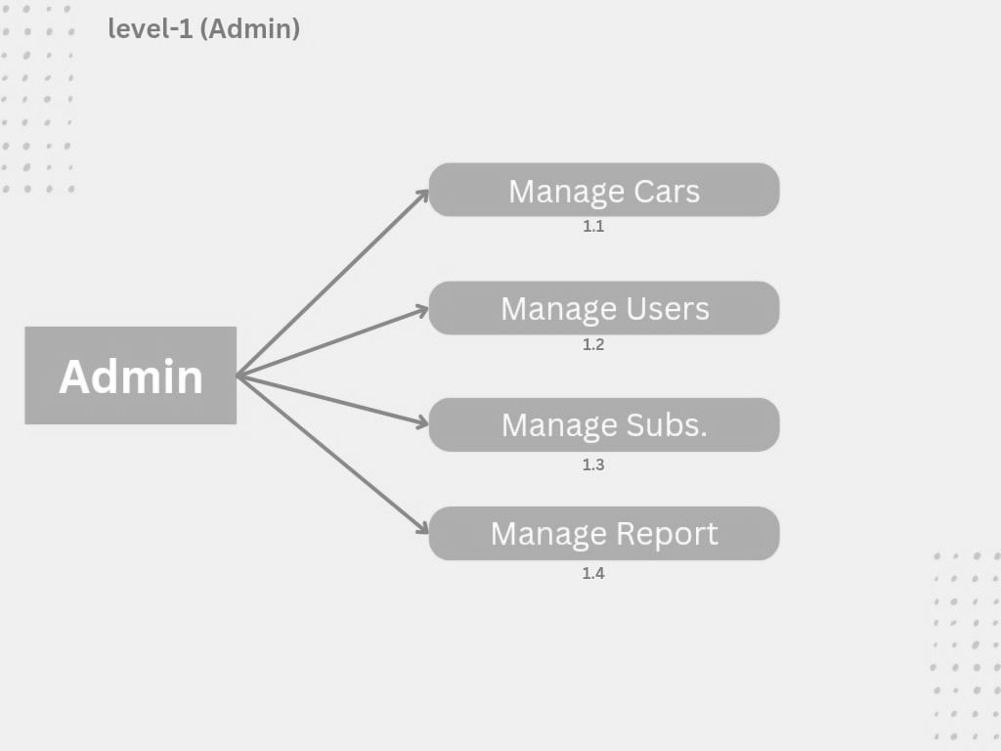
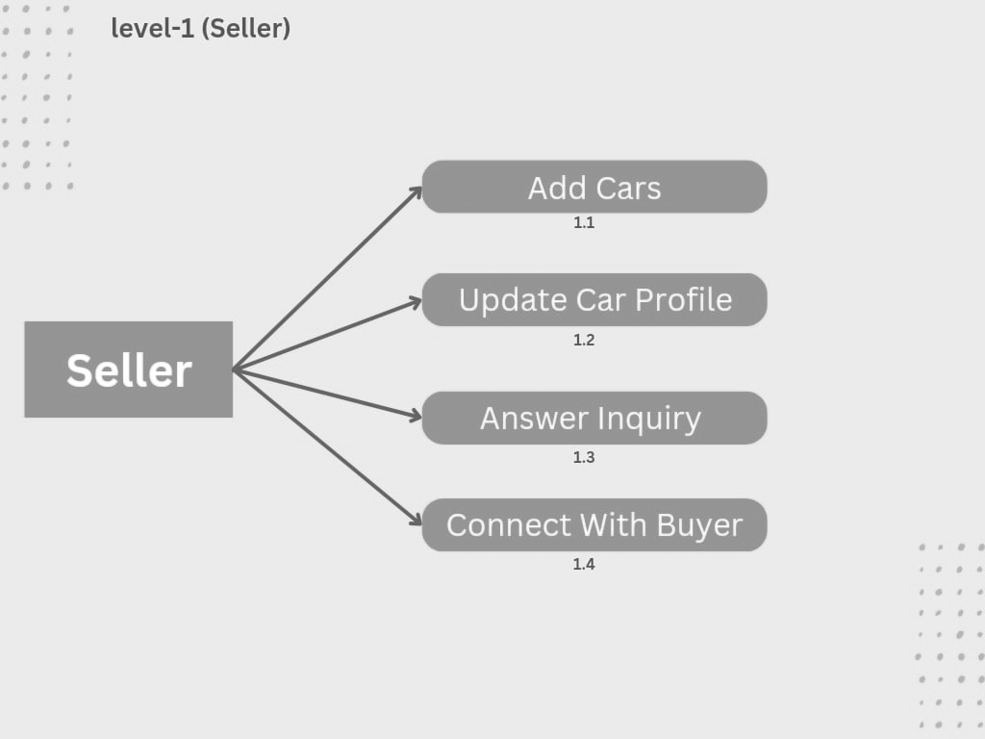

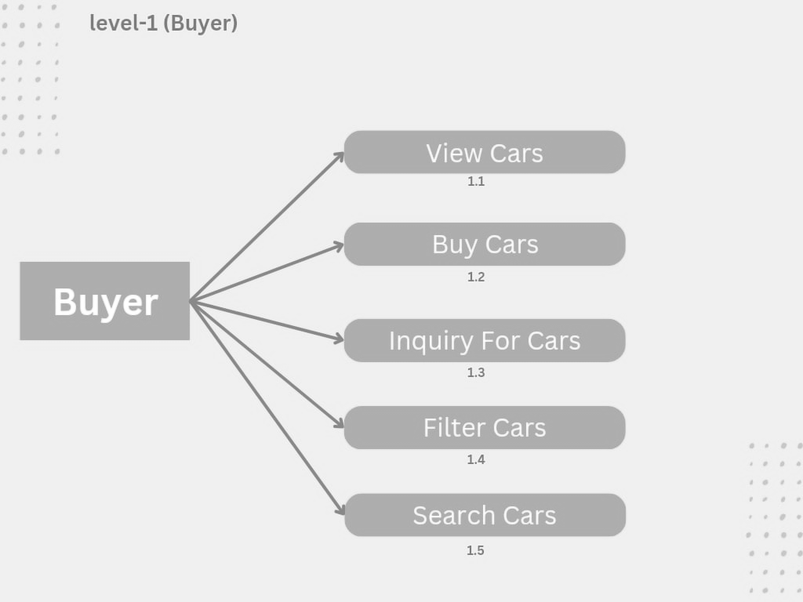

3.2 Data Dictionary
Table Name: - Users
Description: - This table is used for User registration and login .
SR.NO. | FIELD | DATA TYPE | CONSTRAINT | DESCRIPTION
1 | User_id | Varchar(20) | Primary Key | Unique ID
2 | U_Name | Varchar(20) | Not Null | First Name
3 | Password | Varchar(20) | Not Null | Password
4 | E_mail | Varchar(20) | Not Null | E-Mail
5 | F_Name | Varchar(20) | Not Null | First Name
6 | L_Name | Varchar(20) | Not Null | Last Name
7 | Address | Varchar(50) | Not Null | Address
8 | City | Varchar(20) | Not Null | City
9 | State | Varchar(20) | Not Null | State
10 | Phone | Varchar(20) | Not Null | Phone No.
Primary Key: - User_id

Table Name: - Admin
Description: - This table is used for Admin login and detail.
SR.NO. | FIELD | DATA TYPE | CONSTRAINT | DESCRIPTION
1 | Admin_id | Varchar(20) | Primary Key | Unique ID
2 | Password | Varchar(20) | Not Null | Password
3 | F_Name | Varchar(20) | Not Null | First Name
4 | L_Name | Varchar(20) | Not Null | Last Name
5 | E_mail | Varchar(20) | Not Null | E-Mail
6 | Phone | Varchar(20) | Not Null | Phone No.
Primary Key: - Admin_id

Table Name: - Subscription
Description: - This table used to store subscription details.
SR.NO. | FIELD | DATA TYPE | CONSTRAINT | DESCRIPTION
1 | Sub_id | Varchar(20) | Primary Key | Unique ID
2 | sub_Types | Varchar(20) | Not Null | Subscription Type
3 | Price | Decimal(10,2) | Not Null | Price
Primary Key: - Sub_id

Table Name: - Sellers
Description: - This table used for seller.
Primary Key: - Seller_id
SR.NO. | FIELD | DATA TYPE | CONSTRAINT | DESCRIPTION
1 | Seller_id | Varchar(20) | Primary-Key | Unique ID
2 | User_id | Int | Foreign Key | User Id

Table Name: - Buyer
Description: - This table used for Buyer.
Primary Key: - Buyer_id
SR.NO. | FIELD | DATA TYPE | CONSTRAINT | DESCRIPTION
1 | Buyer_id | Varchar(20) | Primary Key | Unique ID
2 | User_id | Int | Foreign Key | User ID

Table Name: - Car_Info.
Description: - This table is used for add new vehicle and Car Information.
Primary Key: - Car_id
SR.NO. | FIELD | DATA TYPE | CONSTRAINT | DESCRIPTION
1 | Car_id | Varchar(20) | Primary Key | Unique ID
2 | Car_name | Varchar(20) | Not Null | Car Name
3 | Regis_Year | Decimal(4) | Not Null | Registration Year
4 | KM_Driven | Decimal(10) | Not Null | KM Driven
5 | Price | Decimal(10,2) | Not Null | Car Price
6 | Car_Brand_id | Int | Foreign Key | Car Brand ID
7 | Model_id | Int | Foreign Key | Model
8 | Variant_id | Int | Foreign Key | Variant
9 | Owner_id | Int | Foreign Key | Owner of car
10 | Ownership | Varchar(20) | Not Null | Ownership
11 | Description | Varchar(20) | Not Null | Description
12 | Photos | Varchar(50) | Not Null | Photos

Table Name: - Car_Brand.
Description: - This table is used to store car brand.
Primary Key: - Brand_id
SR.NO. | FIELD | DATA TYPE | CONSTRAINT | DESCRIPTION
1 | Brand_id | Varchar(20) | Primary-Key | Brand ID
2 | Brand_Name | Varchar(20) | - | Brand Name

Table Name: - Car_Model
Description: - This table use to store car model.
Primary Key: - Model_id
SR.NO. | FIELD | DATA TYPE | CONSTRAINT | DESCRIPTION
1 | Model_id | Varchar(20) | Primary-Key | Unique ID
2 | Model_Name | Varchar(20) | - | Model Name
3 | Brand_id | Int | Foreign Key | Brand Name

Table Name: - Car_Variant
Description: - Its use to store car variants.
Primary Key: - Variant_id
SR.NO. | FIELD | DATA TYPE | CONSTRAINT | DESCRIPTION
1 | Variant_id | Varchar(20) | Primary-Key | Unique ID
2 | Type | Varchar(20) | - | Fuel Type
3 | Variant_Type | Varchar(20) | - | Varients
4 | Model_Id | Int | Foreign Key | Model Name

Table Name: - CarSell_Hist
Description: - Its use to store car selling history.
Primary Key: - Sell_id
SR.NO. | FIELD | DATA TYPE | CONSTRAINT | DESCRIPTION
1 | Sell_id | Varchar(20) | Primary-Key | Unique ID
2 | Car_id | Int | Foreign Key | Car Name
3 | Seller_id | Int | Foreign Key | Seller
4 | Buyer_id | Int | Foreign Key | Buyer
5 | Sell_Date | Timestamp () | Not Null | Date of Sell
6 | Price | Decimal(10,2) | Not Null | Price

3.3 Entity Relationship
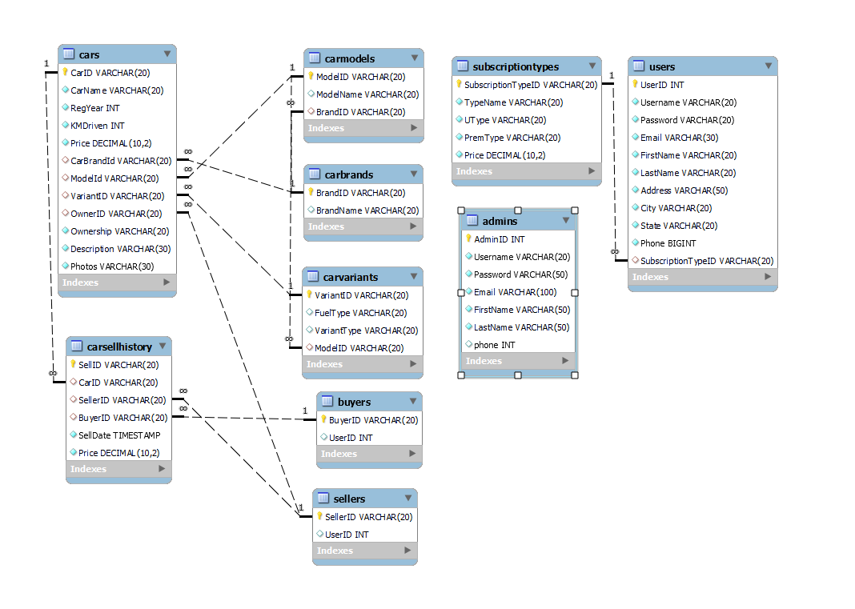

4.INTERFACE DESIGN
4.1 Screenshot :-
4.1.1 User Module :
Home Page
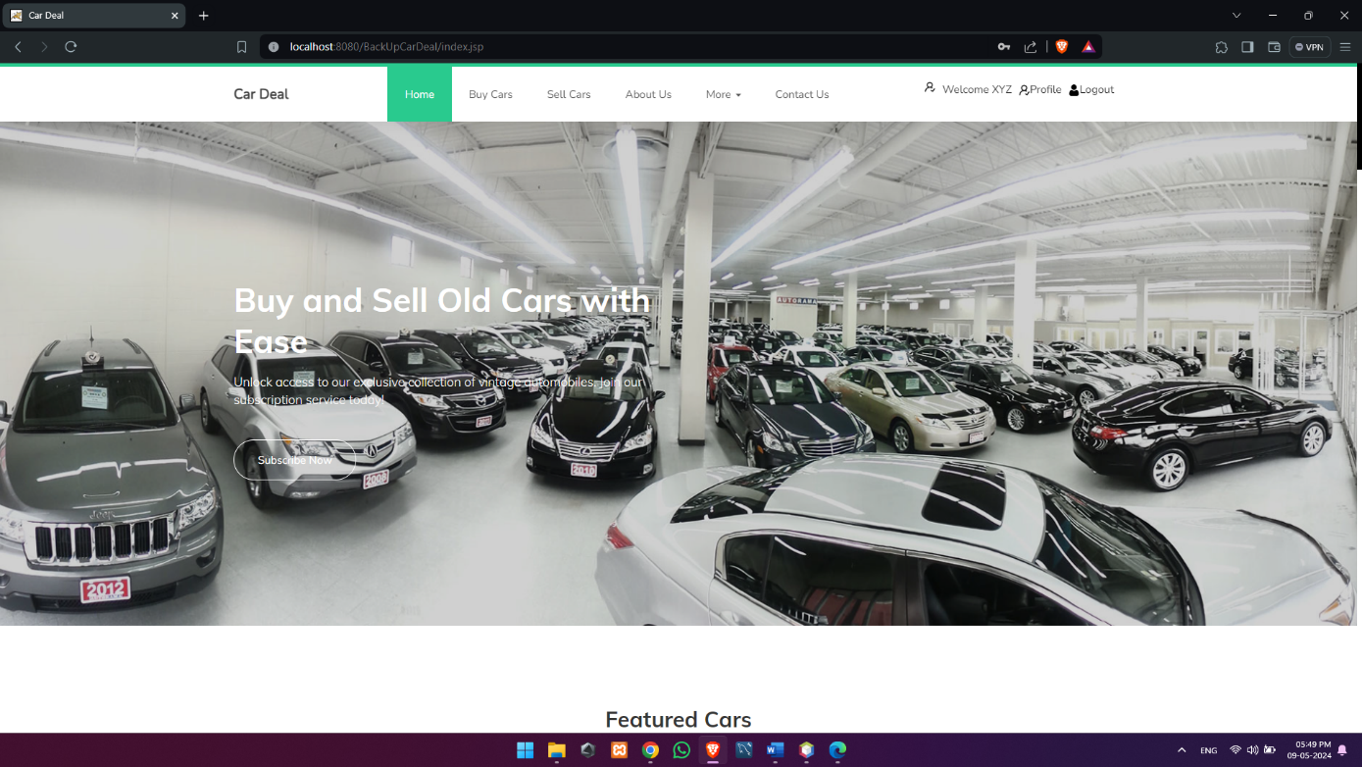
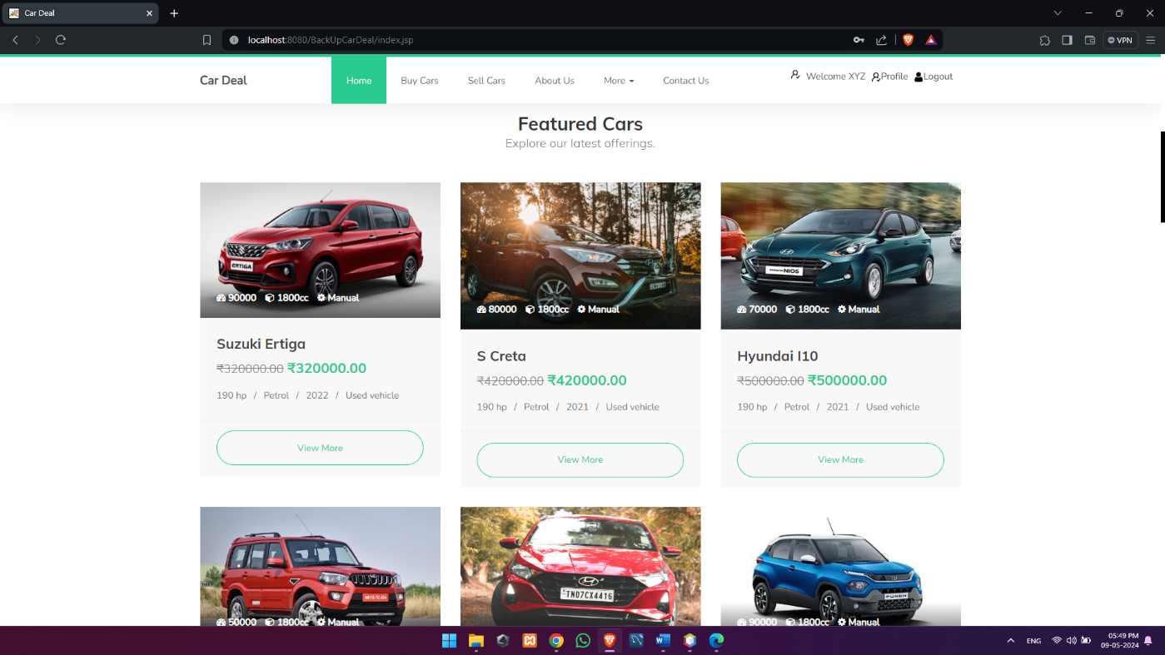
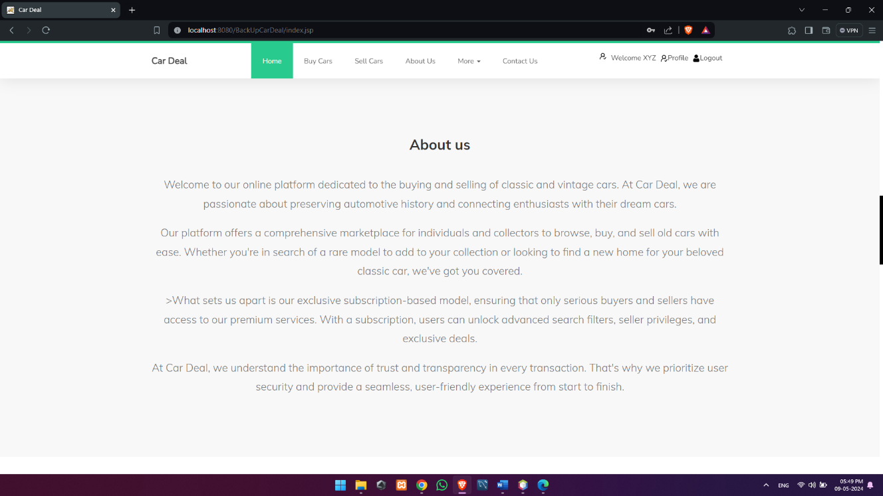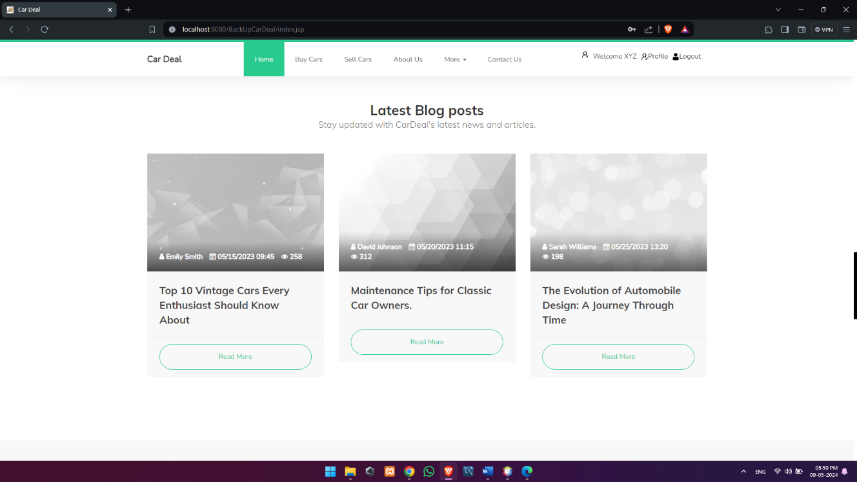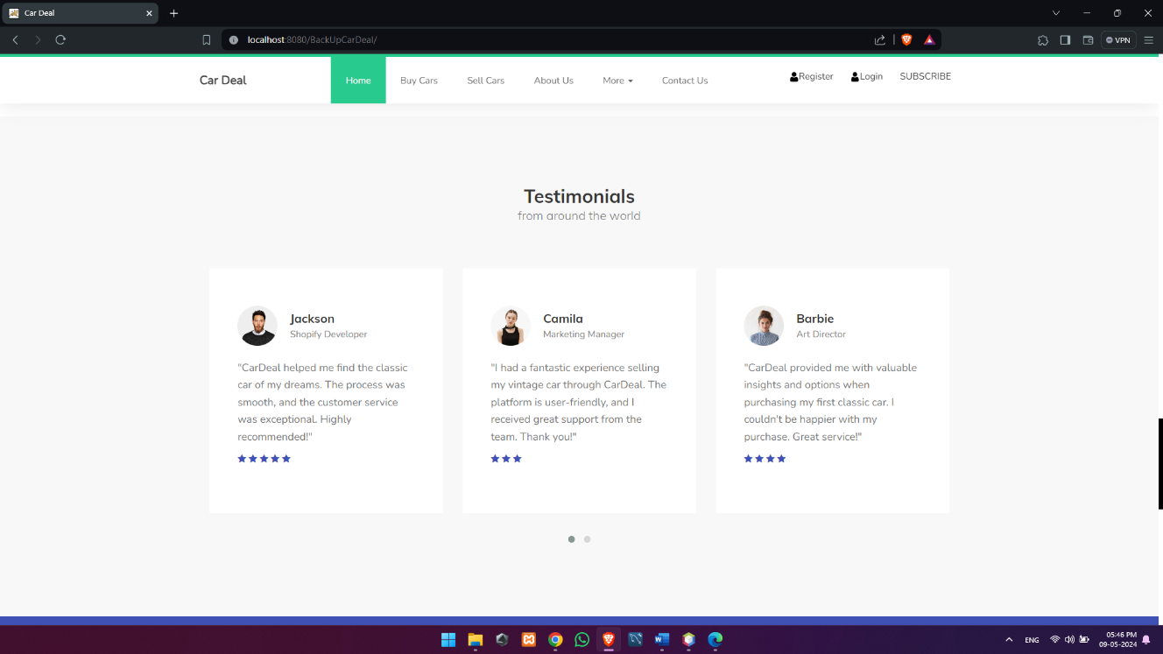
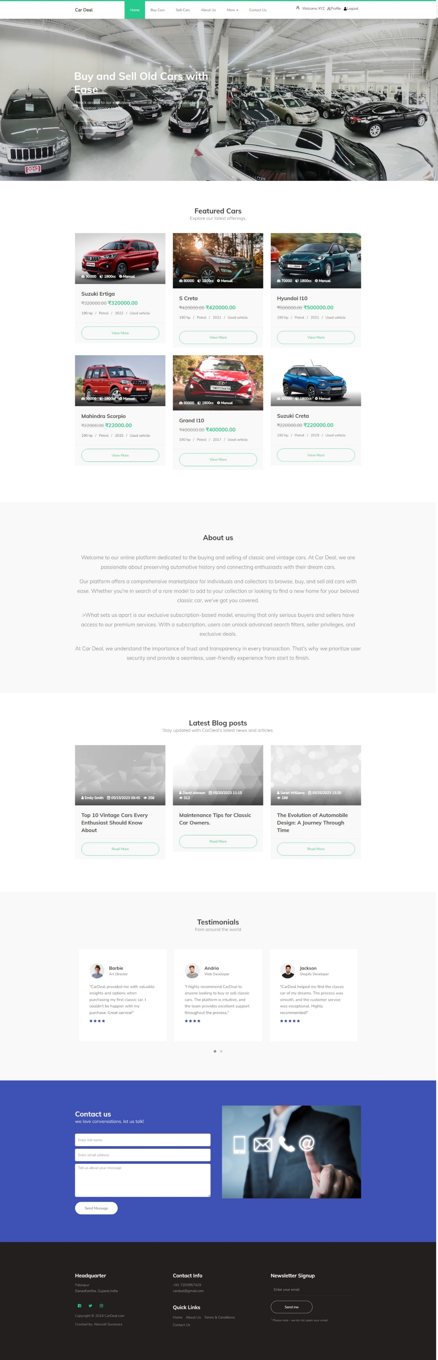

Buy Car/Listed Cars
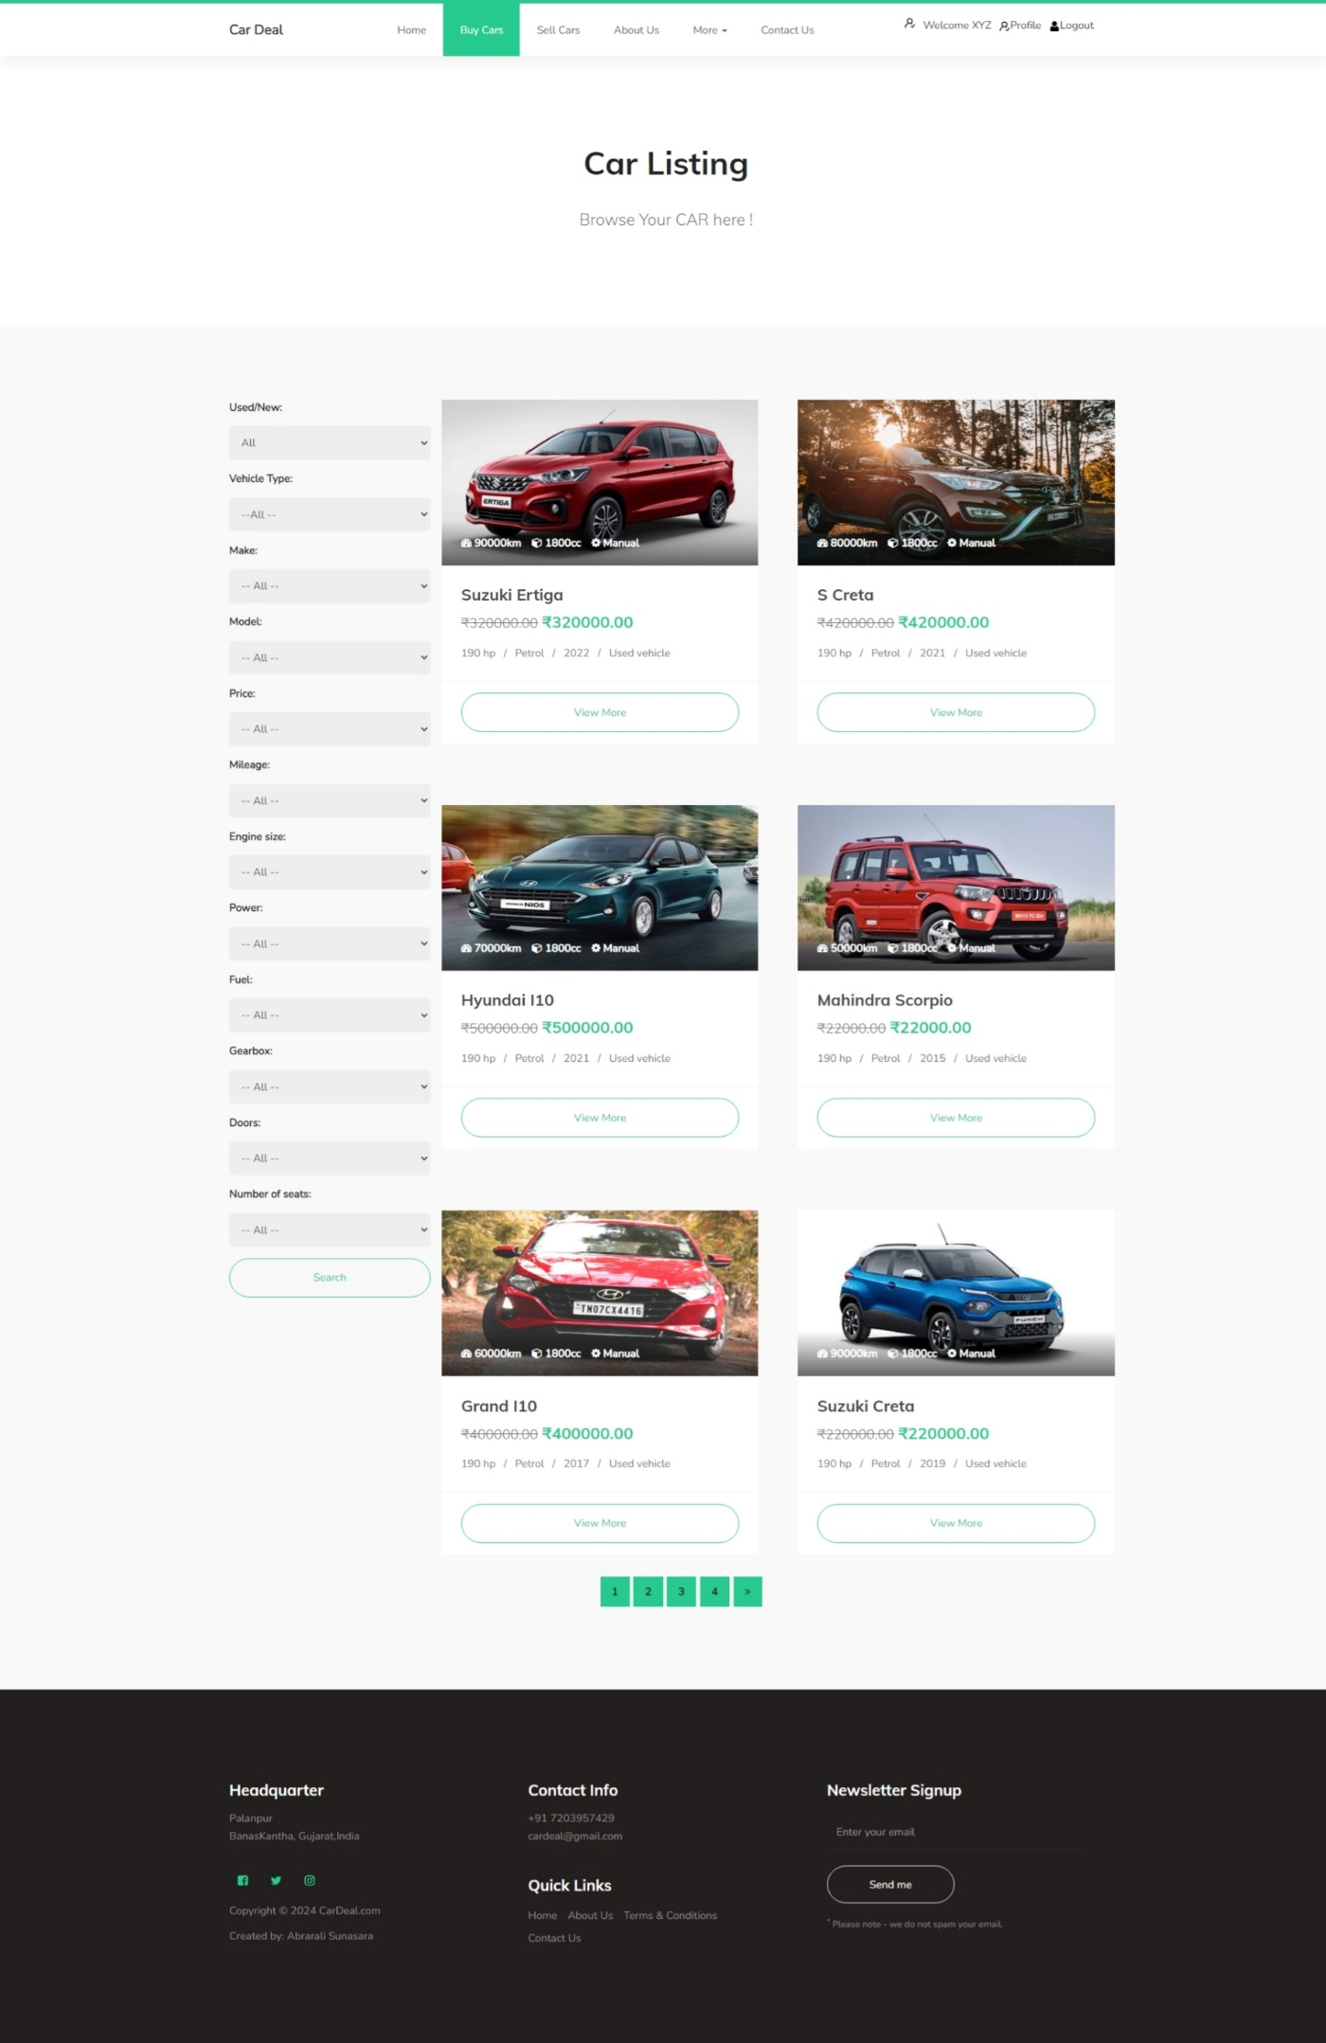
About Us
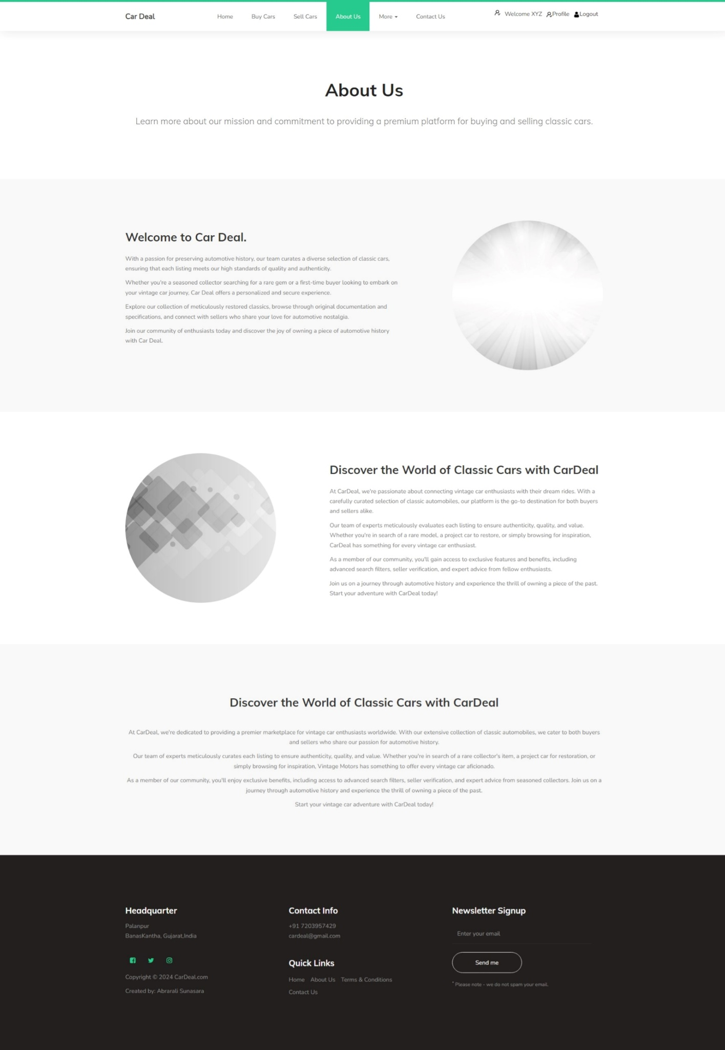
User Register
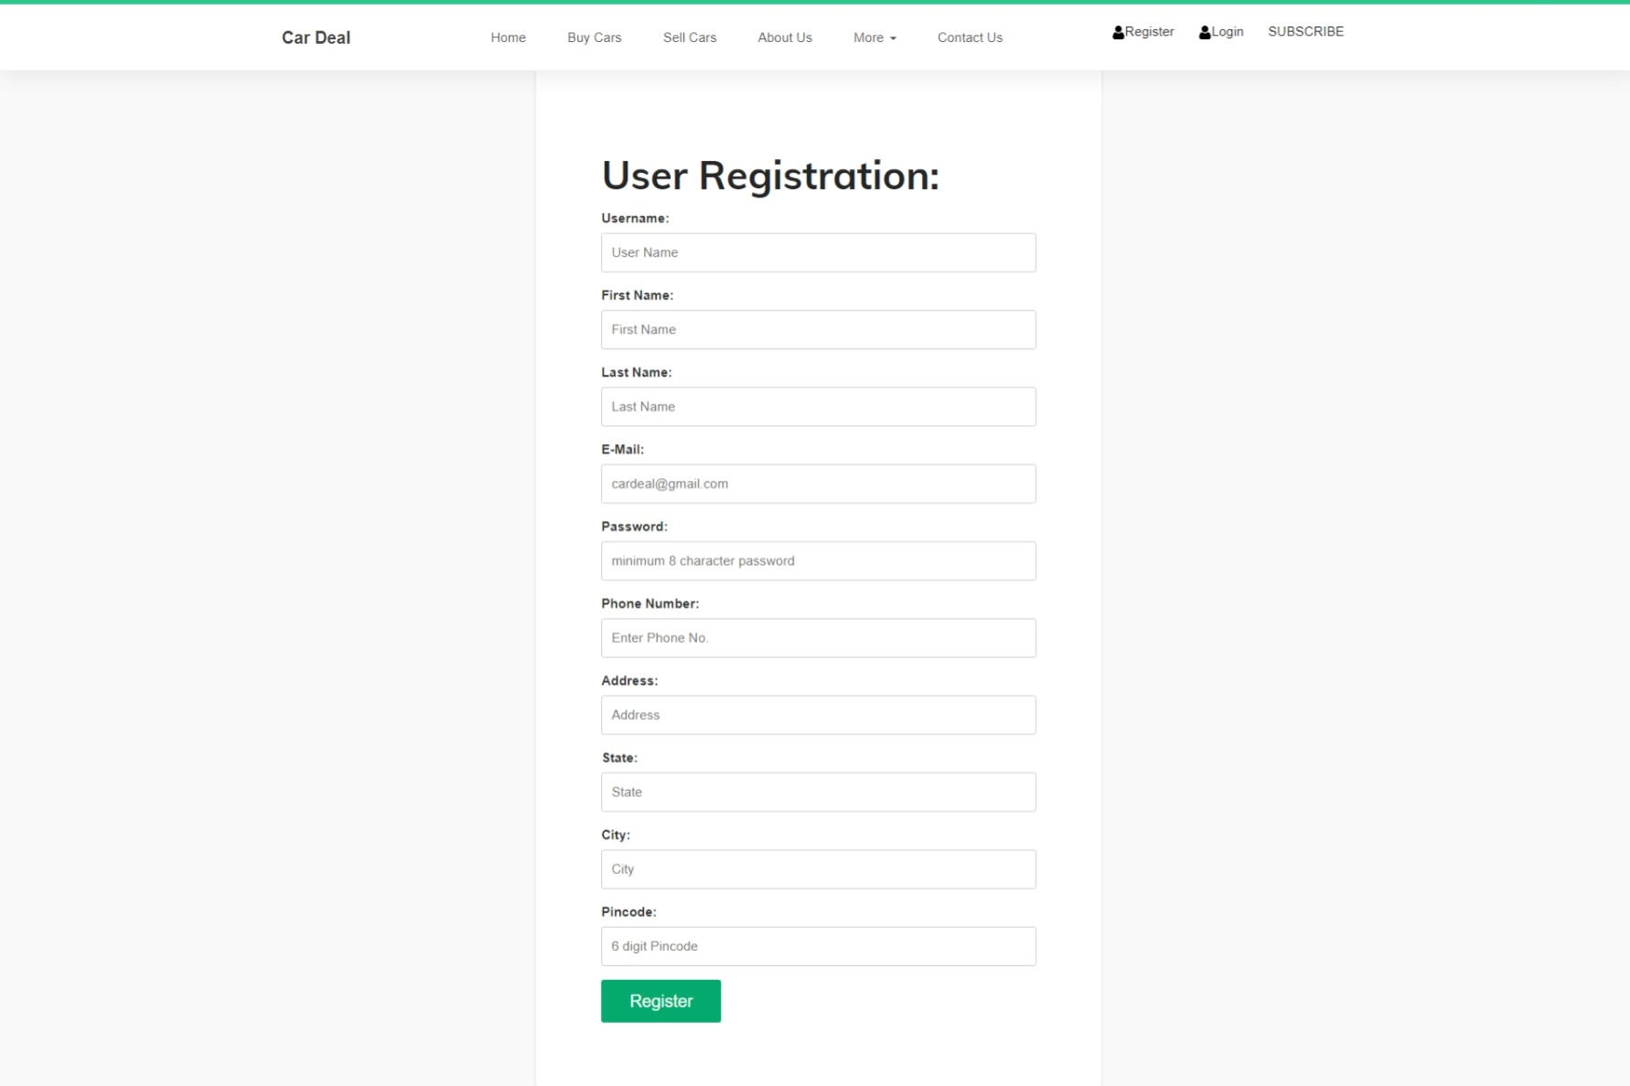
User Login
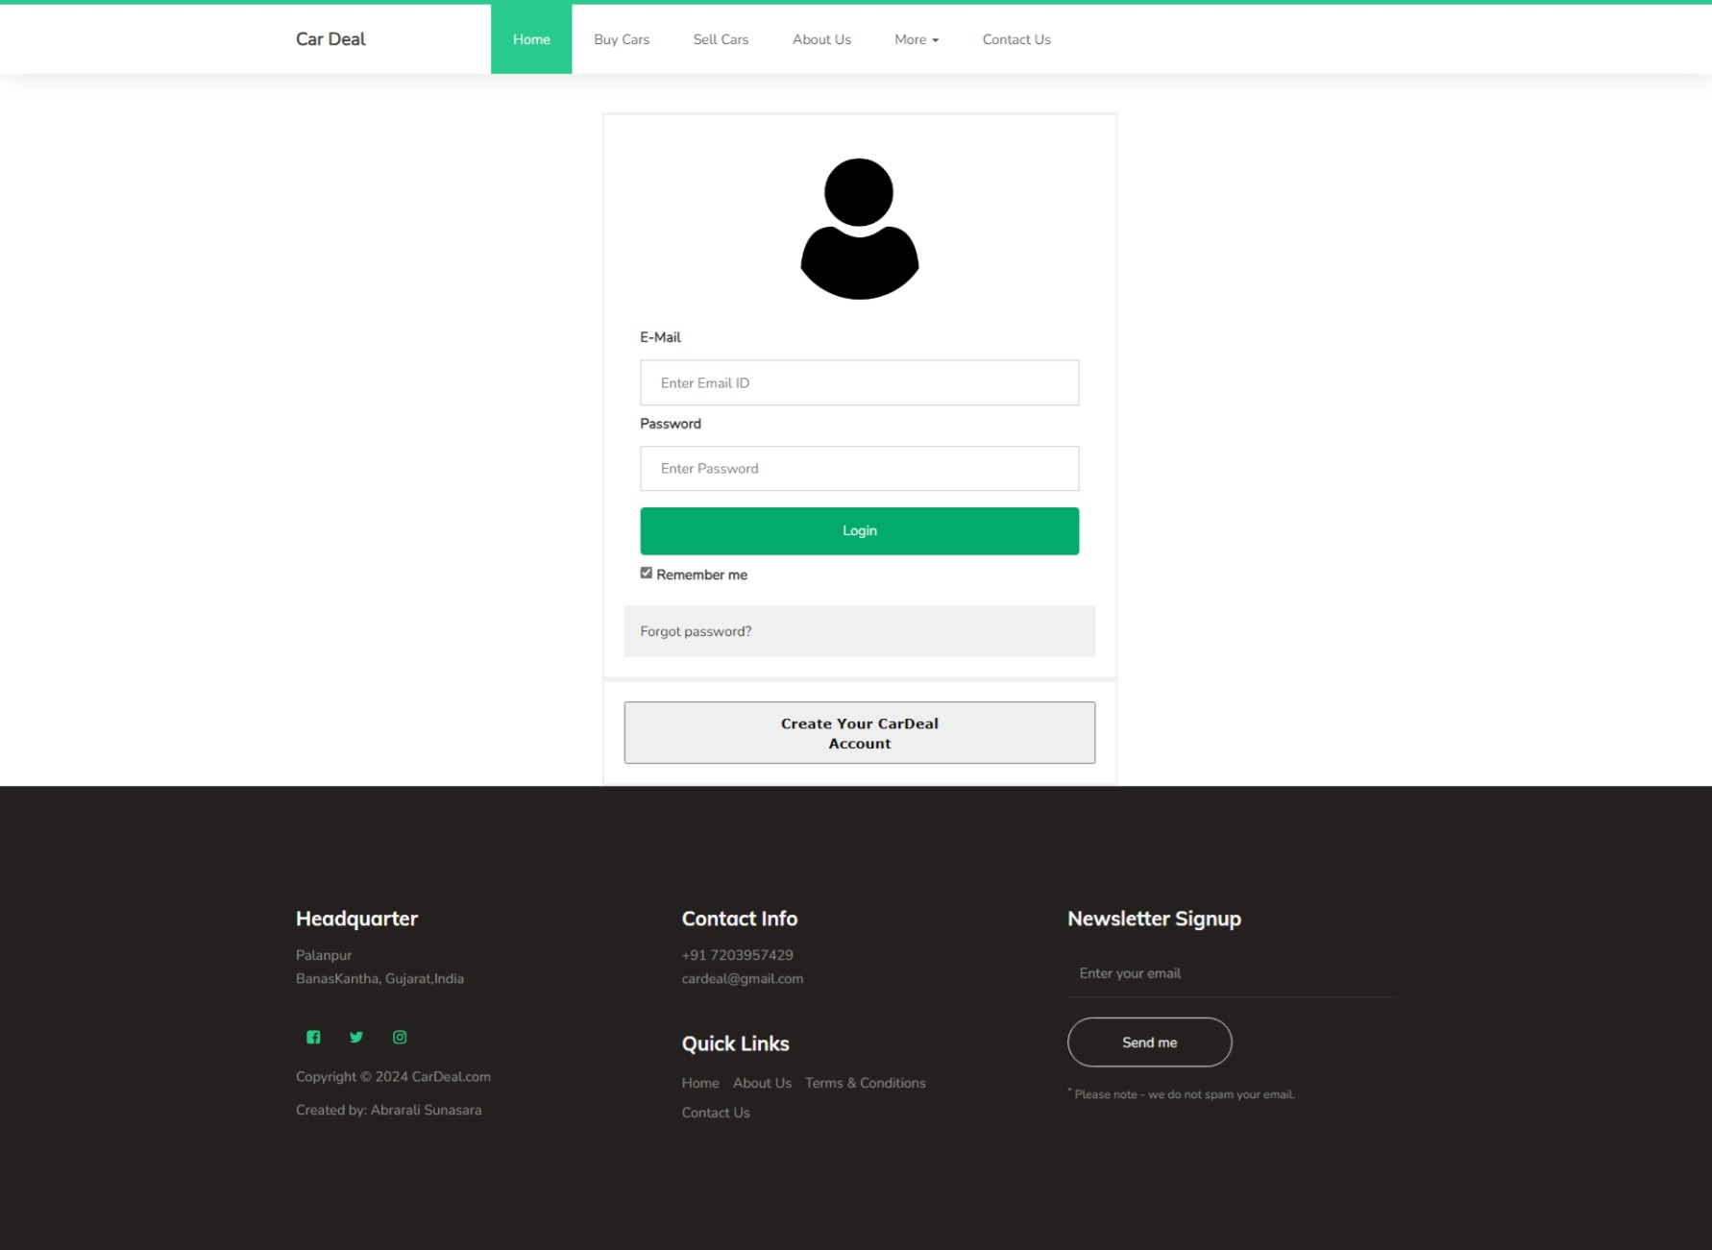

Subscription
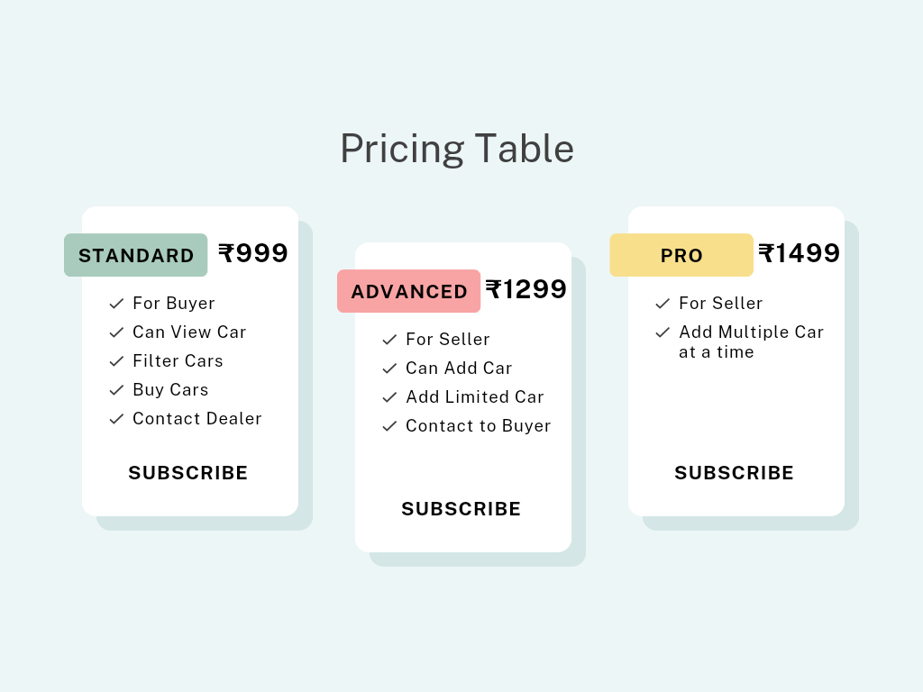

Car Listing/Sell Car
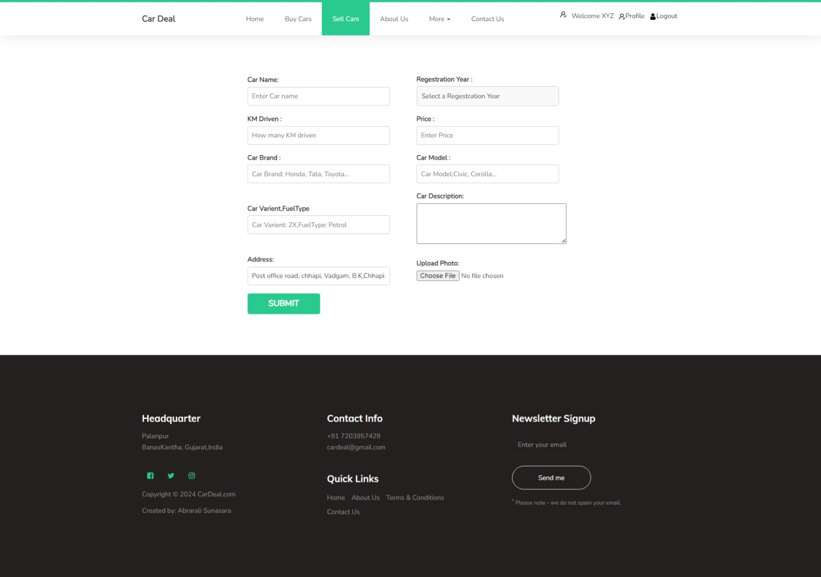

Car Details
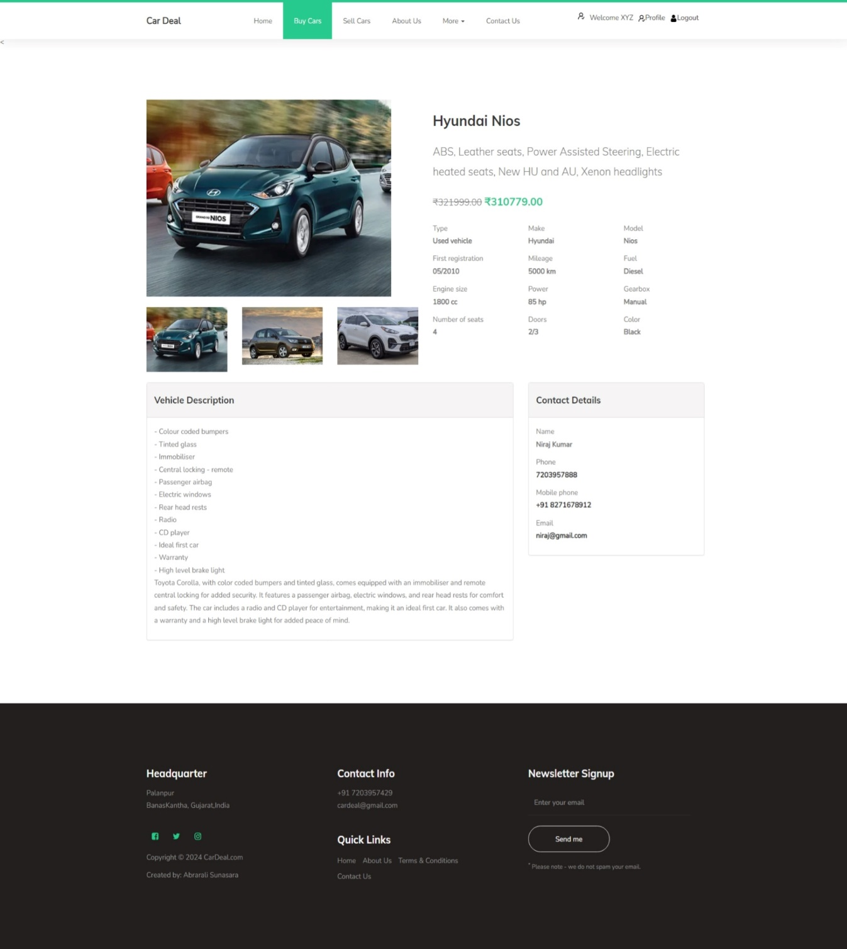

Contact Us
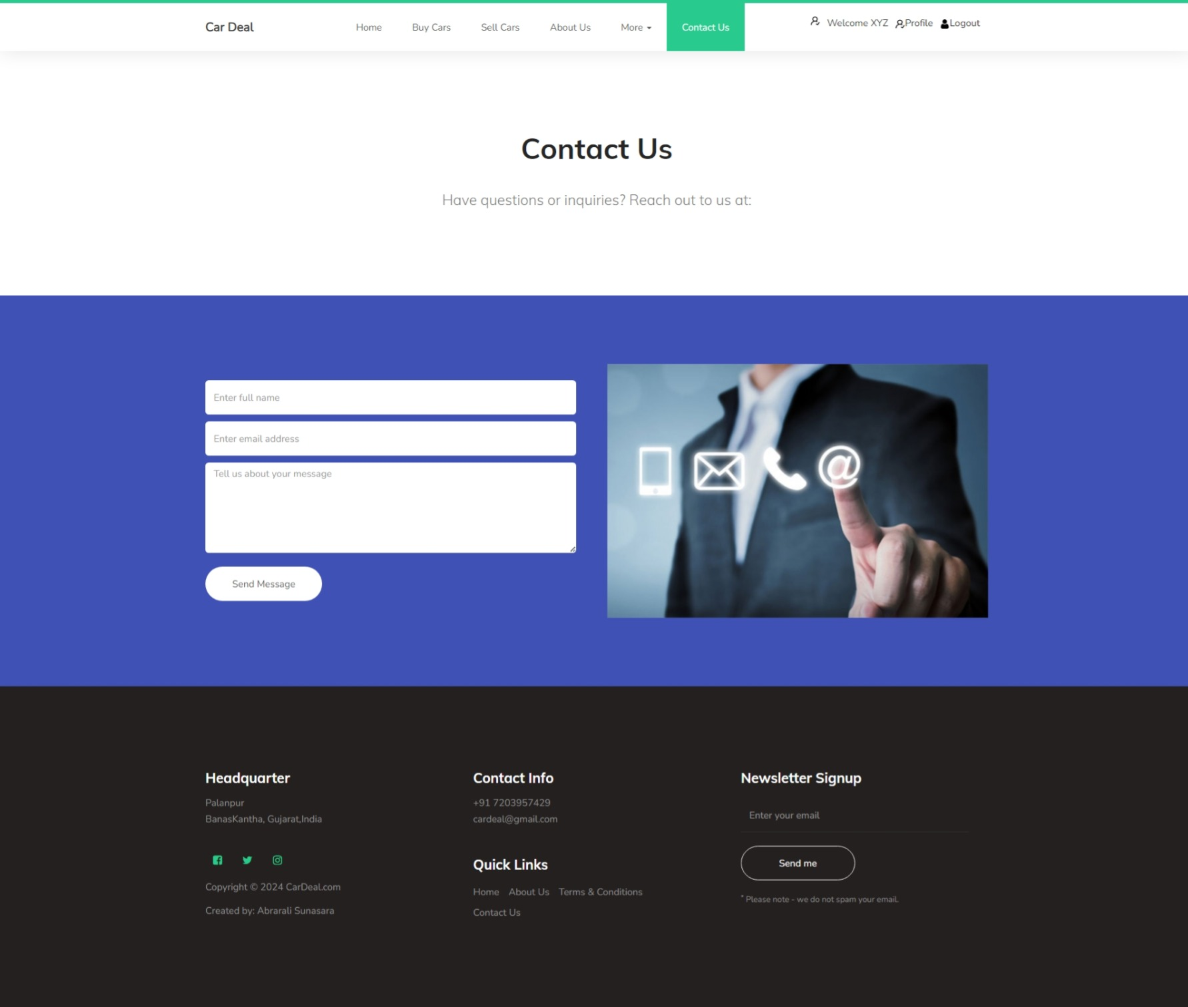

User Profile
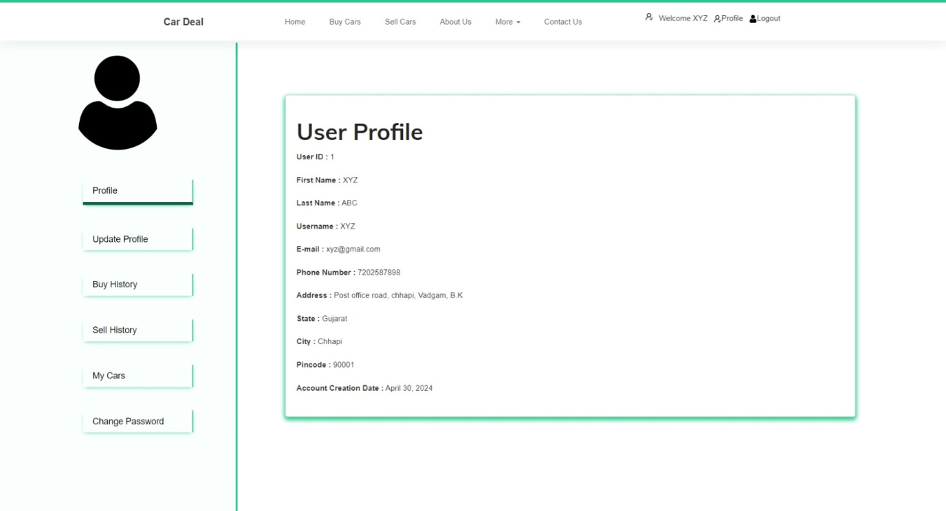

Update Profile
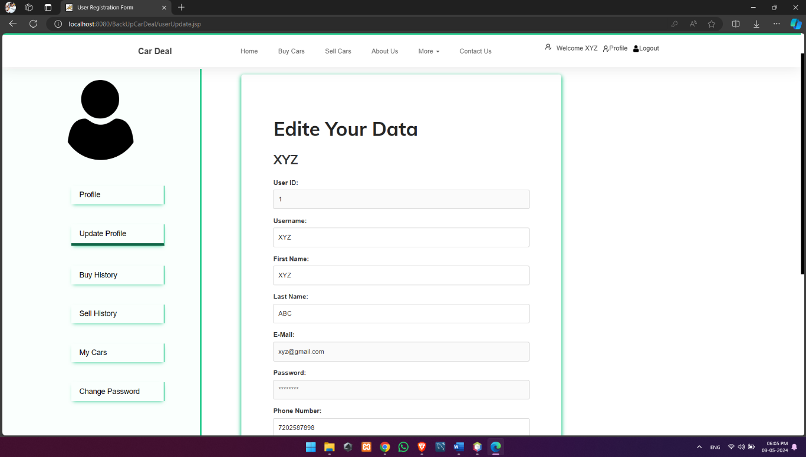
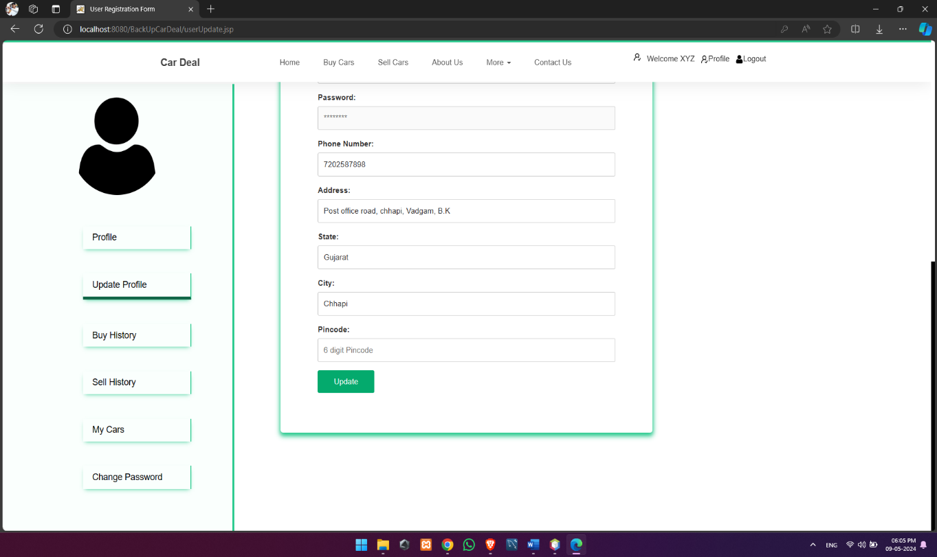

Buy History
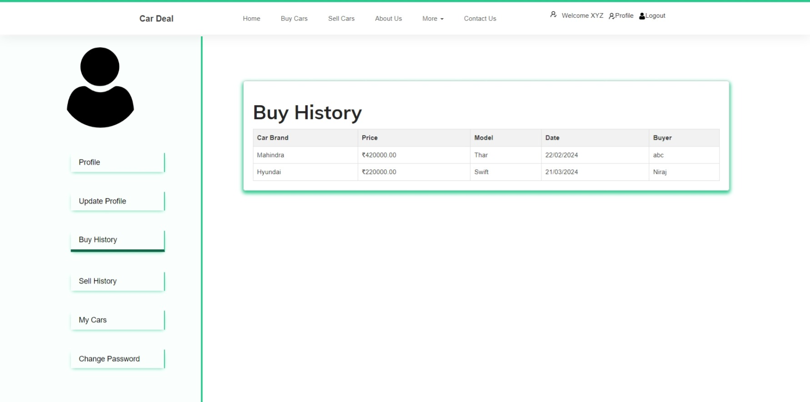

Sell History
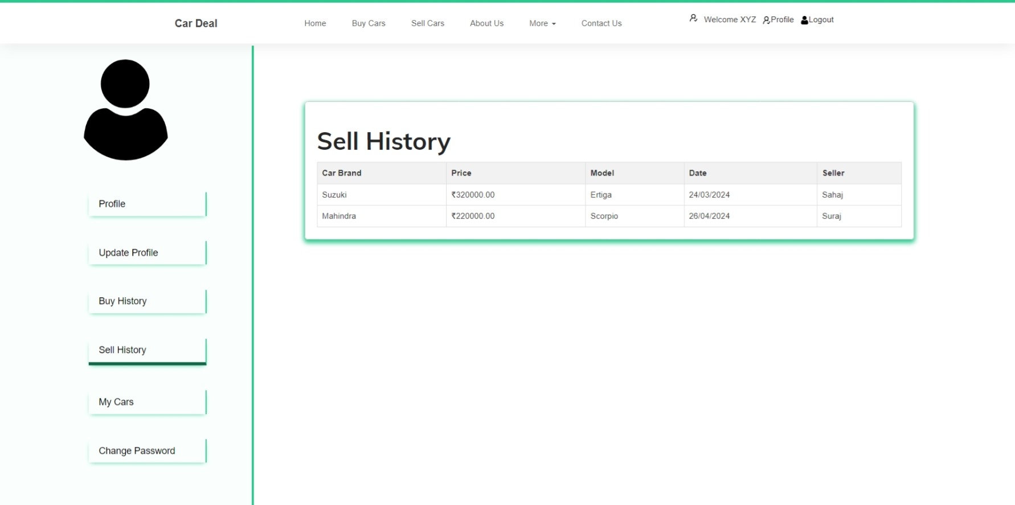

My Cars
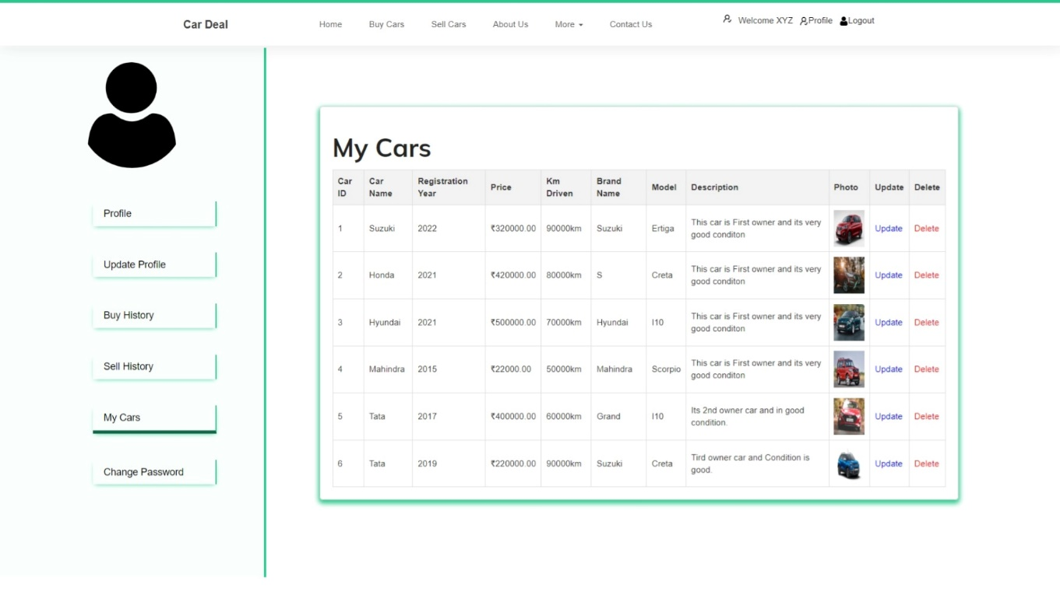

Change Password
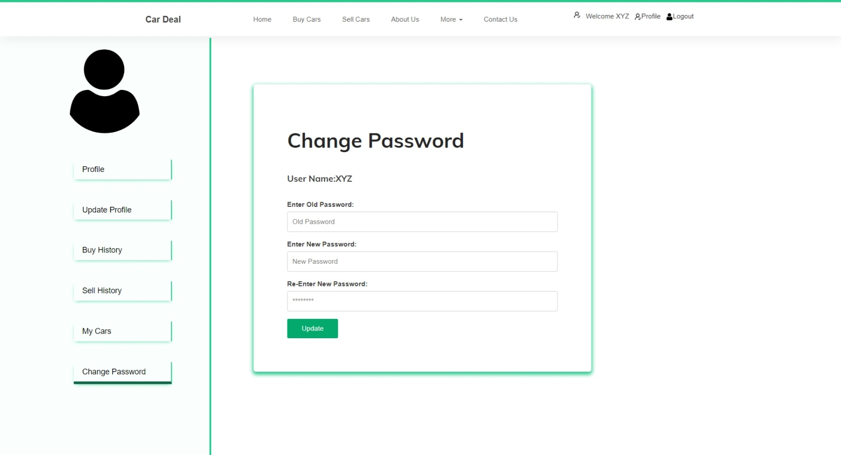

4.1.2 Admin Module:

Admin Login
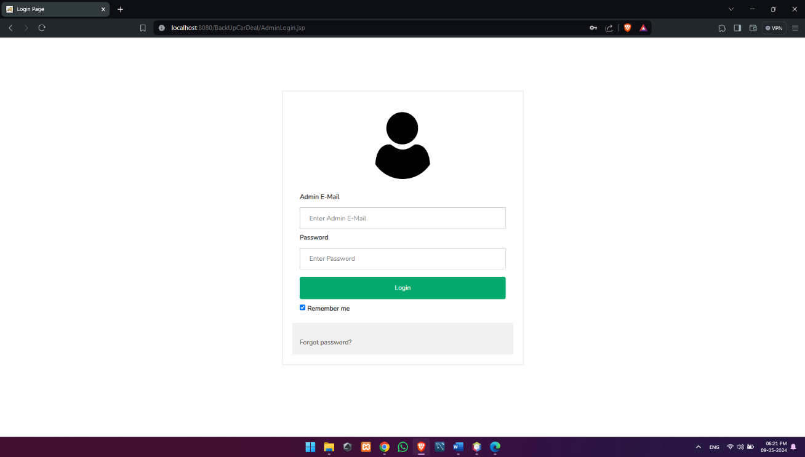

All Users Details
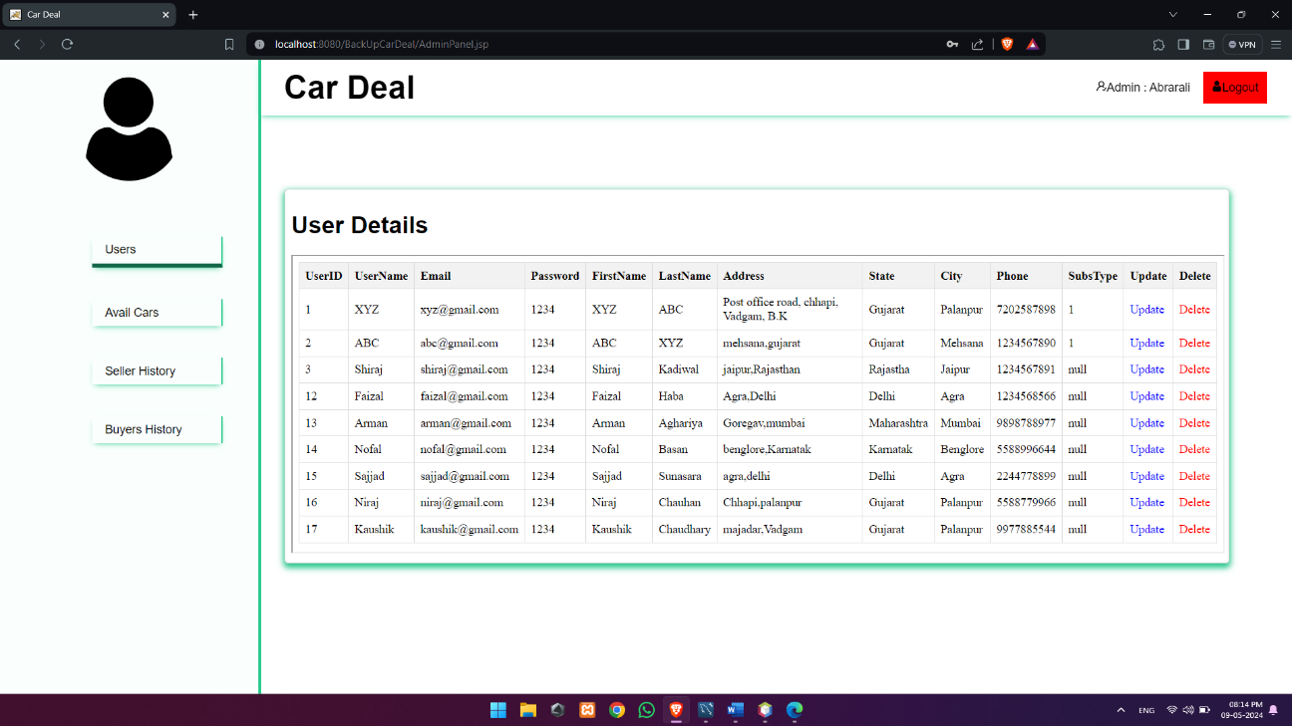

Available Cars
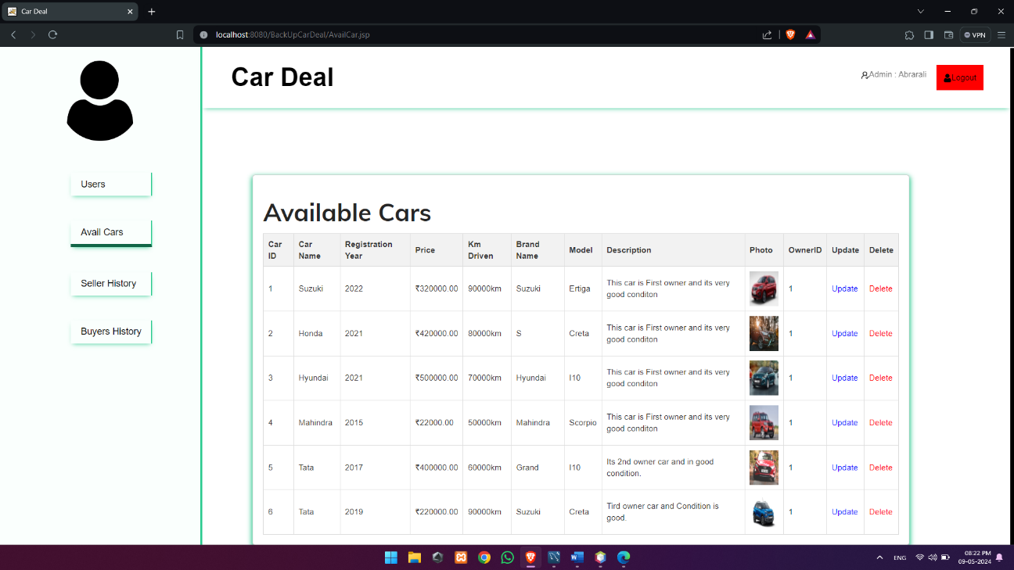

Sell History
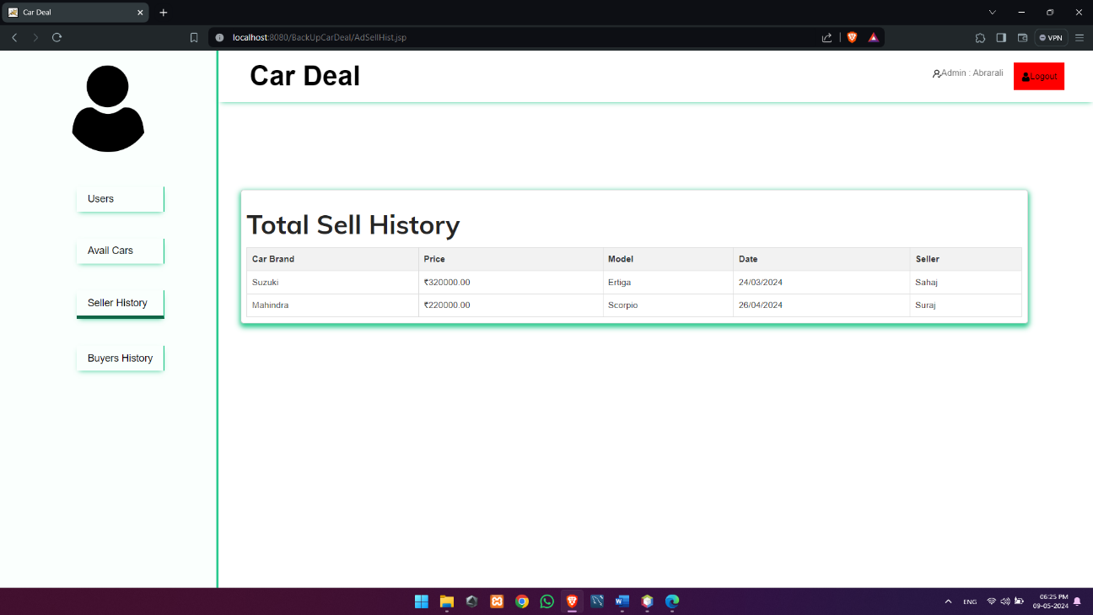

Buy History
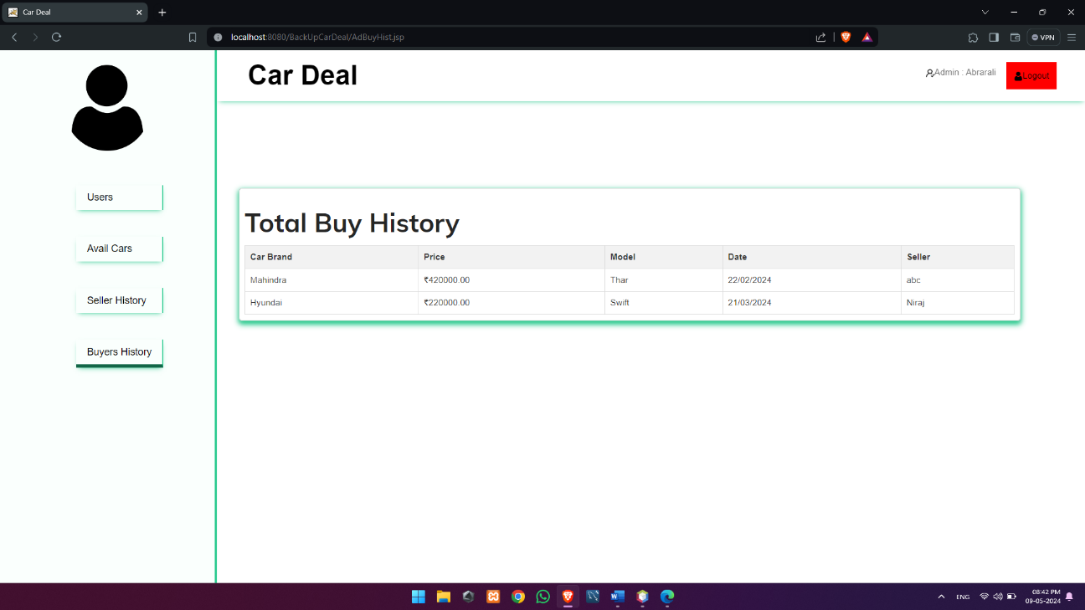

5.Conclusion & Future Work

  - Conclusion
A web-based application which is used for tracking sales, services, reports, leads, accounts maintenance through online for automobile dealers. Better analysis of dealership profitability through retail sales, service and parts analysis. The features included E-mail, SMS alerts, reports, sales, purchase details, transaction, leads and vehicle, and parts ordering through E-mail. DMS solution is designed for automotive industry, and it fully supports all business processes of vehicle dealers, workshops and service companies, used card traders, vehicle importers, and spare part traders. It is completely web-based solution, so it does not require at software to be installed on different branches. The scope of the project includes that what all future enhancements can be done in this system to make it more feasible to use: Databases for different products range and storage can be provided, multilingual support can be provided so that it can be understandable by the person of any language, more graphics can be added to make it more user-friendly and understandable, manage, and backup versions of documents online.

5.2 Future Work
This system is developed such a way that additional enhancement can be done without much difficulty. The renovation of the project would increase the flexibility of the system. Also the features are provided in such a way that the system can also be made better and efficient functionality The programs were coded in an easier and more structured manner so that may further modifications may be incorporated easily. The processing time in this system is very lesser compared to existing system? This system has good flexibility of accommodating any more changes that might arise in the future also. In this system, data integrity is maintained and data redundancy is avoided and it increase system efficiency. The database is designed in such a way that it will be also helpful for enhancement of the system.

6. References & Bibliography

World Wide Web:
- www.w3schools.com
- www.javatpoint.com
- www.mysql.com
- https://chatgpt.com
- www.canva.com

