Department of Software Engineering/ Computer Science
Course Code: CS332
Class: BSCS
Lab 03: OMNet++ IDE
CLO4: Develop Distributed Applications/Systems

Instructors: Dr.Shah Khalid, Dr.Khurram Shahzad

NAME | QALAM ID
ABRAR BUTT | 460297

Tasks:
- In this lab task, we have to simulate the concept of load balancer which evenly distributes the incoming packets from source (Node A).
- You have to simulate the topology mentioned in Fig. 1 using OMNeT++. A[5] are the source nodes, B is the load balancer, and S represent the sink node. Node A[*], B and S[*] having different input and output gates. Node A[0…5] will generate the traffic and act as the traffic generator.
- Node B is the node where you will implement the logic of load balancer. B will forward the message to Node C or D depending upon the node selection criteria you choose for your load balancer (you may use the random number for the decision).
- The other Node S will act as a sink node, they will not bounce back the traffic received from Node A[*]. Each Node A[*]will send only packet by using its initialize function.

Load balancer
Sink nodes
Source nodes
A[0]
A[1]
A[2]
A[3]
A[4]
B
S[0]
S[1]

Source.cc, LoadBalancer.cc, Sink.cc, Lab3.ned (network file), and omnet.ini (initialization file for building the project) are attached with submission.

Some Simulation Frames: -

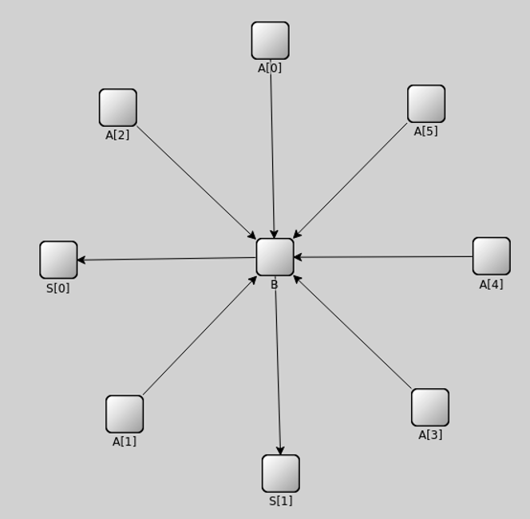

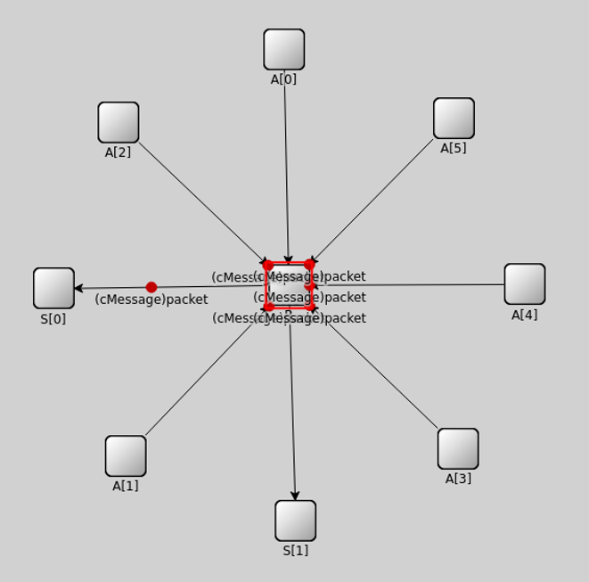

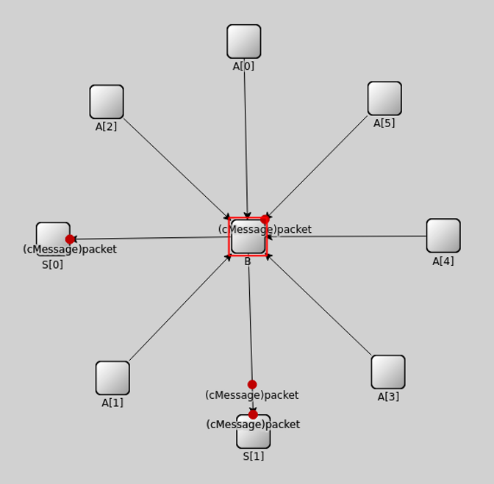

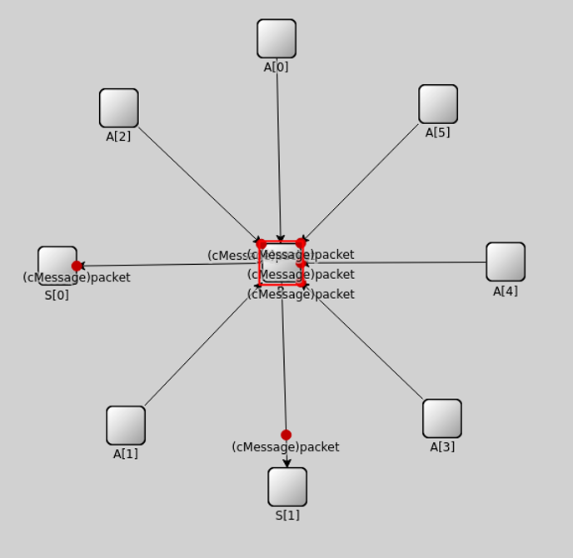

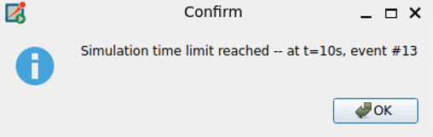

What I Did in This Lab:
In this lab, I designed and implemented a simulation of a load balancer inside a data center using OMNeT++.
First, I created a new OMNeT++ project and defined the network topology using a NED file. The topology consisted of five source nodes (A[0–4]), one load balancer node (B), and two sink nodes (S[0] and S[1]). I connected all source nodes to the load balancer and connected the load balancer to the two sink nodes.
Next, I implemented the behavior of each module using C++:
- In the Source module, I programmed each node to generate and send one packet during the initialization phase.
- In the Load Balancer module, I implemented the decision-making logic using a random selection algorithm (intuniform(0,1)) to distribute incoming packets to one of the two sink nodes.
- In the Sink module, I programmed the nodes to receive and delete the packets, simulating request processing.
After implementing the modules, I configured the simulation environment using the omnetpp.ini file and executed the simulation. I verified that packets were successfully generated, routed through the load balancer, and delivered to the sink nodes.
Finally, I tested and debugged the simulation to ensure correct network configuration, proper packet forwarding, and successful execution without runtime errors.

Note: GitHub code link for lab…

