Department of Computing
Course Code: CS332
Class: BSCS
Lab 05: Understanding the Physical clock algorithms
CLO1: Design Distributed Protocols
Instructors: Dr.Shah Khalid

NAME | ABRAR BUTT
QALAM ID | 460297

Lab 05: Understanding the Physical clock algorithms
Introduction
This lab focuses on the giving overview of physical clock algorithms. An implementation will be required to demonstrate the Cristian and Berkeley Algorithms.

Objectives
To understand the concept of Cristian Algorithm and Berkeley Algorithm.
Tools/Software Requirement
MS Visual Studio 2013
Or any editor of your choice
Language
Any of your choice, C++/Java/Python etc.
Description
Cristian’s Algorithm
Cristian’s Algorithm is a clock synchronization algorithm is used to synchronize time with a time server by client processes. This algorithm works well with low-latency networks where Round Trip Time is short as compared to accuracy while redundancy prone distributed systems/applications do not go hand in hand with this algorithm. Here Round Trip Time refers to the time duration between start of a Request and end of corresponding Response.
Algorithm:
1) The process on the client machine sends the request for fetching clock time(time at server) to the Clock Server at time T_0.
2) The Clock Server listens to the request made by the client process and returns the response in form of clock server time.

3) The client process fetches the response from the Clock Server at time T_1 and calculates the synchronised client clock time using the formula given below.
\[ T_{CLIENT} = T_{SERVER} + (T_1 - T_0)/2 \]
where T_{CLIENT} refers to the synchronized clock time,
T_{SERVER} refers to the clock time returned by the server,
T_0 refers to the time at which request was sent by the client process,
T_1 refers to the time at which response was received by the client process
Berkeley’s Algorithm
Berkeley’s Algorithm is a clock synchronization technique used in distributed systems. The algorithm assumes that each machine node in the network either doesn’t have an accurate time source or doesn’t possess an UTC server.
Algorithm
1) An individual node is chosen as the master node from a pool nodes in the network. This node is the main node in the network which acts as a master and rest of the nodes act as slaves. Master node is chosen using a election process/leader election algorithm.
2) Master node periodically pings slaves nodes and fetches clock time at them using Cristian’s algorithm.
Diagram below illustrates how the master sends request to slave nodes.
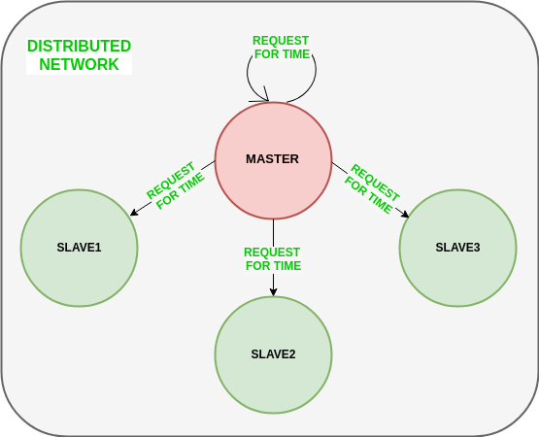
Diagram below illustrates how slave nodes send back time given by their system clock.
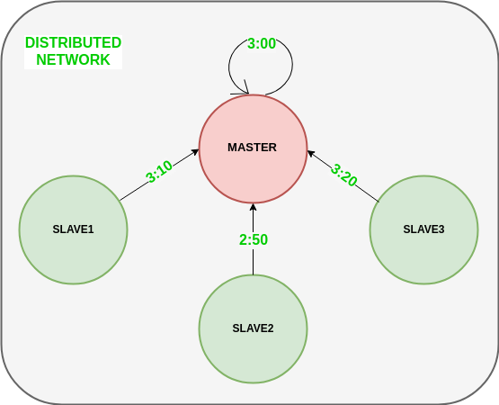

3) Master node calculates average time difference between all the clock times received and the clock time given by master’s system clock itself. This average time difference is added to the current time at master’s system clock and broadcasted over the network.
Psuedocode for above step:
# receiving time from all slave nodes
repeat_for_all_slaves:
time_at_slave_node = receive_time_at_slave()
# calculating time difference
time_difference = time_at_master_node - time_at_slave_node

# average time difference calculation
average_time_difference = sum(all_time_differences) / number_of_slaves

synchronized_time = current_master_time + average_time_difference

# broadcasting synchronized to whole network
broadcast_time_to_all_slaves(synchronized_time)
Diagram below illustrates the last step of Berkeley’s algorithm.
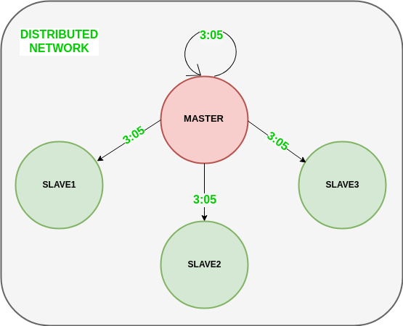

Lab Tasks
- Implement the Cristian Algorithm to get the time returned by server,
Process Delay latency, Actual clock time at client side, and Synchronized process client time.

Code:
#include <iostream>
#include <chrono>
#include <thread>

using namespace std;
using namespace std::chrono;

int main() {

cout << "===== CRISTIAN'S ALGORITHM =====\n\n";

// Step 1: Client sends request at time T0
auto T0 = system_clock::now();

// Simulate network delay (100 ms)
this_thread::sleep_for(milliseconds(100));

// Step 2: Server sends its current time
auto T_server = system_clock::now();

// Simulate response delay (100 ms)
this_thread::sleep_for(milliseconds(100));

// Step 3: Client receives response at time T1
auto T1 = system_clock::now();

// Calculate Round Trip Time
auto RTT = duration_cast<milliseconds>(T1 - T0).count();

// Calculate synchronized client time
auto synchronized_time = T_server + milliseconds(RTT / 2);

// Convert to readable format
time_t server_time = system_clock::to_time_t(T_server);
time_t client_actual = system_clock::to_time_t(T1);
time_t client_sync = system_clock::to_time_t(synchronized_time);

cout << "Server Time: " << ctime(&server_time);
cout << "Client Actual Time: " << ctime(&client_actual);
cout << "Round Trip Time (RTT): " << RTT << " ms\n";
cout << "Synchronized Client Time: " << ctime(&client_sync);

return 0;
}

Output:
===== CRISTIAN'S ALGORITHM =====

Server Time: Thu Feb 19 10:42:35 2026
Client Actual Time: Thu Feb 19 10:42:35 2026
Round Trip Time (RTT): 216 ms
Synchronized Client Time: Thu Feb 19 10:42:35 2026

- Implement the Berkeley Algorithm add 6 clients that need to be synchronized and print receiving time from all slave nodes, time difference, average_time_difference, synchronized_time and finally print the synchronized_time of all the client nodes.

Code:
#include <iostream>
#include <vector>
#include <ctime>
#include <cstdlib>

using namespace std;

int main() {

cout << "===== BERKELEY ALGORITHM =====\n\n";

const int NUM_SLAVES = 6;

// Master clock time
time_t master_time = time(0);

cout << "Master Initial Time: " << ctime(&master_time) << endl;

vector<time_t> slave_times;
vector<long> time_differences;

// Generate slave times (simulate different clocks)
for (int i = 0; i < NUM_SLAVES; i++) {

// Each slave clock differs by random ±5 seconds
int offset = (rand() % 11) - 5;
time_t slave_time = master_time + offset;

slave_times.push_back(slave_time);

cout << "Slave " << i + 1 << " Time: " << ctime(&slave_time);

long difference = master_time - slave_time;
time_differences.push_back(difference);

cout << "Time Difference (Master - Slave " << i + 1 << "): "
<< difference << " seconds\n\n";
}

// Calculate average time difference
long sum = 0;
for (int i = 0; i < NUM_SLAVES; i++) {
sum += time_differences[i];
}

long average_difference = sum / NUM_SLAVES;

cout << "Average Time Difference: "
<< average_difference << " seconds\n\n";

// Calculate synchronized time
time_t synchronized_time = master_time + average_difference;

cout << "Synchronized Master Time: "
<< ctime(&synchronized_time) << endl;

cout << "Updated Slave Times:\n\n";

// Update all slave clocks
for (int i = 0; i < NUM_SLAVES; i++) {

slave_times[i] += average_difference;

cout << "Slave " << i + 1 << " New Time: "
<< ctime(&slave_times[i]);
}

return 0;
}

Output:
===== BERKELEY ALGORITHM =====

Master Initial Time: Thu Feb 19 10:43:45 2026

Slave 1 Time: Thu Feb 19 10:43:48 2026
Time Difference (Master - Slave 1): -3 seconds

Slave 2 Time: Thu Feb 19 10:43:49 2026
Time Difference (Master - Slave 2): -4 seconds

Slave 3 Time: Thu Feb 19 10:43:49 2026
Time Difference (Master - Slave 3): -4 seconds

Slave 4 Time: Thu Feb 19 10:43:41 2026
Time Difference (Master - Slave 4): 4 seconds

Slave 5 Time: Thu Feb 19 10:43:47 2026
Time Difference (Master - Slave 5): -2 seconds

Slave 6 Time: Thu Feb 19 10:43:45 2026
Time Difference (Master - Slave 6): 0 seconds

Average Time Difference: -1 seconds

Synchronized Master Time: Thu Feb 19 10:43:44 2026

Updated Slave Times:

Slave 1 New Time: Thu Feb 19 10:43:47 2026
Slave 2 New Time: Thu Feb 19 10:43:48 2026
Slave 3 New Time: Thu Feb 19 10:43:48 2026
Slave 4 New Time: Thu Feb 19 10:43:40 2026
Slave 5 New Time: Thu Feb 19 10:43:46 2026
Slave 6 New Time: Thu Feb 19 10:43:44 2026

Note: Code and output.txt files link.
https://github.com/Abrarbut/parallel-and-computing-distribution.git.

Deliverables
Submit a single word file with code and screenshots of your output on LMS.

