Industrial Internship Report on
”IoT based Smart Home Automation”
Prepared by
[Mohammed Abrar H]

Executive Summary
This report provides details of the Industrial Internship provided by upskill Campus and The IoT Academy in collaboration with Industrial Partner UniConverge Technologies Pvt Ltd (UCT).
This internship was focused on a Smart Home Automation based on IoT provided by UCT. We had to finish the project including the report in 6 weeks’ time.
The objective of this project was to design and implement a real-time smart home monitoring and control system using MQTT, Python, FastAPI, and Web technologies.
This internship gave me a very good opportunity to get exposure to Industrial problems and design/implement solution for that. It was an overall great experience to have this internship.

TABLE OF CONTENTS
1 Preface 3
2 Introduction 6
2.1 About UniConverge Technologies Pvt Ltd 6
2.2 About upskill Campus 11
2.3 Objective 12
2.4 Reference 12
2.5 Glossary 12
3 Problem Statement 13
4 Existing and Proposed solution 14
5 Proposed Design/ Model 15
5.1 High Level Diagram (if applicable) 15
5.2 Low Level Diagram (if applicable) 16
5.3 Interfaces (if applicable) 17
6 Performance Test 18
6.1 Test Plan/ Test Cases 19
6.2 Test Procedure 19
6.3 Performance Outcome 19
7 My learnings 20
8 Future work scope 21

Preface
Summary of the whole 6 weeks’ work.
During the 6 weeks of internship with upskill Campus and UniConverge Technologies (UCT), I worked on understanding the fundamentals of IoT systems and their real-world applications. The internship started with learning basic concepts such as Internet of Things, MQTT protocol, client-server communication, and API development.
Gradually, I was introduced to practical implementation using Python and FastAPI. I learned how devices communicate using MQTT, how data flows from sensors to backend systems, and how it can be displayed on a user interface.
The major part of the internship involved developing a complete project called NeuroHome – IoT Based Smart Home Automation System, where I implemented a virtual device simulator, MQTT broker communication, backend APIs, and a web-based dashboard.By the end of the internship, I was able to build a full working system and gained practical experience in software-based IoT development.

About need of relevant Internship in career development.
During the 6 weeks of internship with upskill Campus and UniConverge Technologies (UCT), I worked on understanding the fundamentals of IoT systems and their real-world applications. The internship started with learning basic concepts such as Internet of Things, MQTT protocol, client-server communication, and API development.Gradually, I was introduced to practical implementation using Python and FastAPI. I learned how devices communicate using MQTT, how data flows from sensors to backend systems, and how it can be displayed on a user interface.
The major part of the internship involved developing a complete project called NeuroHome – IoT Based Smart Home Automation System, where I implemented a virtual device simulator, MQTT broker communication, backend APIs, and a web-based dashboard.
By the end of the internship, I was able to build a full working system and gained practical experience in software-based IoT development.
Brief about Your project/problem statement.
The project assigned to me was NeuroHome – IoT Based Smart Home Automation System. The main objective of this project was to design and implement a real-time smart home system using software-based tools.
The problem was to create a system that can simulate smart home devices, monitor sensor data such as temperature and motion, and allow users to control devices like lights and fans remotely.
The project uses MQTT for communication, a Python-based device simulator for generating data, FastAPI as the backend server, and a web dashboard for visualization and control. This project demonstrates how real-world IoT systems work in a simplified and practical manner.

Opportunity given by USC/UCT.
upskill Campus and UniConverge Technologies (UCT) provided me with an excellent opportunity to work on a practical and industry-relevant project. The internship was well structured and focused on both learning and implementation.
The training sessions helped me understand core IoT concepts, while the project work allowed me to apply those concepts in a real system. The guidance provided by mentors helped me solve technical issues and improve my understanding of system design and integration.
This opportunity helped me gain hands-on experience and prepared me for future roles in software and IoT-related domains.

How Program was planned
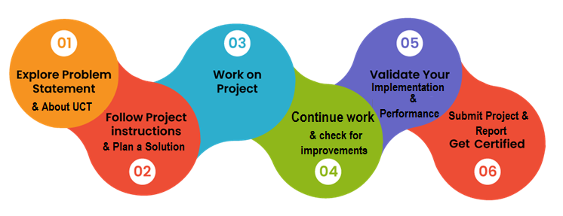
Your Learnings and overall experience.
This internship was a very valuable learning experience for me. I gained practical knowledge about IoT systems, MQTT communication, backend development using FastAPI, and frontend integration. I learned how real-time data flows in a system and how different components such as devices, server, and user interface work together.
I also learned how to debug errors, solve technical problems, and improve my coding skills. Working on this project improved my confidence in handling real-world software projects. I understood the importance of proper documentation, version control using GitHub, and presenting work in a professional manner.
Overall, this internship helped me grow both technically and personally, and it has motivated me to explore more advanced technologies in the future.

Thank to all the Mentors and Intership providers , who have helped you directly or indirectly.

Your message to your juniors and peers.
This internship was a very valuable learning experience for me. I gained practical knowledge about IoT systems, MQTT communication, backend development using FastAPI, and frontend integration. I learned how real-time data flows in a system and how different components such as devices, server, and user interface work together.
I also learned how to debug errors, solve technical problems, and improve my coding skills. Working on this project improved my confidence in handling real-world software projects. I understood the importance of proper documentation, version control using GitHub, and presenting work in a professional manner.
Overall, this internship helped me grow both technically and personally, and it has motivated me to explore more advanced technologies in the future.

Introduction

About UniConverge Technologies Pvt Ltd
A company established in 2013 and working in Digital Transformation domain and providing Industrial solutions with prime focus on sustainability and RoI.
For developing its products and solutions it is leveraging various Cutting Edge Technologies e.g. Internet of Things (IoT), Cyber Security, Cloud computing (AWS, Azure), Machine Learning, Communication Technologies (4G/5G/LoRaWAN), Java Full Stack, Python, Front end etc.
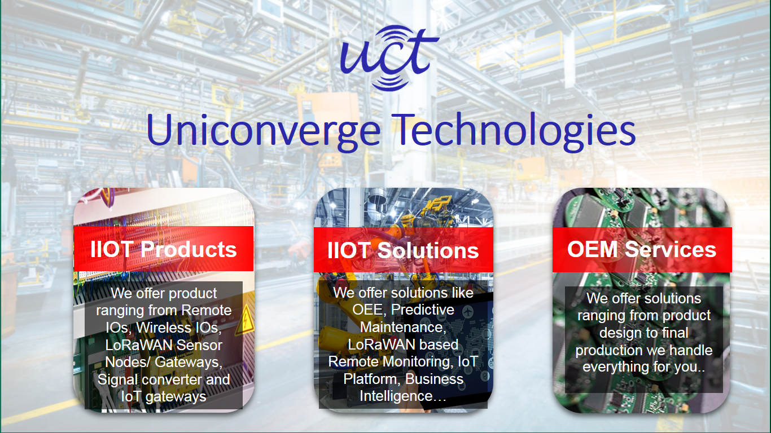
- UCT IoT Platform ()
UCT Insight is an IOT platform designed for quick deployment of IOT applications on the same time providing valuable “insight” for your process/business. It has been built in Java for backend and ReactJS for Front end. It has support for MySQL and various NoSql Databases.
- It enables device connectivity via industry standard IoT protocols - MQTT, CoAP, HTTP, Modbus TCP, OPC UA
- It supports both cloud and on-premises deployments.
It has features to
• Build Your own dashboard
• Analytics and Reporting
• Alert and Notification
• Integration with third party application(Power BI, SAP, ERP)
• Rule Engine

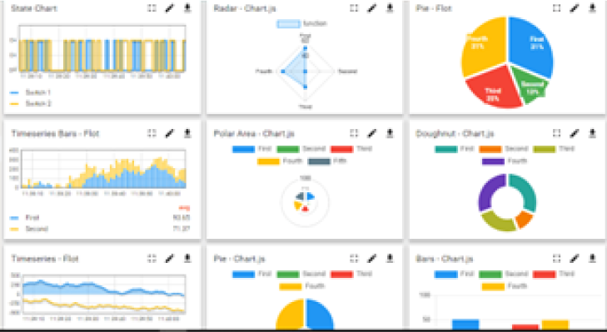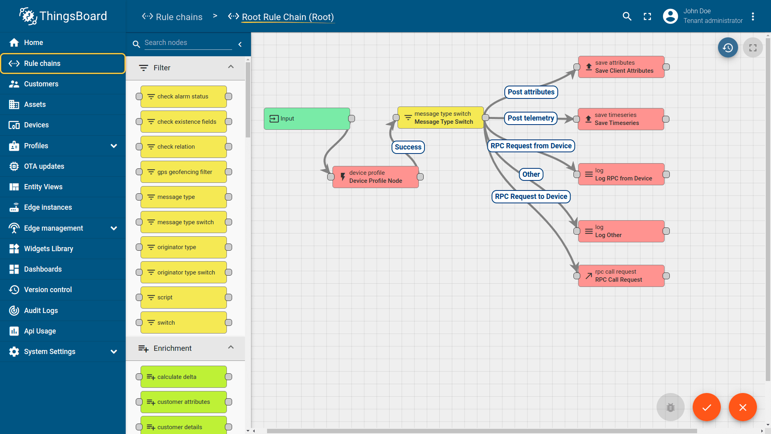

- Smart Factory Platform ()
Factory watch is a platform for smart factory needs.
It provides Users/ Factory
- with a scalable solution for their Production and asset monitoring
- OEE and predictive maintenance solution scaling up to digital twin for your assets.
- to unleased the true potential of the data that their machines are generating and helps to identify the KPIs and also improve them.
- A modular architecture that allows users to choose the service that they what to start and then can scale to more complex solutions as per their demands.
Its unique SaaS model helps users to save time, cost and money.
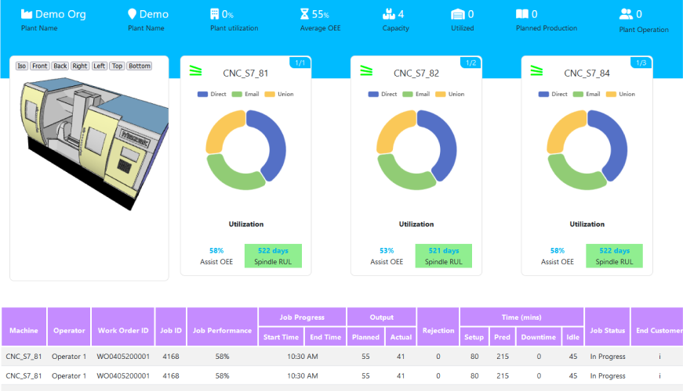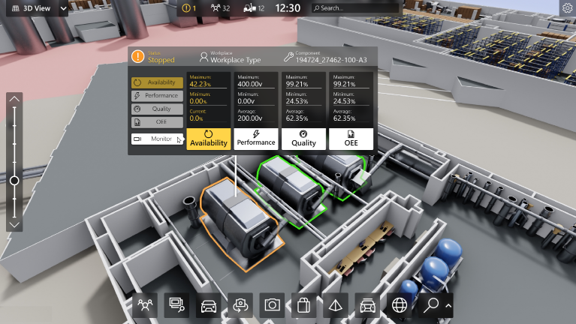

- 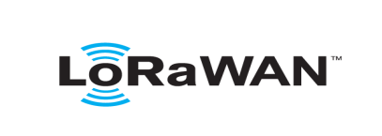 based Solution
UCT is one of the early adopters of LoRAWAN teschnology and providing solution in Agritech, Smart cities, Industrial Monitoring, Smart Street Light, Smart Water/ Gas/ Electricity metering solutions etc.
- Predictive Maintenance
UCT is providing Industrial Machine health monitoring and Predictive maintenance solution leveraging Embedded system, Industrial IoT and Machine Learning Technologies by finding Remaining useful life time of various Machines used in production process.
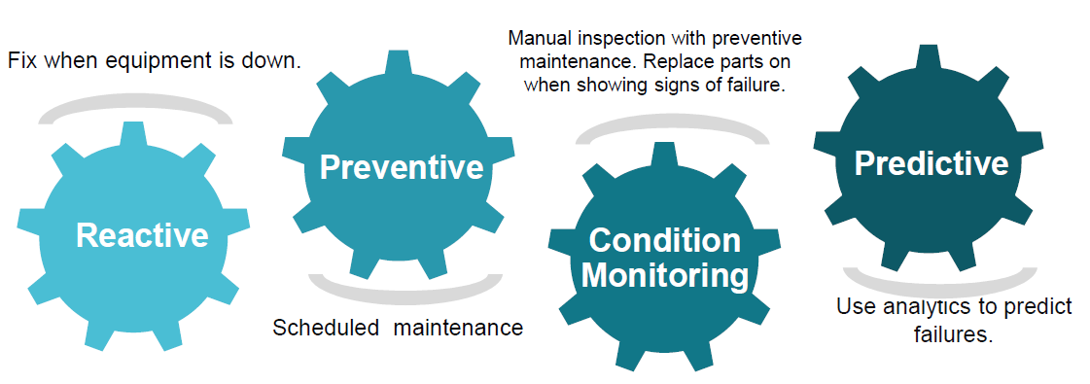

About upskill Campus (USC)
upskill Campus along with The IoT Academy and in association with Uniconverge technologies has facilitated the smooth execution of the complete internship process.
USC is a career development platform that delivers personalized executive coaching in a more affordable, scalable and measurable way.



Seeing need of upskilling in self paced manner along-with additional support services e.g. Internship, projects, interaction with Industry experts, Career growth Services
https://www.upskillcampus.com/
upSkill Campus aiming to upskill 1 million learners in next 5 year






Seeing need of upskilling in self paced manner along-with additional support services e.g. Internship, projects, interaction with Industry experts, Career growth Services

upSkill Campus aiming to upskill 1 million learners in next 5 year

https://www.upskillcampus.com/

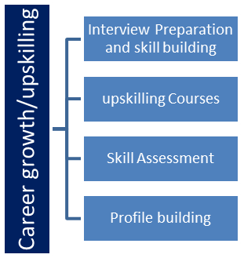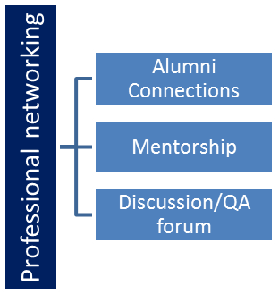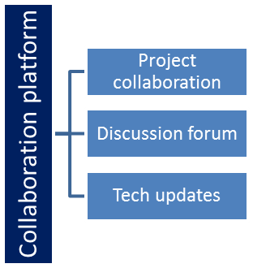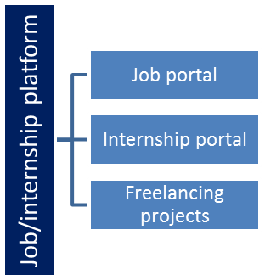

The IoT Academy
The IoT academy is EdTech Division of UCT that is running long executive certification programs in collaboration with EICT Academy, IITK, IITR and IITG in multiple domains.

Objectives of this Internship program
The objective for this internship program was to
☛ get practical experience of working in the industry.
☛ to solve real world problems.
☛ to have improved job prospects.
☛ to have Improved understanding of our field and its applications.
☛ to have Personal growth like better communication and problem solving.

Reference
[1] MQTT Protocol Documentation – https://mqtt.org
[2] Python Official Documentation – https://www.python.org/doc
[3] GitHub Documentation – https://docs.github.com

Glossary
Terms | Acronym
Message Queuing Telemetry Transport | MQTT
Application Programming Interface | API
Representational State Transfer | REST
Fast Application Programming Interface | FastAPI
HyperText Markup Language | HTML

Problem Statement
In the assigned problem statement

The objective was to design and implement a complete IoT-based smart home automation system using software tools and modern technologies. The main problem was to understand how real-world smart home systems work and to develop a simplified version that demonstrates real-time data communication, monitoring, and control.
Traditional home automation systems are often hardware-dependent, expensive, and complex to implement for students. Many learners do not get practical exposure to how devices communicate in real time and how backend systems process and display sensor data. Hence, there is a need for a lightweight, software-based solution that can simulate real smart home behavior without requiring physical hardware components.
The problem was to build a system that can simulate smart home devices such as temperature sensors and motion detectors, send this data to a central server using an IoT communication protocol, and allow users to monitor and control devices through a web interface. The system should be capable of handling real-time updates, device control commands, and should follow an industry-style architecture.
The project required implementing communication using MQTT protocol, developing a backend server using Python and FastAPI, and creating a web-based dashboard for user interaction. The overall goal was to gain hands-on experience in IoT system design, real-time data handling, and full-stack development while solving a real-world problem in a practical and simplified manner.

Existing and Proposed solution

Provide summary of existing solutions provided by others, what are their limitations?
Existing smart home solutions such as Google Home, Alexa, and other commercial IoT systems provide device monitoring and control using mobile applications. However, these systems require expensive hardware, paid cloud services, and proprietary devices. They are not easily customizable and do not provide transparency for learning purposes. Most platforms are closed systems and are difficult for students to understand and experiment with. They also depend heavily on internet connectivity and lack flexibility for educational use.
What is your proposed solution?
The proposed solution is NeuroHome – an IoT-based Smart Home Automation System developed using a software-based approach. It uses a Python-based device simulator to generate sensor data and MQTT protocol for communication. A FastAPI backend processes the data and exposes APIs, while a web dashboard displays real-time values and allows device control. This system demonstrates a complete IoT workflow in a simple and practical manner.
What value addition are you planning?
The main value addition is providing a low-cost and hardware-free smart home system for learning purposes. It allows users to understand IoT architecture, real-time communication, and full-stack integration. The system is flexible, easy to modify, and does not rely on cloud services. It also promotes hands-on learning using open-source tools and industry-relevant technologies.

Code submission (Github link): https://github.com/Abrarih/upskillCampus

Report submission (Github link) :. https://github.com/Abrarih/upskillCampus

Proposed Design/ Model
The proposed design of the system follows a simple and modular IoT architecture. The process starts with a virtual device simulator developed using Python, which generates real-time sensor data such as temperature and motion. These values are published to an MQTT broker using predefined topics.
In the intermediate stage, a FastAPI backend subscribes to these MQTT topics and continuously listens for incoming data. The backend processes this data and stores the latest values in memory. It also exposes REST APIs for retrieving sensor data and for sending control commands to devices.
In the final stage, a web-based dashboard fetches data from the backend APIs at regular intervals and displays it in real time. Users can also interact with the dashboard to control devices such as lights and fans. The entire system works in a continuous loop, providing real-time monitoring and contro

High Level Diagram :

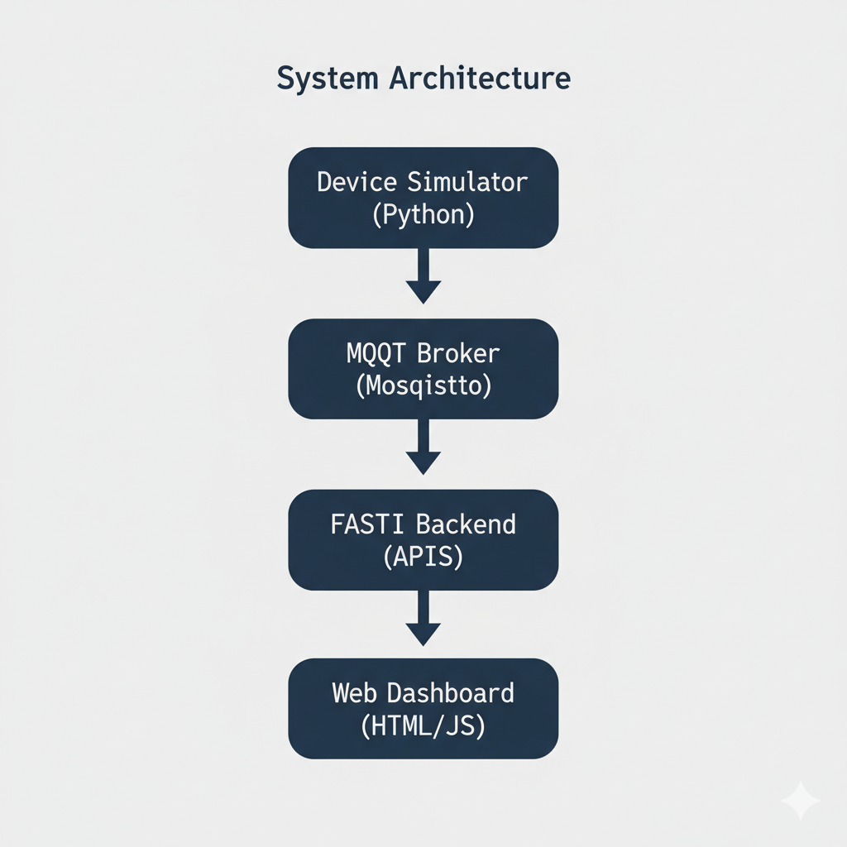

Figure 1: HIGH LEVEL DIAGRAM OF THE SYSTEM

Low Level Diagram :

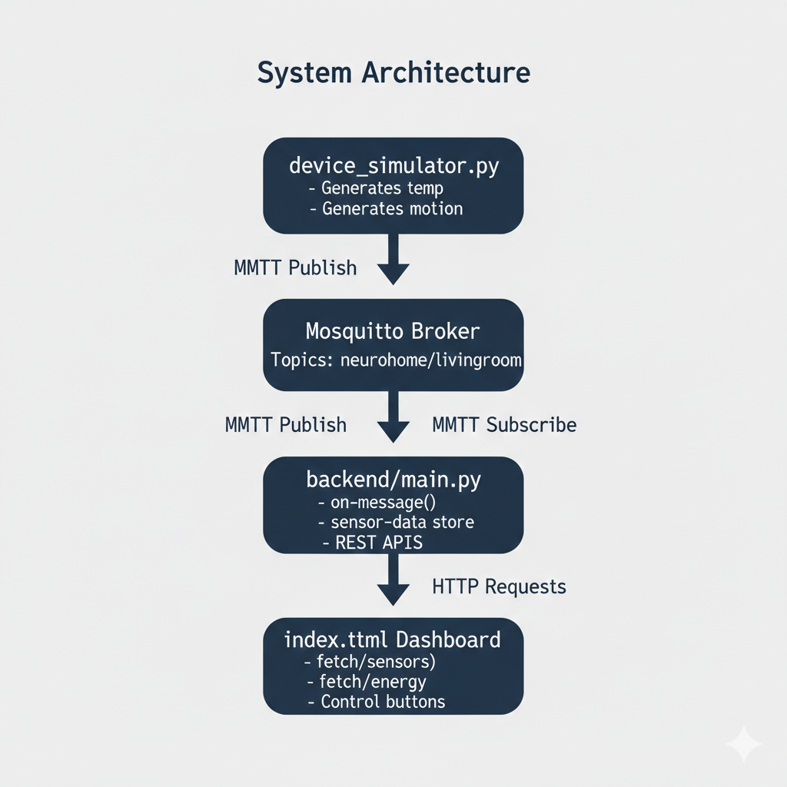
Figure 2: LOW LEVEL DIAGRAM OF THE SYSTEM

Interfaces :
The system consists of multiple interfaces that enable communication between different components. The primary interface is between the Device Simulator and MQTT Broker, where sensor data such as temperature and motion is transmitted using the MQTT protocol. This follows a publisher–subscriber model.
The second interface is between the MQTT Broker and FastAPI Backend, where the backend subscribes to MQTT topics and receives real-time data through callback functions. The backend processes this data and stores the latest values in memory buffers.
The third interface is between the FastAPI Backend and Web Dashboard, which uses HTTP REST APIs. The dashboard sends GET requests to retrieve sensor and energy data and POST requests to control devices. Data flow in the system is continuous and real-time, ensuring smooth monitoring and control.

Simulator → MQTT → Backend → HTTP → Dashboard
Dashboard → HTTP → Backend → MQTT → Devices

Performance Test

This is very important part and defines why this work is meant of Real industries, instead of being just academic project.
Here we need to first find the constraints:
The primary constraints in this system include-
- Response Time: Delay between sensor data generation and dashboard display.
- Memory Usage: Backend must store and process real-time data continuously.
- Processing Speed: Backend must handle frequent updates without crashing.
- Network Dependency: System depends on MQTT and HTTP communication.
- Power Calculation Accuracy: Energy values must reflect correct device states.
How those constraints were taken care in your design?
To handle response time and speed, MQTT was used because it is a lightweight and fast protocol suitable for real-time communication. The backend was designed using FastAPI, which is asynchronous and efficient for handling multiple requests. Memory usage was kept minimal by storing only the latest sensor values instead of large datasets.
The system was also designed to work on a local MQTT broker, which reduces network delay and improves reliability. Power consumption values were calculated using predefined device ratings, ensuring consistent and predictable energy results.

What were test results around those constraints?
To handle response time and speed, MQTT was used because it is a lightweight and fast protocol suitable for real-time communication. The backend was designed using FastAPI, which is asynchronous and efficient for handling multiple requests. Memory usage was kept minimal by storing only the latest sensor values instead of large datasets.
The system was also designed to work on a local MQTT broker, which reduces network delay and improves reliability. Power consumption values were calculated using predefined device ratings, ensuring consistent and predictable energy results.

Test Plan/ Test Cases
The test plan was designed to verify the real-time functionality and reliability of the system. The main test cases included checking whether sensor data is generated correctly, verifying MQTT communication, validating backend API responses, and ensuring that the web dashboard displays updated values. Additional test cases involved testing device control actions such as turning lights and fans ON and OFF and verifying correct power calculation.

Test Procedure
The testing was performed by running the device simulator, backend server, and web dashboard simultaneously. First, the simulator was started to generate temperature and motion data. Then, the backend was observed to ensure it was receiving MQTT messages correctly. Finally, the dashboard was opened in a browser and real-time values were monitored. Device buttons were clicked to test control commands and power updates

Performance Outcome
The testing was performed by running the device simulator, backend server, and web dashboard simultaneously. First, the simulator was started to generate temperature and motion data. Then, the backend was observed to ensure it was receiving MQTT messages correctly. Finally, the dashboard was opened in a browser and real-time values were monitored. Device buttons were clicked to test control commands and power updates

My learnings

This internship provided me with valuable technical and practical learning experience. I gained a clear understanding of how real-world IoT systems are designed and implemented. I learned about MQTT communication, backend development using FastAPI, and how sensor data flows between different system components in real time.
I also learned how to integrate multiple technologies such as Python, APIs, and web interfaces into a single working system. This helped me improve my problem-solving skills, debugging ability, and logical thinking. Working with GitHub taught me version control and the importance of maintaining clean and organized code.
These learnings will help me in my future career by giving me confidence to work on real projects, adapt to new technologies, and understand how software systems are built in industry environments.

Future work scope

The current system demonstrates a basic smart home automation model using simulated devices. However, there are several enhancements that can be implemented in the future. Real hardware sensors such as temperature sensors, motion sensors, and smart switches can be integrated to make the system more practical and industry-ready.

The system can also be extended by adding cloud deployment, allowing users to monitor and control devices from anywhere over the internet. A mobile application can be developed to provide better accessibility and user experience. Additionally, AI-based automation rules can be implemented to automatically control devices based on user behavior and sensor patterns.
Other future improvements include database integration for historical data storage, energy analytics for power optimization, and security features such as authentication and encryption. These enhancements would make the system more scalable, intelligent, and suitable for real-world deployment.

