Part 1 – General Information 1

Chapter 1 Necessary Overhead 2

Origin of this Document 2

Preface 3

Chapter 2 Link Budget 4

Chapter 3 System Time 5

Chapter 4 Tolerances 5

Chapter 5 Forward Compatibility Rules 5

Part 2 – Requirements for Operation 5

Chapter 6 Transmitters 5

Frequencies 5

Voice Signal Quality 5

Emission Type 6

Emission Type Designation 6

Chapter 7 Receivers 11

Frequencies 11

Emission Type 11

Emission Type Designation 12

Chapter 8 Supervision 12

Chapter 9 QSO Processing (System Access!) 12

Chapter 10 Reconfiguration 12

Chapter 11 Idle State 12

Chapter 12 Emergency Communications 13

Chapter 13 mesh operation 13

Chapter 14 Gateways to Other Services 13

-=-=-=-=-=-=-=-=-=-=-

# Part 1 – General Information

## Chapter 1 Necessary Overhead

numeric information, domain specific definitions, preface, section summaries so you know where to go quickly, how necessary it is for the system to be fun and easy to use while also allowing for advanced communications experiments. Motivation, why, where, how, when, and how long the system will be active. What you will be able to do with your equipment after the satellite mission completes or changes! This is very important! Reuse of equipment on other space systems, reuse of equipment in terrestrial applications.

### Origin of this Document

This document originated with the Proposed Table of Contents for the Phase4 Requirements Definition Project. What documents were produced from this content?

1. Common Air Interface, defines how to interface to the system over the air. If you build a circuit that complies with the standard, then it should “just work”. The bulk of the system definition is in here.

2. User Terminal Requirements, defines requirements of the hardware and software of the user terminals. If you build it to where it complies with the requirements, and then comply with the Common Air Interface, then it should “just work”. In general, this content will come from Phase 4 Ground.

3. Space Segment Requirements are the requirements of the hardware and software of the space segment(s). If you build it to where it complies with the requirements, and then comply with the Common Air Interface, then it should “just work”. In general, this content will come from the space segment team.

The Common Air Interface drives the other two. So, we began with that.



### Preface

Phase 4 Ground is the name of an engineering effort sponsored by AMSAT. The focus of this effort is to produce an ensemble of open source solutions for the radio problems that the AMSAT digital microwave payload strategy poses.

The amateur radio service has a space allocation in both 5GHz and 10GHz (Five and Dime), and that’s where AMSAT’s microwave satellite strategy is directed. AMSAT considered all the microwave bands, from 1.2 GHz through 24 GHz, and chose Five and Dime for a combination of technical and regulatory reasons. Choosing the right band for the job involves a lot of moving parts, with each alternative presenting various difficulties and challenges. The selection of Five and Dime resulted from substantial discussion and consideration. The choice has technical repercussions that are discussed in this document.

Phase 4 Ground is pursuing both a manufactured solution and also developing a set of documents. These documents must fully enable motivated operators to build their own gear or assemble a station from commonly available parts and products.

This document provides the information necessary to create (or appreciate) the physical waveforms that the satellite will recognize. This document also describes what is required to be done by the operator in order to comply with the default authentication and authorization schemes. For any particular deployment, additional steps may be necessary at the discretion of the controlling organization or authority. This document fully describes what is required in order to comply with the default set of authentication and authorization conditions.

Re-use of ground terminal equipment from one microwave digital payload to the next is accomplished by standardization. DVB-S2/X was chosen for the downlink.

The reasons for this choice are as follows.

DVB-S2 is a widely adopted satellite standard. It is an open standard. The documentation is available free of charge from <https://www.dvb.org>.

By adopting this standard, we enable technical volunteers to learn, implement, and engineer with an industry-standard methodology. This provides an enormous educational opportunity.

By adopting a well-known, widely-deployed standard, we minimize the risk of a critical design error that could cripple the mission, or unnecessarily restrict future flexibility.

By adopting this standard, we increase the amount of commercial gear that can receive our amateur signals. DVB-S2 receiver cards are widely available.

This document describes the functions and elements of DVB-S2/X that are selected for use by the payloads in the Five and Dime program.

## Chapter 2 Link Budget

detailed description of our environment and link budget.

Current working link budgets can be found in the link budget folder at <https://github.com/phase4ground/documents/tree/master/Engineering/Requirements/Air_Interface>  
  
For example, we expect a common station type to consist of a 5GHz uplink with a 5kHz data rate from an 18-inch DSS style dish with 1 Watt transmit power. This leaves 6dB of margin.

Since station types will vary, adaptive coding and modulation is employed in order to allow each station to achieve optimal throughput.

## Chapter 3 System Time

define system time and how it’s derived and used in the system.

## Chapter 4 Tolerances

what parts of the system have a lot of margin and what do not have a lot of margin. In SDR-based systems, some parts of the system are high performance so that other parts don’t have to be. This chapter defines what those are and how much slop we have. The use of the Rincon SDR for the space segment means much of this is already known, but the other parts of the system that are affected by the Rincon SDR must be well-understood in order to fully utilize the donations we have been offered.

## Chapter 5 Forward Compatibility Rules

if there is extra room for future expansion in the message formats (and there better be) then extra bits are defined and marked as “0”.

# Part 2 – Requirements for Operation

## Chapter 6 Transmitters

### Frequencies

|  |  |  |  |
| --- | --- | --- | --- |
| Mission | Uplink Frequency Band | Bandwidth | Access Type |
| Phase 4B | 5650 – 5660 MHz | 10MHz | FDMA 100kHz channelized |
| Phase 3E | 5650 – 5660 MHz | 10MHz | TBD |
| Groundsat | 5650 – 5660 MHz | 10MHz | FDMA 100kHz channelized |

channel spacing and designation

frequency tolerance

power output characteristics

carrier on/off conditions, power output and power control, modulation characteristics,

### Voice Signal Quality

There is widespread disappointment with perceived voice quality in most CODECs borrowed from industry. Voice codecs literally are the voice of the system. A radio design can be exemplary, but if the codec has low intelligibility, the entire system will be harshly judged.

There are many factors in quality voice coding and decoding. Things like compression, pre-emphasis, deviation limitation, limit filters, and transmit level adjustments all affect voice signal quality.

Phase 4 Ground recommends and implements the following CODECs.

CODEC2

OPUS

…wideband data characteristics, encoding, modulation, limitations on bandwidth,

### Emission Type

### Emission Type Designation

emission designation, conducted and radiated spurious emissions.

Downlink shall be DVB-S2X, and current activity is focused in this direction. Cube Quest Challenge, which Phase 4 Ground also supports, is pursuing DVB-S2X. Phase 4 Ground terrestrial efforts are experimenting with DVB-T2. Homebrew CDMA, BPSK, and QPSK have also been discussed. The downlink shall be linearly polarized, and cross-polarized with respect to the uplink.

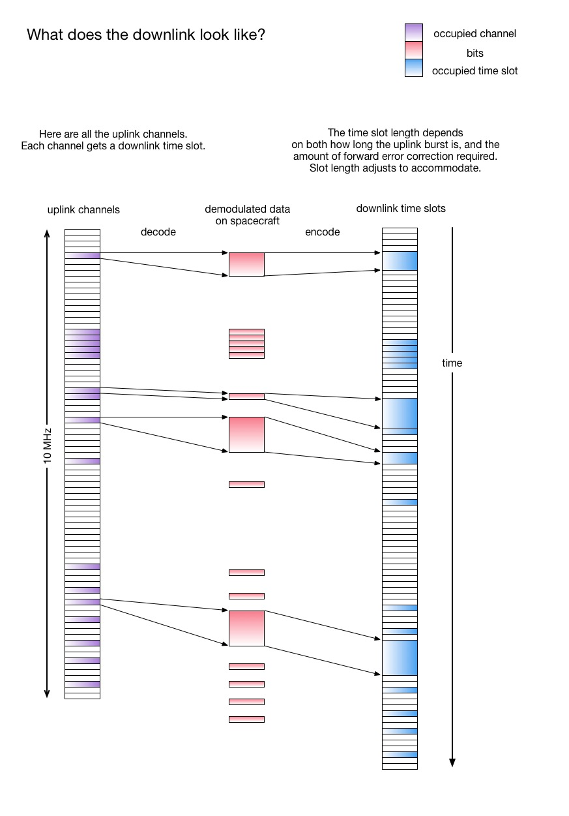

Uplink is expected to be 5kHz data rate (modulation TBD) within 100kHz FDMA channels. Signal shall be linearly polarized, and cross-polarized with respect to the downlink.

Low Data Rate

SatChat 1k mode is expected to be 1kHz (modulation TBD) within a subdivided 100kHz channel.

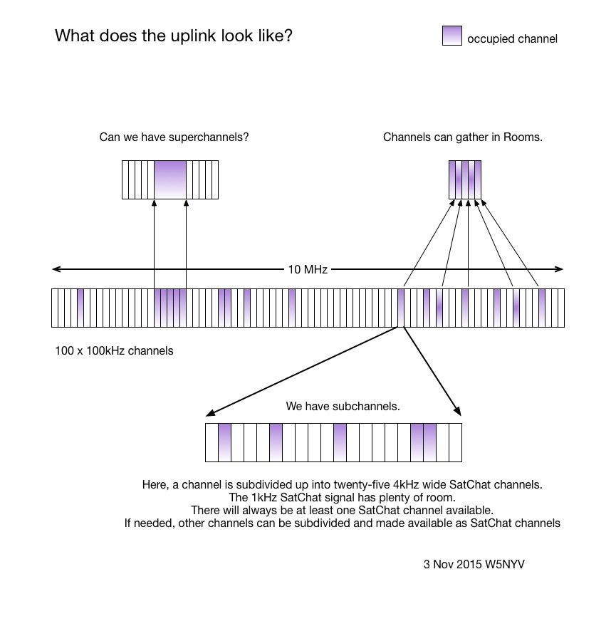

Uplink Preamble

The Phase 4 FDMA uplink channel is currently assumed to be 10MHz wide, consisting of one hundred 100kHz channels.

There are certain things we need from our uplink signal. We need a constant envelope signal. We need reliable signal acquisition at the satellite. We want to reduce adjacent channel interference. We do not want to spend more power than necessary.

We believe that reliable signal acquisition at the satellite can be enabled with a preamble on uplink transmissions. The purpose of the preamble is for the satellite to identify a Phase 4 signal from the earth, obtain symbol timing, obtain frame timing, and then set the modulation, coding, and data rate for the transmission that follows.

Since a user terminal can hear itself on the downlink, it will not have to resynchronize as long as its own signal is being received. If it loses its own signal, then the preamble is resent. For cases where there are uplink-only stations, such as emergency operations, automated operations, or equipment failure, another mechanism must be required that forces resynchronization.

Below are the major components of the preamble in time order.

A fixed-sized header is then sent at the lowest modulation rate. This header describes the packet. The contents of the header are as follows.

The next header field contains the following information. The modulation, coding, and data rate combinations may be encoded in order to make them as compact as possible.

## Chapter 7 Receivers

### Frequencies

|  |  |  |  |
| --- | --- | --- | --- |
| Mission | Downlink Frequency Band | Bandwidth | Access Type |
| Phase 4B | 10450-10460 MHz | 10MHz | TDM |
| Phase 3E | 10450-10460 MHz | 10MHz | TBD |
| Groundsat | 10440-10450 MHz | up to 10MHz | TDM |

channel spacing and designation, demodulation characteristics, voice signal stuff,

### Emission Type

The emission type is a single-channel digital time-division multiplex downlink. The possible modulations include 90° BPSK, QPSK, and 8QPSK. Frames are encoded using LDPC-BCH.

### Emission Type Designation

limitations on emissions, conducted spurious emissions, radiated spurious emissions, security and identification, authentication, station ID, registration, registration memory, access overload (proposed quality of service scheme from 2008), storing and forwarding, MESH networking requirements.

## Chapter 8 Supervision

control operation, failure detection. It may be best to have this controlled by a small team in order to protect access to the space segment.

## Chapter 9 QSO Processing (System Access!)

initialization, system parameters, paging vs. traffic channels, access parameters, access attempt procedures, logging of failures, delay after failures, message passing, how to handle retries, signaling formats. This can make or break the entire project, either by making it irrelevant, or so flexible that it can’t “just work”. Smart people will break this down to several chapters.

## Chapter 10 Reconfiguration

this is very important to get right, and it may need to be in a document that is logically above the Common Air Interface, as the Reconfiguration Definition drives the Common Air Interface. Who is in charge of deciding when and how the system is reconfigured? The SDR allows reconfiguration so that the system can be deployed in many different ways, with different modulations, and different experimental modes. This chapter lays down the law on what has to happen in order to reconfigure user and space segments. What needs to be included is the process of how to propose new modes and schemes, and a history of what modes and schemes have been proposed, why they were accepted or rejected, and what happened when they were tried. This is a political and technical area with great potential, that needs to be fully explored and agreements need to be in place.

## Chapter 11 Idle State

power savings possibilities, or the ability to swap in science projects when traffic is low enough and processing power is available. Defining how to get into and out of idle in order to be able to use the idle state for either just saving power, or some other purpose that we haven’t thought up yet. Using idle cycles could be super useful, but is optional.

## Chapter 12 Emergency Communications

what constitutes an emergency state for the system, what services are provided by both user terminals and space segment in an emergency. There are at least two categories. A declared communications emergency changes the spacecraft state and may change user terminal state. A locally determined emergency does not change the spacecraft state.

## Chapter 13 mesh operation

User terminals will operate as MESH stations. When they are close enough together, then will form ad-hoc networks on their own. This mode should require the user to opt-in and should require minimal configuration. Discuss security implications in detail.

## Chapter 14 Gateways to Other Services

User terminals will operate as gateways. For example, Wi-Fi hotspots. This mode should require the user to opt-in and should require minimal configuration. Discuss security implications in detail.

-=-=-=-=-=-=-=-=-=-=-

Comment and critique welcomed and encouraged. This document will be developed in collaboration with the space segment team.

Editorial Contact:

Michelle Thompson (Phase 4 Ground) w5nyv@yahoo.com