ASSIGNMENT NO 1
by
HASNAT MAQSOOD (FA24-BCS 037)



Submitted to: Miss Haseena Kainat
Subject: Object Oriented Programming
DATE: 03/10/2025

DEPARTMENT OF COMPUTER SCIENCE
COMSAT UNIVERSITY OF
ISLAMABAD, PAKISTAN

[CLO1]: (Demonstrate fundamental principles and concepts of object-oriented programming.)
Q1. Rewrite the following code using object oriented approach.
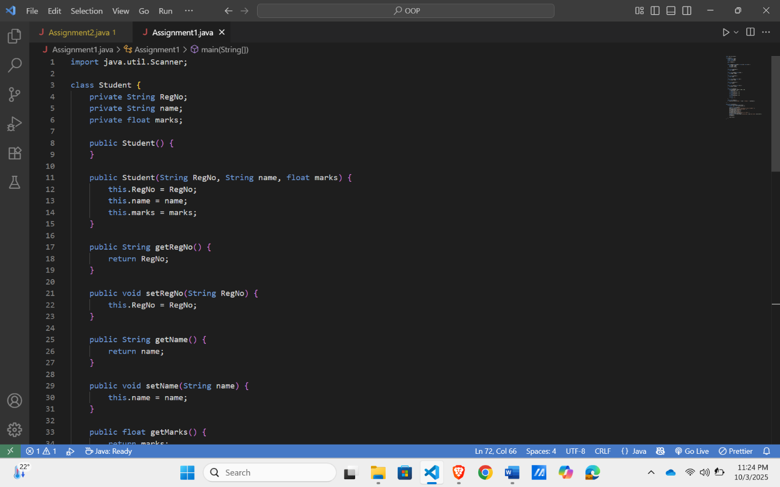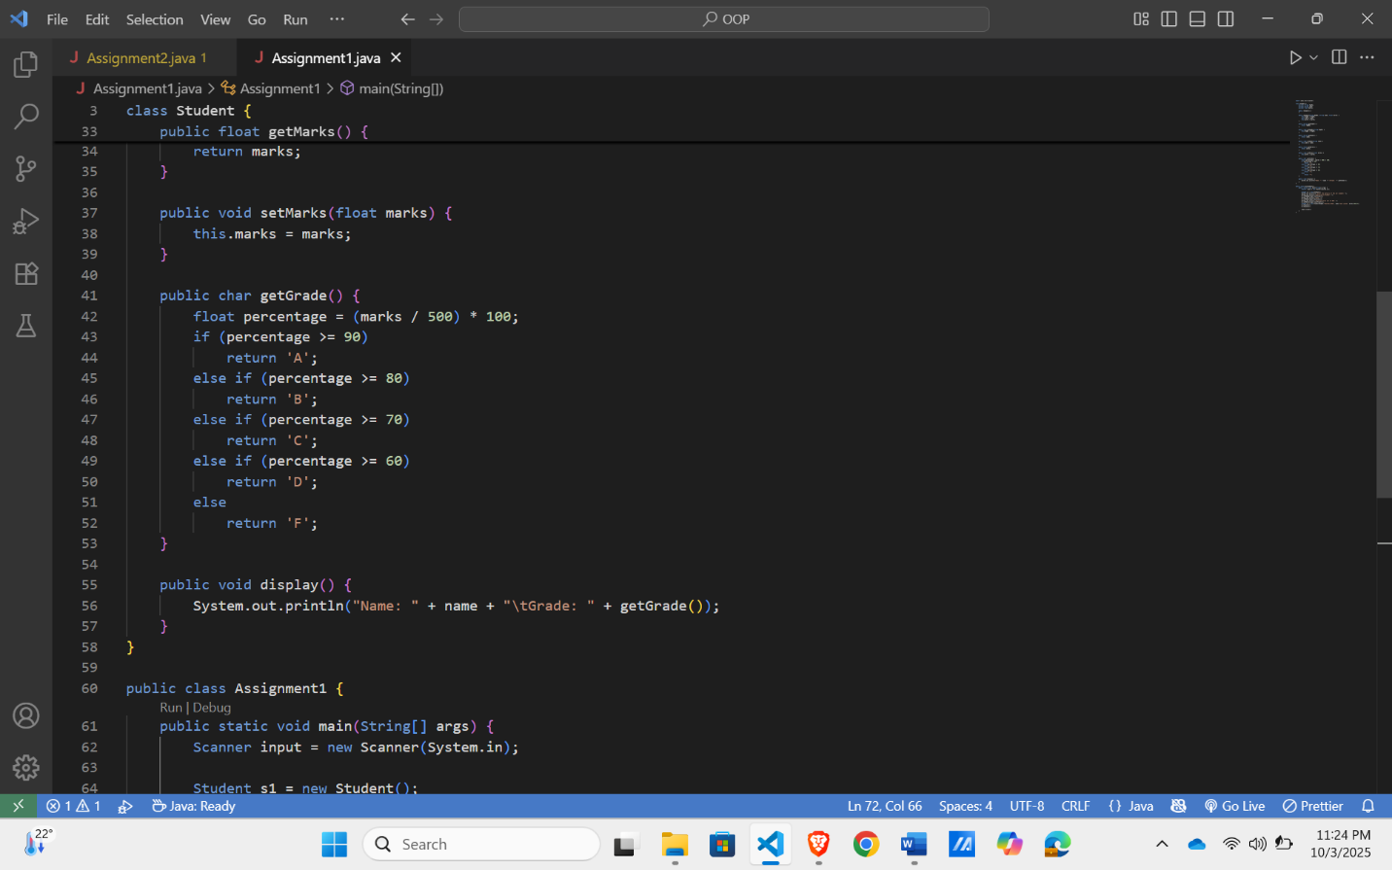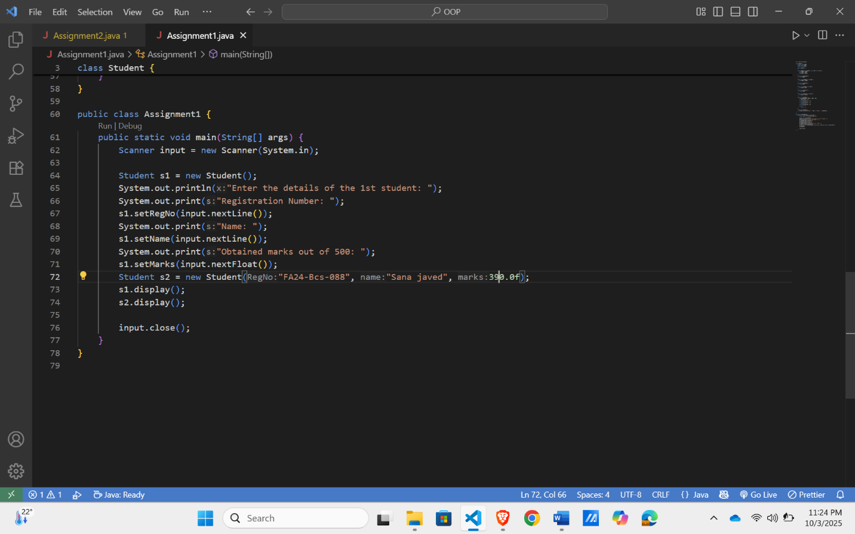
Output:
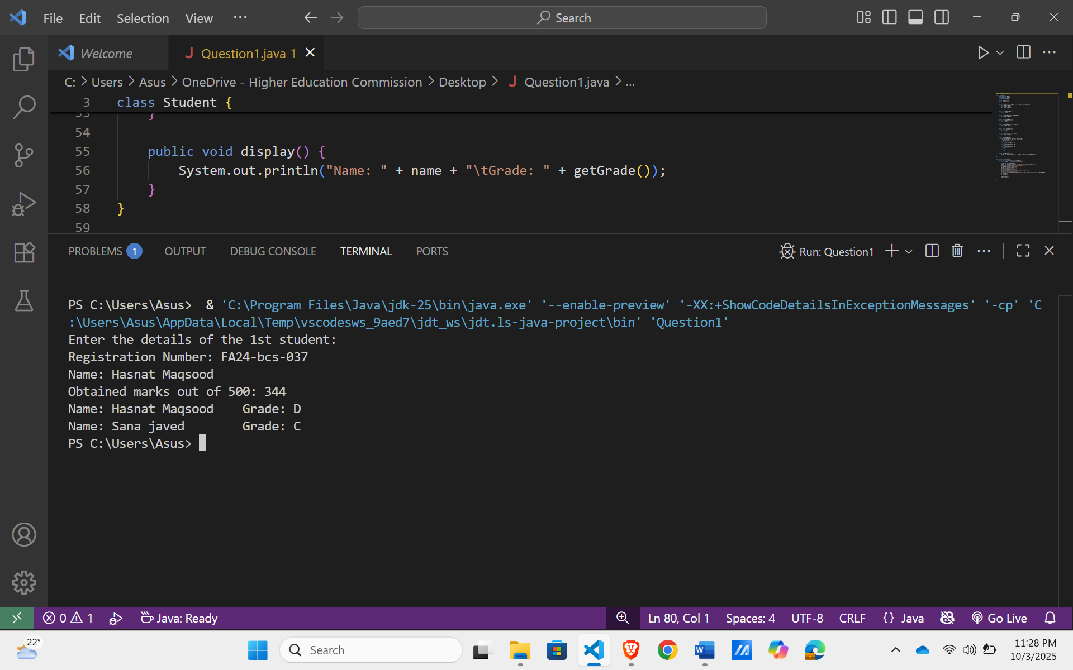
Q2.Consider the concept of a Book in a library management system.
You are required to:
- Define a Book class with appropriate attributes to represent the details of a book in memory.
  - Identify and declare the necessary attributes with suitable data types and access specifiers.
  - At minimum, include details such as title, author, ISBN, price, and available copies.
- Provide appropriate constructors (default, parameterized, and copy constructor).
- Write getter and setter methods to access and modify the attributes.
- Write a display() method to print the details of a book.
- Implement a static swap(Book b1, Book b2) method that swaps the contents of two Book objects.
- Write a Runner class to:
  - Create two Book objects with different data.
  - Display their details before swapping.
  - Call the swap() method.
  - Display their details again after swapping.

Answer:
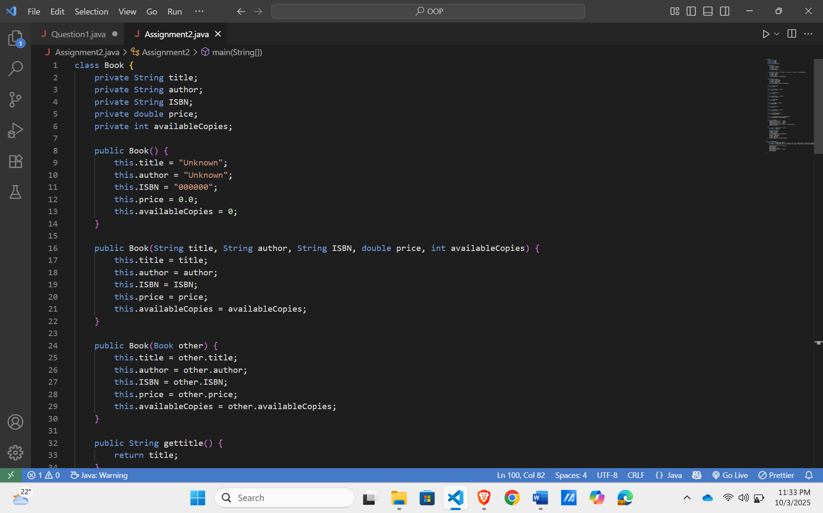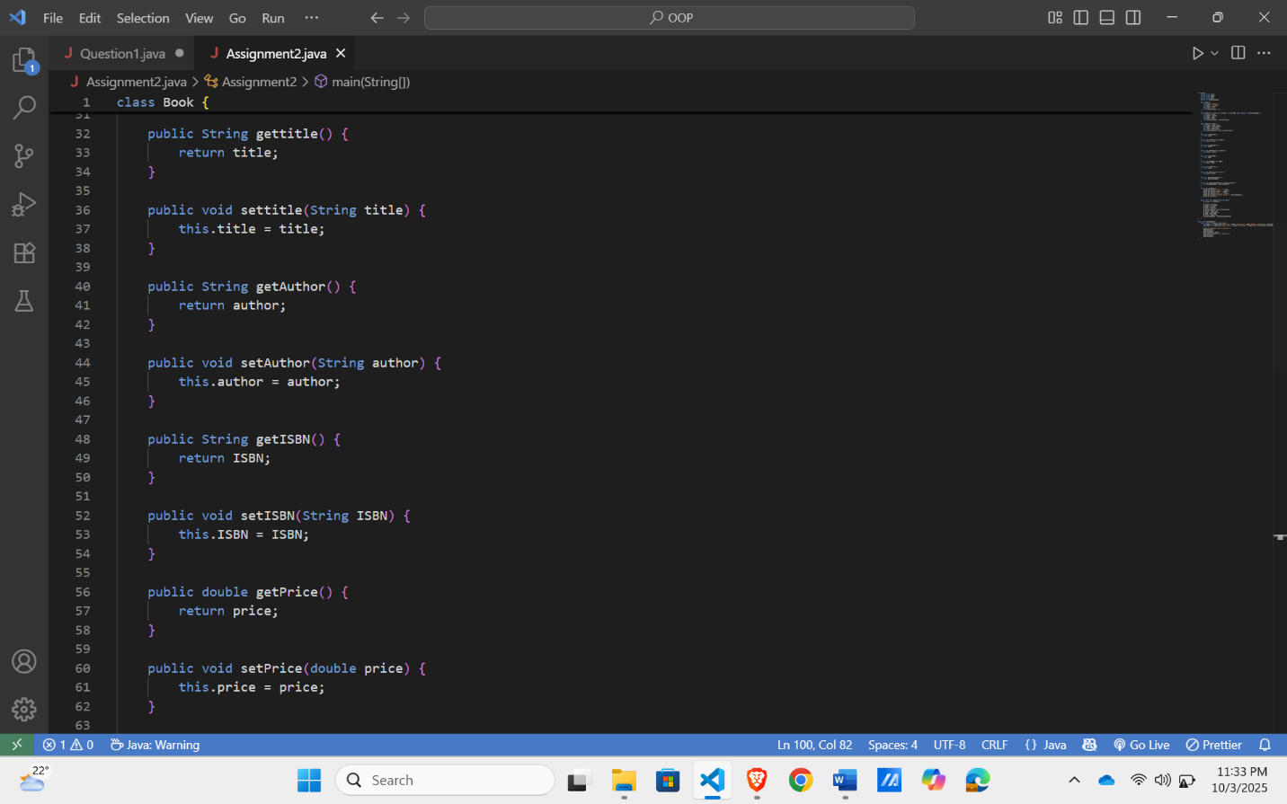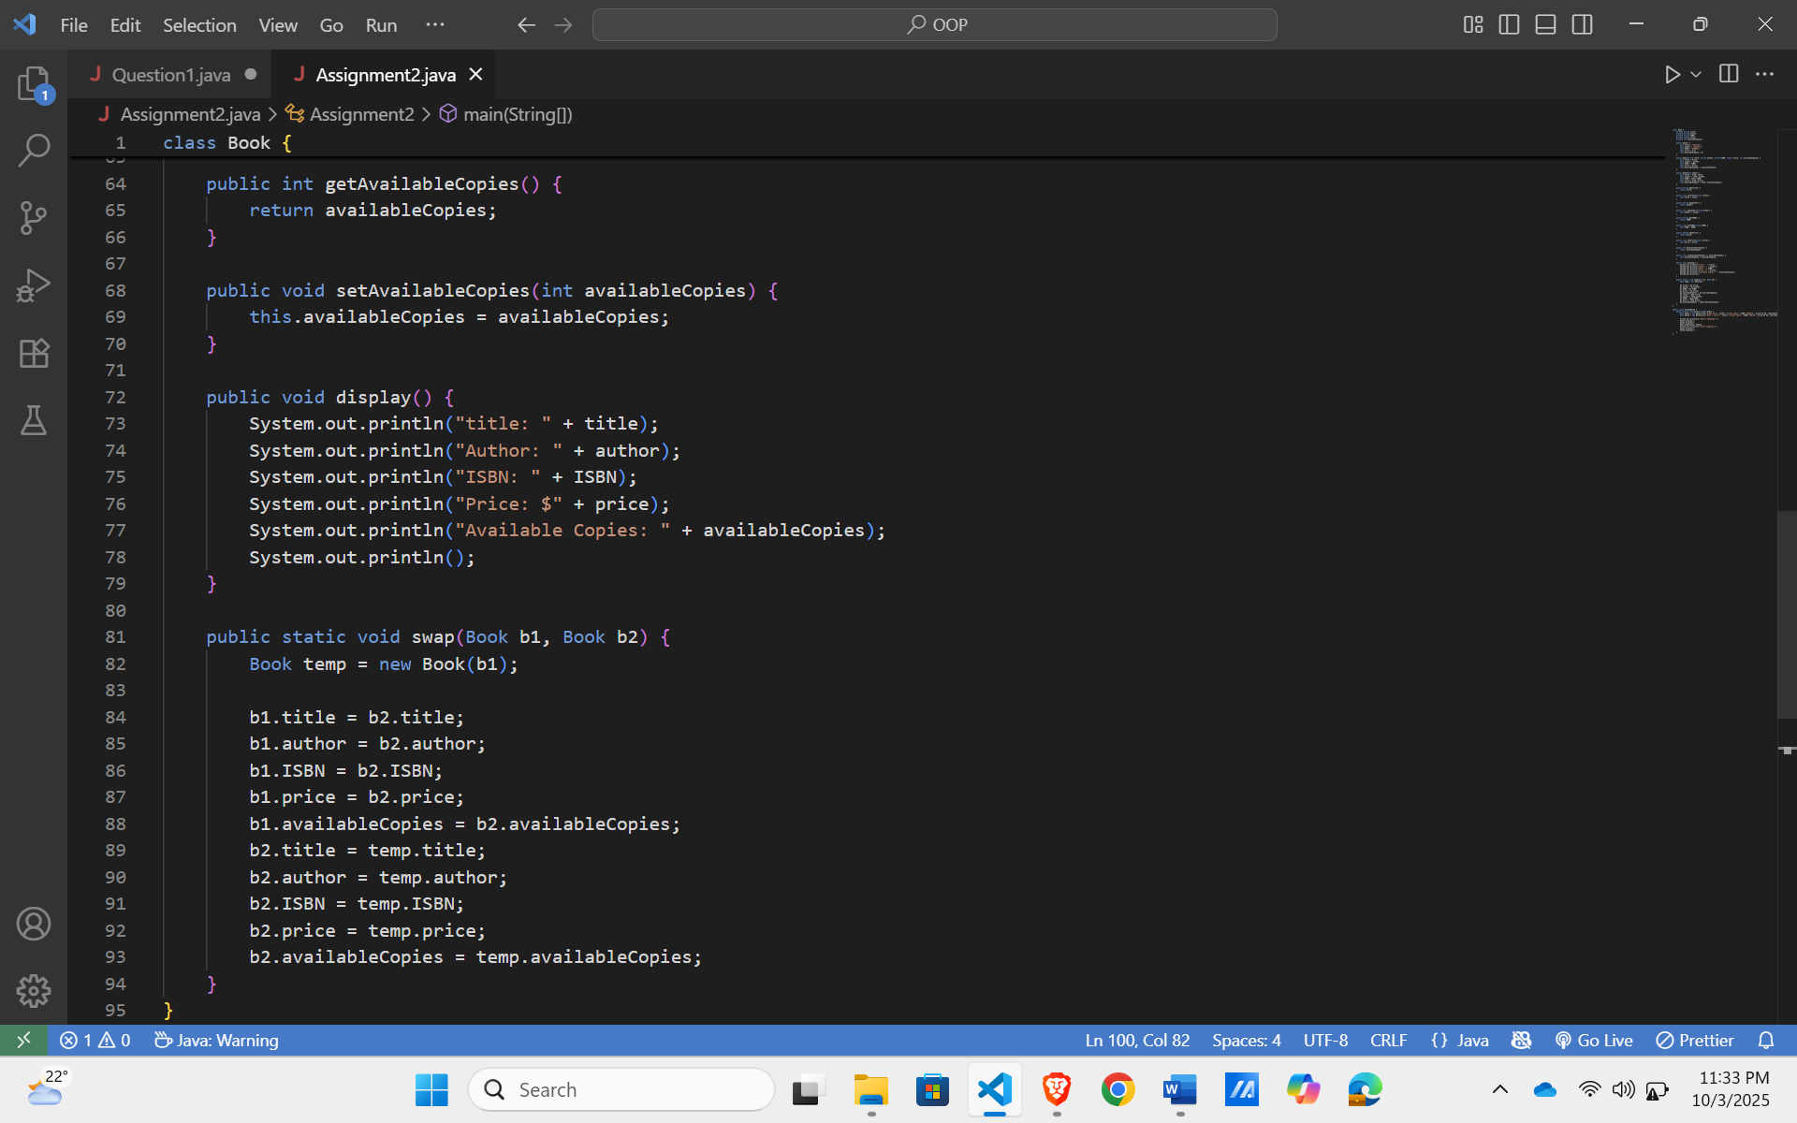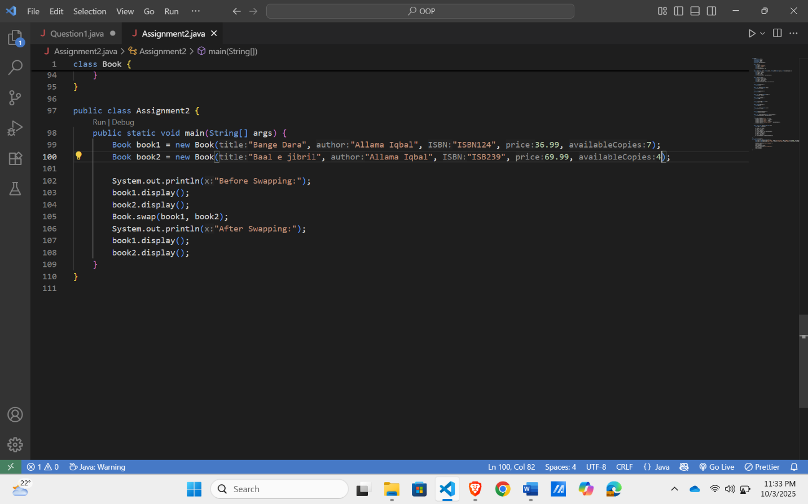

OUTPUT:
