**INITIAL COMMENTS – PHASE 3 in this color**

**Developer Response in this color.**

**Things I need further confirmation/clarification in this color.**

1. Availability: Tickboxes do not appear

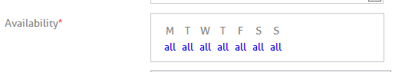—Register Properly i.e. no shortcuts. STEP1- Advisor Registers. STEP2- Admin VERIFIES the account. Which results in a link being mailed to the Advisor. STEP3- Advisor clicks on the link, logs in and fills in the details. This will result in his account being active. THIS IS THE ONLY PROPER WAY TO USE HENCE TEST....

NOTE—Admin has to VERIFY and NOT ACTIVATE. If the admin activates only then can the above problem arise.

1. Videos/images should be viewed when clicked on them
   1. SRS: Once the video is uploaded, it can be reviewed from the website by clicking on it. Downloading the video will not be possible. – This will come in the last phase, please go through the WBS
2. Name for files should be given by the user after download is complete. It should be editable.

* SRS: Uploaded files will be named after the uploading is complete.

1. When an unrecognized file format is uploaded, can you give a warning such as : “This file format is not supported”. And it should NOT navigate to the images page, should remain at the actual page
2. Don’t ask this, let the advisor chose files and system will decide the format based on advisor’s selection 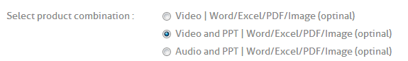-- This wan’t the way in the initial doc, please confirm if you want this change
3. I chose a file, and nothing happened. Advisor should be able to add a many products here. It should add to “exiting files” panel. It should open automatically and add.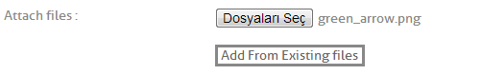

--- If you(the advisor) wants to attach a file to the product which you have already uploaded. You simply click “Add from Existing Files”-All your uploaded files will open up just tick the corresponding check box, IF you wish to upload files as well you can do that too.

--At this stage The Advisor is not sure weather the file is uploaded. But once on the preview page the video/ppt/document will be displayed(In the last phase) he will know that his upload was successfull as he can view that file.

1. Shouldn’t allow product create with no file selected.
2. Shouln’t allow product create with a video OR audio selected – You want a product with a video or audio ---OR--- You want a NO product with a video or audio. I doubt its the later.
3. More than one categories can be added to the product:
   1. SRS: Related Categories (Can add as many categories and sub categories linked to the product) - DONE
4. Product page?? Check WBS Phase 3 – Step 11 a and b – Product page is the page the user can view, similar to the preview page, Goto the advisor profile, View all product tab and click on a product and you shall see the product page.
5. On Advisor view: My experience section should show description. See evisors for an example 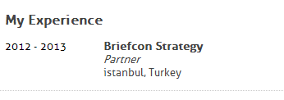
6. Set width to 99% or 100% here 
7. Advisor should be free NOT to chose a 3rd level expertise (skill) When I don’t chose it, it doesnt allow save. A blank page appears 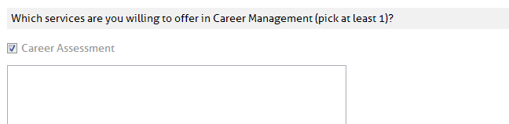
8. Expert information does not look good. Make it EXACTLY like evisors: 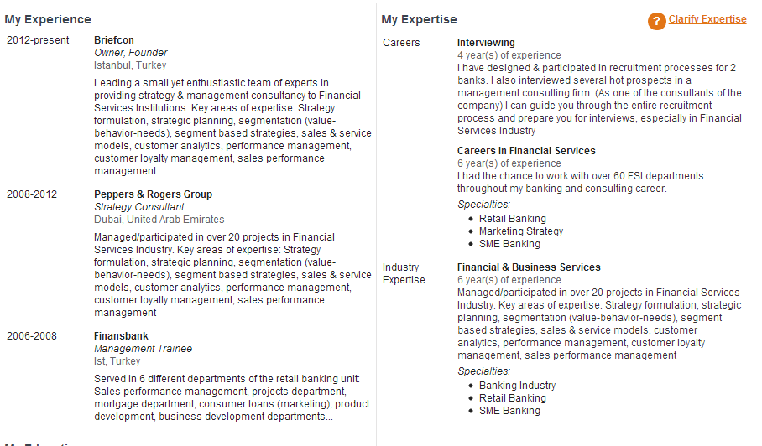
9. For instance: what is that blank line at the end? – Not there any more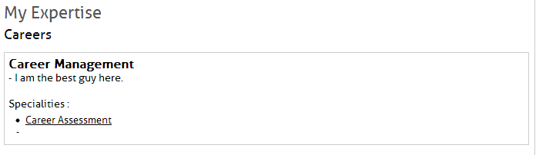
10. Also, when no specialities is selected, it shouldn’t write Specialitiess. - DONE
11. Please Do it EXACTLY like evisors page. Make Hot products width smaller, Overall structure should be like as in evisors

|  |  |  |
| --- | --- | --- |
| Experience | Expertise | Hot pro. |
|  |  |  |
| Education | |

1. Alert info icons should be on right-top corner of EACH section. For instance, if there is a NEW message, it should display the number of new messages

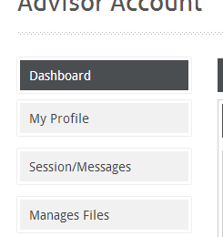

1. If there is no profile photo, u should show a template male.jpg or female.jpg file

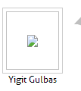

1. On Communication (Free messages) There should be a 300 character limit for both incoming and outgoing. For both initial and reply messages. -DONE
2. Deleting messages on both communication and session/messages should be possible by either user or advisor. If user deletes, messages will show on advisor but will not show on user . Vice verse
3. On message consultancy or web cam consultancy, users & advisors should be able to add files (More than 1 file can be added)
   1. SRS: o If there is a file attached to a session or a meeting, will be showed in the details -- DONE
4. Acecpt button should be “Review”. Added files can be reviewed from here ---DONE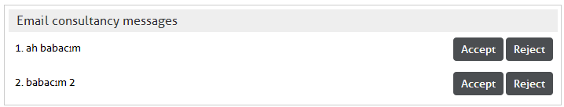
5. Reject button doesn’t work
6. Tis section doesn’t work. Accept/Decline buttons don’t work. Can’t review further -- DONE
7. Should show if there is a new message here. Both here and on the left menu panel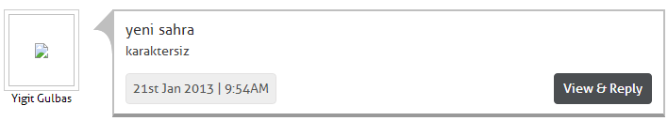
8. Use a text-wrap for all divs (not sure but try supress or normal) 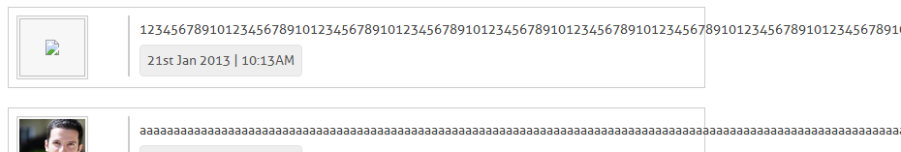
9. Sessions/Messages link doesn’t work for users—Coming up in the next phase
10. When not logged in, it currently says “Your message has been sent” for free messages. Should say, you should create a user account first and navigate to the page - DONE
11. Date / Time schedule doesnt show, since advisor can’t edit it.—READ pt 1
12. Price for webcam consultancy doesnt show in advisor profile -DONE
13. Advisor-Dashboard for advisor doesnt work at all. Pending & Paid requests are dummy, everything is dummy—The dashboard (That one page in user and advisor) is a collection of almost everything that is going on. Will be better if I do it once all the other functionality is done.
14. Do you have a page separator for messages or communication? If i send 1000 messages, will it extend the page height? It should show in different pages with numeration - VAIBHAV
15. In all messages and communication, most recent should be on top. So use ORDER BY time DESC – Now, there are two things here 1- messages 2- replies. Messages should be and is in DESC(time).. But Replies i purposely ordered it as ASC(time) as the last one shows up in the end and just below that is the textbox to reply. IF i order replies by DESC(time) the latest reply is on top and textbox to type reply is at the end, ain’t the later confusing?