* Change – refresh Captcha should be implemented in user and advisor registration

=>Done

* Email authorization should be requested. It says “An email has been sent.” But no email is received. No activation link received.
* Email activation is not working properly in users and advisors
* Become a user / Become an advisor buttons at homepage should direct to <http://64.251.22.148/p630/register>
* When user’s name change, header dashboard tag should change also (It doesn’t update name change)
* Email : should be changed from edit profile. When changed, it should send an activation link to the new mail address and update relevant database tables
* On facebook, “Please enter at least 8 characters.” On normal registration “5 characters”. Consistency required. 5 minimum is ok.

=>

* “You are already registered with, why do not you log in !”after with should write email address
* When registered as a user via facebook, can not login. Doesn’t accept password & mail combination. Try for [yigitgulbas@yahoo.com](mailto:yigitgulbas@yahoo.com) with password:12345678. This is basicly because you link user-facebook registration with “ADVISOR-normal registration” When facebook reg. İs used, it registers as an advisor.
* Activattion Link Send.
* When we try “register via facrbook” when facebook account is NOT Logged on, it should ask user to login with facebook (via fb username and password”) Currently is displays fb information with empy fields, which is wrong:

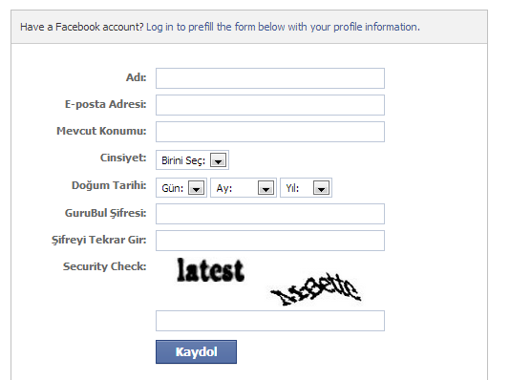

=>

Facebook login details should be text-align:center Currently, it is not centered

* Same email should be used both in user and advisor registration. Currently, when I register as a user, i can not use that email to register as advisor. Should’nt be this way.
* When registered via linked-in or as advisor it should redirect to login as advisor page, currently, it redirects to index.php

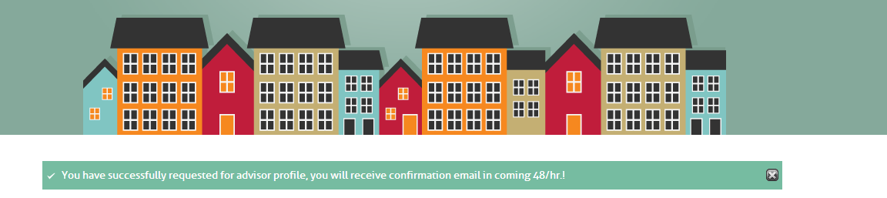

* Check Linked-in public profile validation function. It only should accept proper links. See evisors for detail. Check the user [mehmetonol@gmail.com](mailto:mehmetonol@gmail.com) from advisors panel, linked in profile page redirects to an error page
* On normal registration as advisor, Experience-> Dates should be Month, Year, Month, Year



* Admin approval for activation is not working. Currently, Advisors can signin without verification.
* At first login as advisor, it should redirect to complete profile.
* Phone number \* shouldn’t be mandatory
* Image upload should be same as evisors, in design and texts

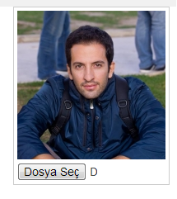 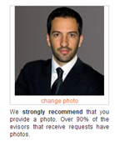

* Availabiliy calander should be identical with evisors. Days and hours should be selected.

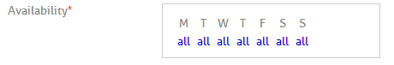

* Should be like: 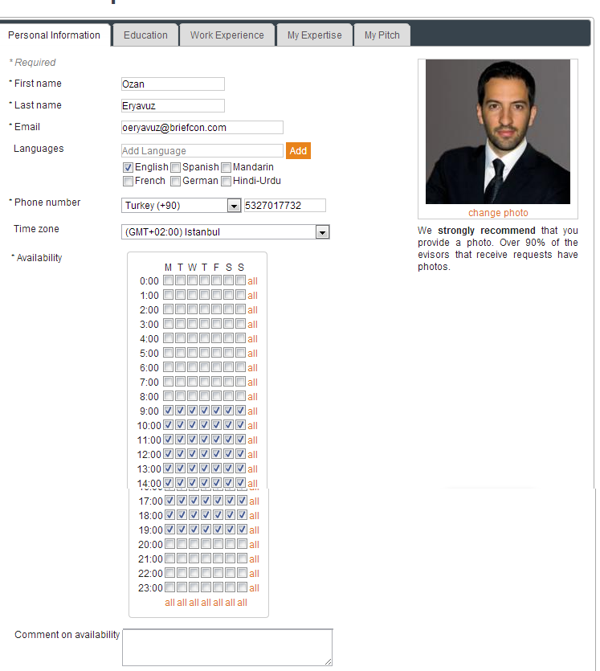
* Abhishek, we have very specific requirements for this section as specified in SRS document, they are obviously not implemented. For instance, the pricing table must show : “What you receive” as a separate field. Check SRS
* This area should be numeric only, but it accepts texts as well. Simple issue, but not implemented properly.
* “Bulk rate for Webcam/Email consulting” remove this..
* In all fields with label & input area, they should be center aligned (vertically) Currently, labels are slightly higher aligned



* In all input boxes, use 2px left and right padding. It shouldn’t be sticking to the left box border
* Delete this section

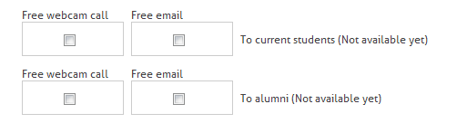

* Separators, they don’t look right. Please correct this and ALL other separators in pages



* Delete internship, we don’t need it



* In expertise, should be ALL expertise areas and sub expertise areas. This is why I explained to you in the mail. It should read from the db table and display ALL records as expertise (Categories) It should include “Business, Careers, Tutoring, and all other areas.” It should update as db changes. How is it doing currently? Is Admissions & Careers only available category1 expertises in db?

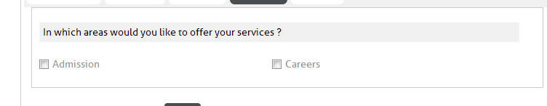

* Please use a proper textbox here. (increase width and height slightly) And to th eright area, use a “This is your time to shine” information box as specified in SRS. (with a link to an image 🡪 See evisors time to shine area)

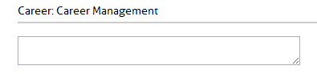

* Remove this area, we don’t need it.

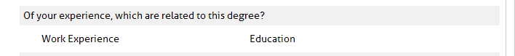

* There should be a “Save and Continue” button in all edit profile sections
* In my pitch section: There should be an information section right to the textarea (see evisors)
* Abhishek, another very simple mistake: On Advisor account, Dashboard is a “User’s Dashboard”. I can’t view an advisor’s Dashboard.
* Again, alignment problem. Should be vertically aligned, here and EVERYWHERE



* This is not working:
  + 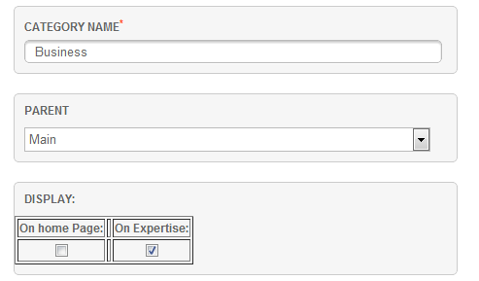
  + When I select “appear on Expertise” it does not.
* Promo video is not implemented. Advisors should be able to add a promo video below profile image.
* We will update you in next phase.