

**Functionality document for Advisor project**

Created by: Mr. Pankaj Barde

Approved by : Mr. Abhishek Bhosale

Creation Date: 20/11/2012

Version: 1.0

**Table of contents**

**1**. Abstract ........................................................................................................................ Page 5

**2**. How it works ..................................................................................................................... Page 6

**3**. Flowchart .......................................................................................................................... Page 7

**4**. Home page ........................................................................................................................ Page 8

**5**. Register ....................................................................................................................... Page 9

**6**. Login ........................................................................................................................... Page 11

**7**. Users account ……….............................................................................................................. Page 12

**8**. About us ............................................................................................................................. Page 26

**9.** Guideline ............................................................................................................................. Page 26

**10.** Search Advisor/products ................................................................................................. Page 27

**11.** How user will review Advisor ............................................................................................ Page 28

**12.** Rating system ..................................................................................................................... Page 34

**13.** Payment ............................................................................................................................ Page 35

**14.** Social Networking integration ……………............................................................................ Page 35

**Technology used**

PHP 5x (Smarty), MySQL 5.2x , Javascript/jQuery, Ajax

**Browser Compatibilty**

Google Chrome 8 onwards , Internet Explorer 8 onwards, Mozilla Firefox and Opera 9 and above.

**Support**

45 days of support from the date the site is configured on server which will help you to resolve any issue related to website functionality as per agreed specification of project.

**1. Abstract:**

The concept of the project is to develop a site where there are two types of users

1. ADVISORS

2. USERS

ADVISORS will offer different types of consulting services through the web portal and USERS will pay to

purchase those services. Services that can be offered by ADVISORS:

1. LIVE VIDEO CONFERENCE: 1-to-1 web-cam video conference / chat consultancy. Both ADVISOR and USER joins to a webcam session inside the web portal. They will have the ability to chat during the webcam session. Will need a ‘scheduling / agenda tool’ for this service. – To come with 2 options (1. Video only + chat box, 2. Video + PPT presentation + chat box).
2. VIDEO / PPT UPLOAD (NOT LIVE): ADVISOR uploads a video and / or a PPT presentation to the website for purchase and view by USERS at anytime. This is not a live video conference. ADVISOR will need to use an ‘upload video and presentation’ tool embedded / included in our webpage. Videos / ppt files will be uploaded from ADVISORS’ computers, not developed in our webpage. Will need a ‘format not suitable’ OR ‘ready to go’ warning signal / check included in the system.

1. EMAIL CONSULTANCY: USER sends an email with questions to the ADVISOR and pays for the service. ADVISOR responds to the USER’s mail questions. Free format (standard mail format). Need to generate auto email addresses and internal mailboxes for ADVISOR and USER to maintain confidentiality – they will not use their personal mail addresses for this service & sending an email to any outside email address or domain will be strictly forbidden.
2. MESSAGING: USER can send free messages to ADVISOR and ask a quick question – chat box to be limited to max 300 characters and follow the Twitter format. ADVISOR should be able to reply in the same format.

**2. How it works?**

1. The Advisor will create their profile under particular service category for free but it will be activated only when it is approved by admin.
2. Once the advisor account is approved by admin they can upload their products such as video, ppt, etc.
3. The user can search for the advisor as per service category and review their profile, products uploaded by the advisors.
4. The users can purchase the products such as videos, ppt uploaded by advisors or they can communicate with advisor and send request for services such as video session based on calendar availability, email consultancy for getting answers/opinion to their queries as per requirement.
5. Once the advisor accept the request, the user has to pay for seeking the service from advisor, once the payment is made by user they can start the session (video/audio).

**Thanks for clarification**

**Reference sites**

1. <http://www.evisors.com/>

2. <http://www.knovio.com/>

3. <http://www.udemy.com/teach>

**3. Flowchart**

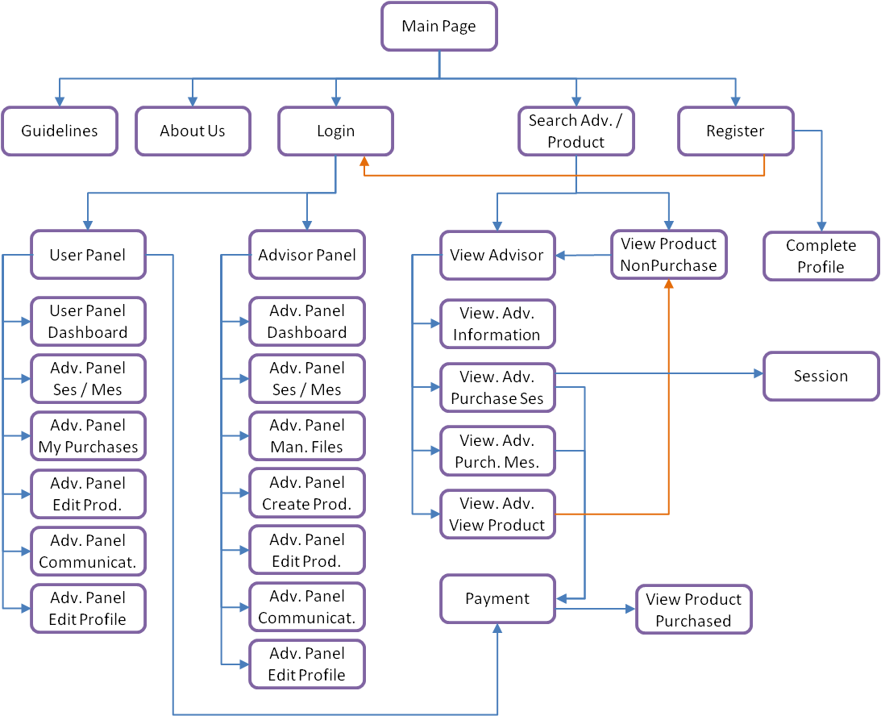

**4. Home page**

* Main page will be similar to [www.evisors.com](http://www.evisors.com)
* Header & footer will be same in ALL pages across the website
* Header will consist of Login, Register and About Us buttons
* Footer will consist of Terms of Service and Privacy buttons
* At the middle section of the page:
  + Top right: There will be a search area similar to evisors : “Search” will direct users to the Search page



* + At the middle, instead of three, there wil be four main categories. 4th one will be “Tutoring” 
  + On mouseover, second-level expertise areas will pop up



* + No google-maps page is required. Out of scope
  + For each main category, top 5 second-level expertise areas will be listed as below: 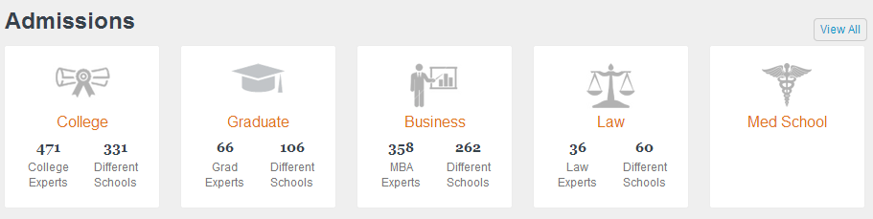
* Rest of the main page will be similar to evisors.com
* Register as user will be facebook-integrated
  + There will be a different section for users who don’t want facebook integration
  + USERS will provide an IBAN number in registration. This area will be optional in registration and can be controlled from the Edit Settings. This IBAN number will be used to cash the money back to USERS in case of system-errors.

**Kindly provide us the registration fields for user who don’t want to use facebook a/c for login.**

**Thanks for fields**

* Register as Advisor will be linked-in integrated (optional, if Linked-in account exists) – see Evisors example below

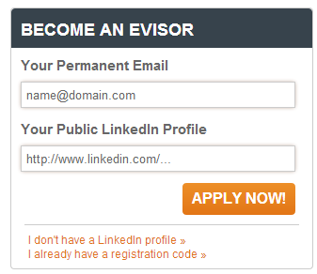

**The user will get the registration code from admin once they enter the above details, kindly confirm.**

**Thanks for calrification**

* + There will be a different section for advisors who don’t wan’t linked-in integration

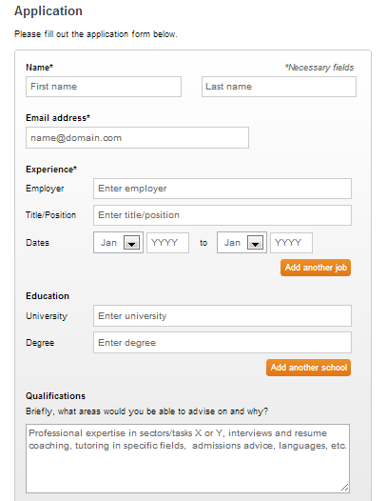

* + E-mail link activation will be required to activate membership – ADMIN (us) will review and approve or reject ADVISOR applicants at this stage. Email link below will only be sent if ADMIN approves applicant
  + From the e-mail link, user should be directed to a page where he/she can set a password
* To become a registered USER, clicking on the activation link will be sufficient
* To become an Advisor, users will be sent a mail as below: 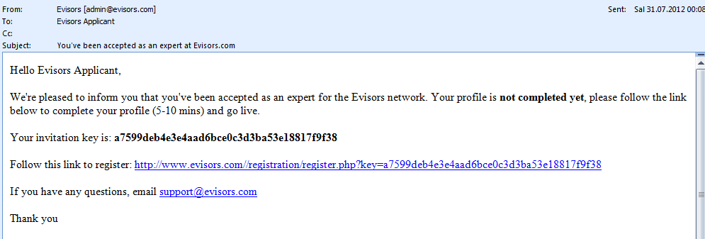
* Once they click on the link, they will be directed to a page from where they can set their passwords: 
* Once the e-mail is verified, Advisors will be direct to complete profile page
* Activation for advisors will be complete only when they complete their profiles

**6. Log in**

* Login page will have the following structure with one difference: Login as user/ Login as advisor will be differentiated with a select tag
* Rest of the page will be similar to evisors.com

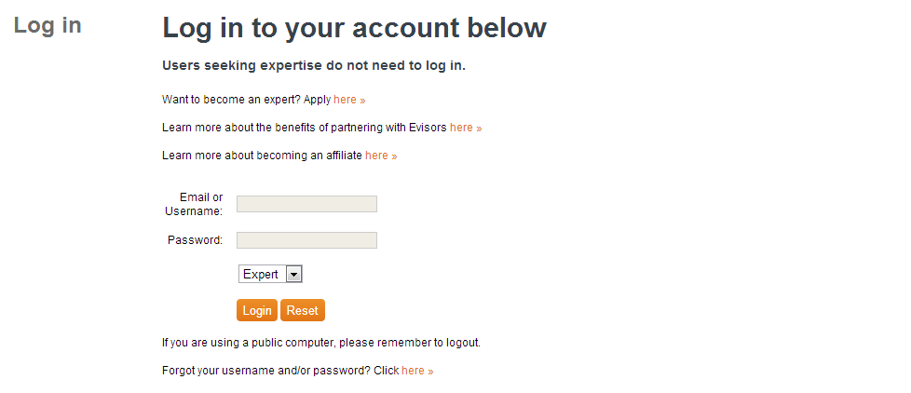

* Forgot password page will be similar to evisors
* Change password should be similar to evisors (from Advisor and User Panels for registered users)

**7. Users account**

**A. Advisor account**

The advisor account has following sections

1. **Dashboard**
   * Pending / Accepted / Completed session requests (on click will direct to “Sessions / Messages”)
   * Unread messages
   * Total earnings (cumulative paid) from Sessions / Message Consultancy / Products
   * Total earnings to be paid (pending) for the current month from Sessions / Message Consultancy / Products
   * My Rates by session, email and product
   * My Ratings (Averages – 1. Session & email, 2. products) and reviews received to date from USERS
2. **Session/Messages**
   * As explained above, this section will display Pending / Accepted / Completed sessions and messages (Only email consultancy messages, message box for free messages as explained in Panel-Communication section).
   * When clicked on a session or a mail, details will be displayed either in this page or a separate one
   * Agenda for webcam sessions should be displayed at top of the screen
   * Accepting / Rejection of the pending requests will be handled from this section
   * If there is a file attached to a session or a meeting, will be showed in the details
   * For each session that has been confirmed and paid for, a notification mail should be sent to both advisor and user 24 hrs before session kick-off
   * For completed sessions and message consultations:
     + For webcam sessions, if there is a chat-log, it will be displayed if clicked on the session
     + For mail sessions, mail conversation will be displayed if clicked on the message
3. **Manage files**

* Uploading files is the first step to create a product:
* Users can upload following file types:
  + - Videos (.MPEG4, 3GPP, MOV, avi, wmv, FLV)
    - Audio files
    - Power point presentations (ppt or pptx)
    - Microsoft Word (doc or docx)
    - Microsoft Excel (xls or xlsx)
    - PDF (.pdf)
    - Image (.jpeg, .gif, .png)
* Uploaded files will be showed in different sections based on their types (as above)
* For video uploads, actual video uploading is MANDATORY - links to another url is not accepted
* Once the video is uploaded, it can be reviewed from the website by clicking on it. Downloading the video will not be possible.
* Maximum video size is 300 MB
* For power point presentations, it can be reviewed by clicking on it. Downloading the presentation will not be possible. Presentation will be displayed from the website (Can use one of the many slide presentation jquery ui plugins, we can decide together once we are there)
* Uploaded files will be named after the uploading is complete.
* Uploaded files cannot be edited.
* Uploaded files cannot be deleted (if they are used in a product). First, the product has to be deleted.

1. **Create product**

**Sorry to say but it was not in initial requirement as agreed by us, it will increase the project scope.**

* Advisors can create products by combining different files in their inventory.
* Possible product combinations allowed for advisors:

|  |  |  |  |  |
| --- | --- | --- | --- | --- |
|  | **Video** | **Audio** | **Presentation (ppt/ keynote** | **Word/Excel/PDF/Image** |
| Combination 1 | X |  |  | X (Optional) |
| Combination 2 | X |  | X | X (Optional) |
| Combination 3 |  | X | X | X (Optional) |

* Only 1 unique document per category Video / Audio / Presentation can be added for a single product
* Up to 10 different files can be added to a product (with a total product MB size limitation)
* Advisor will select files and define which ones are available for “non-purchased” view and which ones are available for “purchased” view from a different screen
* Advisor will continue to a screen where he/she can enter product details: (expertise areas are similar to Advisor profile update, but this time information is provided for the product)
  + Brief definition of the product
  + Related Categories (Can add as many categories and sub categories linked to the product)
* Advisor will continue to View the product (See detail in View Products section)
* Advisor will complete the product after reviewing it
* Once the product is completed, Advisors will define a price for the product
* Files selected as “available for Free / Free of Charge” can be reviewed by everyone
* Files selected as “available for purchased” can be reviewed only by users who paid for the specific product
* Once the product is created in the page, our webpage / system will automatically allow a trailer / preview for the given product. This trailer preview is the first 2 minutes of the video.
  + USERs could display the first 2 minutes of the product video or audio without making a payment – there should be “Pay now and display the whole PRODUCT” button/area for USER who wants to make a purchase the whole PRODUCT
  + If there is a Power Point presentation linked to the product (only the main presentation), USERs could only open up the first 3 slides of the presentation for ‘free view / preview’ – there should be “Pay now and display the whole PRODUCT” button/area for USER who wants to make a purchase the whole PRODUCT
* Advisors can edit product anytime they want. They can only:
  + Add/remove files (supporting: image/pdf/word/etc.)
  + Change pricing
  + Delete product
* When a product is deleted: It remains active on users who already purchased it. It cannot be sold to new users. Once the product expired from all users who bought it, it will be allowed to delete completely. Otherwise, it won’t allow.

**Thanks for clarification**

1. **Edit product**

In this section the advisor can edit the existing (created) product as per requirement.

1. **Communication**

* This section allows users and advisors to communicate with messages. It works similar to a PM (personal message) structure. Consider this section as the personal inbox of the user.
* This section is different from “message consultancy”. In session/messages section, advisors and users will ask/respond questions for only paid services
* This section is for small queries or basic questions such as “Are you experienced in this area?”
* Therefore there is a limit to the number of characters in a message that can be sent from this section. Character limit is 300.
* Deleting mails can be possible

1. **Complete profile/Edit profile**

Once Advisors registers and verifies account email, they will be directed to this page.

This section has same/similar content with “Advisor Panel - Edit Profile” section

Section has 5 sub pages:

1. Personal Information
2. Education
3. Experience
4. Expertise
5. My Pitch

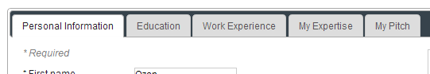

After completing information in each area, users will save / save and continue 

Each page will have following structure:

**i. Personal Information**

* Name / last name, email and will be initially filled. Rest of the page will look like: (Please create an e-visor account to see details.)
* One small difference is: users will be asked to upload one video (trailer) (there will be maximum file size constraint to the video uploaded)
  + This trailer video will be displayed below the advisor profile photo

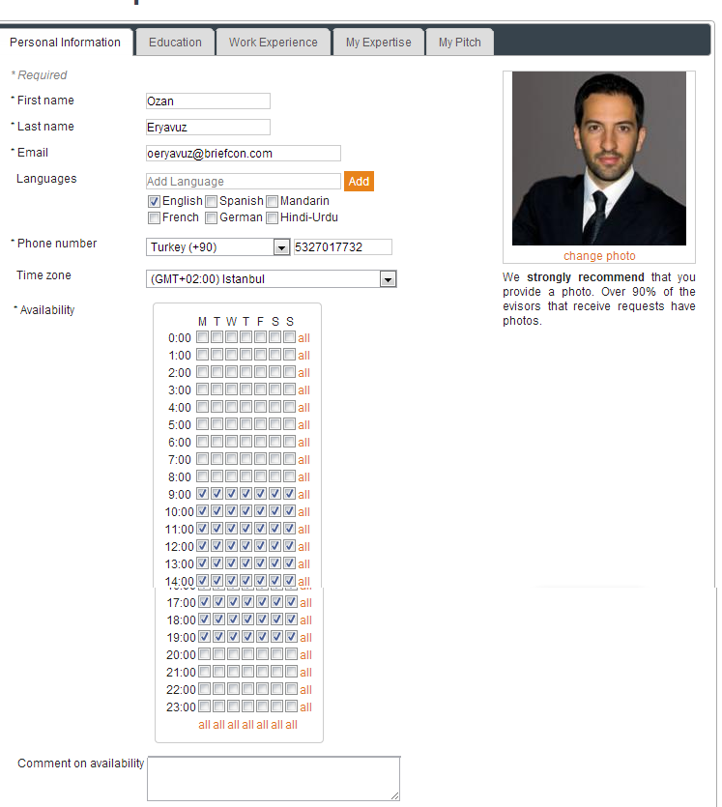

* + Pricing for webcam and message consultancy will also be defined in this section. Different to evisors, advisors will chose pricing for:
  + 1 hr webcam consulting
  + 1 email message consulting
  + Bulk-rate for webcam/message
  + There will be no phone consultancy

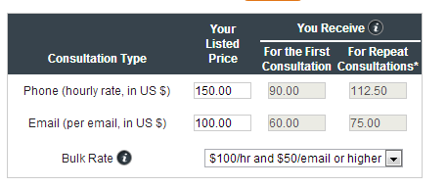

* Advisors will be able to save their social media information

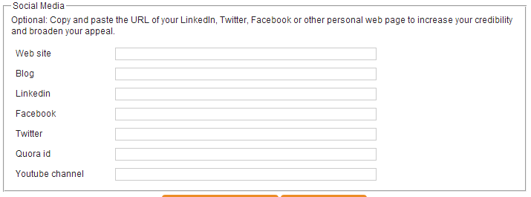

* Advisors will also provide an IBAN account number at this page. This will be used to

transfer money to their accounts

* Save and continue will only be possible when all mandatory areas are filled

**ii. Education**

* Similar to E-visors

Advisors will be able to add multiple schools

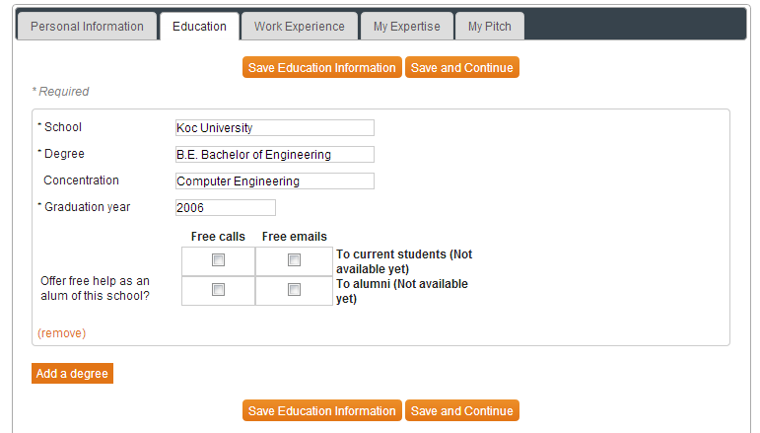

**iii. Work Experience**

* Similar to E-visors

Multiple work experiences can be added

Free text description boxes will have character limitations (e.g. 500 characters each)

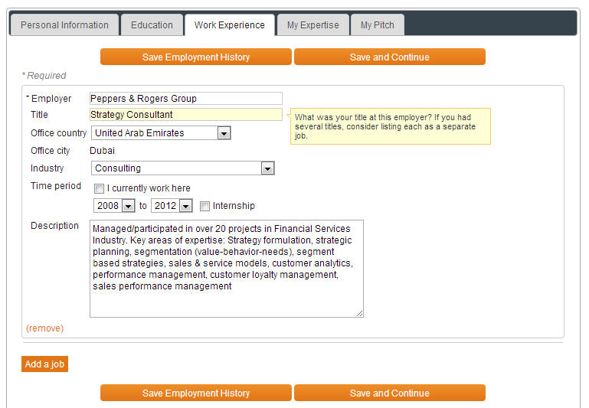

**iv. Expertise**

* Expertise has a multi-level hierarchial category structure. A simple example to demonstrate (taken from search advisors page)

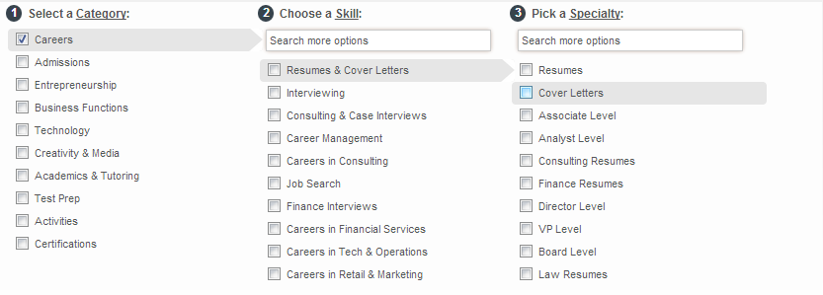

* This page will have the following structure: Initially, the first level categories will be displayed

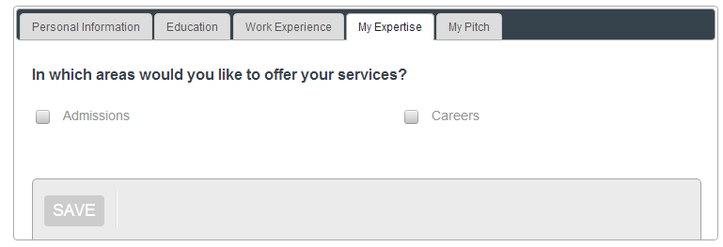

* When advisor clicks on a category, it will expand the skills (2nd level) relevant to the selected category:

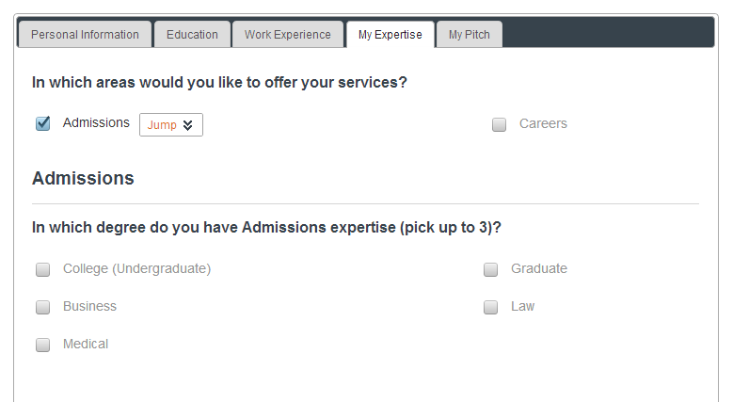

* When users select skills, page will keep adding information about the added skill:

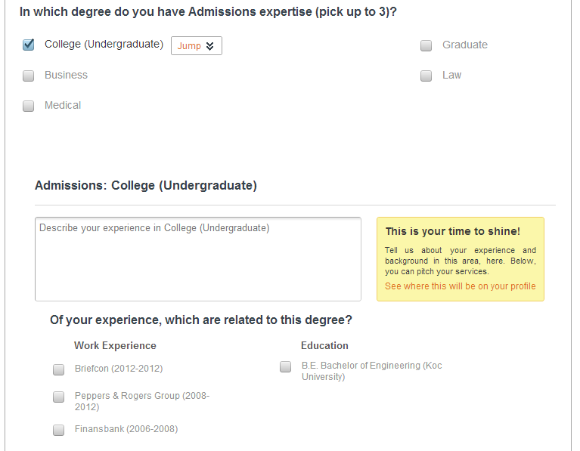

* Advisors will be able to enter description to their category2 and category3 level expertises. Multiple categories/subcategories can be selected at once. They will all add up to the bottom of the page in sequential order. Below the category2 level information, relevant category2 level information will be displayed



* Categories and sub categories will read from a db table.
* To understand the concept better, please register as an Advisor. This section is crucial

**v. My pitch**

* + This section is for users to add their pitch sentence limited to 300 characters. It will appear in their profile when USERs view.

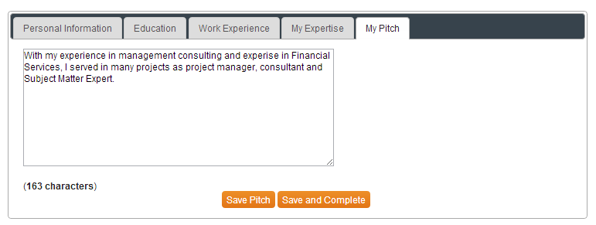

* + This section will have a “Save and Complete” button. Once clicked, registration will be active.
  + Advisor will appear in searches only when registration is activated
  + Advisor will be able to create products and use the advisor-panel section only when registration is activated
  + If user quits during registration, and he turns back to website later on, he will be directed to “Complete Profile” page again

1. **Promote Profile**

Advisors can create badges and mail signatures to advertise & promote their accounts.

Button links are created by the website

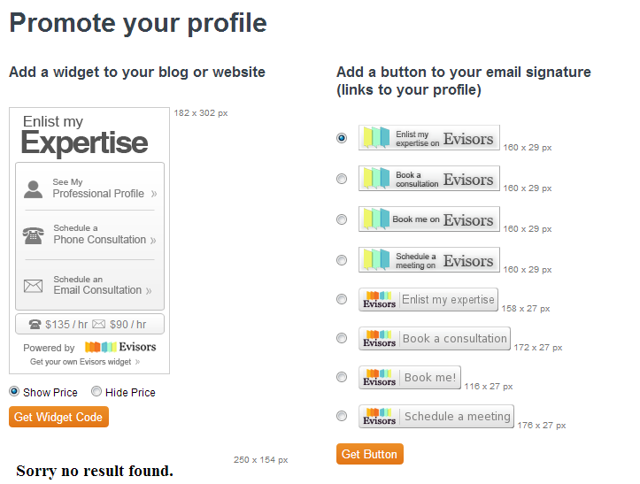

**B. User/Service seeker account**

The user/service seeker account will have following sections

1. **Dashboard**

Dashboard will be similar, with sumary of previous consultancy, total money spent, number of

products purchased, etc + recommended PRODUCTs / ADVISORs

1. **Edit settings**

Edit settings will have the e-mail (username) and password areas as well as Bank code, Branch code and IBAN number. Changing any of these will require e-mail link authorization

In Edit Profile, there will be a enter coupon area

* + Coupons system: There is a database with 4 columns: User_name (mail), coupon_code, amount, Status.
  + Database will be updated/controlled by us (no coding required)
  + When user enters a code, system must check if there is a matching with the user_name (mail) and the coupon_code entered. If there is a record with status “Not_Used”, the amount in 3rd column should be added to the User’s balance and status will be updated to “Used”

1. **My purchases**
   * Sessions / Email consultancies / Products purchased by the user will appear in this area.
   * Products will be displayed with a smaller view compared to “search products” page

* Expiration date will be also displayed on the view
  + Once expired, product will be removed from the list

1. **Sessions/Messages**
   * Session will only be available if the service is purchased by the User
   * From the sessions/messages section, Advisor can select files to be linked with the session. Once the session starts, view will be similar to “View Product” session. There are only 2 main differences
   * 2 webcams will be displayed (1 for own, 1 for other party)
   * There will be a chat section

If possible (plug-in permits), video can be switched to audio by the advisor or user. (Like sykpe)

Once the session is complete, User will be able to rate & comment on the session from the “Sessions / Messages” section

**We assume you will provide us the script/API for video/audio conference**

1. **Communication**

* This section allows users and advisors to communicate with messages. It works similar to a PM (personal message) structure. Consider this section as the personal inbox of the user.
* This section is different from “message consultancy”. In session/messages section, advisors and users will ask/respond questions for only paid services
* This section is for small queries or basic questions such as “Are you experienced in this area?”
* Therefore there is a limit to the number of characters in a message that can be sent from this section. Character limit is 300.
* Deleting mails can be possible

**8. About us**

About us page will consist of several sections, which can be controlled from the left-side menu of the page. Clicking on each of them will change the content of the right-side section 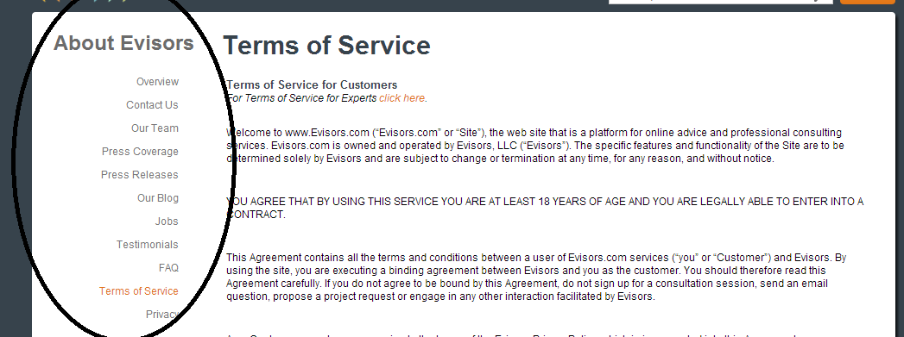

Each section is a static page and should be controlled by admins from a separate interface

Sections required here:

* + Overview
  + Contact us
  + Press / Social Media
  + Jobs
  + FAQ
  + Terms of Service
  + Privacy

See details for each of those static pages (fixed content) from <http://www.evisors.com/general/#!about>

**9. Guideline**

This section will have the same structure as About us section. It will consist of several pages that can be controlled from a left-side menu bar. Each page will have some guidelines/videos about principles such as uploading videos, recommended softwares, etc.

This static (fixed content) module will be editable by admins only.

**10. Search Advisor/products**

* Similar to evisors search page with a difference: Both advisors and products can be searched on the same page.
* Products are videos/presentations created by Advisors, will be explained in following sections
* Search criteria can be Expertise, Industry, Employer, Job Title, Country, Language and Education 
* Search for expertise is 3 leveled. Search for Industry is 2 levelled
  + - Please visit <http://www.evisors.com/search/> to see the details.
    - All search functionality of evisors for mentioned search criteria is requested
* Selection/sorting will auto-update the search results section. (Update sql_array with jquery and display the search results section on sort/tickbox select)
* Search results area wil be populated with the results as evisors, however advisor and product search results will split screen into two: On the left half of the page, there will be Advisors, on the right half of the page, there will be products – these will be 2 separate search results listed based on the same criteria selected at the top of the page (both search and sort criteria)

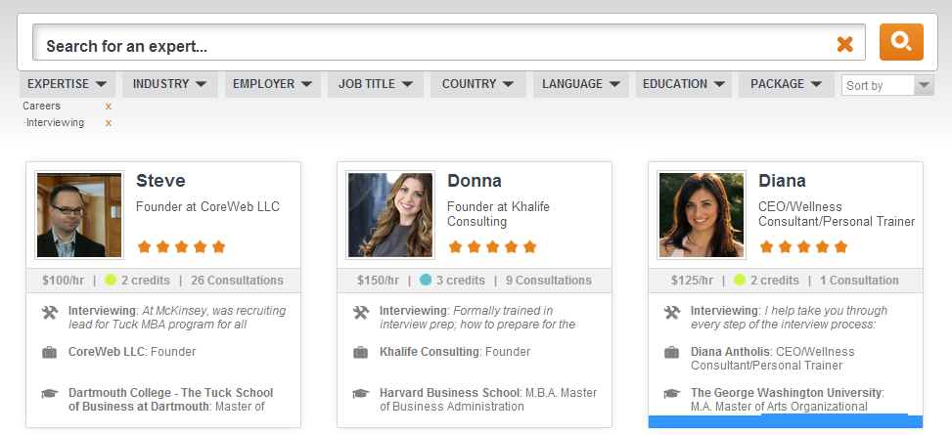

* Will show 2 advisor profiles at a row (for advisors) and 4 products at a row (for products) (total of 6 divs insdead of 3. Product view box will be smaller compared to Advisor view box.)
* Will show 10 rows in total. At the bottom, if user clicks on show more results, will update and add 10 more rows (20 more advisors and 20 more products) (again, update jquery by changing SQL select Limit)

** **(gif file as loads)

* Same criteria and query will be used to update the products and advisors:
  + - Example: Expertise_Category1: Careers & Expertise_Category2: Interviewing selected. Both advisors & products having this expertise will show up

**11. How user can review advisor**

1. **View Advisor Public profile**

When clicked on a div (each result in search advisors area), it will direct to a page where ADVISOR information can be viewed.

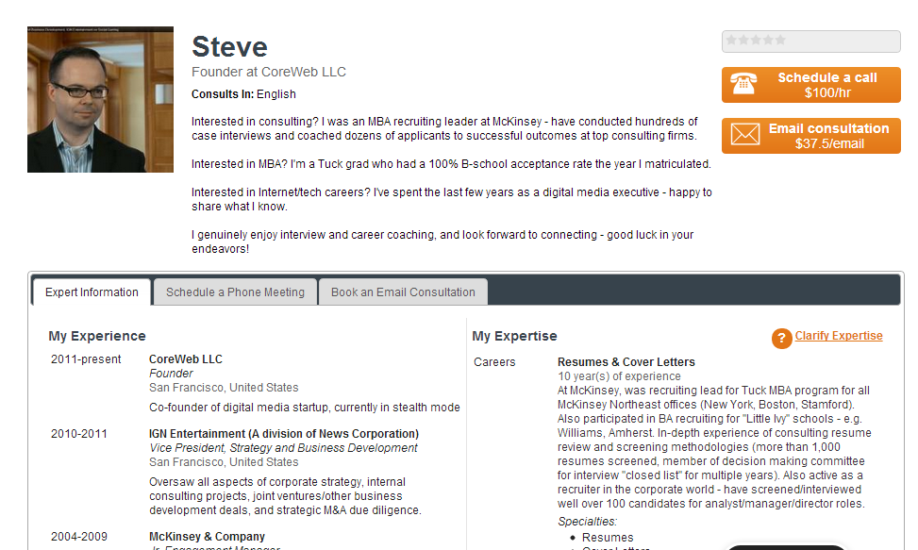

There will be 5 panels in this section:

* Expert information
* Schedule a webcam-session
* Book a message (e-mail) consultation
* Send free messages (max 300 characters. Message appears in Communications box, explained in Panels- Communication section)
* View-Products (This section is additional to evisors)



* All the information filled in “Complete profile” will appear on the sub-panel: “Advisor Information”

1. **Purchase session**

Schedule a webcam session will require user-login. Only registered USERs will be able to schedule a webcam session. Schedule a webcam session has following property:

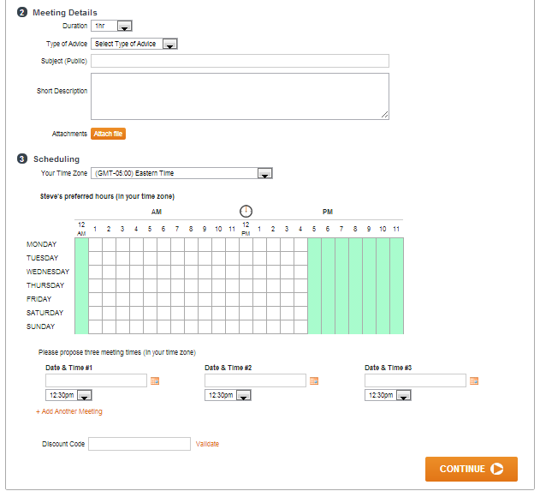

* Files can be attached by USERS
* Once user clicks on CONTINUE, a mail is sent to the User and Advisor.
* When user clicks on continue, a webcam session is created with “PENDING” status in both user and advisor’s panels in “Sessions/Messages” section
* When Advisor clicks on the session request, he will be able to cancel/decline meeting, suggest new times, accept one of the times for meeting, send a message to user: 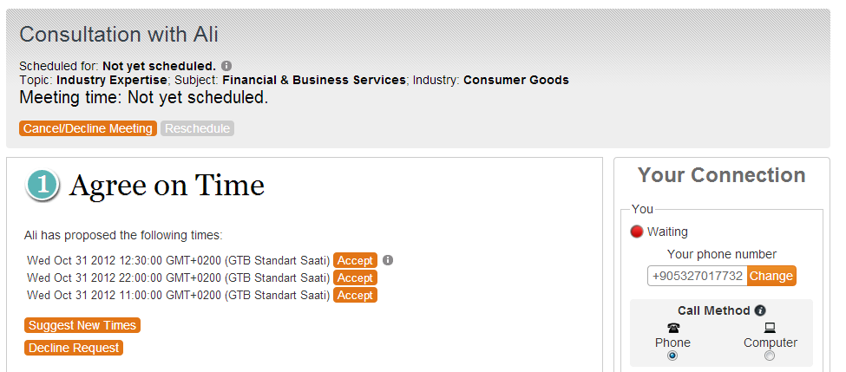
* Once the advisor accepts one of the times for the session, session status will be set to “Waiting_Payment”. This status level will wait for User to make the payment and transfer funds to buy the session
* Once the payment is made notification mail will be sent to both User and Advisor and session status will be set to “Paid”
* Once the session starts, session status will be set to “Started”.
* Once the session is complete, User will be able to rate/comment on the session. Session status will be set to “Complete”

1. **Purchase message**

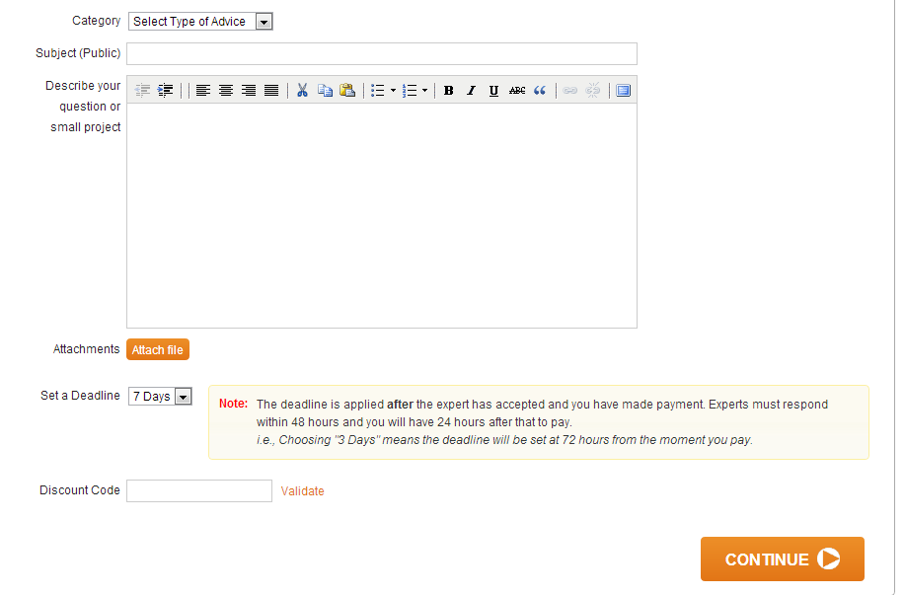

* Discount code works differently, explained in User’s Panel section
* Approval-scheduling and payment for email message consultation works with a similar concept as webcam-session
  + - Advisor reviews question/subject, accept to answer it. Then, user will be requested to make the payment. Once payment is made, Advisor will be able to respond to the question in detail.
* Will be managed from “Sessions/Messages” section in both user and advisor’s panels

1. **Products**

In this section the user can see the product created by advisor, they can view them if they are free to review or else they have to pay for buying products

Depending on the combination of files, viewing product page will have different views:

|  |  |  |  |  |
| --- | --- | --- | --- | --- |
|  | **Video** | **Audio** | **Presentation (ppt/ keynote** | **Word/Excel/PDF/Image** |
| Combination 1 | X |  |  | X (Optional) |
| Combination 2 | X |  | X | X (Optional) |
| Combination 3 |  | X | X | X (Optional) |

High level View (Will be detailed with more information to the left area) for Combination1: Video only

High level View (Will be detailed with more information to the left area) for Combination2: Video & Presentation

* Audio will be similar to video. Only difference is, an audio control area will be replacing the video section
* Video/slide control can be done in parallel and can be managed by the USER. (i.e. A user can move slides while the video is playing). User can scroll forward / back with the video as s/he pleases and can freely move forward / back in the presentation – User controls how s/he will review these documents and how
* Attached files are available for download (if selected as “available for free”. Otherwise will ask to buy the product)
* Presentation and video can not be downloaded
* A “Buy Product” button will be available at upright corner in the screen. Once the User buys the product, he/she can review all files/videos
* If a video file is selected as “available for purchased”, only the first 60 seconds of it will be displayed to users. To watch the full video, Users must buy the product
* If a presentation (power point) file is selected as “available for purchased”, only the first 3 slides of it will be displayed to users. To view the entire presentation, Users must buy the product
* Once bought, a user can have access to the product for only 10 days.
* After 10 days, product will no longer be available to the user (will need to re-purchase for another viewing)

**12. Rating system**

For each purchased service, USERS will have the option to ‘rate’ the ADVISOR (1-very bad, 5-great) and comment (max 150 characters – limitations of words used, e.g. no curse words) on their performance after the session has been completed. Each advisor will get 2 average ratings posted real-time on their profile page for USERS to see:

* Service 1: LIVE VIDEO CONFERENCE
* Service 2: VIDEO / PPT UPLOAD (NOT LIVE)
* Service 3: EMAIL CONSULTANCY
  + Average of all the 1-on-1 video conf (service 1) and email (service 3) consultancy ratings they get.
  + Average of all the video / product (service 2) ratings they get.

**The rating will be displayed as star or number.**

**Okay thanks for clarification**

**13. Payment**

* Payment concept works like freelancer.com. Users deposit money to the website, and they use their balances to purchase sessions/messages/products.
* Page SSL encrypted.
* Paypal and cards based payment methods will be accepted: Cards based: Credit Cards/Debit Cards/Prepaid Cards/Virtual Cards etc (Online POS payment).
* User will not leave the website.
* Payment system method will be direct integration (API).
* We will provide the codes provided by our bank (to handle communication with the bank).
* Once the bank responds with a “Payment Accepted” message, user’s balance will be updated.

**14. Social networking integration (Facebook and Twitter)**

For profiles and video-based consultancy, there will be social media integration: Sharing advisors and products in Facebook / Twitter will be possible. For e.g. ADVISORS will be able to share their PREVIEW videos on Facebook; USERS will be able to share and ‘Like’ and ADVISOR on their Facebook page – all such posts will include a direct link to our E-visors close webpage.