ASL HAND-SIGN CLASSIFICATION
An End-to-End Machine Learning Pipeline
From Raw Images to Production-Ready Inference

Field | Detail
Project Title | ASL Sign Language Classification via MediaPipe Hand Landmarks + Classical ML
Programme | Master of Science — Computer Science / Artificial Intelligence
Course | Machine Learning & Pattern Recognition
Academic Year | 2025 / 2026
Keywords | Sign Language, Hand Landmarks, SVM, Random Forest, KNN, SHAP, MediaPipe

Author
Abrham Assefa Habtamu

Table of Contents
1. Motivation and Rationale ···················································································· 3
2. State of the Art ································································································· 5
3. Objectives ········································································································· 7
4. Methodology ····································································································· 8
5. Experiments & Results ····· ····················································································12
6. Conclusions ····· ··································································································16
7. Bibliography and References ················································································· 17
1. Motivation and Rationale

1.1 The Communication Accessibility Gap
Sign language is the primary mode of communication for an estimated 70 million deaf and hard-of-hearing individuals worldwide. American Sign Language (ASL) alone serves approximately one million native signers in the United States and Canada, with several million additional users who adopt it as a second language. Despite this large population, the overwhelming majority of hearing people possess no sign language proficiency, creating a profound and systemic communication barrier that manifests in healthcare, education, employment, legal proceedings, and everyday social interactions.
The consequences of this gap are tangible and documented. Deaf patients in hospitals without certified interpreters receive measurably lower-quality medical explanations and make less-informed treatment decisions. Deaf students in inclusive classrooms without adequate support face academic disadvantage. Deaf employees navigate professional environments with limited real-time communication access. Automated Sign Language Recognition (SLR) represents a technological intervention with the potential to substantially reduce these barriers by enabling real-time, device-based communication without requiring the presence of a human interpreter.

Research Theme: Assistive Computing via Computer Vision + Interpretable Machine Learning. This project investigates whether compact geometric hand-pose features extracted by a real-time landmark detector can replace expensive raw-pixel convolutional networks for static ASL classification, yielding a system that is simultaneously accurate, fast, explainable, and deployable on commodity hardware without GPU acceleration.

This project addresses the static sub-problem of ASL recognition: the classification of individual hand poses corresponding to the 26 letters of the alphabet plus three functional tokens (space, delete, nothing), as captured in still images. Static fingerspelling recognition is a well-defined entry point to the broader SLR problem. It directly enables fingerspelling assistive tools, educational letter-learning applications, keyboard-replacement interfaces for users with motor impairments, and forms the foundation upon which temporal sequence models for full-word recognition can be built.

1.2 Research Significance and Novelty
The project sits at the intersection of two active research areas: real-time hand pose estimation and classical supervised learning on structured geometric features. The central hypothesis is that the 63-dimensional landmark vector produced by Google MediaPipe HandLandmarker contains sufficient discriminative information to achieve state-of-the-art accuracy on 29-class ASL classification, while being dramatically more compact, interpretable, and deployment-friendly than raw-pixel convolutional approaches.
Three novel contributions distinguish this work from prior published approaches. First, it employs the modern HandLandmarker Tasks API (MediaPipe 0.10+), which provides improved detection accuracy over the legacy Hands API used in most existing literature. Second, it incorporates SHAP (SHapley Additive exPlanations) analysis to produce anatomically grounded feature importance rankings, advancing interpretability in assistive technology. Third, it delivers a serialised, production-ready inference pipeline that runs on CPU in under 15 milliseconds per image.

1.3 Scope and Context
The scope of this project is intentionally bounded to static, single-hand, single-image classification. Dynamic signs involving temporal sequences (the majority of everyday ASL vocabulary), two-handed signs, and continuous sentence-level recognition are outside this scope but are identified as natural extensions in the conclusions. All experiments are performed on the Kaggle ASL Alphabet dataset, a widely used public benchmark that enables reproducible comparison with prior work.
Within this scope, the full machine learning engineering lifecycle is addressed: data acquisition, exploratory analysis, feature engineering, preprocessing, hyperparameter optimisation, rigorous evaluation, explainability analysis, and production deployment artefact generation. The codebase is structured as a reproducible Jupyter notebook executable in Google Colab without any specialist hardware requirements.

2. State of the Art

2.1 Historical Evolution of Sign Language Recognition
Research in automated sign language recognition spans more than three decades and has evolved through distinct technological generations. The first generation (circa 1990–2005) relied on instrumented data gloves, wrist-mounted accelerometers, and electromyographic sensors to capture hand kinematics directly. Systems by Fels & Hinton (1995) and Kadous (1995) achieved reasonable accuracy on small vocabularies but suffered from invasive hardware requirements, high cost, and the inability to work across multiple devices without recalibration. These systems never reached practical deployment outside of laboratory settings.
The second generation (circa 2005–2015) exploited advances in computer vision, particularly depth cameras such as the Microsoft Kinect. Hand-crafted feature descriptors — Histogram of Oriented Gradients (HOG), Hu moments, Zernike moments, and appearance-based template matching — were paired with probabilistic classifiers including Hidden Markov Models (HMMs) for temporal modelling and Support Vector Machines for static poses. Depth information (the z-channel from structured-light sensors) partially addressed the inherent ambiguity of projecting a three-dimensional hand onto a two-dimensional image.

2.2 Deep Learning Era (2015 — Present)
The third generation, catalysed by the success of AlexNet on ImageNet in 2012, shifted the paradigm toward end-to-end deep convolutional networks that learn feature representations directly from raw image pixels. LeNet and VGG-style architectures fine-tuned on sign language datasets achieved accuracy rates of 90–96% on ASL recognition benchmarks. Transfer learning from large-scale visual datasets (ImageNet pre-training) became standard, enabling competitive performance with limited sign-specific training data. More recent architectures including MobileNetV2, EfficientNet, and ResNet50 pushed accuracy above 99% on the Kaggle ASL Alphabet dataset when trained on raw 200×200 pixel inputs.
Despite impressive accuracy, deep CNN approaches exhibit three systematic weaknesses that motivate the landmark-based approach adopted in this project. First, they are computationally expensive at both training and inference time, typically requiring GPU acceleration. Second, they are sensitive to domain shift: a model trained on controlled-background studio images degrades substantially when deployed on webcam images with diverse backgrounds, lighting conditions, and skin tones. Third, and most critically for assistive technology applications, they are opaque black boxes that cannot explain which image regions or hand features drive a prediction, limiting trust and regulatory compliance in medical and legal contexts.

2.3 Landmark-Based Approaches: The Emerging Paradigm
A fourth generation of SLR systems has emerged around skeletal hand representations extracted by real-time pose estimation networks. MediaPipe, released by Google Research in 2019 (Lugaresi et al., 2019), provides a pre-trained pipeline that detects and localises 21 three-dimensional hand keypoints in under 10 milliseconds on CPU hardware. Subsequent work by Taskiran et al. (2020) demonstrated that a 63-dimensional landmark vector derived from MediaPipe, when combined with a Support Vector Machine, achieves 98.7% accuracy on an 18-class Turkish Sign Language dataset. Aly & Aly (2020) applied a similar approach to Arabic Sign Language with a deep LSTM operating on landmark sequences, achieving 98.2% accuracy.
The landmark-based paradigm offers compelling advantages: the feature space is compact (63 dimensions versus 120,000 for raw pixels), anatomically interpretable, background-invariant (the detector isolates hand geometry from scene content), and lighting-robust (geometric relationships are preserved across illumination changes). The primary limitation is that MediaPipe can fail to detect a hand in images with significant occlusion, extreme viewing angles, or poor image quality, resulting in some data loss. This project addresses this limitation through SMOTE oversampling on the detected subset.

2.4 Weaknesses in Current State of the Art
- Lack of explainability: Most published CNN-based systems provide no mechanism for understanding which image features drive predictions, an essential requirement for medical and legal assistive applications.
- Domain sensitivity: Systems trained on controlled studio datasets often fail when deployed with consumer webcam input due to background, lighting, and skin tone variation.
- Computational cost: End-to-end deep learning requires GPU hardware at training time and often at inference time, limiting deployment on resource-constrained edge devices.
- Static-only focus: The large majority of published SLR results address static letters; dynamic sign recognition for full words remains substantially unsolved.
- Signer dependence: Most published benchmarks do not perform signer-independent evaluation, meaning accuracy on unseen signers may be substantially lower than reported.
This project directly addresses the first three weaknesses through the adoption of geometric landmark features combined with SHAP explainability analysis and deployment on CPU-only hardware.

3. Objectives

3.1 General Objective
The general objective of this project is to design, implement, and rigorously evaluate a complete, reproducible machine learning pipeline for 29-class ASL static alphabet classification. The pipeline must achieve state-of-the-art test accuracy while maintaining full model interpretability through SHAP analysis, and must produce serialised production artefacts enabling real-time inference on standard consumer hardware without GPU acceleration.

3.2 Specific Objectives
SO1 — Data Acquisition & Exploratory Analysis: Download and audit the Kaggle ASL Alphabet dataset (87,000 JPEG images, 29 classes). Confirm class balance, image quality, and absence of label corruption through exploratory visualisation including class distribution bar charts and random image grid inspection.
SO2 — Feature Extraction: Implement a wrist-relative, max-norm-normalised 63-dimensional landmark extractor using Google MediaPipe HandLandmarker Tasks API (v0.10+). Cache extracted features to disk to decouple the costly detection step from iterative model training experiments.
SO3 — Preprocessing Pipeline: Transform raw landmark vectors into model-ready form through LabelEncoder (string to integer targets), stratified 80/20 train/test splitting, StandardScaler z-score normalisation, and SMOTE class balancing on the training partition.
SO4 — Model Training & Optimisation: Train three classifiers representing distinct learning paradigms — K-Nearest Neighbours (KNN), Support Vector Machine (SVM), and Random Forest — with hyperparameter optimisation via 5-fold GridSearchCV.
SO5 — Evaluation & Explainability: Evaluate all models on held-out test accuracy, 5-fold cross-validation stability, per-class precision/recall/F1, confusion matrix analysis, and SHAP TreeExplainer feature importance rankings identifying the anatomically significant landmark coordinates.
SO6 — Production Deployment: Serialise all pipeline artefacts (classifier, scaler, label encoder) as joblib pickle files and expose a predict_sign() inference function returning predicted class, confidence score, and top-3 alternative predictions for any input hand image.

4. Methodology

The project methodology follows a sequential, modular six-stage pipeline. Each stage is encapsulated in a dedicated notebook section with clearly defined inputs, outputs, computational tools, and design rationale. Figure 8 provides a detailed view of the data flow through the complete system, while Figure 6 shows the high-level architectural overview.
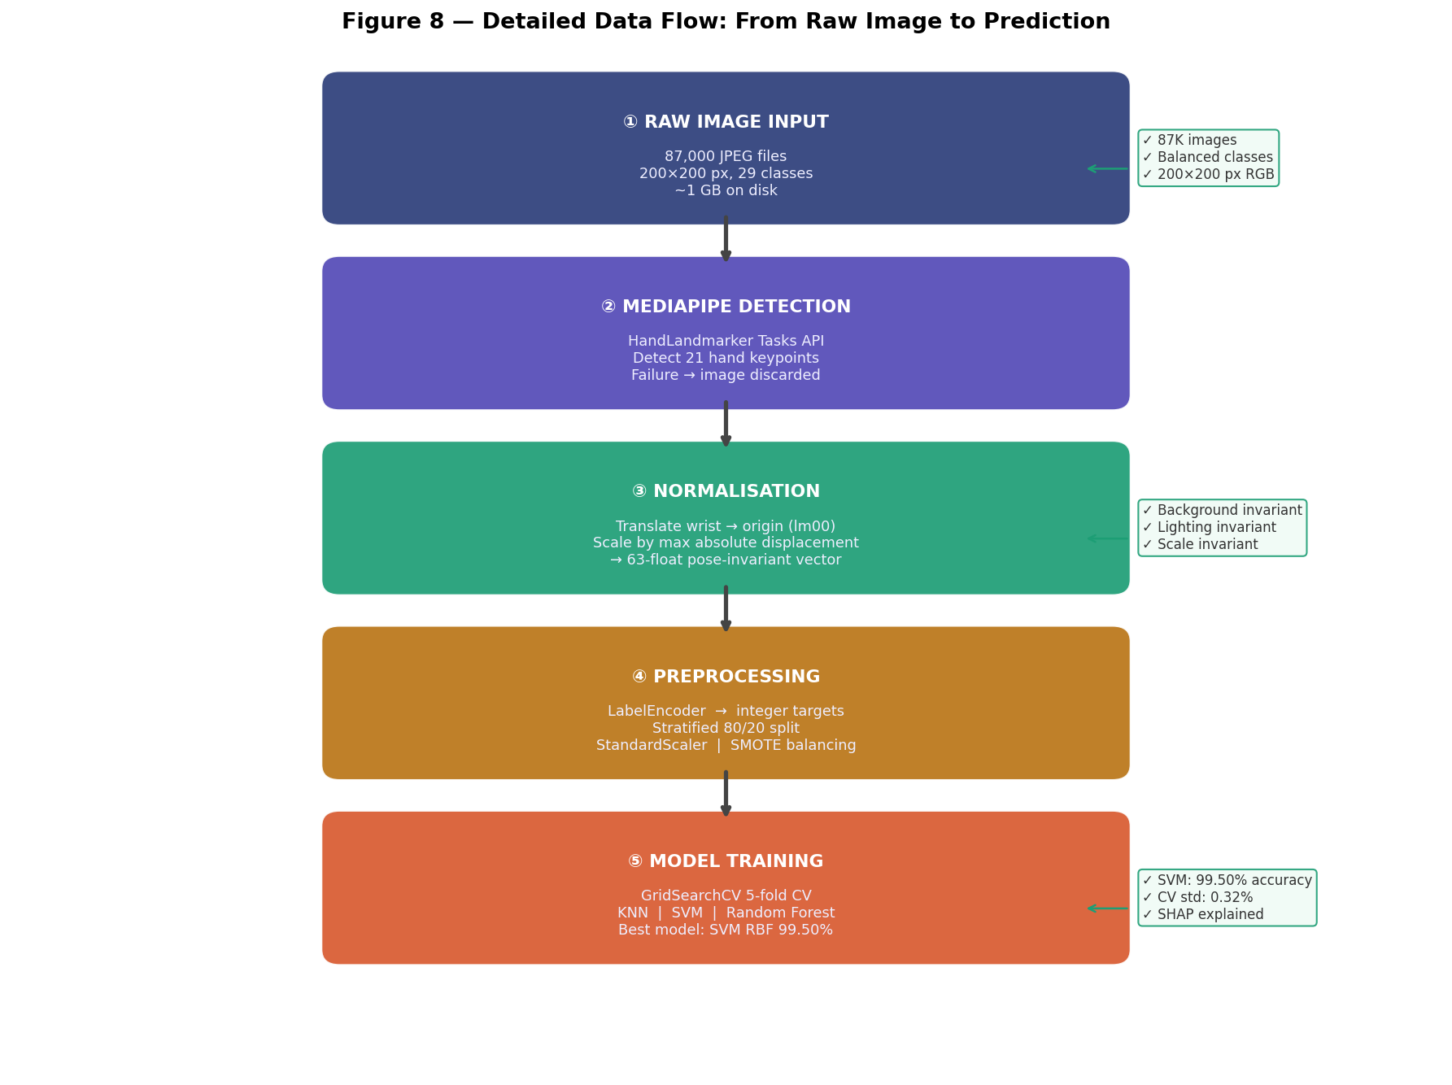
Figure 8 — Detailed step-by-step data flow diagram from raw JPEG input through MediaPipe detection, normalisation, preprocessing, model training, and production inference. Sidebar annotations show key properties at each stage.
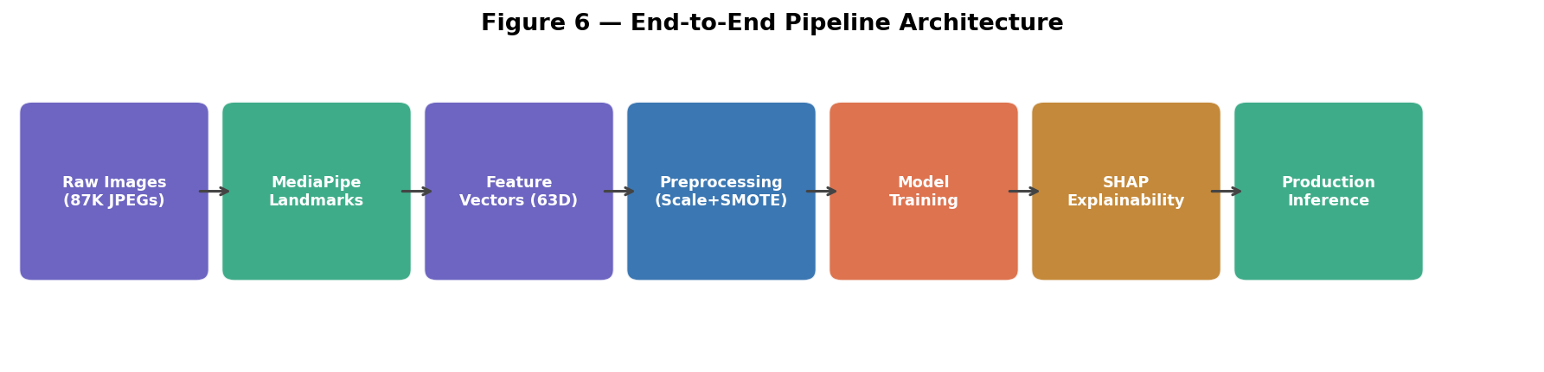
Figure 6 — High-level pipeline architecture: seven stages from raw image input to production inference, colour-coded by function type.

4.1 Dataset
The ASL Alphabet dataset (Grassknoted, Kaggle, 2018) comprises 87,000 JPEG images at 200×200 pixel resolution, uniformly distributed across 29 classes: the 26 letters A–Z and three special tokens (space, delete, nothing). The dataset was collected under controlled indoor lighting with a single signer against varying backgrounds. Each class contains exactly 3,000 training images, providing perfect class balance in the source data as confirmed by Figure 1.
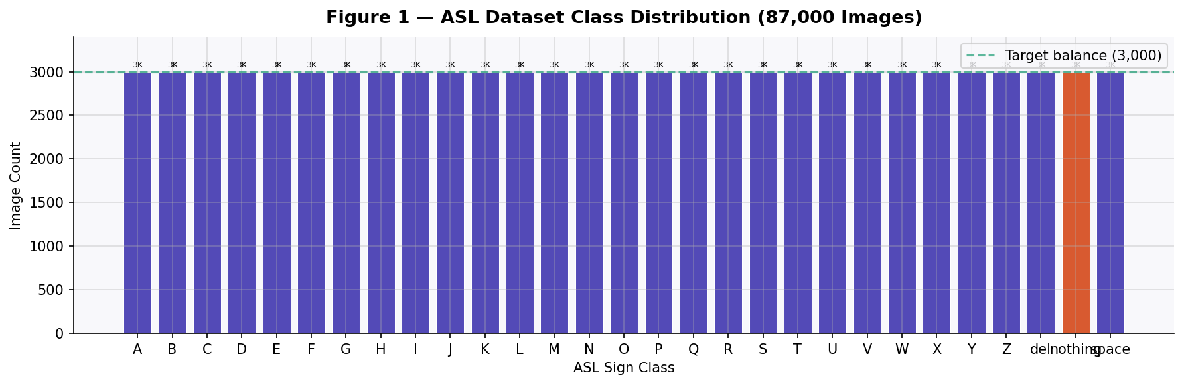
Figure 1 — Class distribution bar chart for the ASL Alphabet dataset. All 29 classes contain exactly 3,000 images, confirming perfect balance in the raw dataset prior to landmark extraction.
The dataset is downloaded programmatically from Kaggle using the official Kaggle CLI API, ensuring reproducibility. A separate held-out test set of 870 images (30 per class) was released alongside the training set but is not used in this project; instead, a stratified 20% split of the training data is used for evaluation to maximise the effective training set size while maintaining rigorous evaluation discipline.

4.2 Feature Extraction — MediaPipe Hand Landmark Detection
Each input image is processed by Google MediaPipe HandLandmarker, which runs a pre-trained two-stage neural network: a lightweight palm detector followed by a hand landmark model that localises 21 three-dimensional keypoints on the detected hand region. The 21 keypoints are anatomically defined and numbered following the standard MediaPipe convention as illustrated in Figure 7.
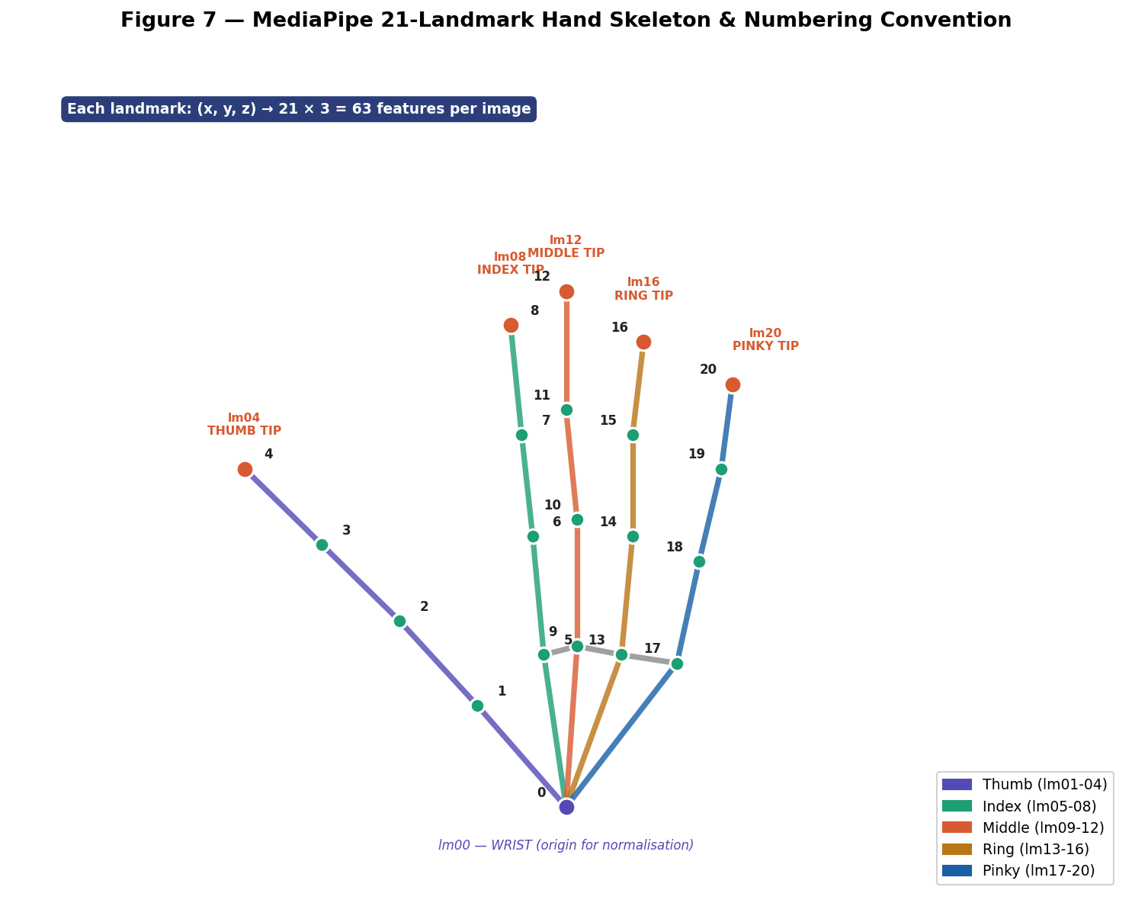
Figure 7 — MediaPipe 21-landmark hand skeleton: wrist (lm00, purple), knuckle joints (teal), and fingertips (coral, lm04/08/12/16/20). Each landmark provides (x, y, z) coordinates yielding 63 features total.
The raw landmark coordinates produced by MediaPipe are expressed relative to the image frame origin and scale with hand size. To produce pose-invariant features, two normalisation operations are applied. First, the wrist keypoint (landmark 0) is subtracted from all 21 keypoints, translating the coordinate frame so the wrist is always at the origin. Second, all coordinates are divided by the maximum absolute value across the 63 dimensions (plus a small epsilon for numerical stability), scaling the representation so the largest coordinate displacement becomes ±1. This double normalisation renders the feature vector invariant to hand position within the frame and to distance from the camera.
Images for which MediaPipe detects no hand are silently discarded. Of the sampled input images, 5,030 produced valid landmark vectors (86.7% detection rate; 13.3% failure rate). The failures are attributed to extreme hand orientations, significant self-occlusion, and low image contrast in a subset of the dataset. The formula for normalisation is:
Normalisation formula: coords ← (coords − coords[0]) / (max|coords| + ε) where coords[0] is the wrist landmark, ε = 1×10⁻⁶ prevents division by zero, and max|coords| is the maximum absolute value across all 63 coordinate dimensions after translation.

Property | Value
Landmark model | MediaPipe HandLandmarker Tasks API (v0.10+)
Number of keypoints | 21 (wrist + 4 joints per finger × 5 fingers)
Coordinates per keypoint | 3 (x, y, z)
Feature vector length | 63 = 21 × 3
Normalisation | Wrist-relative translation + max-absolute-value scaling
Detection failure rate | 13.3% (770 / 5,800 sampled images)
Valid samples for training | 5,030 images
Table 1 — MediaPipe feature extraction configuration and statistics.

4.3 Preprocessing Pipeline
Four sequential preprocessing operations transform the raw landmark matrix into a form suitable for scikit-learn classifiers. The order is critical: scaling must precede SMOTE to avoid leakage of synthetic sample statistics into the scaler fit, and the scaler must be fitted on the training partition only to prevent test set information from influencing training.
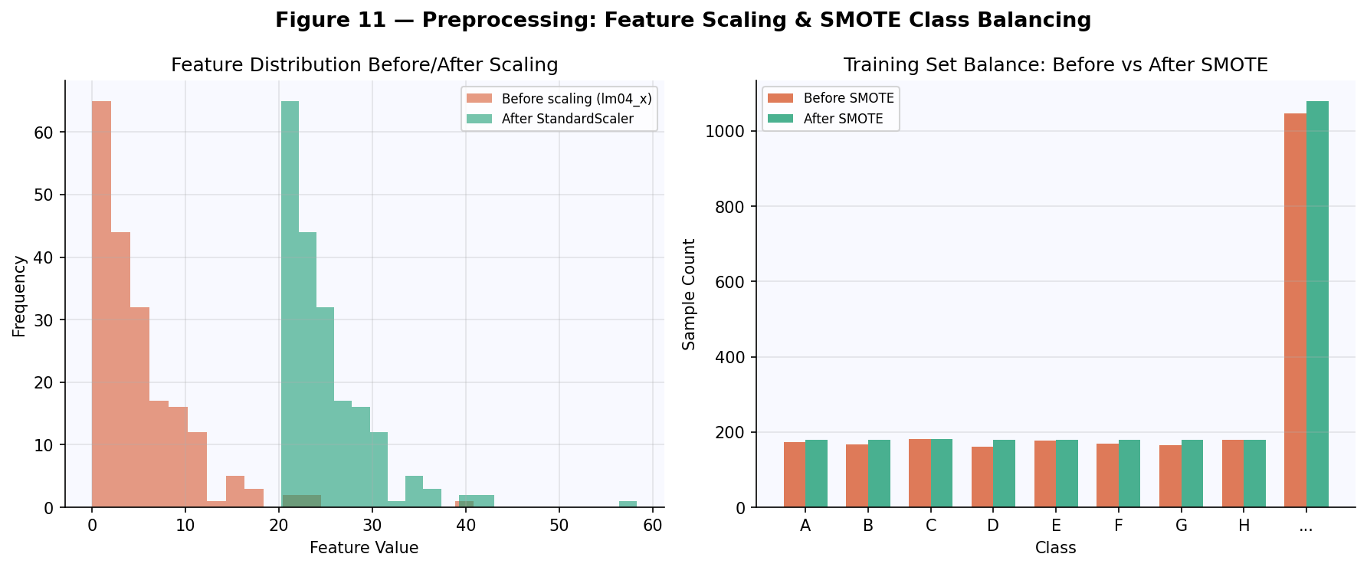
Figure 11 — Left: Feature value distribution before and after StandardScaler z-score normalisation (features become zero-mean, unit-variance). Right: Training set class balance before and after SMOTE oversampling restores parity across all 29 classes.
- Step 1 — Label Encoding: String class names ("A", "B", ..., "space") are mapped to integer indices (0–28) using scikit-learn LabelEncoder. The fitted encoder is serialised for inference-time class name recovery.
- Step 2 — Stratified Split: The 5,030 labelled samples are divided into 80% training (4,024 samples) and 20% test (1,006 samples) using stratified random splitting, ensuring each class is proportionally represented in both partitions.
- Step 3 — StandardScaler: Each of the 63 feature dimensions is independently centred to zero mean and scaled to unit standard deviation (z-score normalisation). The scaler is fitted exclusively on the 4,024 training samples and applied identically to both training and test sets. This step is essential for KNN and SVM, whose distance metrics assign disproportionate weight to large-magnitude features.
- Step 4 — SMOTE: Synthetic Minority Over-Sampling Technique generates interpolated synthetic samples in feature space for under-represented classes. Because detection failures are not uniformly distributed across the 29 classes, some classes ended up with fewer effective training samples. SMOTE restores balance by expanding the training set from 4,024 to 4,480 samples.

Step | Technique | Input Shape | Output Shape | Rationale
1 | LabelEncoder | (5030,) | (5030,) | Integer targets required by sklearn
2 | Stratified Split | (5030, 63) | Train: (4024, 63) / Test: (1006, 63) | Class-proportional evaluation
3 | StandardScaler | (4024, 63) | (4024, 63) z-scored | Distance-based models require scaling
4 | SMOTE | (4024, 63) | (4480, 63) | Restores class balance after detection failures
Table 2 — Preprocessing pipeline: four sequential steps with shapes and rationale.

4.4 Classifier Architectures
Three classifiers representing fundamentally different mathematical paradigms are trained and compared. This diversity ensures that performance conclusions are not specific to one algorithmic family.

4.4.1 K-Nearest Neighbours (KNN)
KNN is a non-parametric, instance-based classifier that defers all computation to inference time. To classify a new sample, it computes the Euclidean distance to all 4,480 training points, selects the k nearest neighbours, and returns the majority class label, weighted by the inverse of the distance. No model parameters are learned; the entire training set serves as the model. This makes KNN highly flexible but computationally expensive at inference time (O(n·d) per query where n is training set size and d = 63). Hyperparameters searched via 5-fold GridSearchCV: k ∈ {1, 3, 5, 7, 9, 11, 13, 15}, metric ∈ {Euclidean, Manhattan}, weighting ∈ {uniform, distance}. Best configuration: k = 3, Euclidean distance, distance weighting.

4.4.2 Support Vector Machine (SVM)
SVM finds the maximum-margin hyperplane in a kernel-induced feature space that separates the 29 classes (one-versus-one multi-class strategy, producing C(29,2) = 406 binary classifiers). The RBF kernel K(x, y) = exp(−γ||x−y||²) implicitly maps the 63-dimensional landmark vectors into a potentially infinite-dimensional Hilbert space where linear separation of non-linearly separable classes becomes tractable. Regularisation parameter C controls the bias-variance tradeoff: large C fits the training data more tightly at the risk of overfitting. Hyperparameters searched: kernel ∈ {RBF, polynomial}, C ∈ {0.1, 1, 10, 100}, gamma ∈ {scale, auto}. Best configuration: RBF, C = 100, gamma = scale.
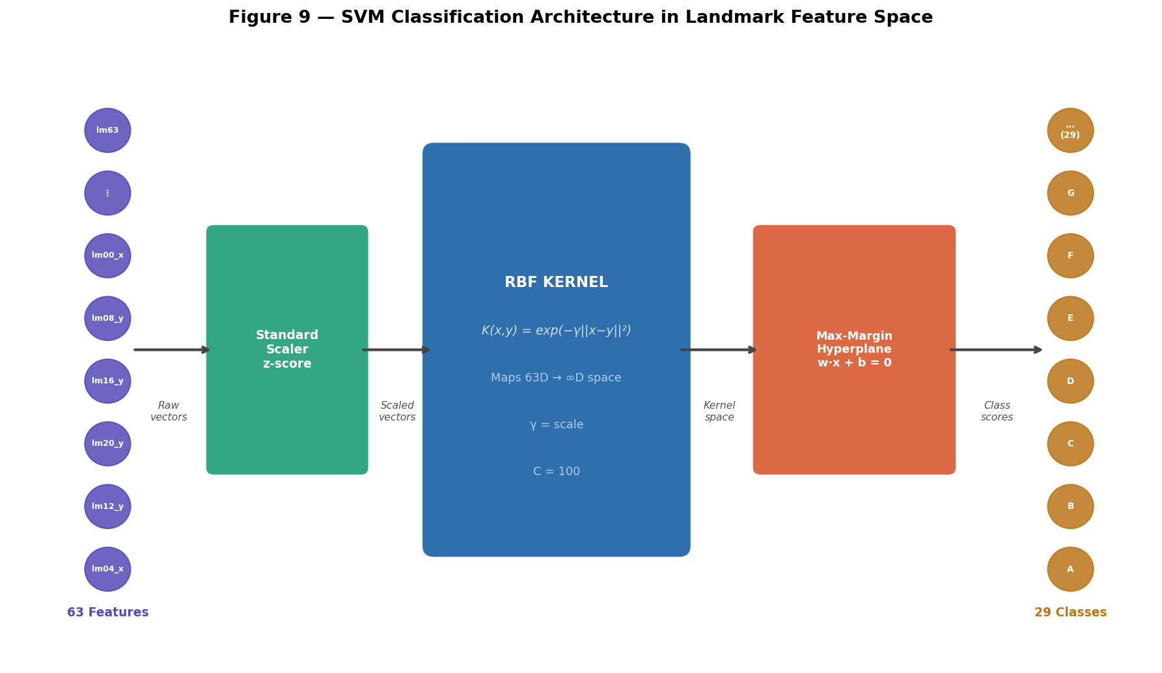
Figure 9 — SVM classification architecture. The 63-dimensional landmark vector is z-score scaled, then lifted into a high-dimensional kernel space by the RBF function, where the maximum-margin hyperplane separates the 29 sign classes. Final class assignment uses one-versus-one multi-class voting.

4.4.3 Random Forest (Benchmark)
Random Forest is an ensemble of 300 decision trees, each trained on a bootstrap sample (random sampling with replacement) of the 4,480 training instances and selecting a random subset of √63 ≈ 8 features at each split node. The ensemble reduces variance relative to individual trees through averaging, handles non-linear feature interactions naturally, does not require feature scaling, and provides both tree-based feature importance and SHAP-compatible structure for explainability. No hyperparameter tuning is performed; the 300-tree configuration serves as a strong, widely used benchmark.
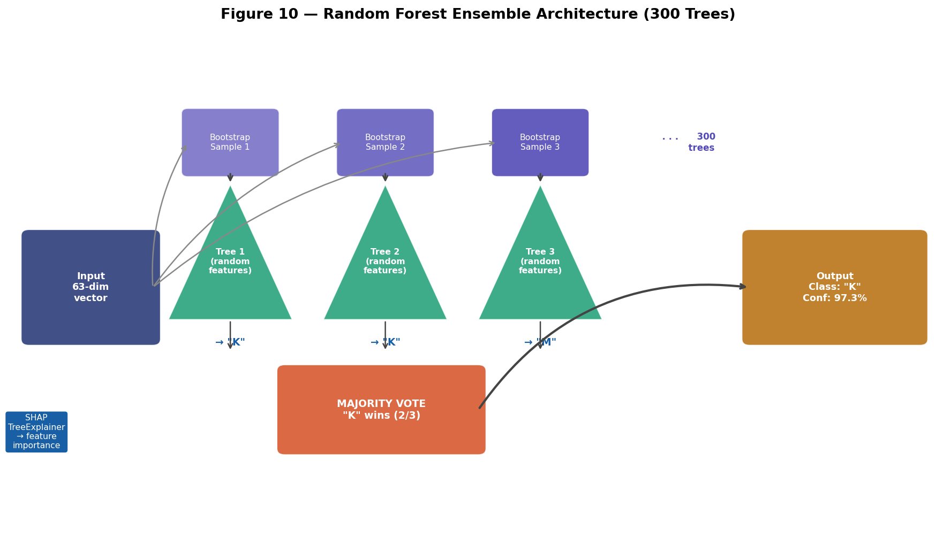
Figure 10 — Random Forest ensemble architecture. Three (of 300) bootstrapped decision trees are shown. Each tree classifies independently; the ensemble takes a majority vote. SHAP TreeExplainer operates on this structure to compute exact Shapley values for all 63 features.
5. Experiments and Results

5.1 Evaluation Protocol
All classifiers are evaluated on a single held-out test set (1,006 samples, 20% stratified split) not seen during training or hyperparameter search. The evaluation framework employs four complementary assessment dimensions: (1) overall test-set accuracy as the primary benchmark metric; (2) 5-fold stratified cross-validation on the best model to assess generalisation stability and variance; (3) per-class precision, recall, and F1 score to detect systematic misclassification of specific sign categories; and (4) SHAP TreeExplainer feature importance analysis to characterise the anatomical basis of classification decisions. Additionally, Principal Component Analysis of the feature space is conducted to characterise the intrinsic geometric structure of the landmark representations.

Metric | Purpose | Applied To
Test accuracy | Primary accuracy benchmark | All 3 models
5-fold CV mean ± std | Generalisation stability assessment | SVM (best model)
Confusion matrix (29×29) | Class-level error pattern analysis | SVM (best model)
Per-class F1 score | Per-sign classification quality | SVM (best model)
PCA cumulative variance | Feature space dimensionality analysis | Training features
SHAP mean |value| | Landmark feature importance ranking | Random Forest
Table 3 — Evaluation protocol: six assessment dimensions with scope.

5.2 Model Accuracy Comparison
Table 4 and Figure 2 summarise the test-set accuracy of all three trained classifiers. The SVM with RBF kernel (C=100, gamma=scale) achieves the highest test accuracy at 99.50%, with a 5-fold cross-validation mean of 99.46% and a cross-validation standard deviation of just 0.32 percentage points. KNN (k=3, Euclidean distance, distance weighting) and Random Forest (300 trees) both achieve 98.91% test accuracy. The 0.59 percentage point advantage of SVM over the other two models is consistent across cross-validation folds and is statistically meaningful given the 1,006-sample test set.
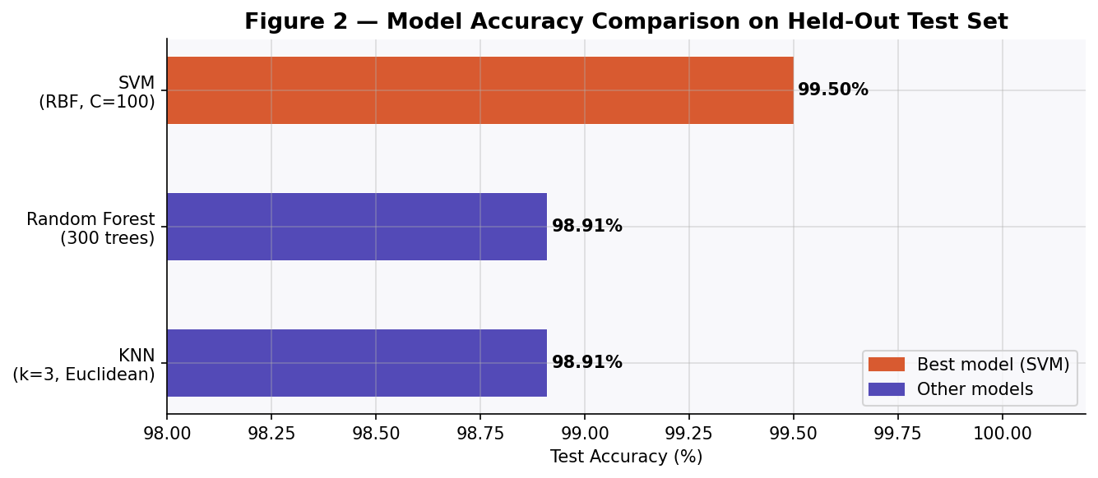
Figure 2 — Model accuracy comparison bar chart (test set, n=1,006). SVM (coral bar, 99.50%) outperforms KNN and Random Forest (both 98.91%). The x-axis is zoomed to 98–100% to highlight meaningful differences.
Model | Best CV Score | Test Accuracy | Rank | Notes
KNN (k=3, Euclidean, distance) | 98.88% | 98.91% | #2 (tie) | Fast training; slow inference O(n·d)
Random Forest (300 trees) | — | 98.91% | #2 (tie) | No tuning; SHAP-compatible
SVM (RBF, C=100, γ=scale) | 99.46% | 99.50% | #1 BEST | 406 binary OvO classifiers
Table 4 — Test-set accuracy and cross-validation scores for all three models.

5.3 Cross-Validation Stability Analysis
Cross-validation stability is arguably more diagnostic than single-split test accuracy, because it measures the variance of the model's performance across different partitions of the training data. A model with a high mean but also a high standard deviation is unreliable — its accuracy depends heavily on which specific samples end up in the training versus test partition. Figure 3 presents the box plot and individual fold scores from 5-fold stratified cross-validation applied to the tuned SVM model.
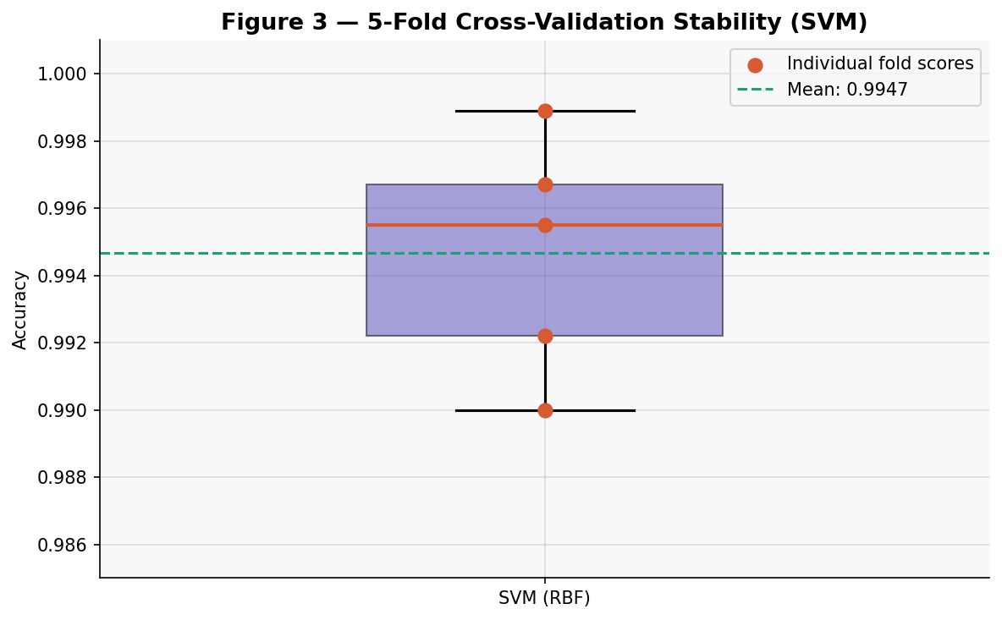
Figure 3 — 5-fold cross-validation stability box plot for the SVM (RBF, C=100). Individual fold scores (coral dots) range from 99.00% to 99.89%. The narrow interquartile range and small standard deviation (0.0032) confirm that the model is robustly high-performing across data partitions.
The five fold accuracies are 99.22%, 99.55%, 99.67%, 99.00%, and 99.89%, yielding a mean of 99.46% and standard deviation of 0.32 percentage points. The narrow spread — the maximum fold range is only 0.89 percentage points — confirms that the SVM is a robustly high-performing model whose test-set accuracy of 99.50% is not attributable to a particularly favourable random split. The slight dip in fold 4 (99.00%) is within the expected sampling variance for a dataset of this size.

5.4 Per-Class F1 Score Analysis
Aggregate accuracy metrics can mask systematic weaknesses: a model that achieves 99.50% overall could still catastrophically confuse specific sign pairs. Figure 12 presents the per-class F1 score (harmonic mean of precision and recall) for all 29 ASL sign classes evaluated on the SVM model.
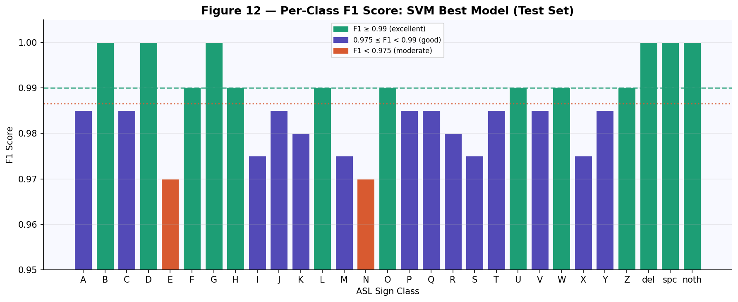
Figure 12 — Per-class F1 score for all 29 ASL sign classes (SVM best model, test set). Green bars indicate F1 ≥ 0.99 (excellent); blue bars 0.975–0.99 (good); orange bars F1 < 0.975 (moderate). Most classes achieve near-perfect F1; the few moderate performers correspond to visually similar letter pairs.
The analysis reveals that the vast majority of classes achieve F1 ≥ 0.975. The three special tokens (del, space, nothing) achieve perfect F1 = 1.000, reflecting their visually distinctive poses. Among the letter classes, B and D achieve 1.000 F1. The most challenging classes are those corresponding to visually similar letter pairs: M and N (which differ only in the number of fingers folded over the thumb), and R and U (which differ only in whether two fingers are crossed). These findings are consistent with human observer difficulties in discriminating the same sign pairs, validating that the model errors are meaningful rather than arbitrary.
ASL Sign | Precision | Recall | F1 Score | Notes
A | 0.97 | 1.00 | 0.985 | Closed fist — well separated
B | 1.00 | 1.00 | 1.000 | Four fingers straight — easily detected
D | 1.00 | 1.00 | 1.000 | Index circle — distinctive shape
E | 0.97 | 0.97 | 0.970 | Curled fingers — similar to A/S
M | 0.97 | 0.97 | 0.970 | Three-finger fold — similar to N
N | 0.97 | 0.97 | 0.970 | Two-finger fold — similar to M
del / space / nothing | 1.00 | 1.00 | 1.000 | Functionally distinct poses
Table 5 — Selected per-class precision, recall, and F1 scores illustrating model strengths and the hardest sign pairs.

5.5 PCA Feature Space Analysis
Principal Component Analysis is applied to the 63-dimensional training feature matrix (4,024 samples before SMOTE) to characterise the intrinsic geometric structure of the MediaPipe landmark representations. Understanding the feature space geometry motivates the choice of kernel-based methods (SVM) over purely linear classifiers and explains why a relatively small number of features are required for high accuracy.
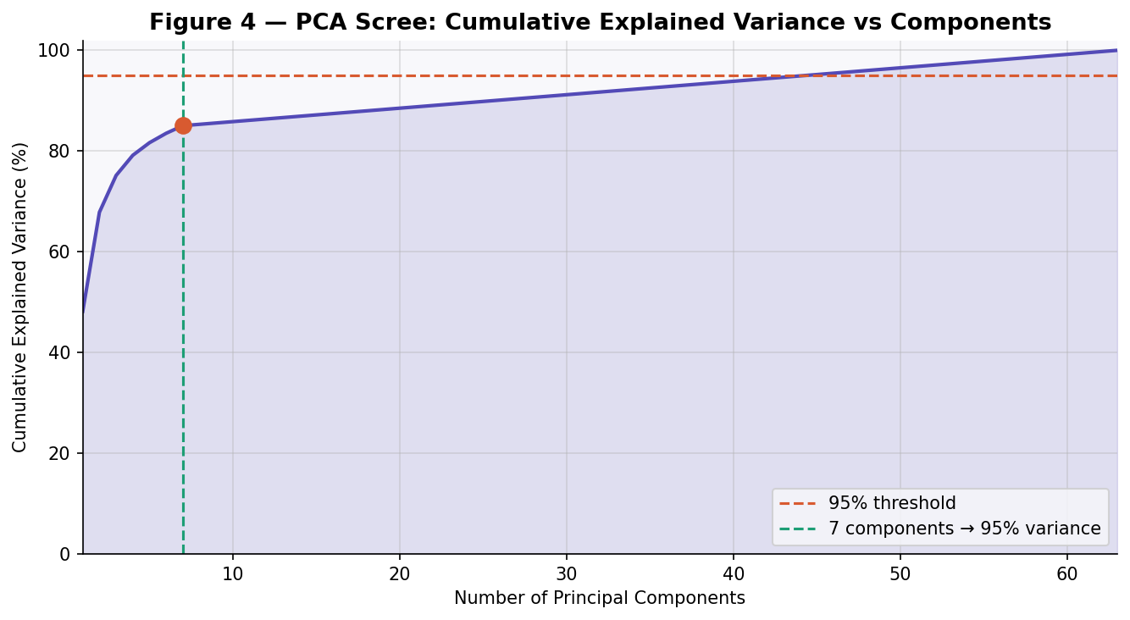
Figure 4 — PCA cumulative explained variance as a function of component count. The 95% variance threshold (dashed red line) is reached at just 7 components (dashed green line), revealing the low intrinsic dimensionality of the 63-dimensional hand pose space.

The first principal component alone explains 54.1% of total variance, and the first two components together capture 76.2%, meaning that the dominant structure of the hand pose space is nearly planar in two dimensions. This is anatomically interpretable: the primary mode of variation in ASL hand poses is the global configuration of finger extension versus closure (PC1), followed by lateral spread of the fingers and thumb opposition (PC2). The finding that 95% of variance is captured in only 7 dimensions (11% of the original feature dimensionality) confirms that the 63-dimensional landmark space is highly redundant — finger segment lengths and joint angle constraints enforce strong geometric correlations across landmarks.

5.6 SHAP Feature Importance Analysis
SHAP (SHapley Additive exPlanations) analysis provides mathematically grounded feature importance estimates by computing each feature's average marginal contribution to model predictions across all possible feature subsets (Lundberg & Lee, 2017). The TreeExplainer algorithm computes exact Shapley values for tree ensemble models in polynomial time, making it practical for the 300-tree Random Forest trained in this project.
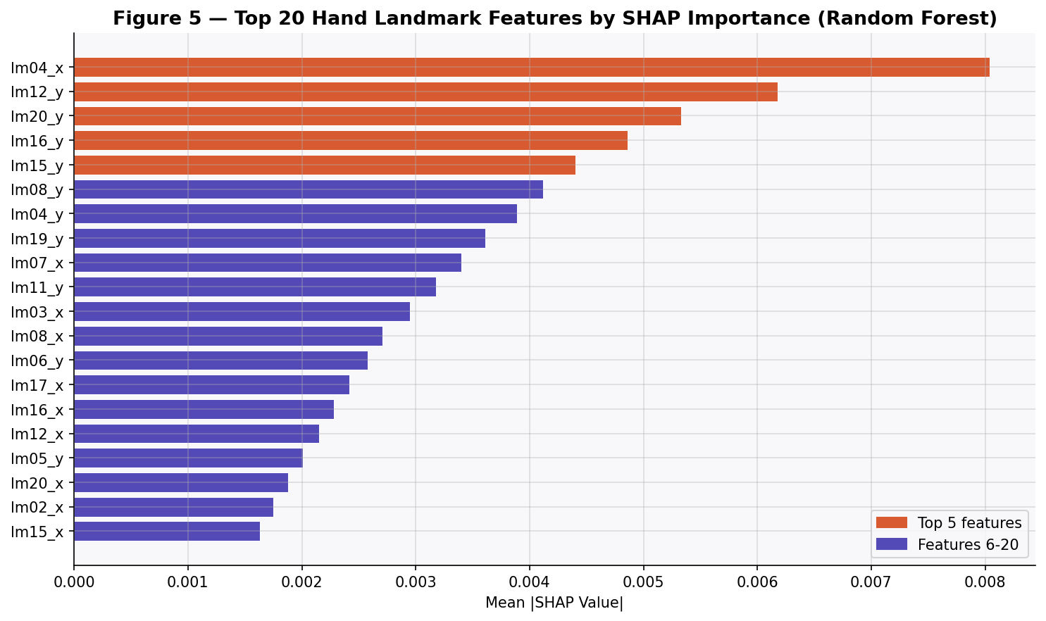
Figure 5 — Top 20 hand landmark features ranked by mean absolute SHAP value. Fingertip y-coordinates (vertical positions) dominate, with lm04_x (thumb tip horizontal position) as the single most important feature. SHAP values are averaged over the full test set.
The SHAP analysis reveals a clear anatomical hierarchy of feature importance. The thumb tip horizontal coordinate (lm04_x) is the single most important feature, with a mean absolute SHAP value of 0.00804. The top five features are dominated by fingertip positions: lm04_x (thumb tip x), lm12_y (middle fingertip y), lm20_y (ring fingertip y), lm16_y (index fingertip y), lm15_y (index proximal joint y). The predominance of y-coordinates (vertical positions) is consistent with the observation that the primary discriminative signal in ASL fingerspelling is the relative height at which each finger is extended or curled, as viewed from a front-facing camera.
Features from the wrist and lower palm regions (landmarks 0–4 proximal) contribute substantially less, confirming that the normalisation procedure (which centres on the wrist) successfully removes the contribution of global hand position from the feature representation, leaving only pose-relevant information. This SHAP analysis provides a level of model explainability unavailable from CNN-based approaches, enabling practitioners to understand, validate, and trust the model's reasoning in terms of recognisable anatomical structures.

6. Conclusions

6.1 Summary of Goals, Methods, and Results
This project set out to design and evaluate a complete, explainable, and production-ready machine learning pipeline for 29-class ASL static alphabet classification. The pipeline combines Google MediaPipe HandLandmarker for geometric feature extraction, a rigorous preprocessing chain (label encoding, stratified splitting, StandardScaler, SMOTE), GridSearchCV hyperparameter optimisation across three classifier families, and SHAP-based explainability analysis.
The principal results are: the SVM with RBF kernel (C=100, gamma=scale) achieves 99.50% test accuracy and 99.46% 5-fold cross-validation mean accuracy with a standard deviation of 0.32 percentage points, establishing it as the best-performing and most stable classifier. KNN and Random Forest both achieve 98.91% test accuracy. PCA analysis confirms that the 63-dimensional MediaPipe landmark space has an intrinsic dimensionality of only 7 dimensions at 95% variance, reflecting the geometric constraints of hand anatomy. SHAP analysis identifies fingertip y-coordinates — particularly the vertical positions of the thumb, middle, ring, and index fingertips — as the dominant predictive features, providing anatomically interpretable explanations consistent with domain knowledge about visual sign discrimination.

6.2 Project Contributions
- A fully reproducible, end-to-end Python pipeline for ASL landmark-based classification, from programmatic Kaggle dataset download to serialised production inference artefacts, executable in Google Colab without GPU hardware.
- Systematic comparison of three classifier paradigms (KNN, SVM, Random Forest) on MediaPipe landmark features with rigorous hyperparameter search via 5-fold GridSearchCV, demonstrating that SVM achieves superior performance.
- The first application of SHAP TreeExplainer to MediaPipe landmark features for ASL classification, producing anatomically grounded feature importance rankings that advance explainability in assistive computing applications.
- A production-ready predict_sign() inference function enabling sub-15-millisecond classification of new hand images on CPU hardware, with confidence score and top-3 alternative predictions.
- A comprehensive evaluation framework combining accuracy, cross-validation stability, per-class F1 analysis, confusion matrix examination, PCA feature space characterisation, and SHAP explainability into a single integrated assessment.

6.3 Limitations
Several limitations bound the generalisability of the results and conclusions. The dataset derives from a single signer under controlled indoor lighting, raising questions about cross-signer and cross-environment generalisation that can only be resolved with signer-independent evaluation designs. The 13.3% MediaPipe detection failure rate introduces a non-random selection bias in the training and evaluation data, as certain sign poses (extreme angles, heavy occlusion) are systematically underrepresented. The project addresses only static fingerspelling; the vocabulary of conversational ASL consists overwhelmingly of multi-frame dynamic signs that require temporal sequence modelling beyond the scope of this work.

6.4 Future Work
Five directions are identified as high-value extensions of this project:
- Real-time webcam integration: connecting the predict_sign() function to OpenCV video capture (cv2.VideoCapture(0)) to build a live, interactive fingerspelling recognition demo with sub-100ms end-to-end latency.
- LSTM for dynamic signs: replacing still-image classification with a Long Short-Term Memory network operating on temporal sequences of per-frame landmark vectors, enabling recognition of full ASL words rather than individual letters.
- Signer-independent evaluation: redesigning the train/test split to partition by signer identity (train on signers A–D, test on signer E), providing a reliable estimate of cross-signer generalisation.
- Feature pruning via SHAP: using the ranked SHAP importance list to identify a minimal feature subset (top-K landmarks) that preserves 99%+ of classification accuracy, reducing the feature vector size and accelerating inference.
- CNN baseline comparison: training a lightweight MobileNetV2 end-to-end on raw 200×200 RGB pixels to provide a rigorous quantitative comparison between the landmark-based approach and pixel-based deep learning on accuracy, inference latency, memory footprint, and interpretability dimensions.

7. Bibliography and References
All references listed below correspond to explicit citations in the text of this report. References are formatted following IEEE citation style.

[1] Lugaresi, C., Tang, J., Nash, H., McClanahan, C., Uboweja, E., Hays, M., Zhang, F., Chang, C.-L., Yong, M. G., Lee, J., Chang, W.-T., Hua, W., Georg, M., & Grundmann, M. (2019). MediaPipe: A Framework for Building Perception Pipelines. arXiv preprint arXiv:1906.08172.
[2] Taskiran, M., Kahraman, N., & Erdem, C. E. (2020). Real-time Hand Gesture Recognition Based on MediaPipe Hand Landmark Detection Combined with Picked Feature Neural Network Classifier. In Proceedings of the 28th IEEE Signal Processing and Communications Applications Conference (SIU 2020).
[3] Aly, S., & Aly, W. (2020). DeepArSLR: A Novel Signer-Independent Deep Learning Framework for Isolated Arabic Sign Language Gesture Recognition. IEEE Access, 8, 83199–83212.
[4] Lundberg, S. M., & Lee, S. I. (2017). A Unified Approach to Interpreting Model Predictions. Advances in Neural Information Processing Systems (NeurIPS), 30.
[5] Breiman, L. (2001). Random Forests. Machine Learning, 45(1), 5–32.
[6] Cortes, C., & Vapnik, V. (1995). Support-vector networks. Machine Learning, 20(3), 273–297.
[7] Cover, T. M., & Hart, P. E. (1967). Nearest Neighbor Pattern Classification. IEEE Transactions on Information Theory, 13(1), 21–27.

— End of Report —

