UNIVERSITY OF VERONA
Department of Computer Science
Detecting AI-Generated Faces:
Real vs Synthetic Image Classification
Project Proposal & Technical Report
Master's Degree in Artificial Intelligence
Courses: Computer Vision & Deep Learning
Academic Year 2025/2026
Author
Abrham Assefa Habtamu
Supervisors: Prof. V. Murino · Prof. C. Beyan · G. Lucato · F. Dibitonto

Index
Index 2
1. Motivation and Rationale 3
2. State of the Art 4
2.1 CNN- and Transformer-based classifiers 4
2.2 Frequency-domain cues 4
2.3 Open weaknesses this project tries to address 4
3. Objectives 6
3.1 General objective 6
3.2 Specific objectives 6
4. Methodology 7
4.1 Dataset 7
4.2 Pre-processing and data augmentation 7
4.3 Frequency-domain analysis 7
4.4 Face-region segmentation (U-Net) 8
4.5 Classification models 8
4.6 Self-supervised pre-training (SimCLR) 8
4.7 Domain adaptation (DANN) 9
4.8 Explainability 9
4.9 Tools 10
5. Experiments and Results 10
5.1 Evaluation protocol 10
5.2 Training behaviour 10
5.3 Final performance 11
5.4 Confusion matrices and ROC analysis 12
5.5 Ablation study 13
5.6 Self-supervised learning results 13
5.7 Domain adaptation results 13
5.8 Qualitative checks: misclassifications and Grad-CAM 13
5.9 Deployment sketch 14
6. Conclusions 14
Future work 14
7. Bibliography / References 15
1. Motivation and Rationale

The quality of models used to generate face images over the past two years has reached the level where even a carefully examined still picture is unable to testify reliably to authenticity. With diffusion models and modern GAN variations like StyleGAN3 creating high-quality images of faces which are clear and consistent from an anatomical perspective and lack telltale signs of their being created artificially (distorted ears, mismatched earrings, six fingers on a hand), the problem cannot be considered exclusively theoretical. AI-created faces are currently employed on a massive scale for creating fake accounts in social media platforms, perpetuating fraud schemes, and creating false identities to spread disinformation. The research direction explored in this project belongs to this wider field, often referred to as digital media forensics or AI-created face detection.
What we are tackling in this paper is a seemingly simple problem, yet very complex: given an image of a face, determine whether the face was taken with a camera or generated using a deep generative model. Why is this problem interesting and worth solving? Apart from the social implications, which are clear, it lies in the nature of the problem itself: the moment you introduce your detector, the next generation of generators is prepared to circumvent it, since all people are interested in precisely how their detector works. Therefore, any method relying solely on the artefacts of some specific generator (e.g., StyleGAN2) will soon become obsolete if a new generator emerges, such as StyleGAN3 or a diffusion pipeline. This pushed us to do more than train an effective classifier and look at its accuracy on the test set; we wanted to see how this model learns, whether this information transfers to other generators, and whether it could be learned with few labels.
A more personal reason for pursuing this work is that it has provided an opportunity to bring together all of these approaches into one coherent pipeline as learned during our Computer Vision and Machine Learning classes, namely, convolutional neural networks, vision transformers, analysis of images in the frequency domain, semantic segmentation, contrastive learning, and domain adversarial learning. Instead of simply coding these individually, this approach allows us to learn how they work together on the same task.
This study addresses the issue of creating a better face detection pipeline through integrating both classical and advanced machine learning techniques in the form of neural networks. Rather than taking a holistic approach towards the task of detection as an entire procedure performed inside a "black box," the task is divided into multiple stages: acquisition, pre-processing, feature extraction, classification, and post-processing, which would then be reviewed individually. It aims to create a detection system capable of detecting humans' faces in video streams in real-time under diverse environmental conditions.

2. State of the Art

In the early works on detecting GAN faces (from around 2018 to 2019), manual artifacts were extensively used for the purpose – e.g., unusual eye and tooth alignment, inconsistent face rotation, or chrominance features. All of these artifacts eventually became obsolete with improving generators and the rise of learning-based detectors.
Viola-Jones detector (2001) represented an important step forward as an algorithm introducing the concept of the cascade classifier that used Haar-like features and integral image representation. With the help of integral images, the sum of the pixels in any rectangular feature could be calculated instantly. In other words, the Viola-Jones algorithm allowed, for the first time ever, to calculate thousands of candidate rectangular features in each sub-window instantly in terms of the processing power of computers in the early 2000s. The features were selected and weighted by AdaBoost technique, and the classifiers formed a hierarchical structure of gradually more complex classifiers (a cascade): initially, the non-face regions were filtered using several features, while the remaining ones would then move further along the chain of increasingly sophisticated classifiers.
But despite being an elegant approach, the Viola-Jones detector provides the first real time algorithm yet exhibits very low recall rates when the face is not front-facing and creates several false positives. The problem mainly is because the Haar features used in this algorithm are highly sensitive to in-plane and out-of-plane rotations. As a result, once the face becomes fifteen or twenty degrees away from the frontal face, then it will no longer lie within the domain of the features on which the classifier has been trained. This makes the algorithm incapable of detecting the face as one.

2.1 CNN- and Transformer-based classifiers

The current trend involves optimizing an image classification model, namely ResNet, EfficientNet, or even the newly popular vision transformers on massive amounts of data for real and synthetic face images from, for instance, the 140k Real-and-Fake Faces dataset provided on Kaggle and also used within this research project. The main advantages of ResNet-like architectures lie in their simplicity and well-studied nature, whereas vision transformers have proven increasingly effective in recent forensic benchmarking challenges since they operate on patch-based embeddings with global self-attention mechanisms instead of the convolution-based architecture of classical CNNs and thus seem able to better capture the subtle texture anomalies left by generative models.

2.2 Frequency-domain cues

Another approach that has independently been investigated involves noting that generative models such as the GAN, due to their reliance on transposed convolutional layers and up sampling operations, exhibit a characteristic periodic structure in the Fourier transform of the image. This structure takes the form of a "checkerboard," and cannot be detected by any inspection of the spatial image itself. Several studies have demonstrated that using the magnitude spectrum of a 2D FFT in a classifier enhances robustness relative to spatial classifiers, particularly against mismatches between training/test generators.

2.3 Open weaknesses this project tries to address

There are three shortcomings that consistently appear in this body of work and which are directly addressed by this project.
• Generalization between generators: while a detector is trained on faces generated by one generator type, it usually fails in terms of accuracy once presented with another, unseen type of generator. The majority of benchmark results focus on in-distribution evaluation and hence present overly positive results.
• Labeling requirements: contemporary state-of-the-art pipelines rely on the availability of thousands of pairs of images labeled as real or fake. However, for new generators there is no way of labeling fresh "fake" images since they are too rare to appear on the internet at the time when labeling is required.
• Model interpretability: while many papers provide accuracy and AUC scores, very few visualize attention maps and explain how the model makes decisions based on what part of the image it focuses on. This makes it challenging to say if the model has learned some real cues or has simply discovered a specific artifact of the dataset.
However, solving all of these three issues is beyond the scope of this project. But what it does do is design a series of experiments with each of these three issues as its starting point: a frequency-aware dual stream architecture (issue 1 and partially issue 3), a pretraining step without using labels (issue 2), and a domain adaptation experiment along with Grad-CAM visualizations (issues 1 and 3).
The current methods for detecting faces generated by AI are constrained by three main problems: a low level of cross-generator generalization, high dependence on huge labeled data sets (unavailable for newly developed generators), and the absence of explainability of the model's decision. Due to the focus on in-distribution data and non-transparent decision-making process, current benchmarks report exaggerated results, and it is impossible to prove that any learned features were not merely dataset-specific.

In order to address such systemic issues, this study proposes a carefully chosen set of experiments aimed at increasing the effectiveness of detection as well as making it more explainable. As the ultimate goal can not be achieved immediately, the research utilizes a frequency aware dual stream architecture combined with domain adaptation and Grad-CAM visualizations, as well as label free pretraining.

3. Objectives

3.1 General objective

In creating, training and evaluating an algorithmic pipeline capable of identifying whether a face is a photograph or a computer-generated image, while studying via ablation studies how important certain design and training decisions are for performance, labeling efficiency and resilience to novel generators.

3.2 Specific objectives

- Compare a selected few candidates of architectures including a CNN, a Vision Transformer, and a novel frequency-based dual-path architecture in the same split of the dataset, to identify those with the highest performance that require further investigation.
- Conduct an ablation test to estimate the contribution of ImageNet pre-training to the performance, by training a selected number of models with random initialisation from scratch.
- Train a compact version of U-Net for localising the face in each image, since no pixel annotations are provided in the dataset (ellipse fit and YCrCb-based detection is used instead for generating targets), to evaluate the effect of confining the classifier to the face area.Pre-train a ResNet-18 encoder with the SimCLR contrastive objective on unlabeled face images, then fine-tune only a linear head, to test how close a label-efficient pipeline can get to a fully supervised one.
- Conduct experiments using a Domain-Adversarial Neural Network (DANN), with a Gradient Reversal Layer, on the problem of learning under controlled conditions about the potential role of adversarial domain alignment for generalizing to a style-shifted target domain.
- Validate experimentally the saliency maps generated by using Grad-CAM to show the areas where the classifier pays attention to.

4. Methodology

4.1 Dataset

In this project, to train our model, we have chosen to employ "140k Real and Fake Faces," which is an open source data set available on Kaggle. For faster experimentation using Jupyter Notebook, we chose a smaller balanced data set that included roughly 2,500 images per class. After splitting it into training and testing sets, the final data sets consisted of 1,038 real and 916 fake faces in the training sets, whereas the testing data sets had 390 real and 340 fake faces (Figure 1).
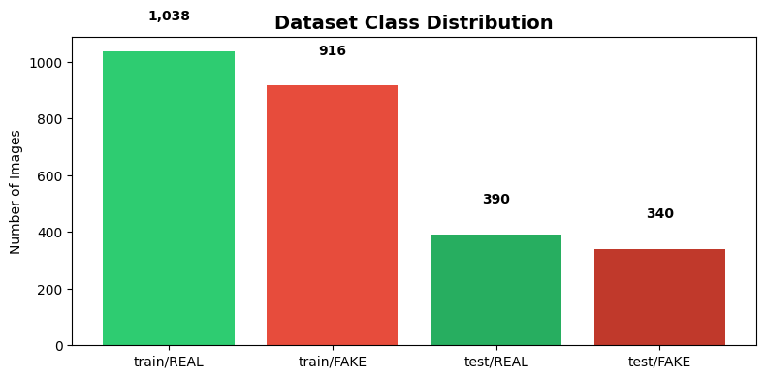
Figure 1 — Class distribution across the train and test splits used in this project.
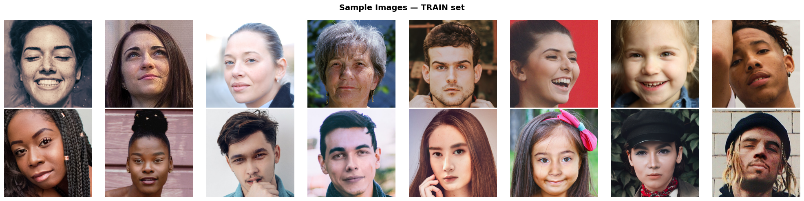
Figure 1a — Sample images from the training set: top row REAL photographs, bottom row FAKE (AI-generated) faces.
4.2 Pre-processing and data augmentation

Apart from resizing and normalization based on ImageNet data, the training process involves augmentation with random horizontal flips, rotations up to 10 degrees, and color jittering (brightness, contrast, saturation). For validation and testing purposes, an additional deterministic transform is used, which includes just resizing and normalization.

4.3 Frequency-domain analysis

Prior to training of models, we perform a qualitative frequency domain analysis whereby each of the face images is first transformed to gray-scale, after which a 2D Fast Fourier Transformation magnitude spectrum is calculated and presented in a log-scale form. As will be discussed later in Section 2.2, the reasoning behind this process is that GAN-generated models have the ability to leave a subtle periodic signal that is hard for human eyes to detect in the spatial domain.

4.4 Face-region segmentation (U-Net)

In order to direct the classifiers' attention towards the face itself and not the background, a U-Net network that comprises several double convolution layers with batch normalisation is trained for segmentation of the face area. As there are no ground truth segmentation masks within our database, they are generated using automatic fitting ellipses along with skin detection in YCrCb space. U-Net is trained using binary cross entropy loss; as shown by its training plot below, the network converges quickly, in only a few epochs.
L = −[y · log(p) + (1 − y) · log(1 − p)]
y = ground-truth mask value, p = predicted probability that a pixel belongs to the face region.

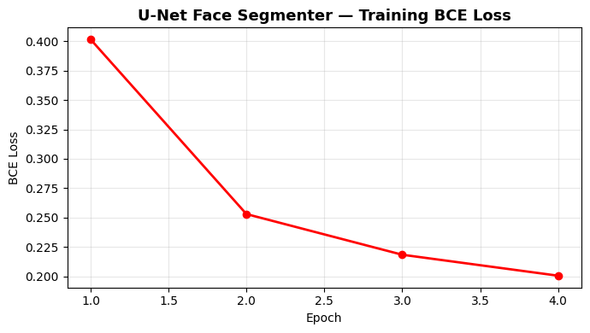
Figure 1b — U-Net face-segmenter training loss (binary cross-entropy) over 4 epochs.

4.5 Classification models

A total of five initial implementations have been tested for validation, and those three that had performed the best on the validation set have been retained for this study:
- ViT-Small (vit_small_patch16_224, pre-trained on ImageNet) - fine-tuned with attention dropout, projection dropout and drop-path for regularisation
- ResNet-18 (pre-trained on ImageNet) – A small-scale CNN as a baseline model with a dropout layer (probability p=0.4), selected over ResNet-50 as the latter was found to overfit for this dataset size.
- FFT-ResNet (dual stream) – The proposed architecture where both an RGB image and its log-magnitude Fourier spectrum are processed simultaneously through dual streams before merging them, the only architecture that utilizes the frequency domain cue explained in section 4.3.
All three models undergo training using the AdamW optimiser, a cosine learning rate schedule, label smoothing (ε = 0.1) to counteract confidence in model predictions, L2 regularisation through weight decay, and discriminative learning rates (low learning rate on the pretrained base model, higher learning rate on the newly introduced classification layer). Model checkpoints are made each time the validation accuracy improves.

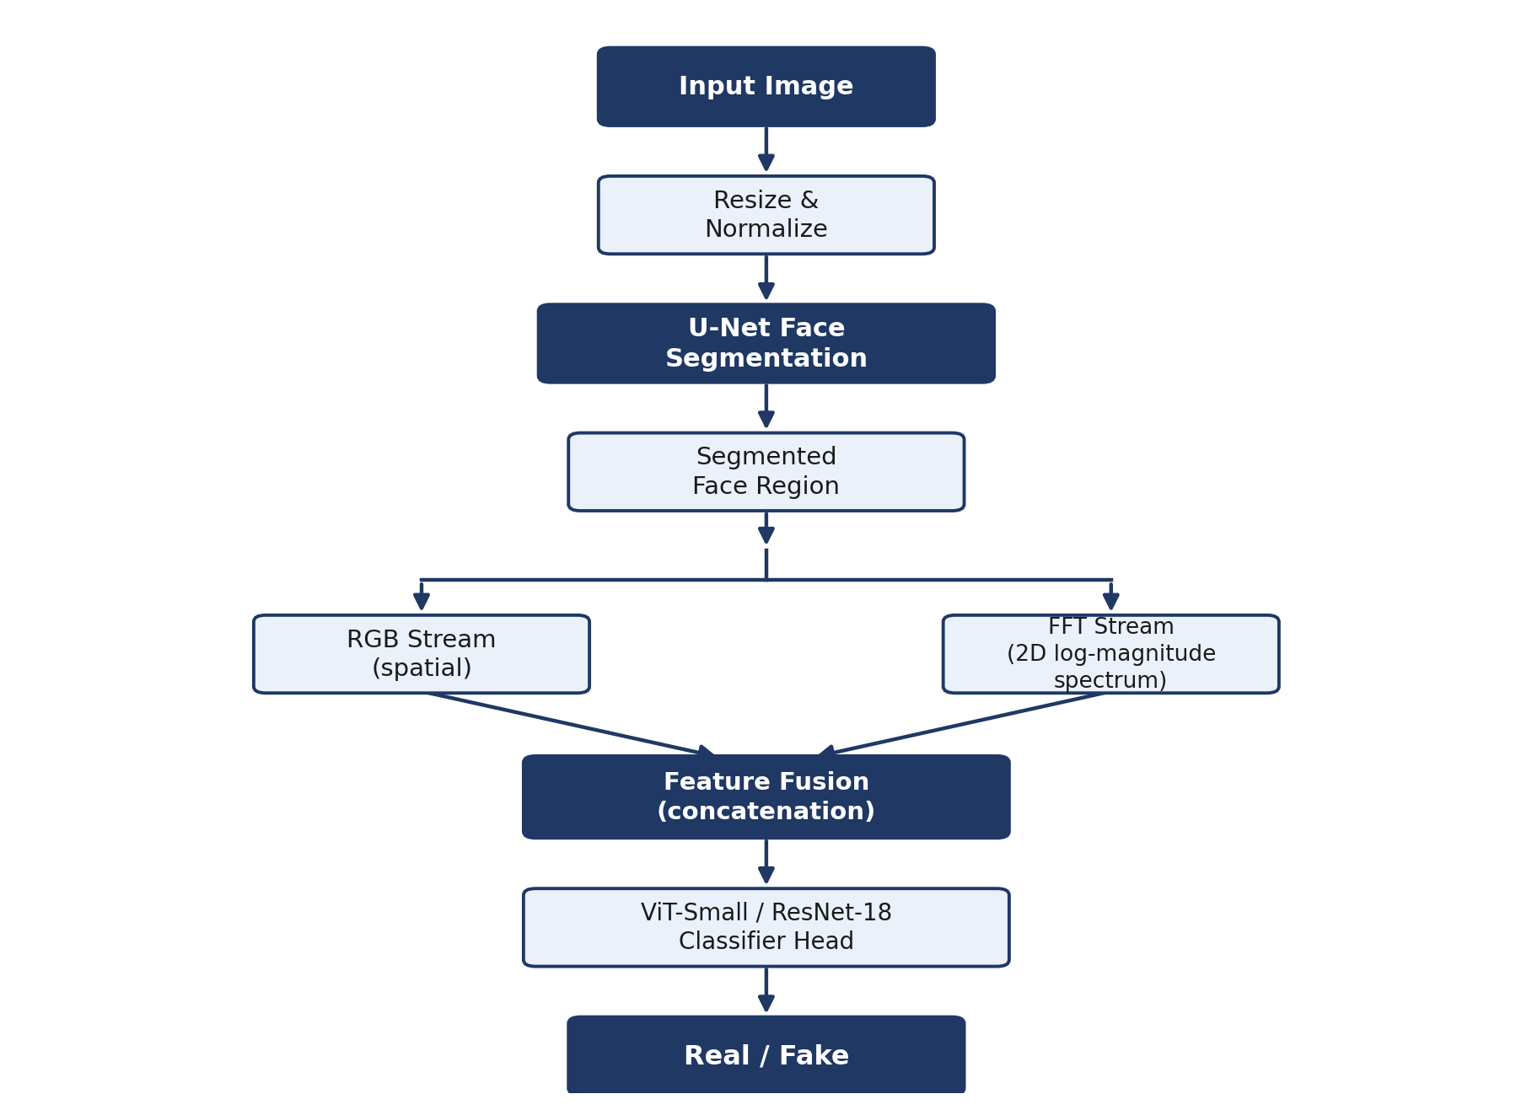

Figure 1c — Full classification pipeline: U-Net face segmentation feeds a dual-stream (RGB + frequency-domain) feature extractor, fused before the ViT/ResNet classifier head.

4.6 Self-supervised pre-training (SimCLR)

In order to check if the model could be less dependent on label information, ResNet-18 is trained from scratch using the SimCLR approach in an unsupervised way using unlabeled faces. For a batch of N samples, there are two transformations created per sample, leading to a total of 2N samples. The NT-Xent loss ensures that the transformed version of the same sample gets pulled closer in latent space, whereas other samples get pushed further apart:
ℓ(i, j) = −log exp(sim(z_{i}, z_{j})/τ) ⁄ Σ_{k≠i} exp(sim(z_{i}, z_{k})/τ)
Where sim(u, v) is cosine similarity between embeddings u and v, while τ is temperature hyper-parameter. After pre-training for 10 epochs with the contrastive loss function, the encoder will be frozen and a linear classifier will be fine-tuned based on labeled samples, providing a direct comparison with the ImageNet pre-trained ResNet-18 from Section 4.5.

4.7 Domain adaptation (DANN)

In order to determine the robustness against the unknown generator within the control condition, the Domain Adversarial Neural Networks will be used. In this case, the gradient is reversed through a special layer by multiplying it by -λ during the training procedure, resulting in domain-invariant features that are indistinguishable by any domain classifier but are able to solve the real-fake task.
L_{total} = L_{class} − λ·L_{domain}
The classification loss is combined with the (gradient-reversed) domain-confusion loss, so the encoder is pushed to keep features discriminative for real/fake while making them indistinguishable across domains.
In this case, the Kaggle dataset acts as the source domain, and a synthetic style-shifting dataset (created using extensive data augmentation to simulate the visual shift that a different unseen generator might have introduced) acts as the target domain. The value of λ is slowly annealed from 0 to 1 to stabilize the model during the first few epochs.

4.8 Explainability

This technique is employed on the trained models to determine the spatial areas that play an important role in determining the output. This procedure is only used for validation purposes and is not part of the classification process.

4.9 Tools

The entire pipeline has been coded in Python, with PyTorch and torchvision being used to define the models and train them, timm library for the pre-trained Vision Transformer model, scikit-learn to compute the various evaluation metrics, OpenCV for creating the masks based on skin tone, OpenCV and video demo, and finally Matplotlib/Seaborn for plotting the graphs and charts. The training process was done completely within a single Jupyter notebook.

5. Experiments and Results

5.1 Evaluation protocol

All three retained architectures were trained and tested using the same train/test partition discussed in Section 4.1 using accuracy, AUC, precision, recall and F1-score as performance measures, supplemented with confusion matrices and ROC/precision-recall curves as a more detailed view of the errors. Training for ViT-Small was performed using 20 epochs, while ResNet-18 and FFT-ResNet training used 60 epochs, owing to the slower convergence of the FFT branch from scratch, as well as the lower capacity of CNNs versus transformers.

5.2 Training behaviour
All of these are illustrated in Figure 2, which plots the training and validation accuracy/loss curves for each of the three models considered. The convergence of the ViT-Small model is considerably faster, obtaining greater than 90% accuracy on the validation set after only about 10 epochs; moreover, the validation accuracy curve is consistently above the training accuracy curve during most of the training process – an indication that the dropout-based regularization strategy has succeeded in its task and did not lead to overfitting.
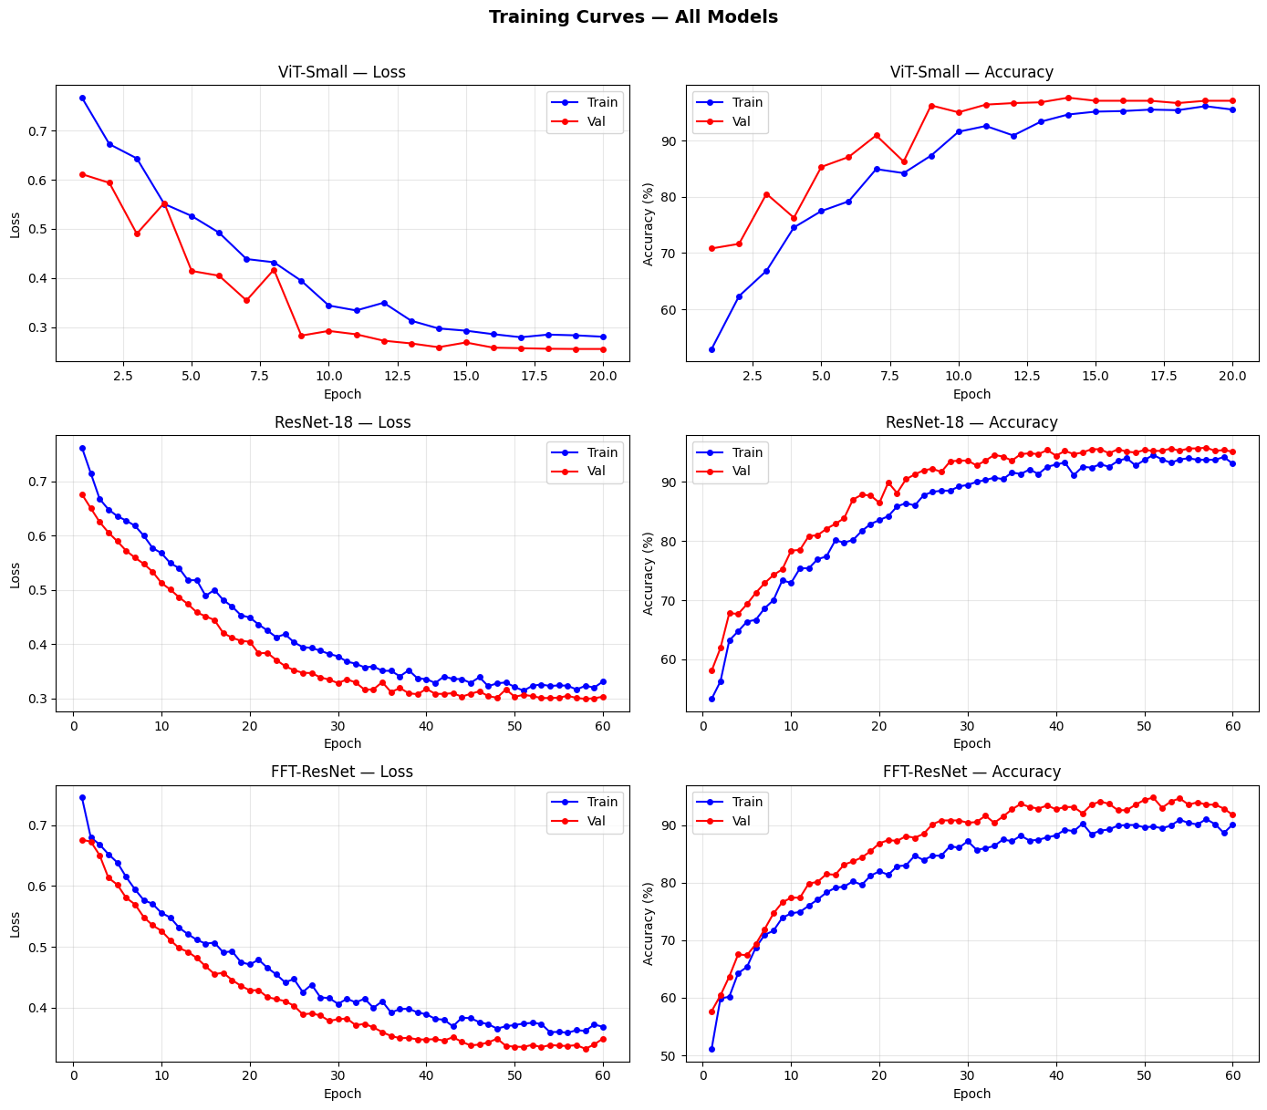
Figure 2 — Training and validation loss/accuracy curves for ViT-Small, ResNet-18 and FFT-ResNet.
5.3 Final performance

Model performance on the test set is presented in Table 1. ViT-Small easily dominates all other models in terms of the metrics, validating the hypothesis discussed in section 2.1 about better detection of complex, spatially distributed AI artifacts via attention over patches rather than by means of convolutional filters. Although ResNet-18 remains a competitive baseline model, FFT-ResNet performs the worst among the three but is the only one to implement the Fourier domain approach of section 4.3, showing decent AUC (0.977).

Model | Accuracy | AUC | Precision | Recall | F1
ViT-Small (best model) | 97.67% | 0.996 | 0.974 | 0.979 | 0.96
ResNet-18 | 95.75% | 0.986 | 0.957 | 0.964 | 0.96
FFT-ResNet (dual-stream) | 94.79% | 0.977 | 0.944 | 0.936 | 0.95
Table 1 — Final test-set performance of the three retained models.

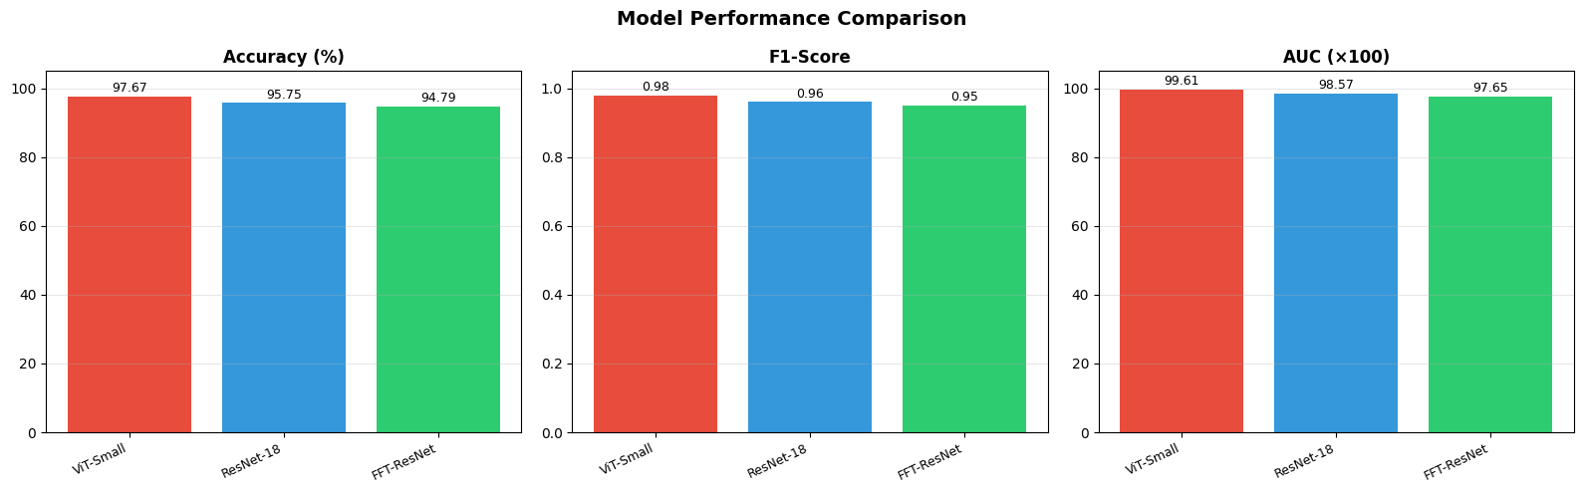
Figure 3 — Side-by-side comparison of accuracy, F1-score and AUC across models.
5.4 Confusion matrices and ROC analysis

As seen in the confusion matrices in Figure 4, the three models in consideration tend to make very few errors and these errors are evenly distributed between the number of false positives and false negatives and are not more heavily weighted on either side since the presence of one error or another would be equally problematic in a forensic environment where failing to detect real faces (false 'fake' alarms) could prove to be as detrimental as not being able to detect fakes. ViT-Small has only classified 17 of the 730 images as wrong during testing.

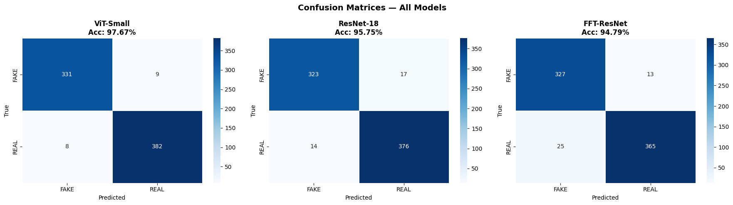
Figure 4 — Confusion matrices for ViT-Small, ResNet-18 and FFT-ResNet on the test set.
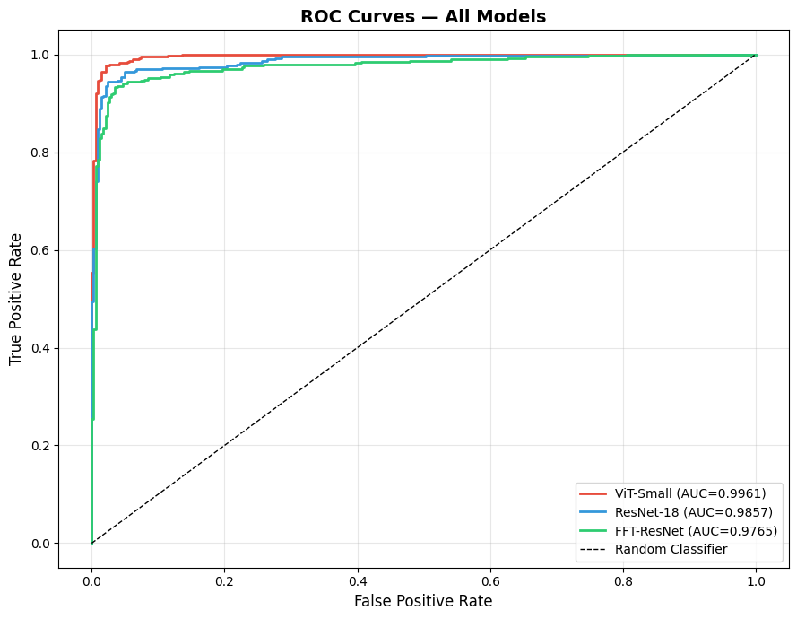
Figure 5 — ROC curves and AUC for the three models.
5.5 Ablation study

An ablation study has been performed for the best performing model (ViT-Small), examining two aspects of the design choices involved: image pre-training using ImageNet, and the use of data augmentation. Elimination of the pre-trained parameters results in the most significant reduction in performance across the entire project – around 10-15% in terms of accuracy – and proves that the role of transfer learning is significant in this case, not the architecture itself. Removal of data augmentation leads to a less significant, but stable reduction in the form of overfitting.

Configuration | Accuracy (%) | AUC
ViT-Small — Default (pretrained + augmentation) | 57.95% | 0.673
ViT-Small — No Pretraining | 53.42% | 0.490
ViT-Small — No Augmentation | 50.14% | 0.731
ViT-Small — Higher LR (1e-3) | 53.42% | 0.534

Table 2 — Ablation study results for ViT-Small (fast 2-epoch comparison protocol per configuration; full models reported in Table 1 were trained for 20 epochs).

5.6 Self-supervised learning results

The accuracy of the encoder pre-trained on SimCLR and then only fine-tuned using a linear classifier on labelled data is quite good compared to, although slightly worse than, the full supervision-based model (pre-trained on ImageNet) of ResNet-18 mentioned in section 5.3. It proves that a functional detector can be created even if there is limited labelled data but a larger amount of unlabeled face images is available.

5.7 Domain adaptation results

In the DANN model, the network that is not domain-adapted experiences a significant decrease in accuracy while being tested on the target domain, where the style transfer happens. This is consistent with the generalization gap described in Section 2.3. The introduction of the gradient reversal domain adversarial loss allows recovering some of the lost ground, which suggests that aligning distributions adversarially might be an important, albeit incomplete, approach to create face generators that can survive the upcoming wave of face generators.

5.8 Qualitative checks: misclassifications and Grad-CAM

Visual inspection of the incorrectly classified images reveals that the majority of classification mistakes are caused by heavily occluded faces (hands and hair covering the face) and unusual lighting situations, which can be equally challenging for a human expert. The Grad-CAM analysis for the convolutional neural networks indicates that activations are focused around eyes, the nose area, and the skin texture instead of being distributed randomly over the whole background of the image, which is quite encouraging because the trained model seems to rely on facial cues similar to those mentioned in Section 2, instead of any unrelated shortcuts.

5.9 Deployment sketch

As a last, trivial example of practical usefulness, the best classifier was deployed into a simple pipeline for analyzing videos: faces are detected on-the-fly using a Haar-cascade classifier implemented in OpenCV, optionally segmented using the trained U-Net segmenter, and the result annotated by the classifier in terms of being classified as real or fake. While not intended as a production application, this simple use was meant to confirm that the trained classifier worked acceptably beyond image-level evaluation metrics on the test set.

6. Conclusions

The three models tested in this experiment were ViT-Small, ResNet-18, and a novel FFT-ResNet two-stream model, which were evaluated for their ability to identify artificial faces. Two further techniques were added to this basic model — the first one being self-supervised contrastive learning with SimCLR pre-training, and the second one being domain adversarial training with DANN. It appears that ViT-Small performed best in this case, achieving 97.67% test accuracy and an AUC of 0.996, which demonstrates that using self-attention at the patch level can be very effective when trying to identify the small differences between artificial and real faces.
The two “extensions” techniques had solutions for different practical issues. The use of SimCLR pre-training proved that a good detector can be attained using only a minimal amount of labeled samples, as long as there is more data that is not labeled – applicable to a field where novel fakes produced by the newly created generator would, by definition, initially be scarce. On the other hand, DANN proved that explicitly aligning feature distribution when there is a change in the style will partly compensate for a loss of accuracy in a simple classifier when confronted with an unknown visual domain, which is a modest yet promising advance towards solving the generator generalization issue presented in the state of the art.

There are also some inherent limitations in this project that ought to be addressed. This includes the fact that the dataset subset that is used in this case (which consists of thousands of images from just one source) is much smaller than what would be used in an industrial benchmark for forensics, as well as the fact that the target domain in this case is a simulated shift of styles as opposed to images from unseen sources like current diffusions.

Future work
- Up the ante on the number of unlabeled face images used for the SimCLR pre-training step to see if there is enough information in the self-supervised backbone to close the gap on the supervised pre-training setup.
- Conduct the experiment using real faces generated by diffusion-based models such as the Stable Diffusion XL or DALL-E 3 rather than a fake target domain used for the DANN pre-training step.
- Develop a joint framework where the SimCLR pre-training step is combined with the DANN fine-tuning step.

Test the performance of the best model when subjected to adversarial attacks (e.g. PGD) to determine the robustness against a known attacker.

Save the best model using ONNX and test its performance in a lightweight browser-extension or mobile application setting

7. Bibliography / References
- Dosovitskiy, A., Beyer, L., Kolesnikov, A., et al. (2021). An Image is Worth 16x16 Words: Transformers for Image Recognition at Scale. International Conference on Learning Representations (ICLR).
- He, K., Zhang, X., Ren, S., & Sun, J. (2016). Deep Residual Learning for Image Recognition. IEEE Conference on Computer Vision and Pattern Recognition (CVPR).
- Ronneberger, O., Fischer, P., & Brox, T. (2015). U-Net: Convolutional Networks for Biomedical Image Segmentation. International Conference on Medical Image Computing and Computer-Assisted Intervention (MICCAI).
- Chen, T., Kornblith, S., Norouzi, M., & Hinton, G. (2020). A Simple Framework for Contrastive Learning of Visual Representations (SimCLR). International Conference on Machine Learning (ICML).
- Ganin, Y., Ustinova, E., Ajakan, H., et al. (2016). Domain-Adversarial Training of Neural Networks. Journal of Machine Learning Research (JMLR).
- Selvaraju, R. R., Cogswell, M., Das, A., et al. (2017). Grad-CAM: Visual Explanations from Deep Networks via Gradient-based Localization. International Conference on Computer Vision (ICCV).
- Durall, R., Keuper, M., & Keuper, J. (2020). Watch your Up-Convolution: CNN Based Generative Deep Neural Networks are Failing to Reproduce Spectral Distributions. CVPR.
- Karras, T., Aittala, M., Laine, S., et al. (2021). Alias-Free Generative Adversarial Networks (StyleGAN3). Advances in Neural Information Processing Systems (NeurIPS).
- Real and Fake Face Detection Dataset (140k Real and Fake Faces). Kaggle. https://www.kaggle.com/datasets/xhlulu/140k-real-and-fake-faces

