**Worksheet 2(C++ Function basic continued)**

1. For each of the functions you define on problem 6 on worksheet1, define a main function that calls (or use) each of them.
2. When and why is a prototype declaration required? Explain also the advantage of using a prototype declaration.
3. Explain what is meant by pass by value and pass by reference
4. Write a function to find, the maximum, minimum, and how many times they both occur in an array of n integers. Write also a complete program that uses this function.
5. Give the output of the following program

#include <iostream>

using namespace std;

void func1(int& x, int y, int& z);

void func2(int& x, int y, int z);

int main( )

{

int a=10, b=50, c=40;

func1(a, b, c);

cout << a << " " << b << " " << c << endl;

return 0;

}

void func1(int& x, int y, int& z)

{

cout << x << " " << y << " " << z << endl;

y= y + x + z;

z= y-x;

func2(x, y, z);

cout << x << " " << y << " " << z <<endl;

}

void func2(int& x, int y, int z)

{

cout << x << " " << y << " " << z << endl;

y= x + z;

z= y-x;

x=z-y;

}

1. Next you are given a prototype declaration of a few functions. Declare them as valid or invalid declaration. Also briefly give your reason why you say invalid.

|  |  |
| --- | --- |
| 1. Prototype( int a, float b[]); (invalid because the return type is not mentioned.) | 1. int * Prototype(int a, ib, d); (invalid because the parameters are not declared properly) |
| 1. int Prototype(int &x=6, int y=5, float z=6.2); (invalid because we cannot initialize an alias with a constant) | 1. int & Prototype(float d, int x); (Valid) |
| 1. float [] Prototype(int & a , char c); (invalid because a function can not return an array) | 1. int Prototype(int x=8, int y, float z=6.2); (invalid because all parameters with a default value must be located to the right most) |

1. What do you think the intention of the programmer for this code? What is wrong with the code? How do you correct it? Modify the code by sharing the variable n as a global variable

|  |  |  |
| --- | --- | --- |
| int f1(int);  int f2(int);  int main () {  int n = 6;  cout<<f2(n);  system("pause");  return 0;  } | int f1(int m) {  if (m==0)  return 1;  else  return m* f2(--m);  } | int f2(int n) {  if (n==0)  return 1;  else  return n*f1(--n);  } |

What do you think the intention of the programmer is for this code? The intention of the programmer is to determine the factorial of 6.

What is wrong with the code?

The parameters should be defined as alias

How do you correct it?

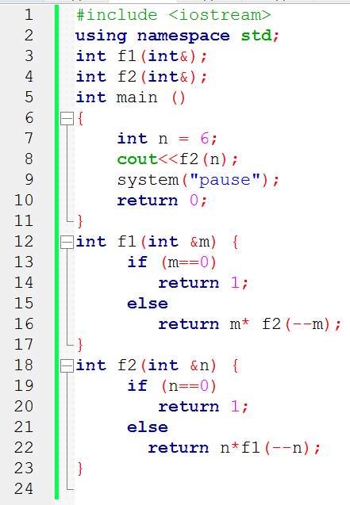

Modify the code by sharing the variable n as a global variable

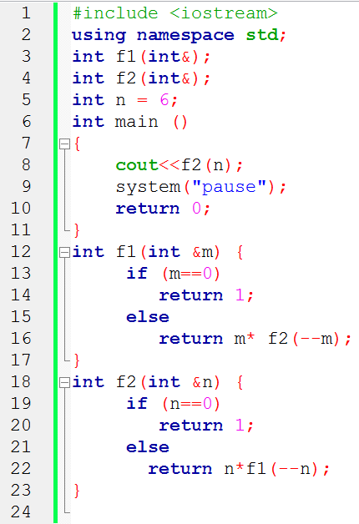

1. What is the output of this program when executed?

|  |  |
| --- | --- |
| #include <iostream.h>  char *str = "Trust";  void Print (char *str=”Peace”){    {  char *str = "Love";  cout << str << '\n';  cout << ::str << '\n';  }  cout << str << '\n';  cout << str << “ is the best”<< '\n';  } | int main (void)  {    Print();  cout << str <<”?” <<'\n';  return 0;  } |

1. Explain each of the following storage classes

Automatic: Register: Static : Extern:

1. What is the output of this program when executed?

|  |  |
| --- | --- |
| void Func(int a ){  while (a != 0 ){  static int n = a;  int x = 0;  cout << “x = " << ++x << ", n = " << ++n + x << ´\ n ´;  a--; }  } | int main (void)  {  Func(4);  return 0;  } |

1. How do you describe the signature of a function? When do we say functions have different signature? Explain what is meant by function overloading.
2. On the space provided give the function that will be called. If unable to resolve the function call, write “problem” and give a brief reason why.

void print ();

void print (long );

void print (double x=1.4);

void print (double, int);

void print (int, double z=1.8);

int main (int a , long b, float c ){

print (); // print ();

print (a ); // print (int, double z=1.8);

print (b ); // print (long );

print ( a, 5); //Problem there is no function with an argument of int int

print (c); // Problem there is no function with a float argument

print (4, 9.4 ); // print (int, double z=1.8);

1. Refer worksheet1 problem 4 and 5. Give their complete implementation.