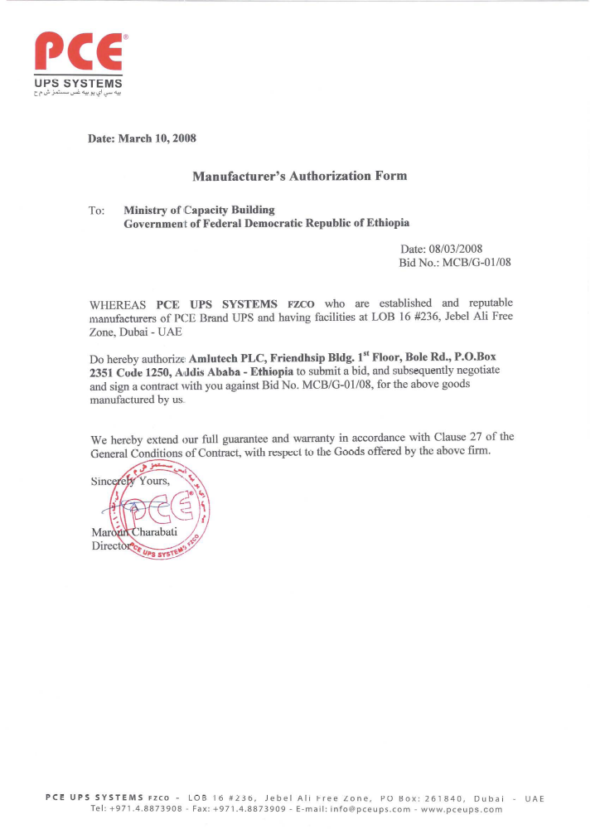

Date: August 5, 2014

Manufacturer’s Authorization Form
PCE UPS SYSTEMS FZCO - LOB 16 #236, Jebel Ali Free Zone, PO Box: 261840, Dubai - UAE
Tel: +971.4.8873908 - Fax: +971.4.8873909 - E-mail: info@pceups.com - www.pceups.com

