TRANSMISSION ASSET MANAGEMENT SYSTEM
Every tower. Every task. Every proof.
TMMS is a geographic, asset-centric operations platform for high-voltage transmission networks. It keeps one authoritative record of every asset and location, and drives each piece of work through a closed loop: Plan → Dispatch → Execute → Document → Verify.
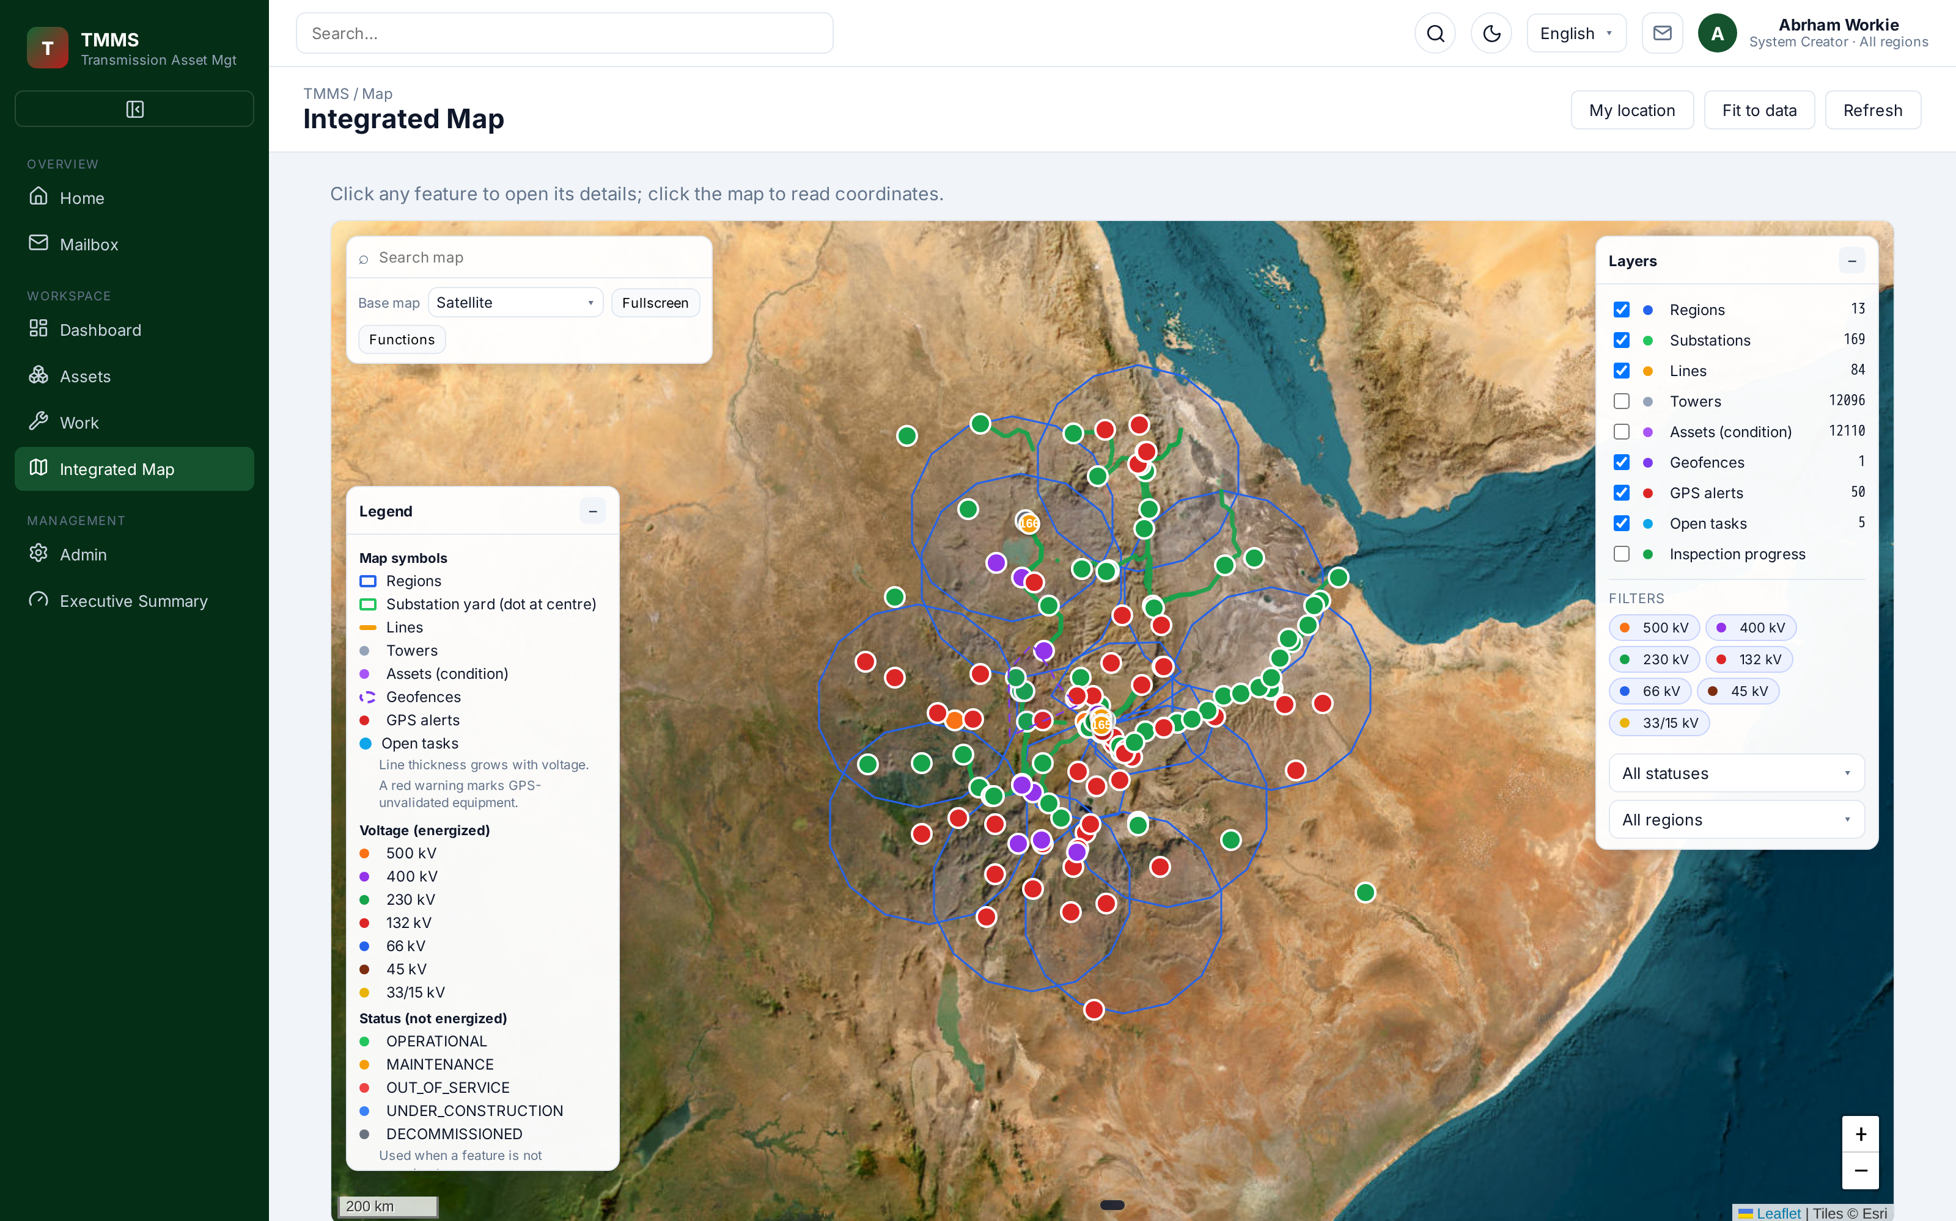
12,148 | 13 | 6 | 1
Georeferenced assets | Regions managed | Lifecycle stages | Source of truth

WHY TMMS
One closed loop from plan to proof

Utilities rarely fail for lack of work orders. They fail because the plan, the dispatch, the field evidence and the verification live in separate places — so nobody can prove what happened, where, or when. TMMS closes that loop in a single georeferenced system.
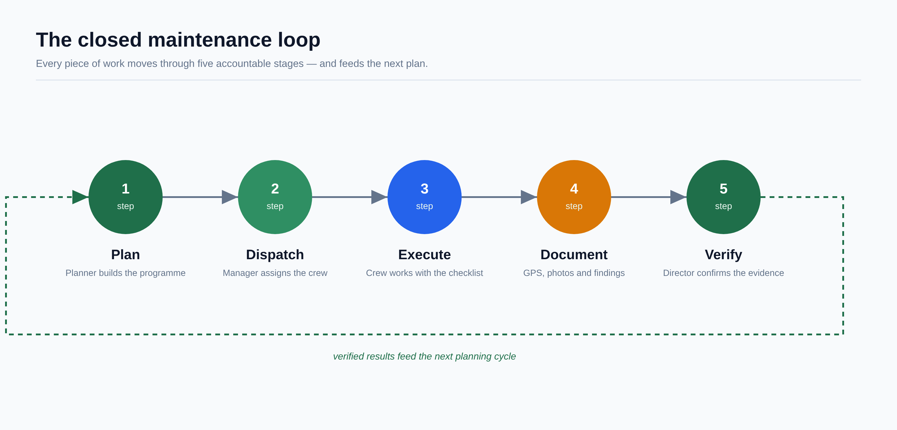
1. Georeferenced by default  Every substation, line, tower and asset carries coordinates. Locations are verified, not trusted. | 2. Accountable to the person  Each stage has one owner. The verifier can never be the executor, and every action is logged. | 3. Nothing disappears  Recurring work is automated, evidence is retained, and closed work feeds the next plan.

Built for the field, trusted by the board
A crew sees only its assigned work. A manager sees the crews it commands. A director sees the region. An executive sees the whole network — the same data, filtered by role, never duplicated.

THE COMMAND CENTER
A home that tells each role exactly what to do

Every signed-in user gets a function banner and one card per task bucket their role owns — execute, schedule, assign, verify or review. Buckets are separate sections, never merged into one queue, so scheduling, assignment, execution and verification never mix.
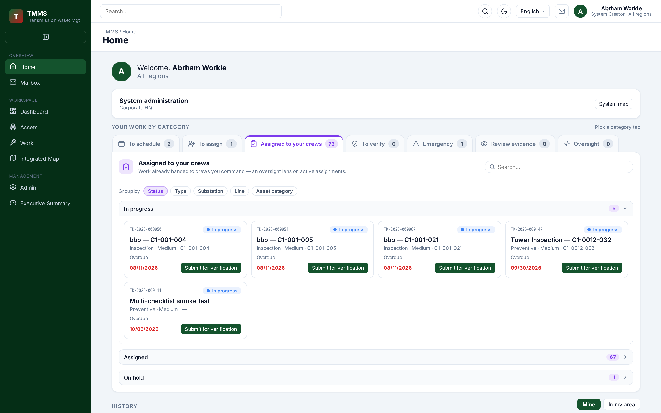
Home — role-scoped buckets with live counts and collapsible sub-categories.
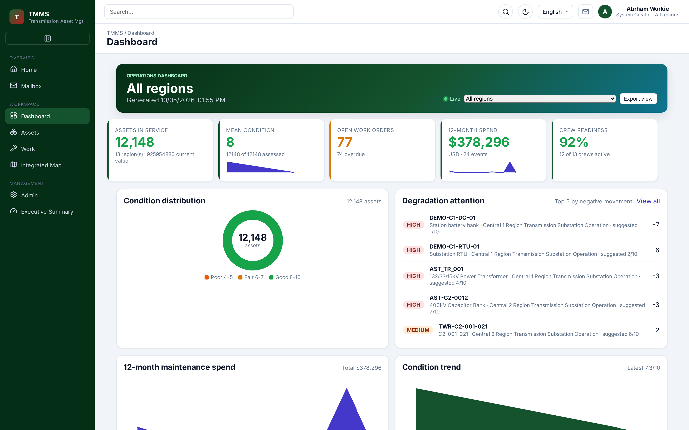 | 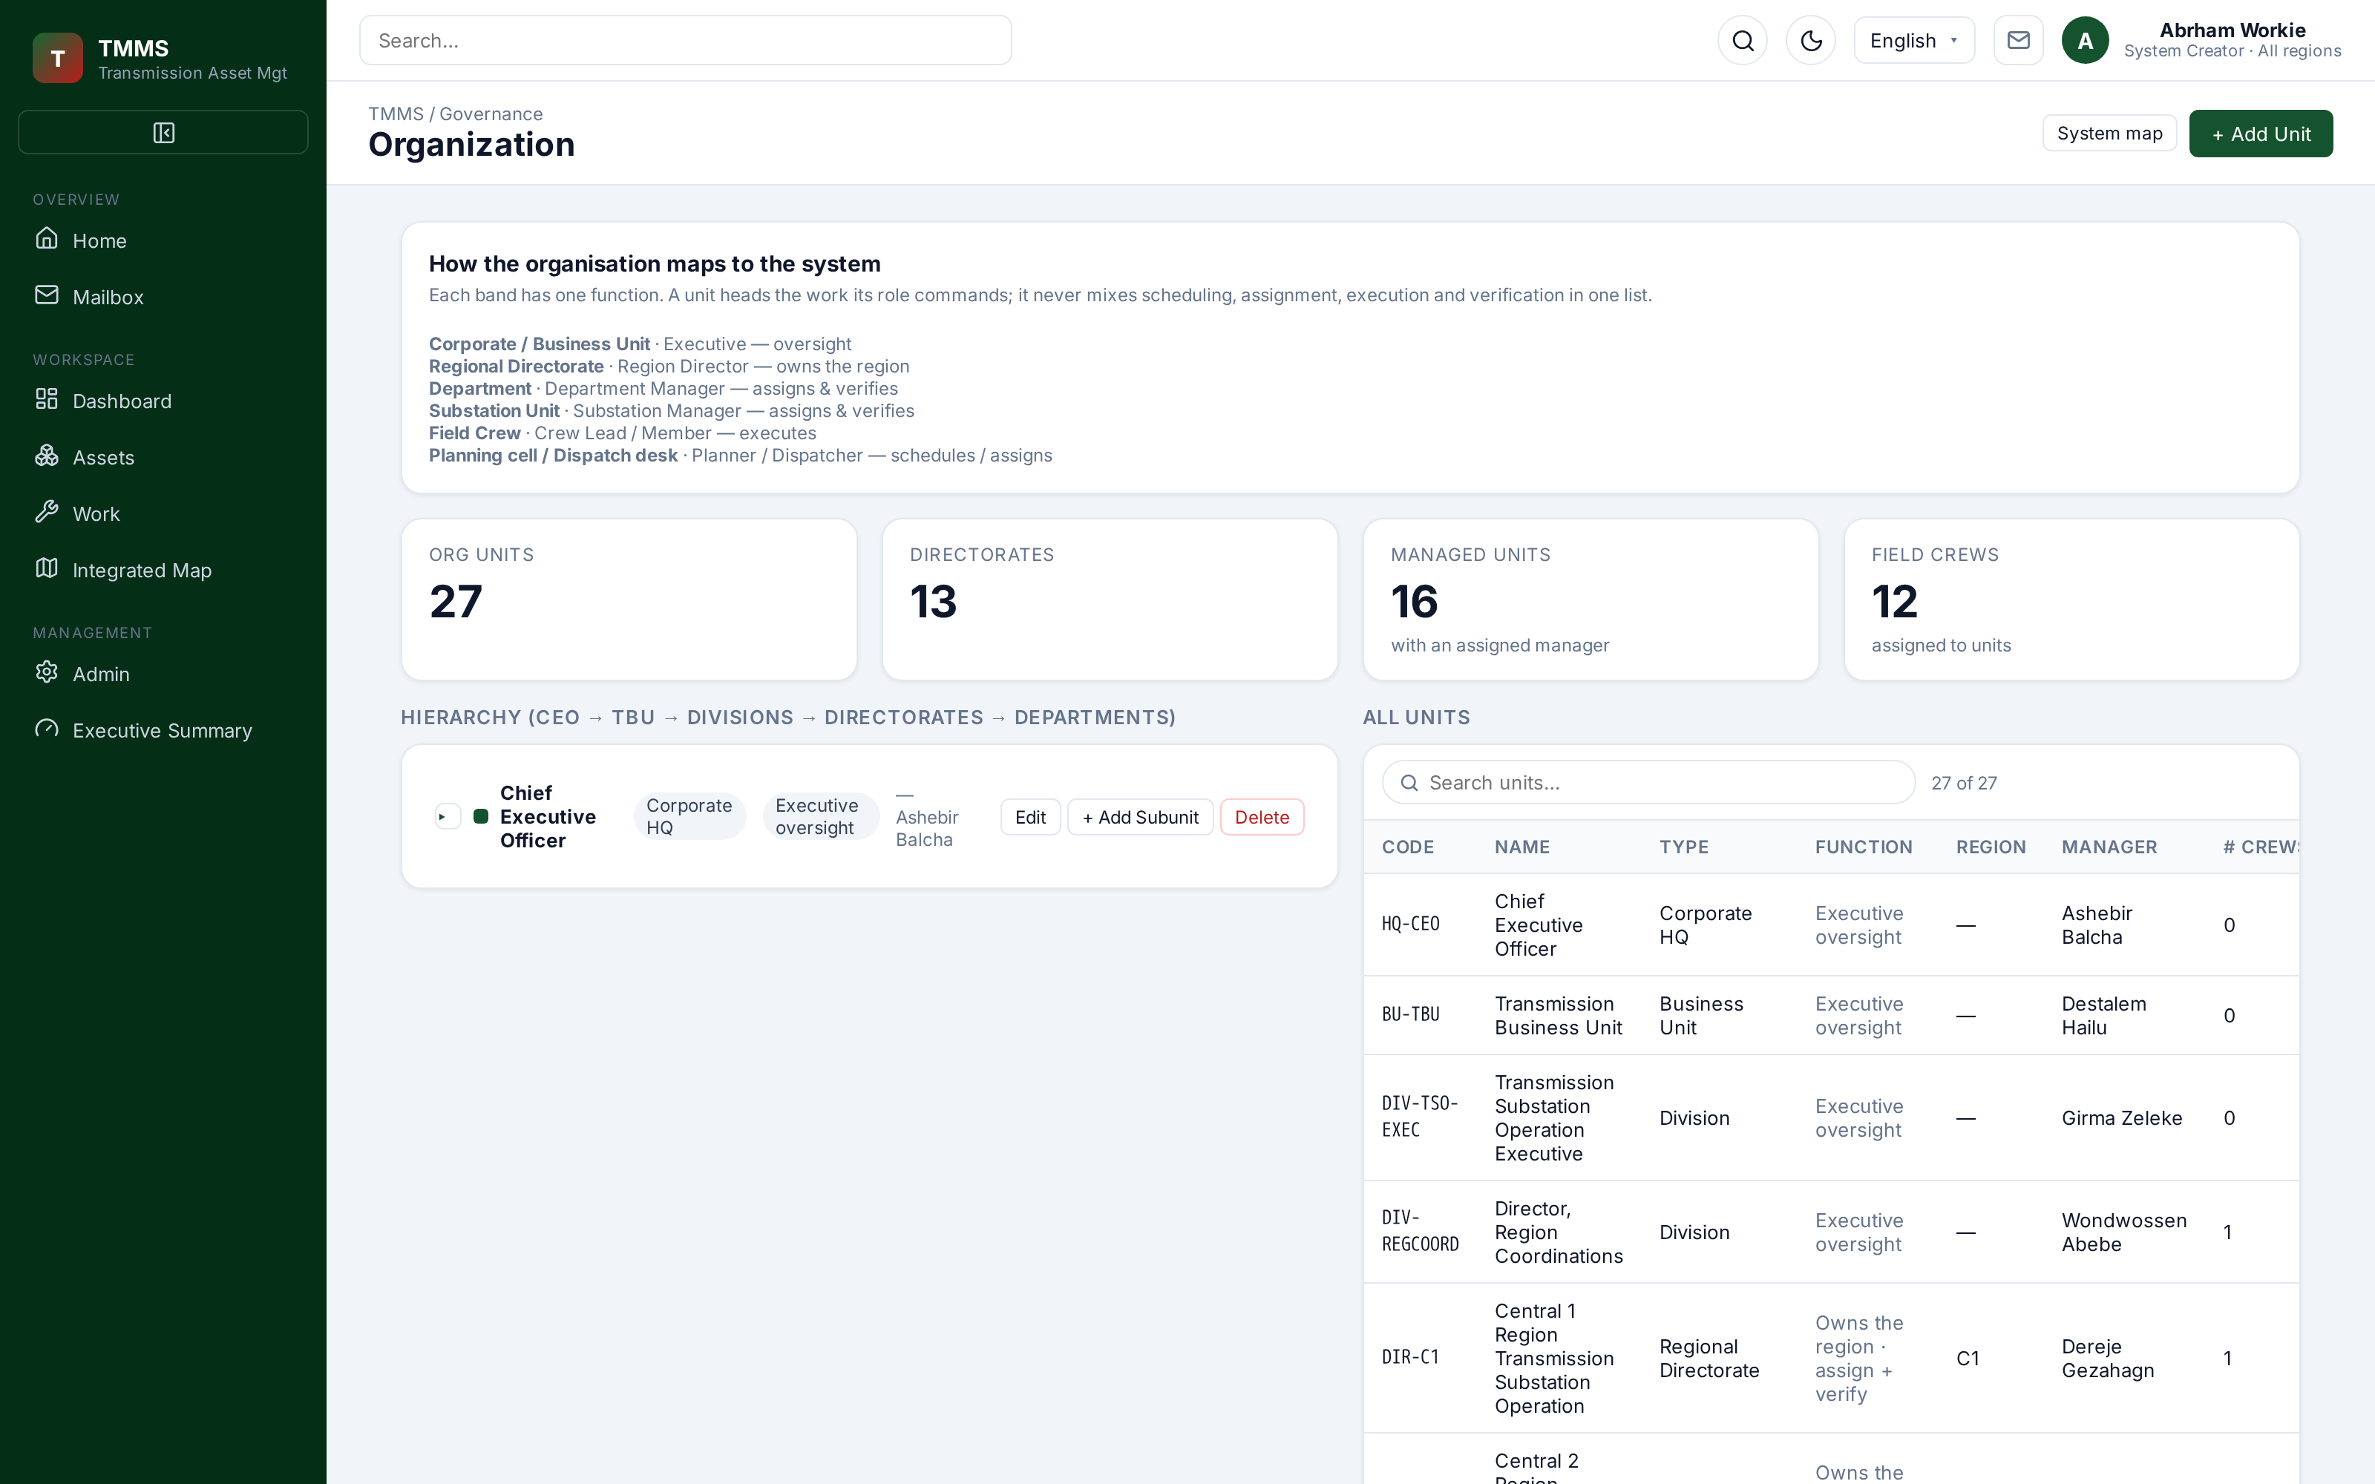
Dashboard — operational overview. | Organization — each unit's function and the role that heads it.

GEOSPATIAL INTELLIGENCE
See the whole network, then prove you were there

Satellite and vector layers plot substations, transmission lines and towers with live inspection coverage. Field capture records a GPS point against the expected device location, so a completed step carries proof of presence — not just a claim.
Integrated map — substations, line corridors and asset coverage in one view.
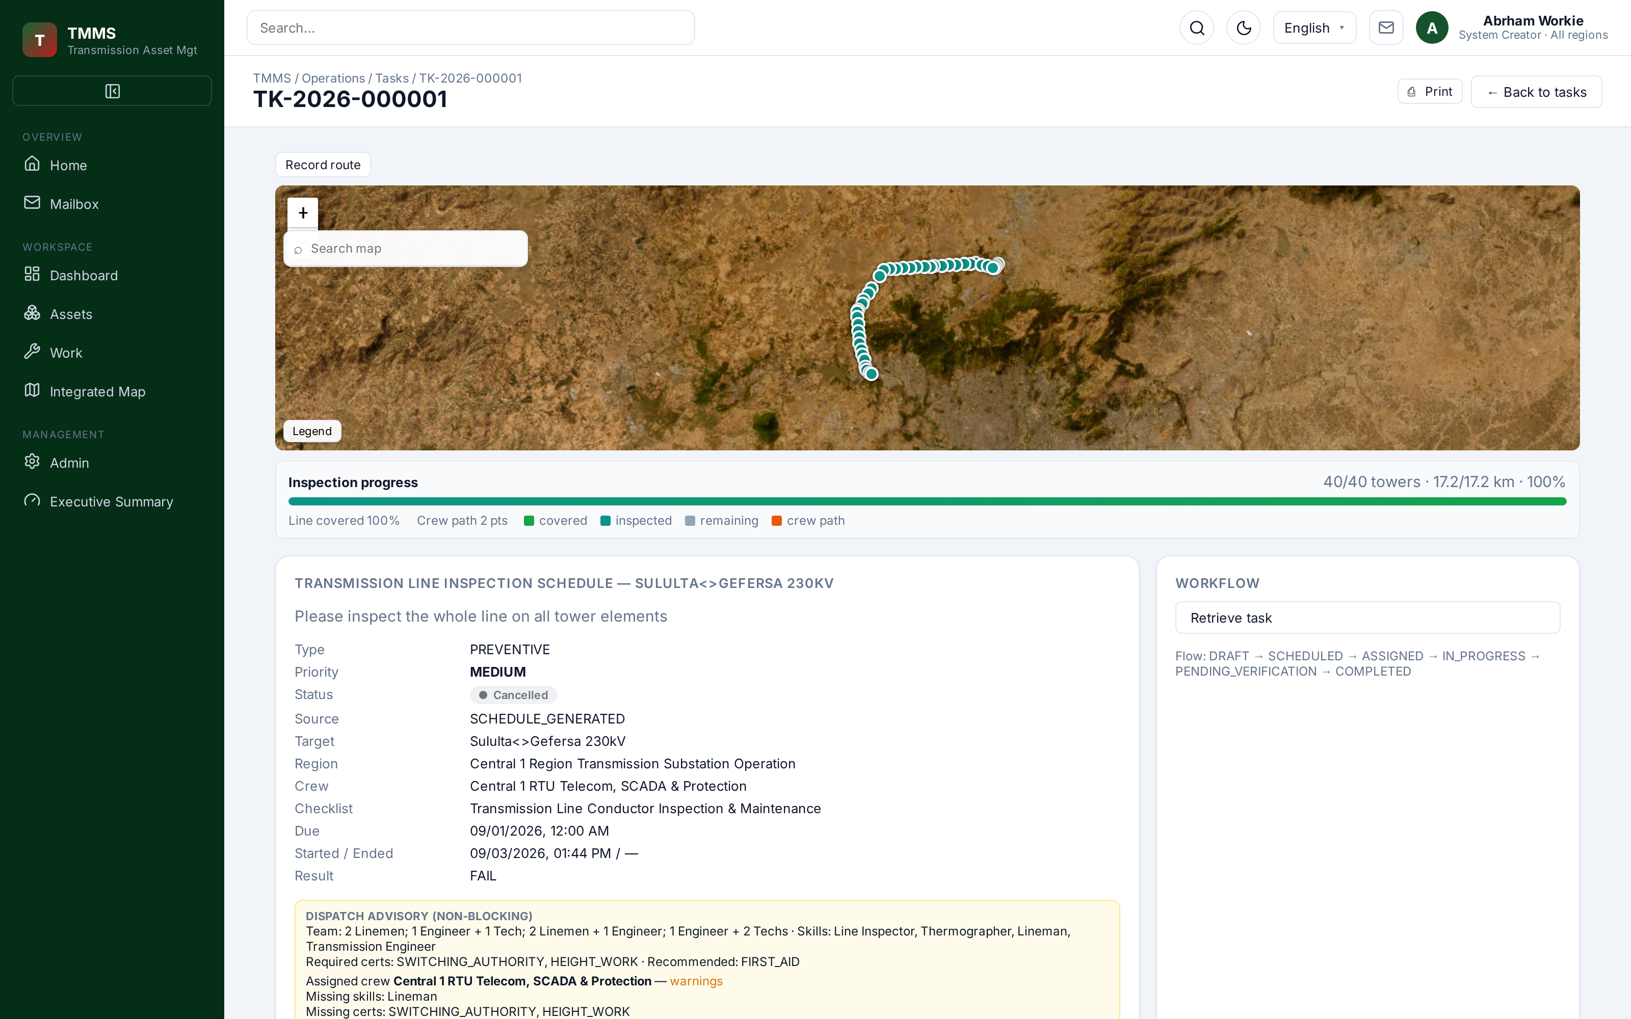 | 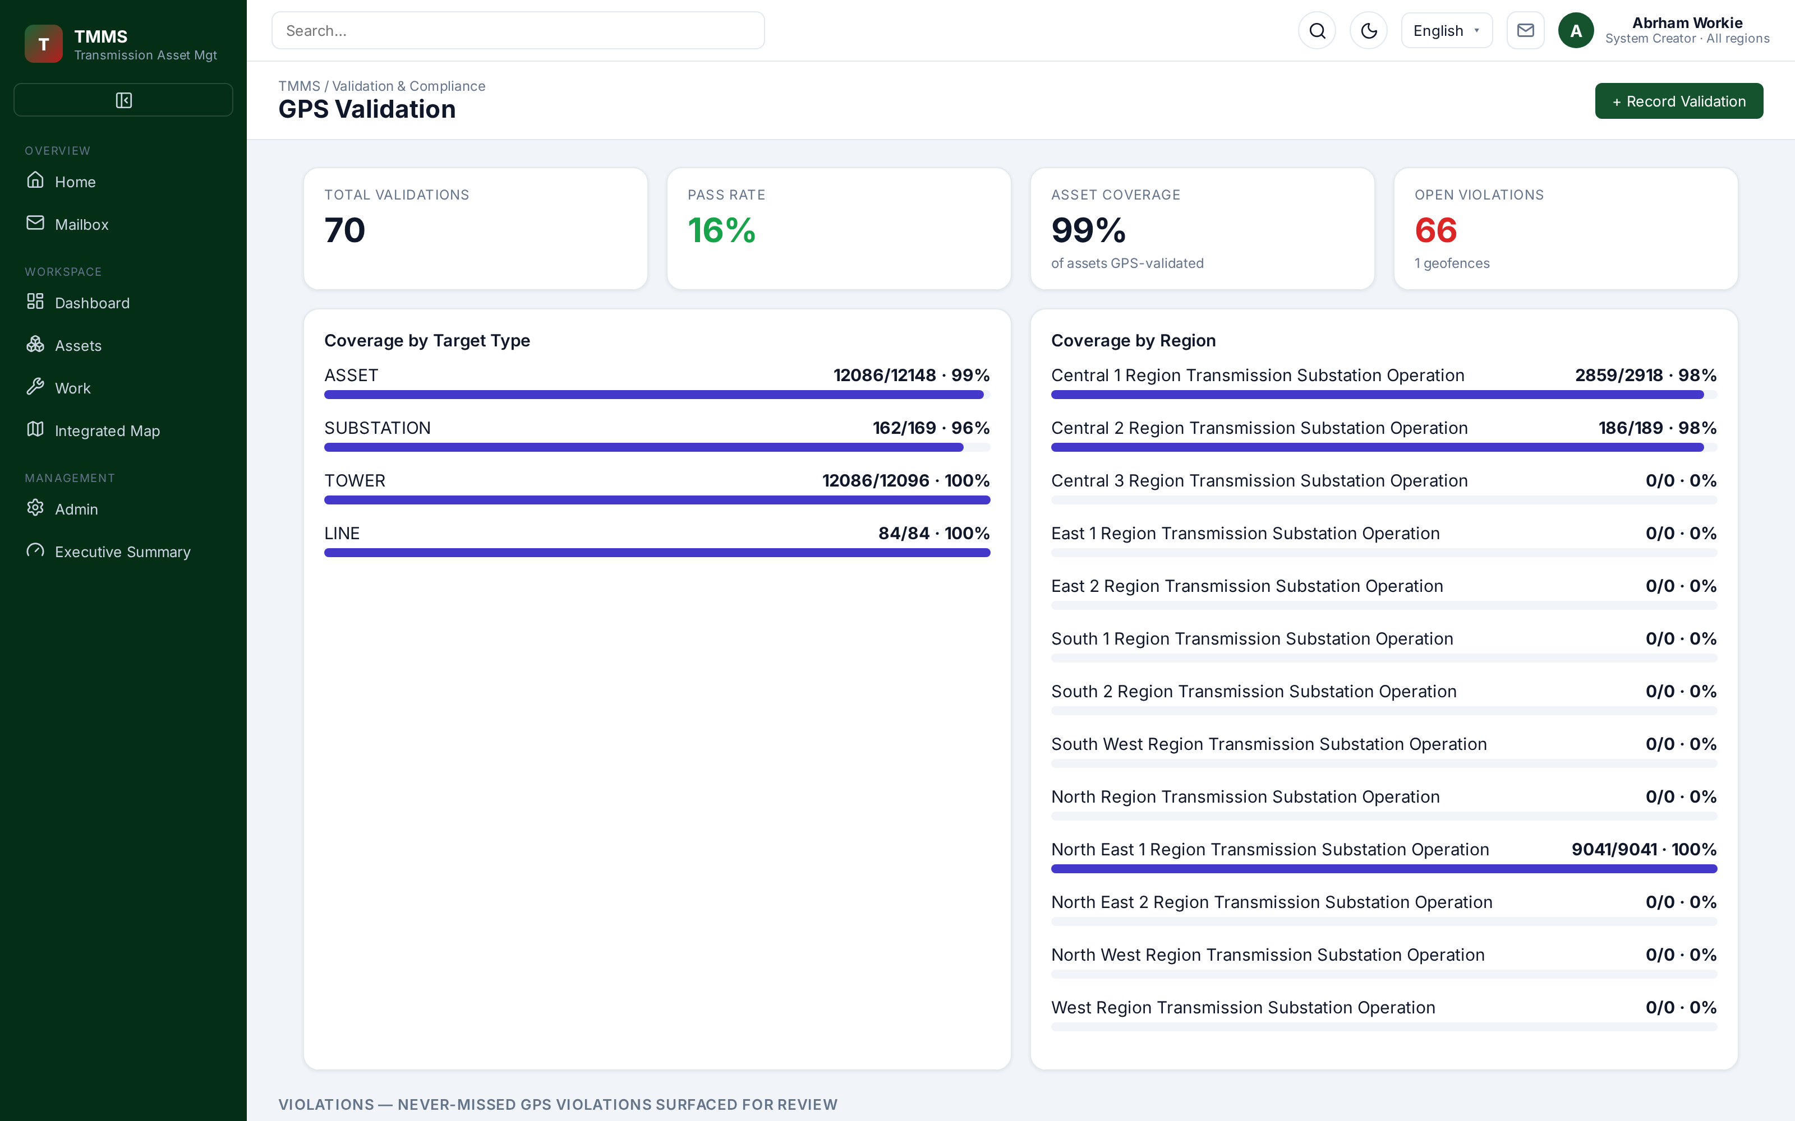
Task route — line coverage, crew path and progress. | GPS validation — capture against device tolerance.
Geofences  Coordinates are checked against the real world before they are trusted. | Coverage  Line and tower inspection progress computed automatically. | Violations  Out-of-tolerance captures are reviewable and auditable.

INFRASTRUCTURE REGISTRY
One authoritative record of every asset

Regions, substations, transmission lines, towers, components and equipment are modelled as one connected tree. Condition scores, class mix, per-region distribution and the top degrading assets are computed from the same source of truth that drives the map and the work.
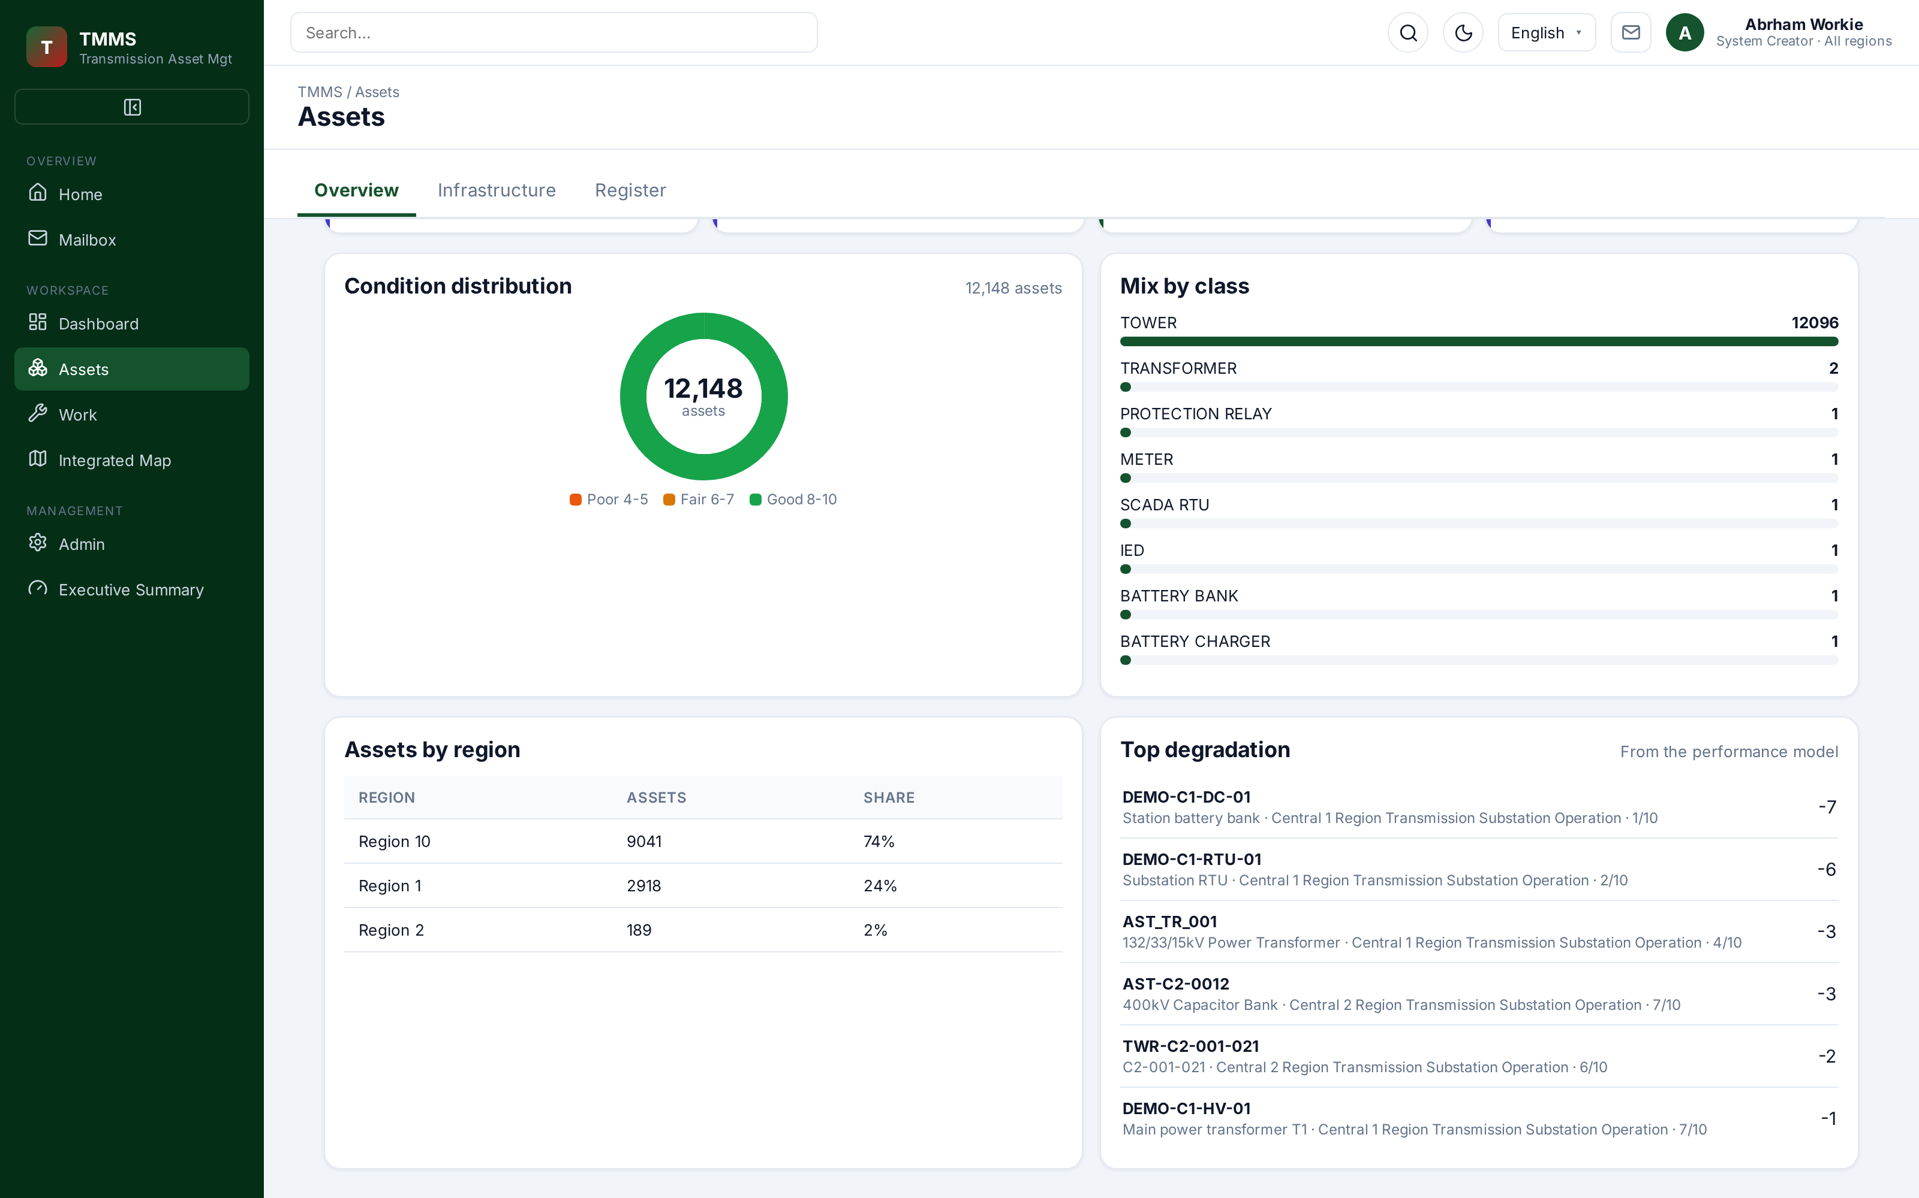
Assets overview — condition distribution, mix by class, by region and top degradation.
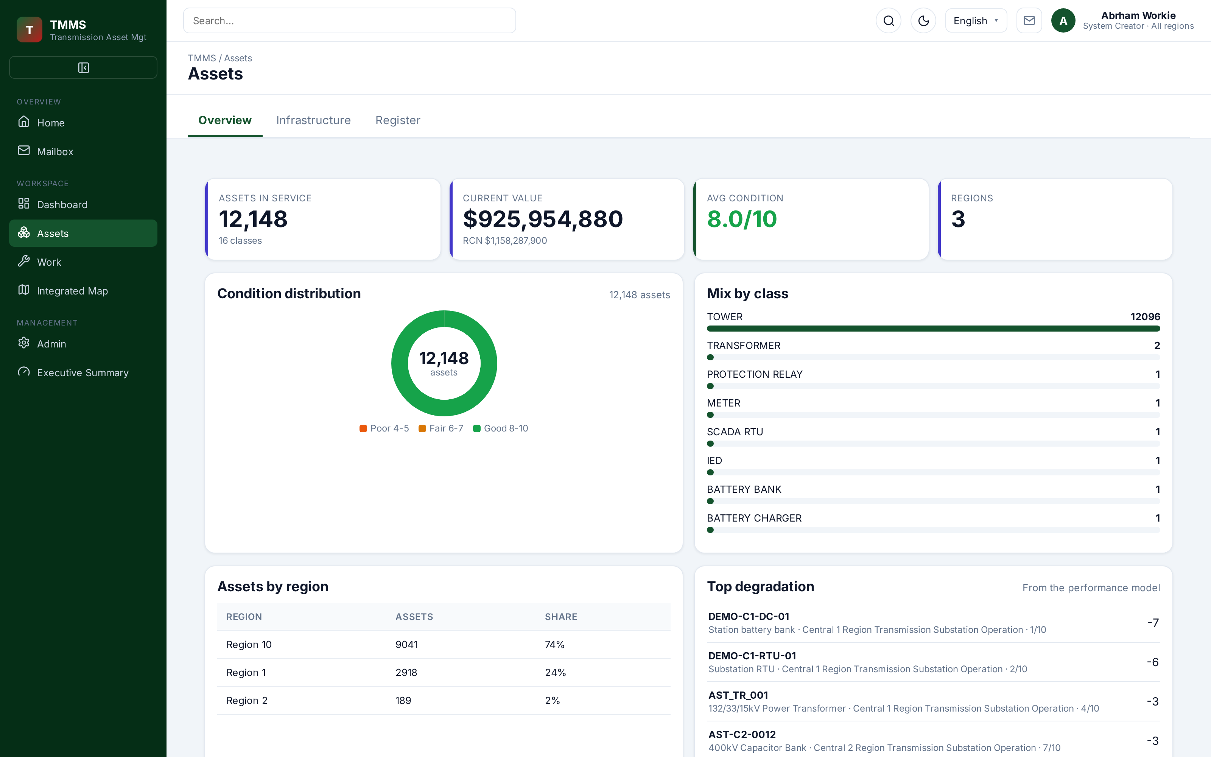 | 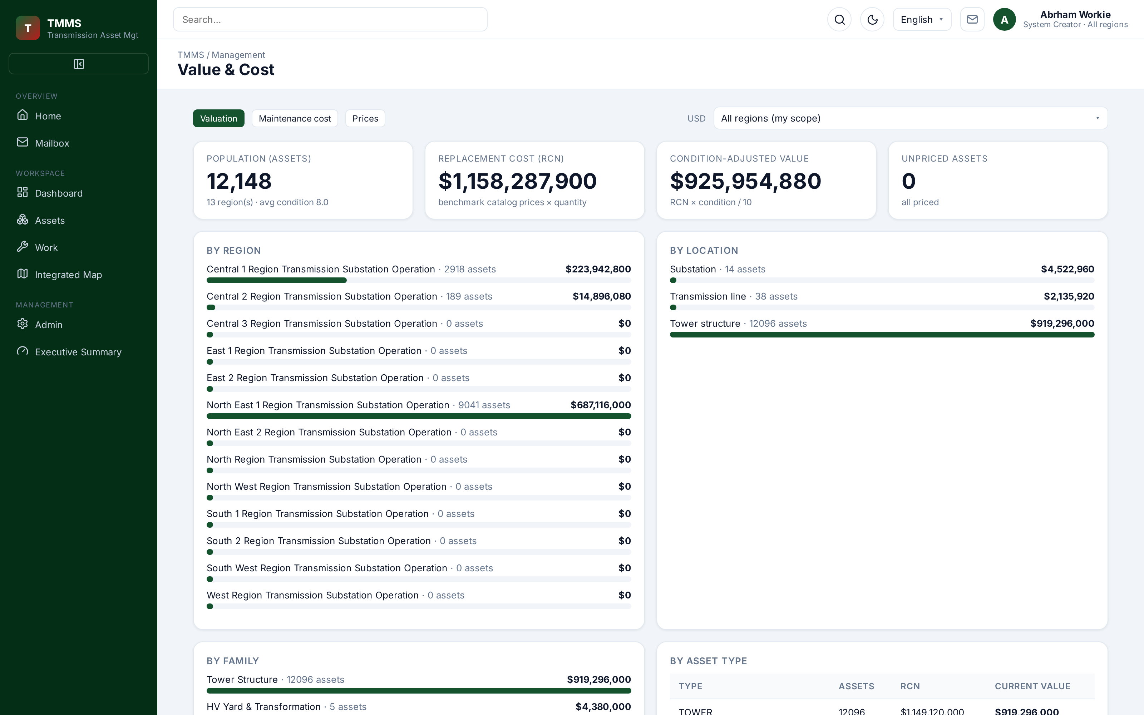
Asset register — paged, filtered, exportable. | The same register carries replacement cost and condition-adjusted value.

TASKS & WORKFLOW
A lifecycle with one owner at every step

Work moves through six accountable stages and cannot skip one. Checklist or GPS gates block completion until the evidence is complete, and the verifier can never be the person who executed the task.
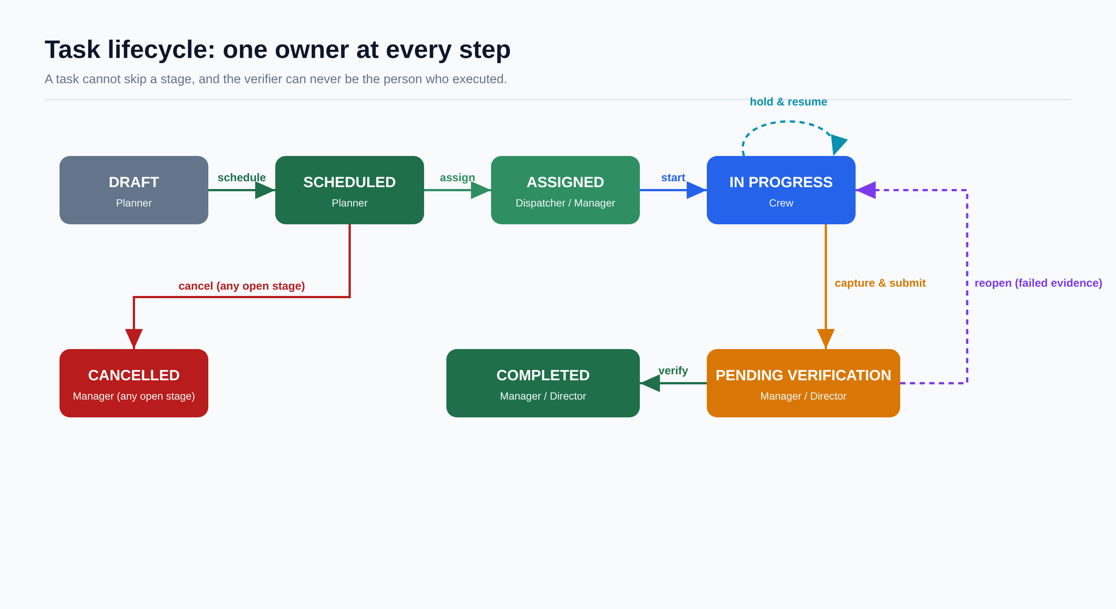
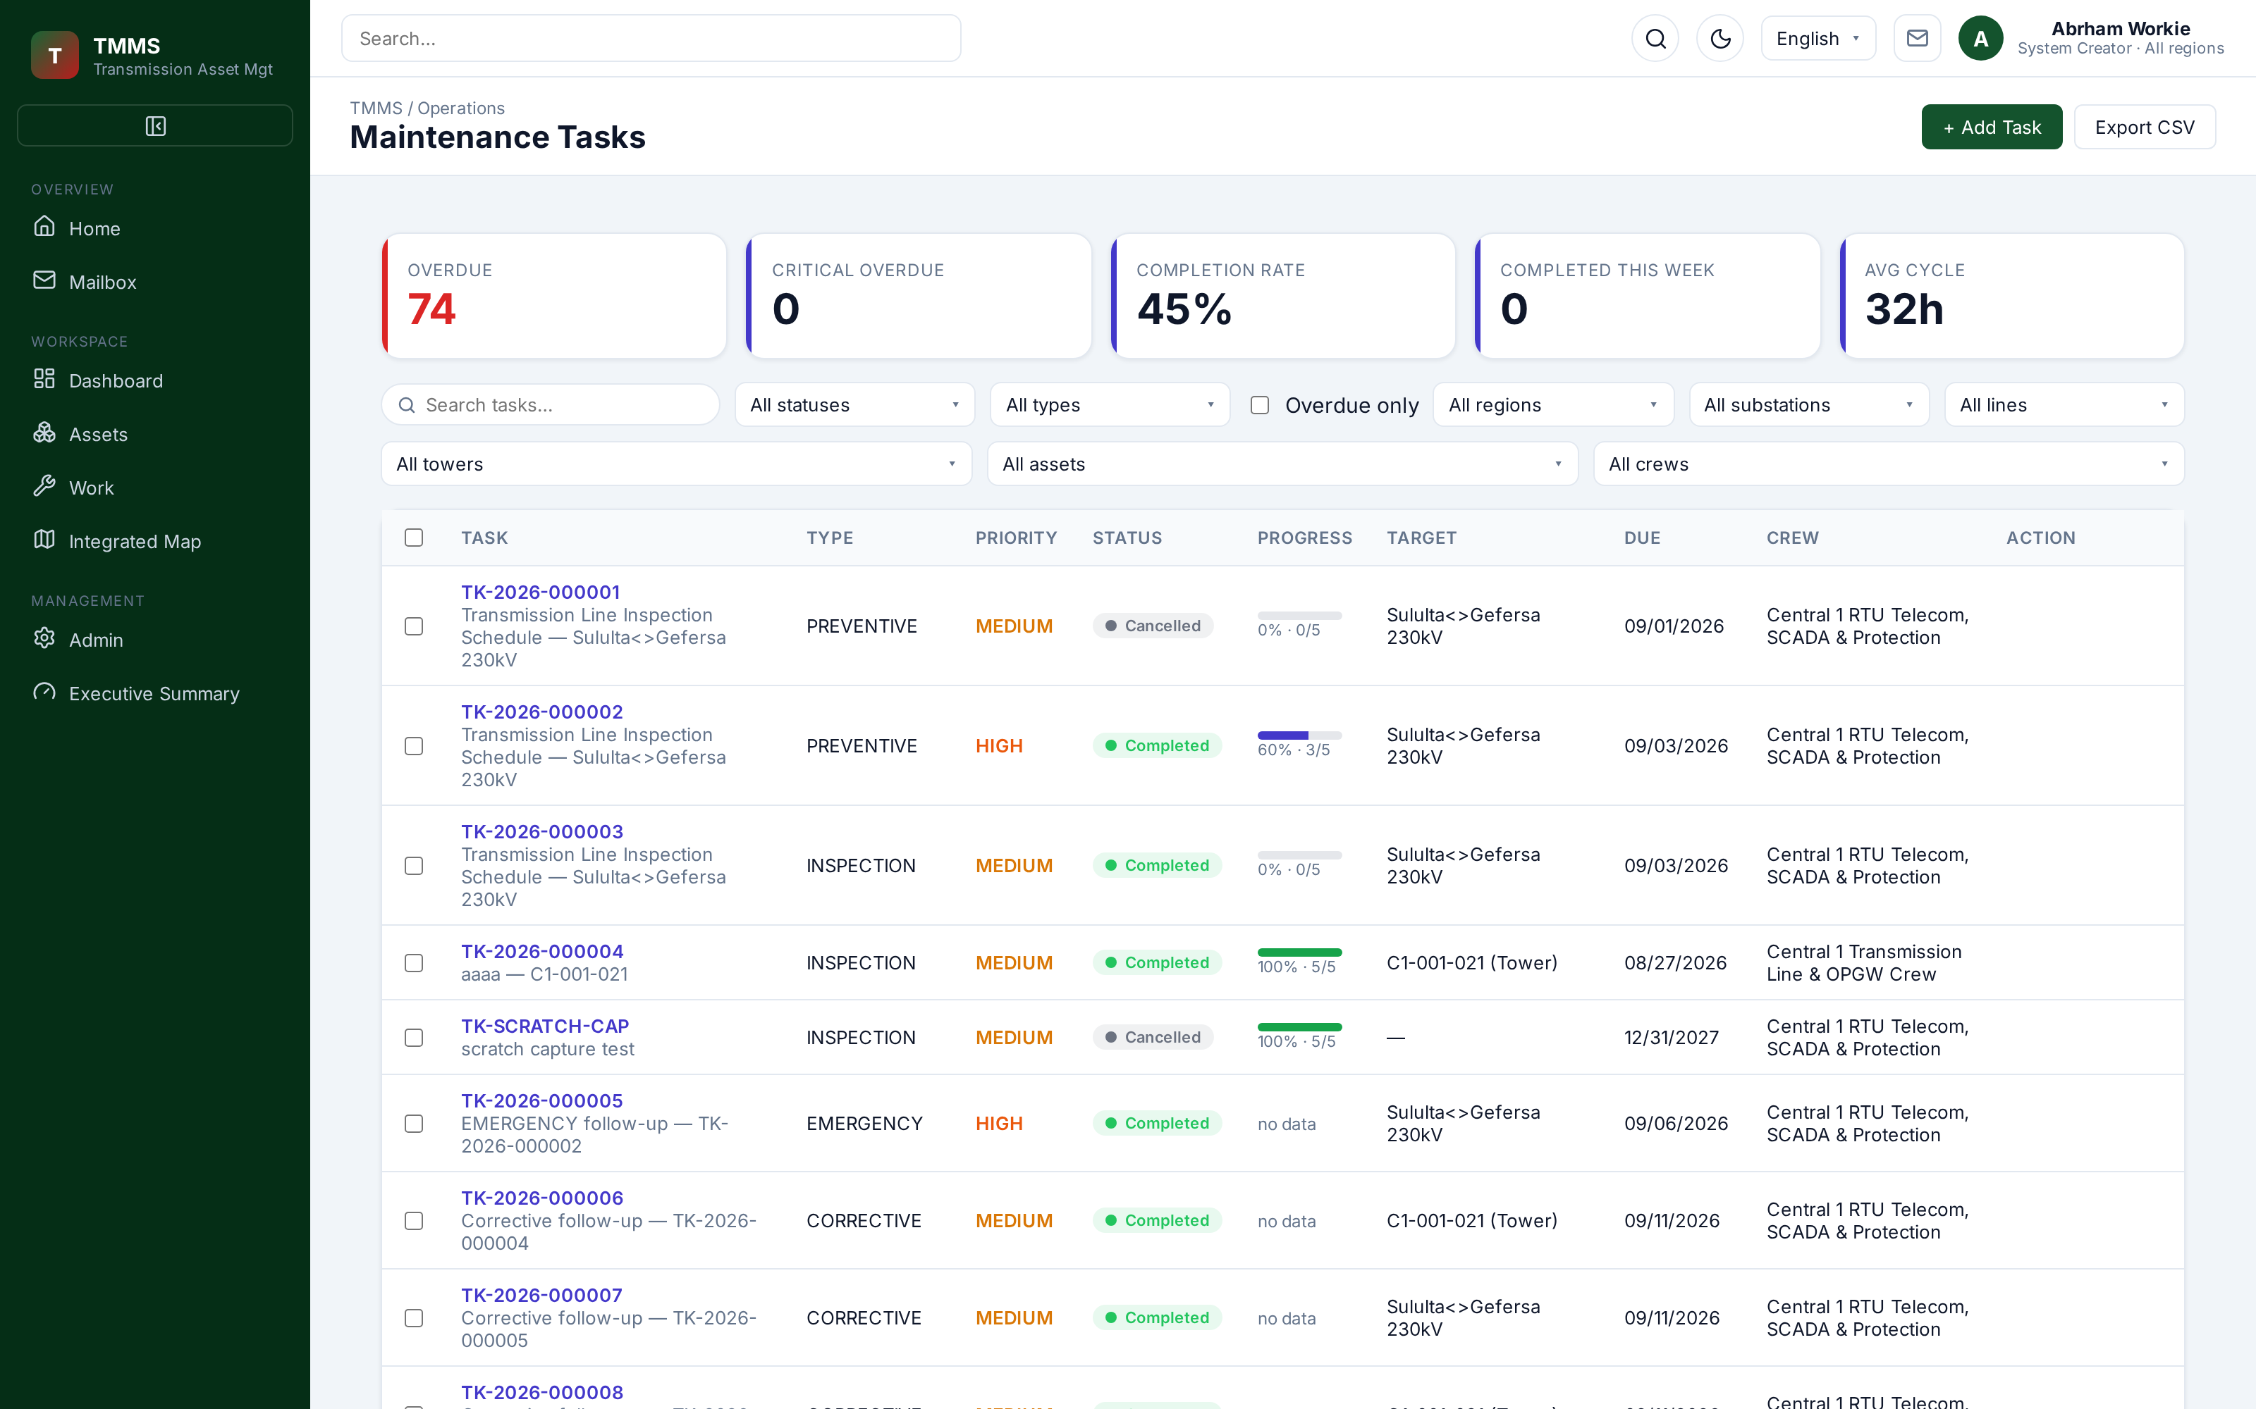 | 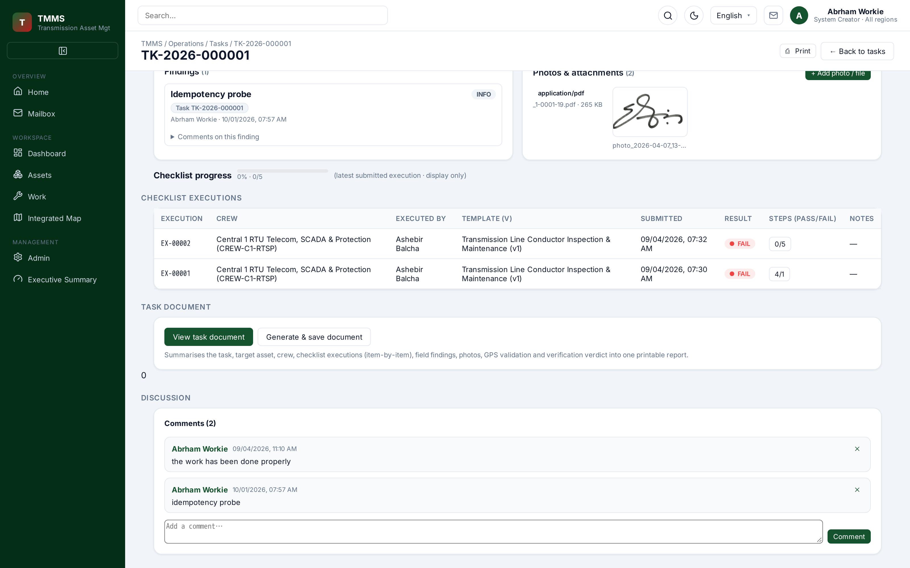
Task list — full list with filtering and bulk work. | Task evidence — checklist executions, photos, signature and document.
Emergency path  A task can be raised straight to ASSIGNED, skipping draft and calendar. | Follow-up work  Failed evidence auto-suggests corrective or emergency follow-ups. | Dispatch eligibility  Skills and certifications are checked before a crew is assigned.

FIELD OPERATIONS
Crews, schedules, checklists and certifications

Recurring maintenance is planned once and generated automatically. Crews execute standardised checklists step by step, and the platform knows who holds which qualification and when it expires.
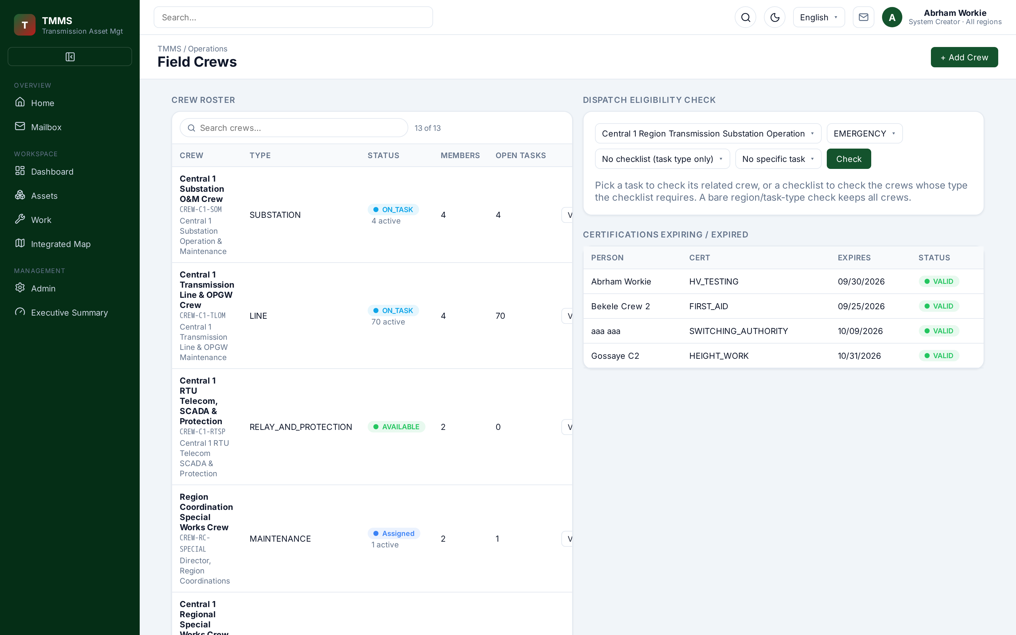 | 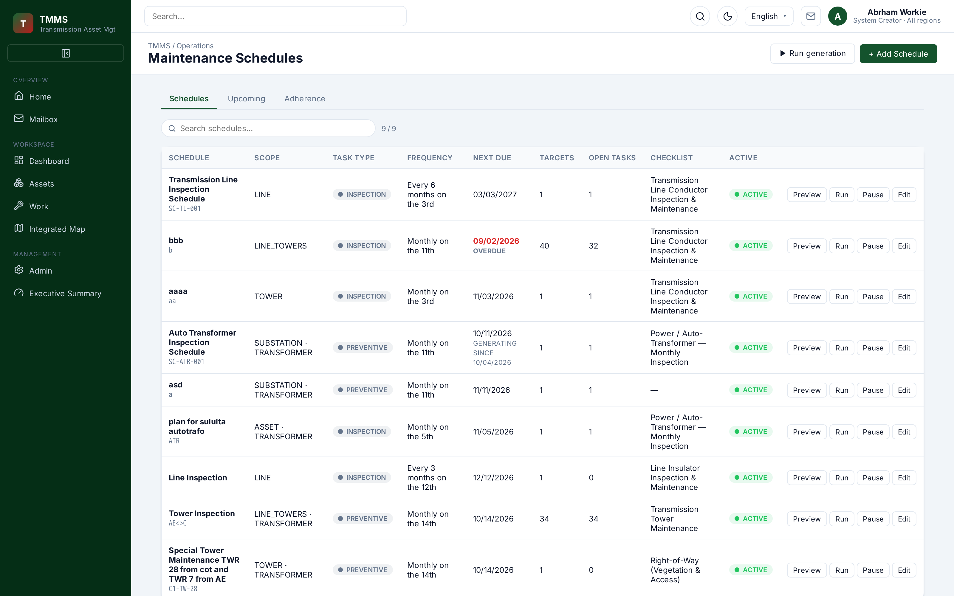
Crews — members, skills and certifications. | Schedules — recurrence rules and generation.
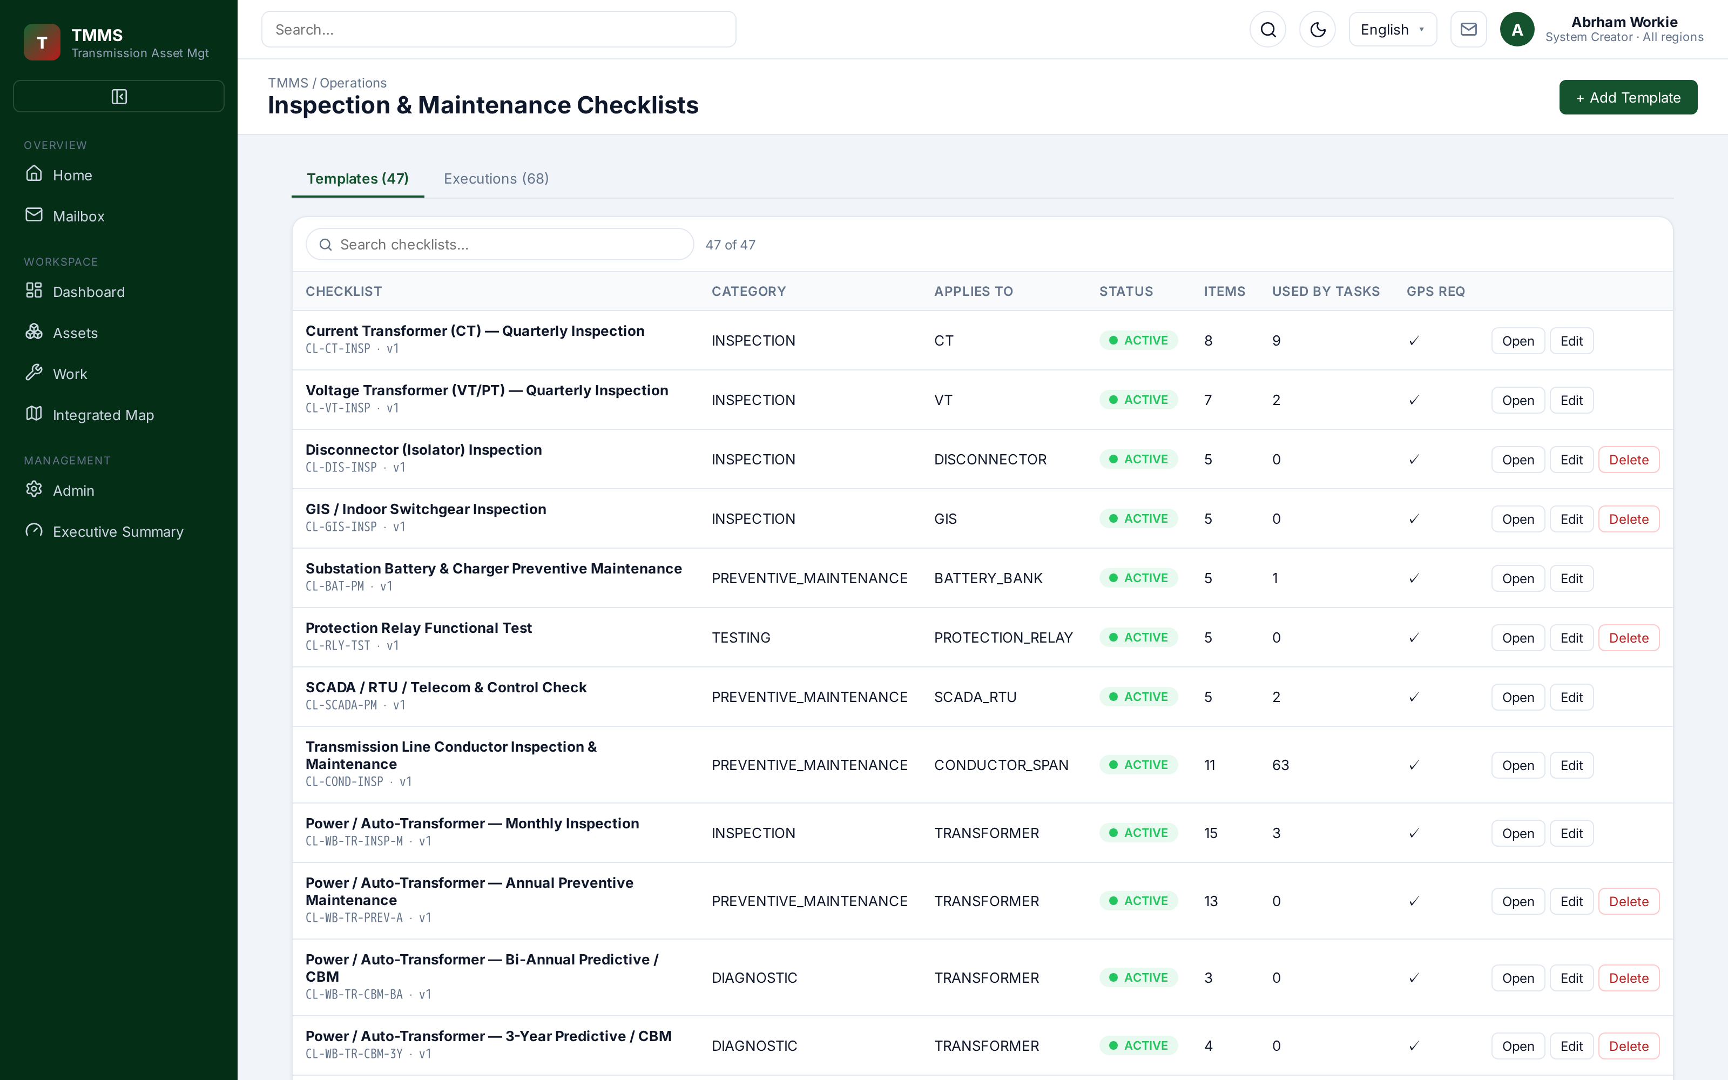 | 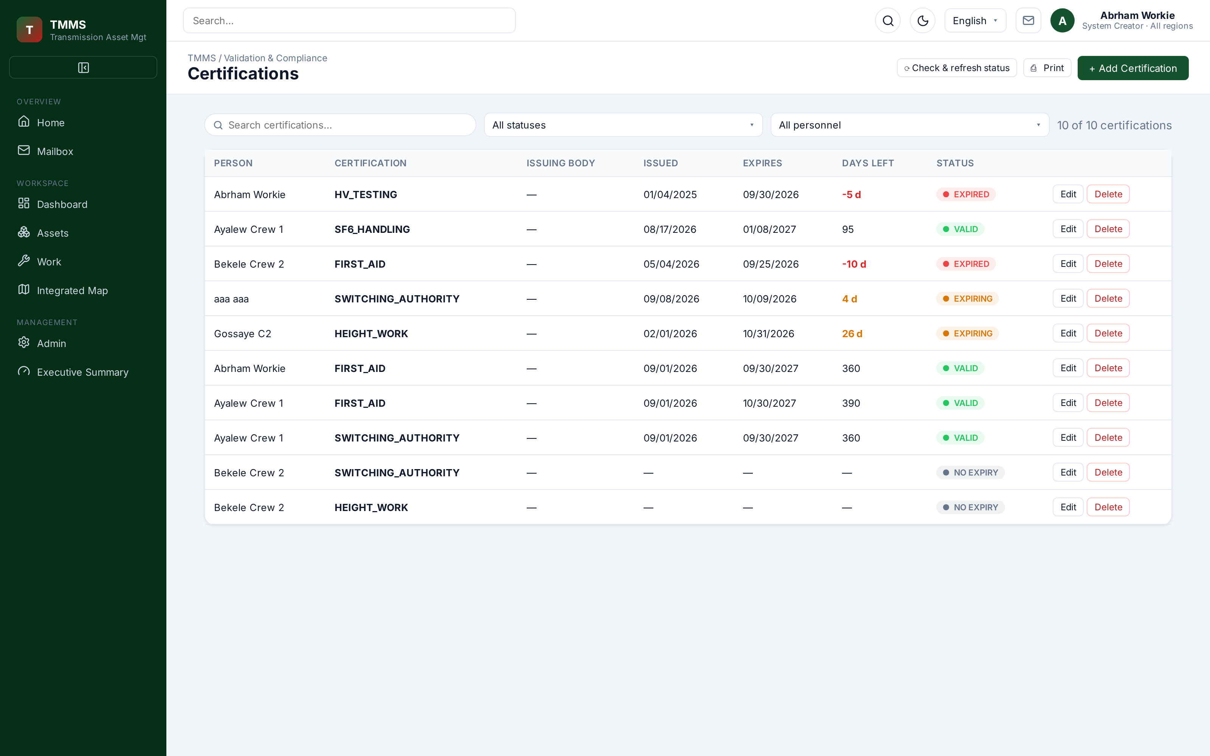
Checklists — templates and step-by-step execution. | Certifications — qualification and expiry tracking.

COMMUNICATION & EVIDENCE
Every task update, message and report in one inbox

The mailbox is the collaboration spine of the operation: task updates, direct messages and generated reports arrive as a single, searchable activity stream, with folders, labels and saved searches.
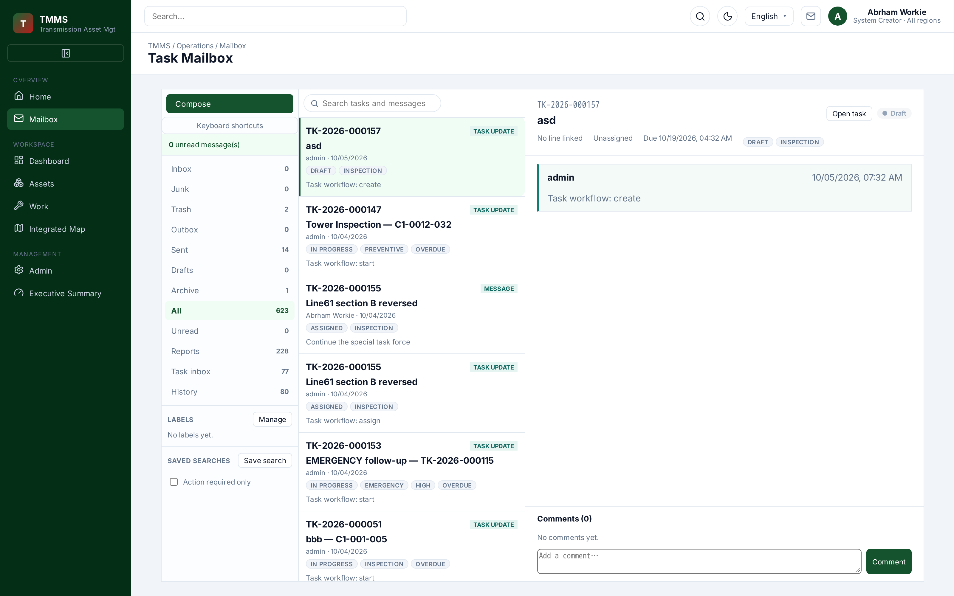
Task mailbox — 623 activity records across folders, labels and saved searches.
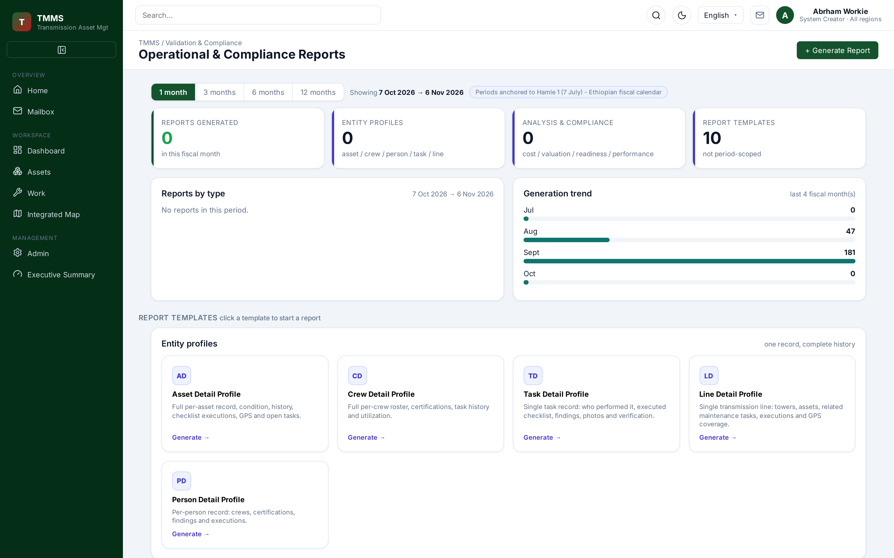 | 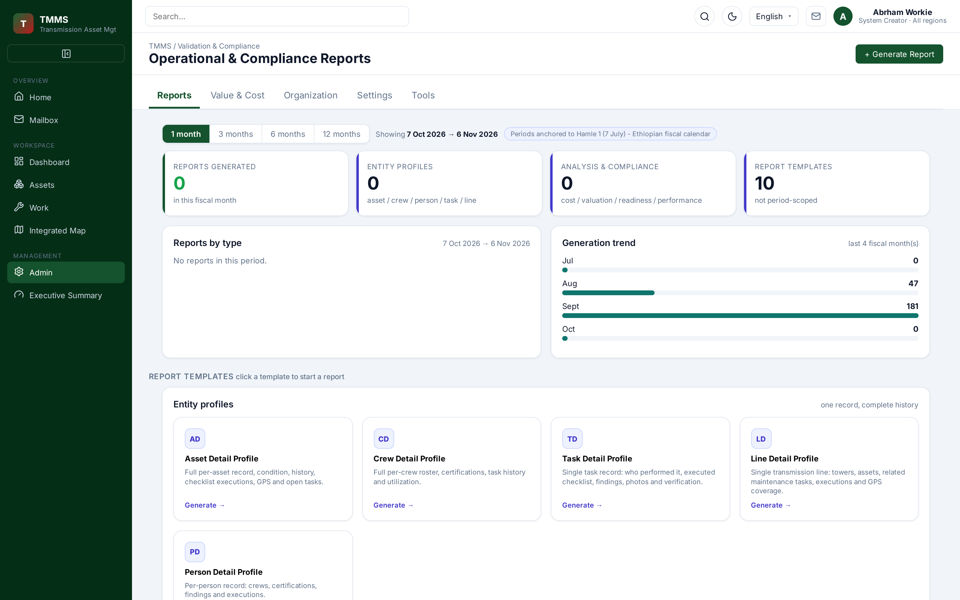
Reports — operational and compliance outputs. | Administration — reports, users and governance.

OVERSIGHT
Executive clarity, organisational discipline

An executive summary distils critical overdue work, GPS violations, expiring certifications and cost into a single board-ready view. The organisation model keeps each unit's function and the role that heads it explicit — so authority is never ambiguous.
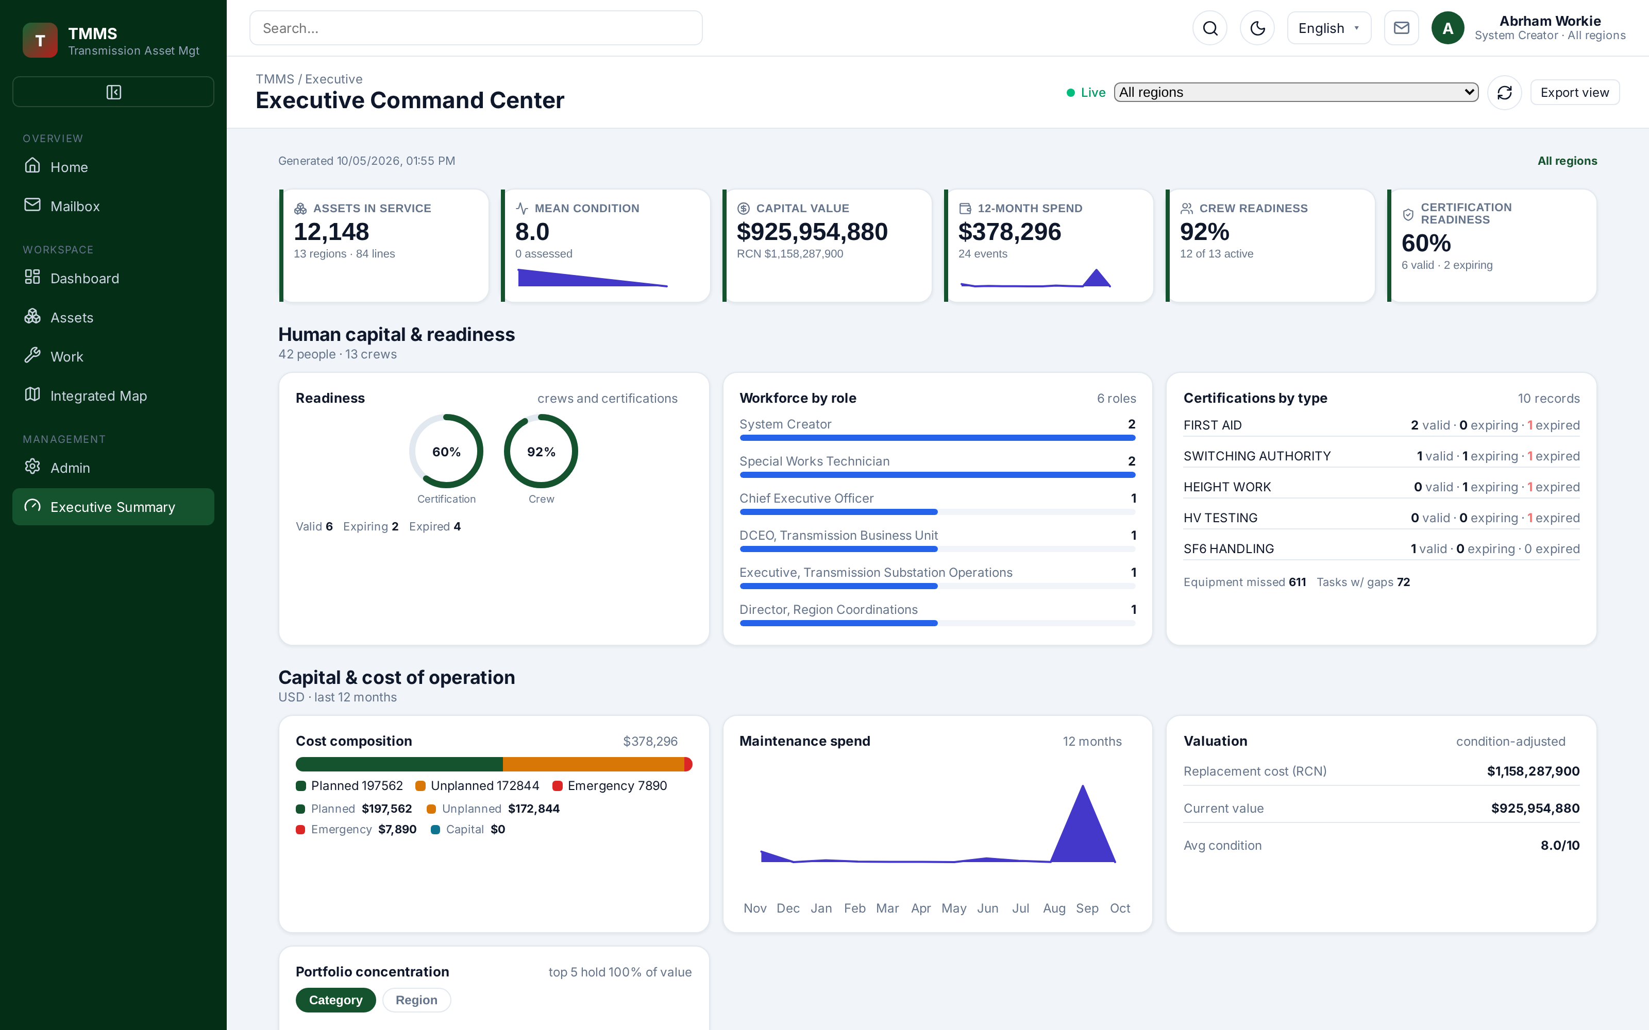 | 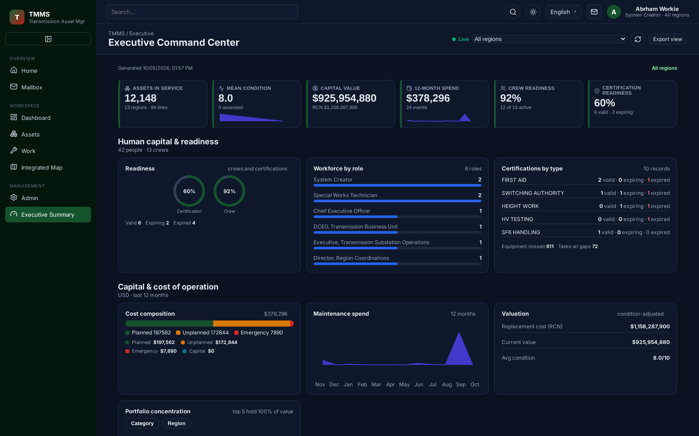
Executive summary — risks, compliance and value. | Dark theme for control-room and after-hours review.
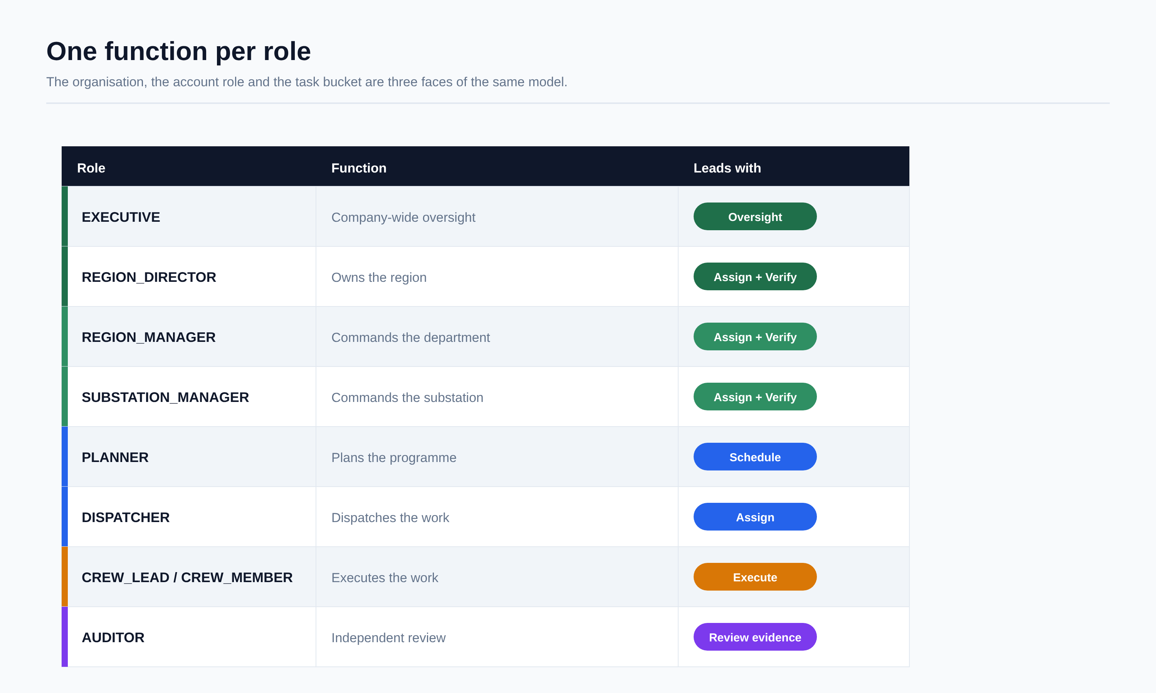

UNDER THE HOOD
Modern, secure and built to stay consistent

A React single-page console talks to a role-scoped Node / Express API over one authoritative SQLite datastore. Schema changes are idempotent, referential integrity is enforced, and every mutation is written to an audit log — with a redacted, size-capped request body.
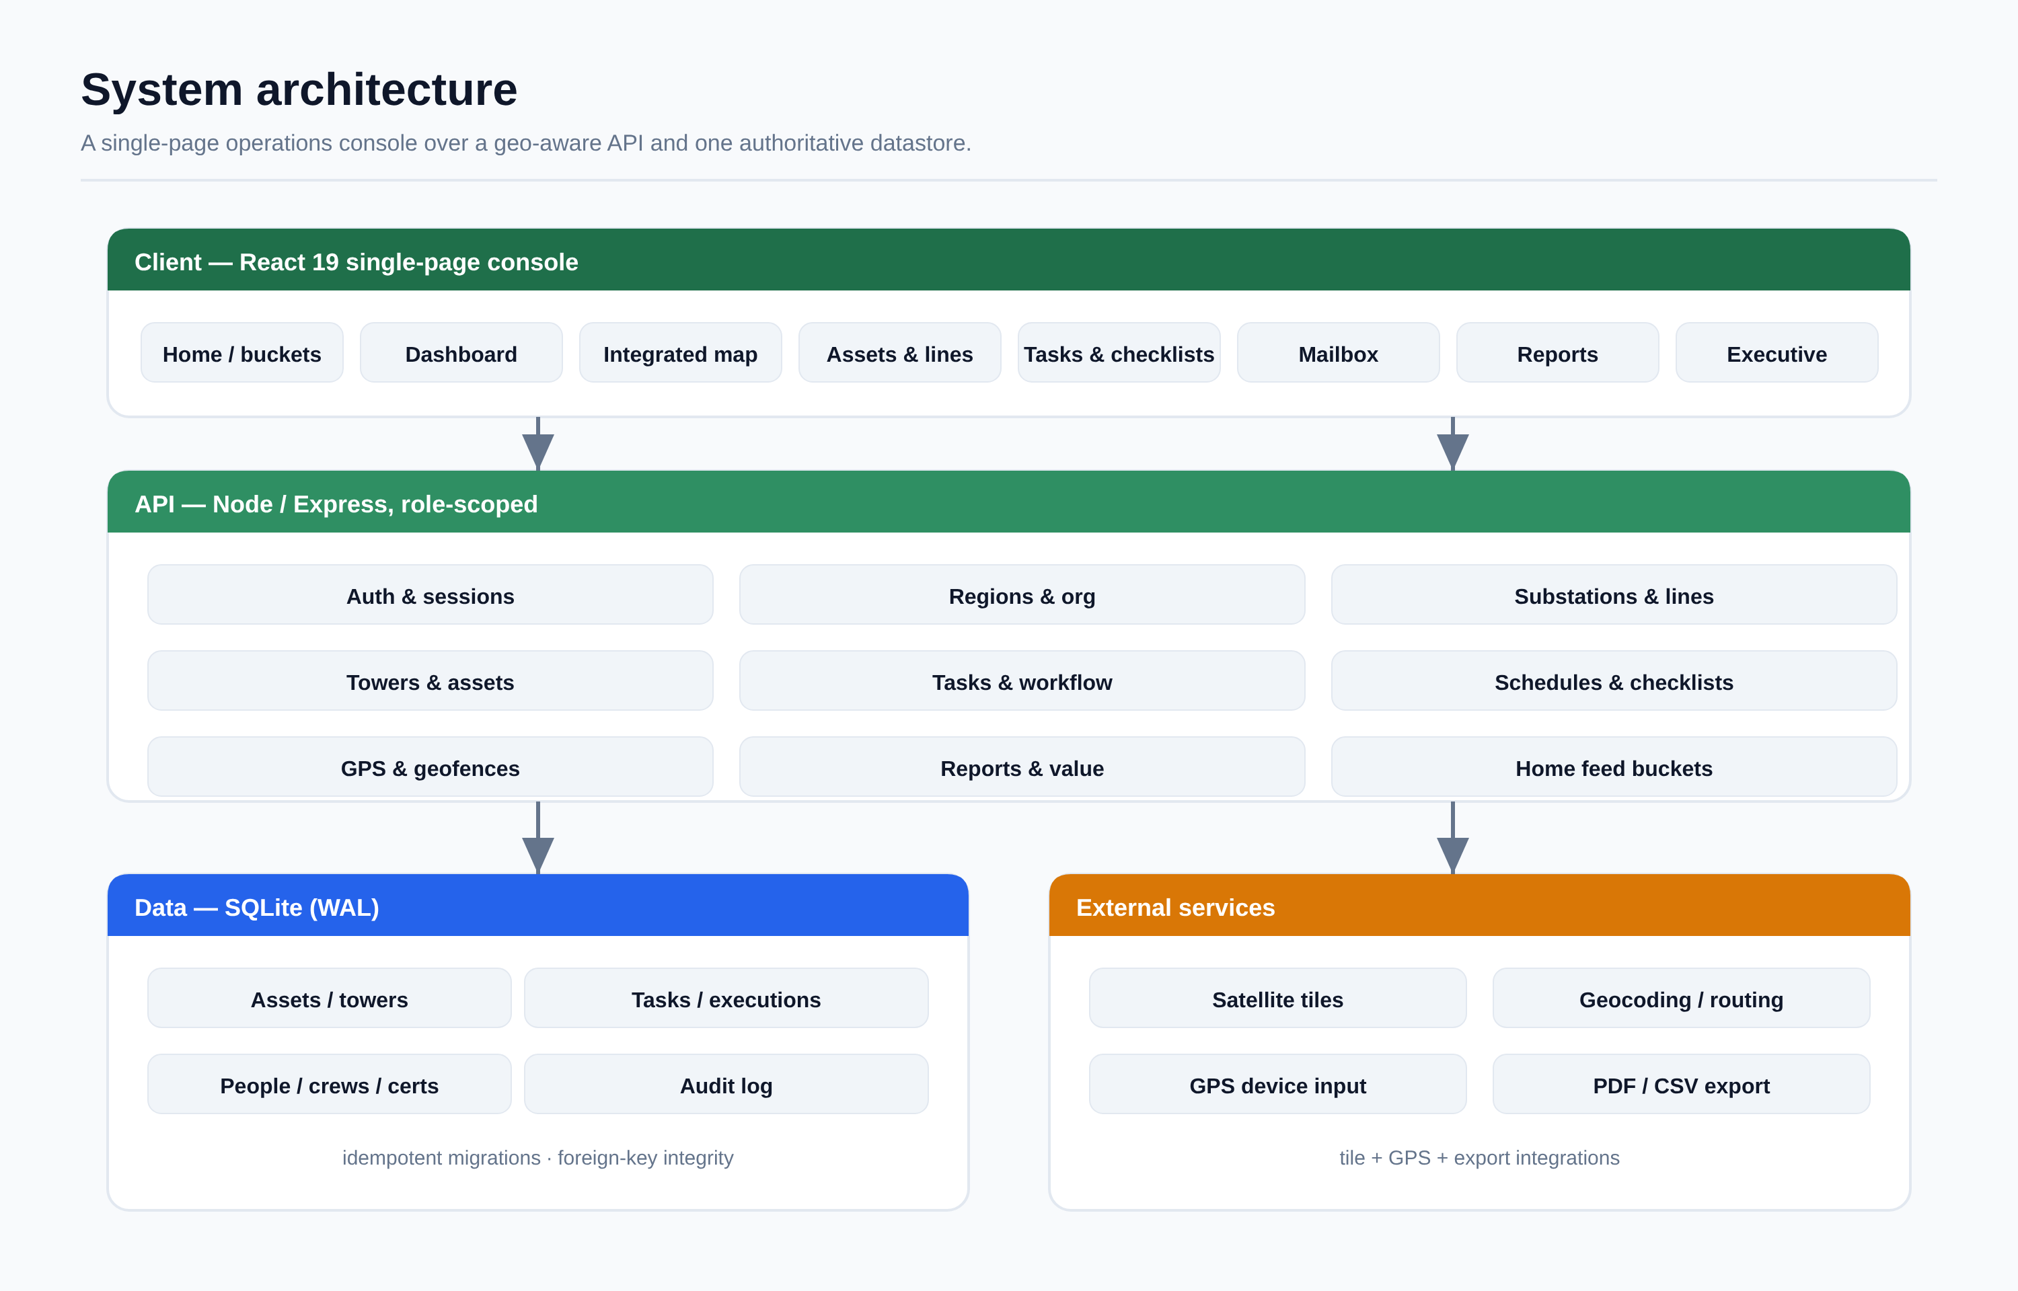
Role-scoped reads  Queries are filtered by region and department, so a manager only ever sees its own domain. | Referential integrity  Cascades are transactional and leave foreign_key_check empty. | Auditable by design  Sessions expire, expired sessions are pruned, and sensitive fields are redacted.

One platform. One truth. Every tower, task and proof.
Plan · Dispatch · Execute · Document · Verify

