FDD 033 Tech Notes

Key components

- Custom .NET WebAPI (CclWebApi)

Target framework: .NET FW 4.6.1
Template: ASP.NET Web Application / Web API (MVC / Web API references)
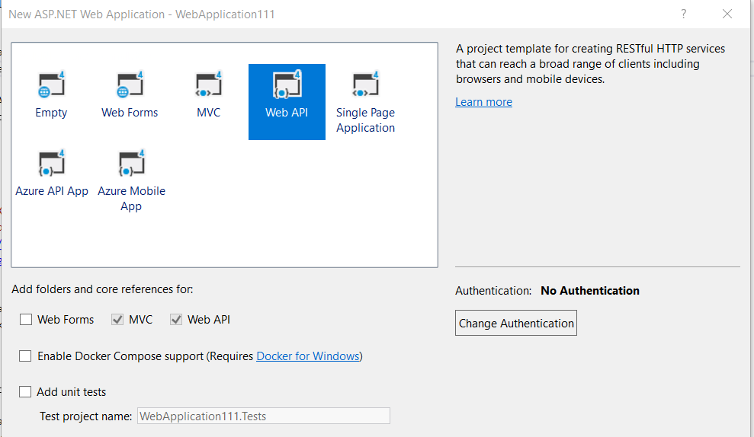
Deployment: Azure as App Service. Azure AD secured (Oauth 2).
References: CRM SDK, ClosedXML (for Excel manipulation)

Notes:
Local test method: https://cclwebapidev.azurewebsites.net/api/Session/GetVersion
Token parameters:
Authority: https://login.windows.net/SAGlobal.onmicrosoft.com
Resource: https://cclwebapidev.azurewebsites.net
ClientID: cd8af6c8-b81c-43ed-9d54-d0ff2da87db1
Secret: 200K7+0XBDkII86B5uo7Mcpc+N9jpbrYCBuh6gclSJo=
TenantID: 85d3d2d0-e41a-4759-ac99-6bc18c0b5f4b

- Client side web resource

Name: ccl_exceltemplate.js - CCLBOT_FormChanges Solution
UI location (screenshot): “Upload Excel” button set on Session/Session Track area
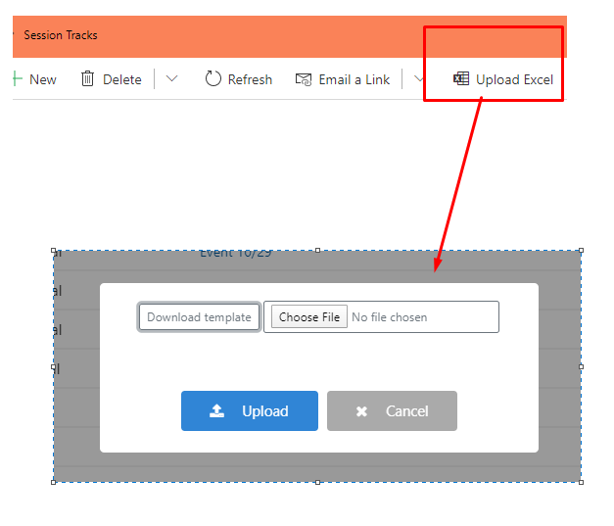
List of referencing JS libraries (with purpose):
- https://cdn.jsdelivr.net/npm/sweetalert2@9
- https://maxcdn.bootstrapcdn.com/bootstrap/4.0.0/css/bootstrap.min.css
- https://cdnjs.cloudflare.com/ajax/libs/font-awesome/4.7.0/css/font-awesome.min.css
Note: if you want to change excel template, open ccl_exceltemplate.js webresource. Find downloadTemplate() function. There, you can change name of the file and content. If you want to change content, you must convert it to base64 string, copy it and replace inside function. Publish webresource…

- Custom WF activity
Name: ccl_ExcelAccessToken – CCLBOT_FormChanges Solution
Purpose: to generate Token so that Web Resource can invoke Web Api
Config parameters (screenshot):
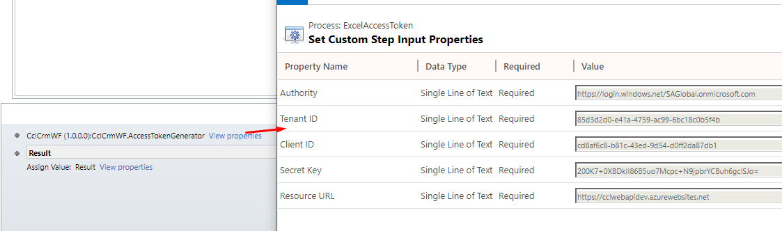
*Deactivate Custom Action and change params

