EXP.NO: 4
Create a web form that accepts a user’s name and age. Write a Servlet to process the form data and display it back on the browser.
DATE: 06/02/2025

AIM:
To design a web form that accepts the user’s name and age, and to develop a Servlet program to process the form data and display it back on the browser.

ALGORITHM:

1. Input:
- The user enters their name and age in a web form.
- The form is submitted to the server.

2. Form Creation:
- Create an HTML form using <form> tag.
- Add input fields:
  - Name (text)
  - Age (number)
- Add a submit button.
- Set:
action="NameAgeServlet"
method="post"

3. Servlet Program Flow:

1. Create Servlet Class:
- Create a Java class extending HttpServlet.
- Use annotation:
@WebServlet("/NameAgeServlet")

2. Handle Request:
- Override doPost() method.
- Retrieve values using:
request.getParameter("name");
request.getParameter("age");

3. Process Data:
- Store name and age in variables.
- Optionally validate age.

4. Generate Response:
- Set content type:
response.setContentType("text/html");
- Use PrintWriter to display output:
Hello [name]! You are [age] years old.

4. Compile the Servlet:
- Compile using javac.
- Generate .class file.

5. Deploy the Servlet:
- Place class file in:
WEB-INF/classes
- Configure using annotations or web.xml.

6. Execute the Program:
- Start Apache Tomcat server.
- Open browser and access:
http://localhost:8080/your-project/index.html

7. Output Display:
- After submitting the form, the browser displays:
Hello [name]! You are [age] years old.

CODE:

Index.html:
<!DOCTYPE html>
<html>
<head>
<title>User Details</title>
</head>
<body>

<h2>Enter Your Details</h2>

<form action="NameAgeServlet" method="post">

Name:
<input type="text" name="name" required><br><br>

Age:
<input type="number" name="age" required><br><br>

<input type="submit" value="Submit">

</form>

</body>
</html>

NameAgeServlet.java:
import java.io.*;
import javax.servlet.*;
import javax.servlet.annotation.WebServlet;
import javax.servlet.http.*;

@WebServlet("/NameAgeServlet")
public class NameAgeServlet extends HttpServlet {

protected void doPost(HttpServletRequest request,
HttpServletResponse response)
throws ServletException, IOException {

String name = request.getParameter("name");
String age = request.getParameter("age");

response.setContentType("text/html");
PrintWriter out = response.getWriter();

out.println("<html>");
out.println("<head><title>Output</title></head>");
out.println("<body>");

out.println("<h2>Hello, my name is " + name + " and my age is " + age + ".</h2>");

out.println("</body>");
out.println("</html>");
}
}

OUTPUT:

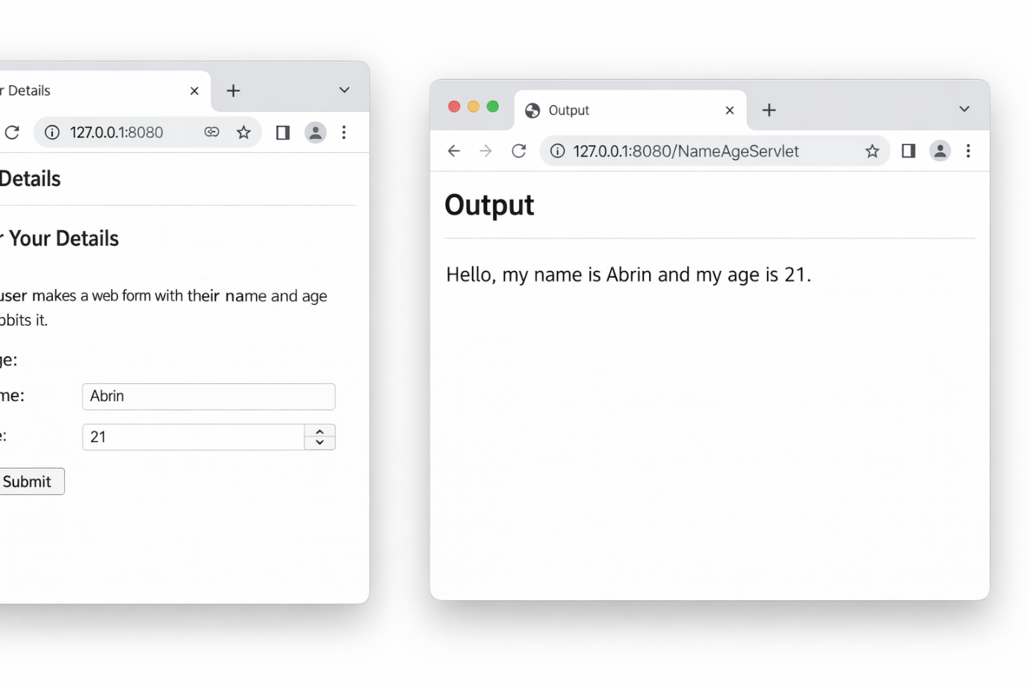

RESULT:
The web form was successfully created and the Servlet program processed the user input and displayed the result on the browser.

