EXP-01
AIM:
To create a Personal Portfolio web page that embeds a map with hotspots, frames, and links. The web page is designed using HTML and incorporates embedded, external, and inline CSS for styling. This experiment helps in understanding multimedia integration, clickable image hotspots, navigation links, and layout design using different CSS methods.

ALGORITHM:
Create the HTML Structure:
• Set up the basic HTML document using <html>, <head>, and <body> tags.
• In the <head>, link the external CSS file using the <link> tag and define the title of the page.
• In the <body>, create the necessary sections such as header, sidebar, content area, and footer.
• Frames: Use the <iframe> tag to embed external content like a Google Map.
• Map: Display the location using an embedded Google Map.
• Hotspots: Use <map> and <area> tags to create clickable regions on an image (GitHub image).
• Links: Use <a> tags to provide navigation links to different sections and external websites.

Create CSS Styles:
• External CSS: Define layout, colors, fonts, and alignment in a separate CSS file.
• Inline CSS: Apply styling directly inside HTML elements using the style attribute.
• Embedded CSS: Define specific styles inside the <style> tag within the <head> section.

Map with Hotspots:
• Use <map> tag to define an image map.
• Use <area> tag with coordinates to create a clickable hotspot that redirects to a GitHub profile.

Frames:
• Use <iframe> tag to embed Google Map showing the user’s location.

Add Links:
• Use <a> tag for sidebar navigation and external GitHub link.

Test the Page:
• Check whether the hotspot image redirects correctly.
• Verify the Google Map loads properly.
• Ensure all CSS styles (inline, embedded, external) are applied correctly.

Program:
Index.html:
<html>
<head>
<title>Personal Portfolio Builder</title>
<link rel="stylesheet" href="style.css">
<style>
.info {
background-color: #e6f2ff;
padding: 10px;
margin: 10px;
border-left: 5px solid blue;
}
</style>
</head>
<body>
<div class="header">
<img src="https://encrypted-tbn0.gstatic.com/images?q=tbn:ANd9GcRRxO6LiCalie3n7O7PnZlzqOd8cfpP70-O9g&s">
<span><h1>Personal Portfolio Builder</h1></span>
</div>
<div class="main">
<div class="container">
<div class="sidebar">
<h3>Sections</h3>
<a href="#">About</a>
<a href="#">Skills</a>
<a href="#">Projects</a>
<a href="#">Contact</a>
</div>
<div class="content">
<h2>Welcome</h2>
<p style="color:green; font-weight:bold;">
Create and customize your professional portfolio website.
</p>
<div class="info">
You can add your GitHub profile and location details here.
</div>
<h2>GitHub Profile</h2>
<img src="https://encrypted-tbn0.gstatic.com/images?q=tbn:ANd9GcRZfLuviePOqQJ1yuhvxr80AsqV91Btr2rqZw&s"
usemap="#githubmap" width="200">
<map name="githubmap">
<area shape="rect"
coords="0,0,200,200"
href="https://github.com/"
target="_blank">
</map>
<h2>Your Location</h2>
<iframe
src="https://maps.google.com/maps?q=Nagercoil&t=&z=13&ie=UTF8&iwloc=&output=embed"
width="100%"
height="250">
</iframe>
</div>
</div>
</div>
<div class="footer">
<p>© 2026 Personal Portfolio Project</p>
</div>
</body>
</html>

Style.css:
body {
font-family: Arial, sans-serif;
margin: 0;
background-color: #f2f2f2;
min-height: 100vh;
display: flex;
flex-direction: column;
}
.main {
flex: 1;
}
.header {
background-color: #333;
color: white;
display: flex;
align-items: center;
gap: 12px;
position: relative;
height: 80px;
padding: 10px 20px;
}
.header img {
width: 150px;
height: auto;
}
.header span {
position: absolute;
left: 50%;
transform: translateX(-50%);
font-size: 20px;
font-weight: bold;
}
.container {
display: flex;
min-height: 80vh;
}
.sidebar {
width: 25%;
background-color: #e6e6e6;
padding: 15px;
}
.sidebar a {
display: block;
padding: 8px;
text-decoration: none;
color: black;
}
.sidebar a:hover {
background-color: #ccc;
}
.content {
width: 75%;
padding: 20px;
}
.footer {
background-color: #004aad;
color: white;
text-align: center;
padding: 10px;
}
.sidebar,
.content {
min-height: 100%;
}

Output:
Personal Portfolio web page is displayed with header, sidebar navigation, GitHub image hotspot, and embedded Google Map showing location.
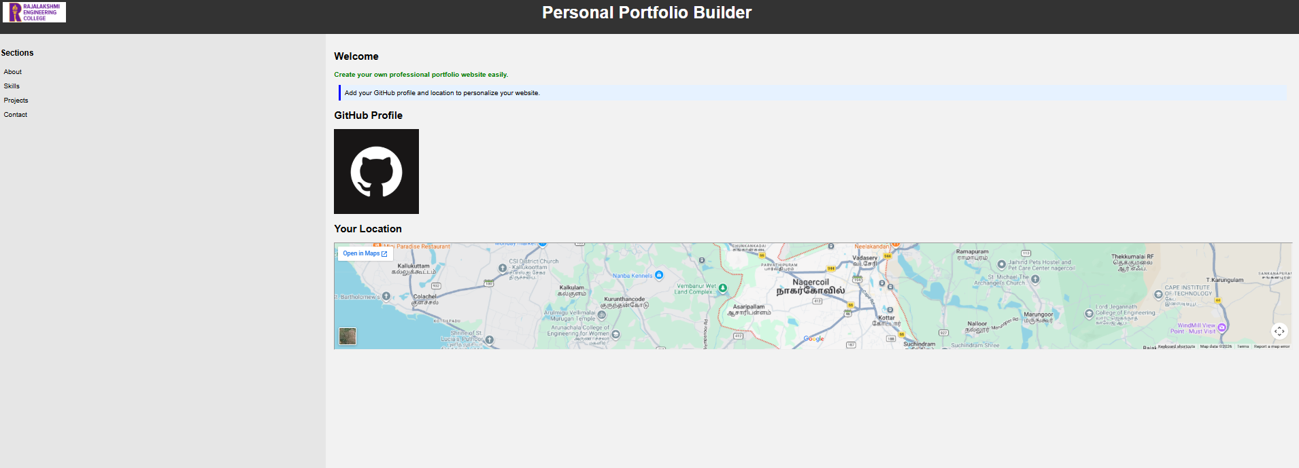

Result:
HTML page is successfully created with embedded map, hotspot image, frames, and links using inline, embedded, and external CSS for the Personal Portfolio project.

