EXP-02
AIM:
To create a Registration page for the Personal Portfolio website and validate user input using JavaScript. The form should verify required fields such as name, email, mobile number, GitHub link, resume upload, and address before submission.

ALGORITHM:
Create the HTML Structure:
• Create a Registration page using basic HTML structure.
• Link external CSS file using <link> tag.
• Link JavaScript validation file using <script> tag.
• Create form fields for user details.
• Use onsubmit event to call validation function.

Design the Form:
• Add input fields for First Name, Last Name, Email, Mobile Number.
• Add GitHub Profile link field.
• Add Resume upload field.
• Add Address field using <textarea>.
• Add Terms & Conditions checkbox.
• Add Submit button.

Apply CSS:
• Use external CSS file for styling.
• Use proper layout and spacing for form elements.

JavaScript Validation:
• Validate name (alphabets only).
• Validate email (must contain @gmail.com).
• Validate mobile number (10 digits).
• Validate GitHub link format.
• Ensure address is not empty.
• Ensure resume is uploaded.
• Ensure terms checkbox is selected.

Test the Page:
• Check all validations work properly.
• Ensure form does not submit if errors exist.
• Confirm success message appears when valid.

Program

Registration.html
<html>
<head>
<meta charset="UTF-8">
<title>Personal Portfolio - Registration</title>
<link rel="stylesheet" href="style.css">
<script src="validate_reg.js"></script>
</head>
<body>
<div class="container">
<h2>Portfolio Registration Form</h2>
<form name="regForm" onsubmit="return validateForm()">
<div class="form-grid">
<div>
<label>First Name</label>
<input type="text" name="fname">
</div>
<div>
<label>Last Name</label>
<input type="text" name="lname">
</div>
<div>
<label>Email ID</label>
<input type="text" name="email">
</div>
<div>
<label>Mobile Number</label>
<input type="text" name="mobile">
</div>
<div>
<label>GitHub Profile Link</label>
<input type="text" name="github">
</div>
<div>
<label>Upload Resume</label>
<input type="file" name="resume">
</div>
<div class="full">
<label>Address</label>
<textarea name="address"></textarea>
</div>
<div class="full terms">
<input type="checkbox" name="terms"> I agree to the Terms & Conditions
</div>
</div>
<input type="submit" value="Register">
</form>
</div>
</body>
</html>

Style.css
body {
margin: 0;
font-family: Arial, sans-serif;
background-color: lightblue;
}
.container {
width: 460px;
margin: 50px auto;
background-color: white;
padding: 25px;
border-radius: 8px;
box-shadow: 0 0 12px rgba(0,0,0,0.15);
}
h2 {
text-align: center;
color: #003080;
}
label {
display: block;
margin-top: 12px;
font-weight: 600;
}
input, textarea {
width: 100%;
padding: 8px;
margin-top: 5px;
border-radius: 4px;
border: 1px solid #ccc;
}
textarea {
resize: none;
height: 70px;
}
.terms {
margin-top: 15px;
}
.terms input {
width: auto;
}
input[type="submit"] {
margin-top: 20px;
background-color: #004aad;
color: white;
font-size: 16px;
border: none;
cursor: pointer;
padding: 10px;
border-radius: 5px;
}
input[type="submit"]:hover {
background-color: #003080;
}
.form-grid {
display: grid;
grid-template-columns: repeat(2, 1fr);
gap: 15px;
}
.form-grid .full {
grid-column: span 2;
}

validate_reg.js
function validateForm() {
let fname = document.regForm.fname.value;
let lname = document.regForm.lname.value;
let email = document.regForm.email.value;
let mobile = document.regForm.mobile.value;
let github = document.regForm.github.value;
let resume = document.regForm.resume.value;
let address = document.regForm.address.value;
let terms = document.regForm.terms.checked;
let namePattern = /^[A-Za-z]+$/;
if (!namePattern.test(fname)) {
alert("First Name must contain only alphabets");
return false;
}
if (!namePattern.test(lname)) {
alert("Last Name must contain only alphabets");
return false;
}
let emailPattern = /^[a-zA-Z0-9._%+-]+@gmail\.com$/;
if (!emailPattern.test(email)) {
alert("Email must be a valid @gmail.com address");
return false;
}
let mobilePattern = /^[0-9]{10}$/;
if (!mobilePattern.test(mobile)) {
alert("Mobile Number must contain exactly 10 digits");
return false;
}
if (!github.startsWith("https://github.com/")) {
alert("Enter a valid GitHub Profile link");
return false;
}
if (resume === "") {
alert("Please upload your Resume");
return false;
}
if (address.trim() === "") {
alert("Address cannot be empty");
return false;
}
if (!terms) {
alert("Please agree to the Terms & Conditions");
return false;
}
alert("Registration Successful!");
return true;
}

Output:
Portfolio Registration page is displayed with form fields and validation functionality.
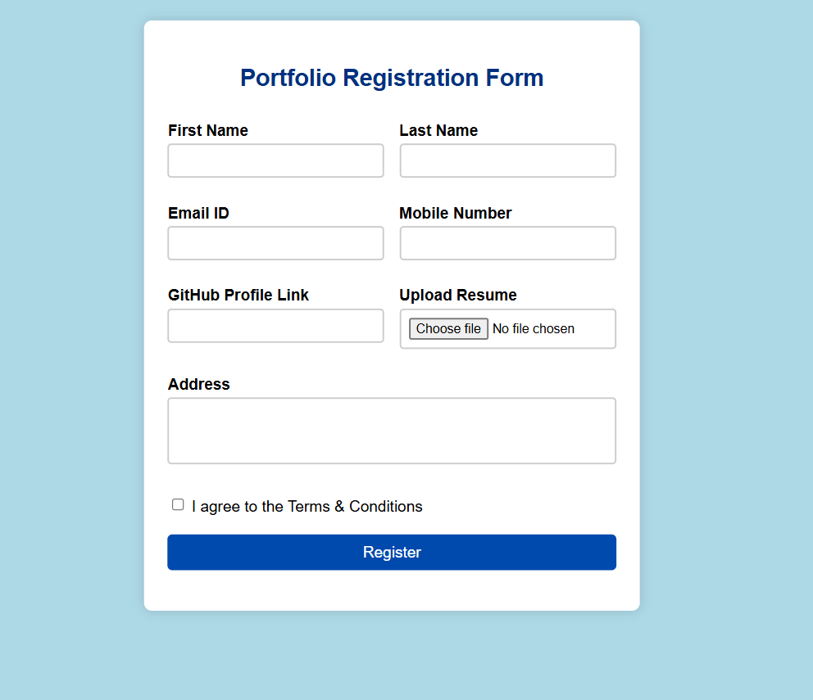

Result:
Registration page for the Personal Portfolio project is successfully created with proper JavaScript validation. All input fields are validated before submission.

