EXP.NO: 5 | Write a Servlet to demonstrate the difference between HTTP GET and POST methods by creating a form and handling requests accordingly.
DATE:05/03/2025

AIM:
To demonstrate the difference between the HTTP GET and POST methods by creating a form in an HTML page and handling the form submissions using two different HTTP methods in a Java Servlet.
ALGORITHM:
1. Input:
- The user fills out a web form with their name and email.
- The form will use both GET and POST methods for data submission.

2. Steps for Creating and Handling the HTTP GET and POST Requests:
- Create an HTML Form:
  - Design an HTML form with two input fields: one for the name and one for the email.
  - Create two buttons to allow the user to submit the form using GET or POST methods.
  - Use the action attribute to define the Servlet URL and specify the form method (either GET or POST).
- Create the Servlet to Handle GET and POST Requests:
  - Write a Java Servlet class that will handle both GET and POST requests.
  - The servlet will have two methods:
    - doGet() to handle the GET requests.
    - doPost() to handle the POST requests.
  - In both methods, retrieve the form data using request.getParameter().
  - In the doGet() method, process and display the data in the URL.
  - In the doPost() method, process and display the data in the HTTP request body.
- Handle GET Requests in the Servlet:
  - In the doGet() method, use request.getParameter() to retrieve the name and email submitted via GET.
  - Output the data as a response, including the name and email in the URL (visible to the user).
- Handle POST Requests in the Servlet:
  - In the doPost() method, use request.getParameter() to retrieve the name and email submitted via POST.
  - Output the data as a response, displaying the name and email without exposing them in the URL (more secure).
- Return the Output:
  - The Servlet should return an HTML page displaying the name and email entered by the user.
  - For the GET method, the output should be visible in the URL.
  - For the POST method, the output should be visible in the response body, not the URL.
- Deploy and Test the Servlet:
  - Compile the Servlet class and deploy it to a Servlet container (like Apache Tomcat).
  - Test the form using GET and POST methods to see the difference in data submission.
- Observe and Compare GET and POST Results:
  - Test the GET method: The form data is sent in the URL.
  - Test the POST method: The form data is sent in the HTTP request body, not visible in the URL.
Code:
Servlet.java
import java.io.*;
import javax.servlet.*;
import javax.servlet.http.*;
import javax.servlet.annotation.WebServlet;

@WebServlet("/Exp5Servlet")
public class Exp5Servlet extends HttpServlet {

// GET METHOD
protected void doGet(HttpServletRequest request,
HttpServletResponse response)
throws ServletException, IOException {

String name = request.getParameter("name");
String email = request.getParameter("email");

response.setContentType("text/html");
PrintWriter out = response.getWriter();

out.println("<html><body style='font-family:Arial;'>");
out.println("<h2 style='color:green;'>GET Method Output</h2>");

out.println("<p>Name: " + name + "</p>");
out.println("<p>Email: " + email + "</p>");

out.println("<p><b>Data is visible in URL</b></p>");

out.println("<a href='exp5.html'>Back</a>");
out.println("</body></html>");
}

// POST METHOD
protected void doPost(HttpServletRequest request,
HttpServletResponse response)
throws ServletException, IOException {

String name = request.getParameter("name");
String email = request.getParameter("email");

response.setContentType("text/html");
PrintWriter out = response.getWriter();

out.println("<html><body style='font-family:Arial;'>");
out.println("<h2 style='color:blue;'>POST Method Output</h2>");

out.println("<p>Name: " + name + "</p>");
out.println("<p>Email: " + email + "</p>");

out.println("<p><b>Data is NOT visible in URL</b></p>");

out.println("<a href='exp5.html'>Back</a>");
out.println("</body></html>");
}
}
exp5.html
<!DOCTYPE html>
<html>
<head>
<title>Portfolio - GET & POST</title>

<!-- Embedded CSS -->
<style>
body {
font-family: Arial;
background-color: #f2f6ff;
}

.container {
display: flex;
justify-content: space-around;
margin-top: 50px;
}

.box {
width: 40%;
background: white;
padding: 20px;
border-radius: 10px;
box-shadow: 0 0 10px gray;
}

h2 {
text-align: center;
}

input {
width: 100%;
padding: 8px;
margin: 8px 0;
}

button {
width: 100%;
padding: 10px;
background-color: #004aad;
color: white;
border: none;
}
</style>
</head>

<body>

<h1 style="text-align:center;">GET & POST Demonstration</h1>

<div class="container">

<!-- GET FORM -->
<div class="box">
<h2>GET Method (Search Portfolio)</h2>

<form action="Exp5Servlet" method="get">
<input type="text" name="name" placeholder="Enter Name">
<input type="email" name="email" placeholder="Enter Email">
<button type="submit">Submit using GET</button>
</form>
</div>

<!-- POST FORM -->
<div class="box">
<h2>POST Method (Register)</h2>

<form action="Exp5Servlet" method="post">
<input type="text" name="name" placeholder="Enter Name" required>
<input type="email" name="email" placeholder="Enter Email" required>
<button type="submit">Submit using POST</button>
</form>
</div>

</div>

</body>
</html>

Output:
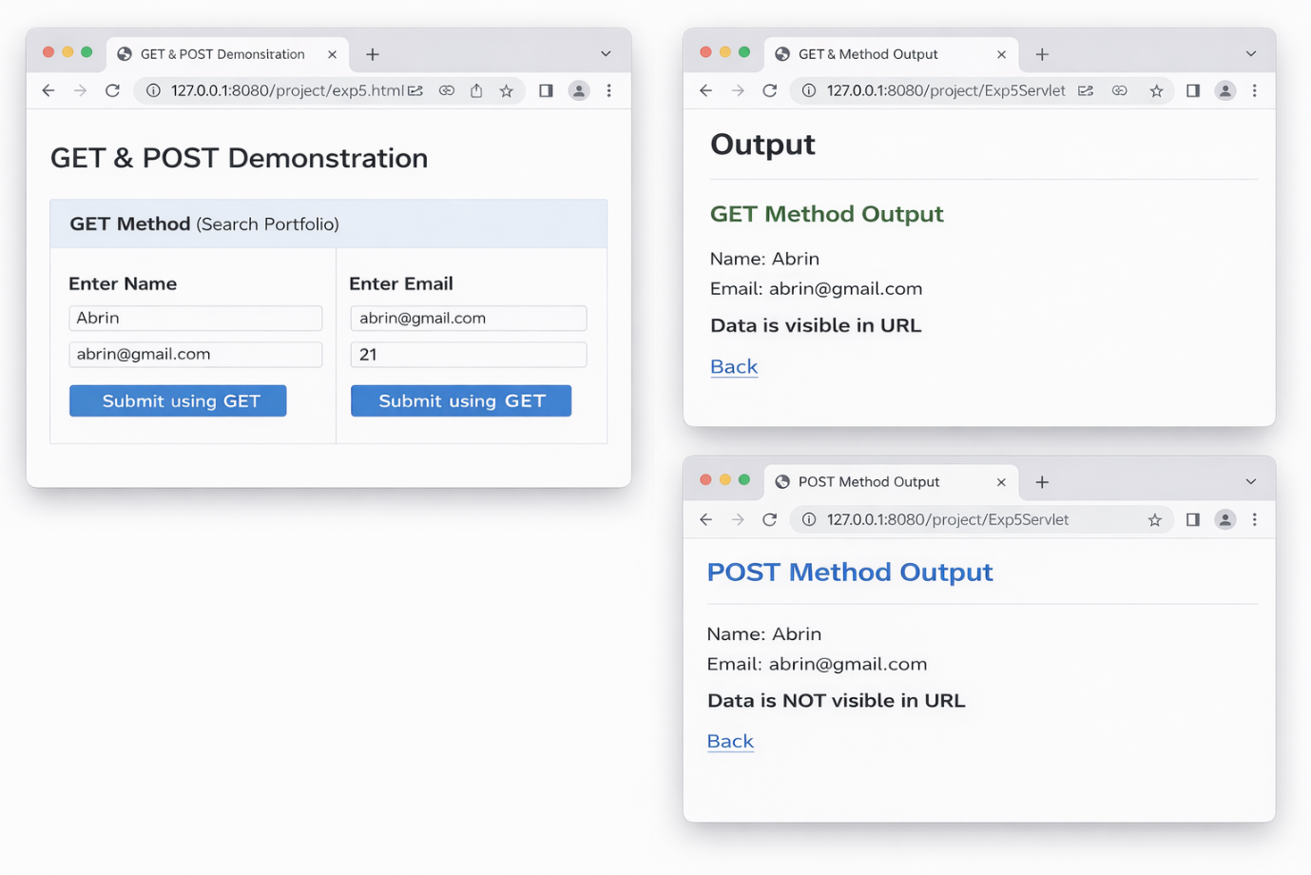
RESULT:
A Servlet is created to demonstrate the difference between HTTP GET and POST methods by creating a form and handling requests accordingly.

