LabadaGo: A Laundry Shop Management System
Karl Andrei Abriz
IT342 G01

1. Introduction

1.1 Project Title
LabadaGo: A Laundry Shop Management System

1.2 System Overview
LabadaGo is a three part system a Spring Boot backend API, a ReactJS web dashboard for staff, and an Android Kotlin mobile app for customers. All three connect to the same database through the backend so data stays consistent across both platforms.

1.3 Purpose of the System
The goal is to replace the manual, paper-based way most small laundry shops track their orders. Staff get a faster way to log and manage orders, and customers can check their laundry status without calling or going to the shop.

1.4 Target Users
- Shop Staff / Admin — uses the web dashboard to manage orders and update statuses
- Customers — uses the Android app to track orders and view order history

1.5 Problem Statement
Most small laundry shops still write orders in logbooks and track everything by hand. This leads to lost records, wrong price computations, and customers having no way to check on their laundry remotely. As the shop gets busier, this system becomes harder to manage without mistakes.

1.6 Scope of the System
The system covers:
- User registration and login for staff and customers
- Creating and managing laundry orders through the web dashboard
- Updating order status through five stages
- Customer order tracking and history through the mobile app
- A shared backend API and database used by both platforms
- Online deployment of the backend and web app

1.7 Assumptions and Constraints
- The shop has at least one computer for staff to use the dashboard
- Customers need an Android device running OS 8.0 or higher
- Both staff and customers need internet access to use the system
- Online payment is not included in this version
- Pickup and delivery scheduling is not included
- The system supports only one shop no multi-branch support

2. Stakeholders and Users
The following people or groups have a direct role in the LabadaGo system:
Stakeholder | Type | Role
Laundry Shop Owner | Primary Stakeholder | Approves system use and oversees operations
Shop Staff / Admin | Primary User | Records orders and updates statuses via the web dashboard
Customers | Primary User | Tracks orders and views history via the mobile app
Developer | Technical Stakeholder | Builds, tests, deploys, and maintains the system

3. Functional Requirements
The table below lists all functional requirements. Each one has a unique ID and is written in a way that can be tested.
ID | Requirement | Description
FR-001 | User Registration | The system must let new users sign up with their name, email, password, and role (staff or customer)
FR-002 | User Login | The system must let registered users log in with their email and password, and reject wrong credentials
FR-003 | Role-Based Access | Staff can only access the web dashboard. Customers can only access order features on the mobile app
FR-004 | Create Laundry Order | Staff must be able to create a new order with customer name, load weight, service type, and price
FR-005 | Update Order Status | Staff must be able to move an order through: Received Washing, Drying, Ready, for Pickup, Claimed
FR-006 | View All Orders | Staff must be able to see all orders and filter them by status
FR-007 | Customer Order Tracking | Customers must be able to see the current status of their active order on the mobile app
FR-008 | Order History | Customers must be able to view past orders with service type, price, and completion date
FR-009 | Logout | All users must be able to log out from both the web and mobile apps
FR-010 | Payment Status | Staff must be able to mark orders as Paid or Unpaid. No online payment is included

4. Non-Functional Requirements
These requirements define the quality standards the system must meet.
ID | Category | Description
NFR-001 | Performance | API responses (like loading orders) must return within 3 seconds under normal connection
NFR-002 | Security | The system must use JWT authentication. Passwords must be hashed using BCrypt. Unauthorized API access must be blocked
NFR-003 | Usability | The web dashboard and mobile app must be simple enough to use without any training
NFR-004 | Reliability | Order data must always be consistent between the web and mobile apps
NFR-005 | Availability | The deployed backend and web app must have at least 95% uptime
NFR-006 | Compatibility | Web app must work on Chrome, Edge, and Firefox. Mobile app must support Android 8.0 or higher
NFR-007 | Maintainability | The backend must follow a layered architecture (Controller Service Repository) to keep future updates manageable

5. Business Rules
These are the rules and conditions the system must follow at all times.
ID | Rule
BR-001 | Users must be registered and logged in before accessing any protected feature
BR-002 | Staff can only use the web dashboard. Customers can only use the mobile app order features
BR-003 | Every new order must be assigned a status right away. Default status is “Received”
BR-004 | Order status can only move forward: Received → Washing → Drying → Ready for Pickup → Claimed. It cannot go backward
BR-005 | An order must have a customer name, a load weight above 0, and a service type before it can be saved
BR-006 | Payment status defaults to Unpaid when an order is created. Staff must manually change it to Paid
BR-007 | Customers can only see their own orders. They cannot view or change other customers’ orders
BR-008 | Email addresses must be unique. The system must not allow duplicate emails during registration

6. Requirements Traceability Table
This table shows how each requirement connects to a use case and the UML diagrams that model it.
Req ID | Requirement | Use Case | UML Models
RT-001 | User Registration | Register Account | Use Case Diagram, Activity Diagram
RT-002 | User Login | Login | Use Case Diagram, Sequence Diagram, Activity Diagram
RT-003 | Role-Based Access | Login / Access Control | Use Case Diagram, Sequence Diagram
RT-004 | Create Laundry Order | Create Order | Use Case Diagram, ERD, Activity Diagram, Sequence Diagram
RT-005 | Update Order Status | Update Status | Use Case Diagram, Activity Diagram, Sequence Diagram
RT-006 | View All Orders | View Orders | Use Case Diagram, ERD
RT-007 | Customer Order Tracking | Track Order | Use Case Diagram, Sequence Diagram
RT-008 | Order History | View Order History | Use Case Diagram, ERD
RT-009 | Logout | Logout | Use Case Diagram
RT-010 | Payment Status | Update Payment | Use Case Diagram, ERD, Activity Diagram

7. Revision History
This table summarizes the changes made from the initial SRS submission to this finalized version.
Version | Date | Description of Changes
1.0 | [Initial submission date] | Initial SRS submitted, covering baseline functional and non-functional requirements, stakeholders, and scope.
2.0 | July 1, 2026 | Revised and reworded all sections for clarity and precision. Refined Functional and Non-Functional Requirements to be more specific and testable, and clarified Business Rules. Added the Requirements Traceability Table linking requirements to UML models. Added the full set of UML models (Use Case Diagram, Entity Relationship Diagram, Activity Diagram, and Sequence Diagram). Added this Revision History table to document the changes made during finalization.

8. System Models (UML Diagrams)

8.1 Use Case Diagram
Actors: Shop Staff and Customer. Use cases include: Register Account, Login, Create Order, Update Order Status, View Orders, Track Order, View Order History, and Logout.

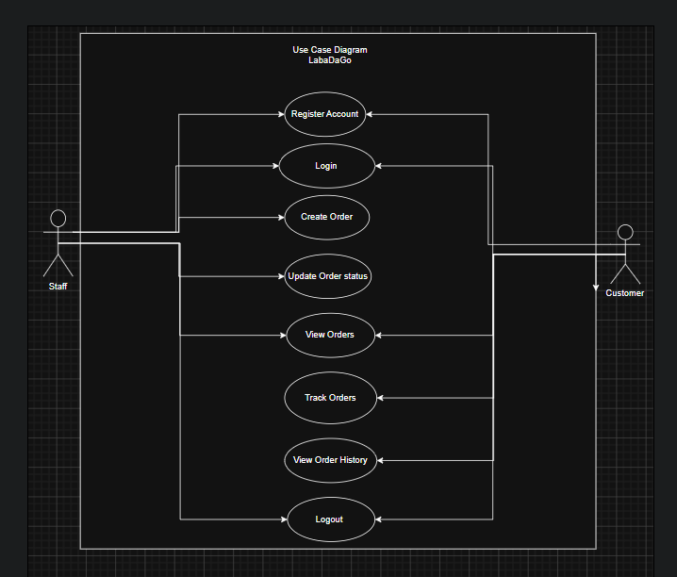

8.2 Entity Relationship Diagram (ERD)
Entities:
- User — UserID (PK), Name, Email, Password, Role
- Order — OrderID (PK), CustomerName, LoadWeight, ServiceType, Price, Status, PaymentStatus, DateCreated, UserID (FK)
- Service — ServiceID (PK), ServiceName, PricePerKg
Relationships: A User can have many Orders. Each Order is linked to one Service type.

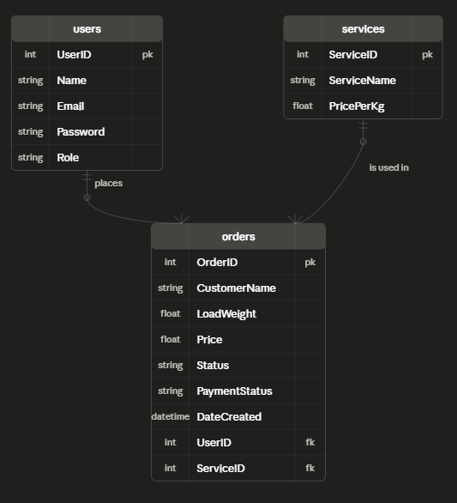

8.3 Activity Diagram
Models the “Create and Track Laundry Order” workflow from staff creating an order to the customer viewing the updated status on the mobile app.
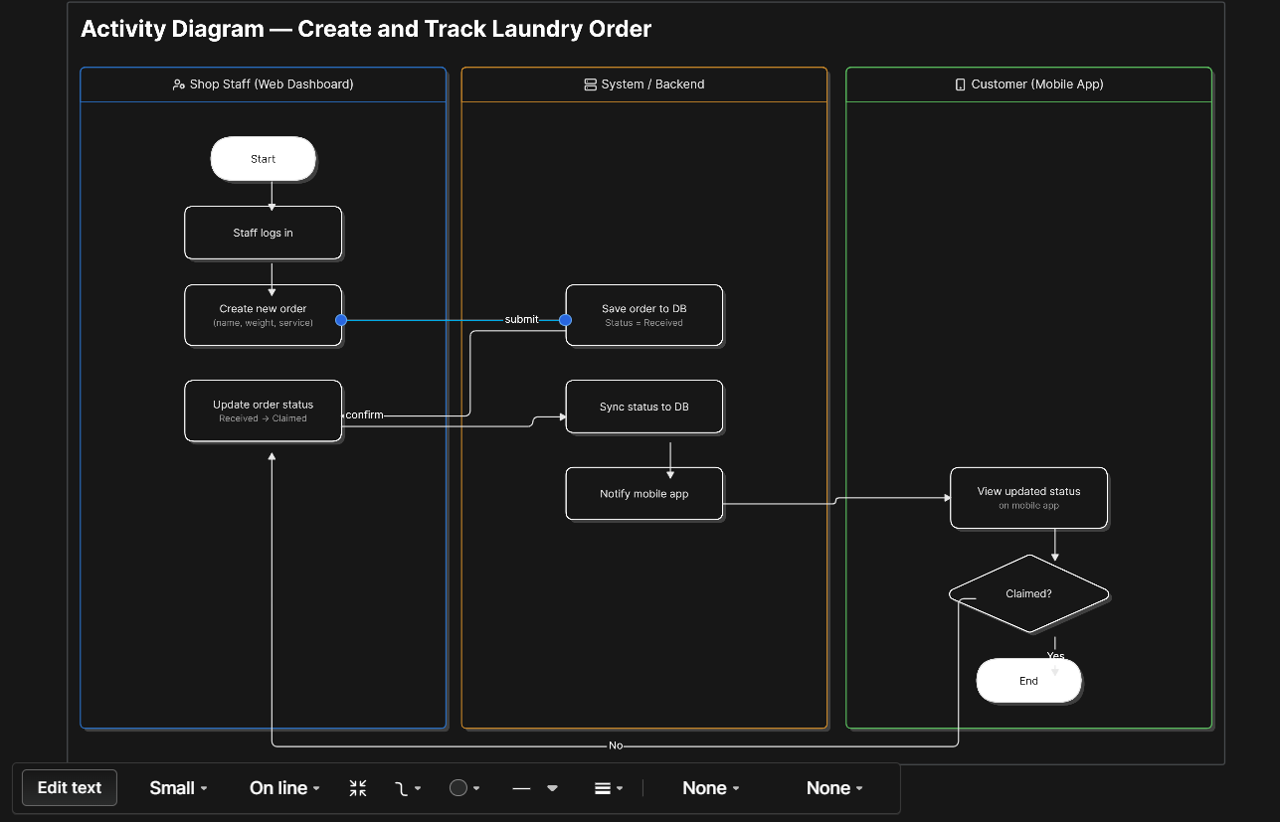

8.4 Sequence Diagram
Models the “Login Process,” showing the interaction between the Actor, Login Page (UI), AuthController (backend), and Database when a user logs in and receives a JWT token.
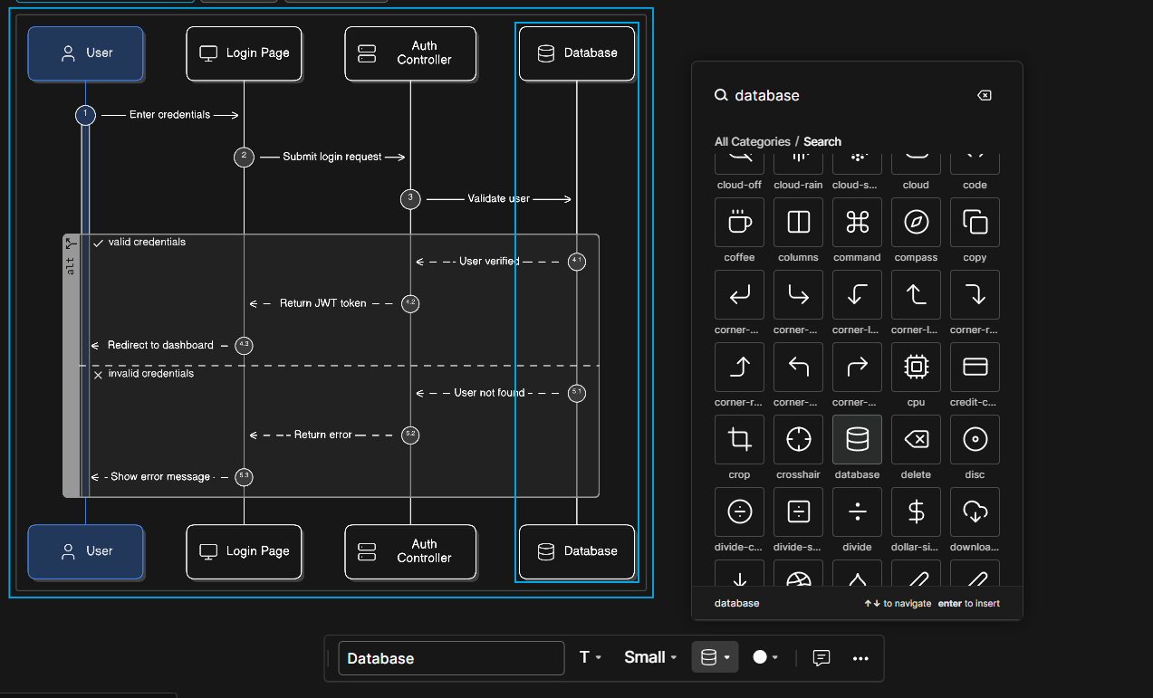

9. Technology Stack
Layer | Technology
Backend | Spring Boot (Java), Spring Security, JWT
Web App | ReactJS
Mobile App | Android (Kotlin)
Database | MySQL / PostgreSQL
Backend Deployment | Render or Railway
Web Deployment | Vercel

10. References
Spring Boot Docs — https://spring.io/projects/spring-boot
React Docs — https://react.dev
Android Kotlin Docs — https://developer.android.com/kotlin
IEEE Std 830-1998: IEEE Recommended Practice for Software Requirements Specifications

