Average

Jamshid Sodiqov

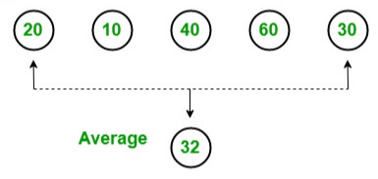

Average metodi to’plamdagi int tipidagi elementlarning o’rtacha qiymatini qaytaradi. Average metodi null, decimal, double yoki float qiymatini qaytaradi.

Quyidagi misolda to'plamdagi barcha butun sonlarning o'rtacha qiymatini qaytaradigan Agerage metodini ishlashi ko'rsatilgan:

IList<int> intList = new List<int>>() { 10, 20, 30 };

var avg = intList.Average();

Console.WriteLine("Average: {0}", avg);

Siz o'rtacha qiymatni olmoqchi bo'lgan lambda ifodasi sifatida sinfning int, decimal, double yoki float propertylarini belgilashingiz mumkin. Quyidagi misolda murakkab turdagi Average metodinini ko'rsatadi:

IList<Student> studentList = new List<Student>>() {

new Student() { StudentID = 1, StudentName = "John", Age = 13} ,

new Student() { StudentID = 2, StudentName = "Moin", Age = 21 } ,

new Student() { StudentID = 3, StudentName = "Bill", Age = 18 } ,

new Student() { StudentID = 4, StudentName = "Ram" , Age = 20} ,

new Student() { StudentID = 5, StudentName = "Ron" , Age = 15 }

};

var avgAge = studentList.Average(s => s.Age);

Console.WriteLine("Average Age of Student: {0}", avgAge);



C# dasturlash tilida Average operatori query sintaksisida qo’llab quvvatlanmaydi.