Ahmed Absal Mohamed (S2101349) (21055511)

Bigcon construction

UFCFW4-30-2 - Design and Analysis of Data Structures and Algorithms Coursework

12 Dec 2022

# Introduction

BigCon, a large construction company has sites in 4 un-inhabitant islands (A, B, C and D). Currently the company is constructing housing facilities at these islands. It owns only one dhoani to carry consumables from supplier islands to construction islands.

The purpose of this coursework is to assist the company you are required to design and implement an appropriate software to undertake the following tasks:

- Taking goods for consumption.

- Accept and add items into dhoani and island warehouses.

- Swap items between dhoani and island.

- Reject quantities of item beyond capacity.

# Identify and justify the choice of data structures and algorithms

## Assessing the current scenario

BigCon, a large construction company has sites in 4 un-inhabitant islands (A, B, C and D). Currently the company is constructing housing facilities at these islands. It owns only one dhoani to carry consumables from supplier islands to construction islands.

­­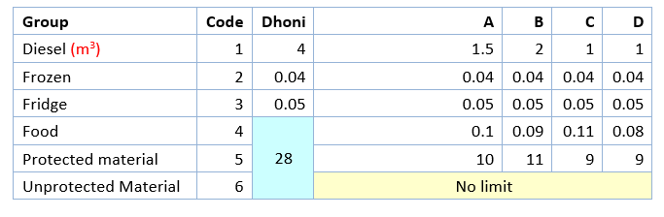

Each site storages for the types mentioned above with the maximum space available defined.

Dhoani travels between supplier islands at two ends visiting construction islands in order from A to B to C to D or D to C to B to A. Dhoni will not stop at an island where the capacity is full (for all product groups).

The following figure gives information about the distance between the islands.

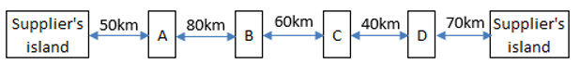

OUTPUTS

Adding materials to dhoani from island.

We start from supplier island.

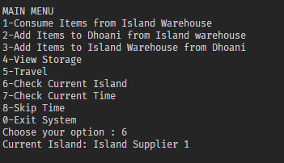

Currently the Dhoani is empty and will be loading items from supplier island one

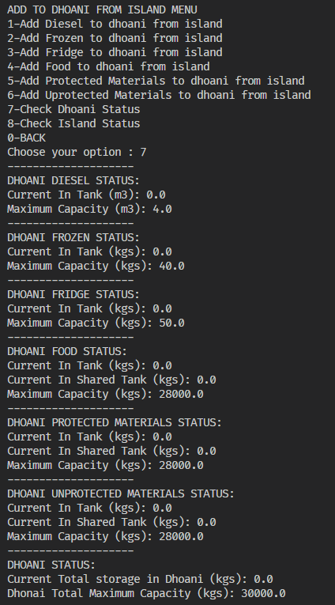

First, lets add the shared spaces in dhoani (Food, protected_materials, unprotected_materials) till the shared space for the 3 items becomes full.

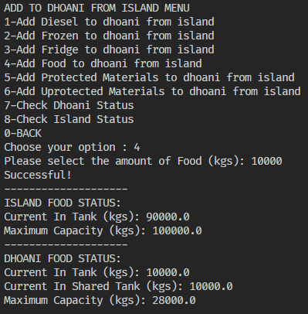 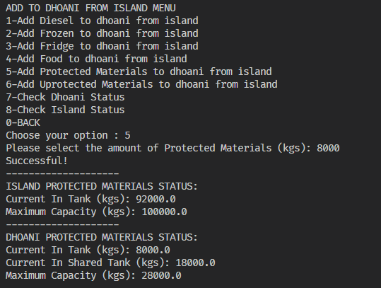 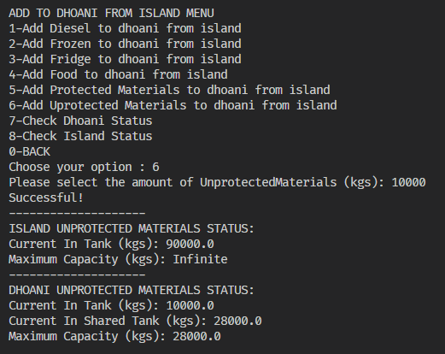

Above We see that indeed the 3 material share the same space in the dhoani.

If we try to add beyond that we see that it is not allowed

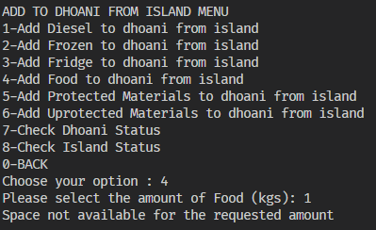

Now let us add diesel to Dhoani from supplier island.

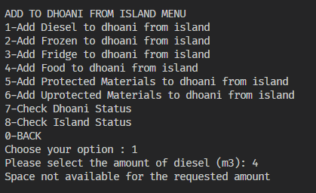

We see that there is no space available, although we did not load any diesel previously.

To investigate, the user can check the dhoani status by choosing option 7 from the menu

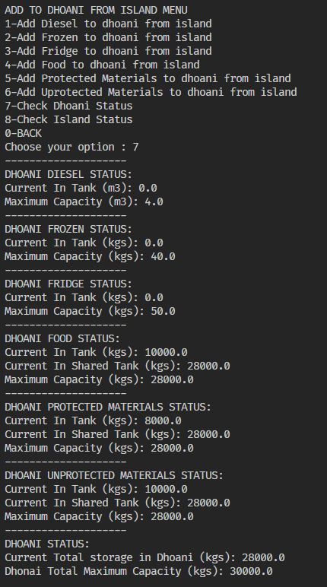

Upon investigating, it can be seen that the dhoani diesel space is available. However, the issue arises from the total dhoani space seen in the most bottom stats. The dhoani has a total capacity of 30,000 kgs. When the user tried to 4(m3) of diesel (which gets converted into kgs) its goes beyond the maximum capacity allowed for dhoani.

The user can transfer some items from dhoani to island to make space.

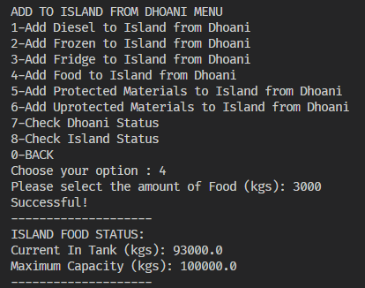 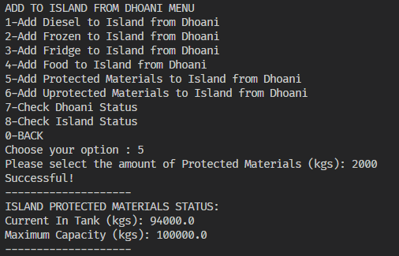 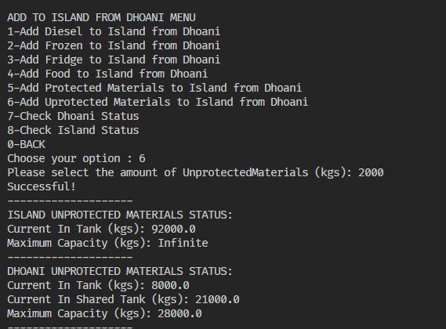

The use can add diesel again and be met with a successful message.

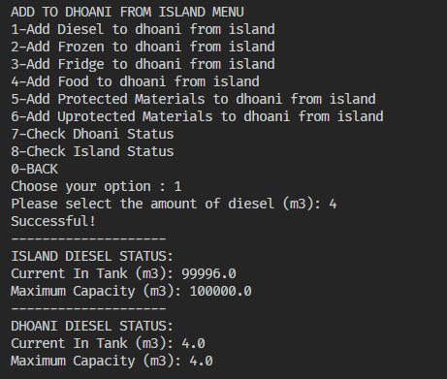

If the user tries to add further diesel, the system will prompt an alert message

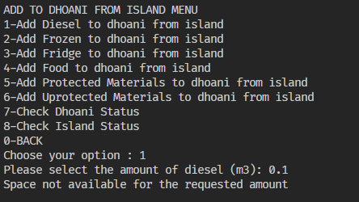

Traveling to Next Island

After getting supplies from the supplier island, the user can travel to next island from the travel menu

The user can try traveling west, but will be met by an alert message.

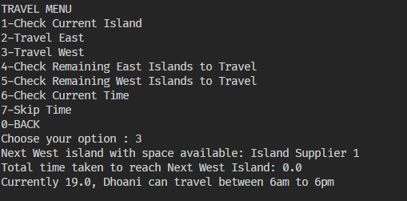

This is because it is currently night time, and the dhoani can travel between 6 am to 6 pm.

Current Time:

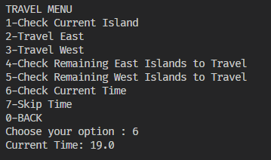

Time can be skipped by giving input in hours.

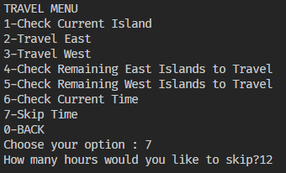 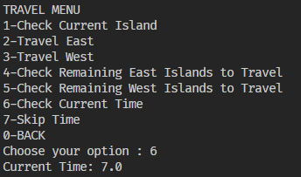

12 hours is skipped and current time is skipped to 7am

The user can try traveling west again, but will still be met with an error message.

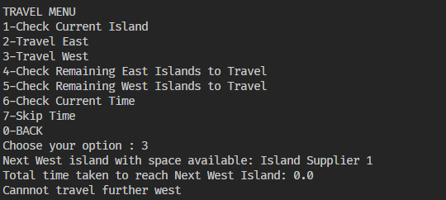

This is because this is the edge island and the user has to travel east.

Note that the system will also display the next island that can be traveled as well as the time taken to travel to next island.

The user can travel to east successfully.

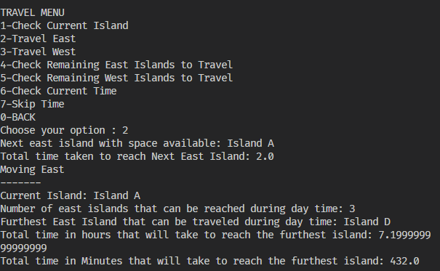

The system will display the next island (Island A) that can be traveled as well as the time taken to travel to next island before traveling.

After successfully travelling to the island, the system will also display the furthest island to the east that can be traveled during day time and the total number of time (in minutes and hours) to reach the furthest island since it is vital information that the captain of Dhoni requires.

DHOANI TO ISLAND

Now that we have reached island A, we can test removing items from dhoani and adding them to island warehouse functions.