# Approach and Methodology Document Approach and Methodology for Developing a Smart Search Tool for Analytics Vidhya's Free Courses

# Problem Understanding The objective is to develop a smart search tool that enables users to efficiently find relevant free courses on Analytics Vidhya's platform. This involves creating a system that can process natural language queries and retrieve pertinent course information.

# Data Collection The first step is to gather data from the free courses available on Analytics Vidhya. This includes course titles, descriptions, curricula, and any other relevant metadata. The data can be collected through web scraping or by utilizing any available APIs provided by Analytics Vidhya.

# Data Preprocessing Once the data is collected, it needs to be preprocessed to ensure consistency and quality. This involves:

# Text Cleaning: Removing any irrelevant information, special characters, or formatting issues.

# Normalization: Converting text to a standard format, such as lowercasing all text.

# Tokenization: Breaking down text into individual words or tokens.

# Stopword Removal: Eliminating common words that do not contribute significant meaning.

# Embedding Model Selection To convert textual data into numerical representations that a machine learning model can understand, embedding models are used. For this project, the following models are considered:

# text-embedding-ada-002: An embedding model provided by OpenAI, known for its efficiency and effectiveness in generating embeddings for text data.

# LangChain Embeddings: LangChain offers integrations with various embedding models, providing flexibility in model selection.

# LlamaIndex Embeddings: LlamaIndex supports multiple embedding models and can be integrated with LangChain for enhanced functionality. The choice of embedding model depends on factors such as performance, computational resources, and compatibility with the retrieval-augmented generation (RAG) system.

# Vector Database Integration After generating embeddings, they are stored in a vector database to facilitate efficient similarity searches. This allows the system to quickly retrieve courses that are most relevant to a user's query.

# Retrieval-Augmented Generation (RAG) System Implementing a RAG system enables the search tool to generate responses by retrieving pertinent information from the vector database and combining it with generative capabilities. This approach enhances the accuracy and relevance of the search results.

# Deployment The developed search tool is deployed on Hugging Face Spaces, making it publicly accessible. Frameworks such as Gradio or Streamlit can be used to create an interactive user interface for seamless interaction.

# Evaluation and Iteration Post-deployment, the tool's performance is evaluated based on user feedback and search accuracy. Continuous improvements are made by refining the embedding models, enhancing the RAG system, and updating the course data to maintain relevance.

# Conclusion By following this structured approach, a robust and efficient smart search tool is developed, enabling users to easily find relevant free courses on Analytics Vidhya's platform. The integration of advanced embedding models and RAG systems ensures high-quality search results, enhancing the overall user experience.

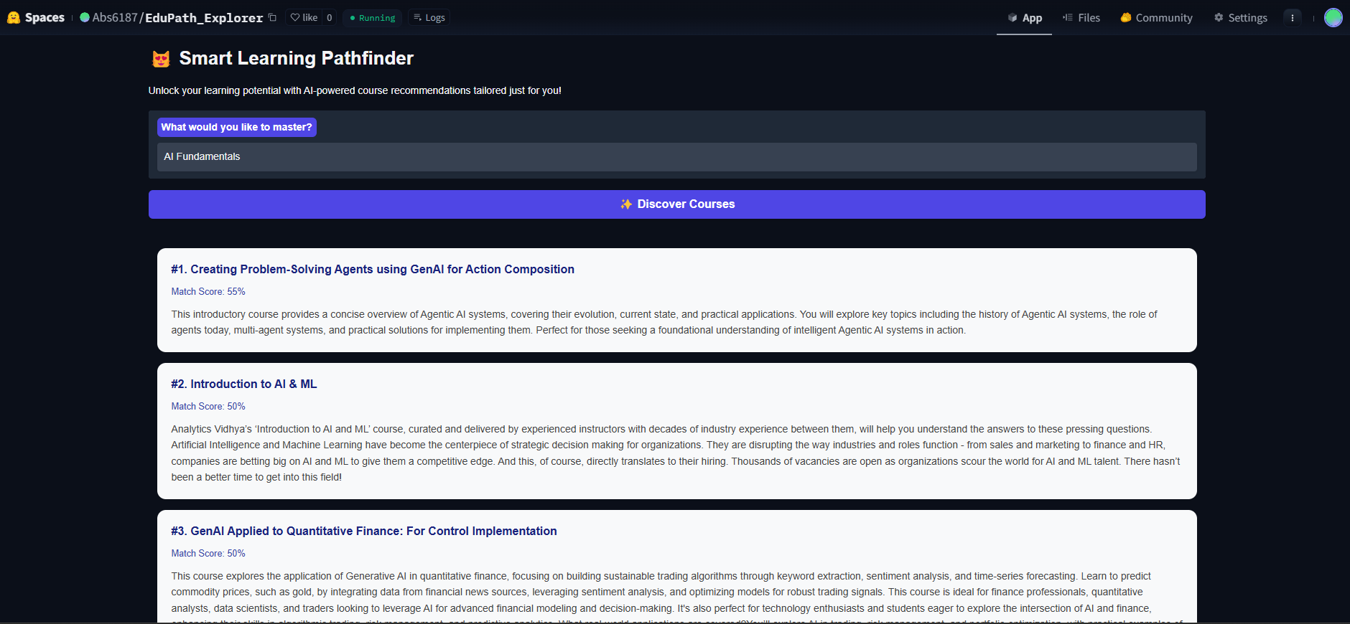

# Project Deployment Link

The smart search tool for finding relevant free courses on Analytics Vidhya's platform has been successfully deployed. Below is the link to the deployed project on Hugging Face Spaces:

<https://huggingface.co/spaces/Abs6187/EduPath_Explorer>