PAGE 1)

• A table is defined using the [<table>](https://html.com/tags/table/) element, and contains a number of [table cells ( <td>, for “table data” )](https://html.com/tags/td/) which are organized into [table rows ( <tr>)](https://html.com/tags/tr/). The markup (HTML code) for a table is always based on rows, never columns.

• Table cells which act as column headers or row headers should use the <th> (table header) element.

• Table cells can be merged using the [colspan](https://html.com/attributes/td-colspan/) and rowspan attributes.

• Tables can be broken into sections using the following elements:

* [<thead> — Table header](https://html.com/tags/thead/)
* [<tbody> — Table body](https://html.com/tags/tbody/)
* [<tfoot> — Table footer](https://html.com/tags/tfoot/)

• A caption can be added to a table using the [<caption>](https://html.com/tags/caption/) element.

• You can use [<col>](https://html.com/tags/col/) and [<colgroup>](https://html.com/tags/colgroup/) to define table columns for styling. However, there are a [number of limitations with this practic](https://html.com/tags/colgroup/)e.

HTML tables allow web authors to arrange data like text, images, links, other tables, etc. into rows and columns of cells.

The HTML tables are created using the **<table>** tag in which the **<tr>** tag is used to create table rows and **<td>** tag is used to create data cells. The elements under <td> are regular and left aligned by default

PAGE 2)

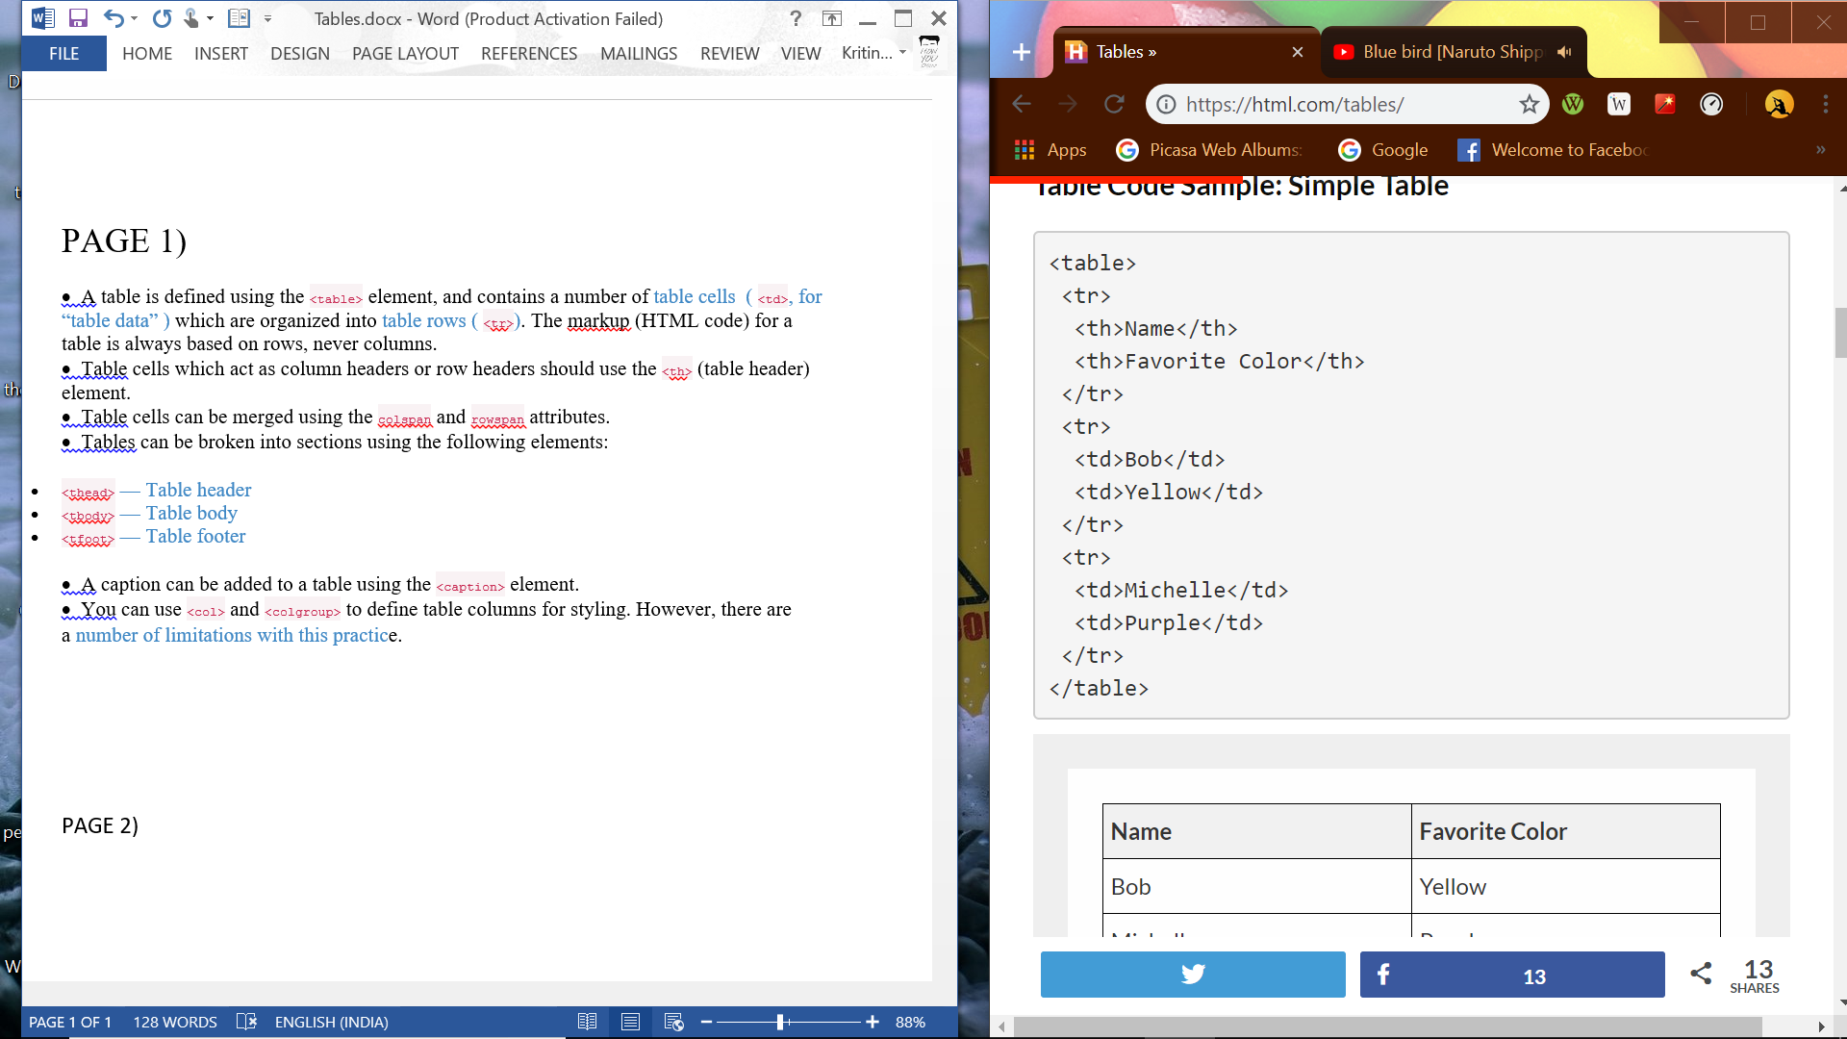

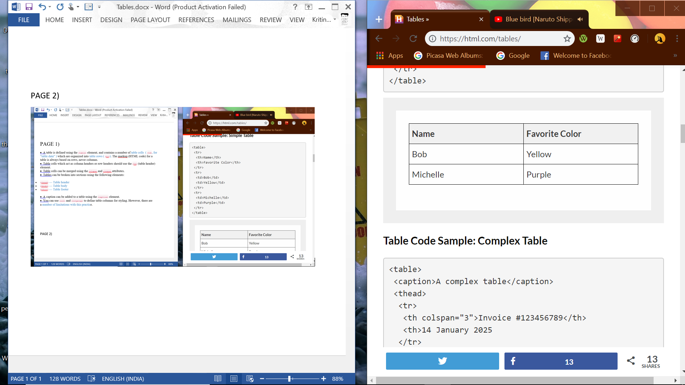

PAGE 3)

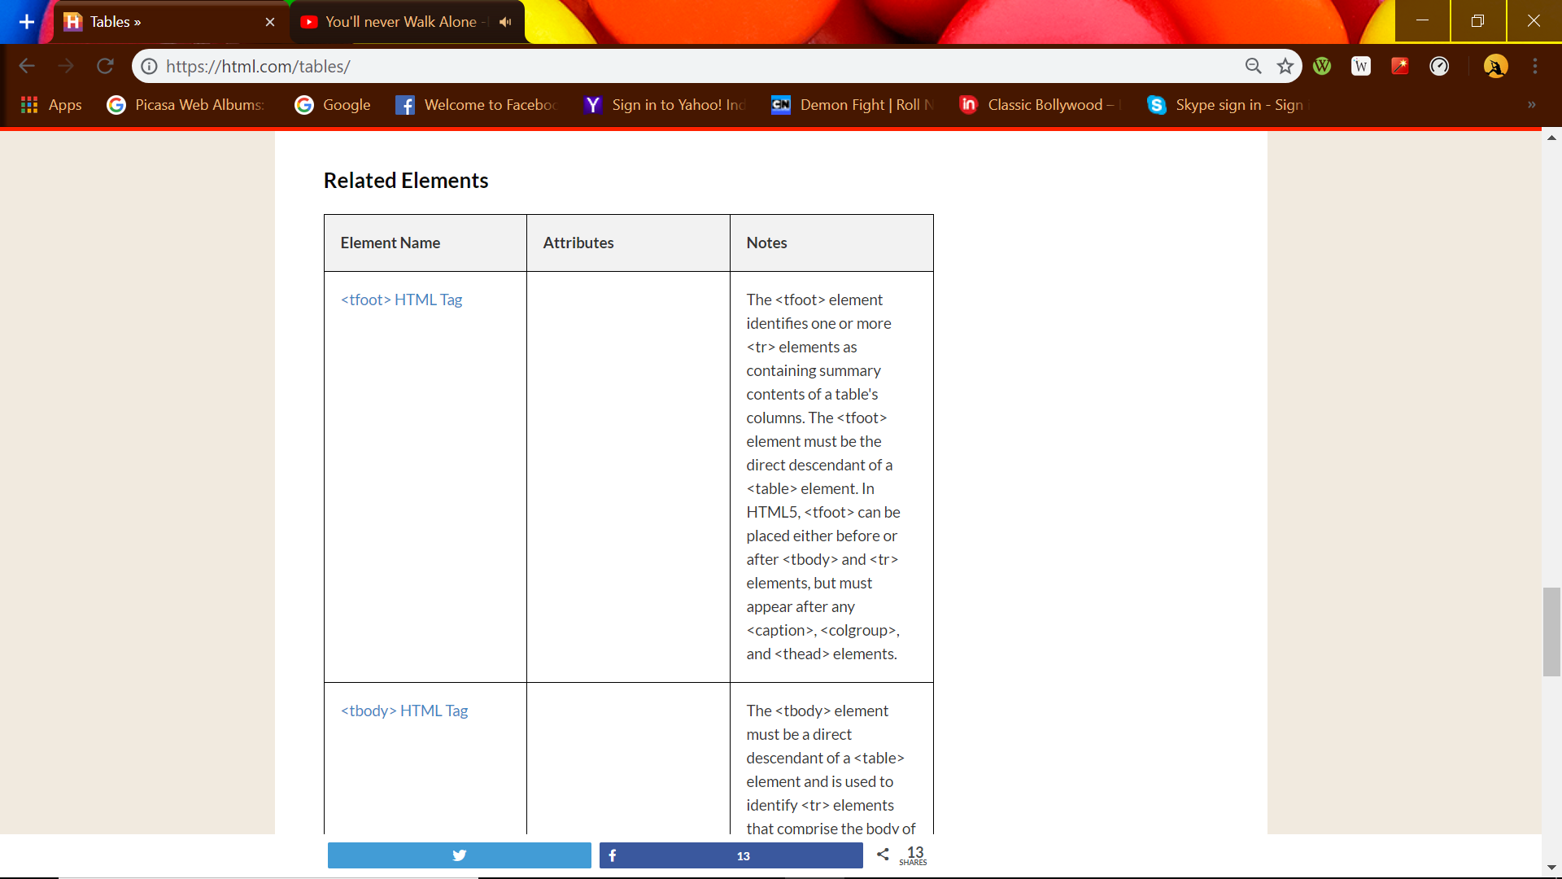

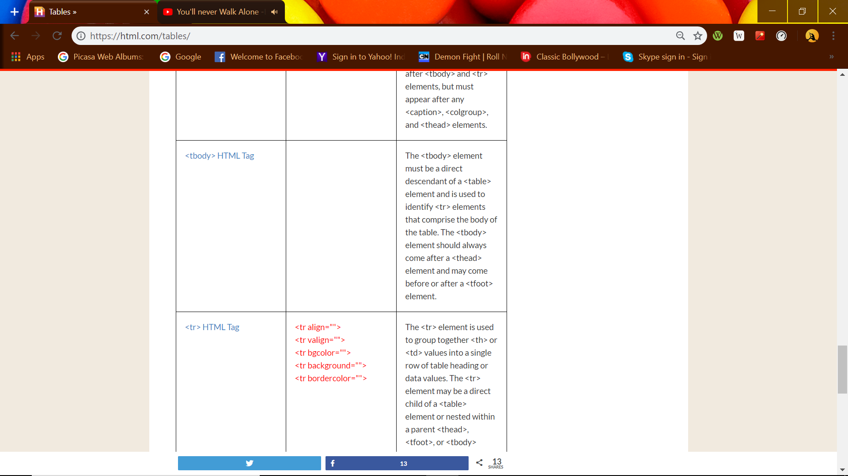

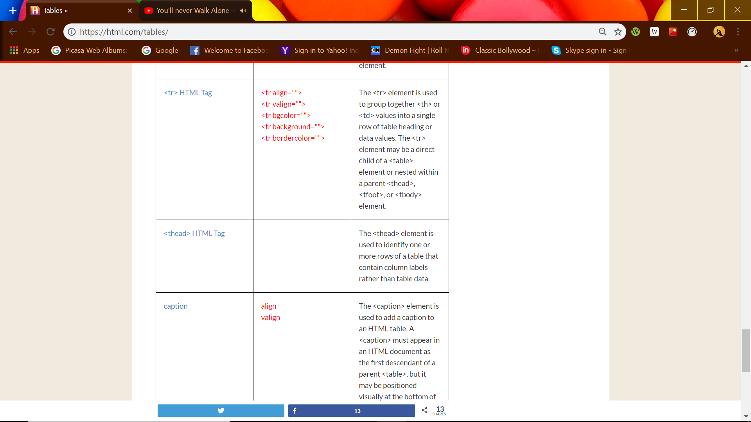

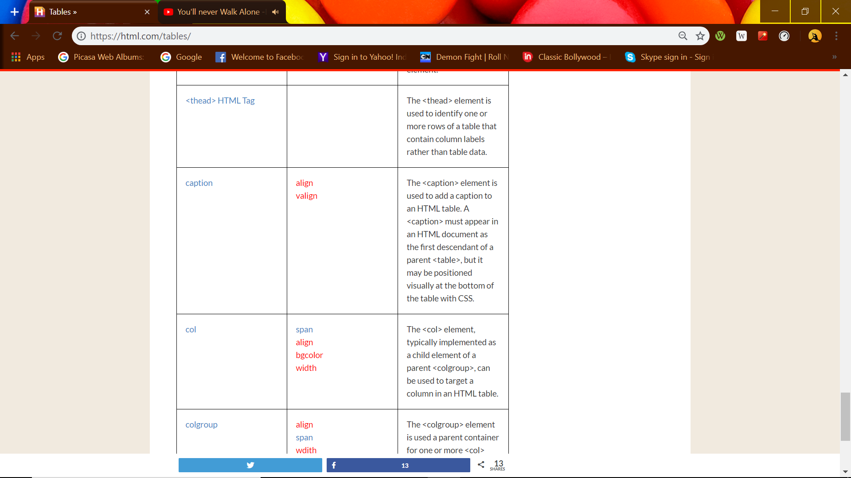

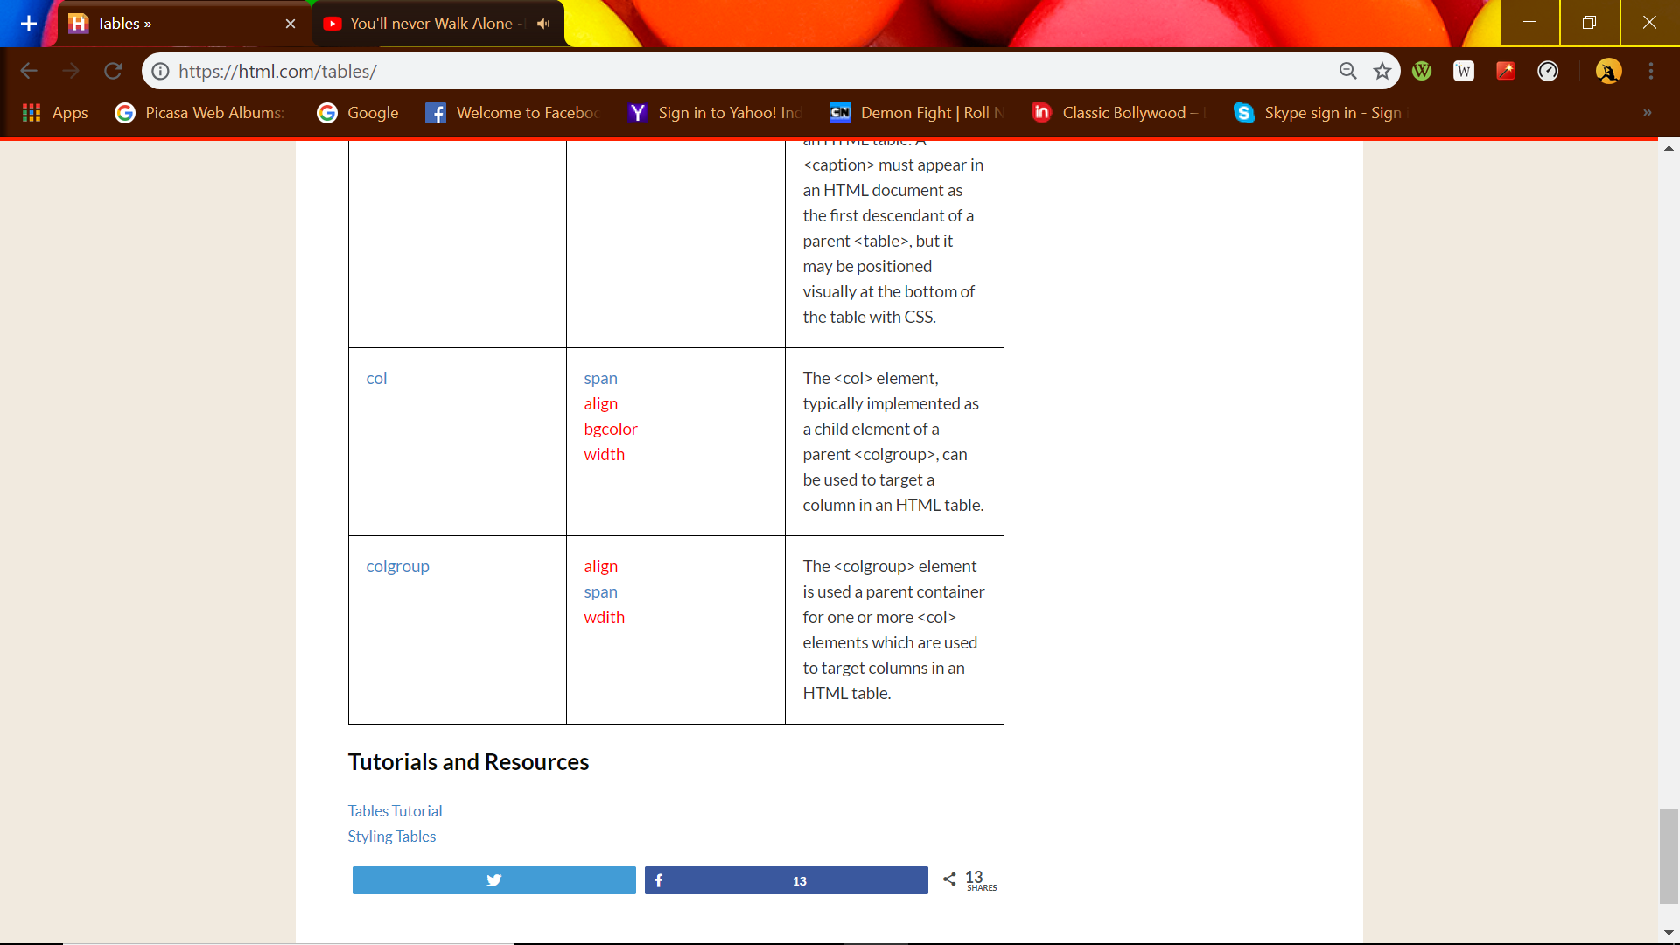

## PAGE 2- Table Heading

Table heading can be defined using **<th>** tag. This tag will be put to replace <td> tag, which is used to represent actual data cell. Normally you will put your top row as table heading as shown below, otherwise you can use <th> element in any row. Headings, which are defined in <th> tag are centered and bold by default.

Example

[Live Demo](http://tpcg.io/7LeM8F)

<!DOCTYPE html>

<html>

<head>

<title>HTML Table Header</title>

</head>

<body>

<table border = "1">

<tr>

<th>Name</th>

<th>Salary</th>

</tr>

<tr>

<td>Ramesh Raman</td>

<td>5000</td>

</tr>

<tr>

<td>Shabbir Hussein</td>

<td>7000</td>

</tr>

</table>

</body>

</html>

This will produce the following result −

|  |  |
| --- | --- |
| **Name** | **Salary** |
| Ramesh Raman | 5000 |
| Shabbir Hussein | 7000 |

## PAGE 3 Cellpadding and Cellspacing Attributes

There are two attributes called *cellpadding* and *cellspacing* which you will use to adjust the white space in your table cells. The cellspacing attribute defines space between table cells, while cellpadding represents the distance between cell borders and the content within a cell.

Example

[Live Demo](http://tpcg.io/P5QBh7)

<!DOCTYPE html>

<html>

<head>

<title>HTML Table Cellpadding</title>

</head>

<body>

<table border = "1" cellpadding = "5" cellspacing = "5">

<tr>

<th>Name</th>

<th>Salary</th>

</tr>

<tr>

<td>Ramesh Raman</td>

<td>5000</td>

</tr>

<tr>

<td>Shabbir Hussein</td>

<td>7000</td>

</tr>

</table>

</body>

</html>

This will produce the following result −

|  |  |
| --- | --- |
| **Name** | **Salary** |
| Ramesh Raman | 5000 |
| Shabbir Hussein | 7000 |

PAGE 4-

Colspan and Rowspan Attributes

You will use **colspan** attribute if you want to merge two or more columns into a single column. Similar way you will use **rowspan** if you want to merge two or more rows.

Example

[Live Demo](http://tpcg.io/ltvfv5)

<!DOCTYPE html>

<html>

<head>

<title>HTML Table Colspan/Rowspan</title>

</head>

<body>

<table border = "1">

<tr>

<th>Column 1</th>

<th>Column 2</th>

<th>Column 3</th>

</tr>

<tr>

<td rowspan = "2">Row 1 Cell 1</td>

<td>Row 1 Cell 2</td>

<td>Row 1 Cell 3</td>

</tr>

<tr>

<td>Row 2 Cell 2</td>

<td>Row 2 Cell 3</td>

</tr>

<tr>

<td colspan = "3">Row 3 Cell 1</td>

</tr>

</table>

</body>

</html>

This will produce the following result −

|  |  |  |
| --- | --- | --- |
| **Column 1** | **Column 2** | **Column 3** |
| Row 1 Cell 1 | Row 1 Cell 2 | Row 1 Cell 3 |
| Row 2 Cell 2 | Row 2 Cell 3 |
| Row 3 Cell 1 | | |

PAGE 5-

## Tables Backgrounds

<>

**Note** − The *bgcolor*, *background*, and *bordercolor* attributes deprecated in HTML5. Do not use these attributes.

### Example

[Live Demo](http://tpcg.io/pPuSKz)

<!DOCTYPE html>

<html>

<head>

<title>HTML Table Background</title>

</head>

<body>

<table border = "1" bordercolor = "green" bgcolor = "yellow">

<tr>

<th>Column 1</th>

<th>Column 2</th>

<th>Column 3</th>

</tr>

<tr>

<td rowspan = "2">Row 1 Cell 1</td>

<td>Row 1 Cell 2</td>

<td>Row 1 Cell 3</td>

</tr>

<tr>

<td>Row 2 Cell 2</td>

<td>Row 2 Cell 3</td>

</tr>

<tr>

<td colspan = "3">Row 3 Cell 1</td>

</tr>

</table>

</body>

</html>

This will produce the following result –

|  |  |  |
| --- | --- | --- |
| **Column 1** | **Column 2** | **Column 3** |
| Row 1 Cell 1 | Row 1 Cell 2 | Row 1 Cell 3 |
| Row 2 Cell 2 | Row 2 Cell 3 |
| Row 3 Cell 1 | | |

Here is an example of using **background** attribute. Here we will use an image available in /images directory.

[Live Demo](http://tpcg.io/MBJetN)

<!DOCTYPE html>

<html>

<head>

<title>HTML Table Background</title>

</head>

<body>

<table border = "1" bordercolor = "green" background = "/images/test.png">

<tr>

<th>Column 1</th>

<th>Column 2</th>

<th>Column 3</th>

</tr>

<tr>

<td rowspan = "2">Row 1 Cell 1</td>

<td>Row 1 Cell 2</td><td>Row 1 Cell 3</td>

</tr>

<tr>

<td>Row 2 Cell 2</td>

<td>Row 2 Cell 3</td>

</tr>

<tr>

<td colspan = "3">Row 3 Cell 1</td>

</tr>

</table>

</body>

</html>

This will produce the following result. Here background image did not apply to table's header.

|  |  |  |
| --- | --- | --- |
| **Column 1** | **Column 2** | **Column 3** |
| Row 1 Cell 1 | Row 1 Cell 2 | Row 1 Cell 3 |
| Row 2 Cell 2 | Row 2 Cell 3 |
| Row 3 Cell 1 | | |

PAGE 6-

Table Height and Width

You can set a table width and height using **width** and **height** attributes. You can specify table width or height in terms of pixels or in terms of

percentage of available screen area.

Example

[Live Demo](http://tpcg.io/HUEBv2)

<!DOCTYPE html>

<html>

<head>

<title>HTML Table Width/Height</title>

</head>

<body>

<table border = "1" width = "400" height = "150">

<tr>

<td>Row 1, Column 1</td>

<td>Row 1, Column 2</td>

</tr>

<tr>

<td>Row 2, Column 1</td>

<td>Row 2, Column 2</td>

</tr>

</table>

</body>

</html>

This will produce the following result –

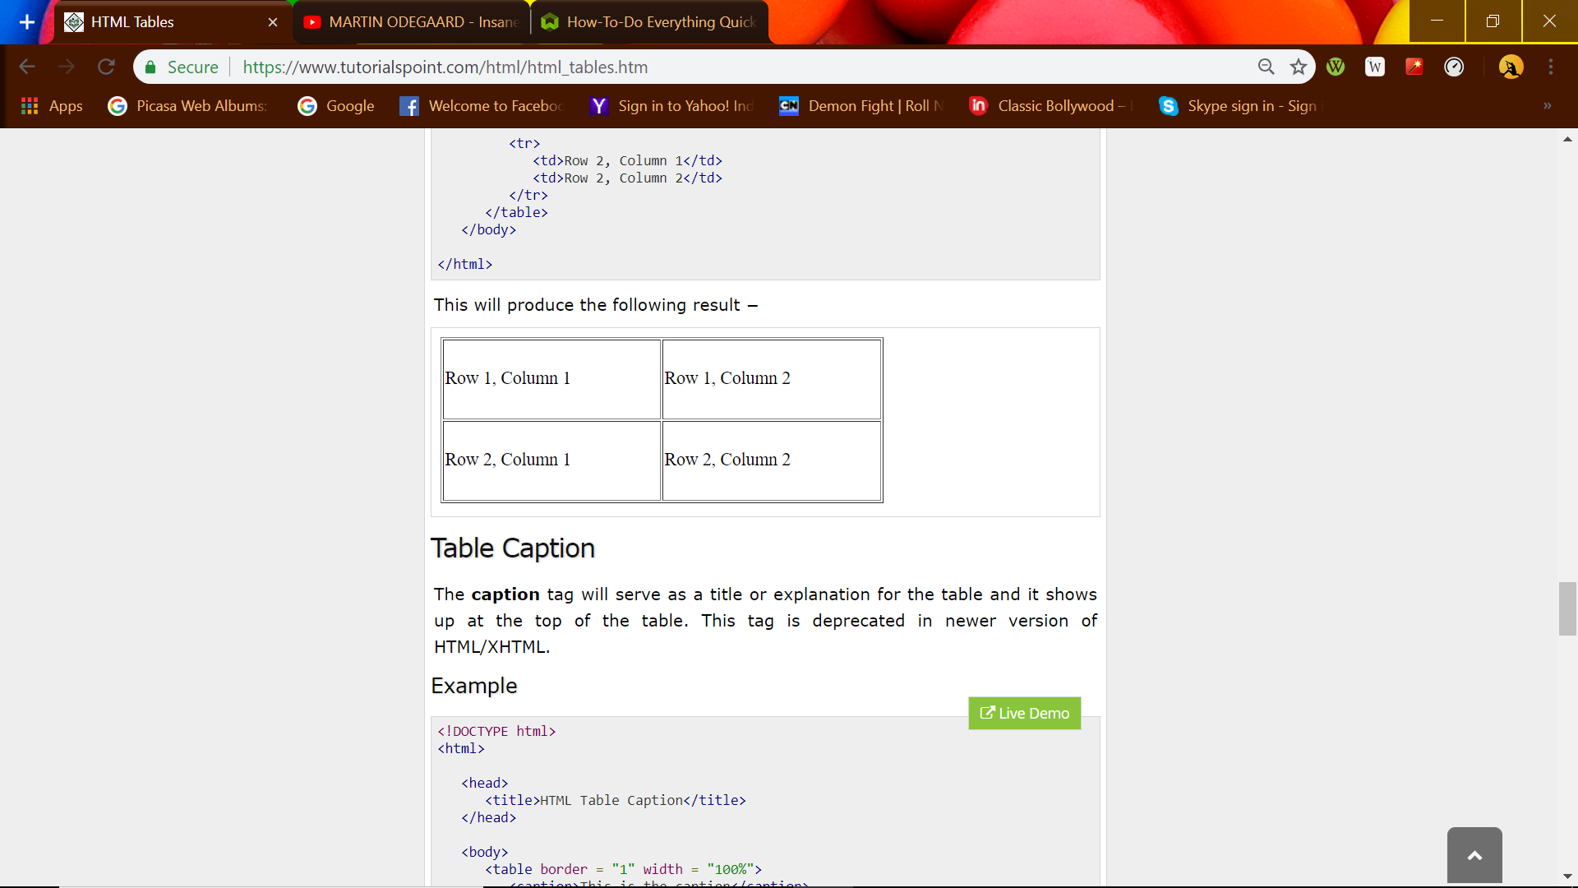

PAGE 7-

Table Caption

The **caption** tag will serve as a title or explanation for the table and it shows up at the top of the table. This tag is deprecated in newer version of HTML/XHTML.

Example

[Live Demo](http://tpcg.io/H0tfxX)

<!DOCTYPE html>

<html>

<head>

<title>HTML Table Caption</title>

</head>

<body>

<table border = "1" width = "100%">

<caption>This is the caption</caption>

<tr>

<td>row 1, column 1</td><td>row 1, columnn 2</td>

</tr>

<tr>

<td>row 2, column 1</td><td>row 2, columnn 2</td>

</tr>

</table>

</body>

</html>

This will produce the following result −

|  |  |
| --- | --- |
| This is the caption | |
| row 1, column 1 | row 1, column 2 |
| row 2, column 1 | row 2, column 2 |

PAGE 8)