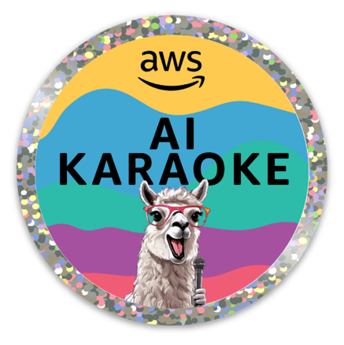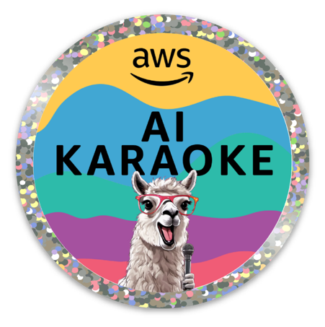

**Instructions**

1. 🎤 Pick up the microphone
2. 🕺 Complete the prompt - Karaoke style!! Speak clearly and close to the mic.
3. 🔴 🔵 Review the completions and push the color button corresponding to the best answer
4. 🔁 Repeat! There are a few different prompt templates to play with.

**Architecture**

