Shieldo schematicai ir panasiai:

https://www.st.com/resource/en/user_manual/dm00453103-getting-started-with-the-xnucleognss1a1-expansion-board-based-on-teseoliv3f-tiny-gnss-module-for-stm32-nucleo-stmicroelectronics.pdf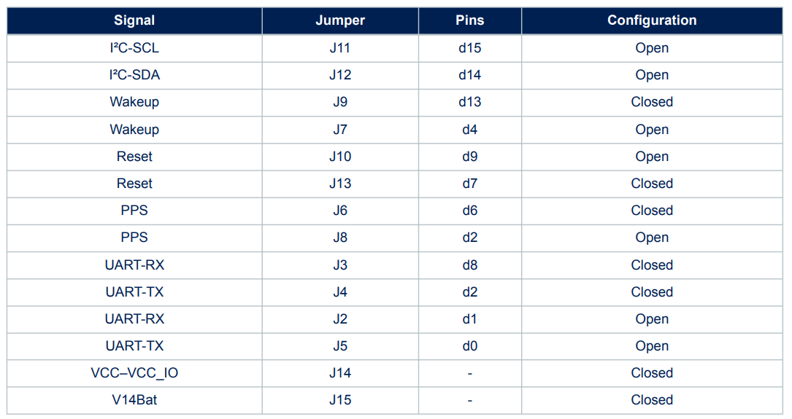

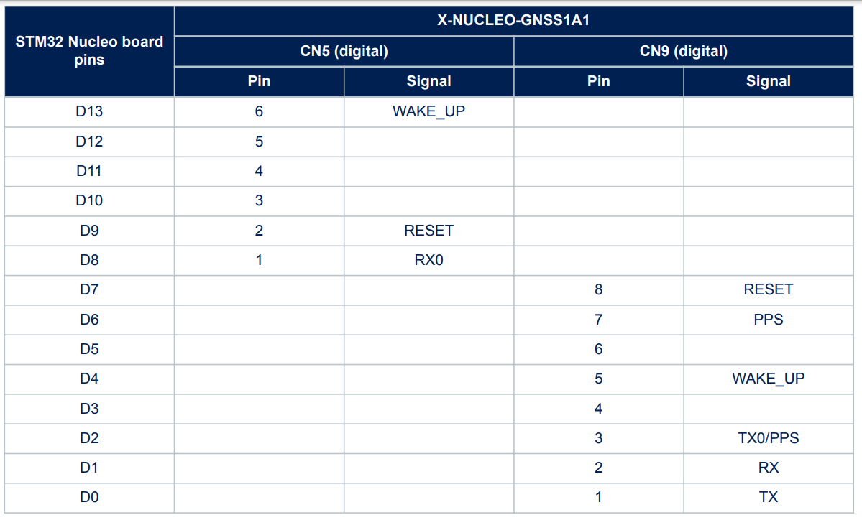

GPS modulio puslapis:

<https://www.st.com/en/positioning/teseo-liv3f.html>

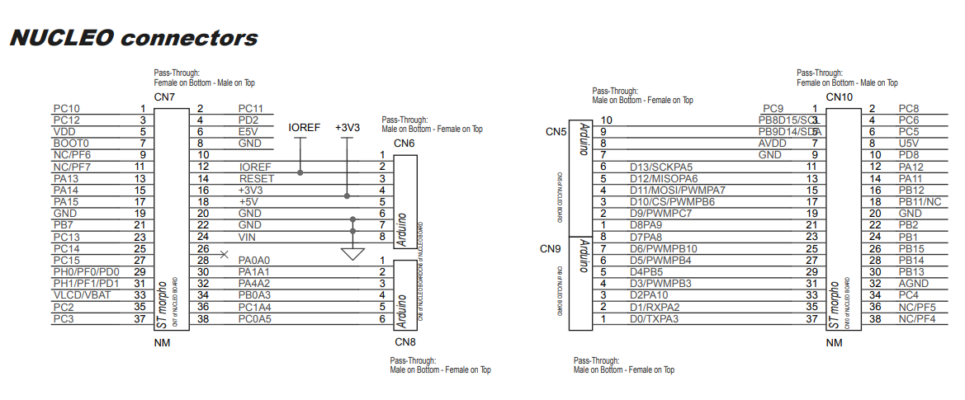

GPS modulio datasheetas Teseo-LIV3:

<https://www.st.com/resource/en/datasheet/teseo-liv3f.pdf>

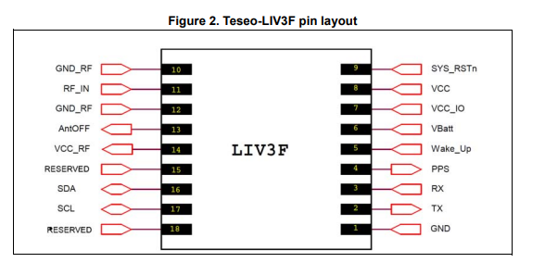

Aprasymai, komandos ir panasiai:

<https://www.st.com/resource/en/user_manual/dm00398983-teseoliv3-gnss-module--software-manual-stmicroelectronics.pdf>

NMEA protokolas iskoduot zinutem

<https://www.sparkfun.com/datasheets/GPS/NMEA%20Reference%20Manual-Rev2.1-Dec07.pdf>

Atrodo geros zinutes pavyzdys, nes laikas prisiderino kaip reikia

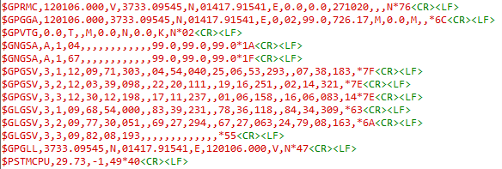

Tikrai gera zinute:

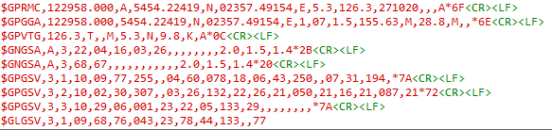

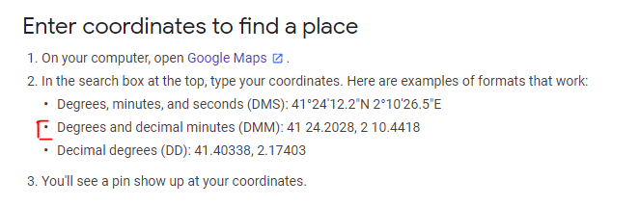

**JUMPERIAI**

GPS:

J7 vietoj J9

J3 vietoj J2

J6 (datasheete default nera?)

Sensoriai:

JP6 nuimti. Perkelti interupto jumperi taip kad butu ant betkuriu kitu sutrumpintu pinu (apatine juosta)