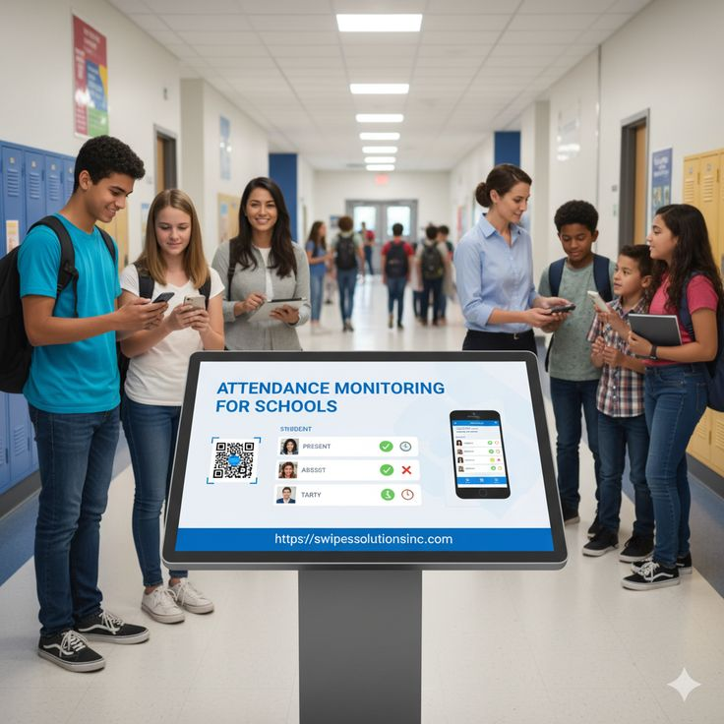
FACULTY OF COMPUTER AND INFORMATION TECHNOLOGY

DEPARTMENT OF COMPUTER APPLICATIONS

Design and Implementation of a Web and Mobile-Based Smart Campus Access and Lost-and-Found Management System
BY
Abshir Adan Hassan ID: C1220665
Abaaz Dahir Ahmed ID: C1221154
Mohamed Dhuh Arif ID: C1220685
Rayan Ahmed Husein ID: C1220432

A GRADUATION PROJECT SUBMITTED IN PARTIAL FULFILLMENT OF THE REQUIREMENTS FOR THE DEGREE OF BACHELOR OF SCIENCE IN COMPUTER APPLICATIONS
SUPERVISOR: Yahye Ali Isse

MOGADISHU, SOMALIA
AUGUST 2026

JAMHURIYA UNIVERSITY OF SCIENCE AND TECHNOLOGY (JUST)
ORIGINAL LITERARY WORK DECLARATION
Name of Candidate 1: Abshir Adan Hassan ID No: C1220776
Name of Candidate 2: Abaaz Dahir Ahmed ID No.: C1221154
Name of Candidate 3: Mohamed Dhuh Arif ID No.: C1220685
Name of Candidate 4: Rayan Ahmed Husein ID No.: C1220432
Name of Degree: Bachelor of Science in Computer Applications
Title of Project/Research Report/Thesis:
Design and Implementation of a Web and Mobile-Based Smart Campus Access and Lost-and-Found Management System
Field of Study: Computer Applications
We, the undersigned, do solemnly and sincerely declare that:
- We are the authors of this project and thesis.
- This work is our original work and has not been submitted to any other institution for the award of any degree or qualification.
- Any use of copyrighted material has been properly acknowledged through appropriate citation and referencing.
- To the best of our knowledge, this work does not infringe upon the intellectual property rights of any individual or organization.
- We hereby assign all copyright ownership of this work to Jamhuriya University of Science and Technology (JUST). Any reproduction or use of this work, in whole or in part, requires prior written permission from the University.
- We understand that if any part of this declaration is found to be false, we may be subject to disciplinary or legal action in accordance with the University's academic regulations.

Candidate 1 Signature: ________________________ Date: ____ / ____ / ______
Candidate 2 Signature: ________________________ Date: ____ / ____ / ______
Candidate 3 Signature: ________________________ Date: ____ / ____ / ______
Candidate 4 Signature: ________________________ Date: ____ / ____ / ______

Supervisor's Name: ______________________________________
Supervisor's Signature: _________________________________
Designation: ___________________________________________
Date: ____ / ____ / ______

ABSTRACT
The increasing adoption of digital technologies in higher education has created new opportunities to improve campus security and student services. However, many universities still rely on manual procedures for student identity verification, campus access control, and lost-and-found management, resulting in inefficient operations, poor record keeping, unauthorized campus access, and low recovery rates for lost property. This study aimed to design, develop, and evaluate a web and mobile-based Smart Campus Access and Lost-and-Found Management System that integrates secure digital identification, QR code-based access control, entry and exit monitoring, and centralized lost-and-found services into a single platform. The system was developed using the Agile Software Development Life Cycle (Agile SDLC). React.js with Vite was used for the web application, Flutter for the mobile application, Node.js and Express.js for the backend, and MongoDB as the database management system. The proposed system supports multiple user roles, including students, security officers, cleaners, staff administrators, and super administrators, while implementing secure authentication, role-based access control, QR code verification, visitor registration, complaint management, notifications, and reporting features. The implemented prototype successfully digitized campus access management and lost-and-found operations, improving operational efficiency, reducing manual processing, enhancing identity verification, and providing centralized management of campus services. The findings demonstrate that integrating access control with lost-and-found management into a single digital platform enhances campus security, improves service delivery, and increases transparency and accountability. The proposed system provides a scalable and practical solution that can support the digital transformation of universities and may serve as a foundation for future smart campus applications.
Keywords: Smart Campus; QR Code Authentication; Access Control; Lost-and-Found Management; Mobile Application; Web Application.

DEDICATION
I dedicate this research work to Almighty Allah for granting me the strength, wisdom, patience, and good health throughout my academic journey and for making the successful completion of this study possible.
I also dedicate this work to my beloved parents, whose endless love, prayers, encouragement, and sacrifices have been the foundation of my education and personal growth. Their constant support has inspired me to overcome every challenge and remain committed to achieving my goals.
Special appreciation goes to my family, friends, and everyone who encouraged and supported me throughout my studies. Their motivation, understanding, and confidence in me gave me the determination to complete this research successfully.
Finally, I dedicate this work to all students, researchers, and future developers who are committed to using technology to improve education, campus security, and student services through innovative digital solutions. It is my hope that this study will contribute to future research and inspire the development of more efficient and intelligent smart campus systems.

ACKNOWLEDGMENT
First, and foremost, we would like to express our sincere gratitude to Allah (SWT) for granting us good health, wisdom, patience, and strength throughout the completion of this research project. Without His guidance and mercy, this achievement would not have been possible.
We extent our deepest appreciation to our respected supervisor,
ENG. Yahya Ali Issa, for his continuous guidance, constructive comments, valuable suggestion, encouragement, and professional support throughout every stage of this research.
His supervision, patience, and commitment have featly contributed to the successful completion of this project.
We are also grateful to the management, lecturers, and staff members of the Faculty of Computer Applications, Jamahiriya University of Science and Technology, for providing us with quality education, practical skills, and continuous academic support throughout our years of study.
Our heartfelt appreciation goes to our beloved parents and family members for their endless love, sacrifices, financial support, encouragement, and prayers. Their unwavering belief in us has been the driving force behind our academic success.
Finally, we would like to thank our classmates, friends, and everyone who directly or indirectly contributed to the successful completion of this project. Your encouragement, cooperation, and support are sincerely appreciated.
May Allah reward everyone who contributed to this work and bless them abundantly.

TABLE OF CONTECT
ABSTRACT 3
DEDICATION 4
ACKNOWLEDGMENT 5
LIST OF ABBREVIATIONS 12
CHAPTER I: INTRODUCTION 13
1.1 Background of the Study 13
1.2 Problem Statement 14
1.3 Research Objectives 15
1.4 Research Questions 15
1.5 Motivation of the Study 16
1.6 Significance of Study 16
1.7 Scope of the study: 18
1.8 Organization of the Study 19
CHAPTER II: LITERATURE REVIEW 20
2.1 Introduction 20
2.2 Overview of Smart Campus Access and Lost-and-Found Management Systems 23
2.2.1 Evolution of Smart Campus Systems 23
2.2.3 Digital Access Control Systems 25
2.2.4 Student Identification Technologies in Smart Campuses 26
2.2.5 Entry and Exit Monitoring Systems in University Campuses 27
2.2.6 Lost-and-Found Management in Academic Institutions 28
2.2.6 Lost and Found Management in Academic Institutions 29
2.2.7 Role of Web-Based Systems in Campus Management 30
2.2.8 Role of Mobile-Based System in Smart Campuses 31
2.2.9 Integrated Smart Campus Platforms 32
2.3 Related Work 33
2.3.1 Campus Access Control Systems 33
2.3.2 Digital Lost-and-Found Management Systems 34
2.3.3 Integrated Smart Campus Platforms 35
2.1 Summary and Comparison of Related Work 35
2.4 Research Gap 37
2.4.1 The Integration Gap: A Chasm Between Security and Service Systems 37
2.4.2 The Trust and Verification Gap in Standalone Services 38
2.4.3 The Need for Cost-Effective and User-Centric Integrated Solutions 38
2.4.4 Summary of the Research Gap 39
2.4.5 Contribution of the Proposed Study 39
CHAPTER III: METHODOLOGY 40
3.0 Introduction 40
3.1 System Overview 40
3.2 System Features 42
3.2.1 User Authentication and Access Control 43
3.2.2 Student Identification and QR Code Verification 43
3.2.3 Student Registration 43
3.2.4 User and Role Management 44
3.2.5 Lost and Found Management 44
3.2.6 Complaint Management 44
3.2.7 Visitor Registration 45
3.2.8 Security Shift Management 45
3.2.9 Communication and Notifications 45
3.2.10 Reports and Analytics 46
3.3 System Architecture 46
3.4 System Requirements 48
3.4.1 Hardware Requirements 49
3.4.2 Software Requirements 50
3.5 System Requirements 51
3.5.1 Functional Requirements 51
3.5.2 Non-Functional Requirements 53
3.6 Feasibility Study 54
3.6.1 Technical Feasibility 54
3.6.2 Economic Feasibility 55
3.6.3 Operational Feasibility 55
3.6.4 Schedule Feasibility 55
3.7 UML Diagrams 56
3.7.1 Use Case Diagram 56
3.9 Database Design 58
CHAPTER IV: IMPLEMENTATION AND RESULTS 60
4.1 Introduction 60
4.2 Web Admin Panel Implementation and Testing 60
4.2.1.1 Functional Testing 65
4.2.1.2 User Interface (UI/UX) Evaluation 67
4.2.1.3 Summary of Web Application Testing 67
4.2.2 Mobile Application Implementation and Testing 68
4.2.2.2 Unit and Integration Testing 74
4.2.2.3 Device Compatibility Testing 75
4.4 Security Implementation and Testing 76
4.4.1 Authentication and Authorization 77
4.2.2 Input Validation 77
4.2.3 Security Testing 78
4.2.4 Chapter Summary 79
CHAPTER V: CONCLUSION AND RECOMMENDATIONS 81
5.1 Introduction 81
5.2 Summary of the Study 81
5.3 Conclusion 82
5.4 Limitations of the Study 82
5.5 Recommendations for Future Work 83
5.6 Final Remarks 83
References 84

LIST OF FIGURES
Figure 3.1: Smart Campus Lost & Found System Architecture 43
Figure 3.2: Use Case Diagram 51
Figure 3.3: Entity Relationship Diagram (ERD) 53
Figure 4.1: Login Page 55
Figure 4.2: Dashboard 55
Figure 4.3: Student Management 56
Figure 4.4: Lost and Found Management 57
Figure 4.5: Reports and Analytics 58
Figure 4.6: Mobile Login Screen 64
Figure 4.7: Dashboard Screen 65
Figure 4.8: QR Code Scanner 66
Figure 4.9: Found Item Reporting 67

LIST TABLES
Table 2.1: Summary and Comparison of Related Work 30
Table 3.1: Hardware Requirements 42
Table 3.2: Software Requirements 43
Table 3.3: Database Design 51
Table 4.1: Functional Testing 58
Table 4.2: Unit and Integration Testing 67
Table 4.3: Device Compatibility Testing 69
Table 4.4: Security Testing 71

LIST OF ABBREVIATIONS
Abbreviation | Meaning
AI | Artificial Intelligence
API | Application Programming Interface
CRUD | Create, Read, Update, Delete
CSS | Cascading Style Sheets
DBMS | Database Management System
ERD | Entity Relationship Diagram
HTML | HypeText Markup Language
HTTP | HyperText Transfer Protocol
ICT | Information and Communication Technology
IDE | Integrated Development Environment
IoT | Internet of Things
JWT | JSON Web Token
ML | Machine Learning
MongoDB | MongoDB Database
QR | Quick Response
RBAC | Role-Based Access Control
REST API | Representational State Transfer Application Programming Interface
SDLC | Software Development Life Cycle
UI | User Interface
UML | Unified Modeling Language
URL | Uniform Resource Locator
UX | User Experience

CHAPTER I: INTRODUCTION

1.1 Background of the Study
Universities are places where students, teachers, cleaners, security guards and sometimes visitors come in and out every day. So that security and student services and their properties are very important. In many universities are still controlled their campus access manually by security guards who check student ID cards by looking at them to make sure if they match the picture on the ID and the student who stand in front of him/her and sometimes students forget their ID cards and are denied entry, and there is no proper record of such cases. Also, unauthorized people can enter the campus by pretending to be visitors or parents.
Smart campus technologies are transforming modern educational institutions by integrating digital infrastructure, Internet of Things (IOT) devices, and intelligent systems to improve learning environments, administrative processes and campus management (Gentle et al., n.d.). These technologies enable real time services such as digital attendance tracking, smart scheduling, surveillance system and personalized services for students and staff (Gbenle, 2022). There for the development of integrated smart campus applications has become essential for improving campus management, communication and service delivery. Mobile-based systems are particularly effective because smartphones are widely used and can support real-time interaction between users and campus services. Implementing smart systems that combine mobile technology, real-time data processing and centralized management can significantly improve campus operations, accessibility and user satisfaction(Rachmaniah, 2020). Such advancements provide the foundation for developing intelligent solutions like smart access control platforms which align with the goals of modern smart campus environments
In addition to campus security and lost-and-found services, universities also experience Challenges in managing student complaints. Students often report issues related to classes, and campus issues. this study also introduces a digital complaint management module to improve communication between students and university administration. There is another problem exist in campus environments including the frequent loss of personal belongings such as keys, phone, ID cards, computers and other items. Reports indicate that such incidents occur regularly among students especially in large universities with many faculties and a large student population. In many cases, students attempt to recover lost items by sharing information through social platforms, massaging applications or announcement portals but these methods are often inefficient because the information does not reach all students (Rahman, 2021). As a result, the chance of successfully recovering lost items remain low due to the lack of a centralized and organized system.

Universities especially those with large campuses face challenges in managing student service efficiently due to their wide geographical areas and large populations. Students frequently lose their items. So many students do not report or return found items which reduces the likelihood of recovery and causes stress and inconvenience for the owners (Kaur, 2021). Modern distributed web systems provide an effective solution to these challenges because they support resource sharing, scalability, reliability and efficient communication between users and servers. In a client-server architecture the user sends requests through a browser or an app which are processed by servers connected to databases that store and manage information.

1.2 Problem Statement
In an ideal university technology helps to manage campus security and student services easily and safely. Students would enter and leave the campus using a digital ID such as a QR code and the system would automatically record their entry and exit time. There would also be a digital lost and-found system where students can report lost items and search for found items using a website or mobile app. Students would receive notification if their lost items found.
Currently many universities manage campus entry manually. Security guards check student ID cards by looking at them. If a student forgets their ID they may not be allowed to enter and there is no official record of this. Entry and exit times are not recorded digitally, so it is hard to track who was on campus. There is also no proper system for lost and found items. Found items are often kept by cleaners, staff or students without any record. Students must go around asking people or visiting officers to look for their lost belongings which takes time and is not reliable. Therefore, there is currently no integrated digital system that combines campus access control and lost-and found management. Another problem identified during system analysis is the lack of centralized complaint management process. Students who experience classroom or campus-related issues often have no formal mechanism to submit and track their complaints.
Because there is no digital system, campus security is weaker. It is difficult to know who entered or left the campus which makes it harder to investigate problems or track visitors. Manual Processes are also waste time and increases work for security guard. Students are also face problems when they lose their items because there is no organized way to find them. Many items are never returned which can cause stress and sometimes financial loss. Overall, the current system is low inefficient and not secure.
This project proposes a web and mobile-based smart campus access and lost and found management system to address these issues. The system uses QR code authentication and a centralized database to manage campus access and lost-and-found services. The solution improves security, save time, ensures accurate records and provides convenient access to services and more organized campus environment.

1.3 Research Objectives
- To design an integrated web and mobile-based smart campus system that improves access control, identity verification, entry-exit monitoring, and lost and found management , complaint management, and campus service delivery university.
- To implement the proposed smart campus access & lost and found management system as a functional prototype with secure authentication, monitoring, and reporting features.
- To evaluate the effectiveness and usability of the implemented system in enhancing campus security and operational efficiency through usability testing and system performance analysis.

1.4 Research Questions
- How can an integrated web and mobile-based smart campus system be designed to improve access control and lost-and-found management?
- How can the implementation of the proposed system support campus security and monitoring, and lost item management processes?
- How effective and usable is the implemented system based on usability testing and system performance analysis?

1.5 Motivation of the Study
The motivation for this study comes from the real challenges faced by students and universities in managing campus security and lost items. Many students experience problems such as being
delayed or denied entry to campus due to forgotten ID cards. At the same time, universities struggle to track who enters and leaves the campus because access control is handled manually.
Another strong motivation is the frequent loss of personal belongings on campus. Students often lose valuable items, and the process of finding them is difficult, time-consuming, and sometimes unsuccessful. The lack of a digital lost-and-found system causes frustration for students and creates extra work for staff.
Advances motivation for this study is the need to improve the way student complaints are handlend within the university. Students often experience classroom and campus-related issues but lack a centralized platform to report, monitor, and follow up the proposed system enables students to submit complaints, support existing complaints instead of creating duplicates, and allows the university administration to prioritize issues that affect students. This improves communication, transparency, and decision-making in campus management.
This study is also motivated by the desire to apply theoretical knowledge of software development to solve real-world problems. The proposed system aims to demonstrate how technology can be used to improve campus management and enhance the daily experience of students, staff, and security personnel.

1.6 Significance of Study
This study is important because it seeks to improve traditional lost and found management systems used university campuses by introducing an integrated web-mobile-based application. In Many universities, lost items are still reported through traditional approaches often cause delays misunderstandings, and lost recovery rates.
The proposed system improve operational skillfulness, transparency, accountability, and digital development within higher education institutions. It provides technological administrative, and academic benefits to different stakeholders within the university community.
Students:
This system will help the students to report the loss of their belongings in an easy manner through a digital platform where they can upload the information and images of the lost belongings. This system also helps the students to search for their found belongings in real time through the digital platform. This helps the students to avoid stress if they have lost valuable items such as laptops, mobile phones, books, or ID cards during college hours. This system also helps the students to save time and money compared to the traditional system.
Security Personnel:
Campus security staff performance from improved monitoring, coordination, and reporting . The system reduces manual paperwork by organizing lost and found reports in a centralized database, enabling quicker and more efficient responses to cases. , the entry and exit monitoring feature records student movement within the campus, improving surveillance, supporting risk identification, and strengthening access control management. Improved documentation also enhances accountability in campus security operation.
University Management:
The university management is able to access the system-generated reports. The system-generated reports are important as they show the most common locations of lost item , the periods of the highest number of incidents, and the usage of the system. The above information enables the management to make effective decisions. The management is therefore able to allocate resources effectively and identify areas that need extra surveillance. Overall, the system promotes transparency, improved governance, and efficient campus administration.
Researchers and Future Developers:
This study approval to academic knowledge in smart campus systems, secure access management, and digital application development, it offers a practical framework that future researchers and developers can build upon. future improvements may include integrating Artificial Intelligence (AI), predictive analytical, machine learning techniques, location-based tracking, or automated notification services. Consequently, this study provides a further advancement in digital campus system and facilitates the digital transformation of higher education institutions.

1.7 Scope of the study:
This study is concentrates on the planning, development, deployment, and assessment of a web and mobile-based system for campus safety and lost-and-found administration. The study aims to benefit students, security personnel, and university management by providing an integrated digital platform for lost item submission, report generation for recovered items, and campus access monitoring.

Context of the Study:

This study focusing on the development of web and mobile-based system designed to improve campus security and manage lost and found services.
The system also has a feature for secure user authentication, entry and exit tracking, a digital lost and found module, and role-based access control. Students access the platform through authorized login methods such as student ID, QR code.
It also monitors the movement of coypus, which improves the process of monitoring and accountability. The lost and found section enables users to report lost items, register found items, upload images, and search. Users have different roles with assigned permissions to ensure security in the system.
The study was carried out at Jamhuriya University of Science and Technology (JUST), which is located in Mogadishu, Somalia.
The reason why Jamhuriya University was chosen as the location for this study was because it is a structured environment that would facilitate academic activities, student population, and would be appropriate for digital campus solutions. The study was conducted over a period of about ten months, from September 2025 to June 2026.
This period is within the 2025-2026 academic year. This Time-frame is apropos because it encompasses all the phases of the research and system development process. including planning, system design, implementation, testing, user feedback. All activities related to organizational, technical, and evaluation aspects of the system were completed within this academic year as part of the undergraduate final year project.

1.8 Organization of the Study
This research report is structured into five separate chapters. Doing this will helpful to provide a logical arrangement from the problem conception to the conclusions achieved. These chapters will help explain the step-by-step research procedure and how the project OBJECTIVES are resolved.
- CHAPTER 1: INTRODUCTION
This chapter provides the preliminary work for overall study. It presents the research area, problem statement is derived from the observations of the real world and clearly describes the study objectives, research question, motivation, significance and scope.
- CHAPTER 2: LITERATURE REVIEW
This chapter presents a critical review of related scholarly literature and practical systems on smart campus technologies dealing with access control and lost-and-found management, the aim of which is to bring out the state-of-the-art as well as the gaps therein and thus establish the novelty and relevance of this research in the present-day context.
- CHAPTER 3: METHODOLOGY
This chapter is the technical manual of the project. Being a Mobile and Web Development FYP, it outlines the process of System Analysis and Design. It explains the selection of development methodology, system architecture, functional and non-functional requirements, UML detailed diagrams (e.g. Use Case, Sequence, Class) and justification for the choice of programming languages, frameworks, and development tools.
- CHAPTER4: IMPLEMENTATION AND RESULTS
This chapter reports the practical development phase of the project. The development of mobile and web applications and the empirical results of system testing will be demonstrated. Evidence of core functionalities, performance measures and usability tests will be presented showing that the system clearly satisfies the goals stated in Chapter I.
- CHAPTER 5: DISCUSSION AND CONCLUSION
The final chapter synthesizes the project's outcomes. It discusses the significance of the results in the context of the literature review, evaluates the extent to which the research objectives were achieved, and frankly addresses the project's limitations. It concludes by summarizing the study's key contributions and offering actionable recommendations for future enhancements and potential large-scale deployment.

CHAPTER II: LITERATURE REVIEW

2.1 Introduction
This part of the book is about a system for universities. It is a website and mobile app that makes the university a safer place. It also helps the people who work at the university do their jobs easily. The system is especially good at checking who people are controlling who can get into areas and helping people find things they lost. The system uses technology to make the university a better place, for students, teachers and staff.
The system is meant to be easy to use and make everything more organized. This part of the book also looks at what other universities doing with technology. It checks what researchers have found out and sees what is missing that our system can fix. The smart campus system is designed to make university security better make administrative tasks easier and improve the services that students get.
The management of university campuses is turning to technologies to make security better make it easier to control who gets in and make it easier to handle lost and found items (Zhang, 2022)
Traditional systems that use paper and people to monitor things are not working well. They make mistakes. Can't give information about what happening on campus right away, (Zeng, 2025)
To fix these problems smart campus systems now use web and mobile apps.
These apps let administrators check people’s identities, control who gets in and track lost items. (Alqahtani, 2022)
Technologies like IoT, 3D GIS and BIM help create campus models.
These models let administrators keep an eye on everything on campus, both physical and digital while keeping data safe and systems reliable. (Zeng, 2025)
Mobile apps like On Campus make it easy for students and staff to report lost property find it and get it back. (Dong, 2016)
By combining access management with lost and found services smart campus systems make operations more efficient.
They also make it easier to keep track of things and make the campus a safer and more organized place.
This makes for an educational environment (Zhang, 2022).
Smart campus systems help make university campuses more responsive, to people’s needs
They do this by using technology to improve security, access control and lost and found services.
Universities have a problem. They need to make sure that only the right people can get into their facilities (Zhang, 2022) If someone gets in who should not be there it can cause a lot of trouble. They might steal things break things or interrupt classes (Ni and Zeng, 2025).
The old ways of checking who someone is do not work well. It is easy for people to fake their identities or sneak past the people who are supposed to be checking. This takes a lot of time and effort to manage (Alqahtani, 2022).
Universities really need a system that uses technology to control who can get in. This system should be easy for the people who are allowed to be but it should also be very strict, about keeping others out. Universities need this kind of system to keep their facilities safe and secure (Dong, 2016).
Another critical aspect of Campus management is a job and one important part of it is dealing with lost and found things (Guinard, 2008) . This is often a mess. Does not work very well. Students often lose things like their phones, books, wallets or school cards. This causes problems for both students and the people who run the school when they try to get these things back (Rahman M. I., 2021).
Without a system for reporting lost things on the computer it can take a long time to get them back and it can be very frustrating. This can make people lose trust in the way things are run (Guinard, 2008)
We know from things that have been studied before that using the internet and phones can make it easier to deal with lost and found things. The system allows students to report items they have lost, search for items that might belong to them and get notification when matching items are found.
To support this, awe and mobile based platform was developed that enables students to report lost items, search the database for possible matches and real time updates when items are recovered. (Rahman M. I., 2021)
By combining access control and lost-and-found features into one system the platform makes it easier for campus services to work together and gets things done efficiently. (Zhang et al., 2022)
This integration helps reduce work cuts down on mistakes and builds trust among students, staff and administrators. (Zeng, 2025)
The system has a web part for administrators to manage users make reports and monitor data and a mobile app for students and security personnel.
The web interface helps administrators manage users generate reports and keep an eye on data.
The mobile app lets students and security personnel check access, report lost items and get notifications in time.
This makes it easier for everyone, on campus to do their jobs and find lost things.
The platform consolidates all the things you need in one place making it easier to manage who gets in and what happens when something gets lost. You get notifications away when something is found, which helps you respond quickly and get things done faster. The platform makes managing access control. Lost and found operations a lot simpler. With the platform you can keep track of lost and found items. Get real time notifications when something is recovered which is really helpful, for managing lost and found operations. (Dong, 2016).
Data security and privacy are prioritized throughout he system (Zeng, 2025). All information is securely stored, and access is restricted to authorized personnel, safeguarding sensitive student and staff data (Zhang et al., 2022). Secure handling of information no only protects individual privacy but also reinforces confidence in the institution’s administrative processes
This chapter is about a web and mobile-based access and lost property management system. The system is important because it deals with security and lost property issues on campus. It makes things run smoothly people are more accountable and students get better services. The web and mobile-based smart access and lost property management system helps make the school a safer and more organized place with technology. This is good, for schools nowadays because they need to use solutions.
The next part, Section 2.2 will talk about the campus technologies that already exist. It will look at what other people have found out and see what is missing which is why we need the web and mobile-based access and lost property management system.

2.2 Overview of Smart Campus Access and Lost-and-Found Management Systems

2.2.1 Evolution of Smart Campus Systems
Universities have traditionally used manual and semi-digital systems in managing their security Universities have traditionally used manual and semi-digital systems in managing their security systems, student affairs, and administrative processes. These systems have traditionally included paper-based records and physical identification cards, and dealings with verification processes. While such systems have worked well enough in small organizations, they have become increasingly inefficient as the number of peoples within universities has expanded and the physical structures have become more complex. The inefficiency of such systems has often led to delays and impreciseness in dealing with campus activities. With the rapid development and advancement of information and communication technology (ICT) systems, there has been a gradual shift towards digital campus systems. The idea of smart campus development was introduced as part of the larger digitalization movement in universities. Smart campus development is the integration and development of information and communication technology systems such as Internet of Things technology, cloud computing technology, big data technology, and mobile technology into campus management and operations. The integration and development of such technology systems allow universities to deal with large volumes of information and make intelligent decisions.
In Earlier years, as campus digitalization progressed, the main areas of digital campus initiatives were academic information systems (student information systems, e-learning platforms, digitized learning resources) and academic administrative information systems. As technology improved and expanded over the years, digital campuses’ existing services grew into newer combined services. Smart campuses now offer a variety of service categories that fall under the heading of ‘smart campus’ (such as intelligent access, smart surveillance, energy management, facility monitoring, digital student services, etc.). These services are designed to provide an integrated, data driven campus experience by enhancing utilitarian efficiency and improving user experience (Polin, 2023).
In this context, the availability of smartphones and wireless network technology has further increased the pace of smart campus technology evolution. With the development of mobile applications, students and staff are now able to access various campus services in real time. These applications have further improved the accessibility and usability of smart campus technology.
In conclusion, the evolution of smart campus technology is an indication of the increasing need for integrated digital technology to support campus management. As universities become more advanced in their use of technology, smart campus technology is expected to become more prominent in improving campus operations.
2.2.2 Security Challenges in University Campuses
University campuses are dynamic systems that attract large numbers of students and staff on a daily basis. The openness of the university is vital in promoting academic collaboration and accessibility; however, this openness also poses various security challenges. The various entrance points and limited monitoring systems may allow unauthorized persons to gain access into the campus. According to various studies, the design and monitoring systems have the potential to promote criminal activities such as theft and vandalism within the campus (Zhang, 2022).
Another significant challenge facing universities is how to monitor and regulate the movement of persons within these facilities. Conventional approaches to security, like manual identification of individuals or having security personnel at entry points, may be inefficient, especially due to human error. For instance, in most learning institutions, individuals entering these facilities, like students, are supposed to show identification cards, but these approaches may be easily circumvented. Consequently, there is a need for automated solutions to improve these processes and ensure that only authorized individuals access restricted areas.
In addition to this, the development and expansion of smart campus technology and digital infrastructure have raised security challenges with regard to management and technology integration. Today's universities are slowly embracing the use of Internet of Things technology and digital security systems to enhance management and security in their respective campuses. Literature that explores smart campus environments emphasizes the significance of integrating digital technology to enhance monitoring systems and security management systems.

2.2.3 Digital Access Control Systems
Digital access control systems have become an essential solution for enhancing security within modern institutions such as universities, government institutions, and corporate buildings. Digital access control systems have become an essential solution for enhancing security within modern institutions such as universities, government institutions, and corporate buildings. The digital access control system utilizes various electronic technologies for the identification of individuals before granting access to restricted areas within the institution. Unlike other forms of security that involve the use of physical keys for access, the digital access control system utilizes digital identification technologies such as smart cards, passwords, QR codes, and biometric identifiers for the authentication of individuals.
Research in access control technology have shown that digital access control technology not only enhances security but also increases efficiency in the management of access control in buildings. The digital access control technology has the capacity to monitor the identity of individuals accessing the buildings, thus reducing the chances of unauthorized access. In addition, the digital access control technology allows for the ease of changing access permissions and revoking access rights, which cannot be done using the lock and key system.
Other studies have also investigated the integration of various authentication technologies in an integrated access control system. For instance, in a research study, the authors proposed an integrated system that used an RFID system, facial recognition technology, and QR code enrollment. This was to improve the reliability of the system in verifying identities in protected environments. According to the findings, integrating various authentication technologies can improve the reliability of an access control system in institutional environments (Bhatt, 2017).

2.2.4 Student Identification Technologies in Smart Campuses
Student identification technologies have become an essential part of the smart campus infrastructure. Universities are increasingly using digital technologies for the management of student identity, access control, and other administrative processes. Conventional student identification approaches, such as the use of attendance sheets and physical identity verification, are being replaced by digital identity management approaches that offer higher efficiency, accuracy, and security. Smart campus infrastructure uses various technologies such as RFID cards, biometric identification systems, QR code technology, and mobile-based identification technologies for the automation of student identification and access control processes (Rashid, 2023) .
One of the most popular technologies used in university student identification is Radio
Frequency Identification (RFID) technology. The RFID identification technology uses electronic tags fixed in student identification cards, which communicate with RFID readers to automatically authenticate student identities. The use of RFID identification technology enables universities to monitor student attendances, access control, and track student movement in university buildings. The study of smart attendance systems based on RFID identification technology revealed that RFID identification reduces administrative work by improving reliability in attendance monitoring systems (Prathap, 2020).
Besides the use of RFID technology, various universities have adopted advanced authentication technologies such as facial recognition technology and QR code technology. These technologies allow for the verification of identity through biometric data or digital codes. The study on smart authentication technology found that the use of a combination of biometric recognition and QR code technology for identity verification can improve the accuracy of student identity verification systems while reducing the chances of impersonation (Ingale, 2023).
Additionally, it is important to understand that smart campus technologies utilize different identification technologies to increase efficiency. For instance, identification technologies may include RFID cards, biometrics, and QR codes. The use of different identification technologies in a university setting is essential in ensuring that a comprehensive identification solution is achieved, hence allowing universities to efficiently manage student services like library access, attendance tracking, as well as campus usage, under a digital umbrella (Bhatt, 2017).

2.2.5 Entry and Exit Monitoring Systems in University Campuses
Entry and exit monitoring systems play an important role in modern campus security infrastructures. This is because universities have large numbers of students, employees, and visitors. It is not easy to monitor the movements of people within the campuses using manual methods. Conventional methods, such as the use of security guards and manual records of people visiting the campus, do not offer accurate records of people entering the campuses. This has forced many institutions to adopt modern systems that monitor the movement of people entering or leaving the campuses (Kumar, 2021).
Digital entry and exit monitoring systems are often associated with electronic identification technologies such as the use of RFID cards, QR codes, and biometric identification. The technology allows access points to record and store information such as the identity of the users, time of entry, and location in centralized databases. As indicated in the study conducted by (Chen, 2020), automated monitoring systems enhance the security of the campus environment through the real-time tracking of individuals and the generation of reliable access logs for the purpose of security analysis.
Another significant advantage of entry and exit monitoring systems lies in their potential to allow data-driven decision-making for university campus management. For instance, university administrators can use data to identify peak usage times, track facility usage, and even detect suspicious usage patterns that may be indicative of potential security risks. Research conducted by (Al-Mansoori A. A.-H.-M., 2019) showed that digital monitoring systems can improve accountability and transparency by maintaining records of usage while reducing the need for manual supervision.
In spite of these advantages, existing entry-exit monitoring systems usually do not integrate with other services provided in the campus. They might only focus on the recording of activities without incorporating other services that might include student service platforms or lost-and found services. This shows that there is a need to integrate smart campus platforms that include various services with the monitoring system.

2.2.6 Lost-and-Found Management in Academic Institutions
Lost and found management is an essential service in university settings, as it is common for university students as well as staff to lose their identification cards, mobile phones, laptops, books, and other items. The large size of university premises, as well as the high rate of movement of individuals, makes it challenging to recover lost items without an effective management system. The traditional lost and found management in many universities is mostly based on manual management techniques, including verbal communication, use of notice boards, or manual records maintained by university security offices. The traditional lost and found management techniques in many universities do not yield effective results in recovering lost items, as there is low documentation of lost items, as well as low success rates in returning lost items to their rightful owners (Sharma, 2018).
To address these problems, digital lost and found management systems have been suggested that offer users the chance to access centralized platforms for reporting lost items. Such digital platforms often allow users to input the description, pictures, and locations of the lost items or the ones that are found. As suggested by (Kumar V. , 2019), web-based lost and found management systems enhance transparency and order through the maintenance of structured databases that allow administrators to match lost and found items efficiently. The system minimizes the use of communication channels and maximizes the chances of recovering lost items.
In addition, recent developments have introduced mobile-based lost and found applications that provide improved user accessibility and interaction. According to the study carried out by (Rahman, M., Islam, S., & Hossain, M., 2021), a mobile-based application was developed to allow students to report their lost items in real time and receive notifications in case the lost items are entered into the system. The study revealed that mobile-based systems improved user participation in the recovery of lost items.
Nevertheless, despite these advancements, existing lost and found services do not integrate well with the official campus management systems. This is because the lost and found services were created as separate applications without integration with the student identification system or the campus access system. This has negatively impacted the reliability of the system, making it hard to authenticate the identity of the user in the system. Thus, integrating the lost and found services with the digital identification system would improve the service efficiency.

2.2.6 Lost and Found Management in Academic Institutions
Lost-and-found management is an important service within university environments because students and staff frequently misplace personal belongings such as identification cards, mobile phones, books, and electronic devices. In many academic institutions, traditional lost-and-found processes rely on informal communication methods such as notice boards, security offices, or social media announcements. These manual methods often result in poor authorization, slow retrieval procedures, and a low success rate in recurring items to their correct owners. Research specifies that the lack of central digital platforms makes it difficult to track lost items and match them efficiently with reported claims (Tan, 2023).
In order to overcome these limitations, several researchers have proposed web-based lost and found management systems for university campuses. The web-based lost and found management system allows users to report lost items, register found items, and search for existing records. For instance, a study carried out by researchers at University Tun Hussein Onn Malaysia presented a web-based lost and found management system that allows users to report, track, and monitor lost items electronically. The proposed system was very effective in organizing lost item records and facilitated the process of matching lost and found items (Arbaiy, 2022).
Additionally, recent studies have focused on smart campus solutions that utilize mobile and web technologies to improve lost-and-found services. The study conducted on lost-and-found applications in campus settings revealed that digital technologies allow users to upload information about lost items, including their description, images, and location. This improves efficiency in retrieving lost items. The applications also allow for verification of items to ensure that they are returned to their rightful owners, hence reducing cases of fraud (Abhiram, 2023).
In spite of these developments, many existing lost and found systems do not integrate with other services offered in the university, such as access control systems or student identification systems. This makes it difficult to ensure the reliability of the existing lost and found systems since it is not easy to verify the identities of the users. This makes it imperative that lost and found systems integrate with smart campus identification systems.

2.2.7 Role of Web-Based Systems in Campus Management
The web-based system has a critical function in the management of contemporary university and campus management, as it offers a central platform for handling administrative actions, security, and service delivery. Universities have increasingly adopted the use of web technology in the management of large volumes of data related to students, campus services, and message delivery between students, operate, and administrators. Compared to traditional manual management systems, the use of web-based systems has the advantage of allowing the university to access and manage data in real-time, eliminating operational errors. According to) (Yousef, 2021), the use of web-based campus management systems allows the university to integrate various services in one digital platform.
Another significant advantage of web-based systems is their capacity for centralized management and remote access. The system can thus be accessed from different locations using standard web browsers. This makes the management of the system much simpler. A study conducted by (Alsharif, 2020) showed that the use of web-based smart campus platforms ensures the consistency of the data and allows the institution to maintain safe digital records. The reporting and analysis of the activities that take place within the institution are also made much simpler.
Moreover, the use of web-based smart campus platforms allows for the integration of other smart technologies such as access control systems, lost and found, and security monitoring systems. The integration of these systems into the smart campus platform ensures that there is no fragmentation of the system. Research conducted by (Zhang, 2022)showed that the integration of the smart campus platform into the web environment makes the management of the system much simpler and ensures that the decision-making process is supported adequately.
Despite these advantages, however, some challenges still exist in implementing web-based campus systems, particularly in terms of security, scalability, and accessibility. For instance, universities need to ensure that web platforms used in smart campuses are sufficiently secured to ensure the security of student data. Nonetheless, web technologies have remained an essential aspect of smart campus infrastructure in facilitating the digital revolution of higher learning institutions.

2.2.8 Role of Mobile-Based System in Smart Campuses
Mobile-based systems have become an essential component of modern smart campus environments due to the widespread use of smartphones among students and staff. Universities increasingly rely on mobile technologies to provide convenient access to campus services such as digital identification, attendance tracking, security notifications, and academic information. Mobile applications allow users to interact with campus systems anytime and anywhere, improving accessibility and efficiency. According to (Kumar A. &., 2021), mobile-based campus management applications significantly enhance communication between students and university administrators while providing real-time access to institutional services.
Another significant advantage of using mobile systems in smart campuses is the ability of the system to facilitate the exchange of real-time data and instant notification. Through the use of mobile application technology, students can be notified concerning security updates, campus announcements, and service notifications. A research study by (Alqahtani, 2022)showed that the use of mobile campus application technology enhances responsiveness and engagement by providing instant communication channels between university systems and the end users of the system.
Another significant advantage of using mobile system technology in smart campuses is the ability of the system to integrate various smart campus application systems into a single system. For example, the system can be used to provide various smart campus application systems, including digital identification, QR code access control, and lost and found reporting in a single system. Research conducted by (Zhang X. &., 2023) showed that the integration of mobile technology in smart campus infrastructures enhances the efficiency of campus management.
Despite the benefits associated with the use of mobile-based systems, there are some challenges that are associated with the implementation of such systems. The challenges include issues of data security, compatibility, and maintenance. The universities must ensure that the mobile-based system is properly secured so that the data of the users is not compromised. Despite the challenges, the use of mobile technology is an essential component of smart campus technology, facilitating the provision of user-centric services and the digitalization of the universities.

2.2.9 Integrated Smart Campus Platforms
An integrated smart campus platform is considered an advanced level in the digital evolution of university campus spaces. An integrated smart campus platform is composed of various campus management systems such as access control systems, student identification systems, monitoring systems, and administrative systems. Unlike other smart campus systems, integrated smart campus systems allow universities to better manage their data and facilitate better integration among different campus management systems. According to (Zhang Y. &., 2022) , integrated smart campus systems help in improving the efficiency of campus operations by facilitating effective communication among different technology-based systems such as web platforms and mobile applications.
Another important feature of an integrated smart campus platform is its capacity to enhance security and monitoring within a campus. The integration of various security tools allows for better monitoring of activities within a university. According to a study carried out by (Alqahtani, 2022)(Bello, 2021), it was established that an integrated campus platform allows for data collection from various sources, hence better insights for security management.
Moreover, the integrated smart campus system can help in the delivery of better services by integrating various digital services under a single platform. For example, various services can be accessed by students through a single web or mobile interface, including student identity verification, campus access, academic information, and lost and found reporting. According to the research conducted by the integrated campus platform can improve the overall experience of the students and university staff in terms of convenience and reduced administrative burden.
Despite these advantages, implementing integrated smart campus systems can present challenges related to system complexity, interoperability, and data security. Universities must ensure that different technological components can communicate effectively while maintaining strict data protection standards. Nevertheless, integrated smart campus platforms remain a key strategy for modern universities seeking to create efficient, secure, and technology-driven campus environments.

2.3 Related Work
A review of existing literature reveals that significant research has been conducted in the areas of smart campus technologies. These studies primarily focus on either access control systems or standalone service applications like lost-and-found platforms. This section analyzes previous studies to understand their methodologies, technologies, performance results, and limitations, thereby contextualizing the gap for an integrated system.

2.3.1 Campus Access Control Systems
Various technologies have been proposed to automate and secure campus access, each with distinct trade-offs between cost, security, and convenience.
- RFID-Based Systems: Early systems relied heavily on Radio-Frequency Identification (RFID). For instance, (Al-Mansoori, 2019) developed an RFID-based system where students gained access by tapping ID cards on readers. While this method was faster than manual checks, its primary limitation was the reliance on physical cards that could be lost, stolen, or cloned. The infrastructure cost for installing numerous RFID readers was also a significant drawback. Another study on an RFID-based system for real-time attendance tracking reported a high accuracy of 99.5% in reading cards, but it did not address the security vulnerabilities of the physical tags themselves. The critical analysis of these systems consistently points to the high cost and the security risks of transferrable physical tokens.
- Biometric Systems: To address these security concerns, more recent studies have explored biometric solutions. (Bello, 2021) proposed a system using fingerprint scanners for authentication. This approach offered superior security, as biometric data is unique. However, an evaluation of a similar biometric system highlighted challenges, including a False Acceptance Rate (FAR) and a False Rejection Rate (FRR), alongside the high cost of scanners and potential for long queues during peak hours. One study reported a fingerprint system's accuracy ranged from 58% to 98% depending on conditions, showing that performance can be inconsistent. Despite improved security, the solution required expensive and specialized hardware, limiting its scalability in many university contexts.
QR Code Systems: The use of QR codes has emerged as a popular, cost-effective alternative. A system developed at the Dar es Salaam Maritime Institute (DMI) used a mobile app to generate QR codes for student verification, following a Design Science Research (DSR) methodology. The evaluation of this system was highly positive, showing it reduced verification time from 20 seconds to under 5 seconds and achieved a 98% accuracy rate. Chen, Lee, and Wang (2020) also developed a mobile-based authentication system using dynamic QR codes generated via a server-based algorithm. The system was praised for its low implementation cost. However, a key limitation was its dependency on a stable internet connection to generate the dynamic codes. The study focused only on access control and ignored service integration, a common theme in such systems.

2.3.2 Digital Lost-and-Found Management Systems
The problem of managing lost items has received less academic attention, and most solutions exist as standalone applications.
- Standalone Mobile Apps: (Sharma, 2018) & Gupta (2018) developed a mobile app where users could post details and images of lost or found items and communicate via an anonymous chat. While effective in creating a centralized database, its primary weakness was its isolation from official campus systems. There was no mechanism to verify a user's identity, leading to a high potential for false claims and misuse.
- Web-Based Portals: Another approach, discussed by (Kumar V. , 2019), involved a web portal integrated with a university's administrative database. This allowed for better identity verification. However, the system was not mobile-friendly and lacked real-time notifications, which reduced its effectiveness. A usability study of a similar web-based system found that while students were "very satisfied" with the functionality, the lack of mobile integration was a significant drawback.
- Evaluated Mobile Systems: A more recent study on a mobile lost-and-found app evaluated its usability with the System Usability Scale (SUS), achieving a score of 82.5, indicating excellent usability. However, even this well-designed system operated independently and lacked integration with any official student identification or campus security framework, confirming that such platforms remain isolated service silos.

2.3.3 Integrated Smart Campus Platforms
A few researchers have attempted to create integrated platforms that combine multiple services, though these often have their own limitations.
- Academically-Focused Platforms: The "Smart University Project" (Zhang Y. &., 2022) integrated class attendance, library access, and campus event notifications into a single mobile application using a Service-Oriented Architecture (SOA). This provided a unified user experience for academic and social activities but did not include modules for security-critical functions or practical services like a dedicated lost-and-found system.
- Partially Integrated Service Apps: Another study detailed a "Smart Campus" app that integrated access control with a notification system for student parcel deliveries. While this shows a move toward service integration, the functionality was limited. The study noted that the complexity of integrating disparate services often means that essential, nonacademic functionalities like lost-and-found are overlooked in favor of more straightforward, data-driven services.

2.1 Summary and Comparison of Related Work
The following table summarizes the key studies reviewed, their methodologies, findings, and limitations.

Table 2.1: Summary and Comparison of Related Work
Authors | Methodology / Technology | Key Findings / Results | Limitations / Critical Analysis
Bhatt & Verma (2017) | IoT-based smart door access control system | Improved access security through IoT-enabled authentication and remote monitoring. | Focused only on door security and did not integrate other campus services.
Suethanuwong & Sukkasame (2023) | RFID, QR Code, and Face Recognition authentication | Multi-factor authentication improved user verification accuracy and reduced unauthorized access. | Requires multiple hardware devices, increasing deployment cost.
Prathap et al. (2020) | RFID-based smart attendance and identification system | Automated attendance recording and reduced manual administrative work. | Limited to attendance management and lacked comprehensive campus service integration.
Ingale et al. (2023) | QR Code and Face Recognition based student authentication | Improved identity verification accuracy while minimizing impersonation. | Performance depends on camera quality and lighting conditions.
Sharma & Gupta (2018) | Web-based Lost-and-Found Management System | Centralized reporting and tracking of lost and found items. | No strong identity verification, allowing possible false ownership claims.
Rahman et al. (2021) | Android-based Lost-and-Found Application | Real-time reporting and notification improved recovery of lost items. | Standalone application without integration with campus identification systems.
Yousef et al. (2021) | Web-based Smart Campus Management Platform | Centralized administration and improved campus service management. | Security and scalability challenges remain for large institutions.
Zhang & Liu (2022) | Integrated Smart Campus Platform (Web + Mobile + IoT) | Unified multiple campus services into a single platform, improving operational efficiency. | Did not include a dedicated lost-and-found module integrated with access control.

2.4 Research Gap
The purpose of identifying a research gap is to determine what has not yet been fully addressed in the existing literature and systems. The preceding review of related work shows that while progress has been made in developing individual smart campus technologies, a holistic analysis reveals several critical, unaddressed gaps. These limitations highlight a clear opportunity for a novel study that integrates previously separate functions to create a more cohesive and effective solution.

2.4.1 The Integration Gap: A Chasm Between Security and Service Systems
The most significant gap identified in the literature is the persistent separation of security systems from campus service systems. The research is clearly divided into two distinct streams:
- Access control systems, such as those proposed by Al-Mansoori et al. (2019), Bello & Adebayo (2021), and Chen, Lee, & Wang (2020), are single-function platforms. They are designed to enhance security by efficiently logging entry and exit, but their utility stops at the door. They do not extend the verified digital identity to any other campus service.
- Lost-and-found systems, such as those by (Sharma, 2018) and (Kumar V. , 2019) are designed to provide a specific service. However, they operate as isolated "community boards" and are disconnected from the university's core security and identity infrastructure.
Even integrated campus platforms, like the one described by Zhang and Liu (2022), tend to bundle academic and social features while overlooking practical, security-adjacent services like lost-and found. There is a clear lack of research into systems that bridge this chasm by combining a security function (access control) with a service function (lost-and-found) into a single, unified platform.

2.4.2 The Trust and Verification Gap in Standalone Services
Flowing directly from the lack of integration is a critical gap in trust and identity verification. As noted in the analysis of the system by Sharma & Gupta (2018), standalone lost-and-found apps that are not connected to official campus systems lack a mechanism to verify a user's identity. This creates a significant risk of fraudulent claims and misuse, which undermines the system's trustworthiness. While Kumar (2019) attempted to solve this by linking a web portal to a university database, the solution was not mobile-first and lacked the convenience needed for high user adoption. The core problem remains: without leveraging a verified digital identity at the point of service, a lost-and-found system cannot be considered truly secure or reliable.

2.4.3 The Need for Cost-Effective and User-Centric Integrated Solutions
The literature highlights two further gaps related to practicality and user experience:
- Dependence on Expensive Hardware: Many robust access control solutions, particularly those using biometrics or extensive RFID infrastructure, require significant financial investment in specialized hardware. This makes them impractical for many universities, especially in developing regions. While QR code systems have been shown to be a cost effective alternative, they have not yet been leveraged in a broader, integrated service context.
- Insufficient Focus on Modern User Experience: Several existing systems, particularly older web portals, are not mobile-friendly and lack features that modern users expect, such as the real-time notifications missing from Kumar's (2019) system. A high usability score (SUS of 82.5) in one standalone app shows that user experience is critical, yet this focus on UX has not been applied to an integrated security-and-service platform.

2.4.4 Summary of the Research Gap
In summary, the analysis of previous studies reveals a clear and compelling research gap. While individual systems for access control and lost-and-found management exist, they operate in isolated silos. Access control systems are secure but functionally limited, while lost-and-found systems are functional but often insecure and untrustworthy due to a lack of identity verification. There is no research that presents a comprehensive, cost-effective, and mobile-first model that leverages a single, verified digital identity for both secure campus access and a trusted lost-and-found network.

2.4.5 Contribution of the Proposed Study
The proposed research aims to directly address this multifaceted gap by designing, developing, and evaluating a web and mobile-based smart campus access and lost-and-found management system. This study will make the following key contributions:
- It will bridge the integration gap by developing a dual-purpose platform where a single QR-code-based digital identity is used for both secure access control and for managing the lost-and-found process.
- It will solve the trust and verification gap by ensuring that only authenticated and verified members of the campus community can report or claim items, thereby building a secure and trustworthy service.
- It will address the need for a cost-effective and user-centric solution by using a QR-codebased mobile approach that minimizes hardware dependency and incorporates essential modern features like real-time notifications and a highly usable interface.

CHAPTER III: METHODOLOGY

3.0 Introduction
This chapter describes the methodology used in the design and development of the Smart Campus Lost & Found System. It explains technologies, and development processes adopted to achieve the objectives of the proposed system. The chapter presents the overall system overview, key features, system architecture, hardware and software requirements, functional and nonfunctional requirements, feasibility study, UML diagrams, and database design.
The Smart Campus Lost & Found System was developed to improve campus security, student personal identity, lost and found management, complaint handling, visitor registration, and communication between students and university staff. The system replaces traditional manual procedures with a secure digital platform that improves efficiency, transparency, and accountability.
The project follows the Agile Software Development Life Cycle (Agile SDLC) methodology. Agile was selected because it supports repetitive development, continuous testing, stakeholder feedback, and gradual improvement throughout the software development process. Each system module was designed, implemented, tested, and refined through multiple development iterations until the required functionality was achieved.
The system consists of a web-based administration panel developed using React.js (built with
Vite), a mobile application developed using Flutter, a backend developed using Node.js and Express.js, and a MongoDB database for storing and managing application data. These components work together to provide an integrated Smart Campus solution capable of supporting multiple user roles and real-time system operations.

3.1 System Overview
The Smart Campus Lost & Found System is a centralized digital platform designed to improve campus management by integrating student identification, campus security, lost and found services, complaint management, visitor registration, notifications, and administrative reporting into a single system. The Complaint Management module enable students to report class issues and campus issues through the mobile application. Instead of submitting duplicate complaints, students can support existing complaints submitted by others.
The system allows students to access digital identification through QR Codes, report lost items, submit complaints, track claim requests, and receive announcements directly from the mobile application. Security Officers use the mobile application to verify student identities through QR Code scanning or Student ID verification, register campus visitors, and receive security alerts.
Cleaners contribute by reporting found items, while Staff Administrators and Super Administrators manage the entire system through the web application.
The system is composed of four major components that communicate through RESTful APIs.
Web Application
The Web Application is developed using React.js with Vite and is intended for Super
Administrators and Staff Administrators. It provides a centralized management dashboard that supports student registration, user management, complaint management, claim verification, blacklist management, visitor monitoring, security shift scheduling, announcements, reports, and audit logs.
Mobile Application
The Mobile Application is developed using the Flutter framework and is designed for Students, Security Officers, and Cleaners. It provides secure login, QR Code identification, QR Code scanning, lost and found reporting, complaint submission, visitor registration, claim tracking, notifications, and profile management through an intuitive mobile interface.
Backend Application
The backend is implemented using Node.js and the Express.js framework. It processes client requests, performs business logic, validates user permissions, manages authentication, communicates with the MongoDB database, and exposes RESTful APIs that enable communication between the web and mobile applications.
Database
The system uses MongoDB, a NoSQL document-oriented database, to store and manage application data. MongoDB stores user accounts, student profiles, complaints, lost items, found items, visitor records, notifications, announcements, claims, access logs, audit logs, and other operational information required by the system.
The Smart Campus Lost & Found System supports the following user roles:
- Super Administrator – Responsible for overall system administration, user management, university configuration, reports, announcements, and audit logs.
- Staff Administrator – Responsible for managing student records, complaints, claims, security shifts, and daily administrative operations.
- Student – Uses the mobile application to access the digital student ID, report lost items, submit complaints, track claims, and receive notifications.
- Security Officer – Verifies student identities using QR Codes or Student IDs, registers visitors, monitors access, and receives blacklist alerts.
- Cleaner – Reports found items through the mobile application to support the recovery of lost property.
These components work together to provide a secure, reliable, and efficient Smart Campus platform that improves campus operations and enhances communication among different university stakeholders.

3.2 System Features
The Smart Campus Lost & Found System consists of several integrated modules that work together to improve campus security, student identification, lost and found management, complaint handling, visitor registration, and administrative operations. Each module is designed to automate manual processes and provide an efficient digital solution for both students and university staff. The major features of the system are described below.

3.2.1 User Authentication and Access Control
The system provides secure authentication to ensure that only authorized users can access the application. Each user logs into the system using registered credentials, after which the backend verifies the information before granting access.
Role-Based Access Control (RBAC) is implemented to restrict users to the functions associated with their assigned roles. Super Administrators, Staff Administrators, Students, Security Officers, and Cleaners each have different access privileges according to their responsibilities.
Authentication is implemented using JSON Web Tokens (JWT), while user passwords are securely encrypted using the bcrypt hashing algorithm before being stored in the database.

3.2.2 Student Identification and QR Code Verification
The system provides a secure digital identification mechanism through dynamically generated
QR Codes. Every registered student is assigned a unique digital Student ID containing a QR Code that can be displayed within the mobile application.
Security Officers verify student identities by scanning the QR Code using the mobile application.
If QR Code scanning is unavailable, the Student ID can be entered manually for verification.
The system immediately retrieves the student's information, verifies the account status, checks blacklist records, and displays the verification result. This process improves campus security while significantly reducing the time required for identity verification.

3.2.3 Student Registration
The Student Registration module enables Staff Administrators to register students individually or import multiple student records through an Excel spreadsheet.
During manual registration, administrators enter the student's personal and academic information, including Student ID, Full Name, Faculty, Department, Class, Phone Number, Parent Information, and Profile Image.
For bulk registration, the system processes a standardized Excel file and automatically creates student accounts. The Student ID is used as the default username, while the system generates an initial password for each registered student.
This feature simplifies student registration and minimizes manual data entry errors.

3.2.4 User and Role Management
The User and Role Management module allows Super Administrators to create, update, activate, deactivate, and manage user accounts throughout the system.
Each account is assigned an appropriate role, ensuring that users can only access the modules required for their responsibilities. The module also supports password reset functionality and account status management.
This feature improves system security while simplifying user administration across the university.

3.2.5 Lost and Found Management
The Lost and Found module provides a structured process for reporting, matching, verifying, and recovering lost property.
Students use the mobile application to report lost items by providing descriptions, categories, locations, dates, and supporting images. Cleaners report found items using similar information.
The system compares lost and found reports based on shared characteristics and identifies possible matches. Staff Administrators review the suggested matches before approving or rejecting ownership claims.
This feature improves the efficiency of recovering lost property while reducing manual verification procedures.

3.2.6 Complaint Management
The Complaint Management module allows students to report academic and campus-related issues directly through the mobile application.
Complaints are categorized into Class Issues and Campus Issues, allowing administrators to assign each complaint to the appropriate department for review and resolution.
Students can monitor the status of their complaints throughout the resolution process. Complaint statuses include Pending, In Review, Resolved, and Closed.
This module improves communication between students and university management while increasing transparency in handling reported issues.

3.2.7 Visitor Registration
The Visitor Registration module enables Security Officers to record visitor information electronically during campus entry.
The system stores visitor details including name, contact information, purpose of visit, host information, entry time, and exit time. These records assist administrators in monitoring visitor activities and improving campus security.
Replacing manual visitor logbooks with digital records improves accuracy, accountability, and record management.

3.2.8 Security Shift Management
The Security Shift Management module allows Staff Administrators to create and manage duty schedules for Security Officers.
Administrators assign officers to specific shifts based on dates, times, and duty locations.
Security Officers can view their assigned schedules through the mobile application.
This module improves workforce coordination, reduces scheduling conflicts, and ensures continuous security coverage across the university campus.

3.2.9 Communication and Notifications
The system provides real-time communication through an integrated notification service.
Notifications are automatically sent whenever important events occur, including successful QR Code verification, complaint status updates, claim decisions, visitor registration updates, security shift assignments, and campus announcements.
This feature ensures that users remain informed about important activities without requiring manual follow-up.

3.2.10 Reports and Analytics
The Reports and Analytics module enables administrators to monitor the overall performance of the Smart Campus Lost & Found System.
The module generates reports related to student registrations, QR Code verification, access logs, visitor records, complaints, lost and found activities, claims, and announcements. Summary charts and statistical reports assist administrators in monitoring system performance and supporting decision-making.
Historical records can also be filtered by date, category, or user role, providing valuable insights into campus operations and security activities.

3.3 System Architecture
The architecture of the Smart Campus Lost & Found System follows a three-tier architecture, which separates the presentation layer, application layer, and database layer. This architectural approach improves system scalability, maintainability, security, and overall performance by separating user interfaces from business logic and data storage.
The architecture enables the React.js Web Application and Flutter Mobile Application to communicate with the backend server through RESTful APIs developed using Node.js and Express.js. The backend processes user requests, applies business logic, and interacts with the MongoDB database to store and retrieve application data.
The overall architecture consists of the following layers:
Presentation Layer (Client Layer)
The Presentation Layer represents the user interface of the system. It consists of both the Web Application and the Mobile Application, allowing different categories of users to access the system according to their responsibilities.
The Web Application is used by Super Administrators and Staff Administrators to manage students, users, complaints, visitors, reports, announcements, and security shifts.
The Mobile Application is designed for Students, Security Officers, and Cleaners. Students use the application to access their digital student ID, report lost items, submit complaints, and track claim requests. Security Officers verify student identities using QR Code scanning and register visitors, while Cleaners report found items.
Application Layer
The Application Layer contains the core business logic of the Smart Campus Lost & Found System. It is implemented using Node.js and the Express.js framework.
This layer processes all incoming requests from the web and mobile applications, validates user credentials, manages role-based access control, processes complaints, verifies QR Codes, handles visitor registration, manages claims, generates reports, and communicates with the database.
RESTful APIs are used to exchange information between the client applications and the backend server using JSON data.
Database Layer
The Database Layer is implemented using MongoDB, a NoSQL document-oriented database.
MongoDB stores all system information, including user accounts, student records, complaints, lost items, found items, visitor registrations, security shifts, announcements, notifications, access logs, claims, blacklist records, and audit logs.
The database provides efficient storage, retrieval, and management of application data while supporting future expansion of the system.
System Workflow
The Smart Campus Lost & Found System follows a structured workflow that begins when a user submits a request through either the Web Application or Mobile Application.
The request is transmitted to the backend server, where authentication, authorization, validation, and business logic are applied. After processing, the backend communicates with the MongoDB database to retrieve or update information before returning the response to the user.
For example, when a Security Officer scans a student's QR Code, the mobile application sends the QR information to the backend server. The server validates the student's account, checks blacklist records, retrieves the student's profile, and returns the verification result to the mobile application within a few seconds.
Similarly, when a student reports a lost item, the information is stored in the database, where it becomes available for comparison with reported found items and administrative review.
This architecture ensures secure communication, efficient processing, centralized data management, and reliable interaction between all components of the Smart Campus Lost & Found System.

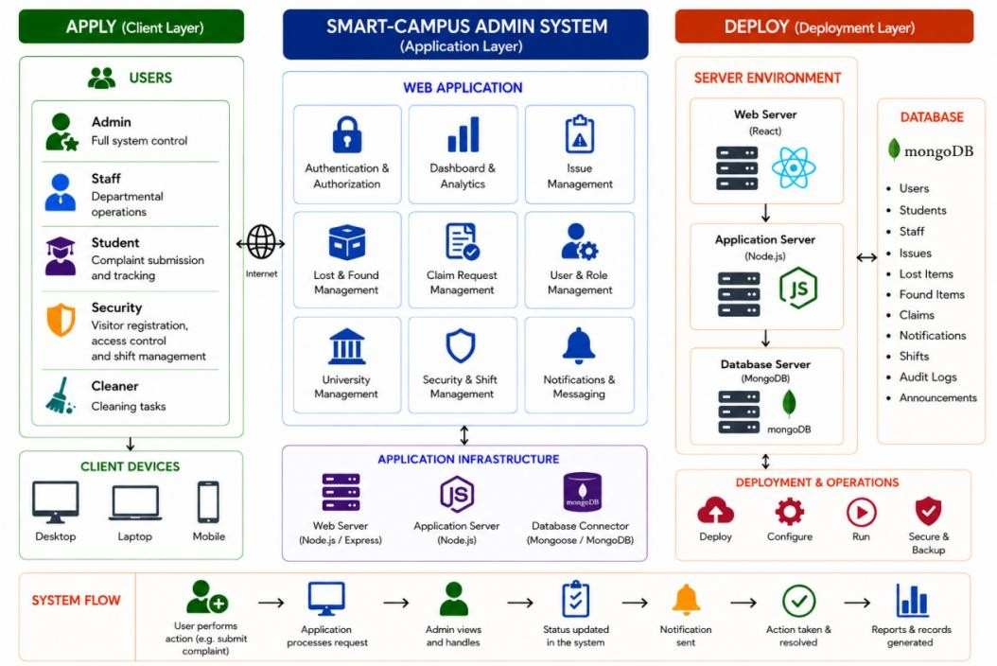
Figure 3.1: Smart Campus Lost & Found System Architecture
Figure 3.1 illustrates the overall architecture of the Smart Campus Lost & Found System, showing the interaction between the Web Application, Mobile Application, Backend Server, RESTful APIs, and MongoDB database.

3.4 System Requirements
The successful implementation of the Smart Campus Lost & Found System requires appropriate hardware and software resources to support development, testing, deployment, and daily operation. These requirements ensure that the system performs efficiently, securely, and reliably within the university environment.
The following sections describe the hardware and software requirements used during the development and implementation of the proposed system.

3.4.1 Hardware Requirements
The Smart Campus Lost & Found System requires appropriate hardware resources to support software development, testing, deployment, and day-to-day operation. The selected hardware provides sufficient processing power, storage capacity, and network connectivity to ensure efficient system performance.
The hardware requirements used during the development of the system are presented below.

Table 3.1: Hardware Requirements
Hardware Component | Minimum Requirement
Processor | Intel Core i5 (8th Generation) or AMD Ryzen 5
Memory (RAM) | 8 GB or higher
Storage | 256 GB SSD or higher
Display | 1366 × 768 resolution or higher
Internet Connection | Broadband Internet Connection
Mobile Device | Android Smartphone (Android 10 or later)

The processor provides sufficient computing power for running the development environment, backend server, database, and frontend applications simultaneously. A minimum of 8 GB RAM ensures smooth execution of multiple software tools, while the SSD improves application startup time and file access performance.
The system is accessible through desktop computers, laptops, and Android smartphones, enabling different categories of users to access the platform according to their assigned roles.

3.4.2 Software Requirements
The Smart Campus Lost & Found System was developed using modern software technologies that support secure, scalable, and efficient application development. These technologies provide the necessary tools for building the web application, mobile application, backend services, and database management system.
Table 3.2: Software Requirements
Software | Purpose
Windows 11 | Development Operating System
Visual Studio Code | Source Code Editor
Node.js | Backend Runtime Environment
Express.js | Backend Framework
React.js (Vite) | Web Application Development
Flutter SDK | Mobile Application Development
Dart | Flutter Programming Language
MongoDB | Database Management System
MongoDB Compass | Database Administration
Postman | REST API Testing
Git & GitHub | Version Control
Firebase Cloud Messaging (FCM) | Push Notification Service
Google Chrome | Web Browser for Testing

The backend server is developed using Node.js and Express.js, while the administrative web application is developed using React.js with Vite. The mobile application is developed using the Flutter framework with the Dart programming language, allowing efficient Android application development.
MongoDB is used to store and manage all application data, including user accounts, student records, complaints, lost and found reports, visitor information, announcements, notifications, security shifts, and audit logs.
During development, Visual Studio Code served as the primary code editor, while Postman was used to test RESTful API endpoints. Git and GitHub were used for source code version control and project management.
To support secure authentication and efficient communication, the system also utilizes several additional software libraries and services, including:
- JSON Web Token (JWT) for secure user authentication.
- bcrypt for password encryption.
- Multer for handling image uploads.
- Sharp for image processing and optimization.
- Socket.io for real-time communication between the server and web application.
- Firebase Cloud Messaging (FCM) for delivering push notifications to mobile users.
These software components work together to provide a secure, reliable, and efficient Smart Campus Lost & Found System.

3.5 System Requirements
The requirements of the Smart Campus Lost & Found System are divided into Functional Requirements and Non-Functional Requirements. Functional requirements describe the services and operations that the system must perform, while non-functional requirements define the quality attributes that ensure the system performs efficiently, securely, and reliably.
The following sections present the functional and non-functional requirements identified during the system analysis and design phase.

3.5.1 Functional Requirements
The functional requirements describe the specific services and operations that the Smart Campus Lost & Found System must perform to satisfy the needs of students, administrators, security officers, and cleaners. These requirements define the expected behavior of the system and ensure that all major functionalities operate according to the project objectives.
The functional requirements of the proposed system are presented as follows:
R1: The system shall provide secure login functionality for all authorized users based on their assigned roles.
R2: The system shall allow Super Administrators and Staff Administrators to register students manually through the web application.
R3: The system shall allow Staff Administrators to import multiple student records using a standardized Excel spreadsheet.
R4: The system shall automatically generate a unique digital QR Code for every registered student.
R5: The system shall allow Security Officers to verify student identities by scanning QR Codes or entering Student IDs manually.
R6: The system shall notify Security Officers whenever a scanned student is blacklisted or has restricted campus access.
R7: The system shall allow Students to report lost items by providing item details, location, date, description, and images.
R8: The system shall allow Cleaners to report found items through the mobile application.
R9: The system shall compare lost and found item reports to assist administrators in identifying possible matches.
R10: The system shall allow Students to submit complaints related to classrooms and campus facilities and monitor their complaint status.
R11: The system shall allow Security Officers to register campus visitors by recording their personal information and visit details.
R12: The system shall allow Staff Administrators to assign and manage security officer work shifts.
R13: The system shall allow Super Administrators to manage user accounts, role assignments, announcements, blacklist records, and audit logs.
R14: The system shall provide real-time notifications for QR Code verification, complaint updates, claim decisions, visitor registration, security shifts, and campus announcements.
R15: The system shall generate reports and statistical summaries related to student registration, QR Code verification, complaints, lost and found activities, visitor records, and overall system usage.

3.5.2 Non-Functional Requirements
The non-functional requirements define the quality attributes that the Smart Campus Lost & Found System must satisfy to ensure reliable, secure, efficient, and user-friendly operation. These requirements focus on system performance, security, usability, maintainability, and other quality characteristics.
Performance
NFR1: The system shall provide fast response times for user authentication, QR Code verification, complaint submission, visitor registration, and lost and found operations.
NFR2: The system shall efficiently process multiple user requests simultaneously without noticeable performance degradation during normal campus operations.
Usability
NFR3: The system shall provide a simple, responsive, and user-friendly interface for both the web and mobile applications.
NFR4: The system shall provide clear validation messages, notifications, and feedback to assist users while interacting with the application.
Security
NFR5: The system shall implement Role-Based Access Control (RBAC), JSON Web Token (JWT) authentication, and password encryption using bcrypt to prevent unauthorized access.
NFR6: The system shall validate all user input before processing or storing information in the database to maintain data integrity and protect against invalid input.
Reliability
NFR7: The system shall maintain reliable operation during normal university activities and recover gracefully from unexpected errors without data loss.
Maintainability
NFR8: The system shall be developed using a modular architecture to simplify future maintenance, testing, and feature enhancement.
Compatibility
NFR9: The web application shall support modern web browsers such as Google Chrome, Mozilla Firefox, Microsoft Edge, and Safari, while the mobile application shall support Android devices.
Availability
NFR10: The system shall be available to authorized users whenever required during normal university operating hours, ensuring continuous access to campus services.

3.6 Feasibility Study
A feasibility study was conducted to evaluate whether the proposed Smart Campus Lost & Found System could be successfully developed and implemented within the available technical resources, budget, operational environment, and project schedule. The study examined the technical, economic, operational, and schedule feasibility of the proposed system.

3.6.1 Technical Feasibility
The Smart Campus Lost & Found System is technically feasible because it is developed using modern and widely adopted technologies, including React.js, Flutter, Node.js, Express.js, and MongoDB. These technologies are open-source, well-documented, and supported by large developer communities.
The system also utilizes QR Code technology for student identification, RESTful APIs for communication between the frontend and backend, and Firebase Cloud Messaging (FCM) for push notifications. These technologies are stable, reliable, and suitable for implementing a secure campus management system.
The development team possesses the required programming knowledge and technical skills to design, implement, test, and maintain the proposed system.

3.6.2 Economic Feasibility
The proposed system is economically feasible because it is built primarily using free and opensource software technologies. Development tools such as Visual Studio Code, Node.js, React.js, Flutter, MongoDB Community Edition, and Postman do not require expensive software licenses.
The university only requires standard computer equipment, internet connectivity, and Android smartphones for users. Since the system replaces manual record keeping and paper-based processes, it can reduce operational costs associated with printing, manual documentation, and administrative workload.
Overall, the benefits of the system outweigh the development and maintenance costs, making the project financially practical.

3.6.3 Operational Feasibility
The Smart Campus Lost & Found System is designed to improve existing campus operations without significantly changing current administrative procedures.
Students can easily report lost items, submit complaints, and access their digital student identification through the mobile application. Security Officers can quickly verify student identities and register visitors, while Staff Administrators can efficiently manage student records, complaints, security shifts, and reports using the web application.
The simple and user-friendly interfaces reduce training requirements and encourage user acceptance. Therefore, the system can be integrated into the university's daily operations with minimal disruption.

3.6.4 Schedule Feasibility
The project was completed according to the planned development schedule using the Agile Software Development Life Cycle (Agile SDLC).
The project was divided into several development iterations, including requirements analysis, system design, database design, frontend development, backend development, testing, debugging, and documentation.
Each phase was completed successfully within the allocated project timeline, demonstrating that the proposed system is feasible from a scheduling perspective.

3.7 UML Diagrams
Unified Modeling Language (UML) diagrams were used to model the structure and behavior of the Smart Campus Lost & Found System. These diagrams provide a graphical representation of the system requirements, user interactions, and relationships between system components.
The UML diagrams improve communication between developers and stakeholders by presenting a clear visualization of how different users interact with the system and how the system components work together.
The UML diagrams developed for this project include the Use Case Diagram, which illustrates the interactions between system users and the available system functions.

3.7.1 Use Case Diagram
The Use Case Diagram illustrates the interactions between the users of the Smart Campus Lost & Found System and the services provided by the system.
The system consists of five primary actors:
• Super Administrator
• Staff Administrator
• Student
• Security
• Cleaner

The Super Administrator manages users, roles, blacklist records, announcements, reports, and audit logs.
The Staff Administrator manages student registration, complaints, claims, visitor records, security shifts, and other administrative activities.
The Student accesses the mobile application to view the digital student ID, report lost items, submit complaints, monitor claim status, and receive notifications.
The Security Officer verifies student identities through QR Code scanning or Student ID verification, registers visitors, monitors access activities, and receives blacklist alerts.
The Cleaner reports found items through the mobile application, allowing administrators to compare them with reported lost items.
The Use Case Diagram provides a clear understanding of the responsibilities assigned to each system user and the interaction between users and the Smart Campus Lost & Found System.

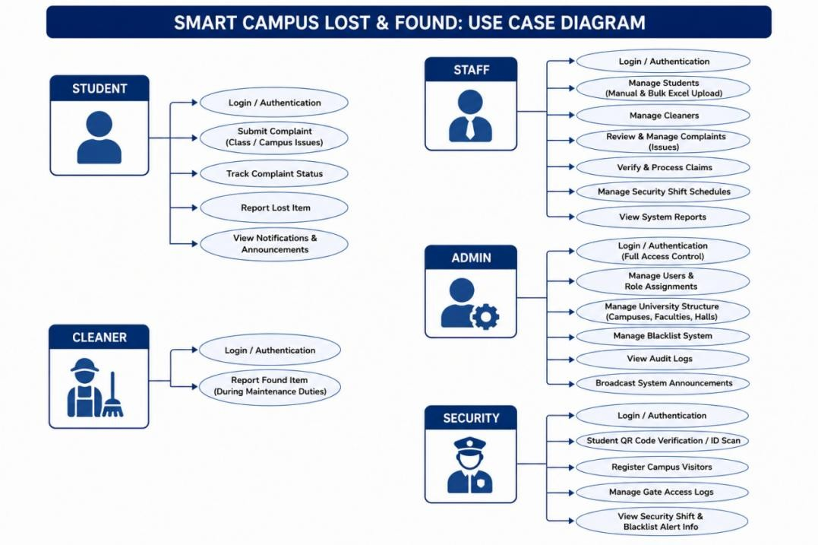
Figure 3.2: Use Case Diagram

Figure 3.2 illustrates the interactions between the five user roles and the major functions of the Smart Campus Lost & Found System.

3.9 Database Design
The database design defines how data is organized, stored, and managed within the Smart Campus Lost & Found System. A well-designed database ensures data consistency, efficient retrieval, secure storage, and reliable communication between the web application, mobile application, and backend services.
The proposed system uses MongoDB, a NoSQL document-oriented database, to store application data. MongoDB was selected because of its flexibility, scalability, and ability to efficiently manage structured and semi-structured information.
The database stores information related to users, students, complaints, lost items, found items, visitor registrations, announcements, notifications, claims, security shifts, access logs, blacklist records, and audit logs.
The relationships between collections are maintained using ObjectId references, allowing related information to be linked while preserving the flexibility of the NoSQL database model.
The complete Entity Relationship Diagram (ERD) is provided in the Appendix. A summary of the primary database collections used in the system is presented in Table 3.9.1.
Table 3.3: Database Design
Collection | Description
Users | Stores user account information, login credentials, and user roles.
Students | Stores student personal and academic information.
Complaints | Stores complaints submitted by students.
Lost Items | Stores reports of lost items submitted by students.
Found Items | Stores reports of found items submitted by cleaners.
Claims | Stores ownership claim requests and their approval status.
Visitors | Stores visitor registration records.
Announcements | Stores campus announcements created by administrators.
Notifications | Stores user notification messages and read status.
Security Shifts | Stores security officer duty schedules.
Access Logs | Stores QR Code verification and campus entry records.
Blacklist | Stores information about restricted users.
Audit Logs | Stores records of important administrative activities.

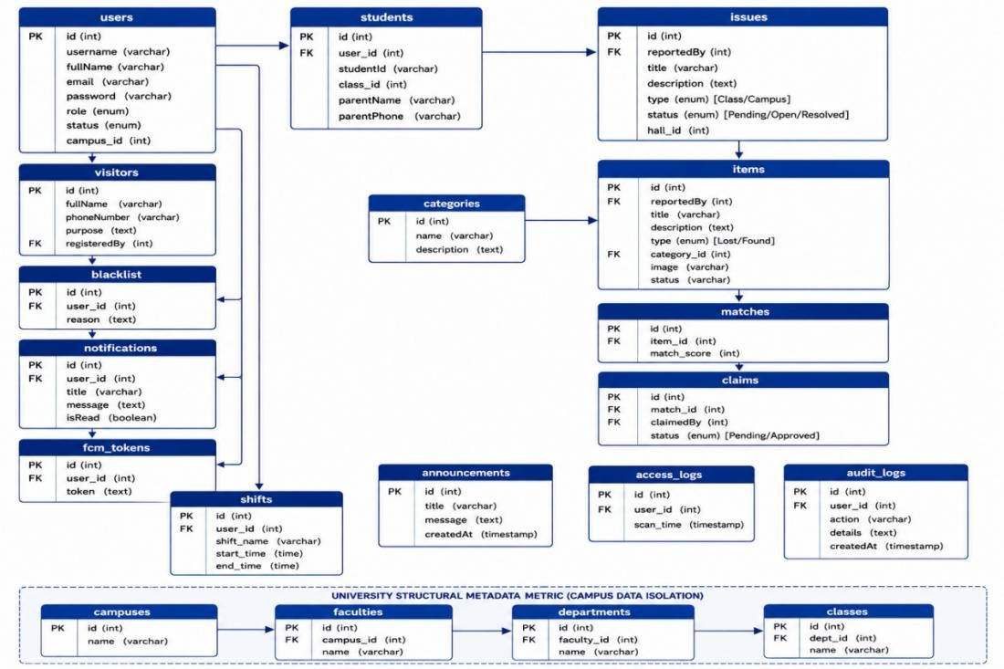
Figure 3.3: Entity Relationship Diagram (ERD)

Figure 3.3 illustrates the database structure of the Smart Campus Lost & Found System, including the major collections and their relationships.
Chapter Summary
This chapter presented the methodology used to design and develop the Smart Campus Lost & Found System. It discussed the system overview, major system features, three-tier architecture, hardware and software requirements, functional and non-functional requirements, feasibility study, UML design, and database structure.
The chapter also explained how modern technologies, including React.js, Flutter, Node.js, Express.js, MongoDB, JWT, and Firebase Cloud Messaging, were integrated to develop a secure and efficient Smart Campus platform.

CHAPTER IV: IMPLEMENTATION AND RESULTS

4.1 Introduction
This chapter presents the implementation and results of the Smart Campus Lost & Found System. It describes how the proposed system was developed based on the analysis and design presented in the previous chapter. The implementation includes the Web Application, Mobile Application, Backend API, and MongoDB database, which work together to provide an integrated platform for managing campus access, lost and found services, complaints, visitor registration, and notifications.
The chapter also explains the testing procedures carried out to ensure that the developed system satisfies both the functional and non-functional requirements. Different testing techniques were applied to evaluate the system's functionality, usability, compatibility, performance, and security. Screenshots of the developed interfaces are included to demonstrate how the system operates in real-world situations.
The purpose of this chapter is to demonstrate that the Smart Campus Lost & Found System was successfully implemented and that it provides an effective digital solution for improving campus security, access control, and lost item management.

4.2 Web Admin Panel Implementation and Testing
The Web Admin Panel serves as the management platform of the Smart Campus Lost & Found System. It allows Super Administrators and Staff Administrators to manage students, cleaners, security officers, complaints, claims, announcements, and reports through a centralized web interface.
The system was developed using React.js for the frontend, Node.js with Express.js for the backend, and MongoDB for data storage. The interface was designed to be responsive, userfriendly, and easy to navigate so that administrators can efficiently perform their daily tasks.
The Web Admin Panel includes several management modules that automate manual campus operations and improve administrative efficiency.
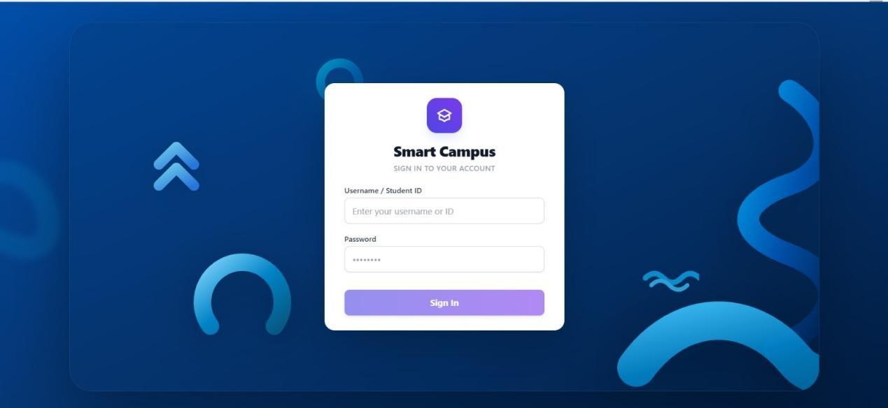
Figure 4.1: Login Page

The login page provides secure authentication for authorized users before accessing the administration panel.
The login module authenticates administrators using secure credentials before granting access to the system. After successful authentication, users are redirected to their respective dashboards according to their assigned roles.

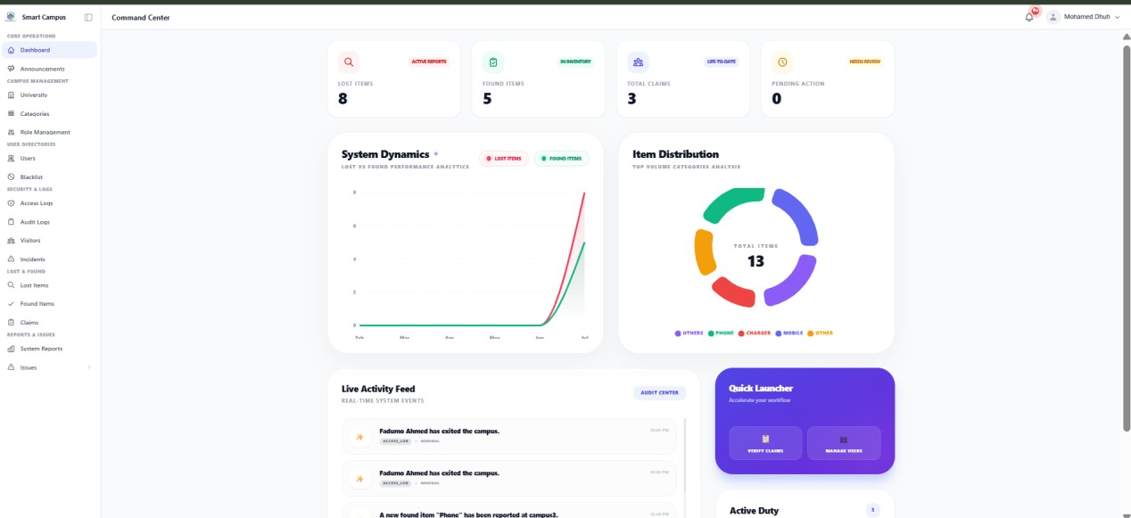
Figure 4.2: Dashboard

The dashboard provides an overview of important system information, including the total number of registered students, cleaners, security officers, reported lost items, found items, complaints, visitors, and recent system activities. This enables administrators to monitor campus operations from a single interface. The dashboard displays an overview of the entire Smart Campus system, including statistics, notifications, and recent activities.

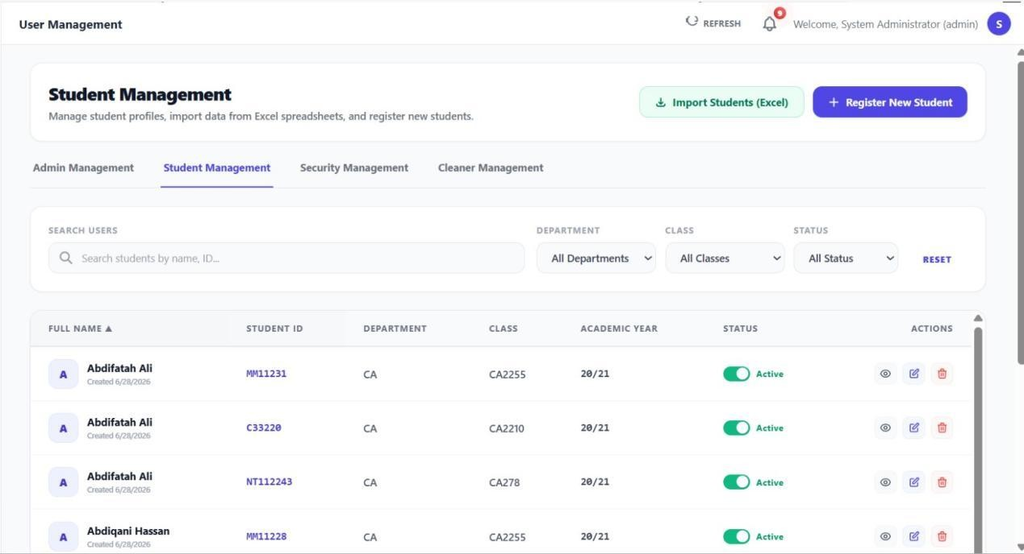
Figure 4.3: Student Management

The Student Management module enables administrators to register new students either manually or by uploading an Excel spreadsheet. During registration, the system automatically generates the Student ID, username, and password for each student.
Administrators can also update student information, deactivate accounts, search for students, and monitor student activities within the system.
The automation of student registration significantly reduces manual work and improves the accuracy of student records.
The Student Management module allows administrators to register, edit, search, and manage student accounts efficiently.
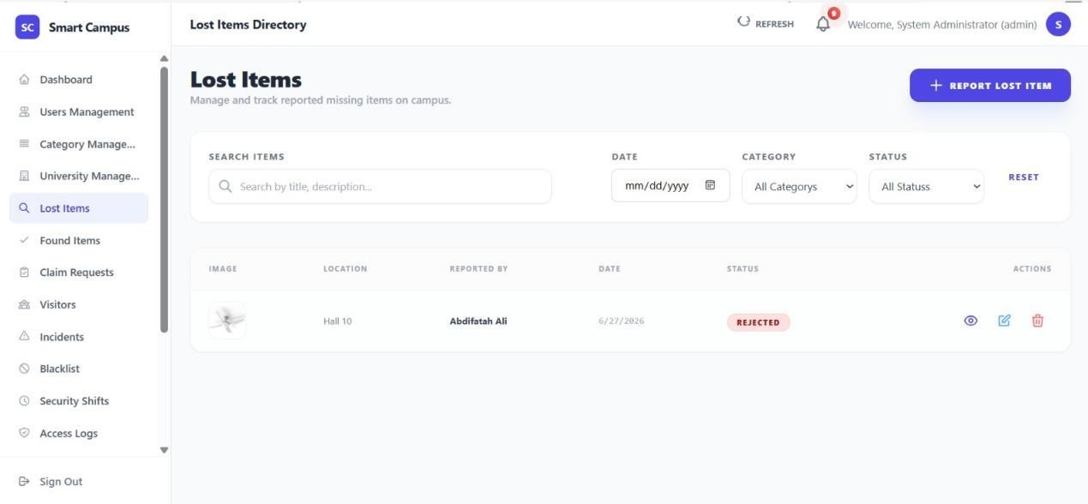
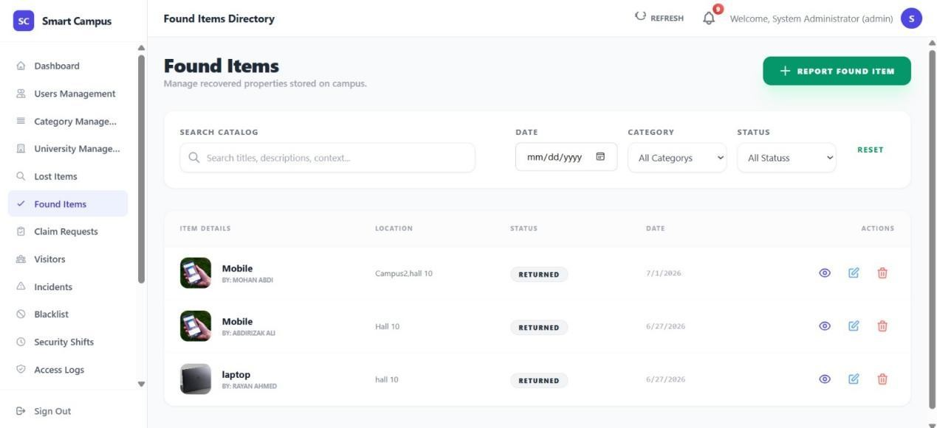
Figure 4.4: Lost and Found Management

The Lost and Found module is one of the core components of the Smart Campus Lost & Found System. It enables students to report lost items while allowing cleaners to report items that have been found within the campus.
When both reports are submitted, the Automatic Matching Engine compares important item attributes such as item category, description, color, brand, location, and date. If a possible match is identified, the system automatically notifies both the student and the administrator for further verification.
Staff administrators review the submitted evidence before approving or rejecting ownership claims. This process reduces manual searching and improves the chances of recovering lost property efficiently.
The Lost and Found Management module enables administrators to monitor reported lost items, found items, and automatically generated matches.
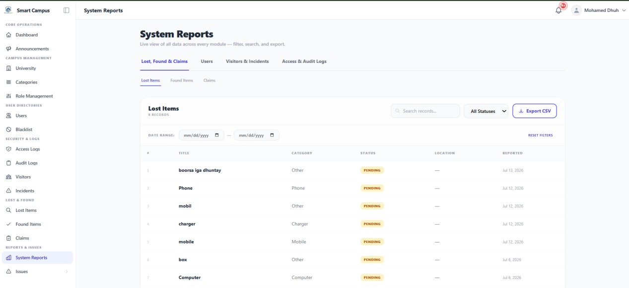
Figure 4.5: Reports and Analytics

The Reports and Analytics module provides administrators with comprehensive statistical information regarding system activities. The dashboard displays reports related to student registrations, QR code scans, access logs, visitor registrations, complaints, lost and found records, and claim processing.
The system automatically generates charts and summary reports that help administrators monitor system performance and identify trends over time. Search and filtering options allow users to retrieve information based on specific dates, users, or activity types.
These reports assist university management in making informed decisions while improving operational efficiency and campus security.

The Reports and Analytics dashboard provides statistical reports, charts, and summaries that support monitoring, evaluation, and decision-making within the Smart Campus system.

4.2.1.1 Functional Testing
Functional testing was conducted to verify that every major function of the Smart Campus Lost & Found System operates according to the specified system requirements. The testing focused on validating user interactions, system responses, data processing, and role-based permissions. A black-box testing approach was adopted, where the functionality of each module was tested by providing different inputs and observing the outputs without considering the internal source code.
The testing covered the major components of both the Web Admin Panel and the Mobile Application, including user authentication, student management, QR code verification, lost and found reporting, complaint management, visitor registration, announcements, and report generation. Each function was tested using valid and invalid input data to ensure that the system handled different scenarios correctly.
The test results demonstrated that the developed system successfully performed all essential operations while providing accurate responses and maintaining data integrity.
Table 4.1: Functional Testing
Test ID | Module | Test Scenario | Expected Result | Status
TC-01 | Login | Login with valid credentials | User is redirected to the appropriate dashboard | Passed
TC-02 | Login | Login with invalid credentials | Error message is displayed and access is denied | Passed
TC-03 | Student  Management | Register a new student | Student account is successfully created | Passed
TC-04 | Student  Management | Upload Excel file | Student records are imported successfully | Passed
TC-05 | QR Verification | Scan a valid QR Code | Student information is displayed immediately | Passed
TC-06 | QR Verification | Scan a blacklisted student  QR Code | Blacklist warning is displayed | Passed
TC-07 | Lost Item | Submit a lost item report | Lost item is stored successfully | Passed
TC-08 | Found Item | Submit a found item report | Found item is recorded successfully | Passed
TC-09 | Claim  Management | Approve a claim request | Claim status changes to  Approved | Passed
TC-10 | Complaint  Management | Submit a campus complaint | Complaint is saved with  Pending status | Passed
TC-11 | Visitor  Management | Register a visitor | Visitor information is stored successfully | Passed
TC-12 | Security Shift | Assign a security shift | Shift is assigned and displayed correctly | Passed
TC-13 | Announcement | Publish an announcement | Notification is delivered to users | Passed
TC-14 | Reports | Generate system report | Report is generated successfully | Passed
TC-15 | User Management | Update user information | Updated information is saved successfully | Passed
The functional testing results indicate that all major system modules operated as expected. Each feature successfully completed its intended task without producing critical errors during testing. The role-based access mechanism correctly restricted users to their authorized functions, while the validation mechanisms prevented invalid data from being stored in the database.
Overall, the functional testing confirms that the Smart Campus Lost & Found System satisfies its functional requirements and is capable of supporting campus access management, lost and found services, complaint handling, visitor registration, and administrative operations in a reliable and efficient manner.

4.2.1.2 User Interface (UI/UX) Evaluation
The user interface of the Smart Campus Lost & Found System was designed to provide
simple, attractive, and user-friendly experience for all system users. Since the system is used by different categories of users, including Students, Security Officers, Cleaners, Staff
Administrators, and Super Administrators, special attention was given to usability, consistency, and accessibility throughout the development process.
The Web Admin Panel follows a clean dashboard layout with organized navigation menus, responsive tables, status indicators, and interactive forms. Administrators can easily navigate between different modules without unnecessary complexity. Icons, buttons, and color combinations were selected carefully to improve readability and reduce user errors.
Similarly, the Flutter Mobile Application was designed with a modern interface that enables users to perform tasks quickly. Frequently used functions such as QR Code identification, Lost
Item reporting, Found Item reporting, Complaint submission, Visitor registration, and Notifications are easily accessible from the application's main dashboard.
To improve user experience, the system provides immediate feedback whenever users perform an action. Success messages, warning notifications, validation messages, and confirmation dialogs help users understand whether an operation has been completed successfully or requires additional attention.
The interfaces were evaluated by several users during the testing phase. Most participants found the system easy to understand and navigate without requiring extensive training. Their feedback contributed to several improvements, including clearer button labels, improved form validation, simplified navigation, and better mobile responsiveness.
Overall, the evaluation confirmed that the developed interfaces satisfy usability requirements and provide an efficient interaction between users and the Smart Campus Lost & Found System.

4.2.1.3 Summary of Web Application Testing
After completing the implementation of the Web Admin Panel, comprehensive testing was carried out to ensure that every module operated correctly under different scenarios. The testing covered user authentication, student registration, user management, blacklist management, complaint processing, claim verification, security shift scheduling, announcement management, reports generation, and audit logging.
The testing results showed that all administrative functions performed successfully with accurate data processing and proper validation mechanisms. Role-based permissions prevented unauthorized users from accessing restricted resources, while the database correctly stored and retrieved information without data loss.
The responsiveness of the web application was also evaluated on different screen sizes and modern web browsers. The interface remained stable and responsive throughout the testing process.
Based on the testing results, the Web Admin Panel met all functional requirements and demonstrated reliable performance suitable for deployment within a university campus environment.

4.2.2 Mobile Application Implementation and Testing
The Mobile Application represents the primary interface used by students, security officers, and cleaners to interact with the Smart Campus Lost & Found System. It was developed using Flutter, allowing the application to operate efficiently on Android devices while providing a responsive and consistent user experience.
The application communicates with the backend server through RESTful APIs developed using Node.js and Express.js. Data is securely stored in MongoDB, while Firebase Cloud Messaging is used to deliver real-time notifications to users.
The mobile application simplifies several campus activities by allowing students to access their digital identification, report lost items, submit complaints, monitor claim status, receive announcements, and receive notifications directly from their smartphones. Security officers can verify student identities using QR Code scanning, register campus visitors, and monitor notifications. Cleaners can report found items and contribute to the recovery process of lost property.
The implementation focused on simplicity, security, and performance to ensure that users can complete their daily tasks quickly and efficiently.

4.2.2.1 Mobile Application Features
The Smart Campus Lost & Found System Mobile Application provides several important features that support daily campus operations. These features are designed according to the responsibilities assigned to each user role.
The major features of the mobile application include:
- Secure user login and authentication.
- Digital Student ID with dynamically generated QR Code.
- QR Code scanning for student verification.
- Lost item reporting.
- Found item reporting.
- Claim request tracking.
- Complaint submission and status tracking.
- Visitor registration.
- Real-time notifications.
- User profile management.
Each feature was implemented to improve efficiency, reduce manual paperwork, and strengthen campus security while providing a convenient digital experience for all users.
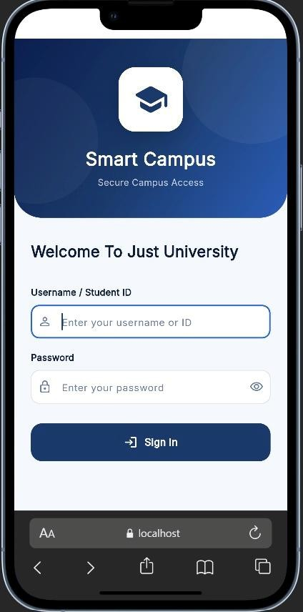
Figure 4.6: Mobile Login Screen
The Login Screen allows authorized users to securely access the Smart Campus Lost & Found System using their registered credentials.
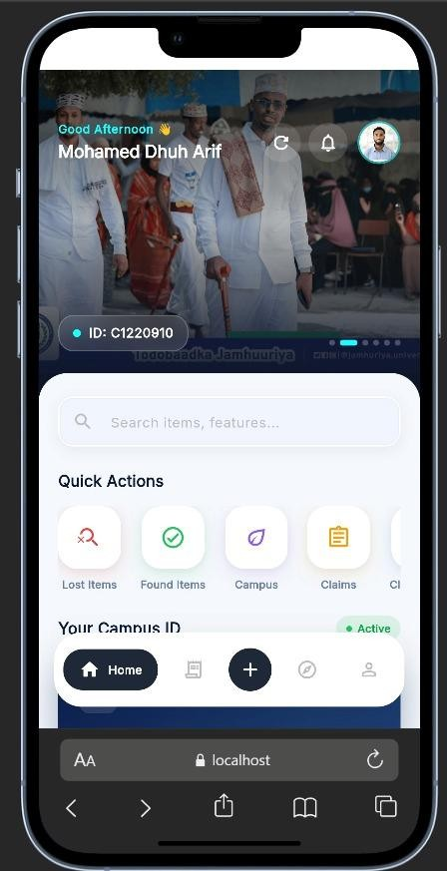
Figure 4.7: Dashboard Screen

The Dashboard serves as the main page after successful login. It provides quick access to the system's major services through organized menus and shortcut buttons. The dashboard layout differs slightly depending on the user's role, ensuring that each user only accesses features relevant to their responsibilities.
Students can report lost items, submit complaints, and access their digital identification card. Security officers can verify student identities and register visitors, while cleaners can report found items.
The Dashboard provides quick access to the major services available within the Smart Campus Lost & Found System.
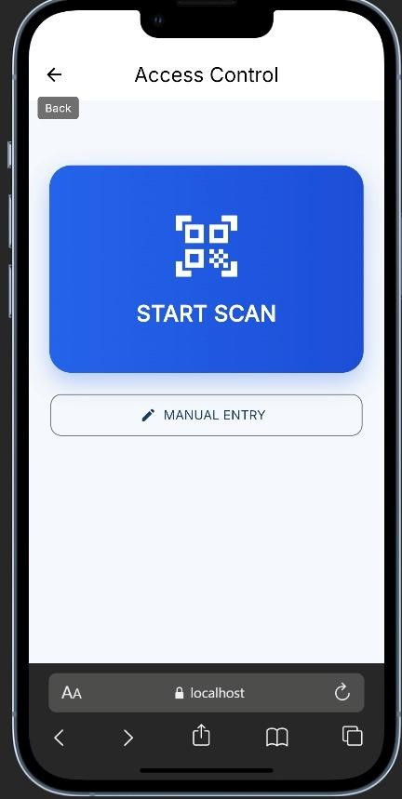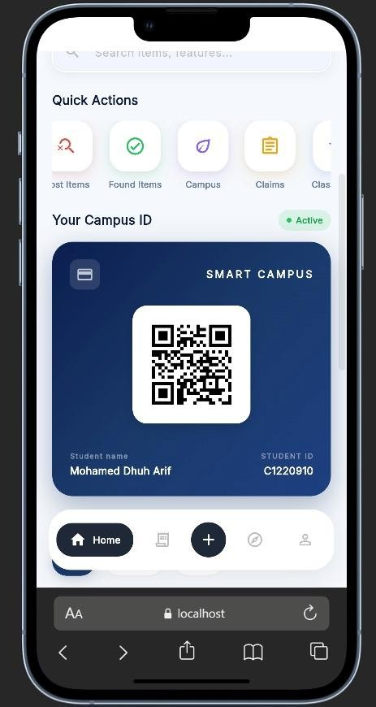
Figure 4.8: QR Code Scanner

The QR Code Scanning feature enables security officers to verify student identities by scanning their digital QR Codes using the mobile device camera. The system instantly retrieves the student's information and checks blacklist records before displaying the verification result.
If the student's account is active, access is granted. If the account has been blacklisted, the application immediately displays a warning message to the security officer.

The QR Code Scanner allows security officers to verify student identities quickly and securely during campus entry.
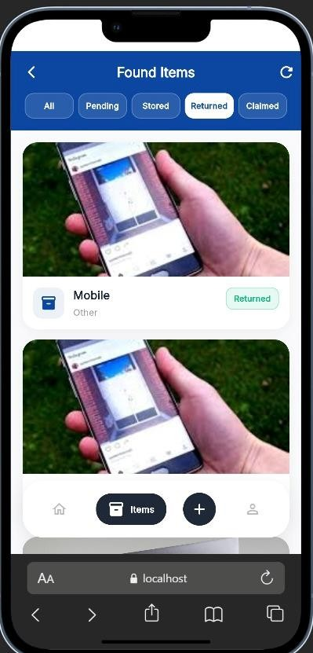
Figure 4.9: Found Item Reporting

The Found Item Reporting feature allows cleaners to register items discovered within the campus. Information such as the item description, location, category, date found, and photographs is submitted through the mobile application.Students can report lost property through the Lost Item Reporting module by providing detailed information such as the item name, category, description, location, date of loss, and supporting images.
The submitted information is compared with reported lost & found items to identify possible matches automatically.
The Lost and Found Items Reporting screen enables cleaners to register recovered items for automatic matching with lost item reports.

4.2.2.2 Unit and Integration Testing
After completing the development of the mobile application, unit testing and integration testing were performed to verify the correctness of individual components and the interaction between different system modules. Unit testing focused on evaluating each module independently, while integration testing verified that communication between the mobile application, backend server, and database functioned correctly.
Testing covered major features including user authentication, QR Code verification, lost item reporting, found item reporting, complaint submission, claim processing, visitor registration, and notification delivery.
The results indicated that all modules communicated successfully with the backend API, and data was accurately stored and retrieved from the MongoDB database. Error handling and validation mechanisms also performed correctly when invalid input was provided.
Table 4.2: Unit and Integration Testing
Test ID |  | Module | Test Scenario |  | Expected Result | Status
UT-01 | Authentication |  | Login with valid credentials | User successfully authenticated |  | Passed
UT-02 | QR Verification |  | Scan valid QR Code | Student information displayed |  | Passed
UT-03 | Lost Item |  | Submit lost item | Record saved successfully |  | Passed
UT-04 | Found Item |  | Submit found item | Record saved successfully |  | Passed
IT-01 | Matching  Engine |  | Compare lost and found items | Matching result generated |  | Passed
IT-02 | Claim  Processing |  | Approve ownership request | Claim status updated |  | Passed
IT-03 | Complaint  System |  | Submit complaint | Complaint stored successfully |  | Passed
IT-04 | Visitor  Registration |  | Register visitor | Visitor information saved |  | Passed
IT-05 | Notification  Service |  | Send notification | Notification delivered successfully |  | Passed
The testing results confirmed that the integration between the Flutter Mobile Application, Node.js backend, Express.js API, MongoDB database, and Firebase Notification Service operated successfully. The application demonstrated reliable performance and fulfilled all functional requirements specified during the system design phase.

4.2.2.3 Device Compatibility Testing
Device compatibility testing was conducted to ensure that the Smart Campus Lost & Found System mobile application performs consistently across different Android devices with varying screen sizes, operating system versions, and hardware specifications. Since students, security officers, and cleaners may use different smartphones, compatibility testing was essential to verify that the application remained functional under different environments.
The testing focused on user interface responsiveness, QR Code generation and scanning, navigation, notification delivery, and communication with the backend server. Each device was evaluated to determine whether the application displayed correctly, responded efficiently, and maintained stable performance.
The results showed that the mobile application operated successfully on all tested Android devices without significant compatibility issues. The user interface automatically adjusted to different screen resolutions while maintaining usability and readability.

Table 4.3: Device Compatibility Testing
Device | Operating System | Screen Size | Test Result
Samsung Galaxy A15 | Android 14 | 6.5 inches | Passed
Tecno Spark 20 | Android 13 | 6.6 inches | Passed
Infinix Smart 8 | Android 13 | 6.6 inches | Passed
Xiaomi Redmi Note 13 | Android 14 | 6.67 inches | Passed
Android Emulator | Android 14 | Virtual Device | Passed
The compatibility testing confirmed that the application maintained consistent functionality across different Android devices. Navigation, QR Code scanning, notification delivery, and data synchronization performed successfully throughout the testing process.

4.4 Security Implementation and Testing
Security is one of the most important aspects of the Smart Campus Lost & Found System because the application stores sensitive information related to students, administrators, security officers, visitors, and campus activities. To ensure the confidentiality, integrity, and availability of system data, several security mechanisms were implemented during the development process.
The system incorporates secure user authentication, role-based authorization, password encryption, input validation, secure API communication, and controlled access to system resources. Security testing was also conducted to verify that the implemented protection mechanisms function correctly under different scenarios.
The following subsections describe the security measures adopted during the implementation and the testing procedures used to evaluate the overall security of the system.

4.4.1 Authentication and Authorization
Authentication is responsible for verifying the identity of users before allowing them to access the Smart Campus Lost & Found System. Every registered user must provide valid login credentials before accessing the system. After successful authentication, the backend generates a JSON Web Token (JWT) which is used to authorize subsequent requests between the client application and the server.
Authorization is implemented using Role-Based Access Control (RBAC). Each user is assigned a specific role, including Super Administrator, Staff Administrator, Student, Security Officer, or Cleaner. Every role has different permissions according to its responsibilities within the system.
For example, only administrators can manage student accounts, approve claims, publish announcements, and generate reports. Security officers can verify student identities and register visitors, while students can report lost items, submit complaints, and track claim requests.
Cleaners are authorized to report found items but cannot access administrative functions.
Passwords are securely encrypted using the bcrypt hashing algorithm before being stored in the MongoDB database. This prevents unauthorized individuals from accessing user passwords even if database information is compromised.
The implementation of authentication and authorization significantly improves the overall security of the Smart Campus Lost & Found System by ensuring that only authorized users can access protected resources.

4.2.2 Input Validation
Input validation was implemented to ensure that only valid and properly formatted information is accepted by the system. Validation is performed on both the client side and the server side to minimize user errors and protect the application against malicious input.
The React.js Web Application and Flutter Mobile Application validate user input before transmitting data to the backend. Required fields must be completed, invalid formats are rejected, and users receive immediate feedback whenever incorrect information is entered.
On the server side, the Express.js backend performs additional validation before processing API requests. The server verifies that all required information is present, data types are correct, and invalid requests are rejected with appropriate error messages.
File uploads, including student profile images and lost item photographs, are also validated to ensure that only supported file formats and acceptable file sizes are uploaded.
These validation mechanisms improve data accuracy while protecting the database against invalid or potentially harmful information.

4.2.3 Security Testing
Security testing was conducted to verify that the implemented security mechanisms effectively protect the Smart Campus Lost & Found System against unauthorized access and common security threats.
Several security scenarios were tested, including authentication validation, unauthorized access attempts, role-based permission verification, invalid input handling, and QR Code verification. The objective was to ensure that protected resources remained inaccessible to unauthorized users while maintaining the integrity of stored information.
The security testing results are summarized in Table 4.5.
Table 4.4: Security Testing
Test ID | Security Test | Expected Result | Status
ST-01 | Login with invalid password | Access denied | Passed
ST-02 | Access Admin page as Student | Permission denied | Passed
ST-03 | Access protected API without JWT | Unauthorized response | Passed
ST-04 | Submit invalid input data | Validation error displayed | Passed
ST-05 | Scan blacklisted student QR Code | Warning message displayed | Passed
ST-06 | Upload unsupported image format | Upload rejected | Passed
ST-07 | Attempt duplicate login session | Session validated successfully | Passed
ST-08 | SQL/NoSQL Injection attempt | Request rejected | Passed

The security testing demonstrated that the implemented authentication, authorization, validation, and access control mechanisms successfully protected the application against unauthorized operations. No critical security vulnerabilities were identified during the testing process.
Overall, the Smart Campus Lost & Found System satisfies the basic security requirements expected for a modern campus management application.

4.2.4 Chapter Summary
This chapter presented the implementation and testing of the Smart Campus Lost & Found
System. The implementation included the development of the React.js Web Admin Panel,
Flutter Mobile Application, Node.js and Express.js backend services, RESTful APIs, and MongoDB database.
The chapter also described the implementation of major system modules, including user management, QR Code verification, lost and found management, complaint management, visitor registration, security shift management, announcements, reporting, and notifications. Screenshots of the developed interfaces demonstrated how users interact with the system during normal operation.
Comprehensive testing was conducted to evaluate the functionality, usability, compatibility, API performance, and security of the system. The testing results confirmed that all major components operated successfully and fulfilled both the functional and non-functional requirements specified during the system analysis and design phases.
Based on the implementation and testing outcomes, the Smart Campus Lost & Found System provides a reliable, secure, and user-friendly solution for improving campus access control, lost property management, complaint handling, and administrative operations. The successful completion of this chapter provides the foundation for the discussion and evaluation of the project results presented in the following chapter.

CHAPTER V: CONCLUSION AND RECOMMENDATIONS

5.1 Introduction
This chapter presents the conclusion of the Smart Campus Lost & Found System project. It summarizes the objectives achieved, discusses the overall findings of the implementation and testing phases, identifies the limitations encountered during the project, and provides recommendations for future improvements. The chapter also highlights the contribution of the proposed system toward improving campus security, student identification, lost and found management, complaint handling, and administrative efficiency.

5.2 Summary of the Study
The primary objective of this project was to design and implement a Smart Campus Lost & Found System that improves campus operations by integrating student identification, QR Code verification, lost and found management, complaint handling, visitor registration, security shift management, and administrative reporting into a single digital platform.
The system was successfully developed using modern web and mobile technologies. The web application was implemented using React.js with Vite, while the mobile application was developed using Flutter. The backend services were developed using Node.js and Express.js, and MongoDB was used as the database management system. Communication between the frontend applications and the backend was achieved through RESTful APIs, while JSON Web Token (JWT) was used for secure authentication and Firebase Cloud Messaging (FCM) was used to deliver push notifications.
The developed system enables Students to access digital student identification, report lost items, submit complaints, monitor claim requests, and receive notifications. Security Officers can verify student identities using QR Codes, register campus visitors, and monitor blacklist alerts. Cleaners can report found items, while Super Administrators and Staff Administrators manage users, complaints, reports, announcements, visitor records, and security shifts through the web application.
Comprehensive testing confirmed that the developed system satisfies the functional and nonfunctional requirements defined during the system analysis and design phase. The implementation demonstrates that the proposed solution can improve campus security, operational efficiency, transparency, and communication between different university stakeholders.

5.3 Conclusion
The Smart Campus Lost & Found System successfully achieved the objectives established at the beginning of this project. The system provides an integrated digital platform that replaces manual procedures for student identification, lost and found reporting, complaint management, visitor registration, and administrative monitoring.
The implementation of QR Code verification significantly improves campus access control by allowing Security Officers to verify student identities quickly and accurately. The Lost and Found module simplifies the reporting and recovery of lost property by allowing students and cleaners to submit reports electronically. The Complaint Management module enhances communication between students and university management through an organized digital workflow.
Furthermore, the system improves administrative efficiency by providing centralized management of users, reports, announcements, security shifts, and visitor records through an intuitive web dashboard. The use of secure authentication, role-based access control, encrypted passwords, and input validation contributes to the overall security and reliability of the application.
Overall, the Smart Campus Lost & Found System demonstrates that integrating modern web technologies, mobile applications, and cloud-based communication services can significantly improve the quality of campus management while reducing manual workload and improving service delivery.

5.4 Limitations of the Study
Although the Smart Campus Lost & Found System achieved its primary objectives, several limitations were identified during the development and testing phases.
The current implementation supports Android mobile devices only. An iOS version of the mobile application has not yet been deployed.
The system relies on internet connectivity for communication between the mobile application, web application, and backend server. Users may experience limited functionality when network connectivity is unavailable.
QR Code verification depends on the availability of mobile device cameras and proper lighting conditions during scanning.
The automatic matching of lost and found items is based primarily on information provided by users and does not utilize advanced artificial intelligence or image recognition techniques.
The system was tested within a limited university environment and has not yet been evaluated under large-scale production deployment involving multiple campuses.

5.5 Recommendations for Future Work
Several improvements can be considered in future versions of the Smart Campus Lost & Found System.
Future work may include the development of an iOS version of the mobile application to support Apple devices.
Artificial Intelligence and Machine Learning techniques can be integrated to improve automatic matching between lost and found items based on images and object recognition.
Offline QR Code verification may be implemented to allow student identification when internet connectivity is temporarily unavailable.
Biometric authentication, such as fingerprint or facial recognition, may be integrated to further strengthen system security.
Future versions may also include integration with university payment systems, student information systems, and library management systems to provide a more comprehensive Smart Campus platform.
Additional reporting dashboards and predictive analytics may also be developed to assist university management in making data-driven decisions.

5.6 Final Remarks
The Smart Campus Lost & Found System provides a practical and reliable solution for improving campus security, student identification, lost property management, complaint handling, and administrative operations. The integration of modern web technologies, mobile computing, QR Code verification, and secure backend services demonstrates the potential of digital transformation within higher education institutions.
The successful implementation of this project provides a strong foundation for future expansion and further research in Smart Campus technologies. With additional enhancements and continuous maintenance, the system can evolve into a comprehensive campus management platform capable of supporting the growing needs of modern universities.

References
Abhiram, P. K. (2023). Smart lost-and-found management application using mobile technology. International Journal of Computer Engineering.
Al-Mansoori, A. A.-H.-M. (2019). RFID based campus access control system. International Journal of Computer Applications.
Al-Mansoori, A. A.-H.-S. (2019). RFID-Based Smart Campus Access Control System. nternational Journal of Computer Applications, 20–27.
Alqahtani, A. A. (2022). Mobile applications for smart campus services: Opportunities and challenges.
Alsharif, M. &. (2020). Web-based smart campus framework for higher education.
Arbaiy, N. &. (2022). Web-based lost and found management system for universities. International Journal of Advanced Computer Science.
Bello, A. &. (2021). Biometric Access Control System for Educational Institutions. International Journal of Scientific & Technology Research, 34–40.
Bhatt, J. &. (2017). Design and development of wireless smart door lock system based on IoT. International Journal of Engineering Development and Research.
Chen, Y. L. (2020). QR code based access control system for smart buildings.
Dong, H. H. (2016). Service-Oriented Smart Campus Architecture for Higher Education.
Gbenle, M. e. (2022). Smart campus technologies for higher education: A systematic review. IEEE Access.
Guinard, D. B. (2008). Internet of Things for Smart Environments. Proceedings of the International Conference on the Internet of Things.
Ingale, S. P. (2023). Face recognition and QR code-based smart attendance system. International Journal of Computer Applications.
Kaur, P. (2021). Challenges of lost and found management in higher education institutions.
Kumar, A. &. (2021). Smart access monitoring system using QR code and IoT. International Journal of Engineering Research & Technology.
Kumar, V. (2019). Development of web-based lost and found management application. International Journal of Innovative Technology and Exploring Engineering.
Polin, K. W. (2023). Evolution of smart campus technologies: A systematic review. Education and Information Technologies, 6941–6963.
Prathap, P. K. (2020). RFID based smart attendance management system. International Journal of Scientific & Technology Research.
Rachmaniah, D. e. (2020). Mobile technologies for smart campus management. Journal of Physics: Conference Series.
Rahman, M. I. (2021). Mobile-based lost and found application for university campuses. International Journal of Advanced Computer Science and Applications, 233–240.
Rahman, M. I. (2021). Mobile-based lost and found management system. International Journal of Advanced Computer Science and Applications.
Rahman, M., Islam, S., & Hossain, M. (2021). Mobile application for lost and found management using Android. International Journal of Computer Applications.
Rashid, M. e. (2023). Smart student identification systems using QR code and mobile technologies. International Journal of Advanced Computer Science and Applications.
Sharma, P. &. (2018). Web based lost and found management system. International Journal of Computer Science and Mobile Computing.
Tan, K. L. (2023). Digital lost and found management system for higher education institutions. Journal of Information Systems.
Yousef, A. C. (2021). Web technologies for smart campus management. Education and Information Technologies.
Zeng, N. a. (2025). Security challenges in university smart campus environments. Journal of Network and Computer Applications.
Zhang, X. &. (2023). Mobile smart campus applications: Design and implementation.
Zhang, Y. &. (2022). Integrated smart campus platform for higher education institutions.

