Spring 2020: CSEN 4366 Project

Abraham Solis K00407724

Tyler Hennig K00400684

Joshua Garcia K00383143

The Calculator program can take input in two ways. It can read user input from the command line, and it can open and read the contents of a file. The program can **add, subtract, multiply, divide, do logic(equals, greater than, less than), trig(cos, sin, tan, acos, asin, atan), ln, log, and sqrt**. All these features are shown working on the second screenshot.

**This screenshot is the program taking user input from the command line.**

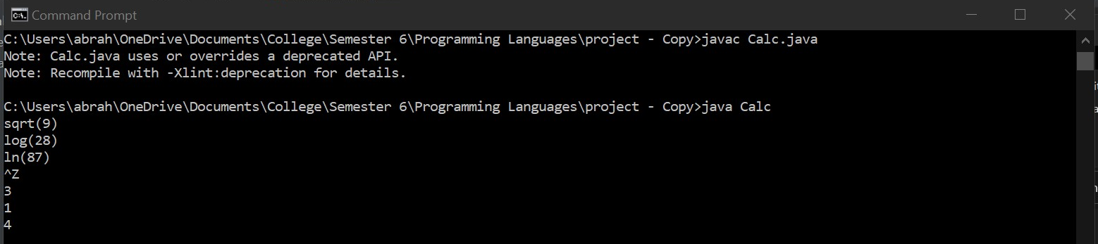

**This screenshot is the program taking input from file test.expr.**

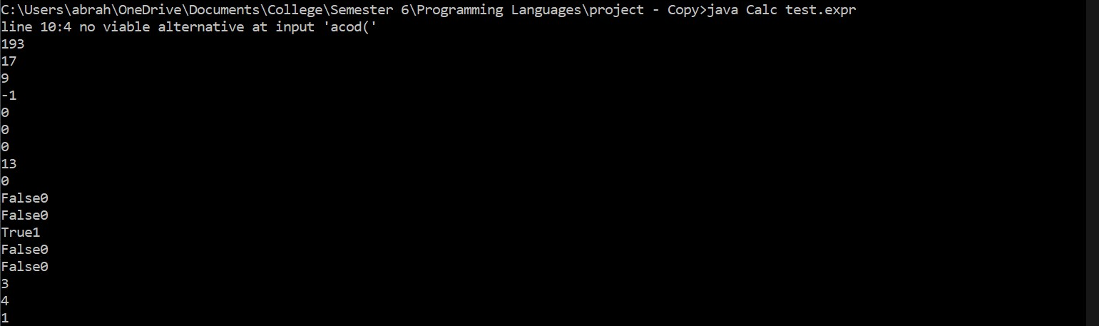

**Below are the contents within the test.expr file.**

