CSCI 3038 FINAL PROJECT
Black Box Optimizer
Technical Design Specification
Controlling runtime behavior, state transitions, interfaces, schemas, algorithms, and validation
DESIGN AUTHORITY
This specification defines how the software will satisfy Project Charter BBO-PC-001 and Scope of Work BBO-SOW-001. It does not add scope, assign team work, or silently resolve conflicts among controlled documents.
Document control | Value
Document ID | BBO-TDS-001
Version | Draft v0.1
Prepared | July 17, 2026
Status | Passed
Governing charter | BBO-PC-001, Draft v0.1
Governing Scope of Work | BBO-SOW-001, Draft v0.1
Effective date | 07/21/2026
Technical ownership | The Snek People
Course requirements | Fulfilled

Design at a Glance
Dimension | Controlling design
Execution | Strictly local, synchronous, sequential; one worker trial at a time
Search | Built-in registry; MVP selects seeded RandomSearch
Objectives | Two or more; independent minimize/maximize directions
Result | All non-dominated eligible TrialRecords as the Pareto Front
Evidence | Immutable TrialRecords; append-only persisted TrialHistory
Lifecycle | Explicit controller states with modular StopPolicy
External contract | JSON configuration, CLI parameters, one-row CSV metrics

t1. Document Control and Design Authority
This Technical Design Specification is the controlling technical baseline for the Black Box Optimizer. It translates the authorized purpose and work obligations into runtime behavior, public interfaces, immutable data contracts, file schemas, state transitions, validation rules, and verification points.
Document | Controlling concern | Status
Project Charter BBO-PC-001 | Purpose, authority, vocabulary, governance, and high-level boundaries | Draft v0.1
Scope of Work BBO-SOW-001 | Work packages, deliverables, exclusions, requirements, and acceptance | Draft v0.1
Technical Design BBO-TDS-001 | State model, interfaces, schemas, algorithms, Pareto rules, and validation | Draft v0.1

1.1 Precedence and conflict handling
- The Charter controls project purpose, authority, controlling vocabulary, and high-level boundaries.
- The Scope of Work controls what the MVP must deliver and how completion is accepted.
- This specification controls how approved software behavior is represented and implemented.
- A conflict is recorded and reconciled through change control; no document silently overrides another.

1.2 Normative language
Word | Meaning
must / shall | Mandatory for the baseline design
must not / shall not | Prohibited by the baseline design
should | Recommended unless a documented reason justifies deviation
may | Permitted but not required
MVP | The specific baseline authorized by the Charter and Scope of Work

1.3 Technical design objectives
- Make every public object and component boundary understandable without requiring advanced optimization mathematics.
- Keep search policy, execution policy, worker invocation, evidence, Pareto evaluation, and reporting independently replaceable.
- Make every worker attempt traceable from proposed parameters through metrics, execution status, history, and final result.
- Prevent RandomSearch assumptions from leaking into the contract, controller, runner, history, or Pareto evaluator.
- Define deterministic behavior wherever the same controlled inputs are expected to reproduce the same outcome.

2. Shared Vocabulary and Controlling Definitions
CONTROLLED VOCABULARY
These definitions repeat the governing Charter and Scope of Work definitions so this specification can stand alone. Code identifiers and documentation must not give these terms a different meaning without approved change control.

2.1 Optimization and result terms
Term | Controlling definition
Algorithm Registry | Approved mapping from an AlgorithmSpec name to a SearchAlgorithm factory. The MVP contains RandomSearch; arbitrary external plugin loading is excluded.
AlgorithmSpec | Immutable selection of one registered algorithm and its algorithm-specific settings. Random seed belongs here.
Candidate Configuration | One complete legal parameter set proposed for one worker trial. It is intended input, not evidence.
Dominance | Trial A is no worse than Trial B on every objective and strictly better on at least one after applying objective directions.
Eligible Trial | Execution-successful TrialRecord with valid metrics containing a finite value for every declared objective.
Metric | Named finite numerical value written by the worker. It becomes an objective only when declared in OptimizationContract.
Minimum Viable Product | Local sequential execution, registered RandomSearch, multiple objectives, Pareto-front output, persistence, and reporting.
Objective | Named metric and direction—minimize or maximize—used for comparison.
OptimizationContract | Immutable, algorithm-independent definition of parameter space and objective set.
Optimization Result | Final structured result containing ParetoFront, termination reason, result status, and completed TrialHistory snapshot.
ParameterDefinition | Immutable declaration of parameter name, type, and legal domain. MVP types are integer, float, and categorical.
Pareto Front | Every eligible TrialRecord not dominated by another eligible TrialRecord. It is a trade-off set, not a universal winner.
ProposalResult | Explicit algorithm response containing a Candidate Configuration or a named reason no candidate can be proposed.
RandomSearch | First registered SearchAlgorithm; samples legal untried candidates from a seeded NumPy generator.
SearchAlgorithm | Modular policy interface that proposes the next candidate from OptimizationContract and read-only TrialHistory.
Search Exhaustion | Normal condition in which an algorithm cannot produce another legal untried candidate.

2.2 Execution and lifecycle terms
Term | Controlling definition
Application Controller | Deterministic finite-state lifecycle governor sequencing selection, execution, recording, stop evaluation, and finalization.
Execution Metadata | Facts observed by Runner: runtime, exit code, timeout, cancellation, launch failure, and captured error information.
Local Execution | Execution on one local machine using local processes and files; networks and remote workers are excluded.
Runner | Builds the argument list, launches one worker synchronously, applies timeout, and observes status. It does not select or rank.
Sequential Execution | No more than one worker trial is active; the controller waits for completion before advancing.
StopDecision | Explicit StopPolicy result stating whether execution may continue and, if not, the termination reason.
StopPolicy | Immutable rules governing execution limits. The controller evaluates and enforces them.
Trial | One attempted evaluation of one Candidate Configuration through the worker contract.
TrialHistory | Append-only ordered TrialRecord collection for one run; algorithms receive a read-only snapshot.
TrialRecord | Immutable record of one attempt: exact parameters, parsed metrics or parse status, and Execution Metadata.
Worker | Opaque external local program being optimized; optimizer code never imports it.
WorkerSpec | Immutable operational specification for command, metrics-output argument, and per-trial timeout.

2.3 Additional technical terms
Term | Technical definition
Execution Success | The worker process launched, did not time out or receive cancellation, and exited with code 0. It does not imply metric validity.
Metrics Validity | The metrics file exists, contains one row, has unique nonempty headers, and every present value is a finite number.
Termination Reason | Named explanation for why the controller entered finalization: maximum trials, search exhaustion, cancellation, or fatal error.
Result Status | Whether a nonempty Pareto Front is available or the run completed with no eligible trials.
Canonical Candidate Key | Stable, hashable representation of parameter assignments in contract order, used for duplicate prevention.
Resolved Configuration | Exact validated configuration written into the run directory before trial 1.

2.4 Critical distinctions
Distinction | Required interpretation
Candidate vs. TrialRecord | Intended input versus immutable evidence of an attempted execution.
Metric vs. Objective | Returned numerical value versus a metric selected for optimization.
Execution success vs. metrics validity | Process outcome versus correctness of the one-row CSV.
Metrics validity vs. eligibility | Valid returned metrics may still omit an objective required by the contract.
Search Exhaustion vs. StopDecision | Algorithm outcome versus execution-policy decision.
Termination Reason vs. Result Status | Why execution stopped versus whether a nonempty Pareto Front exists.
Pareto Front vs. winner | Non-dominated trade-offs versus an unjustified total ranking.

3. Technical Architecture
The system is a local orchestration application organized around six separate concerns: immutable configuration, candidate proposal, lifecycle control, worker execution, evidence preservation, and multi-objective evaluation. Components communicate through declared objects and files rather than worker imports or hidden shared state.
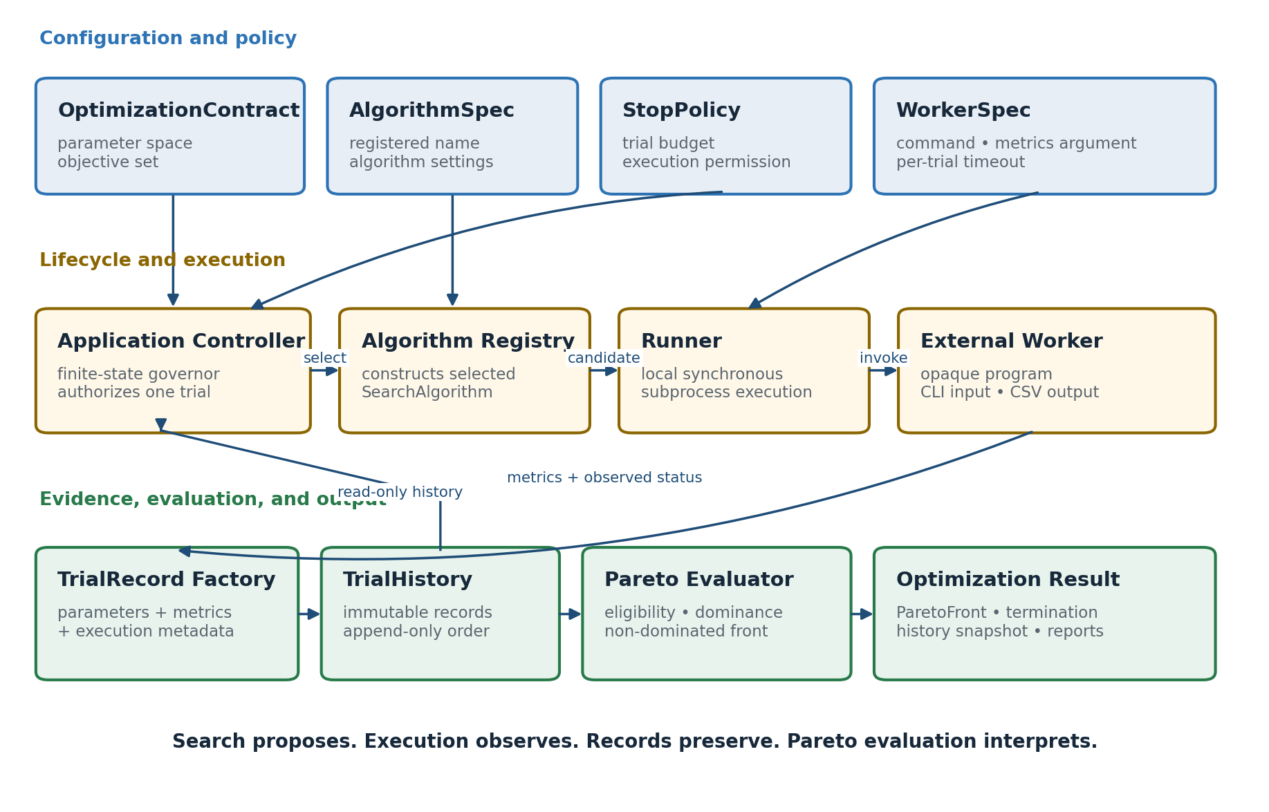
Figure 1. Authoritative component responsibilities and data flow.

3.1 Component responsibility matrix
Component | Owns | Must not own
Configuration Loader | Parse JSON and create validated immutable specifications. | Execute workers or select candidates.
Algorithm Registry | Construct the named registered SearchAlgorithm. | Discover arbitrary external plugins.
SearchAlgorithm | Propose a legal untried candidate or explicit unavailability reason. | Launch workers, enforce budgets, or calculate final reports.
Application Controller | Own state transitions and authorize at most one execution. | Rank metrics or know worker internals.
StopPolicy | Evaluate execution budget and return StopDecision. | Propose candidates or terminate processes directly.
Runner | Invoke the worker, enforce timeout, and observe execution metadata. | Choose parameters or interpret quality.
Record Factory | Parse metrics and construct immutable TrialRecord. | Select another candidate or mutate history.
TrialHistory | Append records and expose a read-only snapshot. | Rewrite, remove, or rank records.
Pareto Evaluator | Derive eligibility, dominance, and deterministic ParetoFront. | Invent weights or a single winner.
Reporter | Export resolved configuration, evidence, front, summary, and plots. | Change the authoritative result.

3.2 Dependency rules
- Application Controller depends on interfaces, not concrete RandomSearch or demo-worker internals.
- RandomSearch depends on OptimizationContract and read-only TrialHistory; it never depends on Runner or Reporter.
- Runner depends on WorkerSpec and Candidate Configuration; it never depends on objectives or Pareto logic.
- Pareto Evaluator depends on OptimizationContract and TrialRecords; it never depends on AlgorithmSpec or WorkerSpec.
- Reporter receives an Optimization Result and paths; it must not mutate TrialHistory or recalculate a different result.
- No runtime module may import the external worker as application code.

3.3 Runtime invariants
- No more than one worker process is active for one optimizer run.
- Every authorized worker attempt receives a unique trial identifier and directory before launch.
- Every attempted worker execution produces exactly one immutable TrialRecord, including launch failure, timeout, cancellation, nonzero exit, missing metrics, and malformed metrics.
- A TrialRecord is appended and persisted before any post-trial StopDecision is enforced.
- OptimizationContract, AlgorithmSpec, StopPolicy, and WorkerSpec do not change after initialization succeeds.
- Algorithms receive a tuple snapshot of TrialHistory and cannot rewrite evidence.
- The authoritative optimization result is the full non-dominated eligible set; visualizations cannot replace it.
- Runtime operation performs no networking, concurrency, remote coordination, database access, or resume behavior.

4. Configuration and Immutable Domain Contracts
One JSON file is validated before trial 1 and converted into four immutable specifications. The objects are separate because they answer different questions: what problem is being solved, which algorithm is selected, what execution budget applies, and how the worker is invoked.

4.1 Foundational types
Interface sketch — parameter and objective declarations
ParameterValue = int | float | str
ParameterKind = Literal["integer", "float", "categorical"]
Direction = Literal["minimize", "maximize"]
@dataclass(frozen=True)
class ParameterDefinition:
name: str
kind: ParameterKind
minimum: int | float | None = None
maximum: int | float | None = None
choices: tuple[ParameterValue, ...] = ()
@dataclass(frozen=True)
class Objective:
metric_name: str
direction: Direction
Object | Concrete example | Interpretation
Integer definition | ParameterDefinition("epochs", "integer", 1, 100) | Inclusive integer range 1 through 100
Float definition | ParameterDefinition("learning_rate", "float", 0.0001, 0.1) | Uniform continuous sampling for RandomSearch
Categorical definition | ParameterDefinition("batch_size", "categorical", choices=(16, 32, 64, 128)) | Select exactly one declared choice
Maximize objective | Objective("accuracy", "maximize") | Larger accuracy is better
Minimize objective | Objective("training_time", "minimize") | Smaller training time is better

4.2 OptimizationContract
@dataclass(frozen=True)
class OptimizationContract:
parameters: tuple[ParameterDefinition, ...]
objectives: tuple[Objective, ...]
The contract is algorithm-independent. It contains no seed, maximum-trial limit, worker command, timeout, weighted score, or algorithm name. The MVP requires at least two objectives; future algorithms may declare different capability requirements without changing this object.
Concrete OptimizationContract
OptimizationContract(
parameters=(
ParameterDefinition("learning_rate", "float", 0.0001, 0.1),
ParameterDefinition("temperature", "float", 0.1, 2.0),
ParameterDefinition(
"batch_size", "categorical", choices=(16, 32, 64, 128)
),
),
objectives=(
Objective("accuracy", "maximize"),
Objective("loss", "minimize"),
Objective("training_time", "minimize"),
),
)

4.3 AlgorithmSpec
@dataclass(frozen=True)
class AlgorithmSpec:
algorithm_name: str
settings: Mapping[str, ParameterValue]
AlgorithmSpec(
algorithm_name="random_search",
settings={"seed": 42},
)
IMMUTABILITY REQUIREMENT
A frozen dataclass does not freeze a normal dictionary. The configuration factory must copy nested mappings and expose them through read-only mappings, or store them as immutable tuples. Callers must not retain a mutable alias.

4.4 StopPolicy and WorkerSpec
@dataclass(frozen=True)
class StopPolicy:
max_trials: int
@dataclass(frozen=True)
class WorkerSpec:
command: tuple[str, ...]
metrics_argument: str
timeout_seconds: float
stop_policy = StopPolicy(max_trials=25)
worker_spec = WorkerSpec(
command=(sys.executable, "demo_worker.py"),
metrics_argument="--metrics-out",
timeout_seconds=30.0,
)
Maximum trials belongs to StopPolicy. Per-trial timeout belongs to WorkerSpec because Runner enforces it for one invocation. Search exhaustion belongs to ProposalResult. User cancellation and fatal errors are runtime events. The controller converts all four sources into explicit finalization behavior.

4.5 Candidate Configuration
@dataclass(frozen=True)
class CandidateConfiguration:
parameters: Mapping[str, ParameterValue]
candidate = CandidateConfiguration(
parameters={
"learning_rate": 0.0125,
"temperature": 0.70,
"batch_size": 32,
}
)
The candidate factory copies and freezes its mapping, orders values according to OptimizationContract, verifies that every declared parameter appears exactly once, rejects undeclared parameters, and validates every value against its declared domain.

4.6 Complete example JSON
examples/project_config.json
{
"worker": {
"command": ["python", "demo_worker.py"],
"metrics_argument": "--metrics-out",
"timeout_seconds": 30.0
},
"optimization": {
"parameters": [
{"name": "learning_rate", "type": "float",
"minimum": 0.0001, "maximum": 0.1},
{"name": "temperature", "type": "float",
"minimum": 0.1, "maximum": 2.0},
{"name": "batch_size", "type": "categorical",
"choices": [16, 32, 64, 128]}
],
"objectives": [
{"metric_name": "accuracy", "direction": "maximize"},
{"metric_name": "loss", "direction": "minimize"},
{"metric_name": "training_time", "direction": "minimize"}
]
},
"algorithm": {
"name": "random_search",
"settings": {"seed": 42}
},
"stop_policy": {"max_trials": 25}
}

5. Application Controller and Stop Model
The Application Controller is a deterministic finite-state lifecycle governor. Its highest-authority operation is granting or withholding permission to launch the next worker trial. It orchestrates components but delegates candidate generation, execution-budget calculation, subprocess behavior, record construction, and Pareto interpretation.
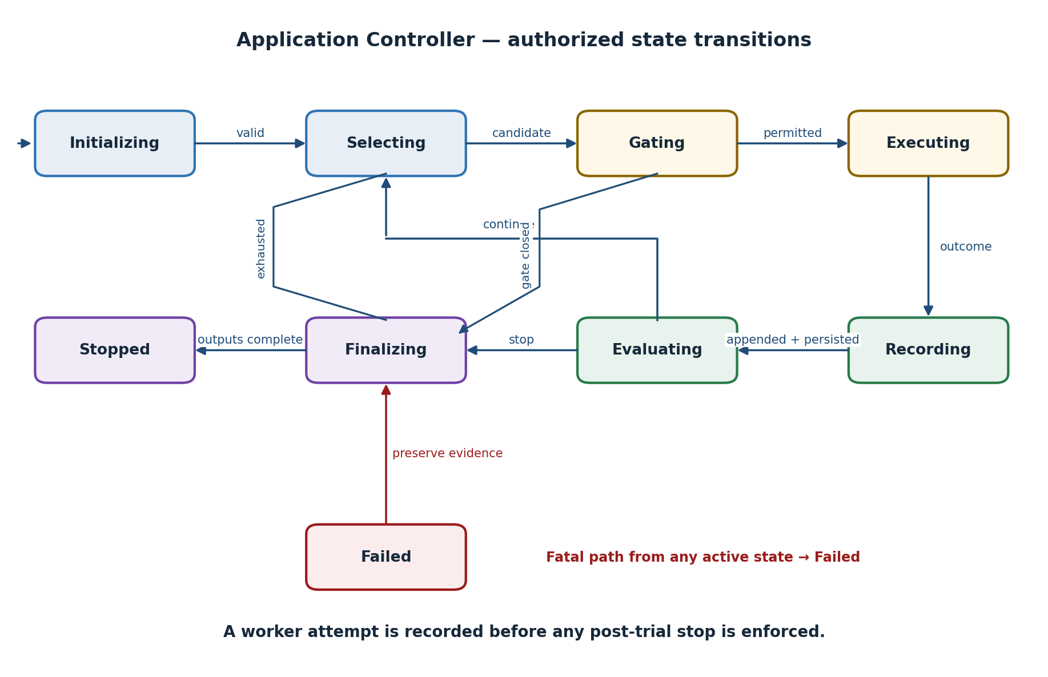
Figure 2. Application Controller state model and permitted transitions.

5.1 State definitions
State | Required behavior | Allowed next state
INITIALIZING | Load JSON, validate contracts, create algorithm, create run directory, write resolved config. | SELECTING or FAILED
SELECTING | Request ProposalResult from SearchAlgorithm using contract and read-only history. | GATING, FINALIZING, or FAILED
GATING | Evaluate StopPolicy before authorizing subprocess launch. | EXECUTING or FINALIZING
EXECUTING | Run one worker synchronously and observe execution metadata. | RECORDING or FAILED
RECORDING | Parse metrics, construct one TrialRecord, append it, and persist history. | EVALUATING or FAILED
EVALUATING | Evaluate post-trial StopPolicy and cancellation/fatal signals. | SELECTING or FINALIZING
FINALIZING | Derive ParetoFront, construct Optimization Result, and write reports. | STOPPED
STOPPED | Terminal state; no further worker may be authorized. | None
FAILED | Capture fatal reason and preserve existing evidence before finalization when possible. | FINALIZING

5.2 State-transition constraints
- A state transition is explicit; application code must not simulate a transition by calling a later component directly.
- EXECUTING cannot begin without one validated Candidate Configuration and a continue StopDecision.
- EXECUTING has at most one child process and blocks until that attempt reaches an observed outcome.
- An authorized attempt reaches RECORDING even when launch, execution, metrics, or cancellation fails.
- FINALIZING is idempotent: repeated entry must not launch workers or append duplicate trials.
- STOPPED and FAILED do not permit a transition back to selection or execution.

5.3 StopDecision and termination reasons
TerminationReason = Literal[
"maximum_trials",
"search_exhausted",
"user_cancelled",
"fatal_error",
]
@dataclass(frozen=True)
class StopDecision:
continue_execution: bool
termination_reason: TerminationReason | None
message: str | None = None
Signal source | Controller interpretation | Record current trial?
StopPolicy: maximum trials | Normal finalization with maximum_trials | No new trial is launched
ProposalResult: search exhausted | Normal finalization with search_exhausted | No candidate exists to record
KeyboardInterrupt before launch | Finalization with user_cancelled | No new trial was attempted
KeyboardInterrupt during worker | Terminate child, record cancelled attempt, then finalize | Yes
Fatal configuration/registry error | FAILED then FINALIZING with fatal_error | No worker was attempted
Fatal error after launch | Record a fallback TrialRecord when possible, then fail/finalize | Yes

5.4 Controller pseudocode
state = INITIALIZING
termination_reason = None
initialize_and_validate()
state = SELECTING
while state not in {STOPPED}:
if state is SELECTING:
proposal = algorithm.propose(contract, history.snapshot())
if proposal.status == "candidate":
state = GATING
elif proposal.status == "search_exhausted":
termination_reason = "search_exhausted"
state = FINALIZING
else:
termination_reason = "fatal_error"
state = FAILED
elif state is GATING:
decision = stop_policy.before_trial(history.snapshot())
if decision.continue_execution:
state = EXECUTING
else:
termination_reason = decision.termination_reason
state = FINALIZING
elif state is EXECUTING:
observation = runner.execute(worker_spec, proposal.candidate)
state = RECORDING
elif state is RECORDING:
record = build_trial_record(proposal.candidate, observation)
history.append(record)
persistence.checkpoint(history.snapshot())
state = EVALUATING
elif state is EVALUATING:
decision = stop_policy.after_trial(history.snapshot())
if decision.continue_execution:
state = SELECTING
else:
termination_reason = decision.termination_reason
state = FINALIZING
elif state is FAILED:
termination_reason = termination_reason or "fatal_error"
state = FINALIZING
elif state is FINALIZING:
result = finalize(contract, history.snapshot(), termination_reason)
reporter.write(result)
state = STOPPED
NO PUBLIC EXECUTIONDATA DOMAIN OBJECT
Execution metadata is a category of observed facts stored directly in TrialRecord. The Runner may use a private helper internally, but the public domain model does not add an unnecessary durable ExecutionData wrapper.

6. Worker Execution and Trial Evidence
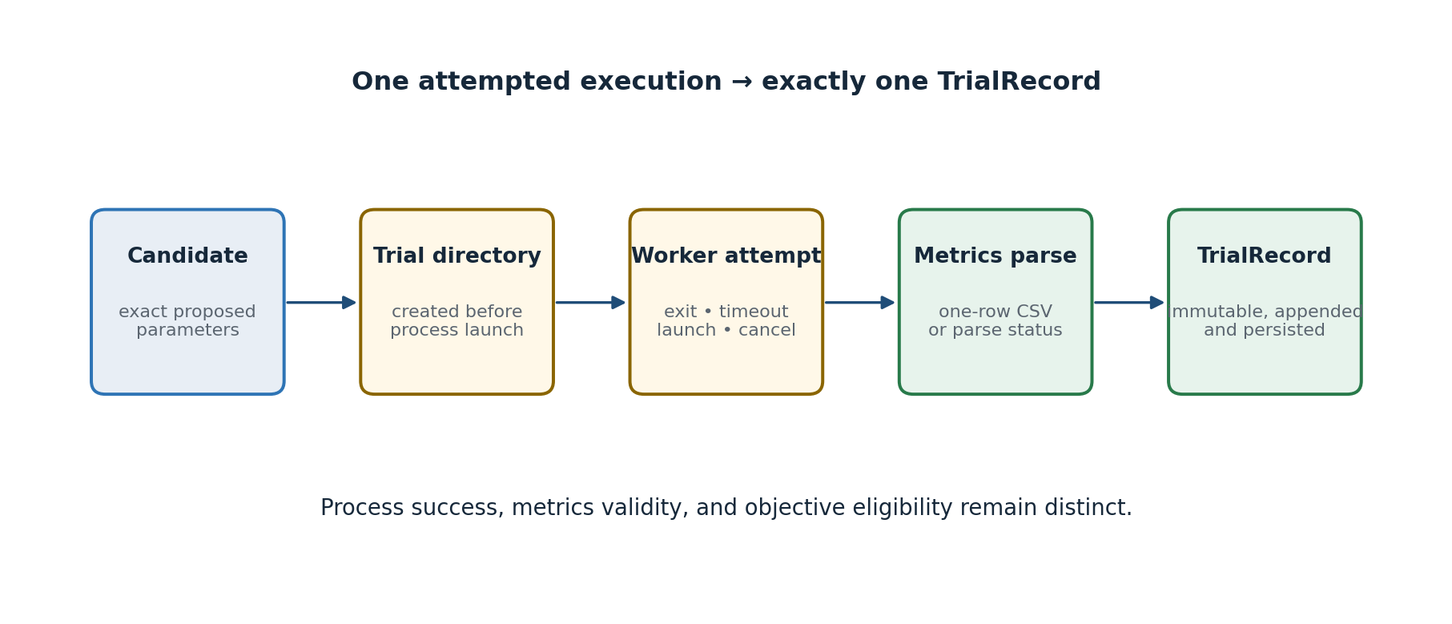
Figure 3. Required evidence path for one attempted worker execution.

6.1 Command-line construction
Runner constructs a list of strings and calls subprocess without shell=True. Parameter names are converted deterministically to flags by replacing underscores with hyphens and adding --. Values are serialized with str(). The metrics argument and absolute trial-specific output path are appended last.
Example subprocess argument list
[
sys.executable,
"demo_worker.py",
"--learning-rate", "0.0125",
"--temperature", "0.7",
"--batch-size", "32",
"--metrics-out", "/.../trials/trial_0007/metrics.csv",
]
- Parameter names must satisfy [A-Za-z][A-Za-z0-9_]* so flag conversion is deterministic.
- The metrics argument name comes from WorkerSpec and is not a tunable parameter.
- The run directory and trial directory must already exist before subprocess launch.
- Standard output and standard error may be captured into trial-local files; they are diagnostic, not metrics.

6.2 Metrics CSV contract
trials/trial_0007/metrics.csv
accuracy,loss,training_time
0.9142,0.1837,1.284
Rule | Required behavior
File path | Worker writes to the exact path supplied through WorkerSpec.metrics_argument.
Row count | Exactly one header row and exactly one data row.
Headers | Nonempty and unique; case-sensitive names.
Values | Every present field parses as a finite float; NaN and infinity are invalid.
Objectives | Every declared objective must appear for eligibility; extra numerical metrics are permitted.
Overwrite | Only the current trial's unique metrics path may be written.

6.3 TrialRecord contract
ExecutionStatus = Literal[
"completed", "process_failed", "timed_out",
"launch_failed", "cancelled"
]
MetricsStatus = Literal[
"valid", "missing", "malformed", "nonfinite"
]
@dataclass(frozen=True)
class TrialRecord:
trial_id: int
parameters: Mapping[str, ParameterValue]
metrics: Mapping[str, float]
execution_status: ExecutionStatus
metrics_status: MetricsStatus
runtime_seconds: float
exit_code: int | None
timed_out: bool
error_message: str | None = None
@property
def execution_succeeded(self) -> bool:
return self.execution_status == "completed"
The factory copies and freezes both mappings. It stores the exact candidate parameters rather than regenerating them. Eligibility is deliberately not stored as an intrinsic TrialRecord field because it depends on the immutable OptimizationContract used to interpret the record.

6.4 Example records
# Execution-successful and eligible under the example contract
TrialRecord(
trial_id=7,
parameters={"learning_rate": 0.0125,
"temperature": 0.7, "batch_size": 32},
metrics={"accuracy": 0.9142, "loss": 0.1837,
"training_time": 1.284},
execution_status="completed",
metrics_status="valid",
runtime_seconds=1.331,
exit_code=0,
timed_out=False,
)
# Timed out; still immutable evidence of an attempted trial
TrialRecord(
trial_id=8,
parameters={"learning_rate": 0.09,
"temperature": 1.8, "batch_size": 128},
metrics={},
execution_status="timed_out",
metrics_status="missing",
runtime_seconds=30.002,
exit_code=None,
timed_out=True,
error_message="Worker exceeded 30.0-second timeout",
)

6.5 Outcome matrix
Observed outcome | Execution status | Metrics status | Objective eligibility
Exit 0; valid complete metrics | completed | valid | Eligible
Exit 0; objective missing | completed | valid | Ineligible
Exit 0; missing CSV | completed | missing | Ineligible
Exit 0; malformed CSV | completed | malformed/nonfinite | Ineligible
Nonzero exit | process_failed | parsed if available | Ineligible
Timeout | timed_out | parsed only if valid file exists | Ineligible
Launch failure | launch_failed | missing | Ineligible
User cancellation during worker | cancelled | parsed only if valid file exists | Ineligible

7. Search Algorithm Boundary and RandomSearch

7.1 Registry and protocol
@dataclass(frozen=True)
class ProposalResult:
status: Literal["candidate", "search_exhausted", "proposal_failed"]
candidate: CandidateConfiguration | None = None
reason: str | None = None
class SearchAlgorithm(Protocol):
def propose(
self,
contract: OptimizationContract,
history: Sequence[TrialRecord],
) -> ProposalResult: ...
AlgorithmFactory = Callable[[AlgorithmSpec], SearchAlgorithm]
ALGORITHM_REGISTRY: Mapping[str, AlgorithmFactory] = {
"random_search": build_random_search,
}
The Registry is a built-in mapping, not dynamic plugin discovery. Unknown names and unsupported settings fail during initialization. Adding a later registered algorithm must not require changes to Runner, TrialRecord, TrialHistory, Pareto evaluation, or controller states.

7.2 RandomSearch sampling
Parameter kind | Sampling rule
integer | NumPy Generator.integers(minimum, maximum + 1); bounds are inclusive.
float | NumPy Generator.uniform(minimum, maximum); lower bound included, upper bound excluded by generator behavior.
categorical | NumPy Generator.choice over the declared choices with equal probability.

- Create one NumPy Generator from AlgorithmSpec.settings['seed'] during initialization.
- Sample one legal value for every ParameterDefinition in contract order.
- Construct and validate a Candidate Configuration.
- Convert it to a canonical candidate key and compare it with every attempted TrialRecord, including failed attempts.
- Return the candidate when untried; otherwise resample up to a bounded duplicate-attempt limit.
- Return search_exhausted when an exactly finite space has no remaining candidate.
- Return proposal_failed rather than looping forever if duplicate sampling stalls without provable exhaustion.

7.3 Canonical candidate key
def candidate_key(
contract: OptimizationContract,
candidate: CandidateConfiguration,
) -> tuple[tuple[str, ParameterValue], ...]:
return tuple(
(definition.name, candidate.parameters[definition.name])
for definition in contract.parameters
)
The contract order, not dictionary insertion order, controls the key. Failed, timed-out, and ineligible attempts still count as attempted configurations and are not silently retried.

7.4 Finite-space exhaustion
A search space is exactly finite when every parameter is an integer with finite inclusive bounds or categorical with finite choices. Its cardinality is the product of each domain size. If the number of distinct attempted canonical keys equals that cardinality, RandomSearch returns search_exhausted without sampling again. A space containing a float parameter is not treated as exactly enumerable; max_trials normally terminates it.
domain_size(integer) = maximum - minimum + 1
domain_size(categorical) = len(choices)
finite_space_size = product(domain_size(parameter))

7.5 Reproducibility guarantee
REPRODUCIBILITY BOUNDARY
The same validated OptimizationContract, AlgorithmSpec, and ordered TrialHistory snapshot must produce the same next proposal. Reproducibility does not require identical timestamps, run-directory names, worker runtime, or operating-system scheduling.

8. Multi-Objective Eligibility and Pareto Evaluation

8.1 Eligibility
def is_eligible(
record: TrialRecord,
contract: OptimizationContract,
) -> bool:
if not record.execution_succeeded:
return False
if record.metrics_status != "valid":
return False
return all(
objective.metric_name in record.metrics
and math.isfinite(record.metrics[objective.metric_name])
for objective in contract.objectives
)
Eligibility does not modify TrialRecord. The same immutable record may be interpreted only under the one immutable OptimizationContract belonging to its run. A valid extra metric has no effect unless declared as an objective.

8.2 Formal dominance
For eligible records A and B and objectives j = 1…m, A dominates B when A is no worse than B on every objective and strictly better on at least one objective. Direction is applied independently for every objective:
Direction | A no worse than B | A strictly better than B
maximize | A[j] ≥ B[j] | A[j] > B[j]
minimize | A[j] ≤ B[j] | A[j] < B[j]

dominates(A, B) =
all(no_worse(A[j], B[j], direction[j]) for j in objectives)
and
any(strictly_better(A[j], B[j], direction[j])
for j in objectives)
- Comparisons use stored finite floats directly; the MVP defines no tolerance, normalization, weighting, or scalarization.
- Equal objective vectors do not dominate one another because neither is strictly better.
- Duplicate objective vectors therefore remain separate non-dominated TrialRecords when both are eligible.

8.3 ParetoFront algorithm
eligible = [r for r in history if is_eligible(r, contract)]
front = []
for candidate in eligible:
if not any(
other.trial_id != candidate.trial_id
and dominates(other, candidate, contract)
for other in eligible
):
front.append(candidate)
front.sort(key=lambda record: record.trial_id)
return ParetoFront(records=tuple(front))
The MVP algorithm is O(n²m), where n is the number of eligible trials and m is the number of objectives. This is acceptable for the authorized local trial counts and is easier to verify than a more complex front-maintenance structure.
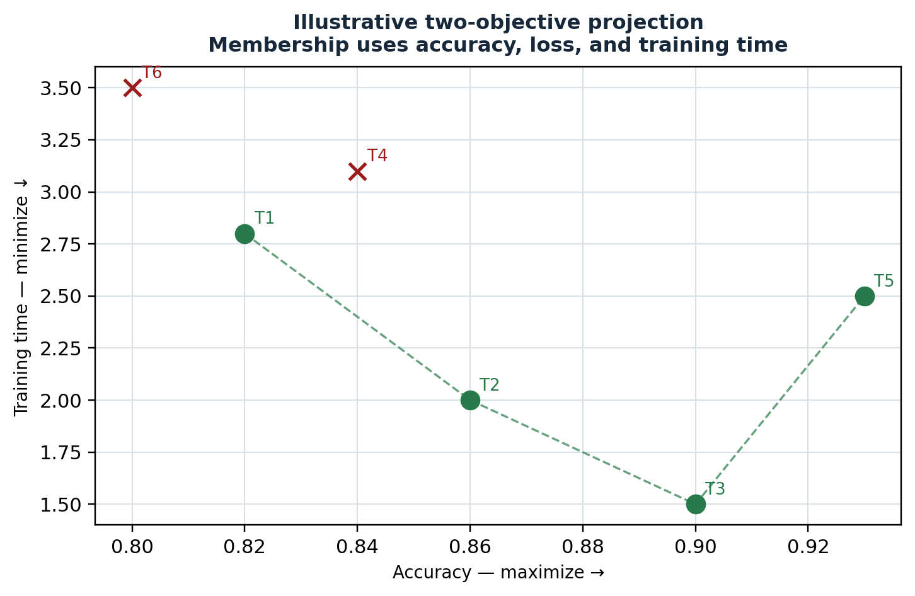
Figure 4. Explanatory projection only; the tabular objective vectors remain authoritative.

8.4 Three-objective fixture
Trial | Accuracy ↑ | Loss ↓ | Time ↓ | Expected result
T1 | 0.82 | 0.15 | 2.8 | Front
T2 | 0.86 | 0.20 | 2.0 | Front
T3 | 0.90 | 0.25 | 1.5 | Front
T4 | 0.84 | 0.26 | 3.1 | Dominated by T2
T5 | 0.93 | 0.30 | 2.5 | Front: accuracy trade-off
T6 | 0.80 | 0.28 | 3.5 | Dominated by T1 and T2

AUTHORITATIVE FIXTURE
The verification suite must encode a hand-calculated mixed-direction fixture and assert the exact trial identifiers in the front. No plot is accepted as proof of Pareto correctness.

8.5 Optimization Result
ResultStatus = Literal["pareto_front_available", "no_eligible_trials"]
@dataclass(frozen=True)
class ParetoFront:
records: tuple[TrialRecord, ...]
@dataclass(frozen=True)
class OptimizationResult:
pareto_front: ParetoFront
termination_reason: TerminationReason
result_status: ResultStatus
history: tuple[TrialRecord, ...]

9. Persistence, Reporting, and Output Contracts

9.1 Run-directory layout
runs/run_2026-07-17_140500_ab12cd/
├── resolved_config.json
├── history.csv
├── pareto_front.csv
├── summary.txt
├── plots/
│ └── pareto_projection.png
└── trials/
├── trial_0001/
│ ├── metrics.csv
│ ├── stdout.txt
│ └── stderr.txt
├── trial_0002/
│ └── ...
└── ...
- A new run creates a new directory; an existing run is never resumed or overwritten.
- resolved_config.json is written after validation and before trial 1.
- Each trial directory is created before subprocess launch and retained regardless of outcome.
- history.csv is checkpointed after every appended TrialRecord.
- pareto_front.csv and summary.txt are finalization outputs and may be regenerated from retained history and the resolved contract.

9.2 History CSV schema
trial_id,execution_status,metrics_status,execution_succeeded,
objective_eligible,runtime_seconds,exit_code,timed_out,
param.learning_rate,param.temperature,param.batch_size,
metric.accuracy,metric.loss,metric.training_time,error_message
Column group | Source | Rule
Trial identity/status | TrialRecord | Required fixed columns; one row per TrialRecord in order.
objective_eligible | Contract + TrialRecord | Derived during export; not intrinsic mutable evidence.
param.* | Candidate Configuration | Every declared parameter, prefixed to prevent collisions.
metric.* | Parsed worker metrics | Union of observed metrics; missing cells remain empty.
error_message | Runner or parser | Human-readable bounded diagnostic; never treated as an objective.

9.3 Pareto export
pareto_front.csv uses the same flattened columns as history.csv but includes only the TrialRecords in OptimizationResult.pareto_front, ordered by trial_id. The export must not add a weighted score or best-trial column.

9.4 Checkpoint behavior
- Flatten the complete read-only TrialHistory snapshot into a new temporary CSV in the run directory.
- Flush and close the temporary file.
- Replace history.csv with the completed temporary file using os.replace where supported.
- Retain the previously committed history.csv if temporary generation fails.
- Treat checkpoint failure as fatal because append-only evidence can no longer satisfy the persistence obligation.

9.5 Summary and visualization
Output | Minimum contents | Authority
summary.txt | Run identifier, termination reason, result status, counts by execution/metrics status, eligible count, Pareto count | Explanatory text
pareto_projection.png | At least one two-objective view distinguishing front members from dominated eligible trials | Explanatory only
history.csv | Every immutable record flattened under resolved contract | Authoritative evidence export
pareto_front.csv | Every and only non-dominated eligible record | Authoritative optimization result export

10. Validation and Error Handling

10.1 Initialization validation
Subject | Validation rule
Parameter names | Unique, nonempty, pattern [A-Za-z][A-Za-z0-9_]*.
Integer domain | Integer bounds; minimum ≤ maximum; bool rejected as integer value.
Float domain | Finite numeric bounds; minimum < maximum.
Categorical domain | At least one unique JSON scalar choice; no duplicate choices.
Objectives | At least two; unique nonempty metric names; direction exactly minimize or maximize.
AlgorithmSpec | Name is registered; RandomSearch has exactly one integer seed setting unless later approved.
StopPolicy | max_trials is a positive integer.
WorkerSpec | Nonempty string command tuple; metrics argument begins with --; timeout is positive finite.
Output root | Creatable and writable without reusing an existing run directory.

FAIL-FAST RULE
Any initialization validation error enters FAILED before trial 1. The controller reports all independently detectable configuration errors together when practical, rather than forcing one edit-and-rerun cycle per field.

10.2 Candidate validation
- Every declared parameter appears exactly once; no undeclared key appears.
- Integer values are ints but not bool and fall within inclusive bounds.
- Float values are finite numbers converted to float and fall within declared bounds.
- Categorical values exactly equal one declared choice with compatible type.
- The canonical key is constructed only after validation succeeds.

10.3 Failure handling matrix
Condition | Detected in | Required evidence | Controller behavior
Unknown algorithm | INITIALIZING | Fatal; no trial | Reject before trial 1
Candidate violates contract | SELECTING | Fatal algorithm-contract defect | No worker launch
Executable missing | EXECUTING | launch_failed TrialRecord | Continue if policy permits
Worker exit nonzero | EXECUTING | process_failed TrialRecord | Continue if policy permits
Timeout | EXECUTING | timed_out TrialRecord | Continue if policy permits
Missing/malformed CSV | RECORDING | Completed execution with invalid metrics record | Continue if policy permits
History checkpoint fails | RECORDING | Fatal after preserving in-memory record | Finalize with fatal_error
Pareto evaluation defect | FINALIZING | Fatal result failure; history remains | No false result export
KeyboardInterrupt | Any active state | Cancellation; record active attempt if launched | Finalize existing evidence

10.4 Error-message requirements
- Identify the component, trial identifier when assigned, and immediate cause.
- Do not include secrets, environment dumps, or unbounded worker output in history.csv.
- Preserve full diagnostic stdout/stderr in trial-local files when captured.
- Use explicit exception types for configuration, algorithm, runner, metrics, persistence, and Pareto failures.
- Never convert a failure into an artificial worst objective vector.

11. Module Layout and Public Interfaces
black_box_optimizer/
├── main.py # CLI entry and dependency construction
├── config_loader.py # JSON parsing and full validation
├── models.py # immutable domain contracts and records
├── controller.py # finite-state lifecycle governor
├── stop_policy.py # StopDecision evaluation
├── runner.py # local synchronous subprocess boundary
├── record_factory.py # CSV parse and TrialRecord construction
├── history.py # append-only history and snapshot
├── persistence.py # atomic history checkpoint and run paths
├── algorithms/
│ ├── protocol.py # SearchAlgorithm and ProposalResult
│ ├── registry.py # approved factory mapping
│ └── random_search.py # seeded MVP algorithm
├── pareto.py # eligibility, dominance, ParetoFront
├── reporting.py # summary, CSV exports, Matplotlib views
├── demo_worker.py # external example worker
├── examples/project_config.json
└── tests/ # unit, contract, integration, acceptance

11.1 Public interface summary
Interface | Return / effect
load_configuration(path) | Validated WorkerSpec, OptimizationContract, AlgorithmSpec, StopPolicy
AlgorithmRegistry.create(spec, contract) | SearchAlgorithm or initialization error
algorithm.propose(contract, history) | ProposalResult
stop_policy.before_trial(history) | StopDecision
runner.execute(worker_spec, candidate, trial_path) | Private observation fields immediately consumed by record factory
build_trial_record(candidate, metrics_path, observed_fields) | Immutable TrialRecord
history.append(record) | None; rejects duplicate/out-of-order trial id
history.snapshot() | tuple[TrialRecord, ...]
evaluate_pareto(contract, history) | ParetoFront
finalize(contract, history, reason) | OptimizationResult
reporter.write(result, resolved_config, run_path) | Required output files

11.2 Allowed dependency direction
Consumer | May depend on | Must not depend on
controller | Protocols, specs, history, result services | demo_worker internals
random_search | models, algorithm protocol, NumPy | runner, reporting, Pareto implementation
runner | WorkerSpec, Candidate Configuration, subprocess | objectives, Pareto, algorithm registry
record_factory | TrialRecord model, candidate, metrics parser | RandomSearch or StopPolicy
pareto | OptimizationContract, TrialRecord | Runner, WorkerSpec, AlgorithmSpec
reporting | Optimization Result, resolved config, paths | candidate generation or execution control
demo_worker | standard library and its own computation | optimizer package

11.3 CLI behavior
python -m black_box_optimizer examples/project_config.json
Exit 0 = run finalized and Pareto Front is available
Exit 2 = run finalized but no eligible trials exist
Exit 3 = user cancelled; retained evidence finalized
Exit 1 = fatal initialization or runtime failure
Exact exit codes may be adjusted through technical review, but the implementation must distinguish successful front production, no-eligible completion, cancellation, and fatal failure.

12. Verification and Requirements Traceability
The Scope of Work acceptance matrix remains controlling. This section identifies the primary technical design element that satisfies each baseline functional requirement; tests may cover more than one requirement.
SOW requirement | Design mechanism | TDS section
FR-01–02 | JSON load and pre-run validation | §4, §10.1
FR-03 | Built-in registry construction | §7.1
FR-04–05 | Seeded legal untried proposals; explicit exhaustion | §7.2–7.4
FR-06 | Controller states and pre-launch gate | §5
FR-07–09 | Sequential Runner, unique directory, timeout/cancel/fatal | §6.1, §9.1, §10.3
FR-10 | One-row finite CSV metrics | §6.2
FR-11–14 | Immutable record, history, persistence, eligibility distinctions | §6.3–6.5, §8.1, §9
FR-15–16 | Mixed-direction dominance and complete front | §8.2–8.4
FR-17–18 | Optimization Result and recoverable failure continuation | §5.3, §8.5, §10.3
FR-19 | Resolved config, history, front, summary, visualization | §9
FR-20 | Multi-objective demo worker contract | §4.6, §6.1–6.2

12.1 Acceptance-scenario design mapping
Acceptance ID | Scenario | Required technical evidence
AT-01 | Valid end-to-end run | Controller integration with all required outputs
AT-02 | Registry selection | Known name constructs; unknown name rejected in INITIALIZING
AT-03 | Reproducibility | Same contract/spec/history produces same proposal sequence
AT-04 | Finite exhaustion | Exact finite cardinality and canonical attempted keys
AT-05–06 | Mixed-direction dominance and trade-offs | Hand-calculated fixture and complete non-dominated set
AT-07–10 | Crash, timeout, metrics failure, incomplete objectives | Outcome matrix and eligibility predicate
AT-11 | Maximum trials | StopPolicy gate prevents N+1 launch
AT-12 | Cancellation | Child termination when active; record if attempted; finalization
AT-13 | No eligible trials | Empty front plus no_eligible_trials result status
AT-14 | Worker substitution | CLI/CSV contract only; no worker imports
AT-15 | Strict locality | Static review and runtime test: no network or concurrent worker
AT-16 | Clean checkout | README command reproduces controlled example outputs

12.2 Minimum test layers
Layer | Primary targets | Examples
Unit | Pure validation, candidate keys, dominance, eligibility | Bounds, directions, equality, duplicate vectors
Contract | JSON, CLI arguments, metrics CSV, flattened exports | Approved fixtures and invalid variants
Component | Registry, RandomSearch, StopPolicy, Runner, history | Seed sequence, exhaustion, timeout, append order
Integration | One-trial vertical slice and sequential loop | Candidate → worker → metrics → TrialRecord
Acceptance | SOW AT-01 through AT-16 | Retained artifacts and expected exit/result status

13. Locality, Portability, and Change Control

13.1 Locality and subprocess safety
- Runner uses subprocess with a string argument list and shell=False.
- No module opens sockets, calls remote APIs, starts servers, or depends on hosted services.
- No thread, asyncio task, process pool, or second concurrent worker trial is created.
- Paths are created with pathlib and commands avoid shell-specific quoting.
- Worker command is supplied by a trusted local project configuration; this MVP is not a multi-user execution service.
- The worker runs with the optimizer process's local user permissions; privilege elevation is excluded.

13.2 Supported environment
Concern | Baseline
Python | Course-required Python 3.13.14
Required libraries | Standard library, NumPy, pandas, Matplotlib
Operating model | Local filesystem and local subprocesses
Networking | Not required and prohibited at runtime
Concurrency | Not implemented
Resume | Not implemented; persisted history is evidence, not restart state

13.3 Design decisions requiring ratification
The following changes are material because they alter controlling definitions, public contracts, work obligations, or acceptance evidence:
- Adding an algorithm implementation beyond RandomSearch or changing the Algorithm Registry discovery model.
- Changing JSON structure, CLI flag conversion, one-row CSV metrics, TrialRecord fields, or output schemas.
- Changing the controller states, the requirement to record before post-trial stop, or the meaning of termination.
- Changing eligibility, dominance, ParetoFront membership, deterministic ordering, or introducing scalarization.
- Adding networking, concurrency, remote execution, resume, database, GUI, hosting, or service behavior.
- Adding a dependency outside the approved baseline or incorporating later instructor requirements.

13.4 Open administrative items
Item | Current state | Technical response
Project-team approval | Pending | TDS remains Draft v0.1 until technical review is recorded.
Instructor requirements | Pending publication | Incorporate only through controlled revision.
Work-package ownership | TBD | Interfaces are defined; names are not assigned by this document.
Milestone dates | TBD | Populate after course deadline is known.

14. Technical Approval
APPROVAL EFFECT
Technical approval establishes this specification as the implementation baseline for WP-02 through WP-08. Approval does not ratify the Charter or Scope of Work, assign individual ownership, or authorize excluded capabilities.
Team member | Decision | Date | Comments
Mel Bailey | Pending | TBD
Emily Tew | Pending | TBD
Kendahl Franklin | Pending | TBD
Charles Freeman | Pending | TBD
Will Reilly | Pending | TBD

Appendix A — Consolidated Architectural Invariants
- The worker is external and opaque; optimizer code does not import or inspect it.
- The OptimizationContract defines the problem and remains independent of algorithm selection.
- Algorithm-specific settings belong only to AlgorithmSpec.
- Execution-budget settings belong only to StopPolicy; per-trial timeout belongs to WorkerSpec.
- The controller is the sole authority for state transitions and worker-launch permission.
- No more than one worker process is active for one run.
- Every attempted execution produces exactly one immutable TrialRecord.
- TrialHistory is append-only and algorithms receive only a tuple snapshot.
- Process success, metrics validity, and objective eligibility are evaluated separately.
- Failed or ineligible trials remain evidence and count as attempted candidates.
- Pareto dominance honors every declared minimize/maximize direction without weights.
- Every eligible non-dominated record is returned; no dominated record is returned.
- Equal objective vectors do not dominate one another and remain separate records.
- History is persisted after every append; persisted evidence does not imply resume support.
- Reports observe the Optimization Result and cannot change it.
- Runtime behavior is local, sequential, synchronous, and free of networking or concurrent candidate execution.
FINAL TECHNICAL SUMMARY
The controller governs execution. The algorithm proposes. The Runner observes. TrialRecord preserves. TrialHistory accumulates. The Pareto Evaluator interprets. The Optimization Result reports why execution stopped and which eligible trials remain non-dominated.

